Assignment

Function Lab

Q Wap to convert Fahrenheit to Celsius  in Java using formula given below  
  
  °C = (°F – 32) / (9/5)

Solution

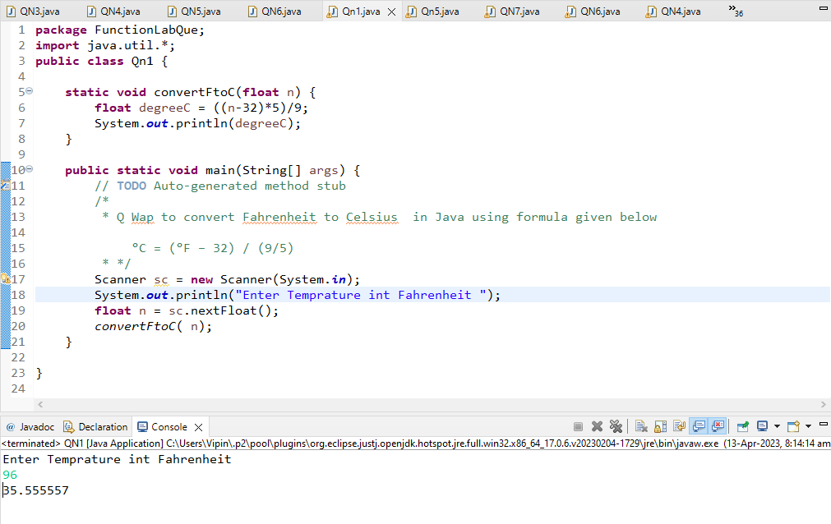

Q 2 wap to check a given number is armstrong or not  i.e. 153 = 1\*1\*1  + 5\*5\*5+3\*3\*3

Solution

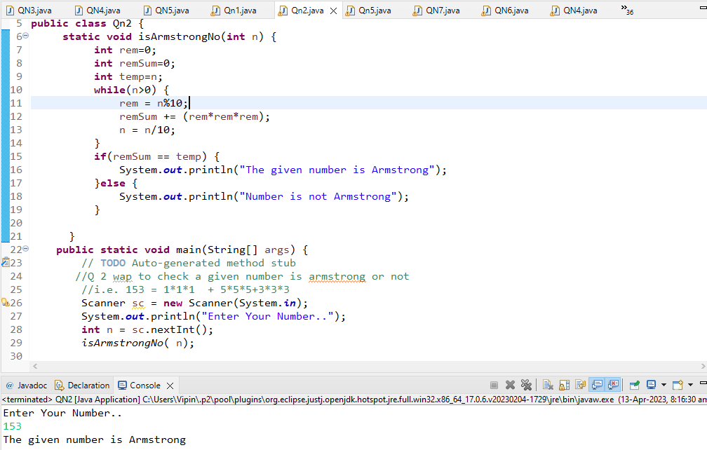

Q 3 Rajan  went to a movie with his friends in a multiplex theatre and during  break time he bought pizzas, puffs and cool drinks. Consider   the following prices :  
  
Rs.100/pizza  
Rs.20/puffs  
Rs.10/cooldrink  
Generate a bill for What Rajan  has bought.

Solution

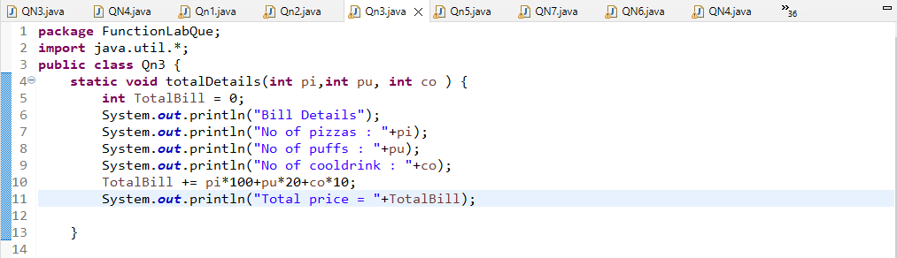

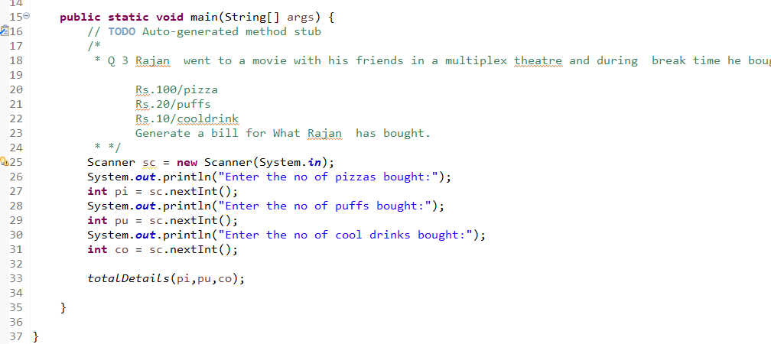

Output

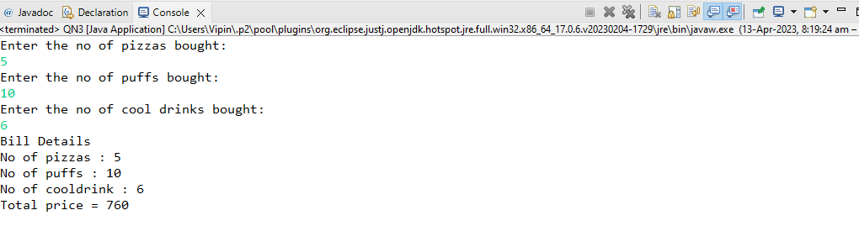

Q 4 Given an integer U denoting the amount of KWh units of electricity consumed, the task is to calculate the electricity bill with the help of the below charges:  
   
  
1 to 100 units – Rs. 10/unit  
100 to 200 units – Rs. 15/unit  
200 to 300 units – Rs. 20/unit  
above 300 units – Rs. 25/unit

Solution

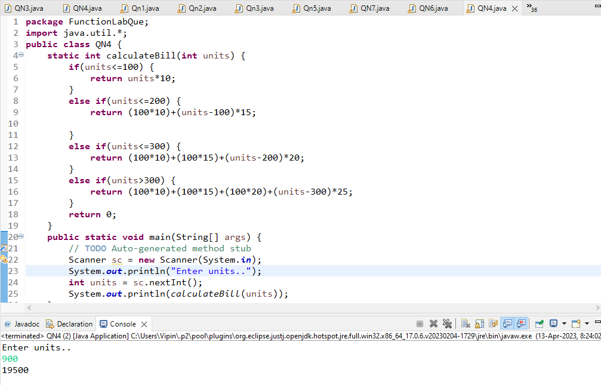

Q 5 Write a java program that  define a sorted array of size N and an integer K, find the position at which K is  
  
present in the array using binary search.

Solution

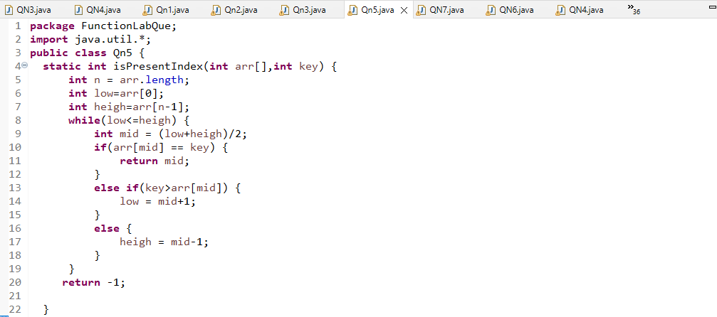

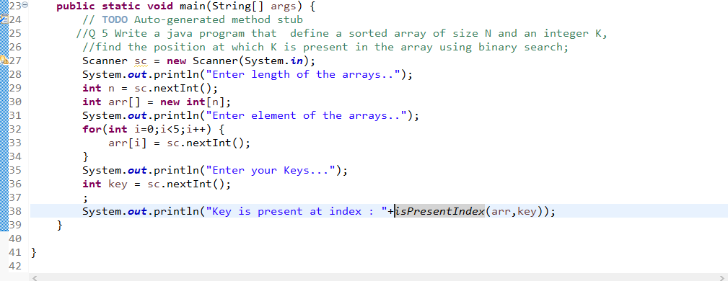

Output

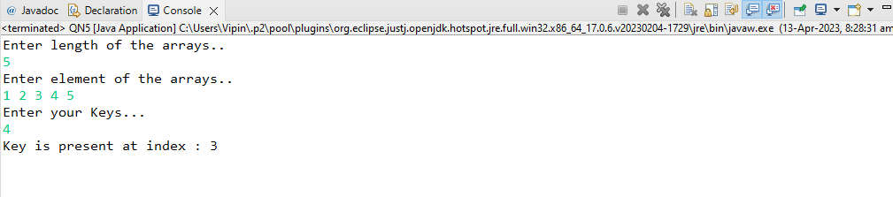

Q 6  write a java program and define  an array, print all the elements which are leaders. A Leader is an element that is greater than all of the elements on its right side in the array.

Solution

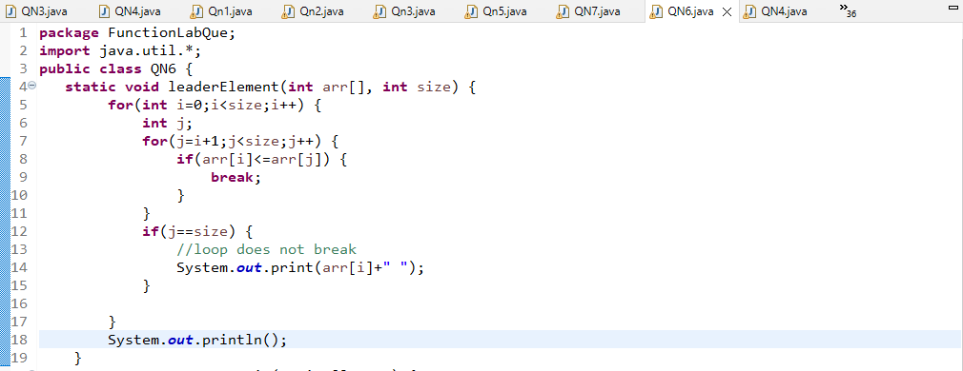

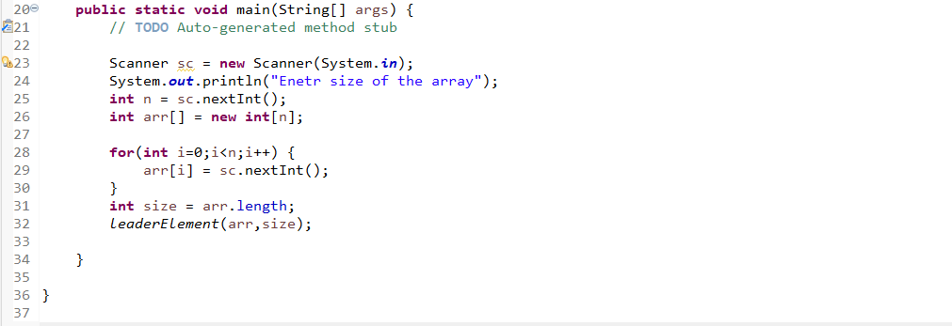

Output

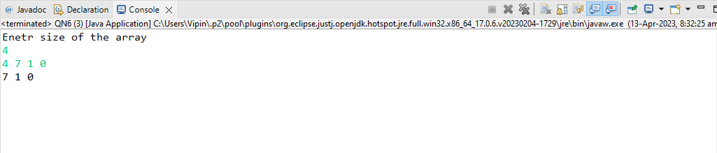

Q 7  Given two strings a and b consisting of lowercase characters. The task is to check whether two given strings are an anagram of each other or not. An anagram of a string is another string that contains the same characters, only the order of characters can be different. For example,  abc  and  bca are an anagram of each other.  
  
Example 1:  
  
Input:a = cdacnoida, b = ciddacnoa  
Output: YES  
Explanation: Both the string have same characters with  
        same frequency. So, both are anagrams

Solution

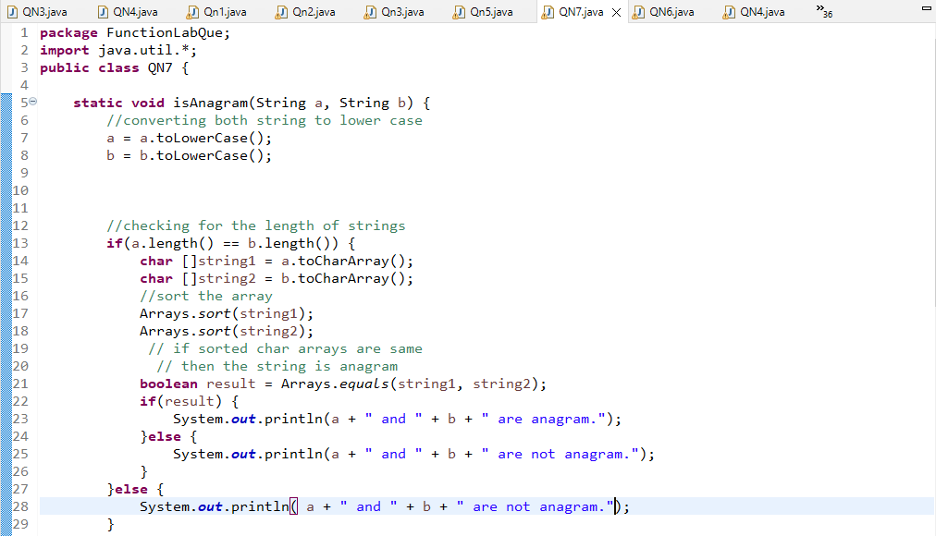

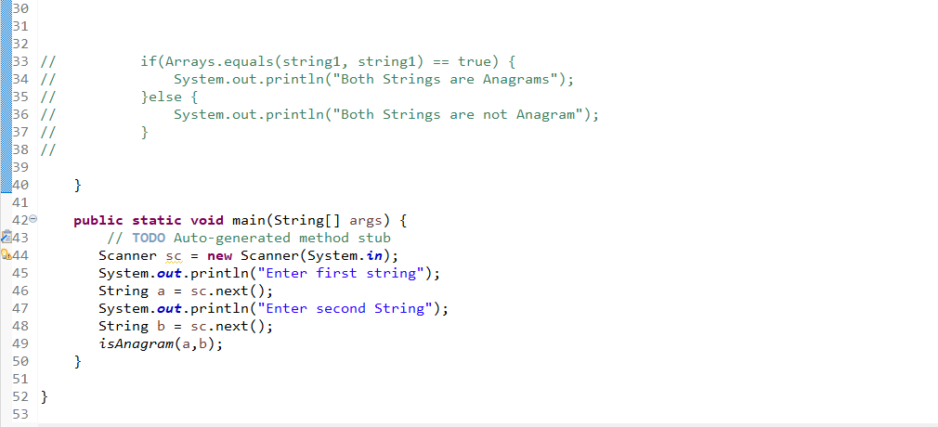

Output

