ASSIGNMENT

Q. Create a local git repository in your local machine first.

Commit the initial code

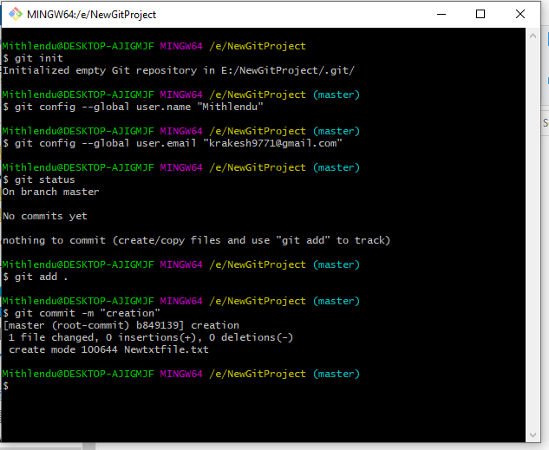

Q. Update the code on the remote server . Also perform some changes on

remote n reflect the same on local.[push/pull operations]

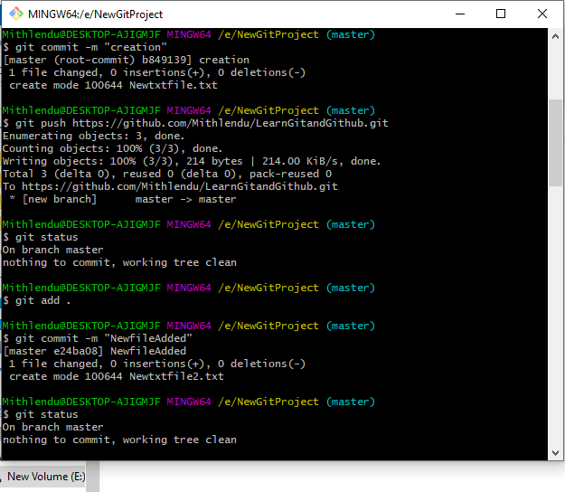

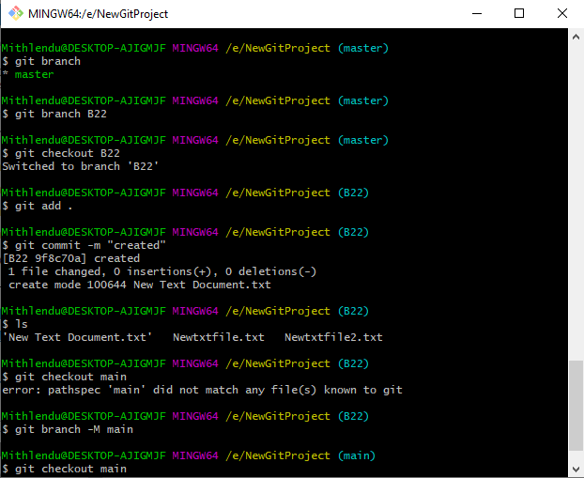

Q. Create g1 branch on the github..................Add 1 txt file .................Raise a

pull request on remote from g1 towards main........................... and merge

without conflicts.

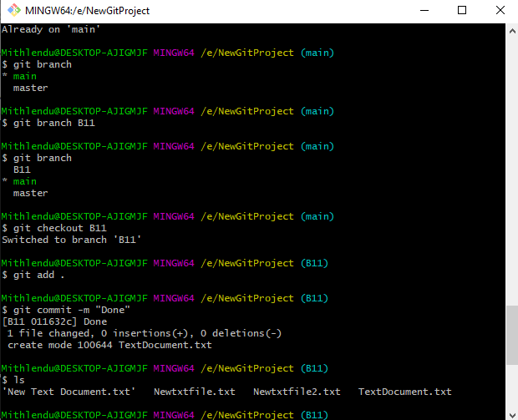

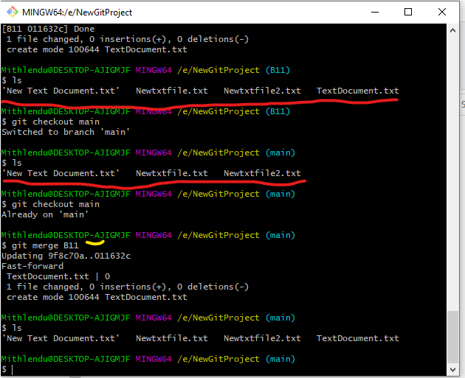

Local git: Use git commands to

o Get the updated files

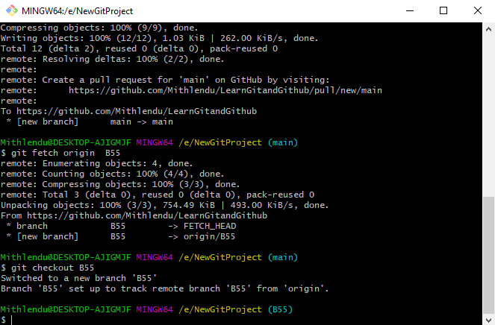

o Perform reset

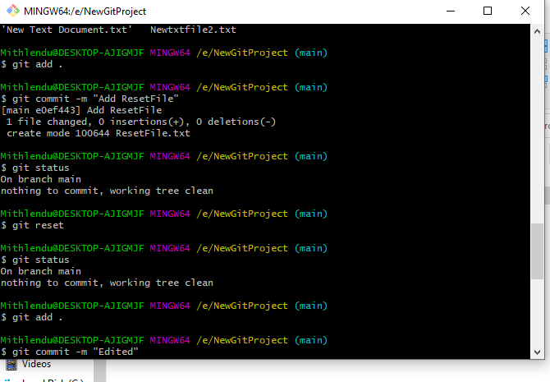

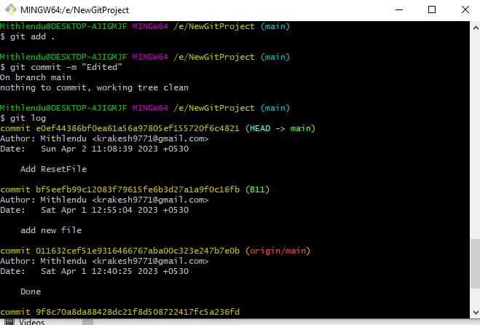

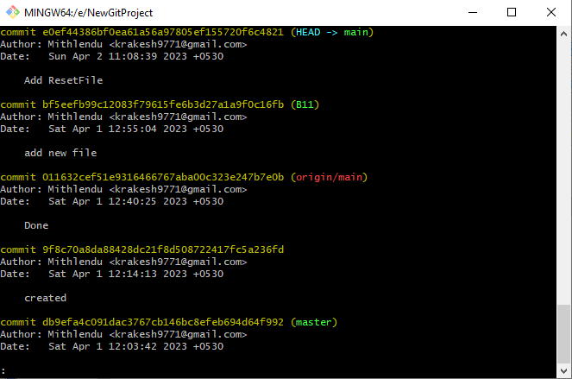

o List the changes

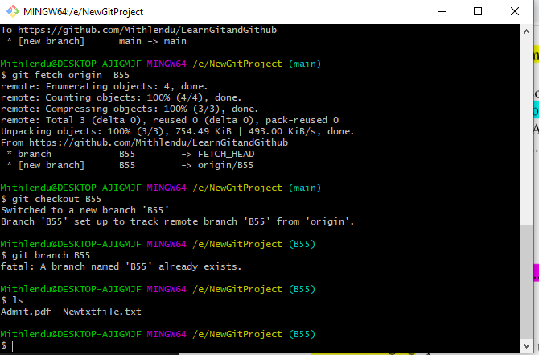

o Create local branches

main>>>B11, update b11>>>b22 update b22, b22>>>b3, and update them as well.

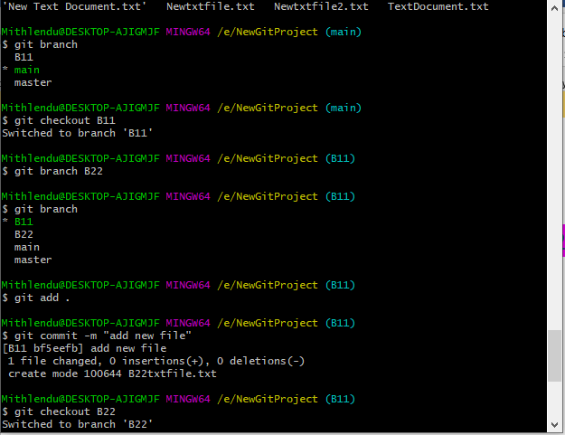

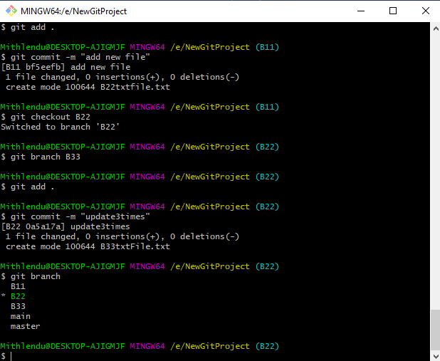

o List the changes [via diff and via ls]

Demonstrate diff between local branches

Perform LOCAL merging operation and after that delete the unnecessary ones

locally as well as remote

Perform fork operations on your repository as well.

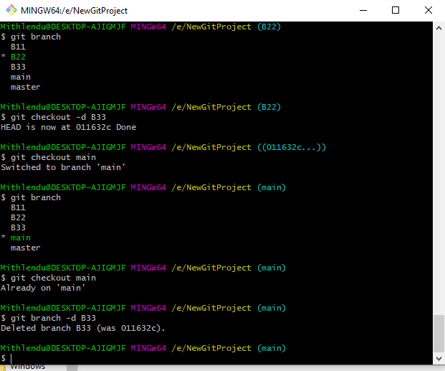

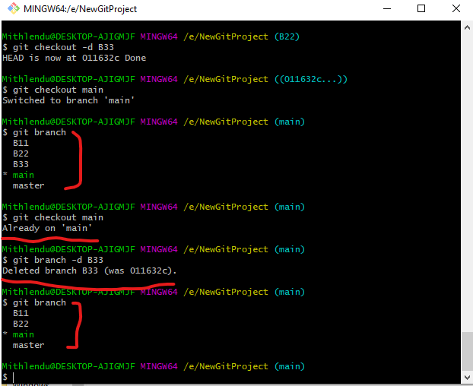

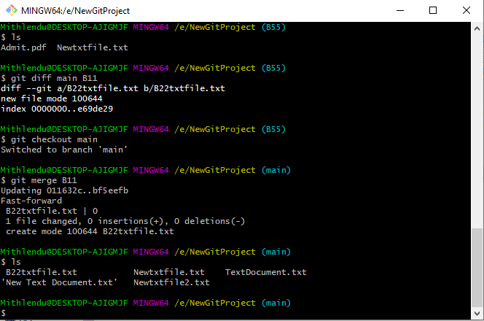

Perform fork operations on your repository as well.

