Lab Test Question

Q 2   Given an array, print all the elements which are leaders. A Leader is an element that is greater than all of the elements on its right side in the array.  
  
Example 1:  
Input:  
arr = [4, 7, 1, 0]   
Output:  
7 1 0

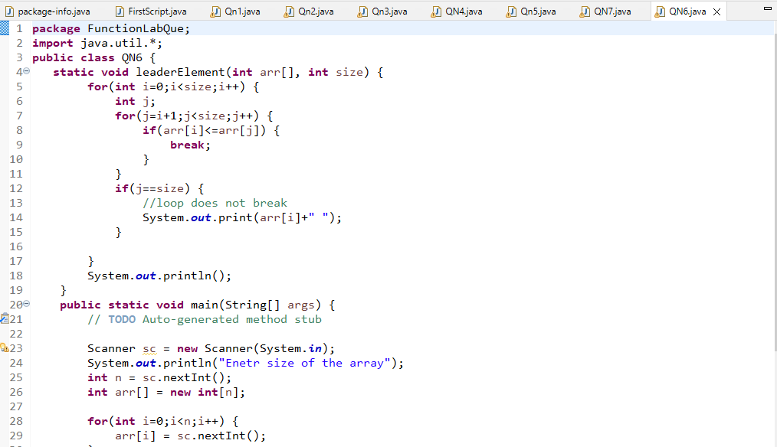

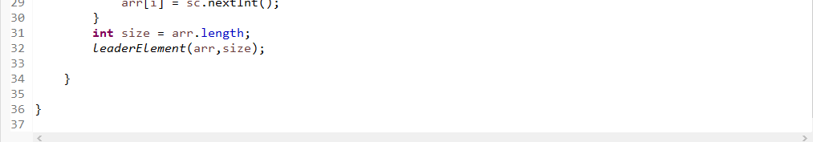

Output:

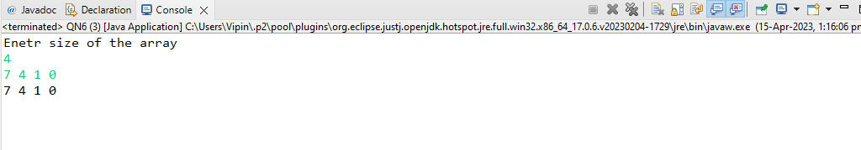

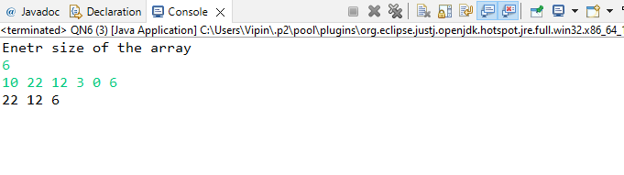Q 3  write a programming to check any number is spy number or not   
example   
1124 is spy  i.e 1+1+2+4  =8   
                     and 1*1*2*4=8

Solution

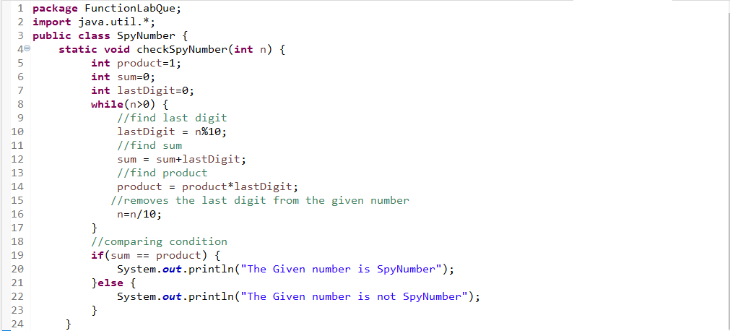

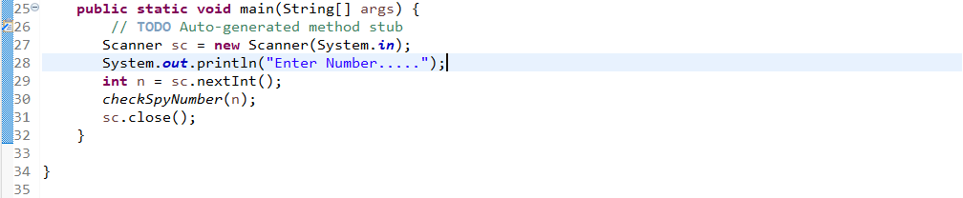

Output:

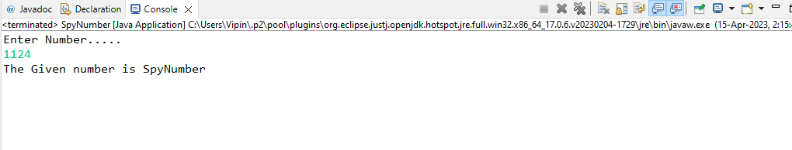

Q 1  Create package MyShop.   
  
A company named MyShop started online portal for flower selling .Design Java application that keeps its flower record and also maintain its customer database for future promotions .  
  
  
b) define class Flower having fields like name ,no_of_petals, price, no_of_piece, total price  
c) define no argument constructor  and initialize with some default values  
d) define parameterized constructor .  
e)  create calculate_discount method that checks if total price is greater than 2000 then give return 200 else return 100  
f) define display method to show all values . and values after discount .  
  
 Part B   
 In same package create another method Customer having fields like cname, address , pincode .  
g) create getData and showDate method to get and display customer data .  
  
Part C   
   
h) Create separate class AllData in same package that contains main method   
i) in main method display menu   
     1) Flower  
     2) Customer   
  
using switch case call particular class method .Keep repeating the menu till user enter 0 (zero)

Solution:

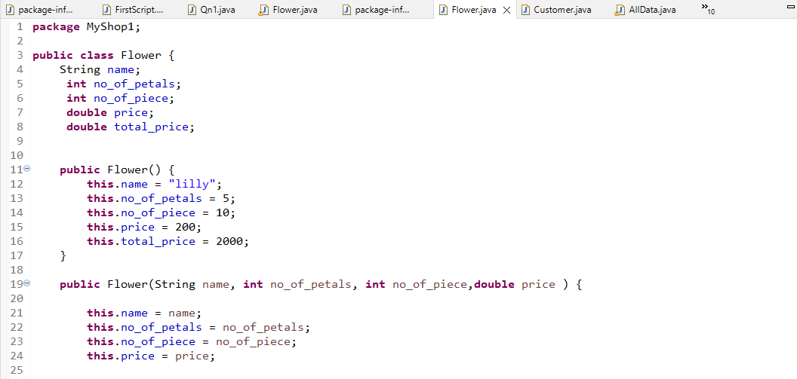

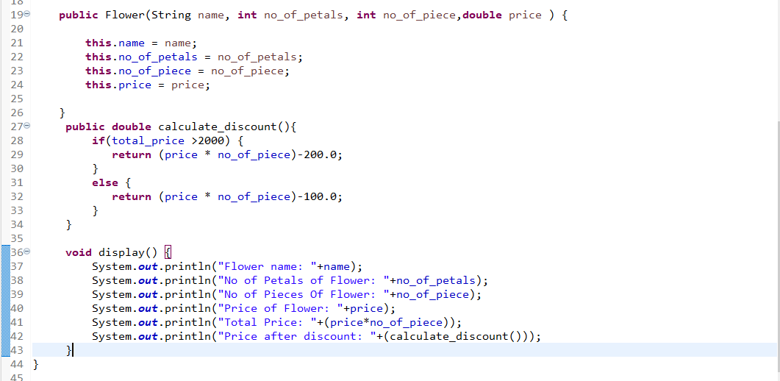

Part B   
 In same package create another method Customer having fields like cname, address , pincode .  
g) create getData and showDate method to get and display customer data .

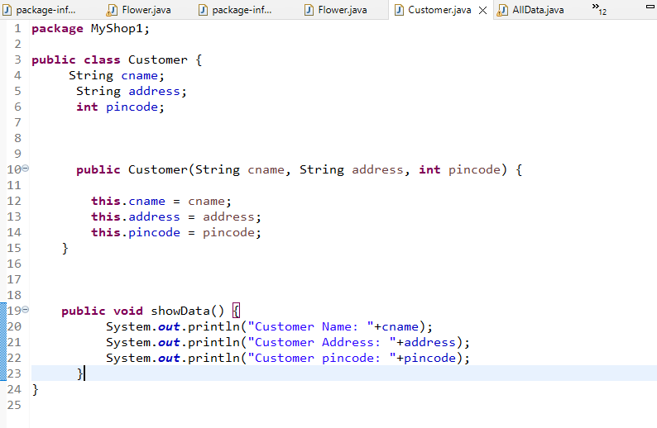

Part C   
   
h) Create separate class AllData in same package that contains main method   
i) in main method display menu   
     1) Flower  
     2) Customer

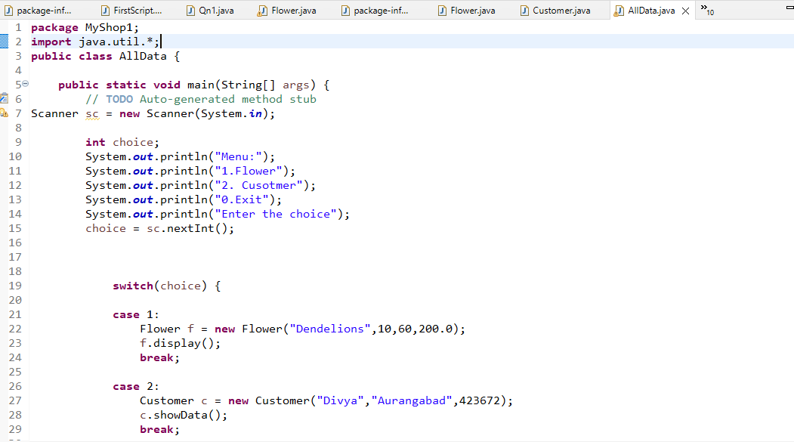

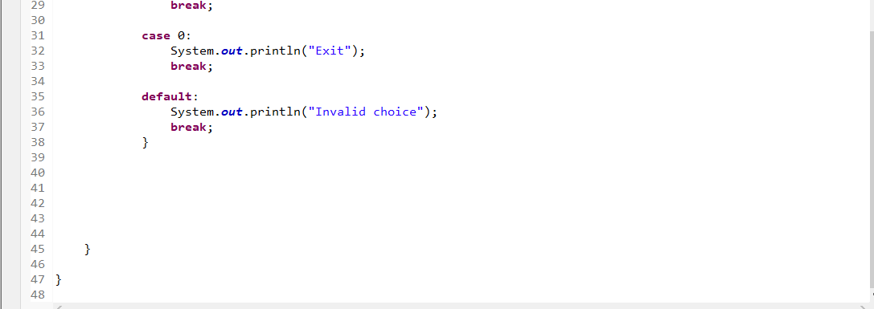

Output:-

