WEBTECH

ASSIGNMENT 1

SubmitBy

Mithlendu Kumar

QN1 Create a webpage that prints your name to the screen.

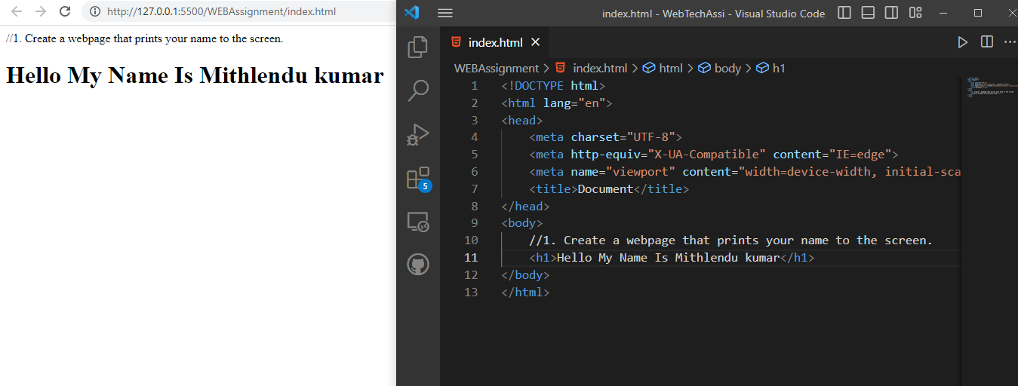

QN2 Create a webpage that prints the numbers 1 - 10 to the screen.

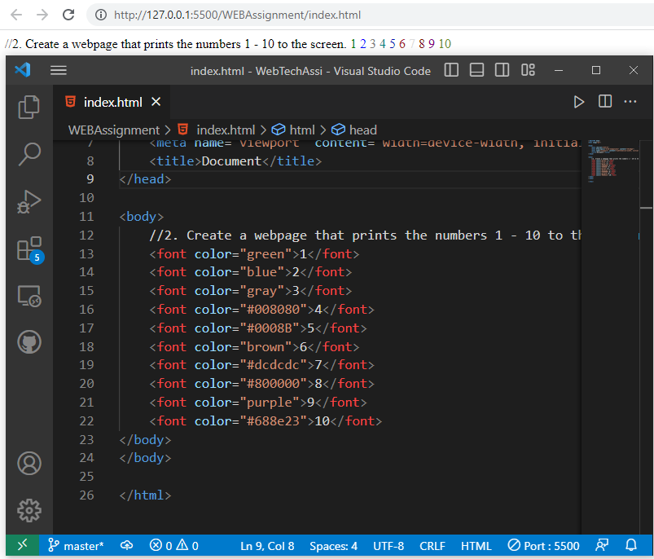

QN3 Create a webpage and set its title to “This is WebPage”;

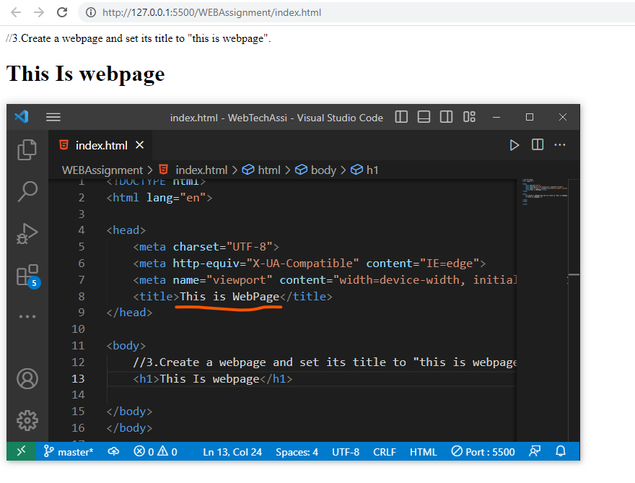

QN4 Create a webpage that prints the message “when was this webpage created? Check pages title for the answer”

to the screen, and set the title of the page to the current date.

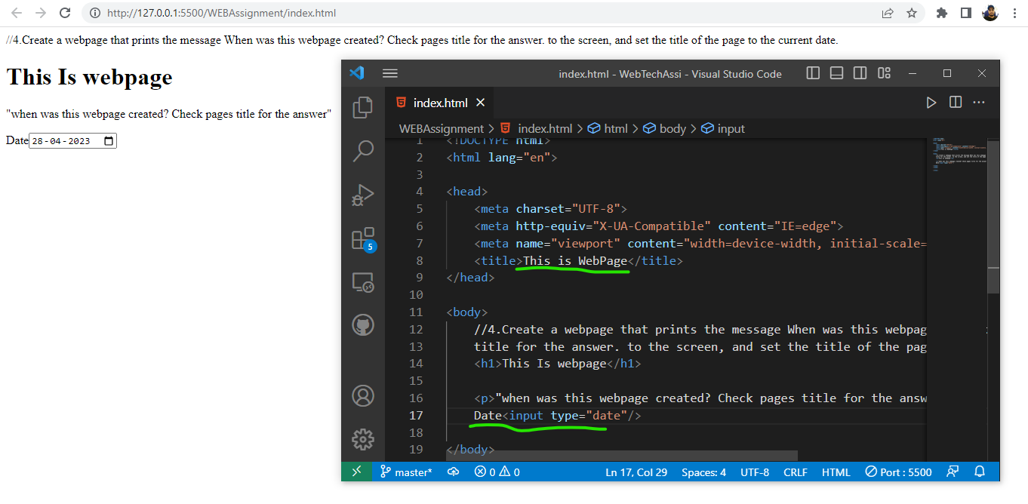

QN5 Create a webpage that prints any text of your choosing to the screen, do not include a head section in the code.

QN5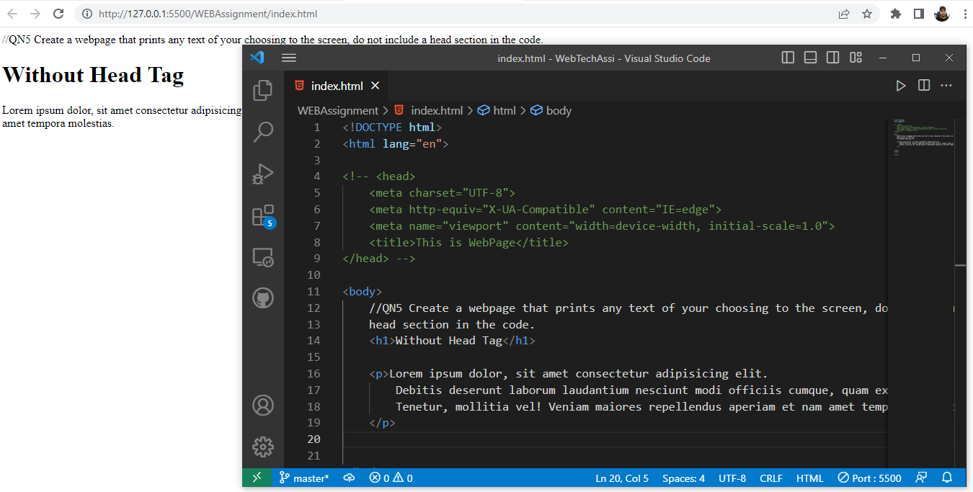

QN6 Repeat exercise #5, but this time include a head section in the code.

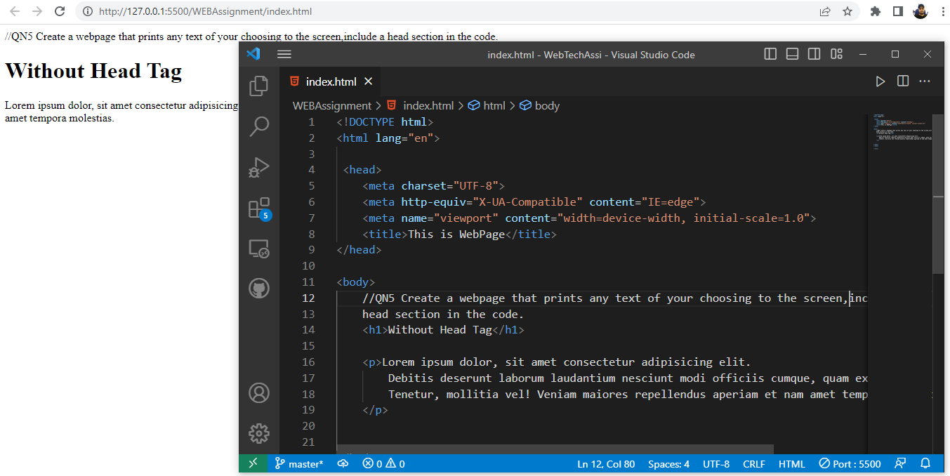

QN7 Print the squares of the numbers 1 - 20. Each number should be on a separate line, next to it the number 2 superscripted, an equal sign and the result.

(Example: 10’ 2  = 100)

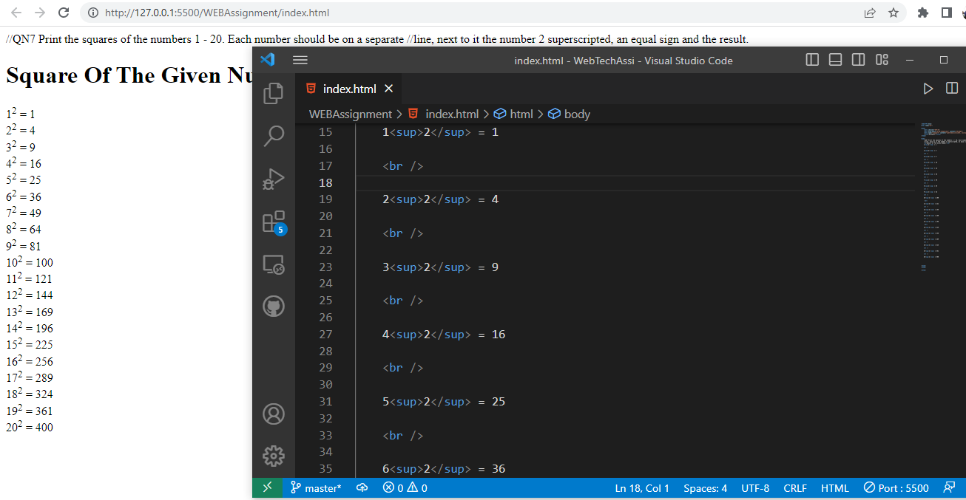

QN9 Print two paragraphs that are both indented using the &amp;nbsp; command.

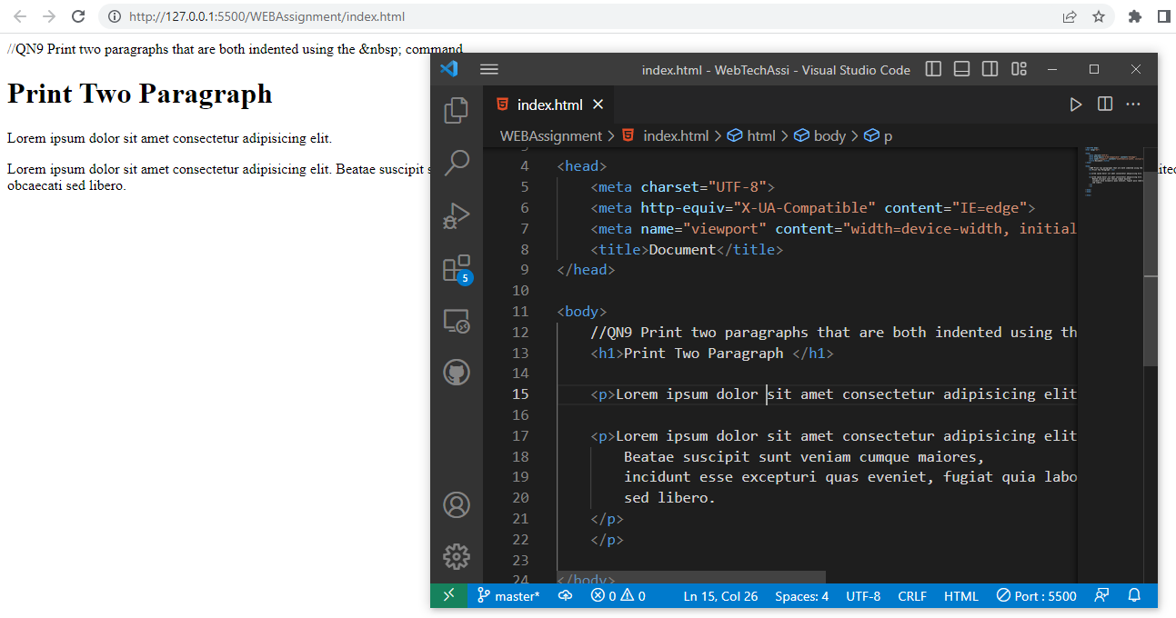

QN10 Print two lists with any information you want. One list should be an ordered list,the other list should be an unordered list.

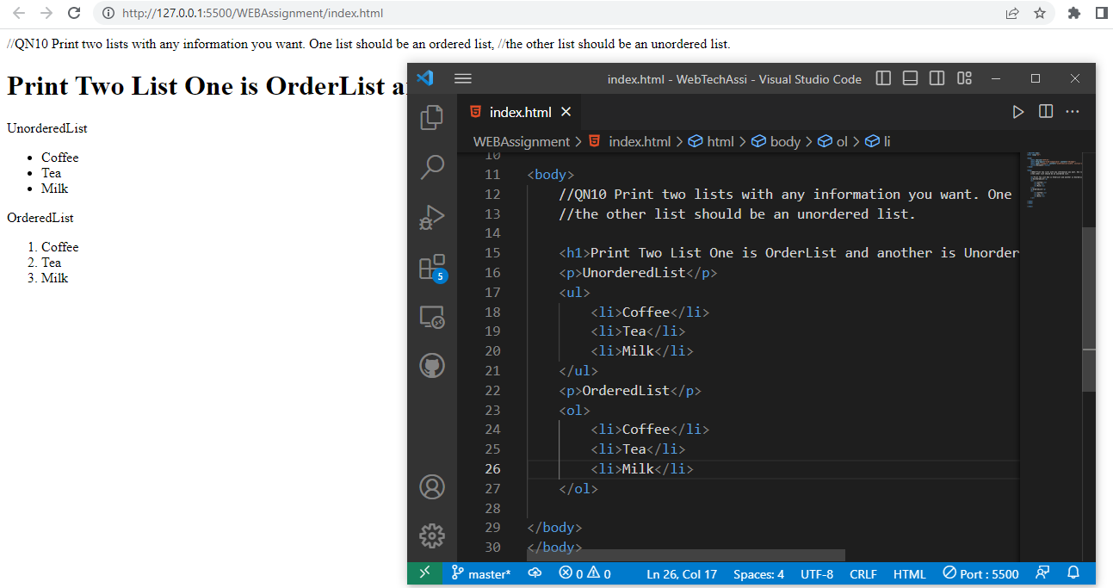

QN11 Prints an h1 level heading followed by a horizontal line whose width is 100%.Below the horizontal line print a paragraph relating to the text in the heading.

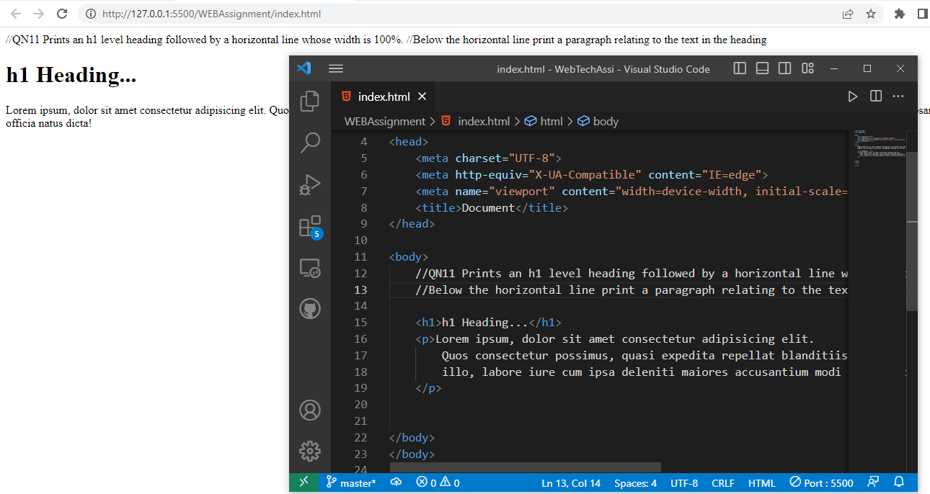

QN12 Print some preformatted text of your choice.

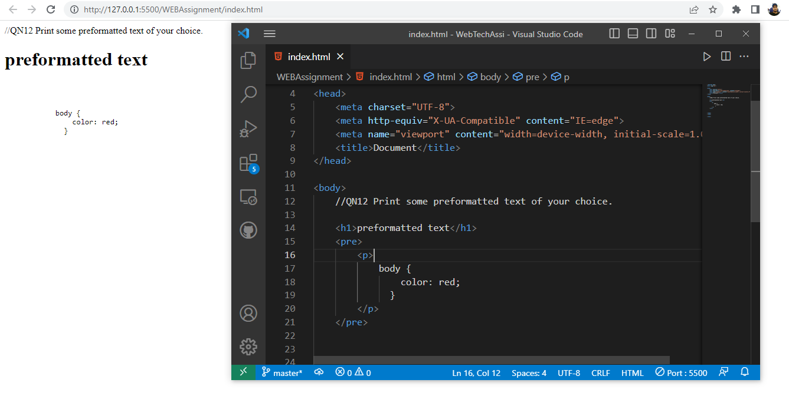

QN13 Print a definition list with 5 items.

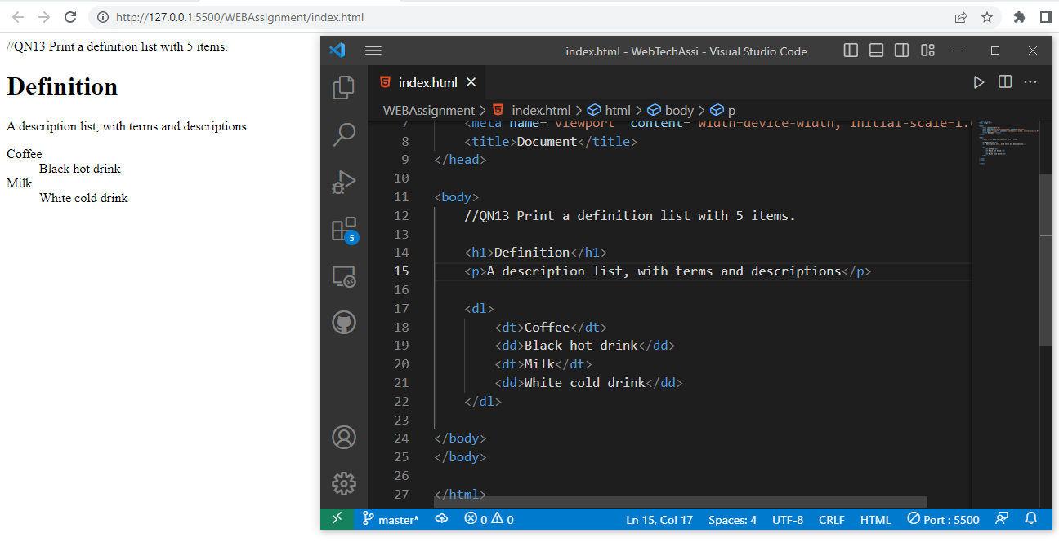

QN14 Print ten acronyms and abbreviations of your choosing, each separated by two lines. Specify the data that the abbreviations and acronyms represent.

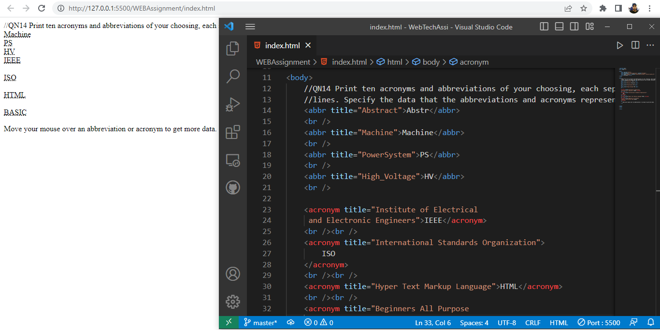

QN15 Create some links to various search engines (google, yahoo, altavista, lycos,etc).

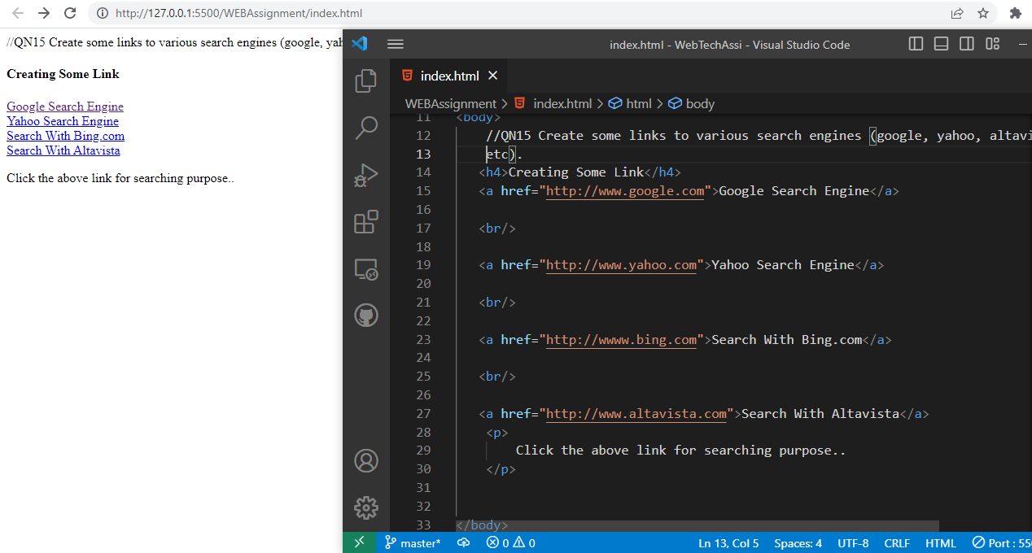

QN16 Create links to five different pages on five different websites that should all open in a new window.

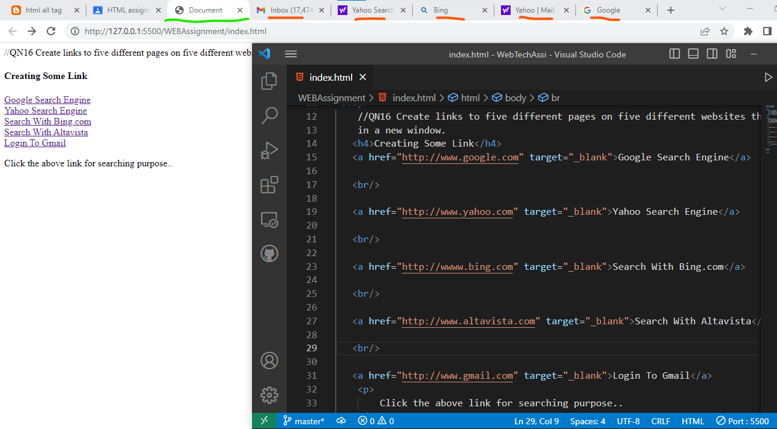

QN17 Create a page with a link at the top of it that when clicked will jump all the way to the bottom of the page.

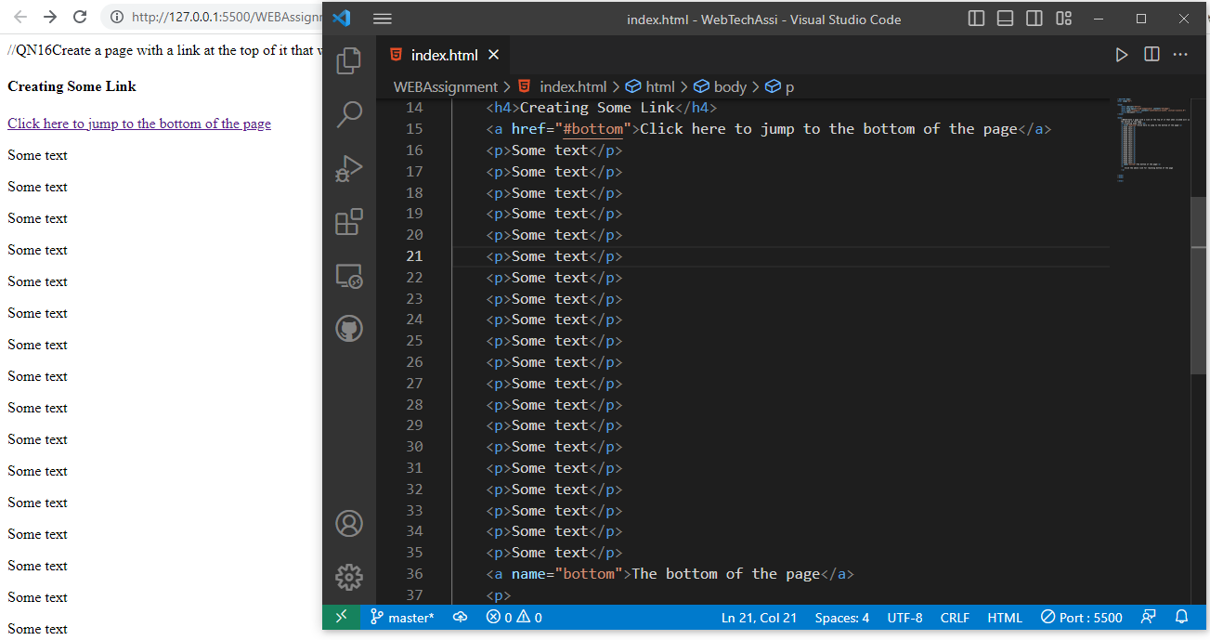

QN18 Display five different images. Skip two lines between each image. Each image should have a title.

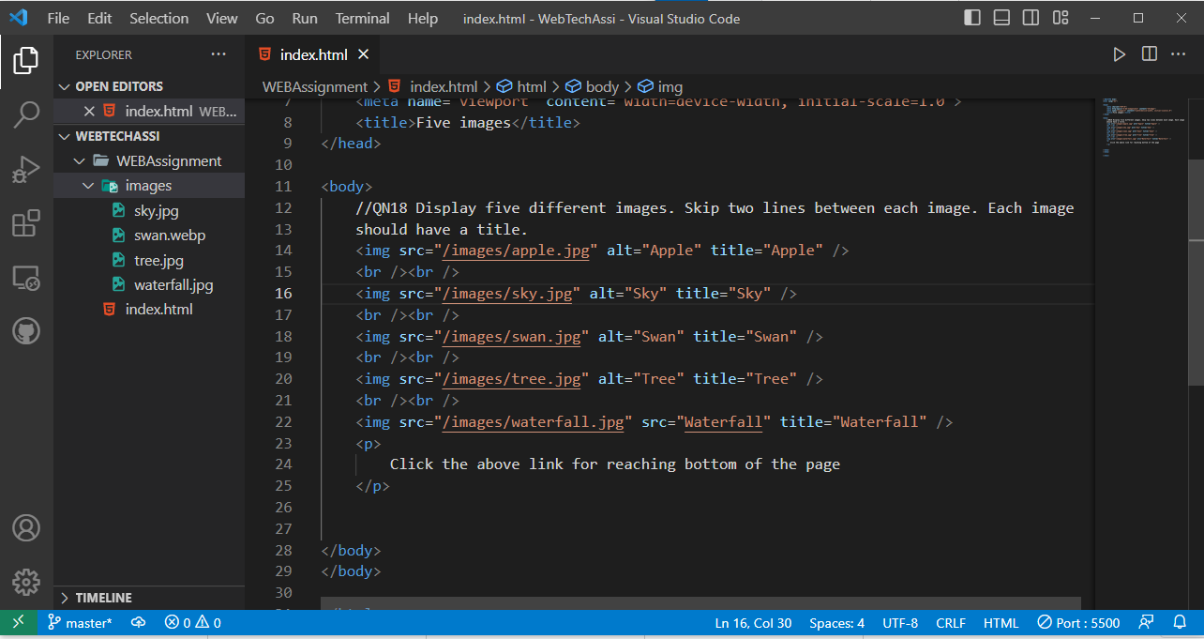

QN19 Display an image that has a border of size 2, a width of 200, and a height of 200.

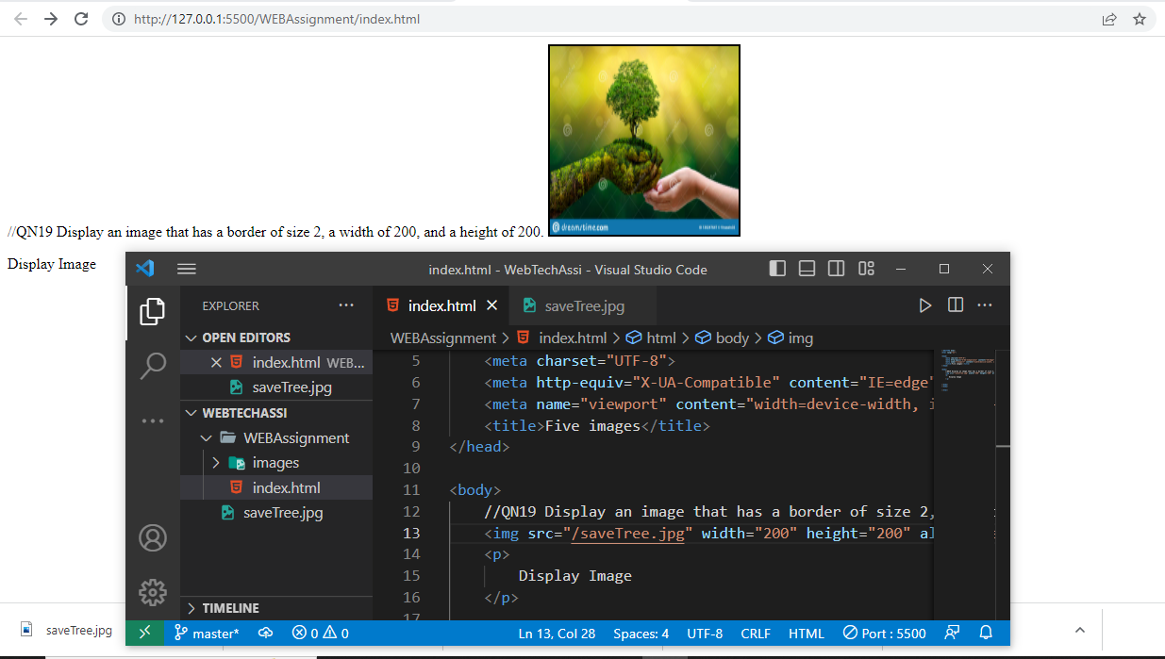

QN20 Display an image that when clicked will link to a search engine of your choice(should be opened in a new window).

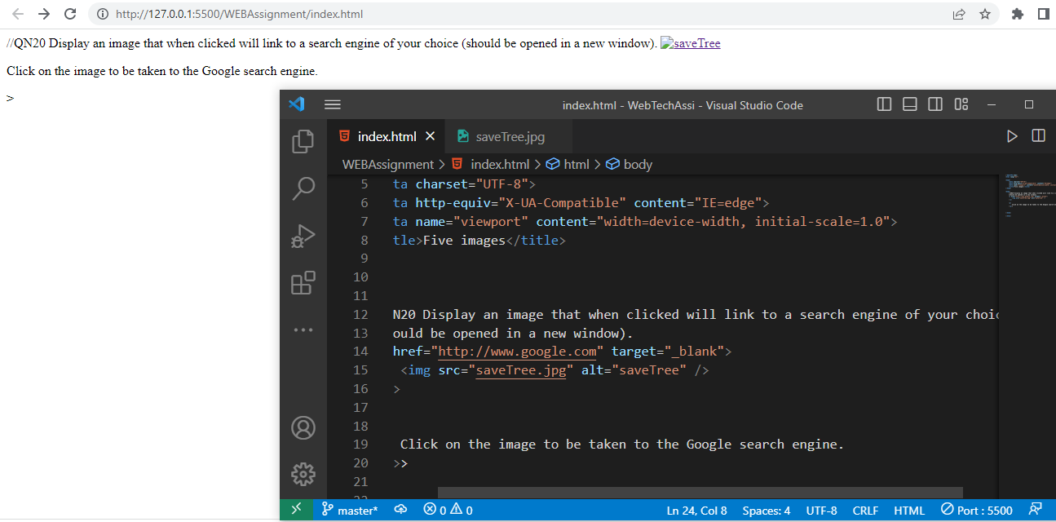

QN21 Display an image that when clicked will link to itself and will display the image in the browser by itself.

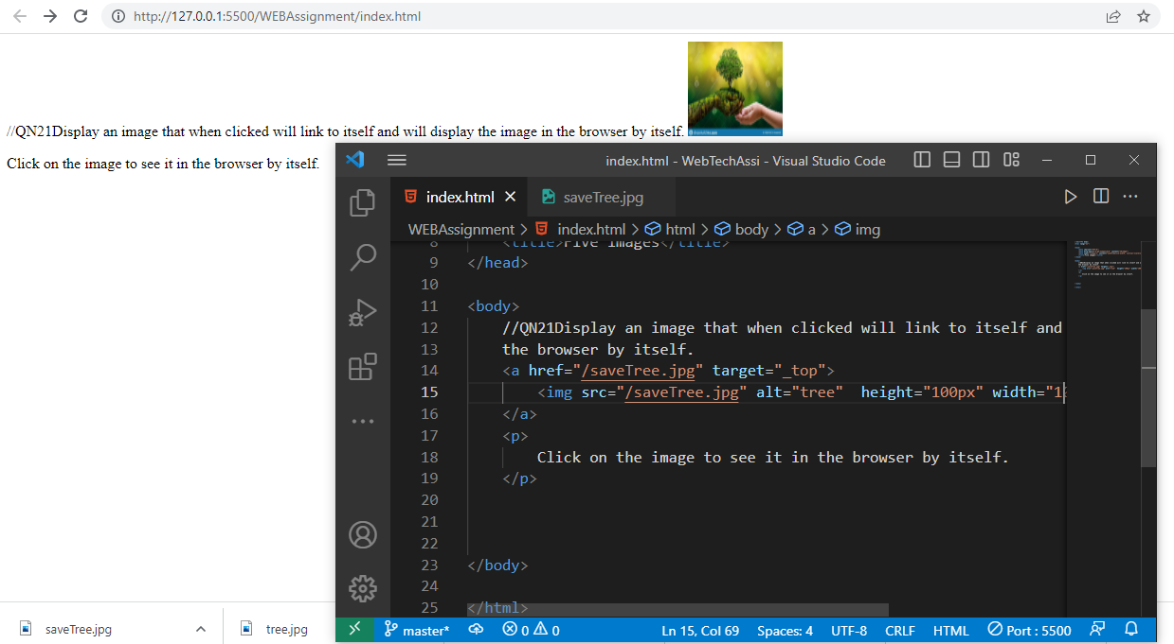

SubmitBy –

Mithlendu Kumar