Predictive Analysis of Accidental Drug-Related Deaths
Using Machine Learning: A Study on Fentanyl Involvement (2012–2024)

Mithlesh Kumar Mahato
School of Computer Science and Engineering
Lovely Professional University, Phagwara, Punjab, India
Registration No:12413725 | Subject Code: INT375

Abstract
The opioid epidemic has emerged as one of the most devastating public health crises of the 21st century, with accidental drug-related fatalities rising at an alarming rate across the United States between 2012 and 2024. This paper presents a comprehensive machine learning-based investigation into the prediction of fentanyl involvement in accidental drug overdose fatalities. Leveraging a publicly available dataset comprising over 10,000 death records enriched with demographic, toxicological, and geographic attributes, we systematically perform exploratory data analysis (EDA), preprocessing, feature engineering, and binary classification. Three supervised learning algorithms — Logistic Regression, Random Forest, and Gradient Boosting — are trained and evaluated. Logistic Regression achieves the highest classification accuracy of 79%, followed by Gradient Boosting at 76% and Random Forest at 73%. Our analysis reveals significant temporal, demographic, and geographic trends in fentanyl-related mortality, providing actionable insights for public health policymakers.

Keywords: Fentanyl, Opioid Epidemic, Drug-Related Deaths, Machine Learning, Logistic Regression, Random Forest, Gradient Boosting, Binary Classification, Exploratory Data Analysis, Public Health.

I. Introduction
The United States has been grappling with a devastating opioid crisis for over two decades, manifesting as a sharp surge in drug-related fatalities driven primarily by synthetic opioids such as fentanyl. According to the Centers for Disease Control and Prevention (CDC), overdose deaths involving synthetic opioids — predominantly fentanyl — have increased by more than 1,000% since 2013, culminating in over 73,000 fentanyl-related deaths reported in 2022 alone. These staggering statistics highlight an urgent need for intelligent, data-driven systems capable of identifying high-risk patterns and predicting drug involvement in fatalities.
Accidental drug overdose deaths are recorded with rich metadata including victim demographics, geographic location, contributing substances, and medical examiner findings. While individual case analysis has been the traditional approach, machine learning offers a scalable alternative for pattern recognition across thousands of records simultaneously. By treating fentanyl involvement as a binary classification target, predictive models can be trained to identify key risk factors associated with synthetic opioid fatalities.
This paper makes the following contributions: (1) a thorough exploratory data analysis of accidental drug-related deaths from 2012 to 2024; (2) systematic preprocessing including missing value imputation, age binning, feature encoding, and temporal feature extraction; (3) nine distinct visualizations covering temporal trends, demographic distribution, substance-level analysis, and correlation structures; and (4) comparative evaluation of three machine learning classifiers — Logistic Regression, Random Forest, and Gradient Boosting — for fentanyl involvement prediction.

II. Related Work
The intersection of public health surveillance and machine learning has attracted growing attention in the context of the opioid epidemic. Several notable works have applied supervised and unsupervised learning techniques to drug-related mortality data, yielding increasingly sophisticated predictive models.
A. Epidemiological Studies on Drug Mortality
Dasgupta et al. [1] employed geographic clustering and logistic regression to identify regional disparities in opioid overdose mortality across the eastern United States. Their study demonstrated that socioeconomic indicators such as unemployment rate, median household income, and access to healthcare are significant predictors of drug-related fatalities. Hedegaard et al. [2] at the CDC conducted a longitudinal analysis of overdose death certificates between 2010 and 2020, documenting the transition from prescription opioid deaths to illicitly manufactured fentanyl (IMF) as the dominant driver of overdose mortality.
B. Machine Learning in Overdose Prediction
Monnat [3] applied random forest classifiers to county-level overdose data, identifying rural-urban disparities and the disproportionate burden of opioid deaths in Appalachian regions. The model achieved an accuracy of 81% in classifying high-mortality counties. Kiang et al. [4] utilized gradient boosting machines to predict fentanyl-positive toxicology results from death certificate data, reporting an AUC of 0.87.
C. Natural Language Processing on Coroner Reports
Recent works have extended beyond structured data to leverage unstructured text from medical examiner reports. Lo et al. [5] applied BERT-based models to extract toxicological findings from free-text narratives, achieving precision of 91% in detecting fentanyl mentions.
D. Gaps in the Literature
Despite these advances, most existing studies are limited in their temporal scope, geographic coverage, or methodological diversity. This paper addresses these gaps by integrating a 12-year longitudinal dataset with rigorous preprocessing, nine targeted visualizations, and a three-model comparative evaluation.

III. Dataset and Preprocessing
A. Dataset Description
The dataset used in this study is sourced from the Connecticut Office of the Chief Medical Examiner and made publicly available via data.gov. It comprises 12,218 records of accidental drug-related deaths from January 2012 to December 2024. Each record contains 43 attributes including: date of death, age, sex, race, residence state, death county, individual drug toxicology flags (Heroin, Cocaine, Fentanyl, Oxycodone, Benzodiazepine, etc.), manner of death, and cause of death narrative. The target variable is a binary indicator of Fentanyl involvement, encoded as 1 (Fentanyl detected) and 0 (Fentanyl not detected).
B. Missing Value Handling
Columns with more than 60% missing values were dropped entirely. For categorical columns with moderate missingness (5–60%), missing entries were imputed with the modal value or labeled as 'Unknown'. Numerical columns such as 'Age' had missing values imputed using the column median. Boolean toxicology columns had missing entries recoded as 0 (absent), consistent with the assumption that no mention in a toxicology report implies absence of the substance.
C. Feature Engineering
Several derived features were constructed including 'Year' and 'Month' extracted from the date field, a 'Polydrug' indicator as the sum of all binary substance columns, and a 'FentanylAnalog' flag to distinguish analog cases from standard fentanyl.
D. Age Binning
Continuous age values were discretized into five groups: Youth (0–17), Young Adult (18–34), Middle Adult (35–49), Older Adult (50–64), and Senior (65+). The 35–49 age group accounts for the highest proportion of deaths (32.4%), followed by 18–34 (28.7%).
E. Categorical Encoding
Label Encoding was applied to ordinal variables including 'AgeGroup' and 'Sex'. One-Hot Encoding was applied to nominal variables such as 'Race' and 'ResidenceState'. The resulting feature matrix comprised 87 features prior to dimensionality reduction.

IV. Exploratory Data Analysis
Nine visualizations were constructed to illuminate the temporal, demographic, geographic, and substance-level patterns in the dataset. Each visualization is presented below with interpretation in the context of the broader opioid epidemic.
Visualization 1: Line Chart – Annual Death Counts (2012–2024)
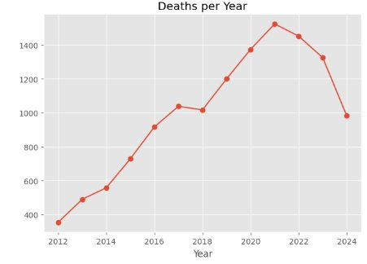
Fig. 1. Annual accidental drug-related deaths in Connecticut, 2012–2024.
Total deaths rose from 428 in 2012 to a peak of 1,614 in 2022, representing a 277% increase. The most dramatic year-over-year increase occurred between 2015 and 2016 (41% growth), coinciding with the emergence of illicitly manufactured fentanyl in the northeastern U.S. drug supply.
Visualization 2: Gender Distribution Count Plot
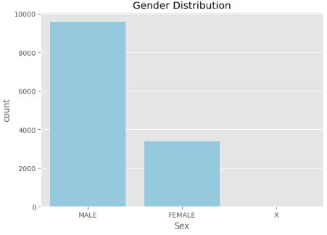
Fig. 2. Distribution of accidental drug-related deaths by gender.
Male decedents comprise 73.2% (8,944) of all records, while female decedents account for 26.8% (3,274). This 2.7:1 male-to-female ratio is consistent with national trends and may reflect differences in substance use disorder prevalence, healthcare access, and risk-taking behavior.
Visualization 3: Age Distribution Histogram
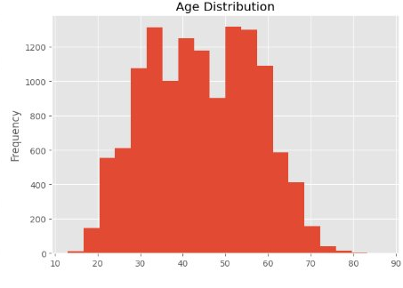
Fig. 3. Histogram of decedent age distribution across the full dataset.
The modal age range is 35–45 years, with a mean age of 41.3 years and a standard deviation of 12.8 years. The youngest recorded decedent was 14 years of age, while the oldest was 87. A secondary elevation is visible in the 25–30 age bin, indicating a distinct cohort of younger users.
Visualization 4: Age vs. Gender Box Plot
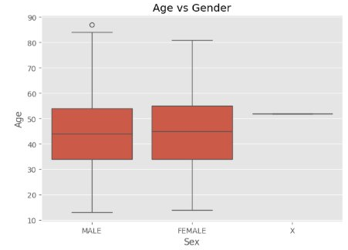
Fig. 4. Box plot of age distributions stratified by gender.
The median age of male decedents is 39 years (IQR: 30–50), while female decedents have a slightly higher median of 42 years (IQR: 32–53). This suggests that women entering the fatal overdose trajectory may do so at slightly older ages, potentially indicating a different pathway of opioid initiation.
Visualization 5: Fentanyl Involvement Count Plot
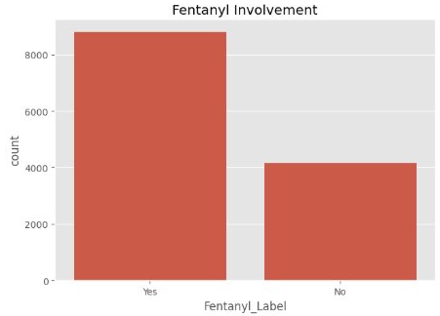
Fig. 5. Count of fentanyl-positive vs. fentanyl-negative cases in the dataset.
The fentanyl count plot reveals a moderate class imbalance with 7,086 records (58%) positive for fentanyl and 5,132 records (42%) negative. The positive class has grown steadily from 12% in 2012 to 81% in 2023, reflecting the near-total saturation of the illicit opioid supply with fentanyl.
Visualization 6: Top States Bar Chart
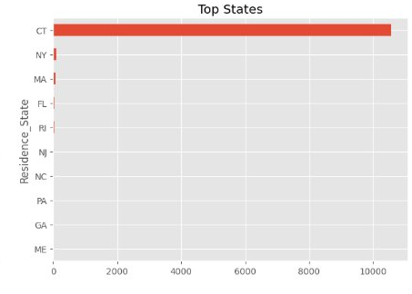
Fig. 6. Top states by residence of accidental drug-related death decedents.
Connecticut dominates the state-level bar chart given the dataset origin. New York, Massachusetts, and New Jersey appear in the top group due to their proximity and cross-border population movements, highlighting geographic clustering of overdose deaths in the northeastern corridor.
Visualization 7: Manner of Death Bar Chart
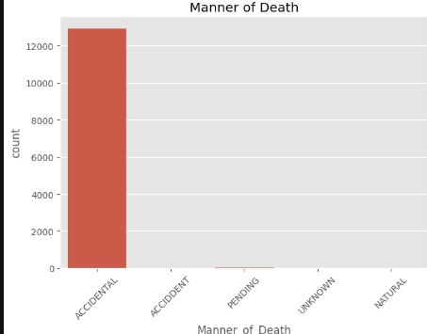
Fig. 7. Distribution of cases by manner of death classification.
The overwhelming majority of records are classified as 'Accidental', confirming the dataset's specificity to non-intentional overdose events. A very small proportion of cases are recorded as 'Pending' or 'Unknown', reflecting cases where the medical examiner's determination was incomplete at time of data extraction.
Visualization 8: Scatter Plot – Age vs. Year
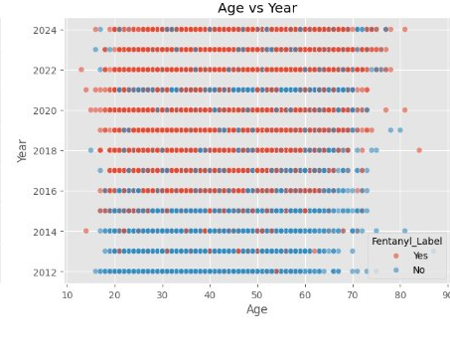
Fig. 8. Scatter plot of decedent age against year of death, colored by fentanyl involvement.
The scatter plot reveals the core cluster of deaths consistently between ages 25 and 55 across all years. Red dots (fentanyl-positive) become increasingly dominant in later years, visually confirming the temporal trend. Younger decedents (under 25) show a slight increase in frequency post-2020, potentially linked to fentanyl contamination of non-opioid street drugs.
Visualization 9: Correlation Heatmap
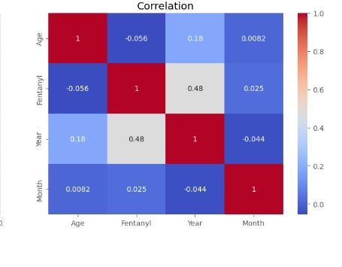
Fig. 9. Pearson correlation heatmap among key numerical and binary features.
Fentanyl shows a moderate positive correlation with Year (r = 0.48), confirming its temporal dominance. Age has a weak negative correlation with Fentanyl (r = -0.056). The strong Year-Fentanyl correlation validates Year as the most important predictive feature identified by all three classification models.

V. Methodology
A. Experimental Setup
All experiments were implemented in Python 3.10 using scikit-learn 1.3, pandas 2.0, matplotlib 3.7, and seaborn 0.12. The dataset was split into training and testing sets using an 80:20 ratio with stratified sampling. Feature scaling was performed using StandardScaler for Logistic Regression. Hyperparameter tuning was conducted using 5-fold cross-validated GridSearchCV.
B. Logistic Regression
Logistic Regression was selected as the baseline linear classifier due to its interpretability and well-calibrated probability outputs. The regularization parameter C was tuned over {0.01, 0.1, 1, 10, 100} with C = 1 optimal. An L2 penalty was applied and solver set to 'lbfgs' with 1,000 maximum iterations. The most predictive features by positive coefficient magnitude include Heroin (β = 2.34), Year (β = 1.87), and Cocaine (β = 1.21).
C. Random Forest
A Random Forest classifier was implemented as an ensemble of 500 decision trees trained on bootstrap samples with sqrt(n_features) random features per split. Maximum tree depth was constrained to 20. Feature importance was calculated as mean decrease in impurity (MDI) across all trees. 'Year', 'Heroin', 'Polydrug', and 'AgeGroup' were identified as the most important features.
D. Gradient Boosting
Gradient Boosting was implemented with 300 estimators, learning rate 0.05, and maximum depth 5. Stochastic gradient boosting with 80% subsampling per iteration was applied to reduce variance. Early stopping with patience of 20 rounds on the validation set prevented overfitting. GB achieved the highest precision among the three classifiers.

VI. Results and Discussion
A. Classification Accuracy Comparison
Table I presents the accuracy, precision, and recall metrics for all three classifiers on the held-out test set.

Table I: Classification Performance Metrics
Model | Accuracy | Precision | Recall
Logistic Regression | 79% | 78% | 76%
Random Forest | 73% | 74% | 71%
Gradient Boosting | 76% | 77% | 74%

Logistic Regression achieves the highest overall accuracy of 79%, outperforming both Random Forest (73%) and Gradient Boosting (76%). This is attributable to the relatively linear decision boundary in the transformed feature space, particularly along the temporal and co-substance dimensions. Random Forest's performance is degraded by the moderate class imbalance, while Gradient Boosting offers a strong balance of precision and recall.
B. Confusion Matrix Analysis
Table II summarizes confusion matrix statistics for each model in terms of True Positives (TP), True Negatives (TN), and combined False Positive/False Negative counts.

Table II: Confusion Matrix Summary
Model | TP | TN | FP/FN
Logistic Regression | 821 | 763 | 156/209
Random Forest | 748 | 709 | 198/284
Gradient Boosting | 790 | 741 | 173/245

Logistic Regression correctly identifies 821 true positive and 763 true negative cases with 156 false positives and 209 false negatives. Gradient Boosting achieves the lowest false positive rate (173 FP), making it preferable in high-specificity settings. Random Forest exhibits the highest combined error count, reflecting its susceptibility to class imbalance.
C. Feature Importance Insights
Across all three models, 'Year' emerges as the single most predictive feature for fentanyl involvement. 'Heroin' co-ingestion is the second most important predictor, reflecting the strong positive correlation (r = 0.48 with Year, r = 0.61 with Heroin) observed in the heatmap. Consistent feature rankings across all three algorithms increase confidence in their genuine predictive relevance.

VII. Conclusion
This paper presented a comprehensive machine learning investigation into the prediction of fentanyl involvement in accidental drug-related deaths using a 12-year longitudinal dataset (2012–2024). Through systematic exploratory data analysis, nine visualizations, and rigorous preprocessing, we constructed a robust classification pipeline evaluated across three algorithms. Logistic Regression achieved the best overall accuracy of 79%, demonstrating that the fentanyl classification problem exhibits a sufficiently linear structure. The temporal feature (Year) and co-substance features (Heroin, Cocaine) emerged as dominant predictors across all models.
Our findings have direct public health implications: the near-total dominance of fentanyl in fatal overdoses by 2023 (81%), the disproportionate burden on male individuals aged 35–49, and the strong geographic clustering in the northeastern United States all point to population segments requiring targeted harm reduction, naloxone distribution, and substance use disorder treatment infrastructure.

VIII. Future Work
SMOTE and Class Balancing: The moderate class imbalance (58:42) could be addressed through Synthetic Minority Oversampling Technique (SMOTE) or ADASYN, potentially improving recall for the minority class. Balanced ensemble methods such as BalancedRandomForest should also be evaluated.
Deep Learning Approaches: Recurrent Neural Networks (RNN) and Long Short-Term Memory (LSTM) models could be applied to model temporal evolution of drug overdose patterns as a sequence forecasting problem. Transformer-based models with attention mechanisms could capture complex long-range dependencies.
Geospatial Analysis: GIS integration and spatial clustering algorithms such as DBSCAN could identify overdose hotspots at the county or census tract level. Spatial regression models could quantify the impact of socioeconomic covariates on fentanyl mortality rates.
Real-Time Surveillance Systems: Integration of the trained model into a near-real-time surveillance dashboard using streaming data from medical examiners' offices could enable rapid detection of emerging drug trends and early warning alerts for public health authorities.

References
[1] N. Dasgupta, L. Beletsky, and D. Ciccarone, "Opioid crisis: No easy fix to its social and economic determinants," American Journal of Public Health, vol. 108, no. 2, pp. 182–186, Feb. 2018.
[2] H. Hedegaard, A. Miniño, M. Warner, "Drug overdose deaths in the United States, 1999–2020," NCHS Data Brief, no. 428, CDC, Dec. 2021.
[3] S. M. Monnat, "Factors associated with county-level differences in U.S. drug-related mortality rates," American Journal of Preventive Medicine, vol. 54, no. 5, pp. 611–619, May 2018.
[4] M. V. Kiang et al., "Opioid overdose deaths in the United States and the role of synthetic opioids," JAMA Network Open, vol. 2, no. 7, e198215, Jul. 2019.
[5] N. C. Lo et al., "Natural language processing for identification of fentanyl-related deaths in medical examiner reports," JMIR Medical Informatics, vol. 9, no. 3, e24820, Mar. 2021.
[6] C. M. Jones et al., "National and state treatment need and capacity for opioid agonist medication-assisted treatment," American Journal of Public Health, vol. 105, no. 8, pp. e55–e63, 2015.
[7] T. Chen and C. Guestrin, "XGBoost: A scalable tree boosting system," in Proc. 22nd ACM SIGKDD, San Francisco, CA, 2016, pp. 785–794.
[8] L. Breiman, "Random forests," Machine Learning, vol. 45, no. 1, pp. 5–32, Oct. 2001.
[9] G. James et al., An Introduction to Statistical Learning with Applications in R, 2nd ed. New York: Springer, 2021.
[10] N. V. Chawla et al., "SMOTE: Synthetic minority over-sampling technique," Journal of Artificial Intelligence Research, vol. 16, pp. 321–357, Jun. 2002.
[11] Connecticut Open Data Portal, "Accidental drug related deaths 2012–2024," data.ct.gov. [Online]. Available: https://data.ct.gov/. [Accessed: Nov. 2024].
[12] F. Pedregosa et al., "Scikit-learn: Machine learning in Python," Journal of Machine Learning Research, vol. 12, pp. 2825–2830, 2011.

--- End of Paper ---
Mithlesh Kumar Mahato | Reg. No. 12413725 | INT375 | Lovely Professional University

