|  |  |  |  |  |  |  |  |  |  |  |
| --- | --- | --- | --- | --- | --- | --- | --- | --- | --- | --- |
|  |  | | Daffodil International University | | | | |  |  | |
|  |  | | |  | | |  | |  | |
|  | | | | | | | | | | |
| http://4.bp.blogspot.com/-SotLIkzmscA/UqQLE9BjdPI/AAAAAAAAARc/-SF46qFfVE0/s1600/daffodil-international-university-logo.png | | | | | | | | | | |
|  | | | | | | | | | | |
| **Online News , commerce and social-network web site** | | | | | | | | | | |
|  | | NAME | | | **:** | Sunirmal Mallick Mithon | | | |  |
| ID | | | **:** | 143-35-800 | | | |
| DEPARTMENT | | | **:** | Software Engineering | | | |
| Faculty of Science and Information Technology | | | | | | | |
|  | | |  |  | | | |
| December 2017 | | | | | | | | | | |

Table of Contents

Chapter 1 1

1. Introduction 2

1.1 About the System 2

1.2 Purpose 2

1.3 Scope 2

1.4 Vision 2

1.5 Why this system is necessary? 2

1.6 Proposed Solution 2

Chapter 2 3

2. System Analysis 4

2.1 Use Case Model 5

2.2 Actor Goal List 5

2.2.1 Assumptions 5

2.3 Use Case Model 5

2.4 Use Case Description (Brief) 5

2.4.1 Register Accounts (Example) 5

2.5 Use Case Description (Detailed) 6

2.5.1 Register Account (Example) 6

2.6 System Sequence Diagrams 6

2.6.1 Register Account 6

2.7 Domain/Conceptual Model 7

2.8 Activity diagram 8

Chapter 3 9

3. System Design 10

3.1 Sequence Diagrams 10

3.1.1 Register Account 10

3.2 Class Diagram 11

3.3 Entity Relationship Diagram 13

Chapter 4 15

4. Implementation 15

4.1 Tools &Technologies 16

4.2 Project Link 16

Chapter 5 17

5. System Testing 19

5.1 Why Software Testing is Essential? 19

5.1.1 Black box testing 19

5.1.2 White box testing 19

5.2 Test Cases 19

5.2.1 Test case: Sign up 19

Chapter 6 20

6. Conclusion 21

6.1 Good Features of the System 21

6.2 Limitations of the System 21

6.3 Future Enhancements 21

Appendices 22

7. User Manual 23

7.1 Log in Screen of Federal Shariat Court Case Flow Automation System. 23

8. References 24

Chapter 1

Introduction

# Introduction

## About the System

This is the **News , commerce and social-network website.**

Here any user can registation in social-network option and share there Images.

Here onle selected person can register and join here and do per-time or full time job.

On the other hand,

In this project other user can comment **commerce option** in this site .

The main objectives of my project is any visitor can watch the news as well as get e-commerc addvertaisment and get entertain by using social-network option.

On using e-commerec option if any user have any problem they can ask in my site and get answer.

So, doing these inovative idea , i hope user stay on my site and pass there time with joy.

## Purpose

* User can make profile after registering
* User can make their question on e-commerce option
* User can give the answer on other question
* User can share ther image on network site

## User can get latest News and headlines.

## Scope

This is the **News , commerce and social-network website.**

Here any user can registation in social-network option and share there Images.

Here onle selected person can register and join here and do per-time or full time job.

On the other hand,

In this project other user can comment **commerce option** in this site .

## Vision

## Why this system is necessary?

This system is necessary to reduce procedure time to make case in road. Also decline car crime or accident on road. To help to pay case fine by this system .not need to go bank or other office. Car owner can manage his or her cars by using this system.

## Proposed Solution

The main objectives of my project is any visitor can watch the news as well as get e-commerc addvertaisment and get entertain by using social-network option.

On using e-commerec option if any user have any problem they can ask in my site and get answer.

So, doing these inovative idea , i hope user stay on my site and pass there time with joy.

# 

Chapter 2

**System Analysis**

# System Analysis

## Use Case Model

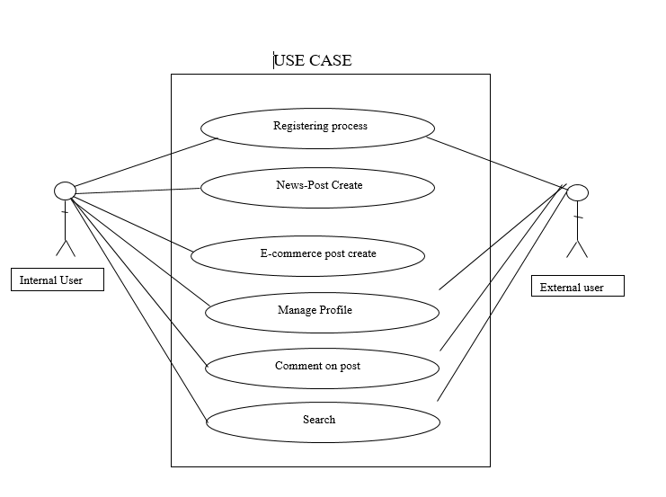

Fig 2.1:Use Case Diagram

## Actor Goal List

### Admin(Internal)

* Admin is a registered member.
* Amin can put a news-post anytime.
* Amin can put a Ecommerce-post anytime
* Admin can manage his profile anytime.
* Admin can comment a post.
* Admin can search any thing.

### User(External)

* User is a registered member.
* User can manage his profile anytime.
* User can comment a post.
* User can search any thing.

## Use Case Model

## Use Case Description (Brief)

### Register process

Admin and Users of System has necessary to post News & E-commerce post of the system. Admin can also register account and can assign roles to accounts registered.

### News-post

Admin can post any News-post on the system.

### E-commerce post

Admin can post any E-commerce post on the system.

### Manage profile

Admin and users can manage his profile

**2.4.5 Comment**

Admin and users can comment any post

### Search

Admin and users can search any thing on the system.

## Use Case Description (Detailed)

### Register process

|  |  |
| --- | --- |
| Use Case ID | 1 |
| Name | Register process |
| Primary Actor | Admin ,users |
| Secondary Actor |  |
| Goal | Register process for different users . |
| Precondition | User go to the login/registation option. |
| Post Condition | A user can instance it was create(instance creation).It was assosiated with the currrent registered (association formed) |
| Main Success Scenario | 1. Admin selects register option to register an account.  2. Admin will enter the relevant data about his information.  3. Admin will enter the date for registration.  5. Admin submits the required description about the system.  6. System will save the record in the database and will show the success message. |
| Scenario Extensions | 1. When admin tries to enter data for an already register user the system will generate an error message.  2. System will not register an accouut unless valid mail adress . |

### News-Post

|  |  |
| --- | --- |
| Use Case ID | 2 |
| Name | News-Post |
| Primary Actor | Admin |
| Secondary Actor |  |
| Goal | To post on the system. |
| Precondition | *Admin can go the news-post option* |
| Post Condition | Admin supmit the news-post artical. |
| Main Success Scenario | 1 login as admin  2 Go to the news post option  3 Submit news-post to server |
| Scenario Extensions | 1 dont able to back date post  2 System disable |

### *Ecommerce-post*

|  |  |
| --- | --- |
| Use Case ID | 3 |
| Name | E-commerce post |
| Primary Actor | Admin |
| Secondary Actor |  |
| Goal | To post on the system |
| Precondition | *Admin can go the Ecommerce-post option* |
| Post Condition | Admin supmit the news-post artical. |
| Main Success Scenario | 1 login as admin  2 Go to the *Ecommerce*-news post option  3 Submit news-post to server |
| Scenario Extensions | 1. dont able to back date post  2 System disable |

### Manage Profile

|  |  |
| --- | --- |
| Use Case ID | 3 |
| Name | Manage Profile |
| Primary Actor | Admin , users |
| Secondary Actor |  |
| Goal | To Manage won profil on the system |
| Precondition | *Login on the system.* |
| Post Condition | Upload image and artical. |
| Main Success Scenario | 1 login as admin or users  2 Go to the *profile* option  3 Submit post to server  4. upload image to server |
| Scenario Extensions | 1. dont able to back date post 2. dont able to upload big files 3. System disable |

## System Sequence Diagrams

**2.6.1** Registered process

**2.6.2** News-Post Create

**2.6.3** E-commerce post create

**2.6.4** Manage Profile

**2.6.5** Comment on post

**2.6.6** Search

**2.6.1.1**

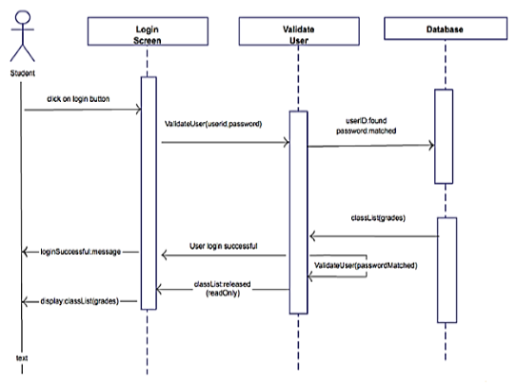

**2.6.1.2 Failure Scenario**

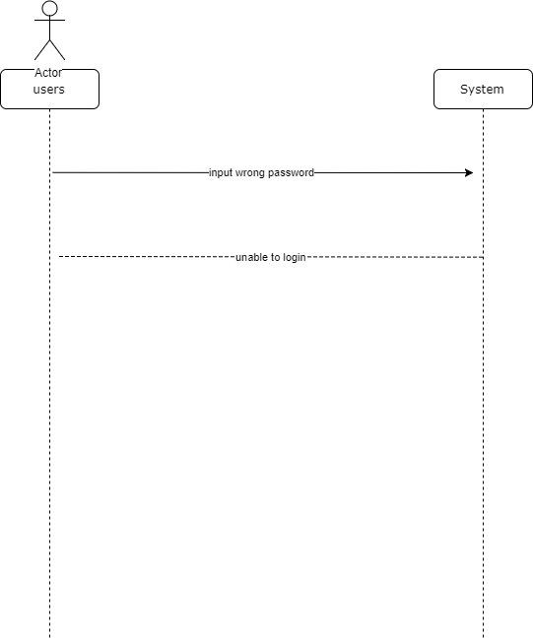

**2.6.2** News-Post Create

**2.6.2.1 Success scenario**

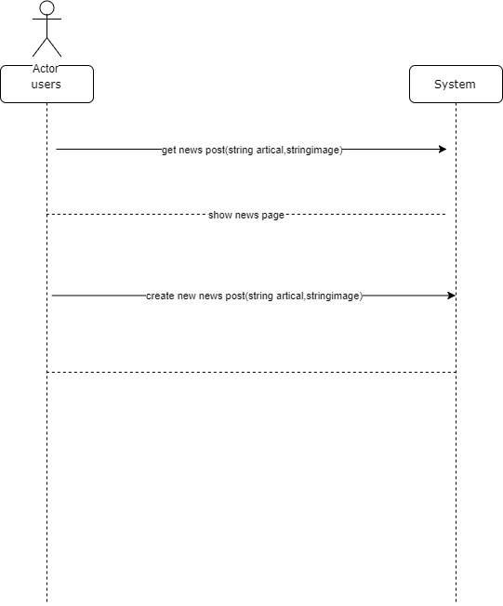

**2.6.3 E-commerce post**

**2.6.3.1 Success scenario**

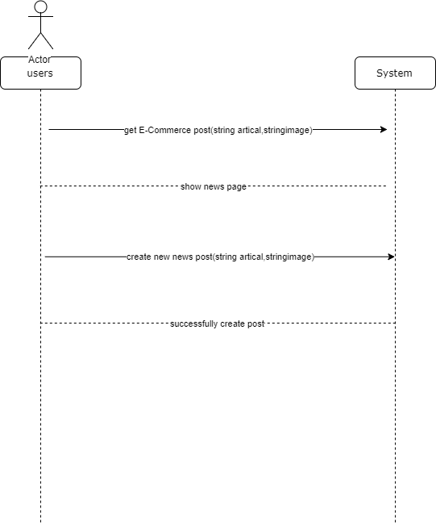

**2.6.3 Manage profile**

**2.6.3.1 Success scenario**

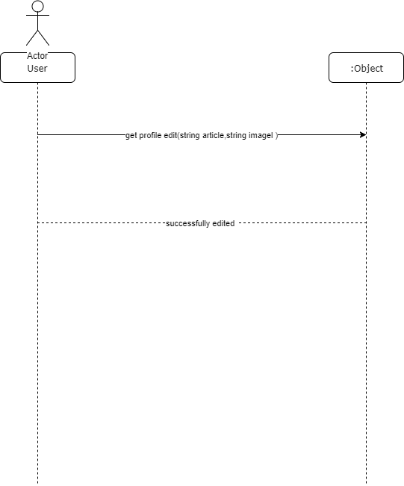

## Domain/Conceptual Model

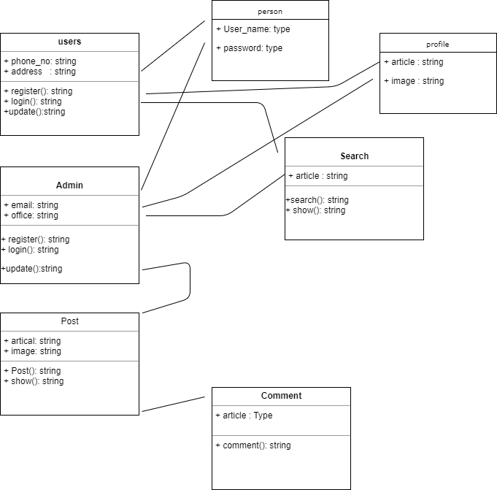

**Figure 2.17 System Domain Model**

## Activity diagram

Activity diagrams are graphical representations of workflows of stepwise activities and actions with support for choice, iteration and concurrency.

In the system workflows starts from the stage when an applications enters the area of Federal Shariat Court i.e. uploaded in the system to last activity that is a judgment comes or the case is dismissed .This whole process is shown in the below diagram.

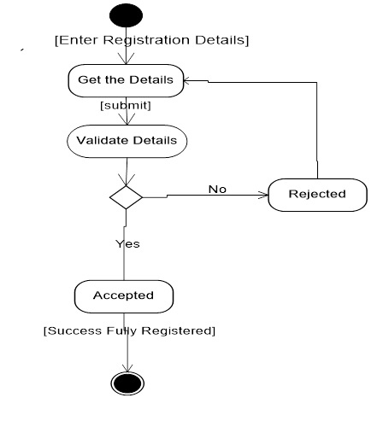

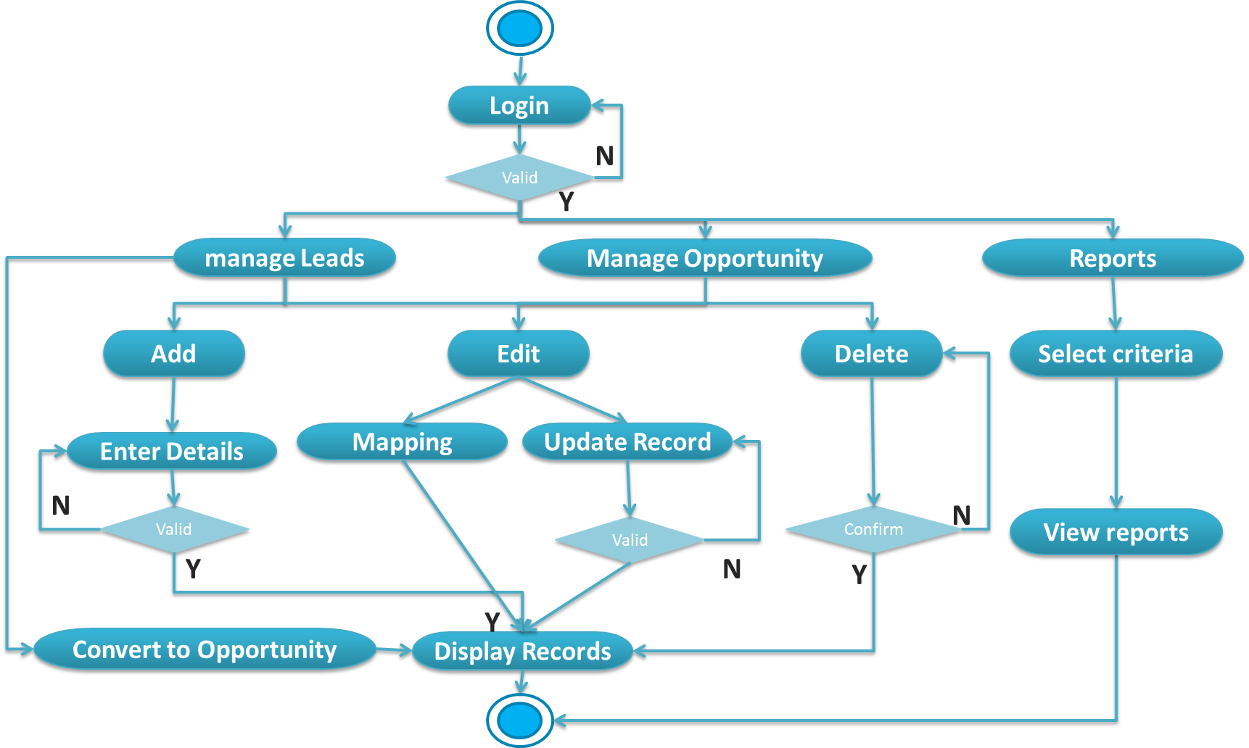

**Figure 2.18 Activity Diagram of the system**

Chapter 3

**System Design**

# System Design

Design is a process that uses the product of analysis to produce a specification for implementing a system. Design is the logical description of how a system will work.

Design emphasizes a conceptual solution that fulfills the requirements, rather than its implementation. For example, a description of a database schema and software objects. Design ideas often exclude low-level or "obvious" details obvious to the intended consumers. Ultimately, designs can be implemented, and the implementation (such as code) expresses the true and complete realized design. The term is best qualified, as in object-oriented design or database design.

## Sequence Diagrams

The UML includes interaction diagrams to illustrate how objects interact via messages. They are used for dynamic object modeling. The term interaction diagram is a generalization of two more specialized UML diagram types:

## Sequence Diagrams(Admin)

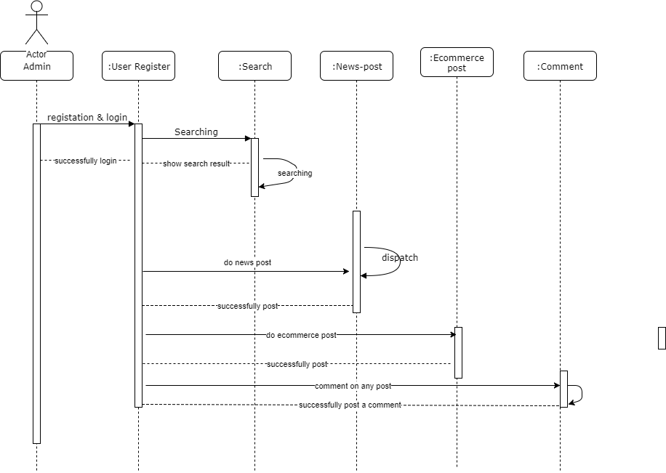

## Figure 3.1 Sequence Diagrams(Admin)

## Sequence Diagrams(Users)

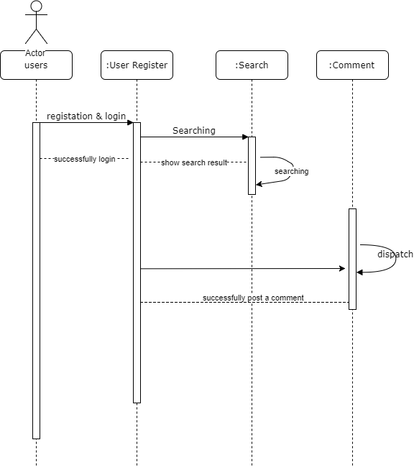

Figure 3.1 **Sequence Diagrams(users**)

## Class Diagram

Class or structural diagrams define the basic building blocks of a model. They are used for static object modeling, describing what attributes and behavior it has rather than detailing the methods for achieving operations.

`

Figure 3.8 Class Diagram of System

## Entity Relationship Diagram

An entity-relationship model is an abstract and conceptual representation of data. Entity-relationship modeling is a database modeling method, used to produce a type of conceptual schema or semantic data model of a system, often a relational database, and its requirements in a top-down fashion. Diagrams created by this process are called Entity-Relationship Diagrams.

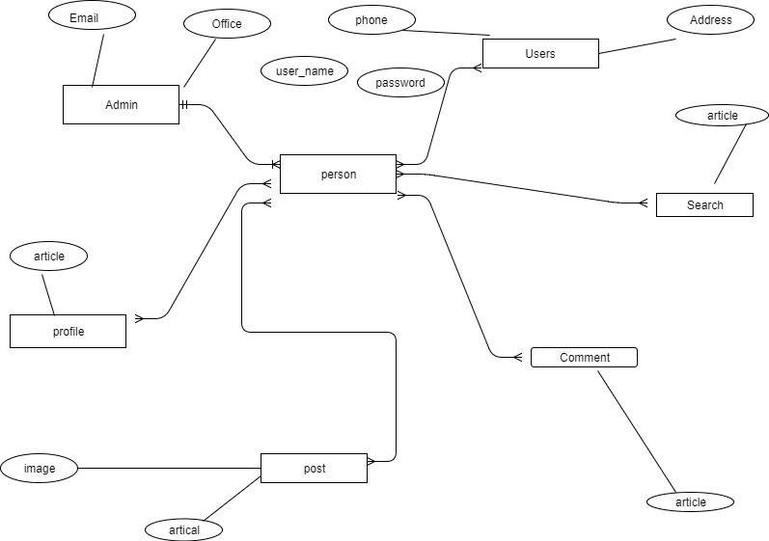

Figure 3.9 Entity Relationship Diagram

Chapter 4

**Implementation**

# Implementation

Implementation (software) perspective describes software implementations in a particular technology (such as Java). In the UP, Implementation means programming and building the system, not deploying it.

In the implementation phase, the developer builds the components either from scratch or by composition given the architecture document from the design phase and the requirement document from the analysis phase. The architecture document should give guidance. Sometimes, this guidance is found in the requirement document. The implementation phase deals with issues of quality, performance and debugging. The end deliverable of implementation phase is the product itself.

## Tools &Technologies

Following are the tools and technologies used in development of this project:

Java Spring Framework

Microsoft SQL Server 2008

Telerik reports

Microsoft Visio

Microsoft Architect

HTML5, CSS, JavaScript, J-query, Twitter bootstrap

## Project Link

They provide github repository link after uploading the project there.

Chapter 5

**System Testing**

# System Testing

## Why SoftwareTesting is Essential?

### Black box testing

### White box testing

## Test Cases

### Test case: Sign up

Project: Project title

Author:

Date:

|  |  |
| --- | --- |
| Test case ID | TC 001 |
| Test case manager |  |
| Functional area | Sign up |
| Test name | Sign up with empty fields. |
| Objective | The purpose of this test case is to verify that none of the fields remain empty when a user signs up to create his account. |
| Pre-requisite | The application is running and displaying sign up form. |
| Steps to perform | 1. Submit the form with a number of empty fields.  2. Click the sign up button. |
| Expected result | Error message is displayed indicating empty fields. |
| Test result | 🗹 Pass 🞎 Fail |

Chapter 6

**Conclusion**

# Conclusion

## Good Features of the System

## Limitations of the System

## Future Enhancements

## Appendices

# User Manual

## Log in Screen of Federal Shariat Court Case Flow Automation System.

# References