T2 Use Performance Analyzer

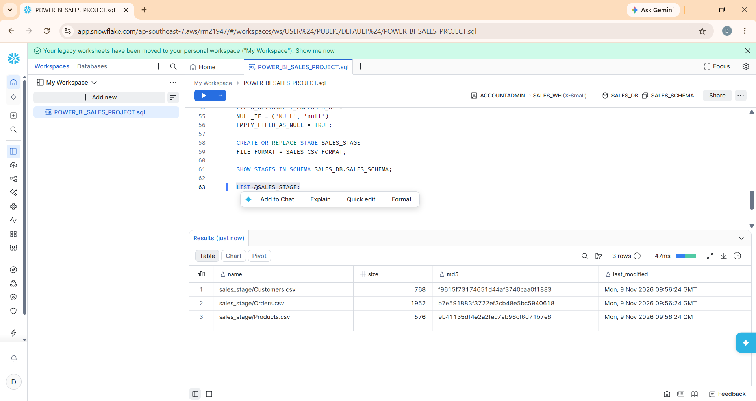

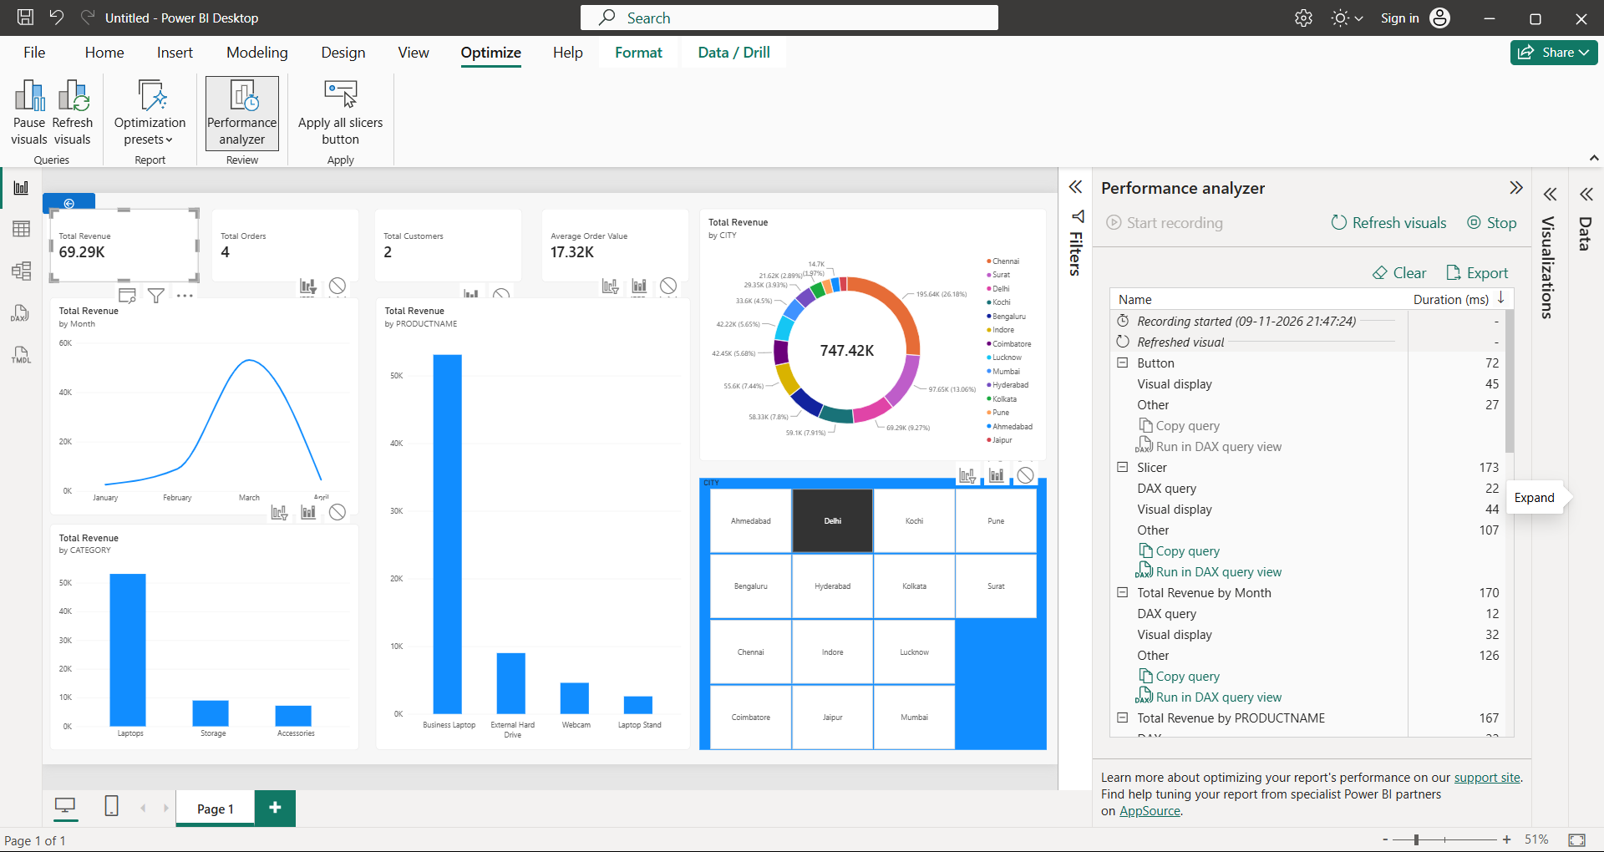

Business Storytelling with Data – Sales Performance Analysis
1. Objective
The objective of this task is to transform raw sales data into meaningful business insights using Snowflake and Power BI.
The CUSTOMERS, PRODUCTS, and ORDERS tables were used to analyze sales performance, customer distribution, product performance, and revenue trends.
The dashboard helps business stakeholders understand sales patterns and make informed business decisions.
2. Tools and Technologies Used
- Snowflake: Used as the cloud data warehouse to store and manage the sales datasets.
- Power BI Desktop: Used to connect to Snowflake, create visualizations, and build an interactive dashboard.
- DAX: Used to calculate business metrics such as Total Revenue, Total Orders, Total Customers, and Average Order Value.
- Power BI Performance Analyzer: Used to measure visual loading, query execution, and rendering performance.
3. Key Business Insights
A. Revenue Trend Analysis
The line chart showing Total Revenue by Month helps identify changes in revenue over time.
Business Interpretation:
- Monthly revenue trends help identify high-performing and low-performing periods.
- Management can use these trends to understand sales growth and fluctuations.
- Low-performing months can be investigated to identify possible reasons for reduced sales.
Business Recommendation:
Plan promotional campaigns and marketing activities during periods where sales performance is relatively low.
B. Product Performance Analysis
The column chart showing Total Revenue by Product Name identifies which products contribute more revenue.
Business Interpretation:
- Products generating higher revenue are important contributors to business performance.
- Lower-revenue products may require further investigation.
- Product-level analysis helps management understand customer purchasing preferences.
Business Recommendation:
Maintain sufficient inventory for high-revenue products and evaluate pricing or promotional strategies for lower-performing products.
C. Category Performance Analysis
The chart showing Total Revenue by Category provides an overview of revenue contribution across product categories.
Business Interpretation:
- Category-level analysis helps identify which product categories contribute most to revenue.
- It helps management understand the overall product portfolio performance.
Business Recommendation:
Focus marketing investments on successful categories while reviewing the performance of categories generating comparatively lower revenue.
D. Customer and City Analysis
The donut chart showing Total Revenue by City helps identify the geographical distribution of sales.
The dashboard also includes a City slicer that allows users to filter the dashboard by individual cities.
Business Interpretation:
- Revenue distribution across cities helps identify important sales markets.
- City-level filtering allows management to investigate regional sales performance.
- The analysis can help identify opportunities for expansion into lower-performing markets.
Business Recommendation:
Strengthen marketing and customer engagement in cities with strong sales potential and investigate opportunities to improve sales in lower-performing locations.
E. KPI Analysis
The dashboard includes KPI cards displaying:
- Total Revenue
- Total Orders
- Total Customers
- Average Order Value
Business Interpretation:
These KPIs provide a quick overview of overall business performance.
Business Recommendation:
Management should monitor these metrics regularly to evaluate revenue performance, customer activity, and order value.
4. Interactive Dashboard Analysis
A City slicer was added to make the dashboard interactive.
For example, selecting Delhi filters the revenue-related visuals and KPI cards to display information for Delhi.
This allows business users to compare regional performance without creating separate dashboards for every city.
5. Power BI Performance Analyzer
Power BI Performance Analyzer was used to evaluate the performance of dashboard visuals.
The following activities were performed:
- Opened the Power BI report.
- Navigated to Optimize → Performance Analyzer.
- Started recording.
- Refreshed the visuals.
- Reviewed the performance results.
- Exported the Performance Analyzer results as a JSON file.
Performance observations from the recorded session:
- The Total Revenue by Month line chart completed its visual lifecycle in approximately 169 ms.
- The Total Revenue by Product chart completed in approximately 170 ms.
- The Total Revenue by Category chart completed in approximately 164 ms.
- The Total Revenue by City donut chart completed in approximately 162 ms.
- The slowest visual lifecycle in the captured session was a KPI card, at approximately 332 ms.
These are visual lifecycle durations, not pure query execution times.
The recorded results indicate that the visuals loaded successfully during the test. No obvious long-running query was observed in the captured results.
6. Business Recommendations
Based on the dashboard analysis, the following actions can be recommended:
- Monitor monthly revenue trends to identify sales fluctuations.
- Prioritize inventory management for high-revenue products.
- Develop marketing strategies for lower-performing product categories.
- Identify cities with strong revenue contributions and strengthen regional sales activities.
- Monitor Total Orders, Total Customers, and Average Order Value to evaluate business performance.
- Continue monitoring report performance and optimize visuals if loading times increase.
7. Conclusion
This task demonstrates how Snowflake and Power BI can be used together to convert sales datasets into meaningful business insights.
Snowflake provides centralized data storage, while Power BI enables interactive reporting and business analysis.
The dashboard helps stakeholders understand revenue trends, product performance, category contribution, and regional sales distribution.
Power BI Performance Analyzer was also used to evaluate visual performance and identify potential optimization opportunities.
Overall, the dashboard supports data-driven decision-making and helps management identify areas for business improvement.

