Task 3: Five Insights, Business Interpretation, and Recommendations
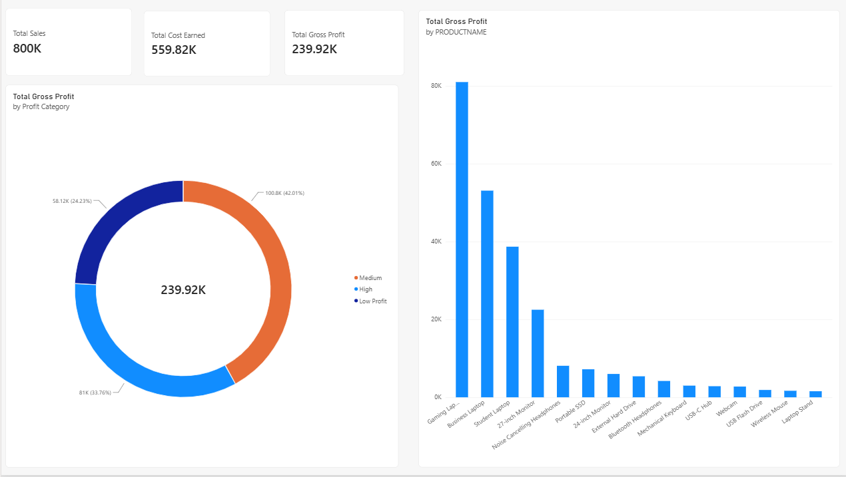
Objective
To analyze the sales dashboard, identify five important business insights, interpret the findings, and recommend suitable business actions.
Business Insights
1. Sales Performance
- Observation: The dashboard displays sales performance across products and months.
- Interpretation: Sales trends help identify demand patterns and business growth.
- Recommendation: Focus marketing activities on products and periods with stronger sales.
2. Product Profitability
- Observation: The product-wise gross profit chart compares profitability across products.
- Interpretation: Different products contribute differently to overall gross profit.
- Recommendation: Prioritize products that generate higher gross profit.
3. Cost Analysis
- Observation: Total sales and total cost are compared using KPI cards.
- Interpretation: Higher product costs reduce gross profit.
- Recommendation: Review product costs and identify opportunities to improve cost efficiency.
4. Profit Category Analysis
- Observation: Profit is classified into High, Medium, and Low Profit categories.
- Interpretation: Profit categories help identify strong and weak profitability areas.
- Recommendation: Review pricing and costs for low-profit products or transactions.
5. Overall Business Performance
- Observation: Total Sales, Total Cost, and Total Gross Profit KPIs summarize business performance.
- Interpretation: These indicators help management understand the overall financial position.
- Recommendation: Monitor the KPIs regularly and take corrective action when profitability declines.
Note on Cost Assumptions
The UNITCOST column was created using 70% of UNITPRICE as an assumed training value because actual unit cost data was unavailable. Therefore, gross profit figures are illustrative.
Conclusion
The Power BI dashboard helps analyze sales, costs, gross profit, and profit categories. These insights support better product decisions, cost management, and business planning.

