T3 – Perform Queries on a table
Queries:
- Count total records
SELECT COUNT(*) AS Total_Records
FROM online_retail;
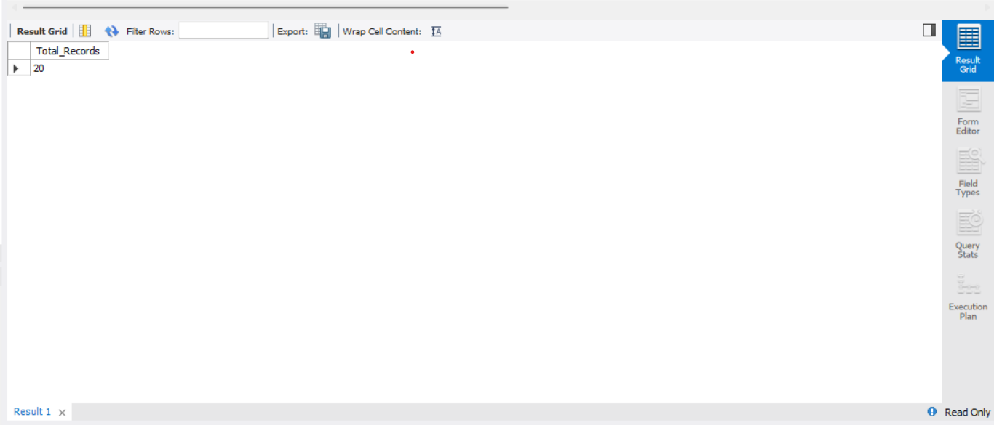

- Find unique countries
SELECT DISTINCT Country
FROM online_retail;
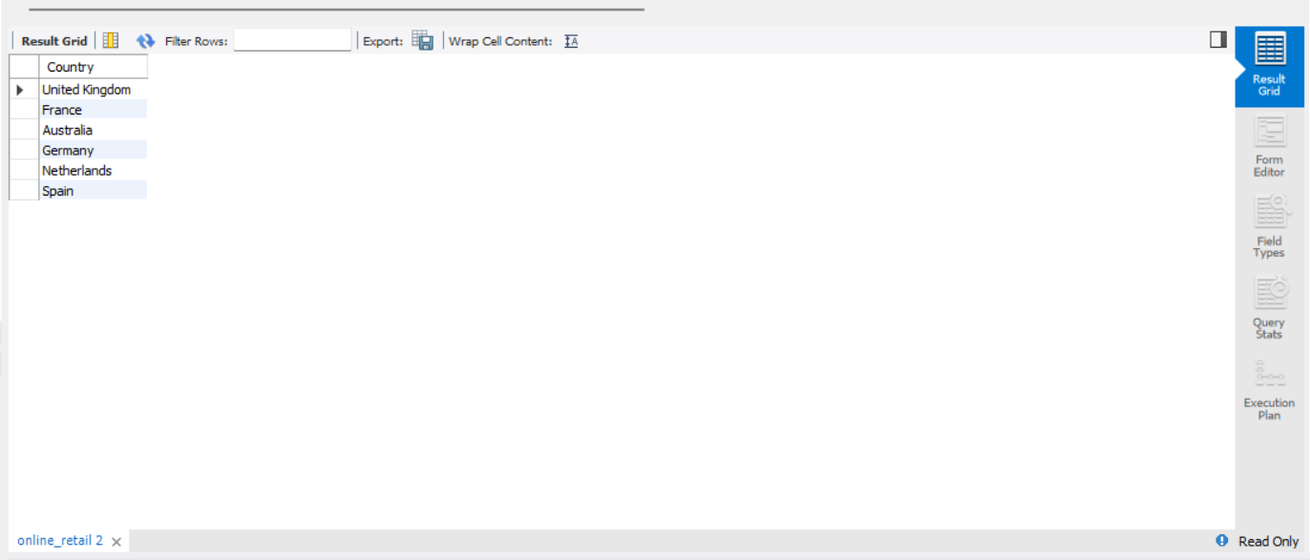

- Find products with quantity greater than 10
SELECT Description, Quantity
FROM online_retail
WHERE Quantity > 10;
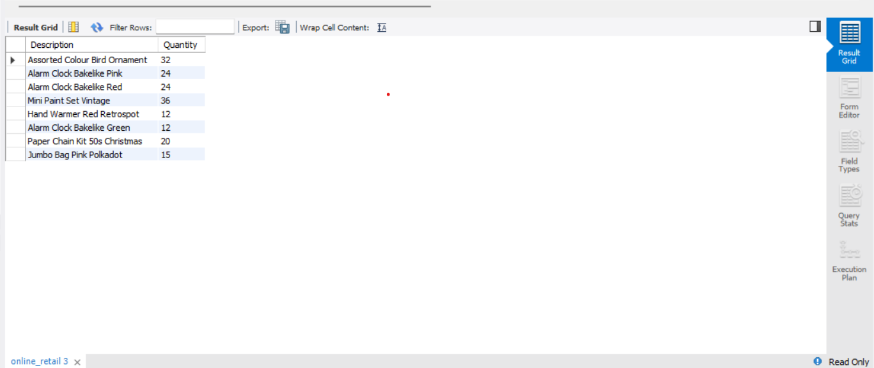

- Find the highest quantity
SELECT MAX(Quantity) AS Highest_Quantity
FROM online_retail;
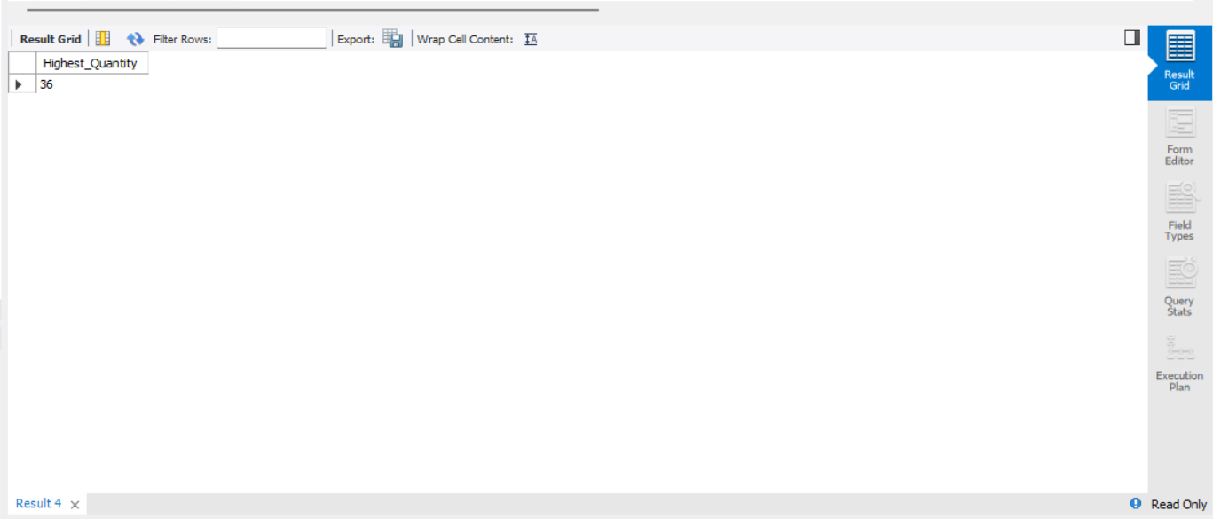

- Find the lowest unit price
SELECT MIN(UnitPrice) AS Lowest_Unit_Price
FROM online_retail;
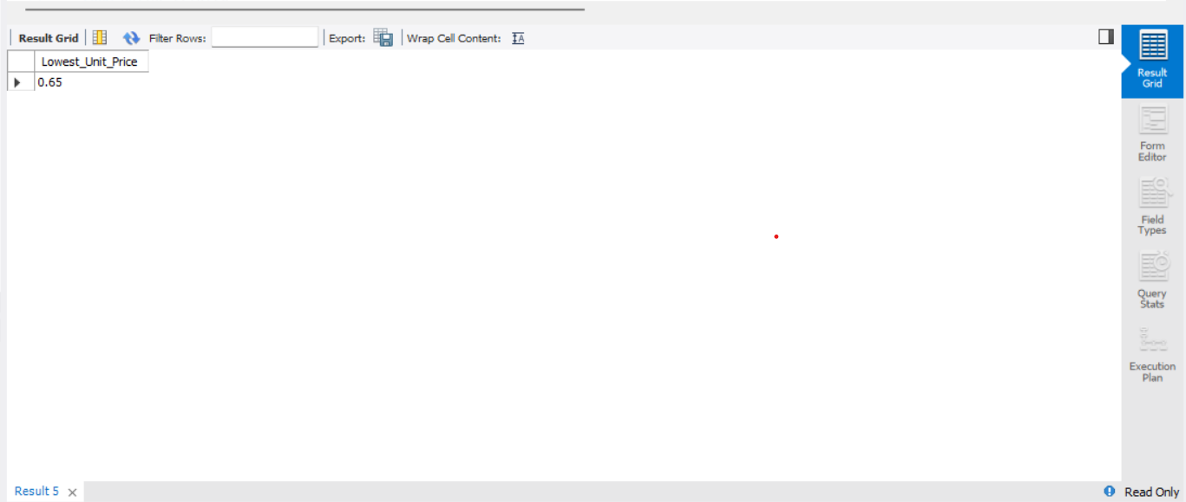

- Count transactions by country
SELECT Country, COUNT(*) AS Total_Transactions
FROM online_retail
GROUP BY Country;
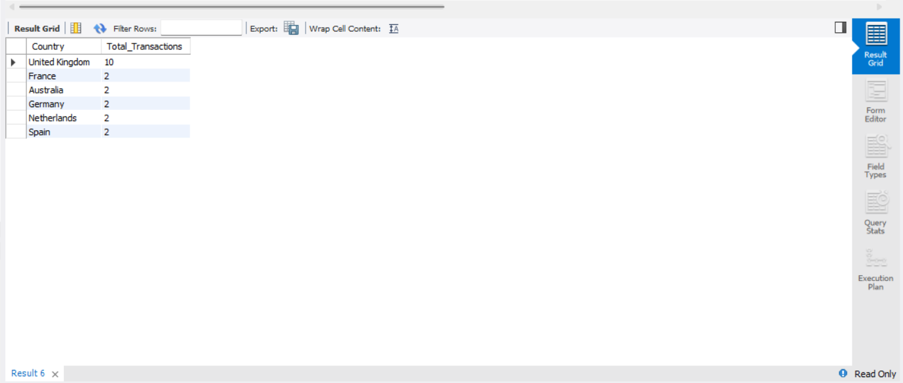

- Find countries with more than 2 records
SELECT Country, COUNT(*) AS Total_Transactions
FROM online_retail
GROUP BY Country
HAVING COUNT(*) > 2;
