SMART INDIA HACKATHON
Problem Statement ID 26144 | Hardware | Smart Automation

ADMI-X

Adaptive Differential Microbarometer with Self-Characterizing Pneumatic Reference & Measurement-Quality Intelligence
Design & Development of a High-Sensitivity Micro-barometer Infrasound Sensor

Item | Detail
Problem Statement ID | 26144
Problem Statement Title | Design & Development of a High-Sensitivity Micro-barometer Infrasound Sensor
Organization | NTRO
Theme / Category | Smart Automation / Hardware
Team Name | THE SONICTRACE
Team ID | 163643
Product Status | ~50% of the prototype built; testing and validation are next

1. Executive Summary
ADMI-X is a precision differential microbarometer for measuring very-low-frequency atmospheric pressure fluctuations in the 0.01–20 Hz infrasonic band. It is not a barometric weather-station sensor and not a microphone: it is a scientific measurement instrument built around one central idea.
Core idea
Most microbarometers output a pressure value and assume their own low-frequency response is fixed. ADMI-X measures its own pneumatic transfer response and its own measurement quality, and attaches both to every data record.

The atmosphere enters through a 4-port symmetrical wind-noise-reduction manifold. The resulting pressure is compared, through a low-range differential pressure transducer, against a controlled reference chamber (~220 mL design starting point) that is vented through a replaceable calibrated capillary/restrictor module. The sensor output passes through a low-noise differential analog front end, an anti-alias filter and a 24-bit-compatible delta-sigma ADC sampled at ~100 SPS. Temperature, humidity and 3-axis vibration are recorded simultaneously.
Physics-based DSP (FFT, Welch PSD, spectrogram, RMS, STA/LTA, coherence) runs on top of the calibrated data. A Measurement-Quality Engine scores each window as GOOD, DEGRADED or UNTRUSTED, and a periodic pneumatic self-diagnostic estimates whether the pneumatic time constant has drifted, indicating possible blockage or leakage.
Honest positioning. The individual building blocks (differential sensing, reference chambers, capillary leaks, multi-port inlets, 24-bit ADCs) are established technologies. The innovation of ADMI-X is their integrated, traceable, experimentally characterized and self-diagnosing architecture. All performance figures in this document are design targets that will be confirmed by measurement.

2. Problem Statement and Design Requirements
Infrasound (below ~20 Hz) is generated by volcanic activity, severe weather, meteors, explosions and rocket launches. Detecting it requires an instrument that resolves pressure changes of a few hundredths of a pascal on top of a ~10⁵ Pa atmospheric background, while rejecting wind, temperature, vibration and electronic noise.

2.1 Requirements the design is built against
Parameter | Requirement
Frequency band | 0.01–20 Hz
Pressure sensitivity | 20 mV/Pa
Pressure resolution | Better than 0.05 Pa
Output | Maximum 24 Vpp
Dynamic range | > 100 dB
Sampling | ≥ 50 Hz
Digitizer | 24-bit compatible

These are design and evaluation requirements, not proof that the prototype already achieves them. Our working principle is TARGET → BUILD → MEASURE → VALIDATE.

2.2 How ADMI-X addresses each problem
Problem | ADMI-X response
Wind noise | 4-port symmetrical pneumatic averaging manifold
Reference drift | Controlled differential reference chamber
Pneumatic uncertainty | Interchangeable capillary + measured transfer function
Temperature effects | Multi-point temperature sensing + temperature-aware calibration
Vibration contamination | Synchronized 3-axis accelerometer + pressure/vibration coherence
Sensor / pneumatic faults | Periodic pneumatic self-diagnostics
Untrusted measurements | Measurement-Quality Engine with quality flags
Scientific reproducibility | Raw pressure + calibration + environmental metadata stored together

3. Proposed Solution

3.1 Key features
- 4-port wind-noise reduction manifold: spatial averaging to suppress local wind turbulence.
- Differential sensing: ΔP = P_atmosphere − P_reference, avoiding digitization of the full ~10⁵ Pa background.
- Interchangeable capillary module: high/medium/low-resistance modules, each experimentally characterized.
- Low-noise differential AFE + 24-bit-compatible ΔΣ ADC: nominal ~100 SPS acquisition.
- Environmental monitoring: temperature (ambient, chamber, PCB), humidity and 3-axis vibration.
- Physics-based DSP: FFT, Welch PSD, spectrogram, RMS, STA/LTA, coherence, Allan deviation.
- Pneumatic self-diagnostic: estimates the pneumatic time constant and flags possible blockage or leakage.
- Traceable data: every record stored with calibration, configuration and quality metadata.

3.2 Measurement chain
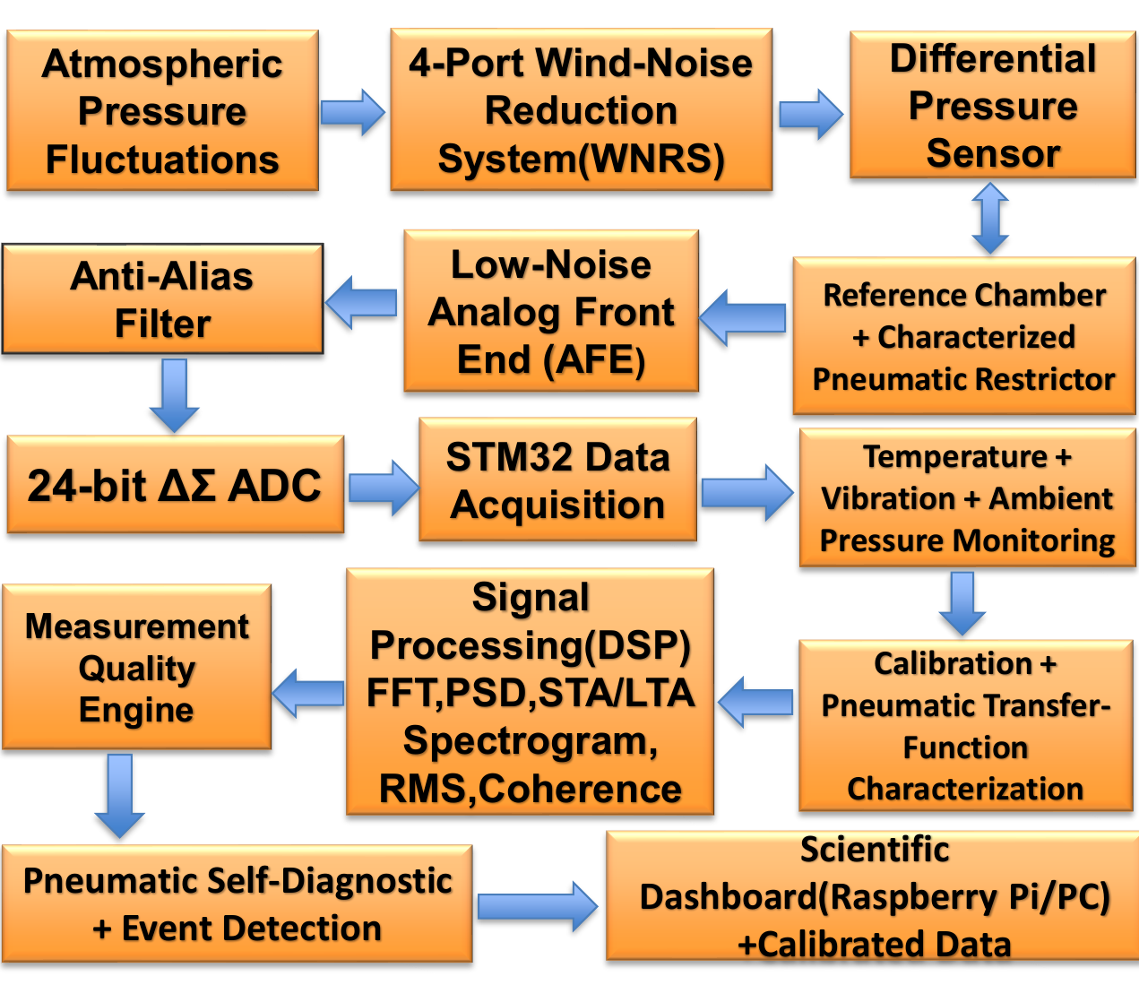
Figure 1. ADMI-X process-flow architecture (from the SIH presentation).
The reference chamber and capillary form a parallel pneumatic branch: the sensor's second port sees the reference chamber, which is vented to the atmosphere through the capillary module, so slow pressure changes equalize while infrasonic changes appear as ΔP.

3.3 Technology stack
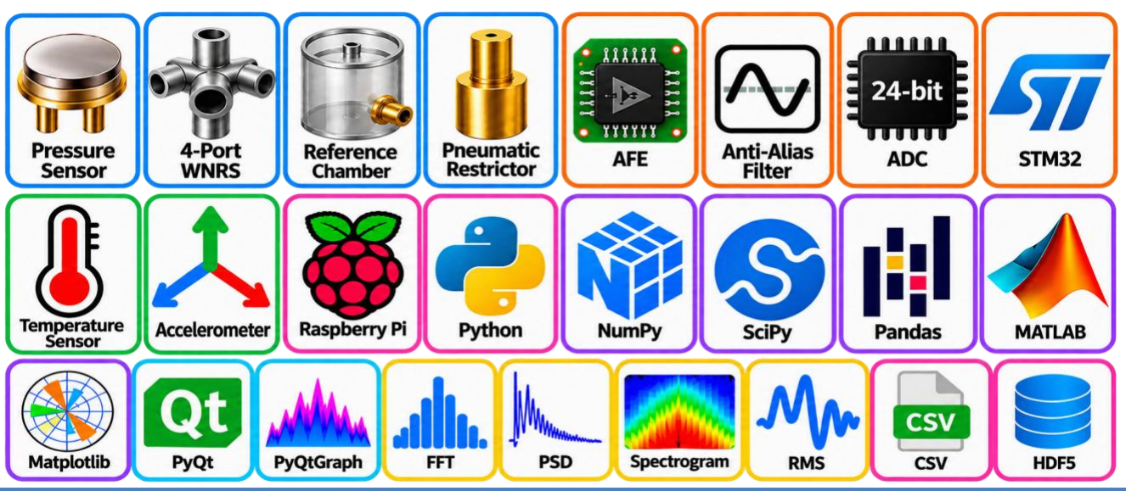
Figure 2. Technology stack: sensing, analog/digital electronics, embedded, software and analysis tools.

4. Core Physics
The atmospheric pressure at the instrument is modelled as:
P(t) = P₀ + ΔP_weather(t) + p_infra(t) + n(t)
where P₀ is the large atmospheric background, ΔP_weather the slow atmospheric variation, p_infra(t) the desired infrasonic signal and n(t) sensor, electronic and environmental noise. The instrument must extract p_infra(t) without weather drift, temperature, wind, vibration or electronics noise dominating it.

4.1 Key relations
Differential pressure:
ΔP = P_atmosphere − P_reference
Pneumatic time constant and cut-off frequency:
τ = R_p · C_p f_c = 1 / (2π R_p C_p) = 1 / (2πτ)
Pressure–voltage conversion:
P = (V_out − V_offset) / S
Signal-to-noise ratio:
SNR = 20 · log₁₀ ( P_signal,rms / P_noise,rms )
Complete system transfer function:
H_system(f,T) = H_wind(f) · H_pneumatic(f,T) · H_sensor(f,T) · H_AFE(f) · H_ADC(f)
For a target cut-off of 0.01 Hz the required time constant is τ ≈ 15.9 s. This is a design starting point only; the cut-off is not claimed until the assembled network has been measured.

5. Hardware Design

5.1 Reference chamber (V1: ≈ 220 mL)
A ~220 mL chamber is the Version-1 engineering starting point, chosen to balance pneumatic response, low-frequency sensitivity, size, thermal stability, leakage and fabrication effort. It is not an official requirement and may be revised after characterization.

5.2 Interchangeable pneumatic module
The capillary/restrictor is replaceable (Module A high resistance, B medium, C lower). Instead of trusting a theoretical capillary calculation, each module follows this workflow:
Design → calculate → fabricate → pressure-step test → measure τ → compute actual f_c → measure frequency response → store H(f).

5.3 4-port wind-noise reduction rosette
Four symmetrically placed ports feed one pressure manifold. Wind turbulence is spatially local and can create large fluctuations at a single inlet; averaging over several ports attenuates it while coherent atmospheric pressure changes pass. Each inlet has a protective hydrophobic membrane against rain, dust and condensation. The achieved wind reduction (in dB) will be measured in comparative wind tests, not assumed.

5.4 Pressure sensor
V1 uses a commercial low-range differential piezoresistive pressure transducer rather than a custom MEMS sensor, so that the pneumatic architecture, wind filtering, electronics, calibration, DSP and environmental stability can be proven first. A ±250 Pa-class range is the proposed starting target, subject to the sensor finally selected; an oversized range (for example ±5 inH₂O-class) combined with 20 mV/Pa gain would waste analog output range. A custom MEMS or optical sensor is a V3 research direction.

5.5 Analog front end
Bridge → input protection → low-noise instrumentation amplifier → precision gain → offset management → anti-alias low-pass → ADC driver → precision reference. The design targets low input-referred noise, low drift and offset, high CMRR, low 1/f contribution and stable gain. A zero-drift/chopper amplifier is used only if the assembled circuit shows a measured advantage; switching artefacts must be checked.

5.6 ADC and acquisition
A 24-bit-compatible precision delta-sigma ADC (ADS1256-class for V1; higher-performance parts evaluated in V2) at ~100 SPS, read by an STM32 microcontroller and streamed to a Raspberry Pi / PC. Note that 24-bit nominal resolution is not 24 effective bits; effective resolution is characterized on the complete system.

5.7 Environmental sensing
- Temperature: T1 external ambient, T2 reference chamber, T3 PCB/electronics (optional T4 sensor head in V2), so that pressure error can be modelled as a function of several temperatures.
- Humidity sensor for condensation risk.
- 3-axis accelerometer (aₓ, a_y, a_z) to detect mechanical contamination through pressure–vibration coherence.

5.8 Enclosure, PCB and power
- Two-zone enclosure: pneumatic/sensor zone (rosette, manifold, chamber, sensor) physically separated from the electronics zone (AFE, ADC, MCU, power).
- 4-layer PCB: signal/components, ground plane, power/controlled routing, signal; short sensor traces, clean analog ground, guarded high-impedance nodes, shielding.
- Power: DC input → protection → low-noise regulation into separate analog, ADC/reference and digital rails, isolated from Raspberry Pi, display, communication and storage noise.

6. Calibration
Stage | Purpose | Method / output
1 – Zero | Offset | Equalize pressure ports; measure V_offset
2 – Static sensitivity | Sensitivity S | Apply known pressures P₁…Pₙ, measure V₁…Vₙ, fit V = aP + b, S = a
3 – Dynamic response | Frequency response | Controlled excitation 0.01 → 20 Hz; determine H(f) = V(f)/P(f), amplitude and phase
4 – Environmental | Temperature dependence | Repeat over temperature conditions; determine K_T(f) where appropriate

Sensitivity, resolution, dynamic range and frequency response are demonstrated through calibration and measurement, not assumed from ADC or sensor datasheets.

7. Software, DSP and Dashboard

7.1 DSP pipeline
Raw ADC → timestamp validation → raw-data storage → calibration → temperature correction → quality assessment → detrending → band processing (RMS, FFT, Welch PSD, spectrogram, STA/LTA, coherence, Allan deviation) → event candidate → quality assessment.

7.2 Measurement-Quality Engine
The instrument outputs P(t) together with Q(t): a quality state derived from temperature, vibration, wind, calibration, pneumatic health, saturation and data integrity. Example: “Pressure = 0.013 Pa, Quality = GOOD, temperature stable, vibration low, pneumatic health NORMAL, calibration VALID.”
In the implemented dashboard (Python, PyQt5 + pyqtgraph) each analysis window is scored out of 100 from five weighted checks:
Check | Pass condition | Weight | Failure indicates
ADC saturation | Peak < 95% of full scale | 30 | Clipped / rejected segment
Signal-to-noise | SNR > 10 dB | 20 | Noise-dominated data
Vibration coupling | Pressure–vibration coherence < 0.6 | 20 | Mechanical contamination
Temperature drift | |drift| < 1 °C/min | 10 | Thermal false signal
Pneumatic response | τ deviation < 20% of baseline | 20 | Blockage / leakage

Score ≥ 80 is GOOD, 50–79 DEGRADED, below 50 UNTRUSTED. Thresholds are initial values and will be tuned after validation.

7.3 Pneumatic self-diagnostic
A known pressure perturbation is applied periodically; the measured response yields τ_current, which is compared with the stored τ_baseline. A significant deviation raises a health flag for possible capillary blockage, leakage, tubing degradation, contamination or a changed pneumatic configuration.

7.4 Scientific dashboard (implemented)
The dashboard runs at 100 Hz with a 60 s display window and provides: live pressure waveform, Welch PSD, spectrogram, STA/LTA event detection (2 s / 30 s windows, trigger ratio 3.0) with event log, temperature/humidity/vibration cards, quality score and per-check status, pneumatic time-constant and cut-off tracking with a fault-injection demo, dark/light themes, and export to CSV, HDF5 and a JSON metadata file. It supports a built-in simulator and a serial (STM32) source using one ASCII line per sample: P,<pressure_Pa>,<temp_C>,<hum_%>,<ax_g>,<ay_g>,<az_g>.
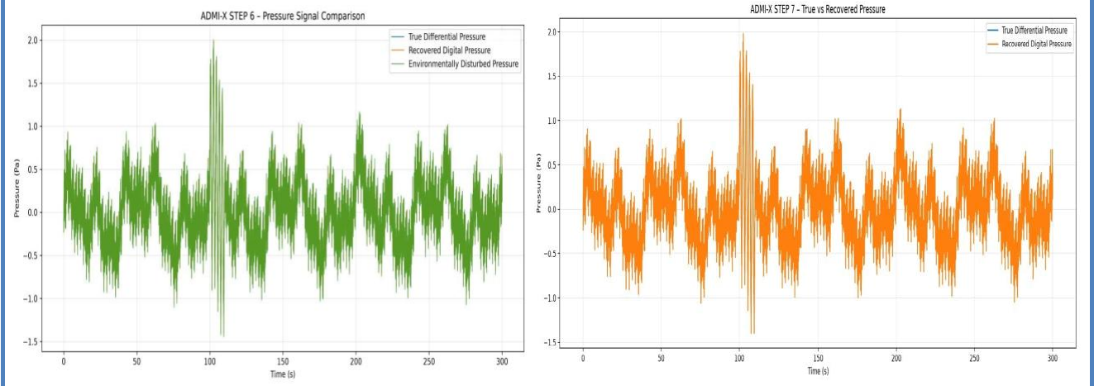
Figure 3. Simulated waveform output: true vs. environmentally disturbed vs. recovered pressure (ADMI-X signal-chain simulation).

7.5 Data record format
Every record contains: timestamp, raw ADC value, calibrated pressure, temperature, humidity, vibration, pneumatic configuration ID, calibration ID, gain, sampling rate, quality flags, health score and processing version, so that every measurement is traceable and reproducible.

7.6 Role of AI / ML
Physics comes first, then calibration, then DSP, and only optionally ML. Machine learning is a later add-on for classifying explosion-like events, meteors, storms, rocket signatures, and mechanical or wind contamination; the pressure measurement itself remains physics-based.

8. Innovation and Uniqueness
- Adaptive pneumatic self-characterization: the pneumatic transfer response is measured, not assumed as a fixed cut-off.
- Modular pneumatic calibration: replaceable, individually characterized capillary modules.
- Multi-port spatial wind-noise architecture: 4-port rosette with experimentally characterized performance.
- Pneumatic health intelligence: τ tracking to identify blockage, leakage or degradation.
- Measurement-quality intelligence: each measurement is labelled with a trust state.
- Environmental error observability: temperature and 3-axis vibration are used as error references.
- Calibration-aware scientific data: raw pressure stored with calibration ID, gain, temperature, pneumatic state and processing configuration.

USP
Self-characterizing pneumatic system: ADMI-X measures its own pneumatic response and measurement quality instead of assuming a fixed response.

8.1 Existing solutions vs ADMI-X
Parameter | Existing | ADMI-X
Sensing | Absolute / basic pressure sensing | Differential pressure sensing
Reference | Fixed / basic reference | Controlled pneumatic reference
Wind noise | Limited reduction | Multi-port wind-noise reduction
Pneumatic response | Fixed / assumed | Measured and characterized
Environment | Limited monitoring | Temperature + vibration monitoring
Calibration | Conventional calibration | Calibration + transfer-function model
Health | Basic monitoring | Pneumatic self-diagnostics
Data quality | Pressure data | Pressure + measurement-quality status
Processing | Basic signal processing | FFT + PSD + spectrogram + STA/LTA + coherence

9. Feasibility and Viability

9.1 Technical feasibility
- Uses proven building blocks: differential pressure sensor, reference chamber, wind-noise reduction, low-noise AFE, precision ADC and DSP.
- Modular development: Electronics proof → Sensor proof → Complete instrument.
- Performance verified through controlled frequency-response, noise, calibration, temperature, wind and stability tests.

9.2 Financial feasibility
- Prototype is based mainly on commercially available pressure, ADC, environmental-sensing and embedded components.
- Modular architecture avoids premature investment in custom MEMS fabrication or complex production hardware.
- Incremental development reduces prototype and validation risk.

9.3 Scalability
Version | Scope
V1 | Proof-of-physics prototype: differential sensor, ~220 mL chamber, interchangeable capillary, 4-port wind filter, AFE, ADC, Python acquisition.
V2 | Precision prototype: optimized pneumatics, improved PCB, thermal and vibration isolation, self-calibration, environmental enclosure, dynamic calibration.
V3 | Research platform: matched dual sensors, coherence measurement, GPS synchronization, distributed arrays, beamforming, direction-of-arrival estimation, digital twin.

10. Risks, Failure Modes and Mitigation
Failure / risk | Detection | Response / mitigation
Wind noise masking weak signals | Noise comparison between ports | 4-port symmetric inlet; comparative wind testing; maintenance flag
Capillary blockage | τ change | Flag; self-diagnostic
Reference leakage | Baseline / τ drift | Flag + service; leak testing; improved chamber sealing
Condensation | Humidity + response change | Hydrophobic protection; flag
Temperature drift | P–T correlation | Thermal characterization; compensation or flag
Vibration coupling | P–acceleration coherence | 3-axis accelerometer; isolation; flag
AFE / ADC saturation or fault | ADC / rail status, data checks | Reject segment / fault state
EMI / power-supply noise | Spectral signature | Grounding, shielding, low-noise rails; flag
Power failure | Voltage monitoring | Safe shutdown; watchdog
Storage failure / data loss | CRC / write checks | Local buffering; buffer/fault state
Calibration drift | Reference test | Periodic calibration / self-test; recalibrate

11. Validation Plan and Acceptance Tests
The instrument will not be called complete until the following are measured:
ID | Test | Evidence
A01 | 0.01–20 Hz response | Measured transfer function
A02 | ≥ 20 mV/Pa sensitivity | Pressure calibration
A03 | < 0.05 Pa resolution | Declared-band RMS noise
A04 | 24 Vpp maximum output | Full-scale electrical test
A05 | > 100 dB dynamic range | Measured ratio with definition
A06 | ≥ 50 SPS | Sample / timestamp record
A07 | 24-bit compatibility | ADC characterization
A08 | Wind reduction | Comparative experiment
A09 | Temperature compensation | Thermal-cycle test
A10 | Long-term stability | 7-day record, Allan deviation
A11 | Pneumatic self-health | Repeated diagnostic test
A12 | Quality engine | Injected-disturbance validation

For precision noise characterization, two matched channels observing the same pressure field are compared using coherence C_xy(f), separating common environmental pressure from sensor-specific noise. Allan deviation σ_A(τ) over increasing averaging times identifies white noise, drift, random walk and long-term instability, which matters because the lowest target frequency corresponds to a 100 s period.

12. Impact and Benefits

12.1 Target users
- Atmospheric and environmental monitoring agencies
- Geophysical and infrasound research institutions
- Disaster monitoring and early-warning systems
- Defence and strategic monitoring organisations
- Universities and scientific R&D laboratories
- Future distributed infrasound monitoring networks
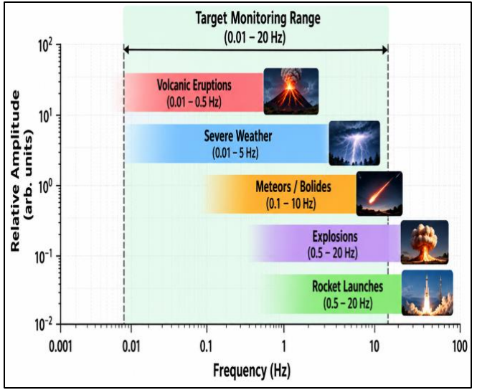
Figure 4. Target monitoring range (0.01–20 Hz) and typical infrasound source bands.

12.2 Benefits
- Scientific: enables 0.01–20 Hz monitoring and characterization of signals from volcanic activity, severe weather, meteors, explosions and rocket launches, with calibration and quality information for reproducible research.
- Economic: reduces dependence on expensive imported microbarometers; a cost-effective modular design enables affordable dense multi-sensor networks.
- Environmental: continuous atmospheric pressure and infrasound monitoring for severe-weather, atmospheric and climate-related research.
- Social / strategic: supports disaster preparedness and early-warning research, strengthens indigenous precision-instrumentation capability, and provides a platform for research and student training.

13. Current Status and Roadmap
Roughly 50% of the product is built and further build is in progress. The scientific dashboard, simulator-based demonstration of the quality engine and DSP chain, and waveform recovery simulations are available. Next steps: complete the hardware build, then run frequency-response, noise, calibration, temperature, wind and stability tests, and tune the quality-engine thresholds with measured data.
Phase | Goal
Phase 1 | Prove the measurement chain (proof of physics)
Phase 2 | Precision prototype with optimized pneumatics, thermal/vibration control and self-calibration
Phase 3 | Research platform: matched sensors, GPS-synchronized arrays, beamforming, direction-of-arrival

14. Claims We Do Not Make
To keep the submission scientifically honest, we do not claim, before measurement, that the prototype achieves a specific resolution (for example 0.001 Pa), that the wind filter gives a specific attenuation, that the pneumatic cut-off is exactly 0.01 Hz, or that the ADC provides 24 effective bits. We also do not claim patentability of established components such as differential sensing, reference chambers, capillary filters, porous filters, 24-bit ADCs or generic AI.

15. References
- Topographically Scattered Infrasound Waves Observed on Microbarometer Arrays in the Lower Stratosphere. Earth and Space Science, 2022. https://doi.org/10.1029/2022EA002226
- Performance Comparison of Measurement Microphones and Microbarometers for Sound Pressure Measurements near Wind Power Plants. Journal of Low Frequency Noise, Vibration and Active Control, 2024. https://doi.org/10.1177/14613484231200852
- On-Site Infrasound Calibration to Correct Wave Parameter Estimation. Journal of the Acoustical Society of America, 2024. https://doi.org/10.1121/10.0025131
- An Accurate and Automated Convective Vortex Detection Method for Long-Duration Infrasound Microbarometer Data. Journal of Atmospheric and Oceanic Technology, 2024. https://doi.org/10.1175/JTECH-D-23-0037.1
- Cyclic Background Noise Variations on Infrasound Microbarometers From Micrometeorology and Human Activity. Geophysical Research Letters, 2025. https://doi.org/10.1029/2025GL116415

