**Project name: Containerized Microservices with ECS Fargate**

GitHub repo: <https://github.com/Mithra1995/sampleproject.git>

# Objective

To design, deploy, and manage a containerized microservices architecture using AWS services, specifically AWS ECS Fargate . The goal is to create a robust, scalable, and secure infrastructure to run microservices in the cloud using Docker containers. The project will include the following:  
- **Containerization of Microservices** using Docker  
- **Deployment using ECS Fargate**   
- **CI/CD pipeline for continuous delivery and management** of microservices  
- **Monitoring and Logging** for performance insights

# Architecture Overview

The architecture consists of multiple AWS services to support microservices, which include ECS Fargate, Application Load Balancer (ALB) for traffic routing. This will be coupled with CI/CD pipelines using Jenkins or AWS CodePipeline.

# Services Used

- **Amazon ECS Fargate** or **Amazon EKS** (Elastic Kubernetes Service) for container orchestration  
- **Amazon RDS** (Relational Database Service) for database storage  
- **AWS Application Load Balancer** (ALB) for routing traffic to microservices  
- **Amazon VPC** (Virtual Private Cloud) for networking and security  
- **AWS CloudWatch** for monitoring and logging  
- **Docker** for containerizing microservices  
- **Amazon ECR** (Elastic Container Registry) for storing Docker images  
- **AWS CodePipeline / Jenkins** for CI/CD automation

# Step-by-Step Implementation Tasks

Step 1: Push the code to GitHub repo

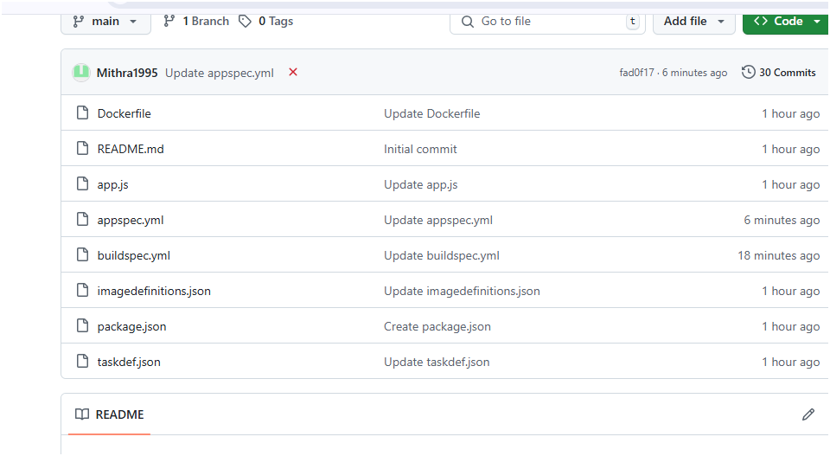

Step 2: create ECR

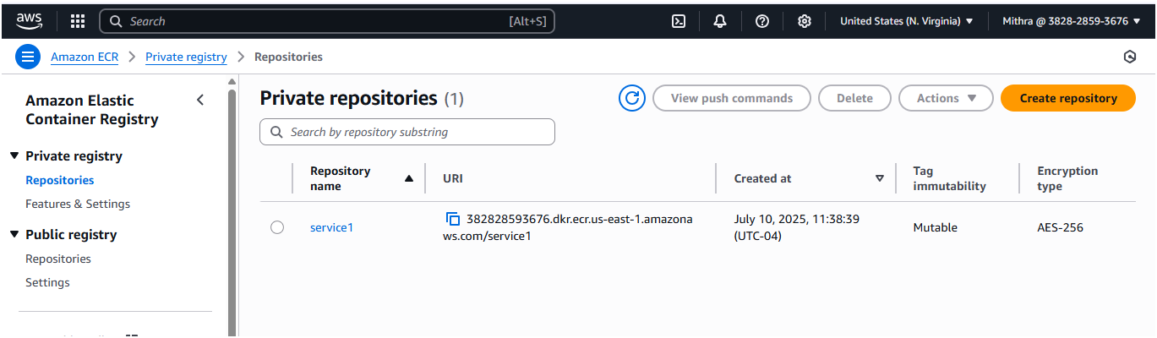

Step 3: Create ECS

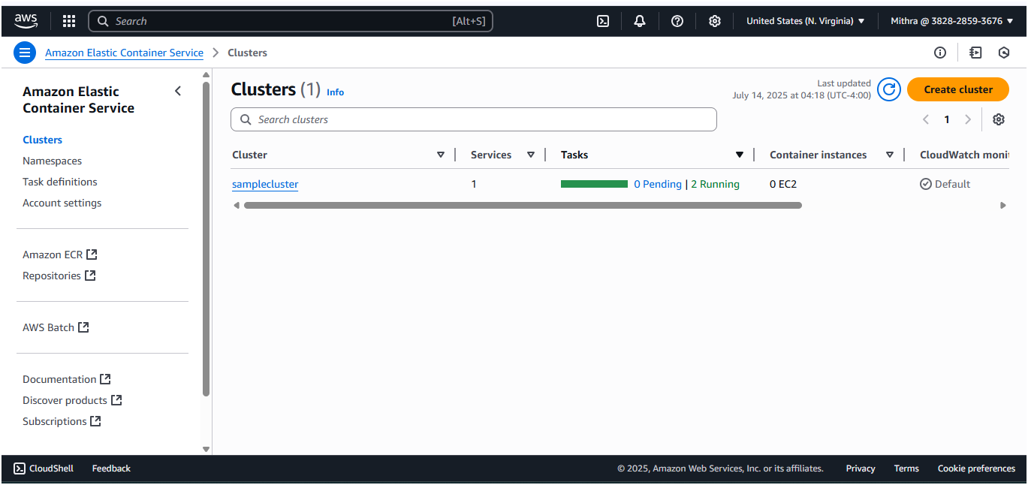

Step 4: create task definition with container port and ECR

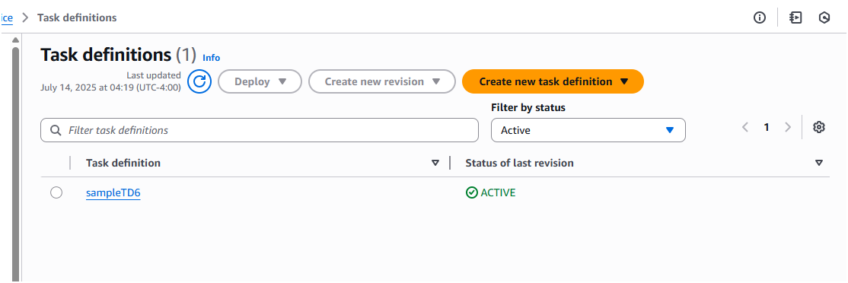

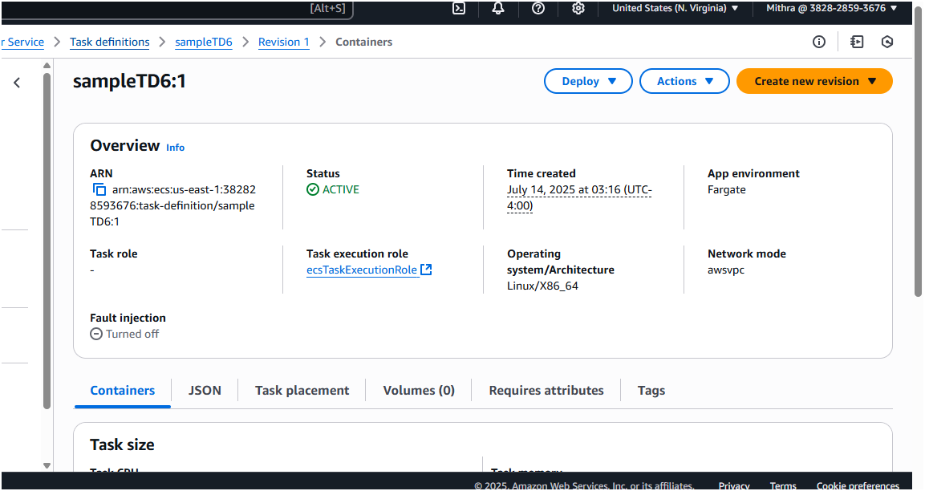

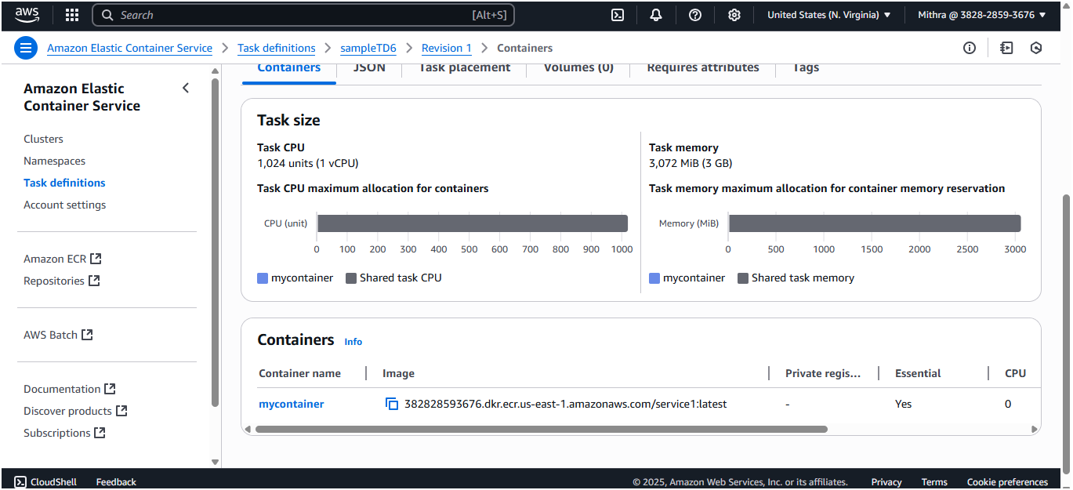

Step 5: create service for ECS

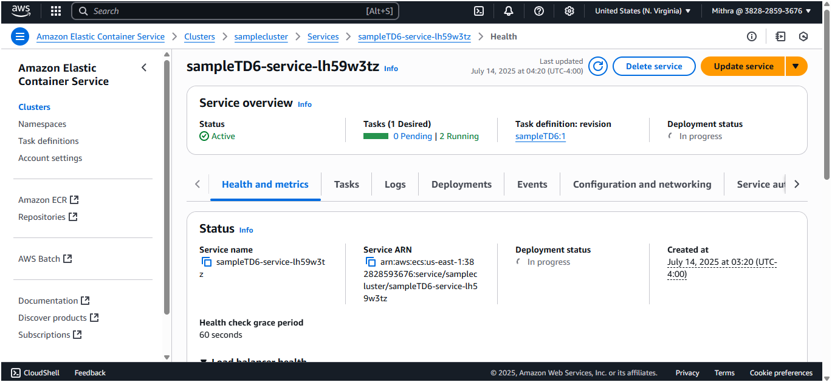

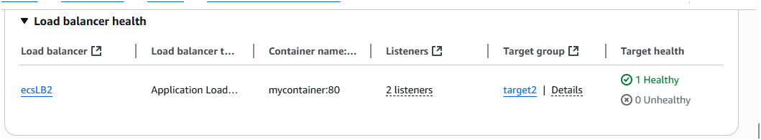

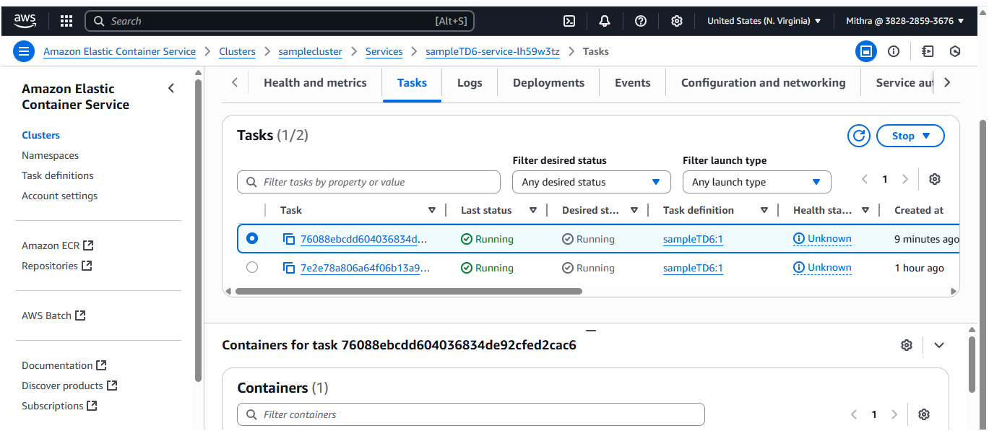

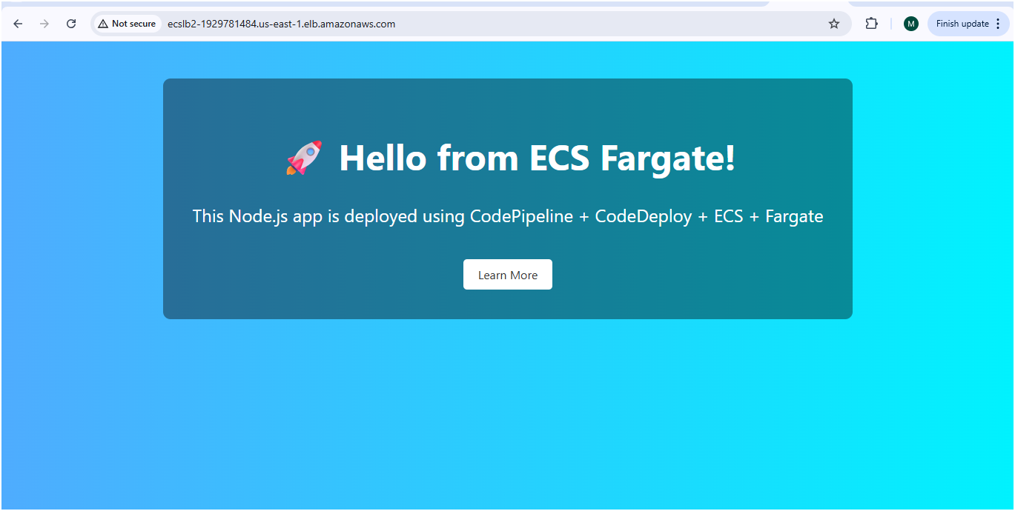

Step 6 : create code pipeline with AWS codedeploy

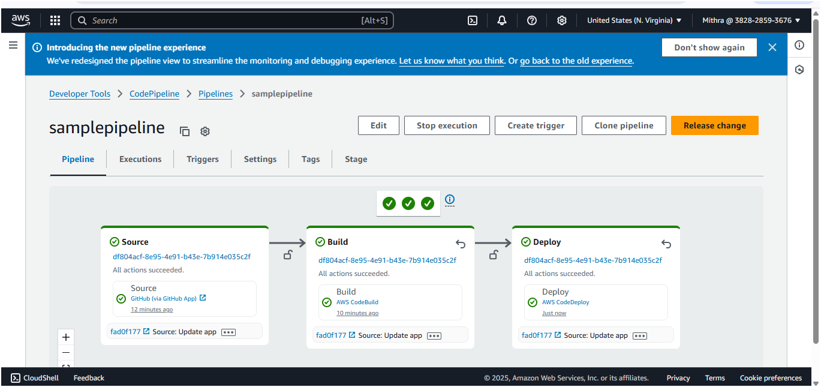

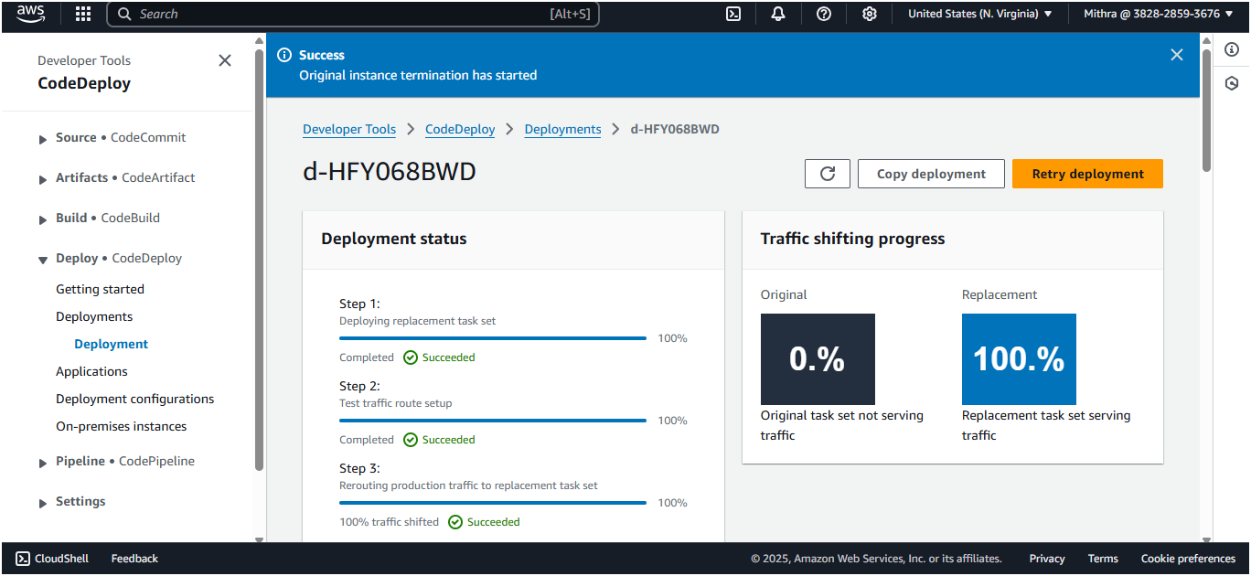

Step 7: Now change the code in github and check

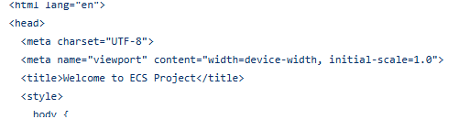

Step 8: Now the pipeline triggered again

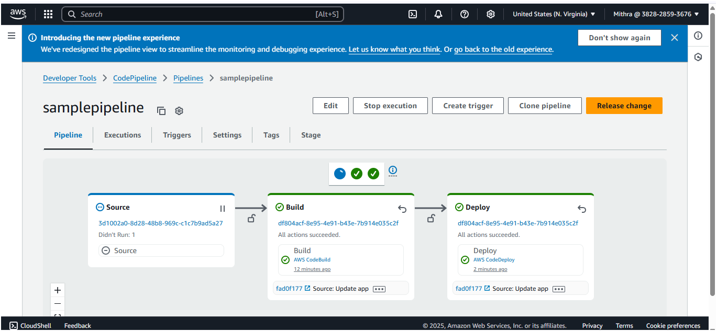

Step 9: Image is pushed to ECR

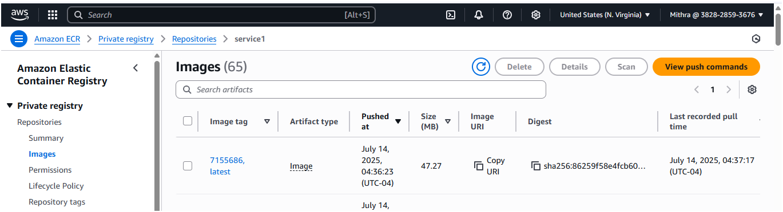

Step 10: now the traffic is moving to replacement task

