NovaAssist Architecture

System Overview
NovaAssist is a Microsoft Word Add-in that provides AI-powered document editing with surgical redlining, policy compliance checking, and OneDrive integration.

Architecture Diagram
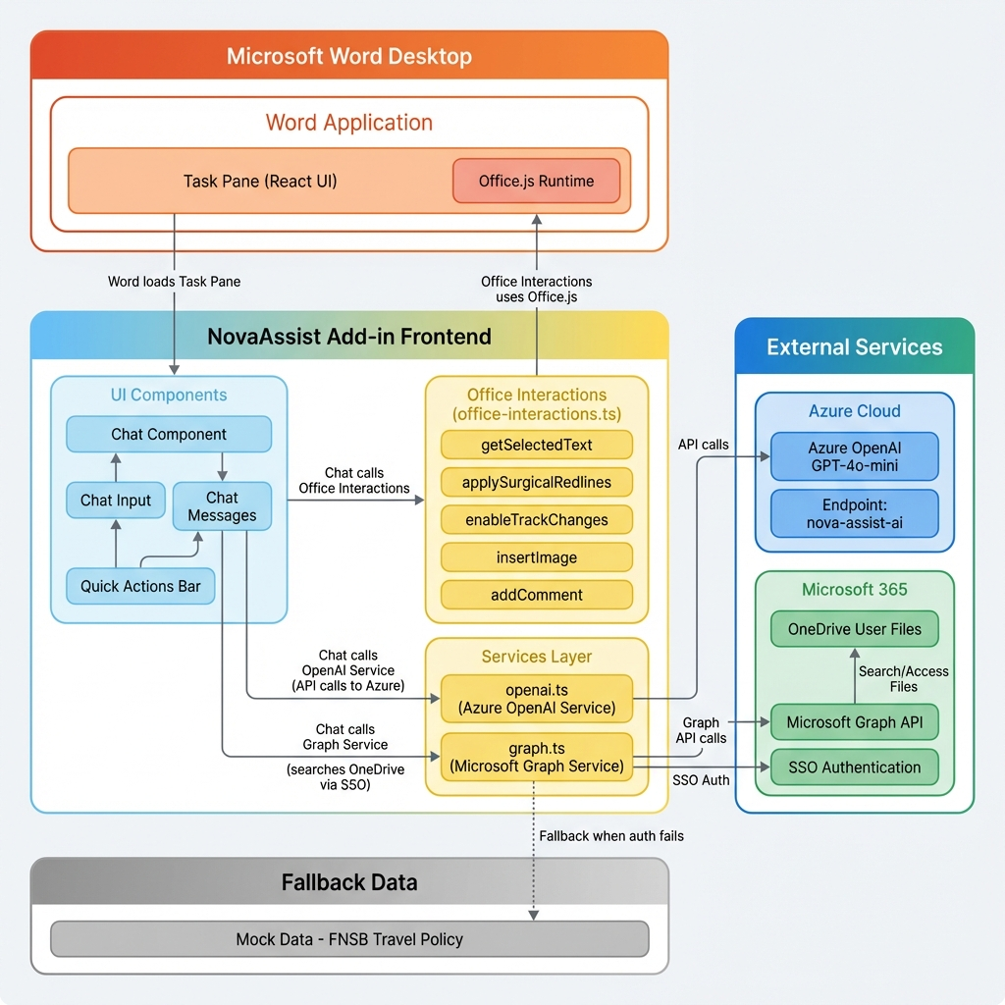
NovaAssist Architecture - Main System Components and Data Flow
Figure 1: NovaAssist System Architecture
This diagram shows the complete architecture of the NovaAssist Word Add-in, including: - Microsoft Word Desktop (top) - The host application with Office.js runtime - NovaAssist Frontend (center) - React-based UI components, office interactions, and services - External Services (right) - Azure OpenAI and Microsoft 365 integrations - Fallback Data (bottom) - Mock policy data for offline/demo scenarios

Component Details

Frontend (React + Fluent UI)
UI Components: - Chat.tsx - Main chat interface with message history - ChatInput.tsx - User input field with send button - ChatMessage.tsx - Individual message bubbles (user/bot) - App.tsx - Root component with quick action buttons
Office Interactions (office-interactions.ts): - enableTrackChanges() - Auto-enables Track Changes - getSelectedText() - Retrieves user selection - applySurgicalRedlines() - Diff-based precise edits using fast-diff - insertImage() - Inserts LivaNova logo - addComment() - Adds justification comments

Services Layer
Azure OpenAI Service (openai.ts): - generateRedlines() - Sends text + instructions to GPT-4o-mini - Returns: { rewritten_text, justification } - Endpoint: https://nova-assist-ai.openai.azure.com/
Microsoft Graph Service (graph.ts): - searchSharePoint() - Searches OneDrive for documents - getFileContent() - Retrieves file content - Uses SSO via Office.auth.getAccessToken() - Fallback: Mock FNSB Travel Policy data

External Integrations
Azure OpenAI: - Model: gpt-4o-mini - API Version: 2024-02-15-preview - Authentication: API Key (from .env)
Microsoft Graph API: - Endpoint: /me/drive/root/search(q='{query}') - Authentication: SSO Token (Office.js) - Permissions: Files.Read.All, User.Read

Data Flow Examples

Redline Flow
- User selects text in Word
- User types: “redline this to use British spelling”
- Chat.tsx detects “redline” keyword
- Auto-enables Track Changes via enableTrackChanges()
- Gets selected text via getSelectedText()
- Calls openaiService.generateRedlines()
- Azure OpenAI returns rewritten text + justification
- applySurgicalRedlines() computes diff using fast-diff
- Applies precise insertions/deletions with Track Changes
- addComment() adds justification to selection

Find Source Flow
- User clicks “Find Source” button
- User searches: “FNSB Travel Policy”
- graphService.searchSharePoint() attempts OneDrive search
- If SSO succeeds: Returns real OneDrive files
- If SSO fails: Returns mock FNSB policy
- User selects document from results
- graphService.getFileContent() retrieves content
- Content stored for context in redline requests

Logo Insertion Flow
- User clicks “Add Logo” or types “logo”
- insertImage() called with LIVANOVA_LOGO_BASE64
- Office.js inserts image at cursor position
- LivaNova logo appears in document

Authentication & Security
SSO (Single Sign-On): - Uses Office.auth.getAccessToken() - Leverages user’s existing Microsoft 365 login - No separate login required - Manifest declares required scopes
API Keys: - Azure OpenAI key stored in .env (gitignored) - Never committed to GitHub - Required for AI redlining features
Manifest Permissions:
<Permissions>ReadWriteDocument</Permissions>
<WebApplicationInfo>
<Scopes>
<Scope>Files.Read.All</Scope>
<Scope>User.Read</Scope>
</Scopes>
</WebApplicationInfo>

Technology Stack
Layer | Technology
Frontend | React 18, TypeScript
UI Framework | Fluent UI React v9
Office Integration | Office.js
Diff Engine | fast-diff
AI Service | Azure OpenAI (GPT-4o-mini)
Graph Client | @microsoft/microsoft-graph-client
Build Tool | Webpack 5
Dev Server | webpack-dev-server (localhost:3000)

Deployment Architecture
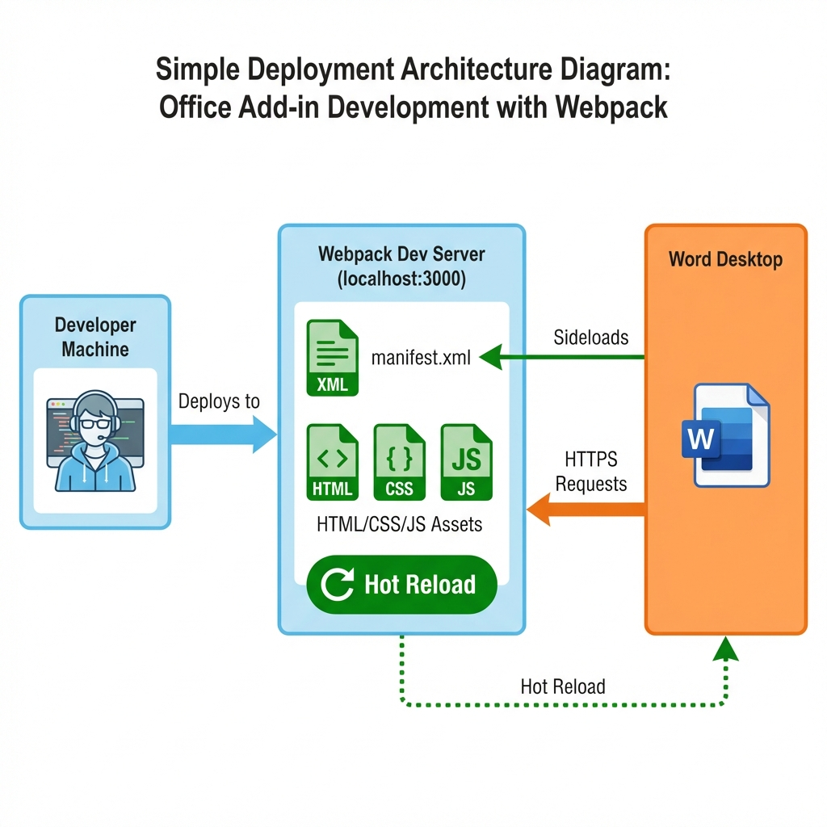
NovaAssist Deployment - Development Environment
Figure 2: Development Deployment Architecture
This diagram shows how the NovaAssist add-in is deployed during development: - Developer Machine runs npm start to launch Webpack Dev Server - Webpack Dev Server (localhost:3000) serves the manifest.xml and all assets (HTML/CSS/JS) - Word Desktop sideloads the manifest and makes HTTPS requests to the dev server - Hot Reload enables live updates during development

Key Features
✅ Surgical Redlining - Precise diff-based edits (not full replacement)
✅ Auto Track Changes - Automatically enables when “redline” is typed
✅ Policy Compliance - Redline based on FNSB Travel Policy
✅ OneDrive Search - Find reference documents (with mock fallback)
✅ Logo Insertion - One-click LivaNova branding
✅ AI Justifications - Explains why changes were made
✅ Offline Ready - Mock data ensures demo always works

Future Enhancements
- ☐ Real Azure AD app registration for production OneDrive
- ☐ Support for multiple policy documents
- ☐ Citation tracking and footnote generation
- ☐ Export redline summary reports
- ☐ Multi-language support

