**Table of contents**

1. Time-series plots – PM 2

2. Time-series plots – outcomes 3

3. Time-series plots – environmental factors (to rerun) 5

4. Time-series plots – PM & environmental factors (to rerun) 6

5. Distributed lag models (DLM) – PM2.5 (to rerun) 14

6. Distributed lag models (DLM) – PM10 (to rerun) 21

# Time-series plots – PM









# Time-series plots – outcomes

















# Time-series plots – environmental factors (to rerun)









# Time-series plots – PM & environmental factors (to rerun)





**Spearman’s correlation coefficients: (to rerun)**

| pm10 pm25 temp rh

-------------+------------------------------------

pm10 | 1.0000

pm25 | 0.8626* 1.0000

temp | 0.3263* 0.3569* 1.0000

rh | 0.1584* 0.2062* 0.3132* 1.0000

| pm10 pm25 temp rh cva ihd resp

-------------+---------------------------------------------------------------

pm10 | 1.0000

pm25 | 0.8626* 1.0000

temp | 0.3263* 0.3569* 1.0000

rh | 0.1584* 0.2062* 0.3132* 1.0000

cva | 0.1275* 0.1790* 0.3231* 0.1300* 1.0000

ihd | 0.0899 0.0655 -0.0148 -0.0021 0.0178 1.0000

resp | -0.0206 -0.1332* -0.5256* -0.2765* -0.1565* 0.1929* 1.0000

hives | 0.1326* 0.1480* 0.4498* 0.0219 0.1501* 0.0200 -0.1844*

ear | 0.0624 0.0295 -0.1608* -0.0803 -0.0695 0.0166 0.1472*

| hives ear

-------------+------------------

hives | 1.0000

ear | -0.0495 1.0000



**PM, temperature & relative humidity daily measurements statistics, by season: (to rerun)**

season variable | N mean sd

--------------------+------------------------------

Winter pm10 | 91.0 49.2 37.4

pm25 | 91.0 26.9 15.9

temp | 91.0 12.7 2.2

rh | 91.0 48.0 7.0

--------------------+------------------------------

Spring pm10 | 92.0 52.6 31.4

pm25 | 92.0 33.9 21.2

temp | 92.0 19.6 3.1

rh | 92.0 57.4 9.4

--------------------+------------------------------

Summer pm10 | 92.0 57.4 36.3

pm25 | 92.0 35.3 21.6

temp | 92.0 26.6 0.9

rh | 92.0 52.7 7.1

--------------------+------------------------------

Autumn pm10 | 91.0 42.8 18.4

pm25 | 91.0 23.8 12.7

temp | 91.0 19.8 3.9

rh | 91.0 50.1 7.4

--------------------+------------------------------

Total pm10 | 366.0 50.5 32.1

pm25 | 366.0 30.0 18.8

temp | 366.0 19.7 5.6

rh | 366.0 52.1 8.5

---------------------------------------------------

**CVA, IHD, respiratory diseases, hives, ear diseases daily admission statistics, by season:**

season variable | N mean sd

--------------------+------------------------------

Winter cva | 91.0 0.3 0.5

ihd | 91.0 11.5 3.9

resp | 91.0 23.7 6.5

hives | 91.0 0.5 0.9

ear | 91.0 0.2 0.5

--------------------+------------------------------

Spring cva | 92.0 0.4 0.7

ihd | 92.0 10.1 3.6

resp | 92.0 16.0 5.7

hives | 92.0 0.7 0.9

ear | 92.0 0.2 0.4

--------------------+------------------------------

Summer cva | 92.0 1.1 1.3

ihd | 92.0 11.7 5.2

resp | 92.0 15.1 5.0

hives | 92.0 1.9 1.4

ear | 92.0 0.1 0.3

--------------------+------------------------------

Autumn cva | 91.0 0.3 0.5

ihd | 91.0 10.9 3.7

resp | 91.0 20.1 6.1

hives | 91.0 1.3 1.2

ear | 91.0 0.1 0.3

--------------------+------------------------------

Total cva | 366.0 0.5 0.9

ihd | 366.0 11.0 4.2

resp | 366.0 18.7 6.8

hives | 366.0 1.1 1.2

ear | 366.0 0.1 0.4

---------------------------------------------------

**Relationship between lag0 temperature and outcomes: (to rerun)**



**Relationship between lag0 relative humidity and outcomes: (to rerun)**



**Relationship between lag0 PM2.5 and outcomes:**



**Relationship between lag0 PM10 and outcomes:**



**Relationship between time and outcomes:**



# Distributed lag models (DLM) – PM2.5 (to rerun)

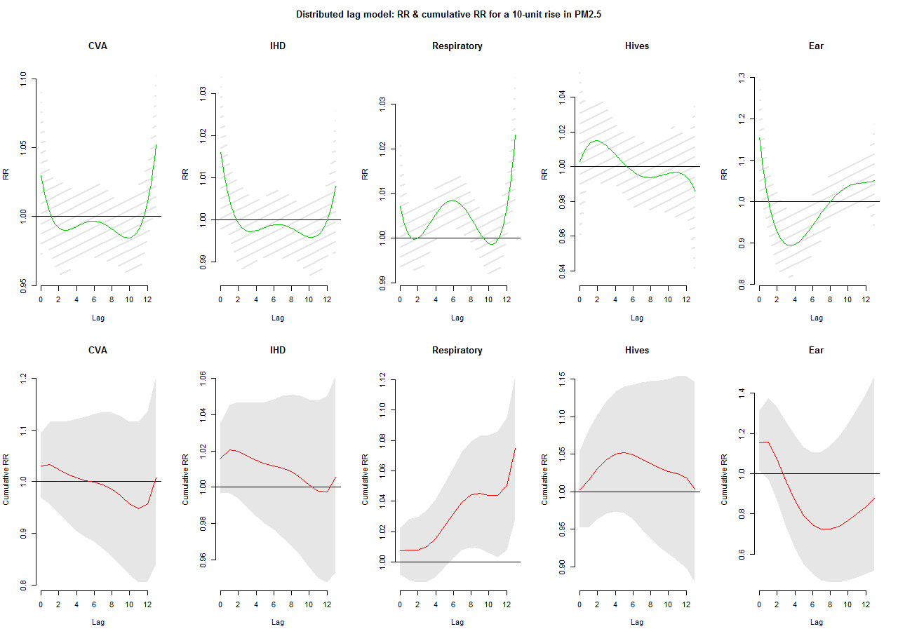

**RR (95% CI for the lags) between respiratory admissions and PM2.5: (to rerun)**

RR 95LL 95UL

lag0 1.0070786 0.9918046 1.022588

lag1 1.0006928 0.9936722 1.007763

lag2 1.0000203 0.9924840 1.007614

lag3 1.0022828 0.9952324 1.009383

lag4 1.0053498 0.9995692 1.011164

lag5 **1.0076985 1.0021310 1.013297**

lag6 **1.0084188 1.0022910 1.014584**

lag7 **1.0072274 1.0010711 1.013421**

lag8 1.0044747 0.9988709 1.010110

lag9 1.0011362 0.9954007 1.006905

lag10 0.9987962 0.9917905 1.005851

lag11 0.9996460 0.9919905 1.007361

lag12 1.0065295 0.9995510 1.013557

lag13 **1.0230857 1.0090347 1.037332**

So, % increase in respiratory admissions at lag6 is given by 0.84% for every 10-unit rise of PM2.5. The % increase in respiratory admissions for all phases is given by 0.72% for every 10-unit rise of PM2.5.

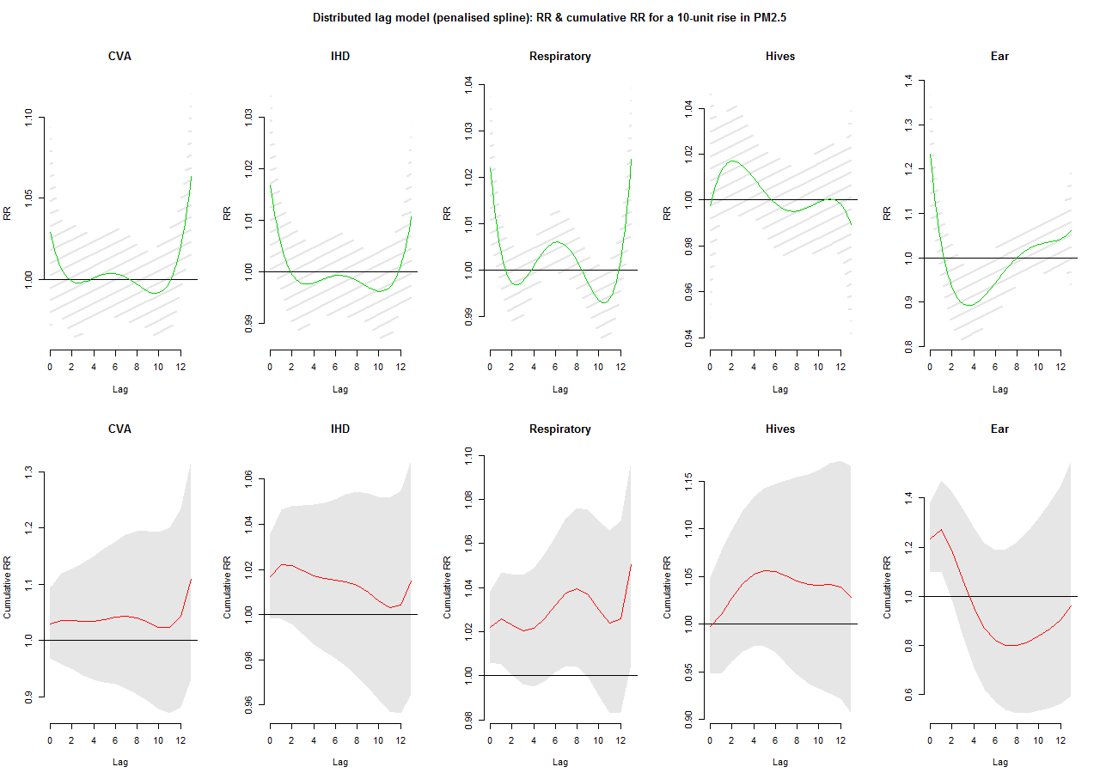

(Sensitivity analysis using **penalised spline**).

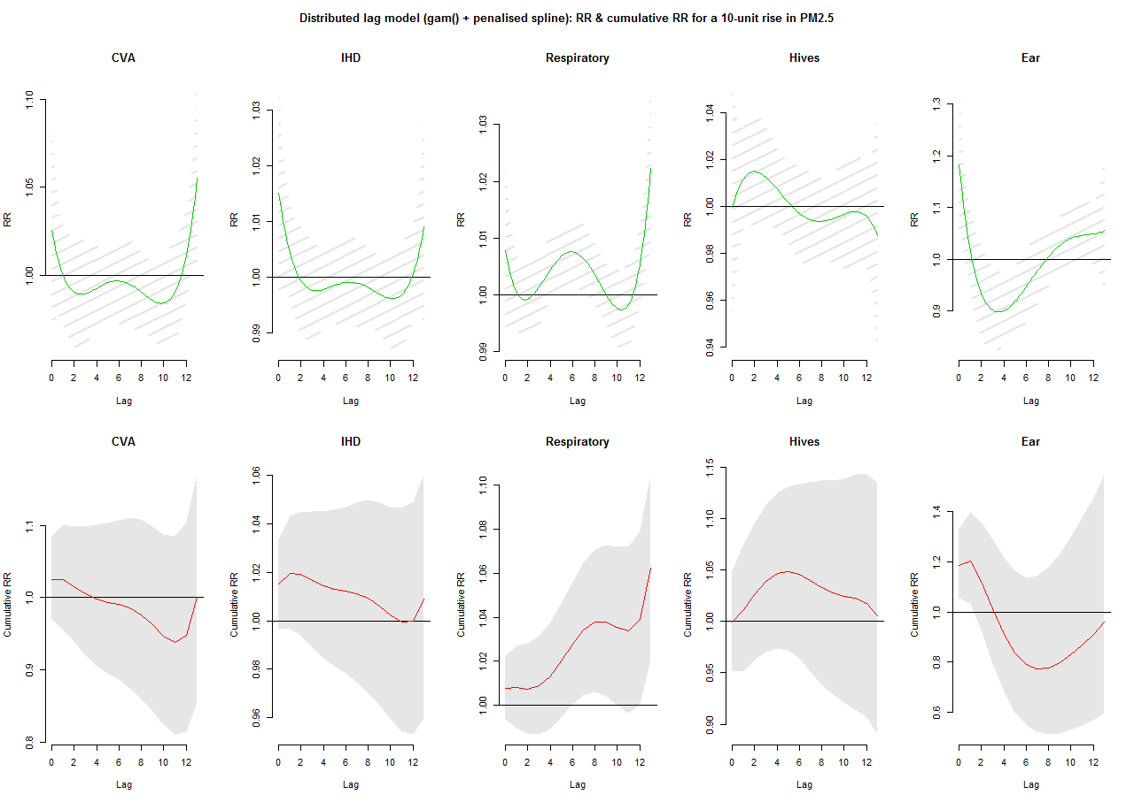

(Sensitivity analysis using **GAM() + penalised spline**).

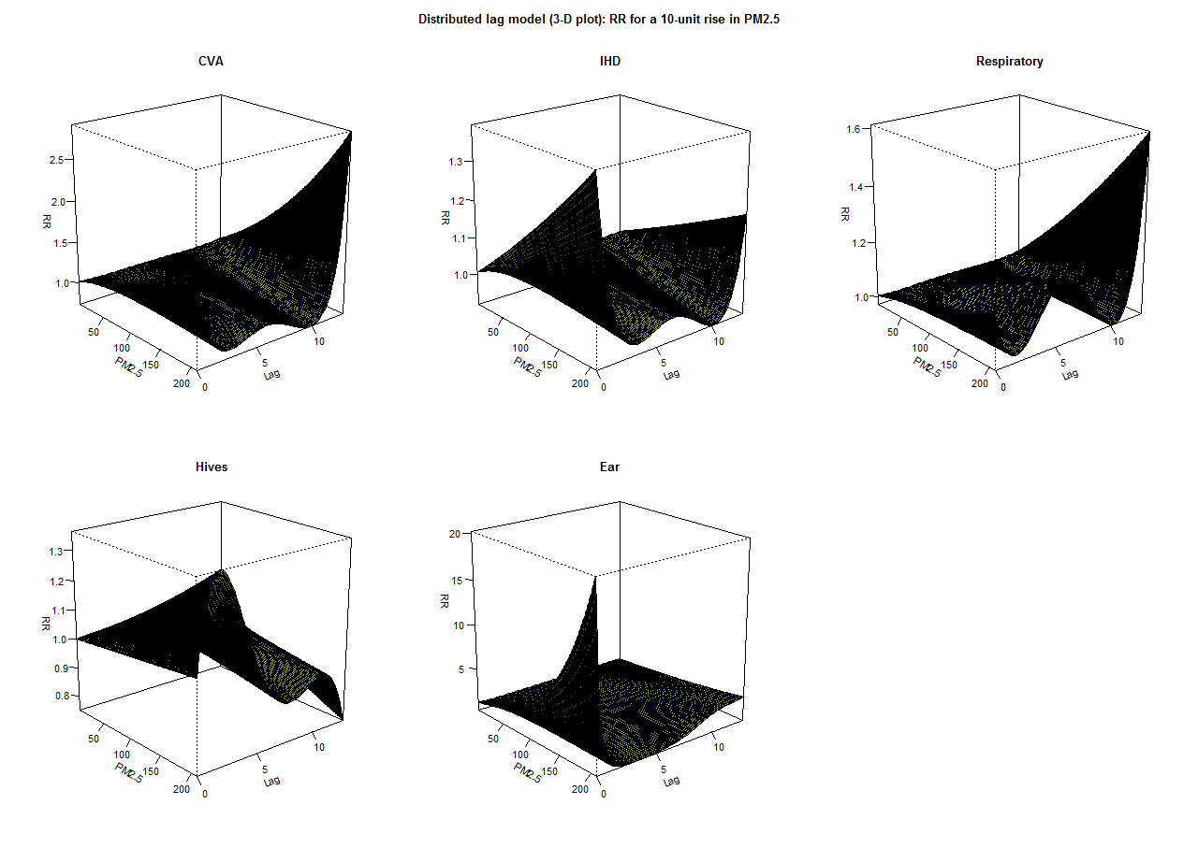

|  |  |  |
| --- | --- | --- |
| Distributed lag model (contour plot): RR for a 10-unit rise in PM2.5 | | |
|  |  |  |
|  |  |  |

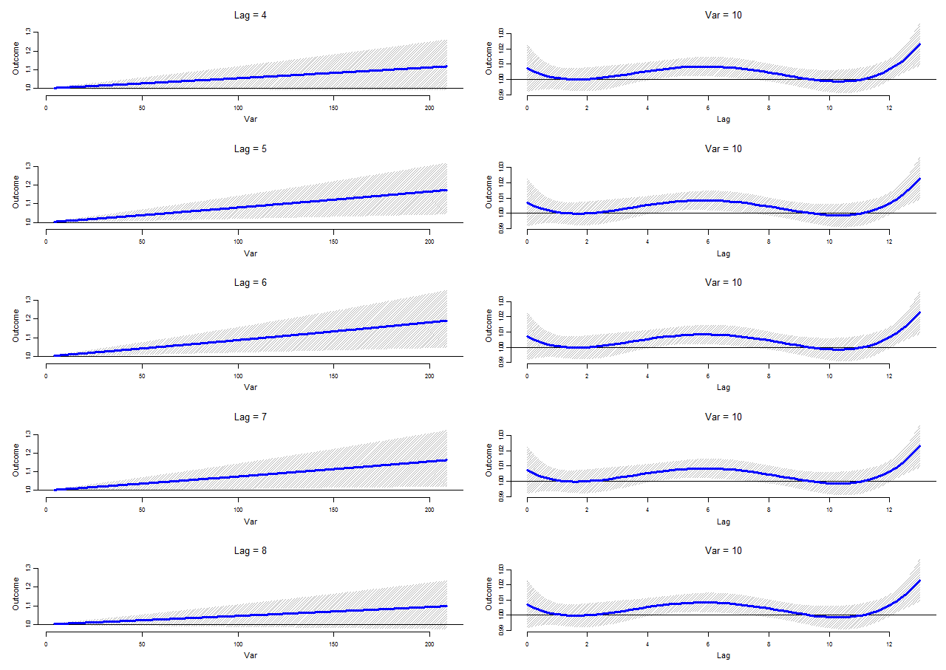

Slicing by different lags by fixing the value of PM2.5 at 10 µg/m3.

# Distributed lag models (DLM) – PM10 (to rerun)

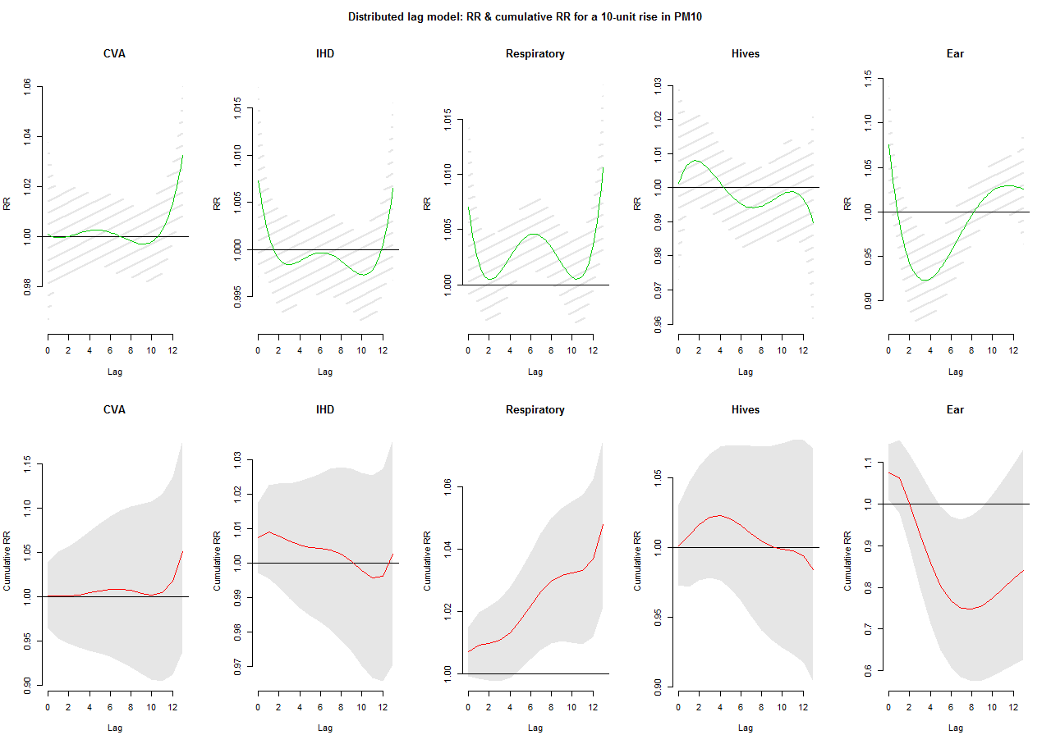

**RR (95% CI for the lags) between respiratory admissions and PM10: (to rerun)**

RR 95LL 95UL

lag0 1.007045 0.9990925 1.015061

lag1 1.001969 0.9980980 1.005855

lag2 1.000497 0.9964691 1.004541

lag3 1.001076 0.9972698 1.004896

lag4 1.002491 0.9992456 1.005747

lag5 **1.003847 1.0007064 1.006997**

lag6 **1.004565 1.0011973 1.007944**

lag7 **1.004387 1.0010041 1.007782**

lag8 **1.003377 1.0001966 1.006568**

lag9 1.001922 0.9986203 1.005234

lag10 1.000726 0.9968304 1.004637

lag11 1.000811 0.9966252 1.005014

lag12 1.003523 0.9995442 1.007518

lag13 **1.010562 1.0029672 1.018214**

So, % increase in respiratory admissions at lag6 is given by 0.46% for every 10-unit rise of PM10. The % increase in respiratory admissions for all phases is given by 0.47% for every 10-unit rise of PM10.

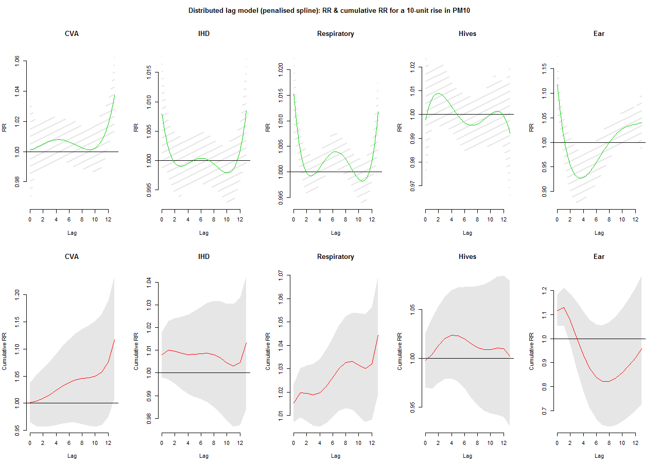

(Sensitivity analysis using **penalised spline**).

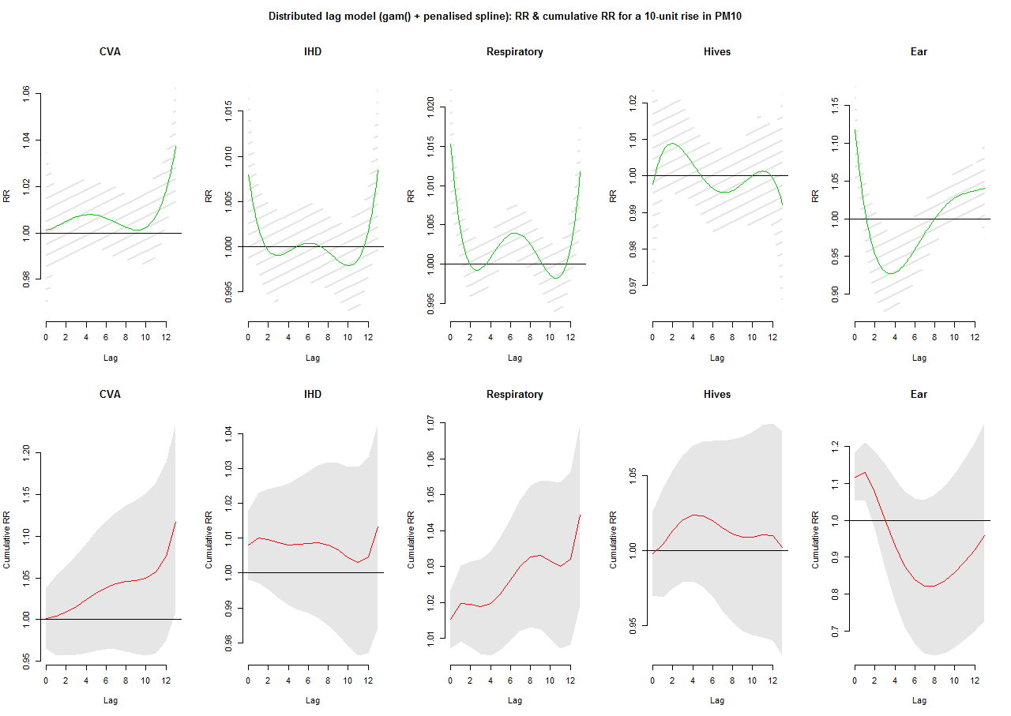

(Sensitivity analysis using **GAM() + penalised spline**).

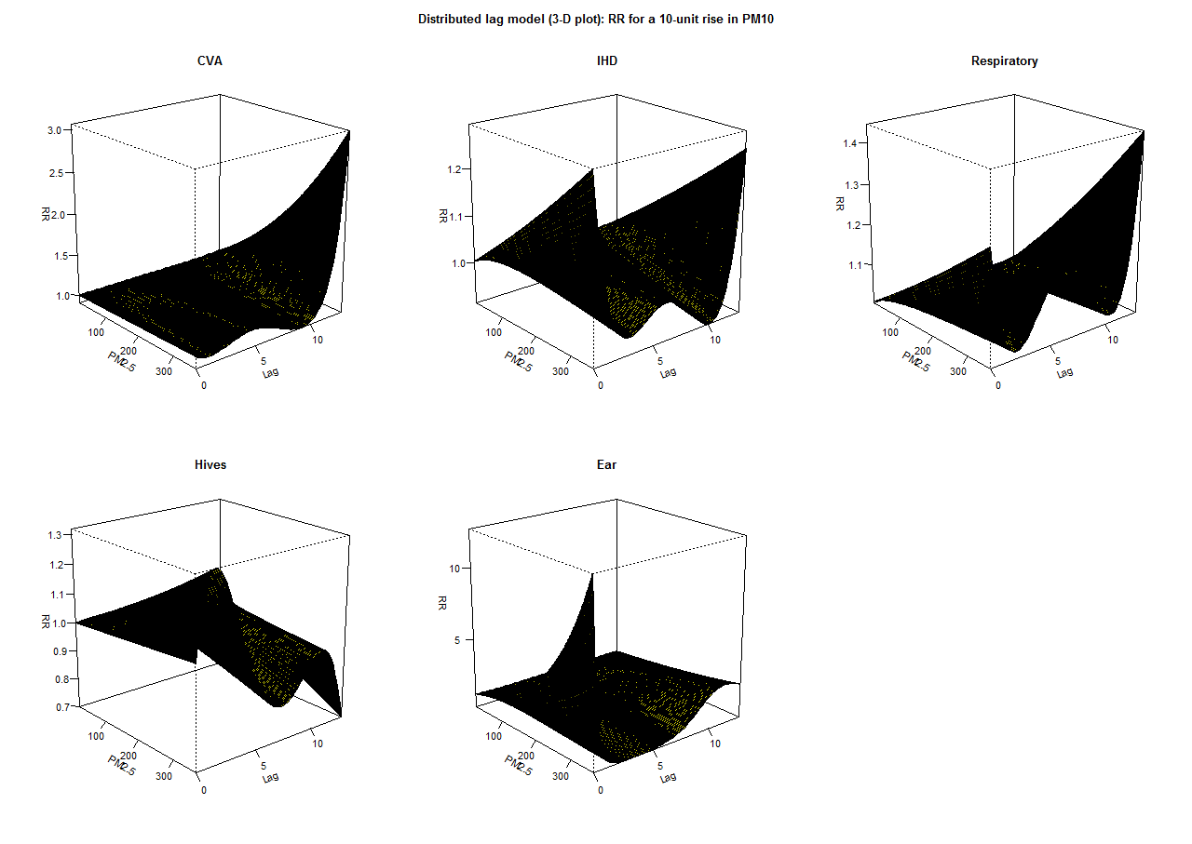

|  |  |  |
| --- | --- | --- |
| Distributed lag model (contour plot): RR for a 10-unit rise in PM10 | | |
|  |  |  |
|  |  |  |

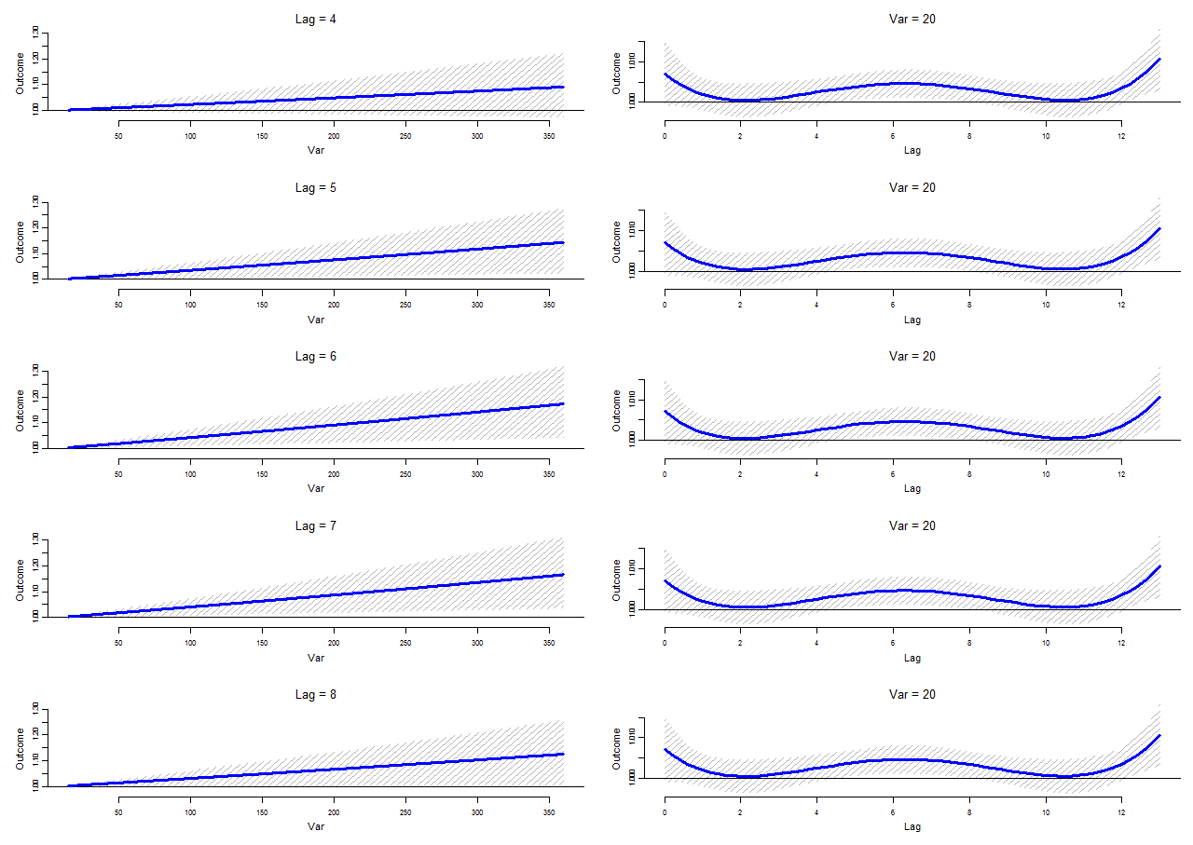

Slicing by different lags by fixing the value of PM10 at 20 µg/m3.

**Important remarks:**

1. All analyses where temperature and relative humidity were involved need to be rerun.
2. What % of data points were missing for PM2.5 & PM10, which were imputed by the respective monthly means ?
3. The delayed lag effect obtained in this study compared to that in the available literature could possibly be due to the fact that people in Beirut might wait for a longer period to report to the hospitalisation than people in the western countries.
4. Cumulative RR interpretation: summing all the contributions (RR) up to the maximum lag (*cf.* Gasparrini, Armstrong & Kenward)).
5. The GAM was used to fit the models under the DLM framework; a natural (cubic) spline with 5 d.f. for the time variable was used to take care of (= smooth) the seasonal variability. The # of d.f. for the time variable chosen empirically by a thumb rule, *i.e.* equal to # of seasons + 1 = 4 + 1 = 5. There was lack of strong apparent seasonality visually in the time-series plots (for more references on d.f., *cf.* Braga *et al.*, Guo *et al.*, Peng *et al.*, Zanobetti *et al.*, Dominici *et al.*, Hajat *et al.*, Tadano *et al.*, Ren & Tong).
   1. A sensitivity analysis was performed for the significant association by varying the d.f. to 2 and 6. Using d.f. ≥ 7 rendered the association non-significant.
   2. Temperature (range, 7 °C to 28 °C) and relative humidity (range, 25% to 75%) however was not transformed using splines, but used as covariates along with ‘dow’ (day of the week, a binary variable, for weekday / weekend).
   3. Also to keep in mind that in our study, we used robust quasi-Poisson distribution to estimate the 95% CI for PM, whereas in other studies, they used Poisson distribution.
      1. The variance >> mean for CVA, IHD, respiratory and hives admissions; only for ear admissions the variance ≈ mean.
      2. In this regard, our approach was conservative (i.e., using both “GLM + natural (cubic) spline” smoothing for the time variable + “quasi-Poisson distribution” for the outcomes). This was THE main approach of the study.
   4. A sensitivity analysis was performed using “penalised splines + glm() function”, and also using “penalised splines + gam() function”. The penalised splines approach gave similar results irrespective of glm() or gam() functions (*cf.* Peng et al.); however, there were some differences between the results obtained by using natural (cubic) splines with those obtained by using penalised splines; but, both showed similar trends.
   5. Again, residual PACF minimisation criteria showed that using splines (both natural (cubic) and penalised) with d.f. = 4 through 6 for the time variable minimised the AIC to a stable range, and in the residual PACF plot, only the first lag was low (close to 0.20) and the rest were all very small for respiratory outcome, whereas for the other outcomes, all lags in the residual PACF plots were very small throughout.
   6. A final point on d.f.: bruto() function {*mda* R-package} showed that 9 d.f. was optimal for CVA and 10 d.f. for respiratory admissions.
6. The basis function for lag (PM) was modelled using a polynomial of 4th degree (*i.e.*, d.f. = 5). The basis function for predictor (PM) was chosen to be linear assuming a linear relation between PM and outcomes.
7. The baseline reference values chosen to fit the models were = 0 µg/m3 for PM2.5, and = 10 µg/m3 for PM10. The predictions were done in the *range* of the data for PM2.5 (4-209 µg/m3) and PM10 (15-360 µg/m3). The response function was expressed in RR-scale for every 10-unit rise in PM (*cf.* Gasparrini & Armstrong). The % increase in outcome was calculated by the formula: (RR – 1) x 100%.
8. The R-packages used were *dlnm*, *mgcv* / *gam* and *splines*.
9. For PM2.5, the association was significant for lag5-lag7 days, with peak at lag6. For PM10, the association was significant for lag5-lag8 days, with peak also at lag6 (with natural (cubic) splines).

**Further analyses from here:**

1. 5 outcomes x 2 exposures (you may try other exposures and all admissions in the same manner).
2. Update temperature & relative humidity information – rerun DLM (me).
3. You can try (S)ARIMA / (G)ARCH models for all combinations or only for significant associations.
4. You can try different combinations:
   1. Splines – natural (cubic) splines, penalised splines (B-splines).
   2. Lags – lag0, lag1, lag2, lag3, lag4, lag5, lag6, lag7 upto lag8 and report the % increase in outcome (95% CI).
   3. D.F. – 2, 5, 6, 7+.
5. Use methodology from the literature.
6. You may also do a by age-group study.