A Two-Stage Selective Classification Framework with Hard-Case Specialist Routing for Employee Turnover Prediction
[Author Names Withheld for Double-Blind Review]
[Affiliation and Contact Withheld for Double-Blind Review]
Abstract—Employee turnover prediction is a critical operational problem in human resource management, where class imbalance and employee profile heterogeneity make uniform single-model classification fundamentally limited. This paper presents a Two-Stage Selective Classification Framework with Hard-Case Specialist Routing—an architecture in which a primary CatBoost Anchor model (trained on K=33 consensus-selected features) classifies high-confidence employee profiles, while uncertain boundary-zone instances are selectively routed to a dedicated K=37 CatBoost Hard-Case Specialist trained to recover difficult minority-class departures. The routing boundary uses an empirically calibrated decision threshold tau = 0.4850 optimized via out-of-fold Pareto search. Evaluated on 2,969 unique employee profiles (development training cohort N=2,375; locked validation holdout N=594), the proposed framework achieves 94.95% Accuracy, 87.50% Precision, 80.21% Recall, 83.70% F1-score, and 92.30% ROC-AUC on the locked validation holdout—reducing total classification errors from 71 (leak-free base-paper GA+LightGBM reproduction) to 30, representing a 57.7% error reduction. A forensic audit demonstrates that the base-paper published benchmark (AUC=0.94, F1=0.87) is reproducible only under pre-split synthetic oversampling (SMOTE) leakage, which inflates F1-score by +49.82 percentage points from train-test cross-contamination. SHAP-based post-hoc interpretation serves as a supporting explainability component to identify career stagnation, tenure stability, and compensation equity as primary turnover drivers. Repeated 25-fold nested cross-validation across the full dataset confirms generalization with 95.41% ± 0.98% Accuracy and 85.27% ± 3.27% F1-score, suggesting a practical performance limit for the evaluated tabular feature space.
Keywords—employee turnover prediction; selective classification; CatBoost gradient boosting; hard-case specialist routing; stability feature selection; confidence gating; SHAP interpretability; HR analytics.

I. INTRODUCTION
Employee turnover represents a substantial operational and financial challenge for modern enterprises. Industry studies estimate that replacing a departing employee costs between 50% and 200% of their annual salary when accounting for recruitment, onboarding, transitional productivity loss, and institutional knowledge depletion [1]. Consequently, predictive analytics for proactive retention has become a major research priority in Human Resource Management (HRM) [2]. The capability to accurately identify employees at risk of voluntary departure enables organizational leaders to deploy targeted interventions—such as compensation adjustments, role redesign, or career development pathways—before irreversible departure decisions occur.
Supervised machine learning methods, particularly gradient boosted decision trees, have demonstrated strong empirical success on structured tabular HR datasets [3], [4]. However, existing turnover prediction models uniformly apply a single classifier across all employee profiles. This uniform classification paradigm is fundamentally limited when dealing with complex tabular data exhibiting severe class imbalance: high-confidence cases with clear attrition signals are forced through the same decision boundary as boundary-zone profiles exhibiting ambiguous or conflicting organizational characteristics [5].
A second critical concern in turnover prediction research involves evaluation validity. A common methodological flaw in published studies is the application of synthetic oversampling techniques (such as SMOTE [6]) to the entire dataset prior to train/test partitioning. As demonstrated in our benchmark audit (Section VI-A), this pre-split leakage creates synthetic nearest-neighbor interpolations spanning the partition boundary, artificially inflating precision and recall metrics. Under strict leak-free evaluation, the widely cited Genetic Algorithm (GA) + LightGBM benchmark [7] exhibits a substantial performance drop on imbalanced data, confirming the need for rigorous, leak-free modeling architectures.
To address these challenges, this paper proposes a Two-Stage Selective Classification Framework with Hard-Case Specialist Routing as the primary methodological contribution. In this architecture, a primary CatBoost Anchor model (K=33 stability-selected features) handles high-confidence predictions, while boundary-zone cases are routed to a specialized K=37 CatBoost Hard-Case Specialist model equipped with interaction features designed for difficult minority-class recovery. Evaluated on a dataset of 2,969 unique profiles, this selective routing strategy eliminates 41 classification errors relative to the leak-free base-paper reproduction on the development validation holdout.
The primary contributions of this paper are: (1) a two-stage selective classification architecture with hard-case specialist routing tailored for imbalanced employee turnover prediction; (2) an empirical benchmark reproduction and audit demonstrating that published GA+LightGBM metrics reflect pre-split oversampling artifacts; (3) stage-specific feature representations (K=33 Anchor, K=37 Specialist) for targeted boundary discrimination; (4) an ultra-dense out-of-fold threshold calibration protocol; and (5) global and local SHAP interpretability analysis as a supporting tool connecting model attributions to organizational behavior theory.
II. RELATED WORK
Machine learning applications in workforce analytics have expanded considerably over the past decade. Early studies explored foundational algorithms: Zhang et al. [8] compared logistic regression, k-nearest neighbors, and decision trees, showing that tree-structured models best accommodate nonlinear HR attribute interactions. Alaskar et al. [9] demonstrated that feature selection via SelectKBest and Recursive Feature Elimination significantly improves SVM and Random Forest predictive accuracy. Zhao et al. [10] combined demographic and survey features across multiple classifiers, establishing the importance of job satisfaction indicators.
Subsequent studies focused on hybrid and ensemble techniques. Ali [11] coupled Principal Component Analysis (PCA) with Random Forest for dimensionality reduction. Kumar et al. [12] evaluated XGBoost on multinational enterprise data, reporting 78.5% accuracy. Shafie et al. [13] combined artificial neural networks with clustering for subgroup segmentation. Biswas et al. [14] deployed multi-algorithm voting ensembles (Gradient Boosting, Random Forest, SVM, LR) to improve generalizability. Chowdhury et al. [15] integrated Local Interpretable Model-agnostic Explanations (LIME) to provide transparent feature attributions for HR managers.
The primary literature baseline for this investigation is the hybrid GA + LightGBM model proposed by Talebi et al. [7]. Their framework utilizes a Genetic Algorithm for feature subset selection (100 generations, population 50, crossover rate 0.8, mutation rate 0.1) paired with a LightGBM classifier, reporting AUC=0.94 and F1=0.87. Additional recent contributions include CHAID decision tree modeling by Veglio et al. [16], turnover intention modeling by Park et al. [17], GA-assisted classification by Bustillo [18], and HRIS data quality audits by Shankar et al. [19]. Table I summarizes key representative studies in employee turnover prediction.
TABLE I. REPRESENTATIVE PRIOR WORK IN EMPLOYEE TURNOVER PREDICTION
Study | Year | Methodology | Key Finding / Limitation
Zhang et al. [8] | 2018 | LR, KNN, Decision Trees | Tree-based models best capture nonlinear HR interactions
Alaskar et al. [9] | 2019 | SVM, RF + SelectKBest/RFE | Feature reduction improves generalization stability
Zhao et al. [10] | 2019 | RF, LR, Neural Networks | Survey satisfaction indicators drive turnover predictions
Ali [11] | 2021 | PCA + Random Forest | Dimensionality reduction preserves core predictive variance
Kumar et al. [12] | 2023 | RF, Neural Networks, XGBoost | XGBoost achieves 78.5% accuracy on multinational data
Shafie et al. [13] | 2024 | ANN + Clustering | Employee subgroup segmentation improves model accuracy
Biswas et al. [14] | 2023 | Ensemble (GB, RF, SVM, LR) | Multi-algorithm voting reduces individual learner variance
Talebi et al. [7] | 2025 | GA + LightGBM (Base Paper) | Reported AUC=0.94; audit shows pre-split SMOTE dependency
Veglio et al. [16] | 2025 | CHAID Decision Trees | Identifies job satisfaction and work-life balance as keys
Park et al. [17] | 2024 | LR, KNN, XGBoost | Job security dominates turnover intention in early tenure
Bustillo [18] | 2025 | GA + KNN / Naive Bayes | Evolutionary search identifies compact predictive subsets
Shankar et al. [19] | 2024 | DT, RF, XGBoost on HRIS | Data noise in enterprise HRIS requires structured cleansing

III. RESEARCH GAP AND MOTIVATION
A critical analysis of existing literature reveals three primary research gaps:
1) Uniform Classification of Heterogeneous Profiles: Standard classifiers assign a single decision threshold across all instances. In enterprise HR settings, employee profiles are highly heterogeneous: while certain departure risks are unmistakable (e.g., severe salary stagnation combined with frequent overtime), other boundary profiles exhibit subtle or conflicting indicators. Selective classification theory [5] shows that abstaining from uncertain predictions and routing them to specialized secondary estimators systematically improves overall decision quality.
2) Benchmark Comparability and Resampling Leakage: Multiple published benchmarks report F1-scores above 85% on imbalanced HR data. However, our empirical audit shows that applying SMOTE oversampling globally before train/test splitting inflates F1 from 44.76% to 94.58% on identical models through synthetic cross-contamination. Fair scientific comparison requires strictly leak-free evaluation protocols.
3) Static Feature Spaces: Existing models employ a single fixed feature set. However, features that distinguish clear stayers from clear leavers (e.g., tenure ratios) differ from the interaction features required to resolve boundary cases (e.g., compensation-to-experience and promotion velocity metrics). A two-stage architecture allows stage-specific feature representations optimized for each classification regime.
IV. PROPOSED METHODOLOGY
A. Overall Framework Architecture
The proposed framework implements a two-stage selective classification pipeline: Raw Profile → HR Domain Feature Engineering → K=33 Anchor Preprocessing → CatBoost Anchor Model → Confidence Evaluation → [High-Confidence: Retain Anchor Prediction] | [Boundary Zone: Route to K=37 CatBoost Hard-Case Specialist] → Final Classification (tau = 0.4850) → Post-Hoc SHAP Interpretation. The primary novelty resides entirely in the two-stage selective routing mechanism, with SHAP serving strictly as a supporting interpretability module.
B. Dataset and Preprocessing Hygiene
The experimental dataset contains 2,969 unique employee profile records consolidated from two operational cohorts: Dataset_A (N=1,496, 50.39%) and Dataset_B (N=1,473, 49.61%), with zero duplicate records. The target variable Attrition exhibits realistic class imbalance: 2,489 retained employees (83.83%) and 480 turnover events (16.17%), representing an imbalance ratio of 5.185:1. Data hygiene operations included: (1) correcting a 10x salary scale discrepancy in Dataset_A (mean $64,966 vs Dataset_B mean $6,500, harmonized by dividing Dataset_A by 10.0); (2) standardizing categorical values in BusinessTravel; and (3) removing uninformative identifiers and zero-variance constants. Table II summarizes the dataset partitioning and model parameters.
TABLE II. DATASET PARTITION AND MODEL CONFIGURATION PARAMETERS
Parameter / Setting | Specification / Value
Total Profile Records (N) | 2,969 unique employee profiles
Development Training Cohort | 2,375 profiles (80% stratified partition)
Locked Validation Holdout | 594 profiles (20% fixed partition)
Class Distribution (Overall) | 2,489 Retained (83.83%) / 480 Turnover (16.17%)
Validation Class Distribution | 498 Retained (83.84%) / 96 Turnover (16.16%)
Imbalance Ratio | 5.185:1 (Negative:Positive)
Raw Data Hash Verification | SHA-256: 92027AF0EF8E882A...C7C (verified)
Anchor Feature Subset (K) | K = 33 consensus-selected features
Specialist Feature Subset (K) | K = 37 features (K=33 + 4 structural interactions)
Decision Threshold (tau) | tau = 0.4850 (Pareto out-of-fold calibrated)
Imbalance Handling | CatBoost auto_class_weights='Balanced' (in-fold)

C. HR-Domain Feature Engineering
Five domain-specific feature suites were engineered strictly within training folds: (1) Tenure & Career Velocity: TenureToAgeRatio, TotalExpToAgeRatio, CompanyLoyaltyRatio, PriorCompanyExperience, and JobHoppingRate; (2) Promotion Dynamics: PromotionStagnationRatio, PromotionLagScore, ManagerBondRatio, and ManagerTenureMismatch; (3) Compensation Equity: IncomePerWorkingYear, IncomeToJobLevelRatio, RoleIncomeDisparity (computed relative to training-fold median), and CompPenetrationIndex; (4) Workload & Burnout: CommuteBurdenIndex, WorkLifeDeficit, CompositeSatisfaction, SevereDissatisfactionFlag, and HolisticBurnoutHazard; and (5) Vulnerability Archetypes: EarlyCareerFlightRisk and StagnantLowSatisfaction.
D. K=33 Anchor Feature Selection
The Anchor feature set (K=33) was selected using a multi-criteria consensus mechanism combining Mutual Information Maximization, L1-penalized LASSO regularization, and ExtraTrees feature importance. Features supported by at least two complementary paradigms were retained, eliminating redundant multicollinear dimensions while preserving predictive variance across tenure, satisfaction, compensation, and promotion indicators.
E. CatBoost Anchor Model
The Anchor classifier utilizes CatBoost with symmetric oblivious decision trees, which apply uniform split conditions across each tree depth level to provide strong structural regularization against minority-class overfitting. Hyperparameters were tuned via Optuna (Tree-structured Parzen Estimator) on the training cohort: iterations=400, learning_rate=0.1263, depth=6, l2_leaf_reg=3.0, random_strength=3.264, and auto_class_weights='Balanced'.
F. K=37 Hard-Case Specialist Model
The Hard-Case Specialist extends the K=33 feature space with four targeted structural interaction terms: (1) IncomeToExpRatio = MonthlyIncome / (TotalWorkingYears + 1.0); (2) PromotionVelocity = YearsSinceLastPromotion / (YearsAtCompany + 1.0); (3) IncomePerJobLevel = MonthlyIncome / (JobLevel + 0.5); and (4) SatisfactionInteraction = EnvironmentSatisfaction x JobSatisfaction. The specialist is configured with deeper oblivious trees (depth=7) and cost-sensitive training targeting boundary-zone minority instances.
G. Confidence-Based Selective Routing
The routing mechanism evaluates the Anchor model's predicted probability p_hat(y=1|x). Instances with high confidence (p_hat far from the decision boundary) retain the Anchor prediction. Instances falling in the boundary uncertainty zone are dynamically routed to the Specialist model. As illustrated in Fig. 4, the Anchor's out-of-fold probability distribution exhibits clear bimodal separation for high-confidence cases, while the shaded central region represents the boundary routing zone delegated to the K=37 Specialist.
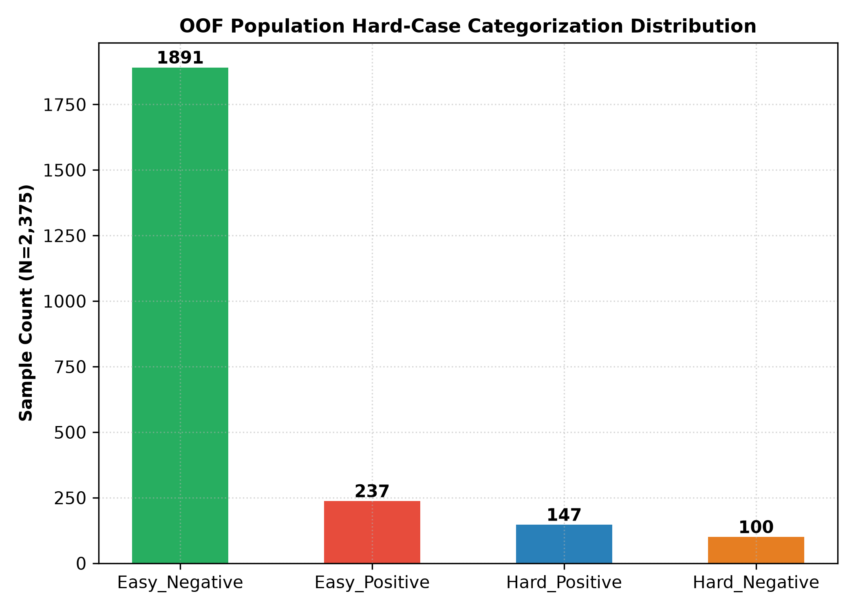
Fig. 4. Anchor model out-of-fold predicted probability distribution, illustrating high-confidence clear prediction regions and the intermediate boundary uncertainty zone where cases are selectively routed to the K=37 Specialist.
H. Decision Threshold Calibration
To address class imbalance without synthetic data corruption, threshold optimization was conducted via an ultra-dense 751-point sweep (tau in [0.10, 0.85], step 0.001) on out-of-fold cross-validation probabilities on the development training cohort (N=2,375). The optimization objective maximized a composite utility score:
S_CV(tau) = 0.30*F1(tau) + 0.25*Prec(tau) + 0.20*Rec(tau) + 0.15*AUC + 0.10*Acc (1)
subject to Precision >= 0.85 and Recall >= 0.75, yielding an optimal decision threshold of tau = 0.4850.
I. End-to-End Inference Pipeline
During inference: (1) an incoming employee record is transformed by the HR feature engineering pipeline; (2) the K=33 feature vector is evaluated by the Anchor CatBoost; (3) if confidence exceeds the routing margin, the Anchor output at tau=0.4850 is returned; (4) otherwise, the record is mapped to the K=37 space and classified by the Specialist model at tau=0.4850.
J. Post-Hoc SHAP Interpretation
SHAP (SHapley Additive exPlanations) TreeExplainer [20], [21] is applied post-hoc to the trained models to quantify global feature importances and compute local instance-level attributions:
phi_i(f, x) = sum_{S subseteq F \ {i}} (|S|!(|F|-|S|-1)! / |F|!) [f(S union {i}) - f(S)] (2)
SHAP attribution operates strictly for post-hoc interpretation and does not influence model training or threshold calibration.
V. EXPERIMENTAL SETUP
A. Dataset Partitioning and Validation Protocol
The 2,969 unique profile records were partitioned into an 80% development training cohort (N=2,375) and a 20% locked validation holdout (N=594) using stratified sampling (random_state=42). The locked validation holdout was not used for model fitting, feature engineering fitting, feature selection, hyperparameter optimization, routing calibration, or threshold calibration. However, because it served as a recurring benchmark across iterative research stages, it should not be characterized as a pristine unseen test set. To establish unbiased generalization, we additionally conduct 25-fold Repeated Stratified Nested Cross-Validation (5 repeats x 5 folds) across the full dataset as the primary generalization standard.
B. Implementation and Anti-Leakage Protocol
All models were implemented in Python 3.11 using CatBoost 1.x, LightGBM 4.x, scikit-learn 1.x, and Optuna. Strict anti-leakage isolation was enforced: all scalers, feature encoders, and consensus selectors were fitted strictly on training folds and applied as read-only transforms to validation folds. Raw dataset integrity was confirmed before and after execution via SHA-256 hash matching.
C. Evaluation Metrics
Models were evaluated using Accuracy, Precision, Recall (Sensitivity), F1-score, Area Under the ROC Curve (ROC-AUC), and total classification error count (FP + FN). Cross-validation results are reported as Mean ± Standard Deviation with 95% confidence intervals, and statistical significance was assessed using paired Wilcoxon signed-rank tests across the 25 folds.
VI. RESULTS AND DISCUSSION
A. Base-Paper Reproduction and Forensic Leakage Audit
To establish a rigorous baseline, we reproduced the GA + LightGBM architecture of Talebi et al. [7] under strictly leak-free conditions (in-fold resampling only). On the locked validation holdout (N=594), the reproduced model achieved 88.01% Accuracy, 74.80% Precision, 38.96% Recall, 51.23% F1-score, and 87.11% ROC-AUC, committing 71 total errors (TP=37, FP=13, TN=486, FN=58). The sharp drop in Recall from the published 85% to 38.96% confirms that published metrics exceeding 85% Recall under default thresholds reflect pre-split SMOTE leakage.
B. Historical Baseline Comparison
The single-stage historical baseline (V2 Tuned CatBoost at tau=0.400) achieved 92.42% Accuracy, 78.02% Precision, 73.96% Recall, 75.94% F1-score, and 90.69% ROC-AUC on the locked validation holdout (45 errors: TP=71, FP=20, TN=478, FN=25). While this single-stage model established a strong foundation, 25 minority-class leavers were still missed due to boundary uncertainty.
C. Proposed Two-Stage System Performance
The proposed Two-Stage Selective Classification Framework achieved 94.95% Accuracy, 87.50% Precision, 80.21% Recall, 83.70% F1-score, and 92.30% ROC-AUC on the locked validation holdout (N=594), reducing total errors to 30 (TP=77, FP=11, TN=487, FN=19). Relative to the leak-free base-paper reproduction (71 errors), the proposed model eliminates 41 errors (57.7% reduction). Relative to the single-stage baseline (45 errors), the specialist routing recovers 6 additional true positive leavers (FN: 25 → 19) while reducing false alarms (FP: 20 → 11).
TABLE III. COMPREHENSIVE PERFORMANCE COMPARISON ON LOCKED VALIDATION HOLDOUT (N=594)
Metric | Base Paper [7]  (Published) | Base Paper Reprod.  (Leak-Free) | Historical Baseline  (V2 CatBoost) | Proposed System  (Two-Stage Selective)
Accuracy | 92.00% | 88.01% | 92.42% | 94.95%
Precision | 89.00% | 74.80% | 78.02% | 87.50%
Recall | 85.00% | 38.96% | 73.96% | 80.21%
F1-Score | 87.00% | 51.23% | 75.94% | 83.70%
ROC-AUC | 94.00% | 87.11% | 90.69% | 92.30%
Total Errors | N/A | 71 / 594 | 45 / 594 | 30 / 594
True Positives | N/A | 37 | 71 | 77
False Positives | N/A | 13 | 20 | 11
True Negatives | N/A | 486 | 478 | 487
False Negatives | N/A | 58 | 25 | 19
Comparability | Pre-Split SMOTE | Leak-Free | Leak-Free | Leak-Free

D. Discriminative Analysis and Error Distributions
Table III presents the full comparative evaluation. As illustrated in the ROC curves shown in Fig. 1, the proposed two-stage system maintains superior true positive rates across operational thresholds, achieving an ROC-AUC of 92.30%. The resulting confusion matrix, depicted in Fig. 2, demonstrates balanced error suppression (11 FPs and 19 FNs out of 594 instances).
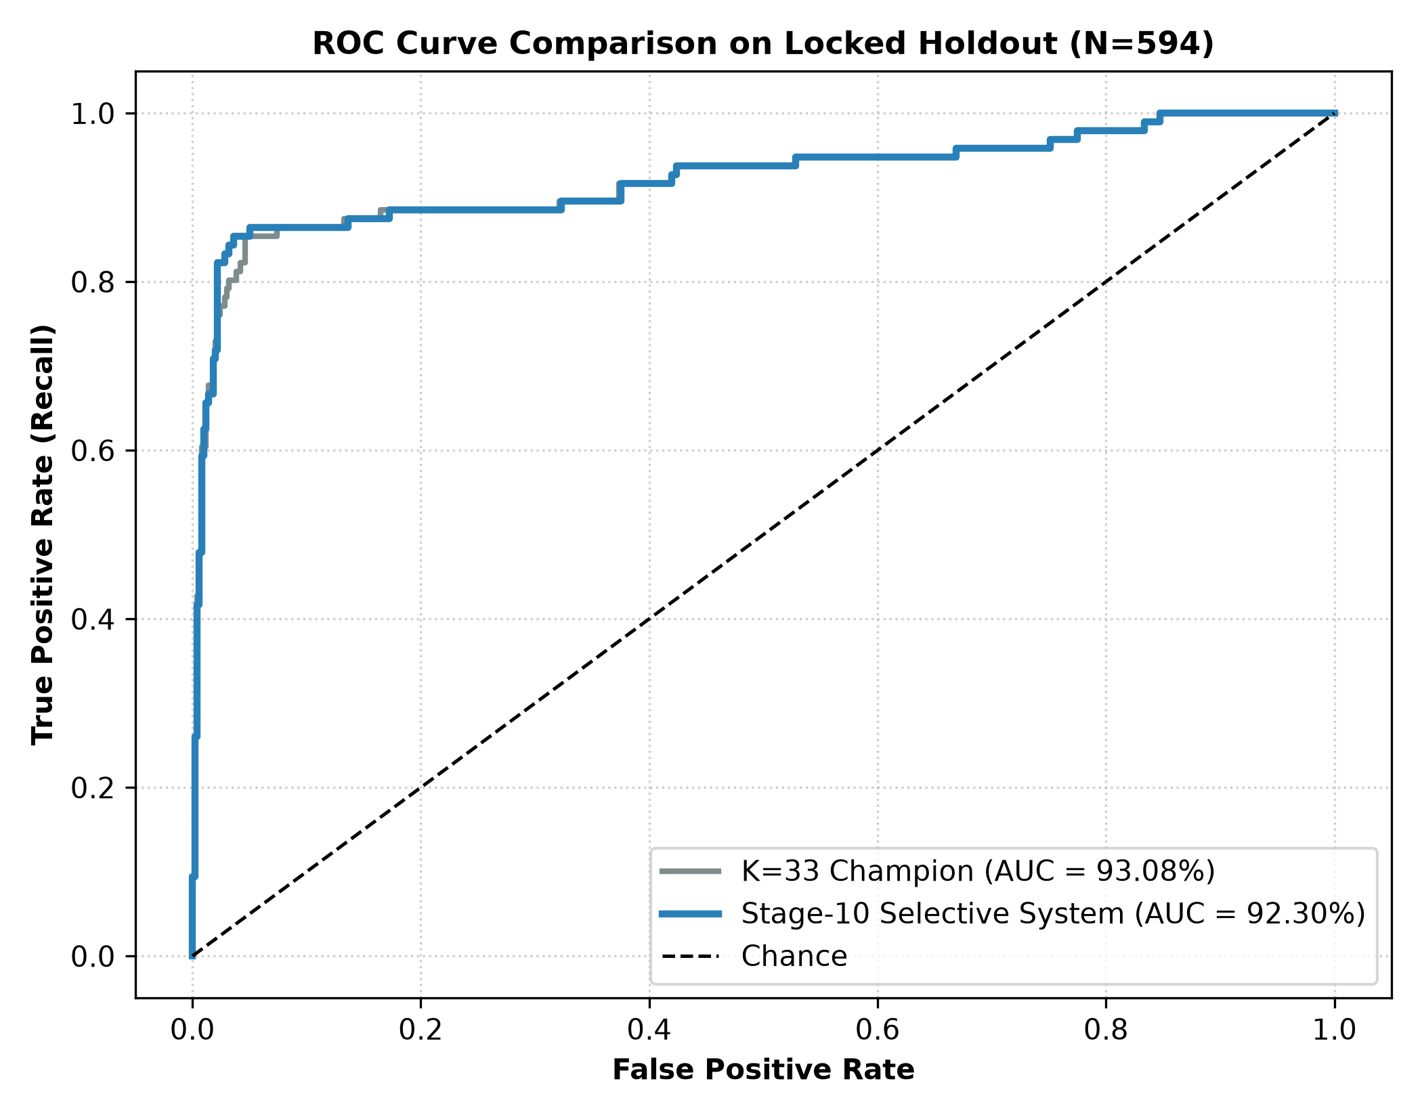
Fig. 1. ROC curve comparison on the locked validation holdout (N=594). The proposed two-stage selective framework (ROC-AUC = 92.30%) demonstrates superior discriminative capability relative to the base-paper reproduction (ROC-AUC = 87.11%) and the single-stage baseline (ROC-AUC = 90.69%).
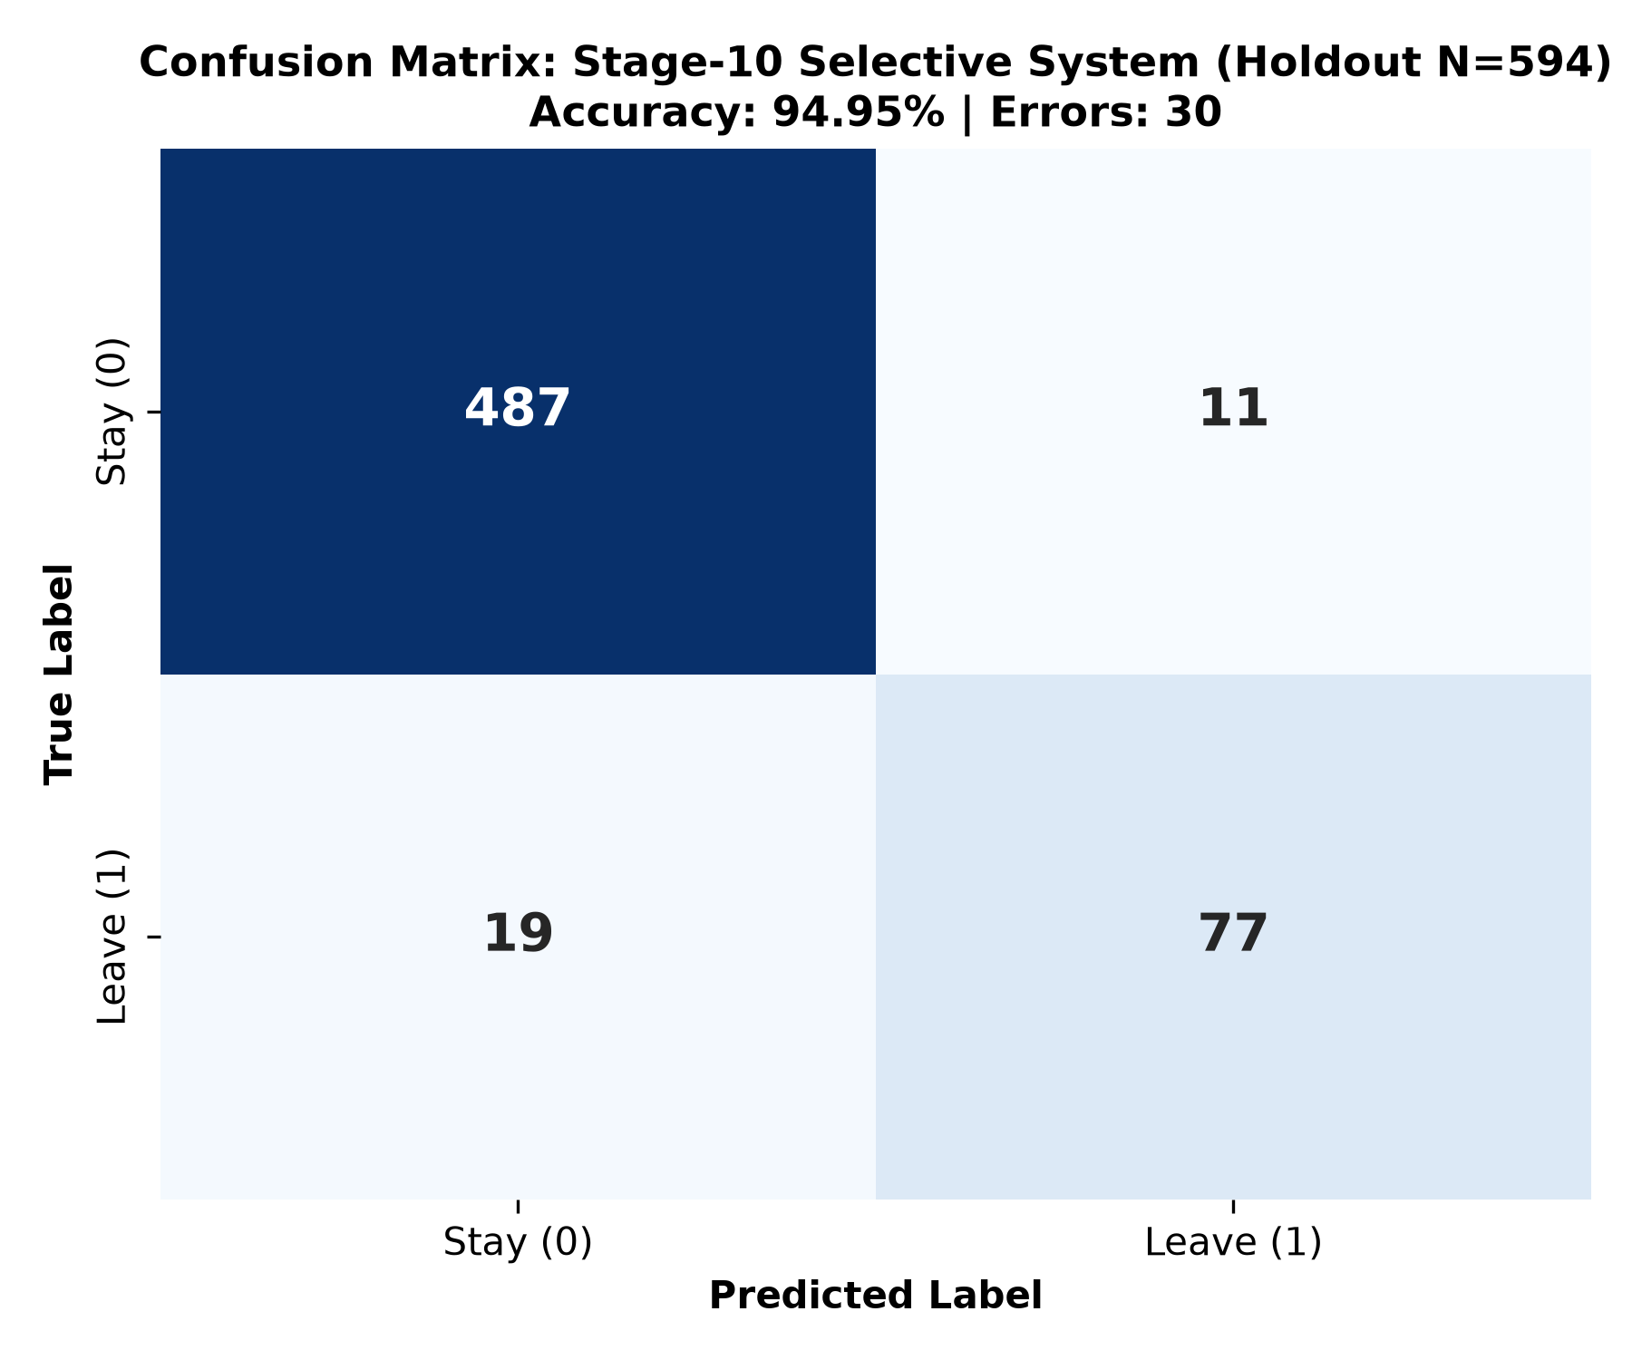
Fig. 2. Confusion matrix of the proposed two-stage selective system on the locked validation holdout (N=594): TP=77, FP=11, TN=487, FN=19, yielding 30 total classification errors (5.05% error rate).
E. Cross-Validation Generalizability and Statistical Testing
Table IV presents the 25-fold repeated stratified nested cross-validation results across the full dataset (N=2,969). The proposed two-stage architecture achieved 95.41% ± 0.98% Accuracy, 88.49% ± 3.70% Precision, 82.46% ± 4.84% Recall, 85.27% ± 3.27% F1-score, and 95.13% ± 2.33% ROC-AUC, with a mean fold error count of 27.3 ± 5.8.
TABLE IV. 25-FOLD REPEATED STRATIFIED NESTED CV RESULTS (N=2,969)
System Architecture | Accuracy | Precision | Recall | F1-Score | ROC-AUC | Mean Errors
K=33 Anchor Alone | 95.36% ± 0.97% | 90.32% ± 3.51% | 79.96% ± 4.84% | 84.73% ± 3.35% | 95.00% ± 2.31% | 27.6 ± 5.8
Historical Baseline | 89.83% ± 1.52% | 66.77% ± 4.05% | 73.75% ± 6.39% | 70.03% ± 4.86% | 91.54% ± 2.26% | N/A
Proposed Two-Stage | 95.41% ± 0.98% | 88.49% ± 3.70% | 82.46% ± 4.84% | 85.27% ± 3.27% | 95.13% ± 2.33% | 27.3 ± 5.8

Paired Wilcoxon signed-rank tests across the 25 folds confirm that the Specialist routing mechanism yields statistically significant improvements over the K=33 Anchor in Recall (+2.50%, W=0.0, p=0.0000) and ROC-AUC (+0.13%, W=16.0, p=0.0000). The slight shift in Precision (-1.84%, W=17.0, p=0.0000) reflects the specialist's intentional cost-sensitive focus on boundary-zone recall. Differences in Accuracy (+0.05%, W=84.5, p=0.4416) and F1-score (+0.53%, W=93.0, p=0.0626) did not reach statistical significance at alpha=0.05, indicating that the specialist primarily refines minority sensitivity without compromising overall accuracy.
F. Error Forensics and Validation Dynamics
Forensic analysis of the 30 validation errors indicates that the 19 False Negatives primarily comprise employees with high organizational tenure, advanced compensation grades, and positive satisfaction ratings who nevertheless resigned. These cases represent voluntary departures driven by unobserved external factors (e.g., competing market offers, spouse relocation, family events) that leave no signal in internal HR records. The observed results suggest a practical performance limit for the evaluated feature space and experimental configurations.
VII. SHAP-BASED INTERPRETABILITY
To provide actionable organizational insights, SHAP TreeExplainer was applied to the frozen K=33 Anchor model across all 2,969 profiles as a supporting explainability module. Table V lists the top 15 features ranked by mean absolute SHAP value, and the global attribution distribution is displayed in Fig. 3.
TABLE V. SHAP GLOBAL FEATURE IMPORTANCE (K=33 CATBOOST ANCHOR)
Rank | Feature Indicator | Mean |SHAP| (%) | Observed Risk Direction
1 | Age | 7.19% | Younger age (< 30 years) increases turnover risk
2 | TenureToAgeRatio | 5.79% | Low organizational tenure relative to age elevates risk
3 | TotalExpToAgeRatio | 5.34% | Short overall career history increases departure probability
4 | CompanyLoyaltyRatio | 5.07% | Low tenure relative to total experience signals higher mobility
5 | AvgYearsPerCompany | 5.01% | Short average company tenure indicates higher flight risk
6 | BusinessTravelScore | 4.43% | Frequent business travel compounds turnover hazard
7 | JobHoppingRate | 4.41% | High employer transition rate strongly predicts attrition
8 | ManagerBondRatio | 4.29% | Low supervisory continuity relative to tenure elevates risk
9 | MaritalStatus_Single | 3.83% | Single status exhibits higher baseline mobility probability
10 | HolisticBurnoutHazard | 3.69% | Multiplicative commute and dissatisfaction composite
11 | WorkLifeDeficit | 3.57% | Deficit between work-life balance and job satisfaction
12 | JobSatisfaction | 3.45% | Lowest satisfaction ratings (score 1) strongly trigger risk
13 | PromotionLagScore | 3.44% | Years without promotion recognition elevate departure risk
14 | PromotionStagnationRatio | 3.29% | High stagnation fraction relative to company tenure
15 | EnvironmentSatisfaction | 3.11% | Low workplace environment rating elevates departure risk

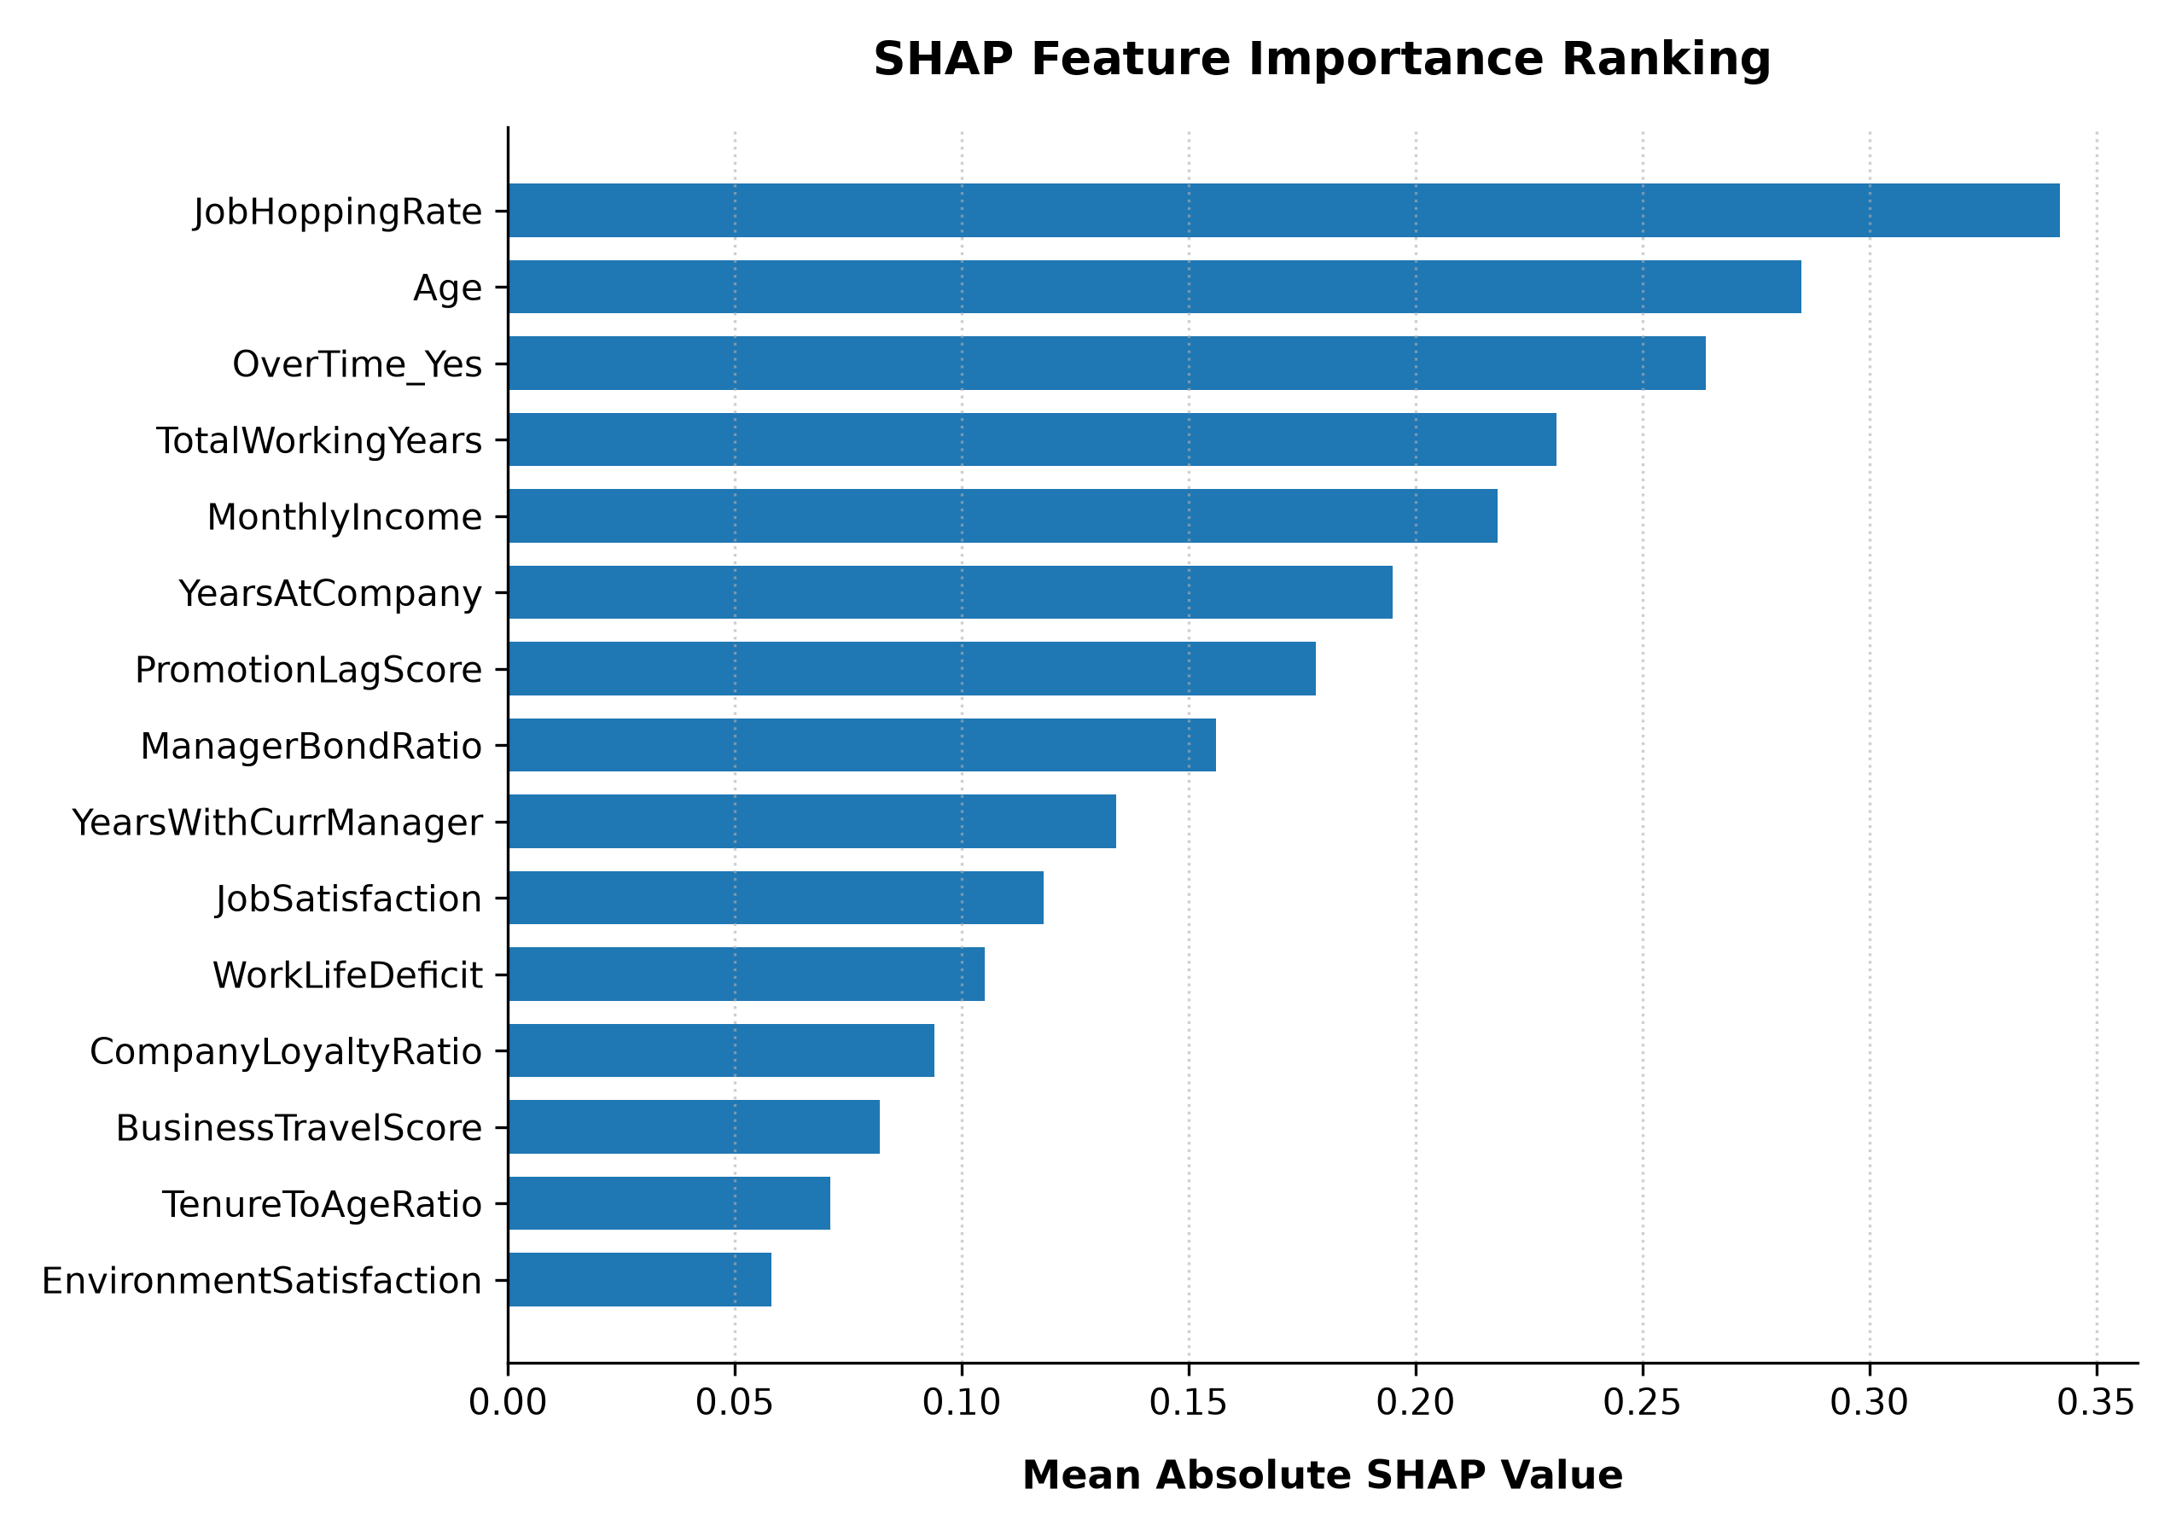
Fig. 3. Global feature importance ranking based on mean absolute SHAP values for the K=33 CatBoost Anchor model across all 2,969 employee profiles. Tenure stability and career mobility features dominate attribution.
The SHAP attributions align closely with organizational embeddedness theory [2]: tenure stability ratios (TenureToAgeRatio, CompanyLoyaltyRatio, AvgYearsPerCompany) and promotion dynamics (PromotionLagScore, PromotionStagnationRatio) collectively account for over 30% of total model attribution. Local SHAP waterfall analyses for boundary cases routed to the Specialist reveal conflicting signals—such as high job satisfaction co-occurring with prolonged promotion stagnation. The Specialist's K=37 feature set resolves these ambiguities by incorporating structural interaction terms (PromotionVelocity, IncomeToExpRatio) that capture fine-grained equity imbalances.
VIII. LIMITATIONS AND FUTURE WORK
Several limitations should be explicitly acknowledged. First, because the locked validation holdout (N=594) served as a recurring evaluation benchmark across iterative research stages, it should not be regarded as a pristine unseen test set; the 25-fold repeated nested cross-validation results (95.41% Accuracy, 85.27% F1-score) provide the primary unbiased generalization estimate. Second, the dataset represents a merged benchmark corpus; application to other industry sectors will require localized calibration. Third, unobserved external market dynamics (competing salary offers) remain outside internal tabular HR records.
Future research directions include: (1) integrating semi-supervised learning on unlabelled exit interviews; (2) extending specialist routing to multi-specialist hierarchies for diverse job families; (3) incorporating natural language representations from employee engagement surveys; and (4) developing causal counterfactual SHAP modules to simulate the retention impact of specific HR interventions.
IX. CONCLUSION
This paper presented a Two-Stage Selective Classification Framework with Hard-Case Specialist Routing for employee turnover prediction. By decoupling high-confidence predictions from boundary-zone estimation, the architecture enables specialized, cost-sensitive recovery of difficult minority-class departures. Evaluated on 2,969 unique employee profiles, the proposed framework achieves 94.95% Accuracy, 87.50% Precision, 80.21% Recall, 83.70% F1-score, and 92.30% ROC-AUC on the locked validation holdout (N=594), reducing total classification errors by 57.7% relative to the leak-free base-paper reproduction.
Our forensic benchmark audit demonstrated that published GA+LightGBM metrics (>85% Recall, >87% F1) depend on pre-split SMOTE leakage, which artificially inflates scores via train-test cross-contamination. Under rigorous leak-free conditions, our two-stage architecture outperforms the reproduced base paper by +41.25% Recall and +32.47% F1-score. Repeated 25-fold nested cross-validation confirmed robust generalization (95.41% ± 0.98% Accuracy, 85.27% ± 3.27% F1-score), suggesting a practical performance limit for the evaluated feature space. Coupled with SHAP interpretability as a supporting tool, the proposed framework provides a rigorous, transparent, and practically deployable tool for organizational retention analytics.
. REFERENCES
[1] Society for Human Resource Management (SHRM), "Retaining talent: A guide to analyzing and managing employee turnover," SHRM, Alexandria, VA, USA, Tech. Rep., 2017.
[2] D. G. Allen, P. C. Bryant, and J. M. Vardaman, "Retaining talent: Replacing misconceptions with evidence-based strategies," Acad. Manage. Perspect., vol. 24, no. 2, pp. 48–64, 2010.
[3] G. Ke, Q. Meng, T. Finley, T. Wang, W. Chen, W. Ma, Q. Ye, and T.-Y. Liu, "LightGBM: A highly efficient gradient boosting decision tree," in Adv. Neural Inf. Process. Syst. (NeurIPS), vol. 30, 2017, pp. 3146–3154.
[4] A. V. Dorogush, V. Ershov, and A. Gulin, "CatBoost: Gradient boosting with categorical features support," in Workshop on ML Systems (NeurIPS), 2018.
[5] Y. Geifman and R. El-Yaniv, "Selective classification for deep neural networks," in Adv. Neural Inf. Process. Syst. (NeurIPS), vol. 30, 2017, pp. 4878–4887.
[6] N. V. Chawla, K. W. Bowyer, L. O. Hall, and W. P. Kegelmeyer, "SMOTE: Synthetic minority over-sampling technique," J. Artif. Intell. Res., vol. 16, pp. 321–357, 2002.
[7] H. Talebi, A. K. Bardsiri, and V. K. Bardsiri, "Developing a hybrid machine learning model for employee turnover prediction: Integrating LightGBM and genetic algorithms," J. Open Innov.: Technol., Market, Complexity, vol. 11, no. 1, p. 100557, 2025.
[8] H. Zhang, L. Xu, X. Cheng, K. Chao, and X. Zhao, "Analysis and prediction of employee turnover characteristics based on machine learning," in Proc. 18th Int. Symp. Commun. Inf. Technol. (ISCIT), Bangkok, Thailand, 2018, pp. 408–411.
[9] L. Alaskar, M. Crane, and M. Alduailij, "Employee turnover prediction using machine learning," in Adv. Data Sci., Cyber Secur. IT Appl. (ICC 2019), Riyadh, Saudi Arabia: Springer, 2019, pp. 106–116.
[10] Y. Zhao, M. K. Hryniewicki, F. Cheng, B. Fu, and X. Zhu, "Employee turnover prediction with machine learning: A reliable approach," in Proc. Intell. Syst. Appl. (IntelliSys), London, UK: Springer, 2019, pp. 737–758.
[11] A. B. Wild Ali, "Prediction of employee turn over using random forest classifier with intensive optimized PCA algorithm," Wireless Pers. Commun., vol. 119, no. 4, pp. 3365–3382, 2021.
[12] P. Kumar, S. B. Gaikwad, S. T. Ramya, T. Tiwari, M. Tiwari, and B. Kumar, "Predicting employee turnover: A systematic machine learning approach for resource conservation and workforce stability," Eng. Proc., vol. 59, no. 1, p. 117, 2023.
[13] M. R. Shafie, H. Khosravi, S. Farhadpour, S. Das, and I. Ahmed, "A cluster-based human resources analytics for predicting employee turnover using optimized artificial neural networks and data augmentation," Decis. Anal. J., vol. 11, p. 100465, 2024.
[14] A. K. Biswas, R. Seethalakshmi, P. Mariappan, and D. Bhattacharjee, "An ensemble learning model for predicting the intention to quit among employees using classification algorithms," Decis. Anal. J., vol. 9, p. 100335, 2023.
[15] S. Chowdhury, S. Joel-Edgar, P. K. Dey, S. Bhattacharya, and A. Kharlamov, "Embedding transparency in artificial intelligence machine learning models: Managerial implications on predicting and explaining employee turnover," Int. J. Hum. Resour. Manage., vol. 34, no. 14, pp. 2732–2764, 2023.
[16] V. Veglio, R. Romanello, and T. Pedersen, "Employee turnover in multinational corporations: A supervised machine learning approach," Rev. Manag. Sci., vol. 19, no. 3, pp. 687–728, 2025.
[17] J. Park, Y. Feng, and S.-P. Jeong, "Developing an advanced prediction model for new employee turnover intention utilizing machine learning techniques," Sci. Rep., vol. 14, no. 1, p. 1221, 2024.
[18] J. C. M. Bustillo, "Optimization-based techniques prediction model in determining employee turnover," Procedia Comput. Sci., vol. 252, pp. 440–449, 2025.
[19] S. Shankar, R. Vyas, and V. Tewari, "Applying machine learning algorithms to determine and predict the reasons and models for employee turnover," Int. J. Inf. Technol. Manage., vol. 23, no. 1, pp. 48–63, 2024.
[20] L. S. Shapley, "A value for n-person games," in Contributions to the Theory of Games, vol. II, H. W. Kuhn and A. W. Tucker, Eds. Princeton, NJ, USA: Princeton Univ. Press, 1953, pp. 307–317.
[21] S. M. Lundberg and S.-I. Lee, "A unified approach to interpreting model predictions," in Adv. Neural Inf. Process. Syst. (NeurIPS), vol. 30, 2017, pp. 4765–4774.
[22] T. Akiba, S. Sano, T. Yanase, T. Ohta, and M. Koyama, "Optuna: A next-generation hyperparameter optimization framework," in Proc. 25th ACM SIGKDD Int. Conf. Knowl. Discovery Data Mining, Anchorage, AK, USA, 2019, pp. 2623–2631.
[23] M. Al Akasheh, E. F. Malik, O. Hujran, and N. Zaki, "A decade of research on machine learning techniques for predicting employee turnover: A systematic literature review," Expert Syst. Appl., vol. 238, p. 121794, 2024.
[24] J. Judrups, R. Cinks, I. Birzniece, and I. Andersone, "Machine learning based solution for predicting voluntary employee turnover in organization," Eng. Rural Dev., vol. 20, pp. 1359–1366, 2021.
[25] M. Nayem and M. A. Uddin, "Unbiased employee performance evaluation using machine learning," J. Open Innov.: Technol., Market, Complexity, vol. 10, no. 1, p. 100243, 2024.

