# Code Documentation

Based on the knowledge gained from the Udemy certifications, the following code annotation sample is developed using the JSDoc markup language for JavaScript on Visual Studio Code editor:

## Using “Visual Studio Code” editor

Index.js file

// @ts-check

const { caltotal } = require("./petcounter");

/**

 * @file index.js is the homepage for this application

 * @author Mithun

 * @see <a href="https://en.wikipedia.org/wiki/India">India</a>

 */

/**

 * Pet name

 * @type {string}

 */

const string = "Ruby";

/**

 * Pet number

 * @type {number}

 */

const number = 100;

/**

 * My Array

 * @type {Array<number>}

 */

const myArray_number = [10, 132.12, 100];

// const myArray = [10, 132.12, 100, "Hi", true]

/**

 * Pet object

 * @type {{id: number, name: string, age: number|string}}

 */

const object = {

  id: 1,

  name: "Coco",

  age: "2",

};

/**

 * Calculate pet age

 * @param {number} current current year

 * @param {number} yearOfBirth year of pet birth

 * @returns {string} pet age

 */

const calculateAge = (current, yearOfBirth) => {

  return `${current - yearOfBirth}`;

};

console.log(calculateAge(2021, 2019));

//////////////////////////

/**

 *

 * @typedef {Object} Dog

 * @property {number} id

 * @property {string} name

 * @property {number|string} age

 * @property {boolean} [isMale] gender {optional}

 */

/**

 * Custom Object

 * @type {Dog}

 */

const custom_object = {

  id: 1,

  name: "Bean",

  age: 2,

  // isMale: true,

};

/**

 * Class to create a new pet owner

 */

class Owner {

  /**

   * Pet owner detail

   * @param {Object} ownerDetail

   */

  constructor(ownerDetail) {

    /**

     * @property {string} name pet owner name

     */

    this.name = ownerDetail.name;

    /**

     * @property {number} age pet owner age

     */

    this.age = ownerDetail.age;

  }

  /**

   * @property {Function} printOwner print out owner information

   * @returns {void}

   */

  printOwner() {

    console.log(`Owner's name is ${this.name} and her age is ${this.age}`);

  }

}

/**

 * Link to Owner class

 * See {@link Owner}

 */

const owner_call = new Owner({

  name: "Kelly",

  age: 18,

});

owner_call.printOwner();

console.log(caltotal(19, 5));

The following is the “Home page” of the generated document (JSDoc):

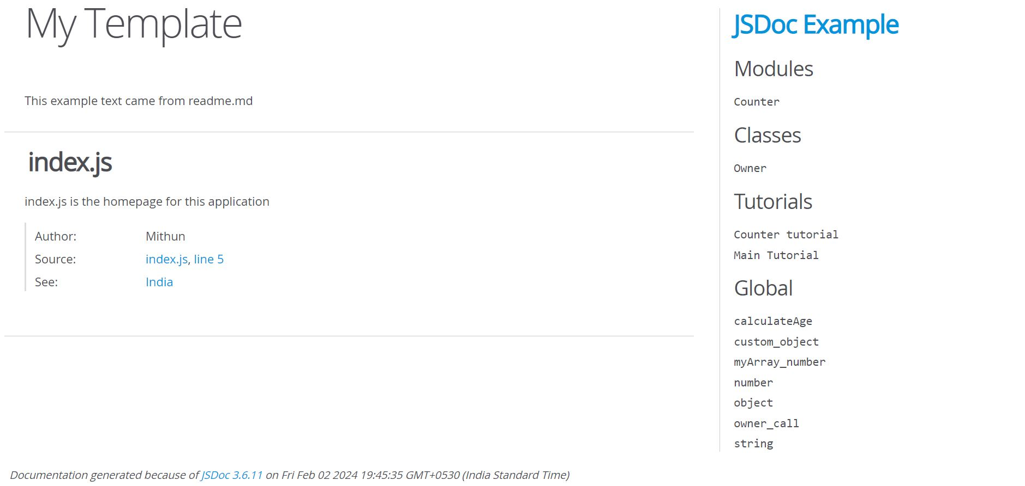

The following three slides show the Class documentation:

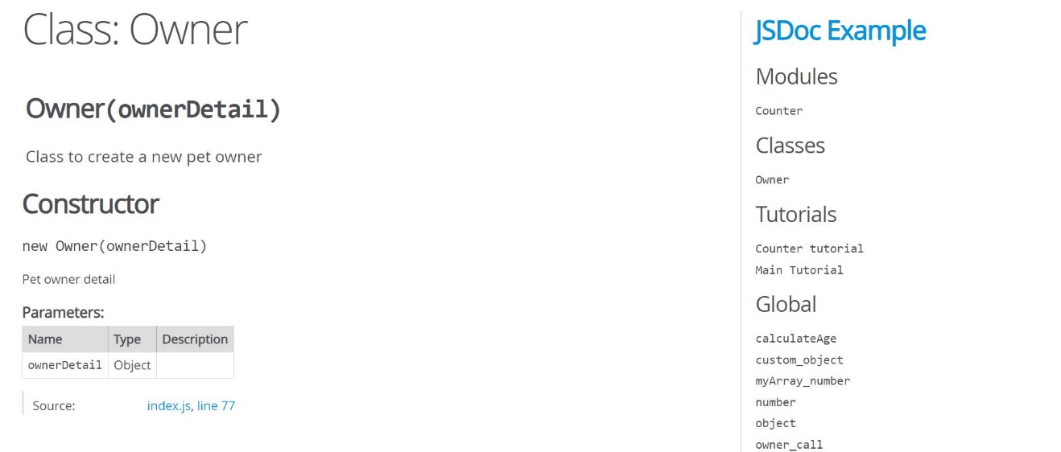

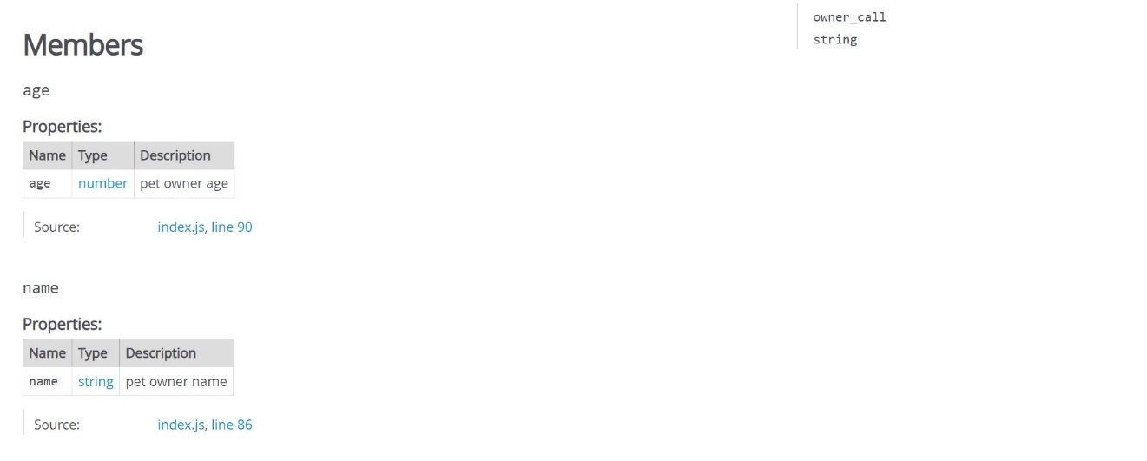

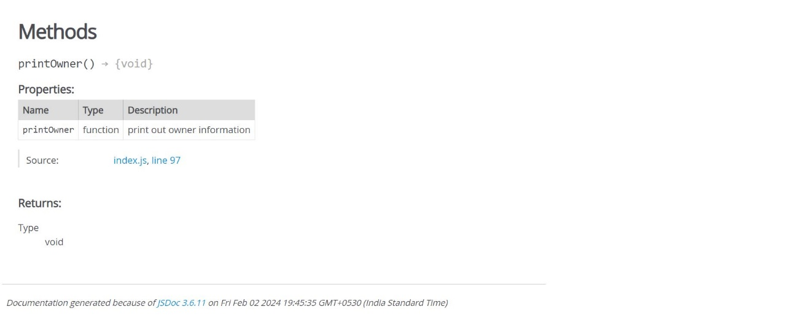

More explanation on the entire sample available on the Home page will be shared during the discussion.

# Documenting a JSON Request

The following JSON code sample represents a request to book a conference room:

{

"conference": {

"time": "2024-01-31 11:00",

"duration": 30,

"description": "2016 Project Planning Meeting",

"location": "Tower: 2, Building 18, Room 108",

"reminder": 18,

"invitees": ["Vinay@example.com", "Sangeetha@example.com",

"Siri@example.com", "Prathap@example.com"]

}

}

The following sample is the documentation for the above JSON request:

|  |  |  |  |  |  |
| --- | --- | --- | --- | --- | --- |
| **Element** | | **Description** | **Type** | **Required** | **Notes** |
| Conference | | Top Level | Conference data object | Required |  |
|  | time | When the meeting begins | String | Required | Format:  YYYY-mm-dd HH:MM |
|  | duration | How long the conference lasts | String | Required |  |
|  | description | A description of the conference | String | Required |  |
|  | location | Location of the conference | String | Optional | Default is an empty string |
|  | reminder | How many minutes before the meeting a reminder event should take place | String | Optional | Default is 10 minutes. |
|  | invitees | A list of email addresses of people to invite to the meeting | String | Optional | The strings should be valid email addresses. Default is an empty array. |
|  |  |  |  |  |  |

# Documenting an XML Request

The following XML code sample represents a request for a daily data from an airport weather office:

<routineData>

<date>2024-31-01</date>

<hourlyData>

<time>10:00</time>

<device>

<id>28</id>

<temperature>40</temperature>

<humidity>11</humidity>

</device>

<device>

<id>29</id>

<temperature>41</temperature>

<humidity>9</humidity>

</device>

. ..

</hourlyData>

<hourlyData>

<time>11:00</time>

<device>

<id>28</id>

<temperature>38</temperature>

<humidity>10</humidity>

</device>

...

</hourlyData>

...

</routineData>

The following sample is the documentation for the above xml request:

Top Level

|  |  |  |
| --- | --- | --- |
| **Element** | **Description** | **Type** |
| routineData | Humidity and temperature data for one day | routineData element |

routineData: Represents humidity and temperature data for one day

|  |  |  |  |
| --- | --- | --- | --- |
| **Element** | **Description** | **Type** | **Notes** |
| date | The date when the humidity and temperature data was collected | String | Format: YYYY-mm-dd |
| hourlyData | Humidity and temperature data for one hour | hourlyData element |  |

hourlyData: Humidity and temperature data for one hour

|  |  |  |  |
| --- | --- | --- | --- |
| **Element** | **Description** | **Type** | **Notes** |
| time | Local time when the data was collected | String | Format: YYYY-mm-dd |
| device | One or more device objects having the data | device element |  |

device: contains temperature and humidity data collected from a device object

|  |  |  |
| --- | --- | --- |
| **Element** | **Description** | **Type** |
| Id | The device’s identifier | number |
| temperature | The measured temperature in degree celsius | number |
| humidity | The measured humidity in percentage | number |

# REST APIs Documentation

The following sample shows how to document the POST and GET calls:

## **Uploading a Sound File**

Uploads a sound file for a user’s profile.

### URL

POST <https://api.date.com/profile/sound>

### Headers

|  |  |  |  |
| --- | --- | --- | --- |
| **Header Name** | **Description** | **Required** | **Values** |
| Bearer | Access token | Required | See Authorization section. |
| Content-Type | The format of the sound file to upload | Optional | audio/mpeg or audio/x-wav.  Default is audio/mpeg. |
| Accept | The format of the returned data | Optional | application/xml or application/json. Default is application/json. |

### POST or PUT Body

The sound file.

**Note:** The sound file must be 3 minutes or shorter.

### Sample Request

POST <https://api.date.com/profile/sound>

Bearer: {access token}  
Content-Type: audio/mpeg  
Accept: application/json

{sound file}

### Response

|  |  |  |  |
| --- | --- | --- | --- |
| **Element** | **Description** | **Type** | **Notes** |
| Id | The ID of the new sound file | number |  |
| length | The length of the sound file | float | Length is in seconds |

### Sample Response

{

"id": 3543,

"length": 19.8

}

## **Retrieving a List of Sound Files**

Retrieves a list of sound file URLs and their lengths for the specified user.

### URL

GET https://api.date.com/user/{user id}/profile/sound

where {user id} is the ID of the user whose profile contains the sound files.

### Query Parameters

|  |  |  |  |  |
| --- | --- | --- | --- | --- |
| **Parameter** | **Description** | **Type** | **Required** | **Notes** |
| sortOrder | The order to return the sound file information. | String | Optional | Valid values: mostRecent, earliest, shortest, longest.  Default is mostRecent. |

**Note:**

* **mostRecent** returns the most recent sound files to the earliest.
* **earliest** returns the earliest sound files to the most recent.
* **shortest** returns the shortest sound files to longest.
* **longest** returns the longest sound files to the shortest

### Headers

|  |  |  |  |
| --- | --- | --- | --- |
| **Header Name** | **Description** | **Required** | **Values** |
| Bearer | Access Token | Required | See Authorization section |
| Accept | The format of the returned data | Optional | application/xml or application/json. Default is application/json |

### Sample Request

GET <https://api.sounddate.com/user/345354/profile/sound?sortOrder=shortest>

Bearer: {access token}  
Accept: application/json

### Response

|  |  |  |  |
| --- | --- | --- | --- |
| **Element** | **Description** | **Type** | **Notes** |
| Soundfiles | List of sound file information | Array |  |
| id | The ID of the sound file | integer |  |
| url | The URL of the sound file | string |  |
| length | The length of the sound file | Float | The length in seconds. |

Sample Response

{

"soundFiles": [

{

"id": 23456,

"url": "https://api.sounddate.com/profile/sound/23456.mp3",

"length": 11.2

},

{

"id": 24559,

"url": "https://api.sounddate.com/profile/sound/24559.mp3",

"length": 19.8

}

]

}

## Status Codes and Errors

The following table lists the returned HTTP status codes.

|  |  |  |
| --- | --- | --- |
| **Code** | **Description** | **Notes** |
| 200 | OK | Sound file was successfully added. |
| 401 | Unauthorized | Access token is invalid |
| 413 | Request Entity Too Large | Uploaded sound file is longer than 5 minutes. |

# Open API Specification Documentation

openapi: 3.0.1

info:

title: Strope Usage Records

description: "Usage records allow you to report customer usage and metrics to Stripe\

\ for [metered billing]( https://stripe.com/docs/billing/subscriptions/metered-billing)\

\ of subscription plans."

version: 2019-02-19

servers:

- url: https://api.stripe.com/v1

security:

- basicAuth: []

paths:

/subscription_items/{subscription_item}/usage_records:

post:

description: |

Creates a usage record for a specified subscription item and date, and fills it with a quantity.

Usage records provide `quantity` information that Stripe uses to track how much a customer is using your service. With usage information and the pricing model set up by the [metered billing](https://stripe.com/docs/billing/subscriptions/metered-billing) plan, Stripe helps you send accurate invoices to your customers.

The default calculation for usage is to add up all the `quantity` values of the usage records within a billing period. You can change this default behavior with the billing planâ€™s `aggregate_usage` [parameter](https://stripe.com/docs/api/plans/create#create_plan-aggregate_usage). When there is more than one usage record with the same timestamp, Stripe adds the quantity values together. In most cases, this is the desired resolution, however, you can change this behavior with the `action` parameter.

The default pricing model for metered billing is [per-unit](https://stripe.com/docs/api/plans/object#plan_object-billing_scheme) pricing. For finer granularity, you can configure metered billing to have a [tiered](https://stripe.com/docs/billing/subscriptions/tiers) pricing model.

parameters:

- name: subscription_item

in: path

description: The ID of the subscription item for this usage record.

required: true

schema:

type: string

requestBody:

content:

application/x-www-form-urlencoded:

schema:

required:

- quantity

type: object

properties:

quantity:

type: string

description: The usage quantity for the specified timestamp.

action:

type: string

description: |

Valid values are `increment` (default) or `set`. When using `increment` the specified quantity will be added to the usage at the specified timestamp. The `set` action will overwrite the usage quantity at that timestamp. If the subscription has [billing thresholds](https://stripe.com/docs/api/subscriptions/object#subscription_object-billing_thresholds), increment is the only allowed value.

enum:

- increment

- set

timestamp:

type: string

description: "The timestamp for the usage event. This timestamp\

\ must be within the current billing period of the subscription\

\ of the provided `subscription_item`, and must not be in the\

\ future. When passing `\"now\"`, Stripe records usage for the\

\ current time. Default is `\"now\"` if a value is not provided."

required: true

responses:

"200":

description: Successful response

content:

application/json:

schema:

$ref: '#/components/schemas/usageRecord'

/subscription_items/{subscription_item}/usage_record_summaries:

get:

description: |

For the specified subscription item, returns a list of summary objects. Each object in the list provides usage information thatâ€™s been summarized from multiple usage records and over a subscription billing period (e.g., 15 usage records in the billing planâ€™s month of September).

The list is sorted in reverse-chronological order (newest first). The first list item represents the most current usage period that hasnâ€™t ended yet. Since new usage records can still be added, the returned summary information for the subscription itemâ€™s ID should be seen as unstable until the subscription billing period ends.

parameters:

- name: subscription_item

in: path

description: Only summary items for the given subscription item.

required: true

schema:

type: string

- name: ending_before

in: query

description: "A cursor for use in pagination. `ending_before` is an object\

\ ID that defines your place in the list. For instance, if you make a list\

\ request and receive 100 objects, starting with `obj_bar`, your subsequent\

\ call can include `ending_before=obj_bar` in order to fetch the previous\

\ page of the list."

schema:

type: string

- name: limit

in: query

description: "A limit on the number of objects to be returned. Limit can range\

\ between 1 and 100, and the default is 10."

schema:

maximum: 100

minimum: 1

type: integer

- name: starting_after

in: query

description: "A cursor for use in pagination. `starting_after` is an object\

\ ID that defines your place in the list. For instance, if you make a list\

\ request and receive 100 objects, ending with `obj_foo`, your subsequent\

\ call can include `starting_after=obj_foo` in order to fetch the next page\

\ of the list"

schema:

type: string

responses:

"200":

description: Successful response

content:

application/json:

schema:

$ref: '#/components/schemas/usageRecordSummary'

components:

schemas:

usageRecord:

type: object

properties:

id:

type: string

description: Unique identifier for the object.

object:

type: string

description: String representing the objectâ€™s type. Objects of the same

type share the same value.

enum:

- usage_record

livemode:

type: boolean

description: Has the value `true` if the object exists in live mode or the

value `false` if the object exists in test mode.

quantity:

minimum: 0

type: integer

description: The usage quantity for the specified date.

subscription_item:

type: string

description: The ID of the subscription item this usage record contains

data for.

timestamp:

type: integer

description: The timestamp when this usage occurred.

usageRecordSummary:

type: object

properties:

object:

type: string

description: String representing the objectâ€™s type. Objects of the same

type share the same value.

enum:

- list

url:

type: string

description: URL of the subscription item summaries.

has_more:

type: boolean

description: "Whether or not there are more elements available after this\

\ set. If `false`, this set comprises the end of the list."

data:

type: array

items:

$ref: '#/components/schemas/usageRecordData'

description: "A dictionary with a `data` property that contains an array of\

\ up to `limit` summaries, starting after summary `starting_after`. Each entry\

\ in the array is a separate summary object. If no more summaries are available,\

\ the resulting array is empty."

usageRecordData:

type: object

properties:

id:

type: string

description: ID of the usage record.

object:

type: string

description: String representing the objectâ€™s type. Objects of the same

type share the same value.

enum:

- usage_record_summary

invoice:

type: string

description: ID of the invoice.

livemode:

type: boolean

description: Has the value `true` if the object exists in live mode or the

value `false` if the object exists in test mode.

period:

type: object

properties:

end:

type: integer

description: Ending timestamp.

start:

type: integer

description: Starting timestamp.

description: Time period.

subscription_item:

type: string

description: ID of the subscription item.

total_usage:

type: integer

description: The total number of usage records in the billing plan.

securitySchemes:

basicAuth:

type: http

scheme: basic

x-original-swagger-version: "2.0"