Business Requirements Document
Blenrep NZ CSP Portal
V1.2 — BRD for Sharing with Vendors for RFP

Document owner | Mithun Aggarwal
Status | Draft for business review
Version | V1.2
Date | 30th Apr
Purpose | Sharing with External vendor for briefing for RFP submission

Prepared for: Business Review

Table of Contents
1. Purpose of this Document 3
2. Executive Summary 3
3. Business Objectives 4
4. Scope Summary 4
4.1 In Scope 4
4.2 Out of Scope 5
5. Guiding Principles 5
6. Users and Roles 5
6.1 CSP Admin 5
6.2 GSK Programme Admin 5
6.3 Private Haematologist 6
6.4 Private Pharmacist 6
6.5 Out-of-Scope Actors 6
7. Access Model 6
8. Portal Boundary 6
9. Process Design 7
Process 1: Patient starts on private funding pathway 7
Process 2: Patient is registered into the CSP portal before cycle 4 7
Process 3: First 3 paid doses are confirmed 7
Process 4: Free-dose period is activated 7
Process 5: Portal-generated milestone notification to GSK Programme Admin 7
Process 6: Treatment continues and reorders are managed 8
Process 7: Free-dose period expires and model resets 8
Process 8: External approval and scarcity / stock approval handling 8
10. Core Business Rules 8
11. High-Level Functional Capability Areas 9
11.1 User and Access Management 9
11.2 Patient Record Management 9
11.3 Registration Workflow 9
11.4 Paid-Dose Confirmation 9
11.5 Free-Dose Eligibility Management 9
11.6 Reorder Workflow 10
11.7 Transaction Recording 10
11.8 Notifications 10
11.9 Dashboards and Work Queues 10
11.10 Vial Calculator 10
11.11 Audit and Governance 10
12. Data and Record Principles 10
13. Compliance, Privacy, and Security 11
14. Reporting and Operational Visibility 11
15. Assumptions Requiring Business Confirmation 11
16. Open Items for Later Design / Vendor Confirmation 12
17. Risks and Considerations 12
18. Recommended Next Steps 12
19. Summary 13

1. Purpose of this Document
This Business Requirements Document (BRD) defines the proposed business scope, user journeys, platform expectations, process design, and high-level requirements for the Blenrep NZ CSP Portal.
This version is intended for business review so stakeholders can validate the operating model, confirm what is in scope and out of scope, align on user roles and journeys, and identify open decisions and assumptions before vendor engagement.
This document is not a final technical design or signed-off functional specification. It is a business-aligned V1 baseline for review.

2. Executive Summary
The Blenrep NZ CSP Portal is intended to support administration of a New Zealand cost-share / paid-to-free treatment program for Blenrep.
- The patient begins treatment under a private paid pathway.
- The first 3 doses / cycles are privately funded.
- Once those first 3 paid doses are confirmed, the patient becomes eligible for free doses.
- The free-dose period runs for 1 year from the first paid dose date.
- After that period ends, the patient returns to a new paid period and the cycle restarts.
The portal is intended to support the administrative and workflow management of this model. It is not intended to replace clinical systems, wholesaler systems, reconstitution provider systems, or formal HCL workflows.
The portal may support limited notification and restricted visibility relating to scarcity / stock approval handling, but any HCL-triggered scarcity email and any HCL-side process remain outside portal scope.

3. Business Objectives
- Register patients into the CSP pathway before cycle 4.
- Support collaboration between haematologist, pharmacist, CSP Admin, and the GSK Programme Admin where relevant.
- Capture and manage confirmation that the first 3 doses have been privately funded.
- Manage the transition from paid pathway to free-dose eligibility.
- Support reorder-related workflow during active treatment.
- Provide traceability using a clinic patient identifier / code.
- Support notifications, dashboards, and auditability.
- Handle patient-related information in a governed, compliant way, with restricted non-sensitive visibility only where needed for scarcity / stock approval handling.
- Support portal-generated milestone notifications to the GSK Programme Admin for scarcity / stock approval handling.
- Provide a production-grade platform suitable for vendor delivery and operational use.

4. Scope Summary

4.1 In Scope
- Production-grade standalone NZ web portal.
- Role-based access for Private Haematologist, Private Pharmacist, and CSP Admin, plus optional highly restricted dashboard-only visibility for GSK Programme Admin if confirmed in later design.
- User self-registration and CSP Admin approval.
- Patient registration by Haematologist into the CSP pathway before cycle 4.
- Use of a clinic patient ID / code in the portal workflow.
- Pharmacist-assisted data entry and haematologist final submission for initial registration.
- CSP Admin review, verification, and full portal administration.
- Confirmation / attestation of the first 3 paid doses.
- Limited recording or upload of evidence needed to support eligibility, if required in final design.
- Automatic calculation of the free-dose period from the first paid dose date.
- Patient status progression through the paid-to-free program lifecycle.
- Reorder workflow support.
- Manual transaction / order recording against the patient record.
- Dashboard and email notifications, including portal-generated milestone notifications to GSK Programme Admin for scarcity / stock approval handling.
- HCP dashboards, CSP Admin work queues, and potentially a limited dashboard-only operational view for GSK Programme Admin subject to confirmation.
- Audit trail and governance support.
- Vial calculator functionality. ( we would have a smaller version of this https://blenrep-dose-and-vile-calculator.streamlit.app/)
- Compliant handling of patient-related information aligned with NZ requirements and GSK expectations.

4.2 Out of Scope
- Patient portal access.
- Eyecare professional access.
- HCL portal access.
- Reconstitution provider portal access.
- Full end-to-end management of the private funding journey.
- Clinical decision support and prescribing decisions.
- Direct integration to HCL systems.
- Direct integration to reconstitution provider systems.
- Direct operational management of third-party inventory systems.
- Vendor creation of unapproved medical or promotional content.

5. Guiding Principles
- Administrative, not clinical: the portal supports administration and workflow only.
- Clear scope boundaries: external parties such as HCL and reconstitution provider remain outside direct platform control.
- Auditability and governance: all key actions should be traceable and reviewable.
- Role-appropriate access: users should only see records relevant to them, with CSP Admin holding broader oversight.
- Patient information is CSI and should be handled with best CSI handling practice.
- Business-approved content: approved wording and content will be provided by business / brand teams.

6. Users and Roles

6.1 CSP Admin
- Full portal administrator and true administrative owner of the CSP portal.
- Responsible for HCP and pharmacist verification / onboarding, portal-related administration, access and role management, record creation, editing, reopening, and override where needed.
- Retains full operational visibility across the CSP.
- Acts as the main point of contact for HCP / pharmacist for portal and CSP administrative matters.
- Acts as the main coordination point between portal users and GSK on CSP administrative matters.

6.2 GSK Programme Admin
- Main point of contact from GSK for scarcity / stock approval handling.
- Limited-access operational stakeholder, not a full portal operations user.
- Not a normal portal user role.
- If represented in the portal at all, access should be dashboard-only with highly restricted visibility.
- Any visibility should use only patient ID / clinic patient code and non-sensitive operational milestones.
- Should not have access to critical or sensitive patient information.
- Manages scarcity / stock approval handling outside the core CSP portal workflow, including coordination relating to HCL.

6.3 Private Haematologist
- Portal user responsible for creating patient records directly where needed, reviewing records prepared by pharmacist, approving and submitting patient registration, confirming relevant treatment and paid-dose milestones, and viewing allocated patient records.

6.4 Private Pharmacist
- Portal user expected to support operational data entry and reorder-related activity.
- Creates and updates patient records, enters clinic patient ID / code and operational details, saves records for haematologist approval, supports confirmation of privately funded doses, records manual transaction / order events, and manages reorders based on date / timing set by HCP.

6.5 Out-of-Scope Actors
- Patient
- Eyecare professional
- HCL
- Reconstitution provider

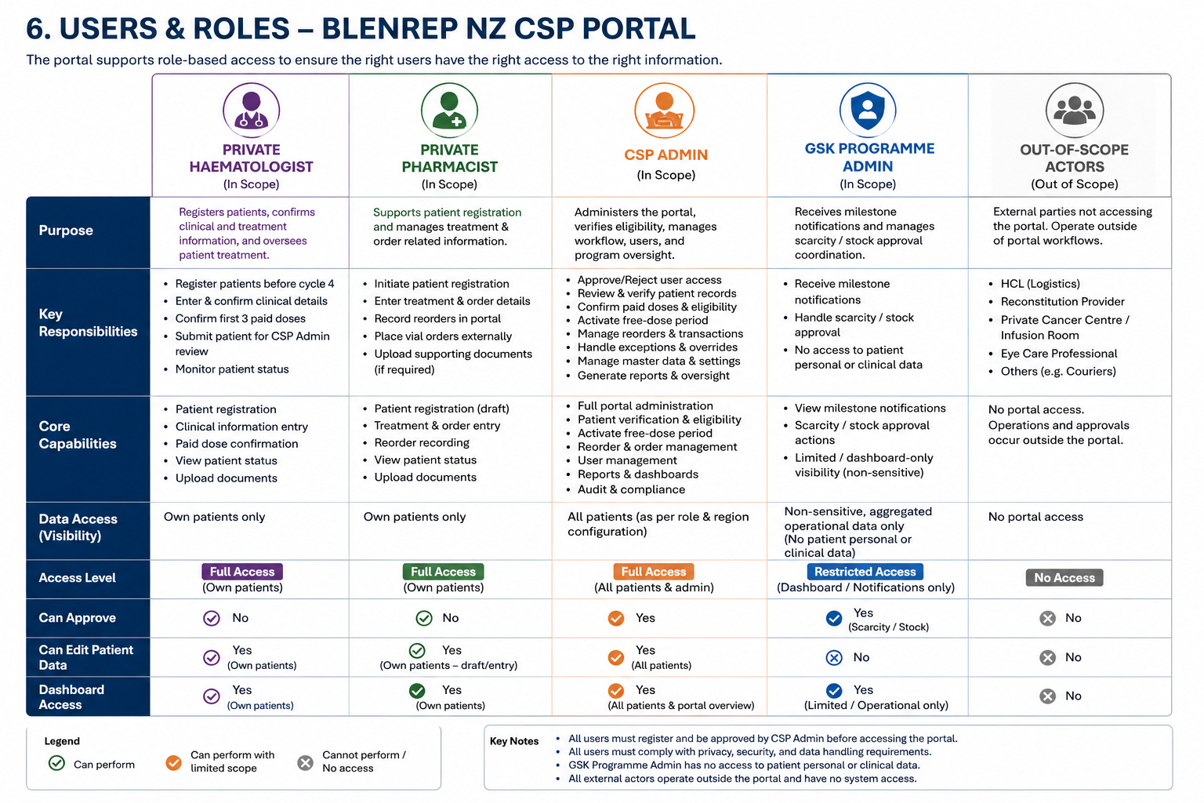

7. Access Model
The solution is intended to be a single NZ portal.
- Users self-register.
- CSP Admin approves access.
- Profile-based access is assigned initially based on selected role.
- CSP Admin can edit and correct access / role settings.
- Haematologists see only patients allocated to them.
- Pharmacists see only patients allocated to them and / or relevant site relationships.
- CSP Admin can view broader program records and manage visibility issues.
- GSK Programme Admin is not a normal portal user. If included in access design, access should be dashboard-only (A3 model) with very restricted visibility and no critical or sensitive patient information.

8. Portal Boundary
The portal is intended to support the CSP administration layer around the paid-to-free model.
It is not intended to fully run the private treatment journey. The private funding pathway remains largely outside the portal, except where the portal will need to register the patient prior to cycle 4, record or upload confirmation / evidence that the first 3 doses were privately funded, track transition into the free-dose period, and support related reorder and administrative workflow.
HCL remains fully out of scope. There is no direct integration with HCL. The portal only supports notification and limited visibility related to scarcity / stock approval handling.
Portal-generated milestone emails (distinct from any HCL emails) are sent to GSK Programme Admin (and copied to CSP Admin) when [defined milestone].
- These emails contain non-sensitive operational information only and direct the recipient to log into the portal to review details.
- The email triggered by the portal is not the same as the external HCL scarcity email.
- Any HCL-triggered stock / scarcity email remains outside CSP portal scope.
- No formal HCL workflow is managed inside the portal, and no formal stock approval status tracking is required in the portal at this stage.

9. Process Design

Process 1: Patient starts on private funding pathway
- Patient consults private haematologist.
- Prescribing decision is made outside the portal.
- Baseline eye assessment and treatment readiness occur outside the portal.
- Private ordering, wholesaler handling, reconstitution, and treatment operations largely remain outside the portal.
- The portal does not manage the full private funding journey.

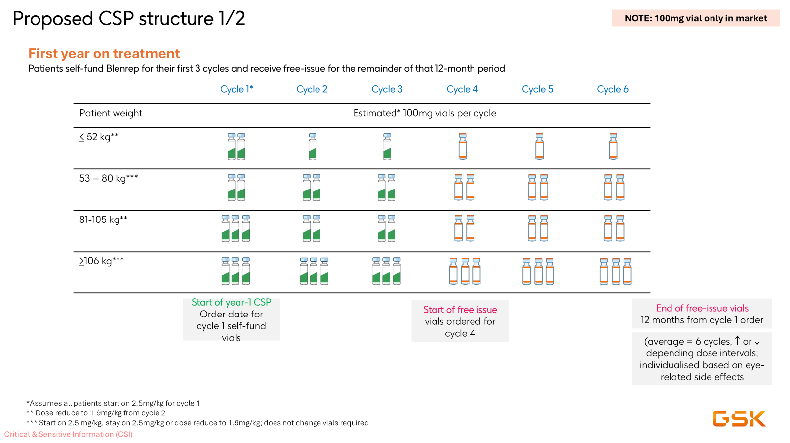

Process 2: Patient is registered into the CSP portal before cycle 4
- Patient may be registered into the portal at any point prior to cycle 4.
- Pharmacist may prepare the record and save it for haematologist approval.
- Haematologist may also create and submit the record directly.
- Haematologist is currently assumed to be the final approver / submitter for initial registration.
- The portal stores the clinic patient ID / code and program-related information against the record.

Process 3: First 3 paid doses are confirmed
- The first 3 doses / cycles are privately funded.
- Pharmacist and / or haematologist provide confirmation / attestation that the first 3 paid doses occurred.
- The portal may support recording and, if required in final design, upload of supporting evidence.
- CSP Admin verifies the relevant eligibility-related information.

Process 4: Free-dose period is activated
- Once required confirmation is completed and verified, the patient becomes eligible for free doses.
- The portal calculates the free-dose period from the first paid dose date.
- The free-dose period runs for 1 year from the date of the first paid dose.
- Notifications and dashboard status updates are issued to relevant users.

Process 5: Portal-generated milestone notification to GSK Programme Admin
- When relevant programme milestones are reached, the portal triggers a notification to GSK Programme Admin for scarcity / stock approval handling.
- Milestones include: when the first 3 paid doses are confirmed; when the free-dose period becomes active; and when a reorder for free stock is needed and when free-dose period concludes.
- These are portal-generated milestone notifications only.
- They are administrative notification / coordination steps, outside direct HCL system workflow, outside formal patient treatment management, and outside clinical decision-making.
- Notification content should remain high level and non-sensitive, and may include clinic patient ID / patient ID, order number / order sequence where relevant, first paid dose date, or other non-sensitive milestone information.

Process 6: Treatment continues and reorders are managed
- Reorders are primarily operationally driven by pharmacist based on HCP-set dates / timing.
- Reorders may be directly submitted by pharmacist or may involve HCP review / approval.
- The final reorder approval model is not yet fully locked and remains an open design point.
- Relevant transactions are manually entered and recorded in the portal against the patient record.

Process 7: Free-dose period expires and model resets
- At the end of the 1-year treatment period (including paid and free doses), the portal resets the patient to a new paid pathway status.
- The same patient record remains active.
- Historical program information remains visible in the same record.
- The next cycle of paid-to-free management can be handled in that same record.

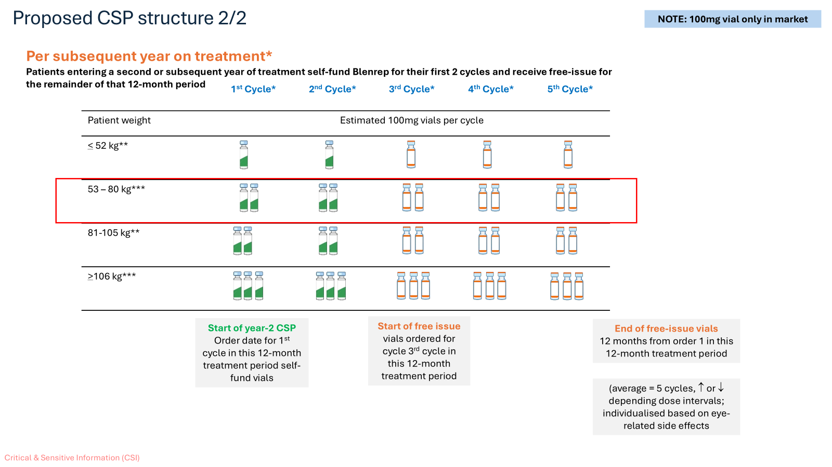

Process 8: External approval and scarcity / stock approval handling
- HCL is the wholesaler holding inventory in its own third-party environment.
- The reconstitution provider also operates in its own environment.
- A separate scarcity / stock approval handling process exists outside direct portal control.
- In every case, HCL would require confirmation from GSK / CSP before release.
- The portal should support related administrative visibility / workflow at a high level only.
- Detailed HCL-side and reconstitution-provider operational logic remains out of scope.

10. Core Business Rules
- Patient begins on a private paid pathway.
- First 3 doses / cycles are privately funded.
- Patient may be registered in the portal any time prior to cycle 4.
- Pharmacist may prepare and save a record; haematologist is currently assumed to be final submitter for initial registration.
- Preferred operational identifier is the clinic patient ID / code.
- That code should also be used in relevant external order comments / communications.
- Confirmation of the first 3 paid doses is provided by pharmacist and / or haematologist.
- CSP Admin verifies the eligibility-related confirmation.
- Free dose period begins at the conclusion of paid dose 3 and concludes 12 months from date of paid dose 1
- Free-dose period concludes one year from date of first paid dose.
- After that period ends, patient returns to a new paid pathway.
- The same record remains active across repeated periods.
- Reorder workflow is in scope at a business-process level.
- Portal milestone → email notification → offline GSK approval → HCL release
- Full private treatment operations remain mostly outside the system.
- Vial calculator is in scope.
- Dose calculator is out of scope.
- The portal is non-clinical and administrative in nature.
- GSK Programme Admin is the main point of contact from GSK for scarcity / stock approval handling.
- GSK Programme Admin is not a full portal operations user.
- No formal HCL workflow or HCL integration is in scope.
- No formal stock approval status tracking is required in the portal at this stage.

11. High-Level Functional Capability Areas

11.1 User and Access Management
- Self-registration for HCP & Pharmacist.
- CSP Admin approval.
- Role / profile assignment.
- Role / access correction by CSP Admin.
- Secure authentication and session management.

11.2 Patient Record Management
- Create / update patient record.
- Save for approval.
- Final submission.
- Reopen / override by CSP Admin.
- Maintain one longitudinal record across repeated periods.

11.3 Registration Workflow
- Patient registration prior to cycle 4.
- Recording key patient / program data.
- Linking patient to haematologist / pharmacist / site relationships.
- Management of status through workflow stages.

11.4 Paid-Dose Confirmation
- Structured attestation by pharmacist and / or haematologist.
- Support for limited evidence recording / upload if required.
- CSP Admin verification.

11.5 Free-Dose Eligibility Management
- Calculate one-year free-dose period from first paid dose date.
- Transition patient to eligible / active free-dose status.
- Reset to paid status on expiry.

11.6 Reorder Workflow
- Support pharmacist-led reorder activity.
- Support HCP involvement where applicable.
- Record reorder-related transactions.
- Keep detailed approval model open for final design.

11.7 Transaction Recording
- Manual entry of transaction / order events.
- Associate transactions to patient record.
- Distinguish paid vs free issue.
- Retain historical transaction visibility.

11.8 Notifications
- Email notifications (no sensitive info; CTA to login)
- In-portal notifications (visible after login; role-based detail)
- Approval and status reminders.
- Expiry reminders.
- Relevant copying to CSP Admin.
- Portal-generated milestone notifications to GSK Programme Admin for scarcity / stock approval handling.

11.9 Dashboards and Work Queues
- HCP dashboard.
- Patients requiring attention.
- Eligibility visibility.
- Expiring free-dose visibility.
- CSP Admin work queues for approvals and oversight.
- Optional restricted dashboard-only visibility for GSK Programme Admin if confirmed later.

11.10 Vial Calculator
- Vial calculator functionality included in scope.
- Detailed business rules for calculator logic to be separately specified and approved.

11.11 Audit and Governance
- Audit trail.
- User action history.
- Verification / approval traceability.
- Support for governance reporting.

12. Data and Record Principles
- Clinic patient ID / code.
- Patient-related program reference information.
- Haematologist and pharmacist details.
- Site / organisation relationship details.
- Treatment milestone dates.
- First paid dose date.
- Free-dose period dates.
- Transaction / order history.
- Workflow status history.
- Attestation and verification data.
- Audit trail information.

If any visibility is provided to GSK Programme Admin, it should be highly restricted and limited to non-sensitive operational information such as clinic patient ID / patient code and milestone dates, subject to confirmation during later design.

13. Compliance, Privacy, and Security
The portal must support compliant handling of patient-related information and be aligned to applicable New Zealand requirements and relevant GSK policies, standards, and best practices.
- Role-based access control.
- Secure authentication.
- Auditability.
- Appropriate hosting and data handling.
- Controlled use of approved business content only.
- No introduction of unapproved medical content by vendor.
The platform must be positioned as a non-clinical administrative platform. Treatment decisions remain with healthcare professionals.
GSK Programme Admin should not have access to critical or sensitive patient information.

14. Reporting and Operational Visibility
Reporting changes should remain light. The business expects operational visibility including, at minimum:
- Patients registered.
- Patients awaiting approval.
- Patients pending admin verification.
- Patients eligible for free doses.
- Active free-dose patients.
- Expiring free-dose periods.
- Patients reset to paid status.
- User access approvals.
- Record history and audit visibility.
If included in design, any GSK Programme Admin dashboard visibility should remain restricted and operational only. Deep stock reporting is not currently the focus of this portal.

15. Assumptions Requiring Business Confirmation
- Haematologist is the final submitter / approver for initial patient registration.
- CSP Admin can reopen, edit, or override records where required.
- Preferred operational identifier is the clinic patient ID / code rather than a portal-generated identifier.
- The same clinic patient ID / code will be used in relevant external order communications / comments.
- Limited evidence upload / recording may be supported for paid-dose confirmation, but final evidence model is still to be confirmed.
- Reorders are pharmacist-led based on HCP timing / date, but final approval / submission model for reorders is still to be confirmed.
- The same patient record remains active across repeated paid / free periods.
- The platform will remain integration-light in the initial scope, with no direct integration to HCL or reconstitution provider systems.
- Detailed vial calculator rules will be separately specified.
- Detailed patient data fields and hosting controls will be finalized in later design phases.
- If represented in the portal, GSK Programme Admin will have dashboard-only restricted visibility only, with no sensitive patient information exposed.

16. Open Items for Later Design / Vendor Confirmation
- Final reorder approval / submission model.
- Exact workflow statuses and state transitions.
- Detailed data model and field list.
- Evidence model for paid-dose confirmation.
- Detailed notification rules and recipients.
- Exact dashboard layouts and work queue rules.
- Detailed Dose Suggestion vial calculator logic and UI.
- Hosting architecture and environment model.
- MFA and detailed security control set.
- Detailed scarcity / stock approval handling at operational level.
- Nice-to-have only: future possibility for GSK to send a templated automated email response back to the vendor or related party.

17. Risks and Considerations
- If the boundary between private workflow and portal workflow is not clearly maintained, scope may expand unnecessarily.
- Manual transaction entry could increase administrative burden if not designed carefully.
- Identifier design must be agreed early to avoid downstream workflow confusion.
- Reorder workflow ambiguity could affect role design and approval logic.
- Patient-data handling requirements must be validated before detailed build design.
- Vendor selection may influence whether a configurable CRM / workflow product can be used versus custom development.
- If role boundaries between CSP Admin and GSK Programme Admin are not clearly maintained, sensitive-information exposure risk may increase.

18. Recommended Next Steps
- Confirm scope and out-of-scope boundaries.
- Confirm role ownership and reorder model.
- Confirm assumptions listed in this document.
- Define detailed functional requirements.
- Define detailed vial calculator requirements.
- Define data fields, statuses, and reporting needs.
- Prepare vendor briefing pack and user journeys.
- Complete security / privacy / architecture review inputs.
- Confirm the intended restricted visibility model for GSK Programme Admin.

19. Summary
The Blenrep NZ CSP Portal is intended to be a production-grade, non-clinical administrative platform supporting the paid-to-free treatment program journey in New Zealand.
- Registration before cycle 4.
- Confirmation of first 3 paid doses.
- Activation and tracking of the free-dose period.
- Reorder-related workflow support.
- Manual transaction recording.
- Dashboards, notifications, and auditability.
- Compliant handling of patient-related information.
- Vial calculator capability.
- Portal-generated milestone notifications to GSK Programme Admin for scarcity / stock approval handling.
This V1.1 document is intended to serve as the initial business-aligned baseline for review before vendor engagement.

