**CHAPTER 1**

**INTRODUCTION**

**1.1 Background**

India is an agriculture country, 70% of Indian economy depends on agriculture. Plant diseases have turned into dilemma as it can cause significant reduction in both the quality and quantity of agricultural products. Diseases may occur due to environmental condition changes such as huge rainfall, drastic changes in temperature or may be due to improper maintenance and some insects and pesticide. These diseases lead to the loss of major crops which results in economic loss. Cotton is one of the most important fiber crops in our country that provide basic raw materials for textile industry. There are mainly four cultivated species of cotton namely Gossypium arboreum, G.herbaceum, G.hirsutum and G.barbadense. Detection of cotton plant diseases at earlier stage is necessary to reduce the loss. About 80 % of disease on the cotton plant can be diagnosed from its leaves. Therefore this project focuses on the leaf of the cotton plant rather than whole cotton plant. Moreover the leaves are easy for viewing and analysing the disease without damaging the plant. Diseases are due to the invasion of leaf tissues by disease causing agents such as bacteria, virus, fungus etc. leading to degradation of the leaf as well as the plant. This can be characterized by spots on the leaves, color change and shape of leaves. There are mainly four diseases related to cotton leaves i.e. Myrothecium Leaf Spot, Alternaria Leaf spot, Leaf Crumple, Cercospora leaf spot.All these diseases are common to the different species of cotton. These four diseases their symptoms and sample leaf image are given in the Table 1 to Table 4.

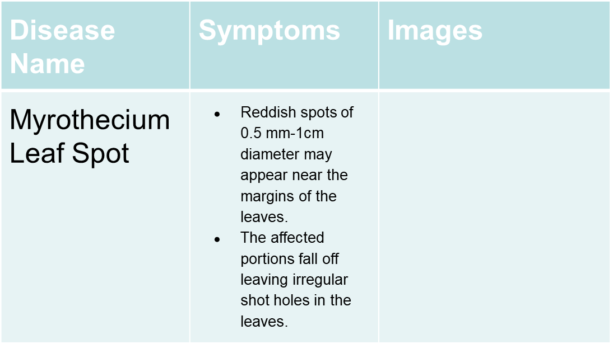**COTTON LEAF DISEASES:**

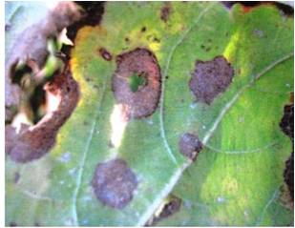

Table 1:Myrothecium Leaf Spot

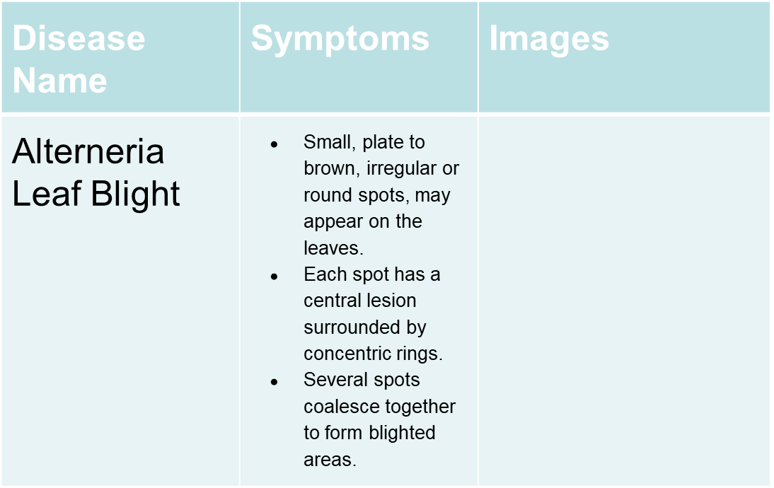

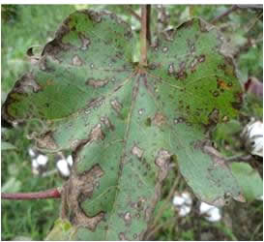

Table 2: Alternaria Leaf Spot

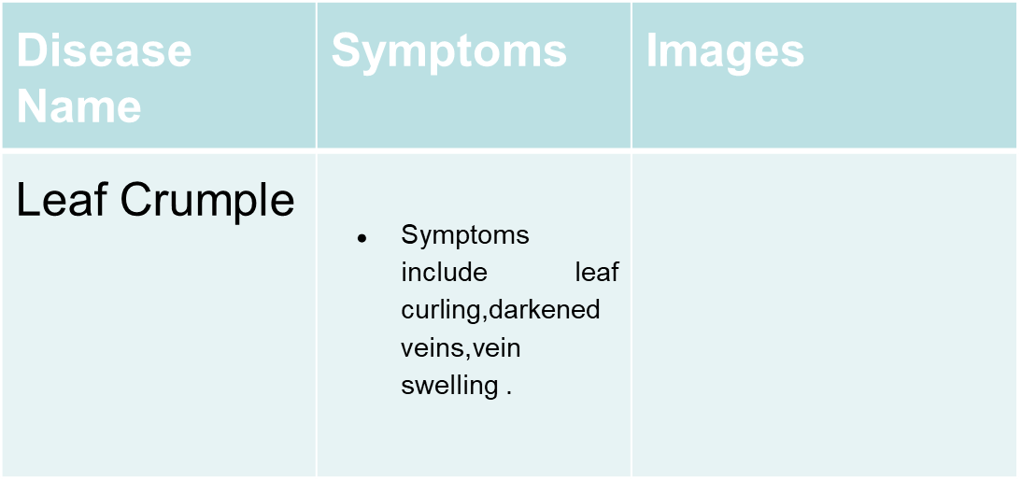

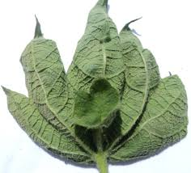

Table 3: Leaf Crumple

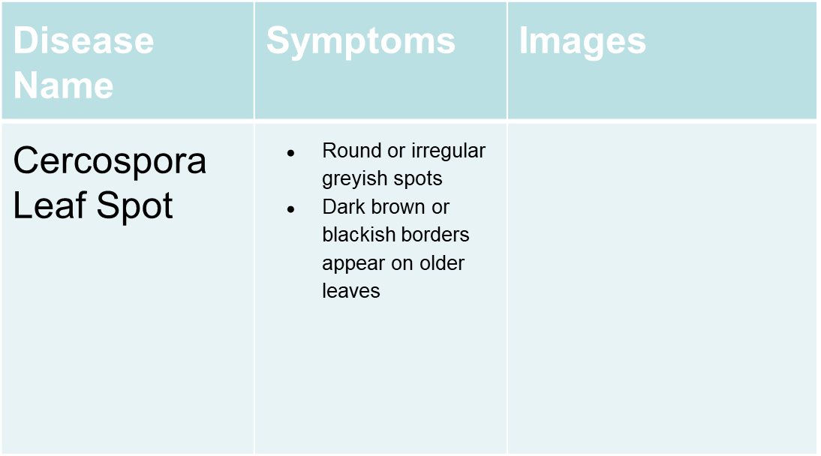

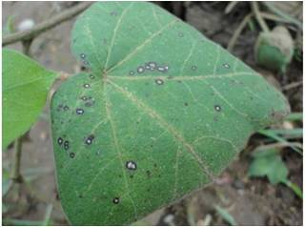

Table 4: Cercospora Leaf Spot

The development of controlled environment farming demands the monitoring of plants regularly for automatic disease detection. Early detection of disease allows better disease control without using pesticides. Hence there is a rise in the need of automatic disease detection using computer vision and image processing algorithms. The leaf images are captured using cameras and processed to extract features that will help in identification of diseases. Various Machine learning algorithms have emerged to increase the accuracy of the system.

**1.2 Problem Statement**

The intention of this project is to provide an efficient detection method that would take an image of cotton leaf as input and then provides the output with classified disease. The project uses image processing techniques such as segmentation and feature extraction for the classification task. This system will be implemented for the four cotton diseases mentioned above.

**1.3 Specific Objectives**

Considering the present trends that had emerged in deep learning and machine, Deep learning algorithms requires large number of datasets for better accuracy and efficiency, whereas machine learning algorithms requires more precise specification of features. For smaller datasets machine learning algorithms can give us better results if provided with more specific features. This project aims in identifying appropriate features for better cotton plant disease detection.

Many Image processing algorithms perform better when the environmental conditions such as lighting, position and distance of the camera etc. remain the same and performs poorly when the conditions change. This requires the extraction of invariant features and machine learning algorithms to achieve better accuracy.

In this project, input image is pre-processed to extract necessary details and are given to machine learning algorithms for classification of cotton disease. The image is resized to a common dimension and fed to different classifiers such as Naïve bayes, Decision tree, KNN and their performance are analyzed. Since the most of the images contain non leaf area, K means clustering algorithm is applied for segmenting the image. Features are to be extracted from cluster of an image and classification of the disease is to be done by using better classifier.

**1.4 Limitations**

* To maintain consistent accuracy of this application we have considered only the four major diseases that occur in cotton crops.
* Since Image processing algorithms are used, the input images should contain majorly the diseased leaf region.
* Implementing this on a larger scale would require a very large database of various crop diseases.

**CHAPTER 2**

**LITERATURE SURVEY**

[1] The main objective of this is to study different types of techniques to detect diseases and to develop a simple algorithm. The diseases that affect the cotton crop in large amount are Red Spot, White Spot and Leaf Crumple.

Generally, the Image processing technique is based on 5 important steps i.e. Image Acquisition, Image Pre-processing, OTSU Global Thresholding method(for segmentation), Color Co-occurrence method (for Feature Extraction), Multi SVM(for Classification).

A total of 103 cotton leaf images are collected out of which 23 are healthy remaining are diseased images. As we go through this paper we come to some advantages and disadvantages, the proposed method has high recognition accuracy but this method only works on leaf diseases and it detects only the main three diseases.

[2] To reduce the cost of farming and to identify the disease at early stages they introduced Android Application. After defining which type of disease it is they further plan on how to recover or how to prevent from infection or viruses. The diseases it mainly concentrated are Bacterial Blight, Fusarium Wilt, Leaf Blight, Root Rot, Nutrient Deficiency, Verticillium Wilt.

The five major steps implemented are namely: Capture the image from the camera (image acquisition),Scaling Process, Color Transformation, Adaptive Thresholding (pre-processing) , image segmentation, feature extraction and classification. The techniques used are Erosion & Dilation methods (for Edge detection), SVM-GA classifier (for classification using SVM).

This SVM-GA Classifier has an accuracy of 99.3%. The Advantage with this paper is in this they are comparing the accuracy for all the existing classifiers and their proposed classifier classifies several cotton diseases.

[3] Image processing is used in the agriculture for detecting veins, texture and colour of plant leaf. In cotton plants, approximately 90 per cent of diseases are on cotton leaves. Cotton leaves are mainly suffered from diseases like Alternaria leaf spot, Fungus, Foliar leaf spot etc.

The steps implemented are Image Acquisition(collecting diseased leaf images),Image Segmentation(k-means clustering),Feature Extraction(Discrete Wavelet Transform),Feature Extraction (PCA Algorithm),Classification(Back propagation Neural Network).

Images captured are given to this algorithm. The proposed algorithm has an accuracy of 97%. It is still a theory and it needs to be implemented in real-time.

[4] This paper gives techniques for identifying plant diseases using Image Processing. The steps for plant disease detection are Image Pre-processing(Image Scaling for Resizing Image), Image Segmentation(K-Means Clustering), Feature Extraction (Morphological Operations), Detection and Classification of plant diseases (Deep Learning Algorithm).

They proposed a system which detects the leaf diseases where the images are captured from the mobile phone. The Advantages of this system are Accuracy is improved with this proposed algorithm and it is very fast as compared to other algorithms. One can get more accurate results by increasing the layers of the deep learning algorithm.

[5] In farming, finding the disease in its early stage is important. Automatic detection of leaf diseases is the most important research topic and it detects the diseases from the symptoms that present on the plant leaves. The diseases identified are Alternaria Atternata, Anthracnose, Bactorial blight.

The steps for the proposed system are Identify one healthy and infected leaf images, image pre-processing(Extracting features), Image segmentation(K-Mean clustering), Image classification(SVM classifier), comparison of healthy and infected leaf and finally disease detection.

The advantages of this system are we can easily classify the disease and the computation is fast. Disadvantages is that the proposed system is limited to just 3 diseases only.

[6] Plant diseases cause economic losses and damage to crops. Reduction of diseases in early stages may result in improvement in the quality of the product. A lot of cotton crop yield is lost every year due to pests and insects. Infected plants can show a lot of symptoms such as abnormal leaf growth, stunted growth, colour distortion, rots and damaged pods.

The techniques used are Image Acquisition (Collecting Images), Image pre-processing(Median filtering technique),Image Segmentation(Spatial FCM clustering),Image classification(PNN classifier).Spatial FCM is a powerful method for noisy image segmentation.

The advantages of this methodology are it yields regions more homogeneous than those of other methods. It reduces spurious blobs. The Disadvantage is time complexity of FCM technique is very high when compared to K-means Clustering.

[7] Identifying plant disease is very difficult in agriculture. If anything went wrong there will be a huge loss. So, it is important to identify disease clearly.

The proposed methodology is Image Acquisition(loading the image), Image pre-processing (Contrast enhancement, converting RGB to HSI), Image Segmentation(K-Means Clustering Algorithm), Extracting of features, Image Classification(SVM Algorithm).

The advantages of this system are the user can know the affected area of a leaf in percentage by identifying the disease properly. Disadvantages are the proposed system is not applicable to all cotton diseases.

[8] Generally, the crops are destroyed mainly of two reasons. They are pathogens (98% of destruction) and Natural Calamities(2% of destruction).So, there is a need for plant disease detection. Various researches in this field concluded that Image processing gives better results than any other.

The techniques used are Image Acquisition(Collecting images),Image Pre -processing( Image smoothing, Image Enhancement), Image segmentation(Otsu's method, K- means clustering),Feature Extraction, Image classification(SVM classifier).

The Advantages are after detection of the disease the name of pesticide will be sent to our mobile with the help of GSM. The Disadvantages are it is limited to main diseases only.

[9] Monitoring the health of plants plays an important role in the cultivation of crops. If the disease detection is done manually it will take a time to identify the disease and there is a need for technical expertise.so there is a need for automated software.

The proposed methodology has 5 steps for detecting the disease. Image Acquisition, Image pre-processing( Removing noise by image clipping and Histogram equalization ), Image Segmentation(K- Means clustering and Otsu's methodology), Feature Extraction, Image Classification(ANN and Back propagation algorithm).

The advantage for this methodology is the loss to the product is been avoided by detecting the disease at the initial stage and disadvantage is it takes more time to get the results.

[10] Cotton one of the important cash crops of the country and also called “The White Gold”. So, it is important to take necessary actions to prevent the cotton plant from pesticides. The general diseases occur on cotton leaves are Bacterial disease (Bacterial Blight, Crown Gall, Lint Degradation), Fungal diseases (Anthracnose, Leaf Spot), Viral disease (Leaf Curl, Leaf Crumple, Leaf Roll).

The image processing techniques used are Image Acquisition(Capturing leaf images), Image pre-processing(used histogram equalization to increase the contrast of Image), Image Segmentation(k means clustering algorithm), Feature Extraction, image classification( Neural network to identify the disease).

The advantages are the Classification of diseases can be done easily and the accuracy is also high. The disadvantages are The proposed system is not applicable to all cotton diseases.

[11] Cotton is the important crop of India. The main cause for disease is its leaf part. About 80% of disease on the cotton plant is on its leaves. The various diseases recognize on the cotton leaf spots are classified as Grey mildew, Bacterial blight, Leaf curl, Fusarium wilt, Verticillium Wilt.

The Proposed methodology is Image Acquisition, Image Pre processing(used OTSU’s Segmentation and Morphological operations),Feature Extraction(shape and color), Statistical Analysis, Image classification(SVM classifier).

The advantage of this system is they are comparing the accuracy for all the existing classifiers and their proposed classifier for several cotton diseases and disadvantage is it can only identify cotton leaf spot diseases.

[12] The diseases that occur on the cotton plant are Red spot disease, White spot disease, Crumple leaf disease.

The steps for the proposed model are Image Acquisition, Image pre-processing, Image Segmentation, Feature Extraction(Hue saturation value(HSV) used for colour extraction),Image classification(error back propagation neural network). They have utilized pattern recognition techniques for disease detection.

The advantage of this model is this paper will give information about the possible diseases and the treatment to provide and disadvantage is it is a slow process.

**CHAPTER 3**

**SYSTEM SPECIFICATION**

The proposed system requires the following specifications:

Software requirements:

* Mat lab R2014b
* R Studio

Hardware requirements:

* RAM- 4GB and above.
* Processor- i5 and above.

**CHAPTER 4**

**ARCHITECTURE**

DATASET

IMAGE ACQUISITION

IMAGE SEGMENTATION

IMAGEPREPROCESSING

FEATURE EXTRACTION

CLASSIFICATION

The leaf spots are the major indication for this group of disease. Since the leaf spots can be identified from the color, simple segmentation algorithms are sufficient to identify leaf spots.

The individual category of cercospora leaf spot, myrothecium leaf spot and alternaria leaf spot can be identified based on the number of leaf spots and their sizes. So features are extracted from these leaf spots to identify the correct class.

**4.1 Leaf spot segmentation and Feature extraction**

Cotton leaf images at various resolutions for different diseases are stored in the dataset. An image of a cotton leaf is loaded from the dataset. During pre-processing, the contrast of the image is enhanced. The RGB image is converted to LAB colour image, which is later on converted into Black and White (BW) image. Morphological closing is applied to the complemented BW image using the structural element as specified by (1)

(1)

Closing of an image A is dilation of A by B which is followed by erosion on that image by B. Here A is cotton disease leaf and B is disk structural element.

The features from the given cotton leaf image are extracted using connected components algorithm. The properties eccentricity, major axis length, area of each connected components are determined and stored as features. These features are fed as input to the classifiers for identifying the disease.

**4.2 Classification of Leaf spot diseases**

KNN classifier, Naive Bayes and decision tree algorithms are used for classification. Given a set of sample leaf images with a disease label whose features are extracted and stored in the knowledge base. The input image is pre-processed, features are extracted and given as input to the classifiers.

**4.2.1 KNN classifier**

The KNN Classifier computes the distance of the test sample with the knowledge base to determine k closest samples, from which the disease label is given. In this classifier, Euclidean distance is used to find the distance between the features P and Q. Let P and Q be denoted by feature vectors P = (x1, x2, …, xm.) and Q = (y1, y2, …, ym), where m is the dimensionality of the feature space. The distance between P and Q is calculated by (2).

(2)

Here, the value of k is taken as 3.

**4.2.2 Bayes classifier**

The probability of a feature vector belonging to a known sample is calculated as posterior probability and class labels are assigned accordingly. Posterior probability can be calculated by (3).

(3)

where

X is the feature.

is the class i.e cotton leaf disease.

P(|X) is the posterior probability of class conditioned on X.

P(X|) is the probability of X conditioned on class .

P(X) is the prior probability of X.

Class label is assigned based on (4).

 (4)

**4.2.3 Decision tree classifier**

This is a hierarchical classification algorithm in which the ranking of features using their information gain. This classifier assigns the class label using tree representation. Each internal node of the tree represents an attribute, and each leaf node represents a class label. Information gain is used as an attribute selection measure. Information gain is calculated by (5).

(5)

D is the data. is the probability that a tuple in D belongs to class .

**4.3 Leaf Crumple disease identification**

Since the leaf crumple does not have clear colour distinction from that of normal region, suitable algorithm to differentiate them has to be used before segmentation and feature extraction. In this paper, histogram equalization on the colour component is performed to bring out the distinction between leaf crumple and normal leaf parts.

The RGB image of leaf crumple diseased cotton leaf is converted into HSI image. Then Histogram equalization is applied on the H and S part of HSI image.

**4.3.1 Histogram equalization Algorithm:**

1. Derive intensity mapping for image pixel data by finding the frequency of the intensity values.
2. Calculate the probability of occurrence of a pixel for all the gray scale levels by (6)

(6)

is the probability of occurrence of a pixel at level i.

is the frequency in the level i.

is the total frequency.

3. Calculate the cumulative distribution function for all the gray scale levels by (7).

(7)

is cumulative distribution function value at level i.

is the probability of occurrence of a pixel at level j.

1. Then cdf is normalized to [0,255] i.e. histogram equalization is done by (8)

(8)

is cumulative distribution function value at level k.

is minimum cumulative distribution function value.

is number of pixels in image.

L is total number of gray levels.

Otsu segmentation is applied on the output image of histogram equalization.

**4.3.2 Otsu segmentation algorithm:**

1. Compute histogram and probabilities for each intensity level.
2. Initialize the class probability and class means to 0.
3. Step through all possible thresholds.
4. Update class probability and class means.
5. Compute the inter class variance.

4. Desired threshold corresponds to the maximum value of inter class variance.

Then edge detection algorithm is applied on the segmented image.

**4.3.3 Edge detection Algorithm:**

1. Remove the noise without affecting the true edges.
2. Apply a filter to enhance the quality of the edges in an image.
3. Using thresholding, determine which edge pixels should be discarded as noise and which should be retained.
4. Determine the exact location of the edge using edge thinning and linking.

{\displaystyle d(\mathbf {p} ,\mathbf {q} )={\sqrt {(q_{1}-p_{1})^{2}+(q_{2}-p_{2})^{2}}}.}

**CHAPTER 5**

**RESULTS AND DISCUSSIONS**

Cotton leaf image is taken as input and it is checked whether the given image contains spots by considering the threshold range of h-part as [0.08, 0.12] and I-part as [0.16, 0.33] of HSI image.

**5.1 Results of cercospora leaf spot:**

Cotton leaf with cercospora leaf spot disease is taken as input and pre-processing is done by enhancing contrast. The result is shown in Fig.5.1 (a) and (b).

(a) (b)

Fig. 5.1 (a) Input image (b) Contrast enhanced image

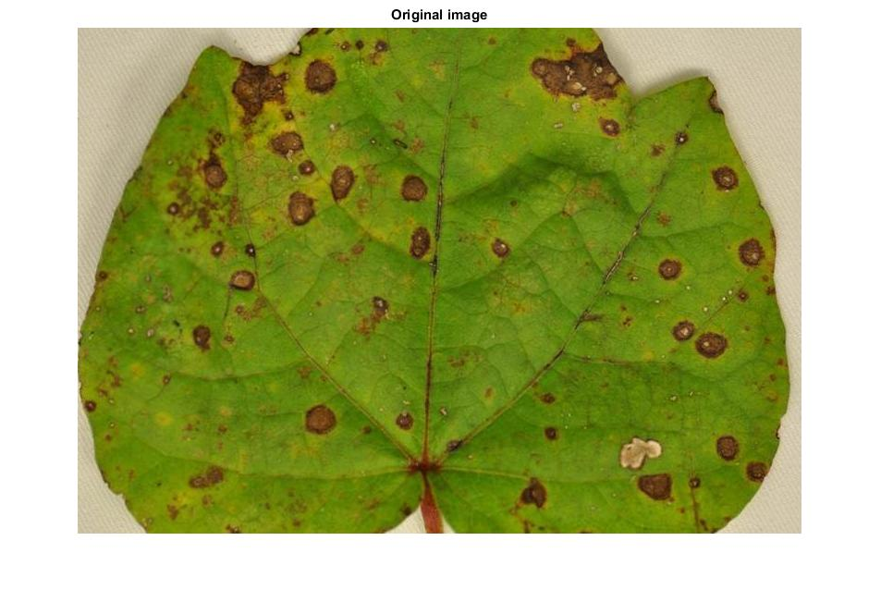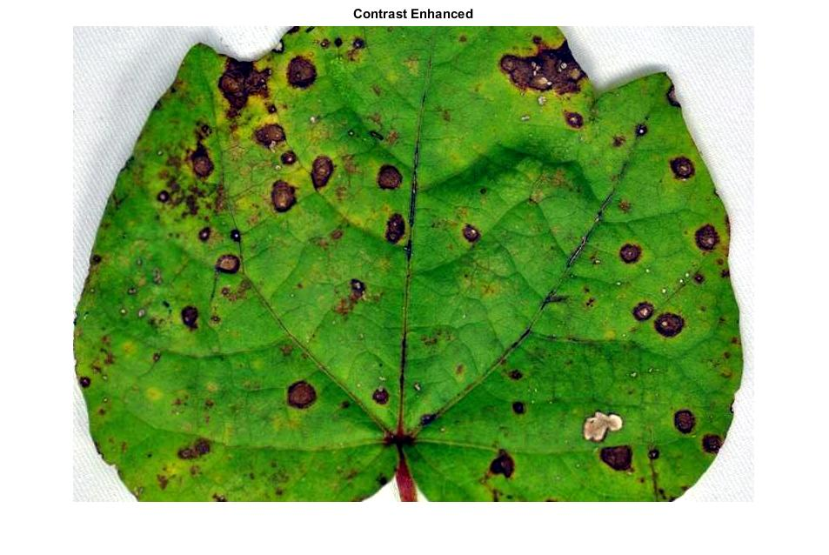

RGB image in Fig. 5.1(b) is converted to lab color space image. ’a’ component is extracted from lab image. The result is shown in Fig. 5.2 (a) and (b).

(a) (b)

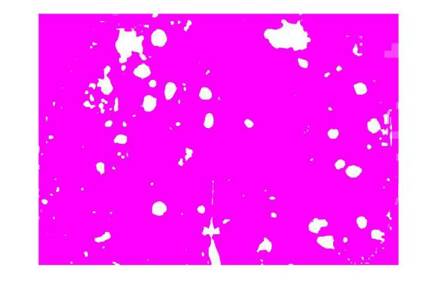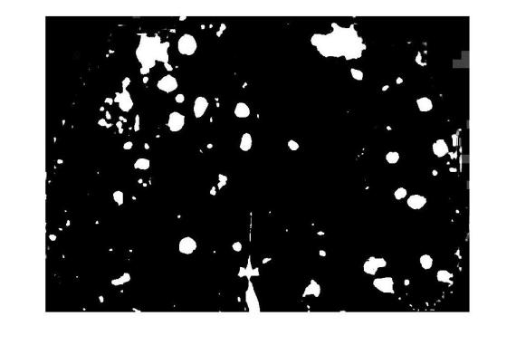

Fig 5.2 (a) Lab converted image (b)’a’ component in Lab image.

Fig. 5.2(b) is converted into BW image. Then complement is applied on that image. The result is shown in Fig. 5.3 (a) and (b).

1. (b)

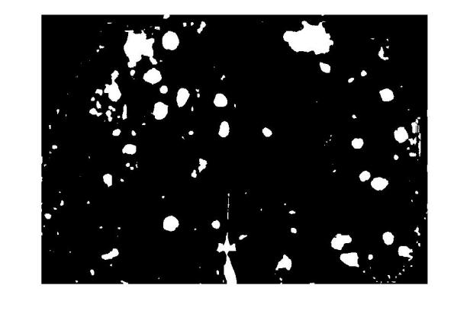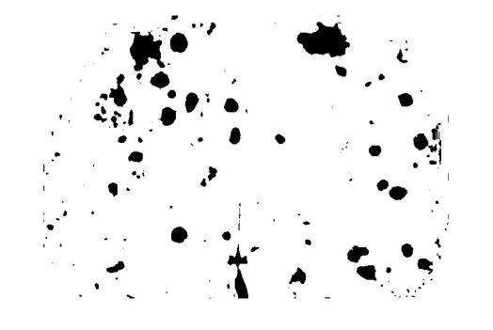

Fig. 5.3 (a) BW image (b)Complement of BW image

Morphological closing is applied on Fig. 5.3(b) using disk structural element. Then complement is applied on the output image. The result is shown in Fig. 5.4 (a) and (b).

1. (b)

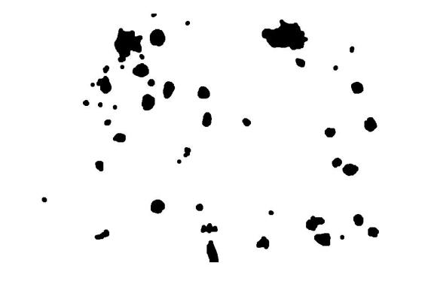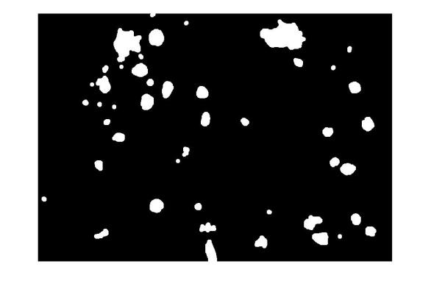

Fig. 5.4 (a) Morphological closing (b)Complement of Morphological closing

Components that are attached to the border in Fig. 5.4 (b) are removed. Then the number of spots are calculated and features are extracted using connected components algorithm. Then graph is plotted between the number of spots and features of the components. ( eccentricity ,major axis length, area).

(a)

(b)

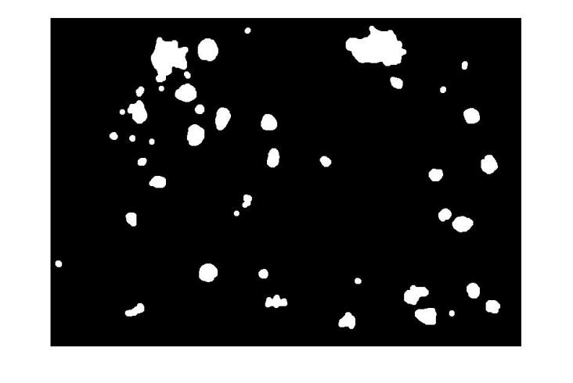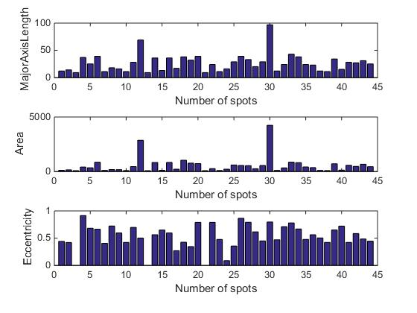

Fig. 5.5 (a)Clearing border (b)plot between number of spots and features.

**5.2 Results of alternaria leaf spot:**

(a) (b)

(c) (d)

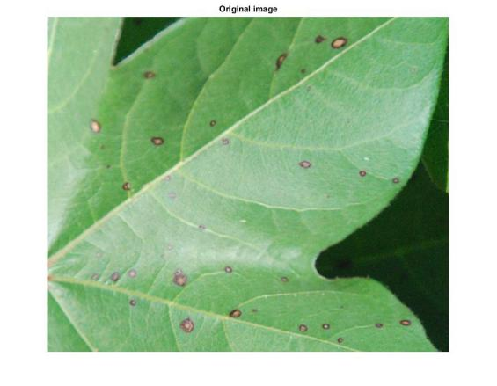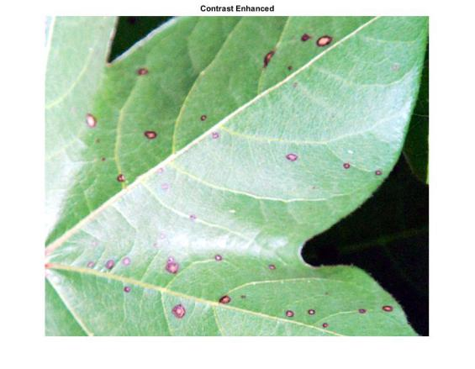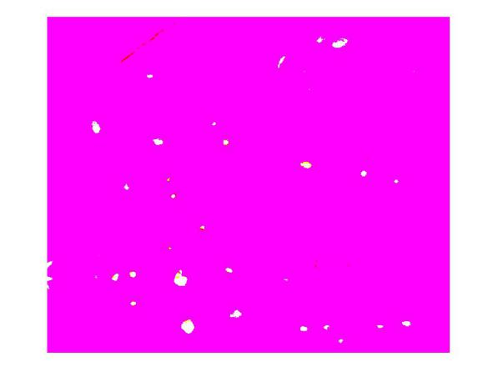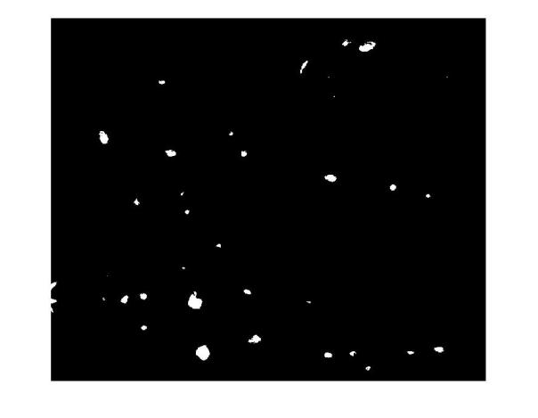

(e) (f)

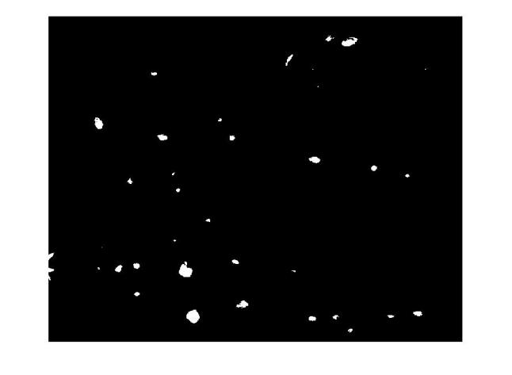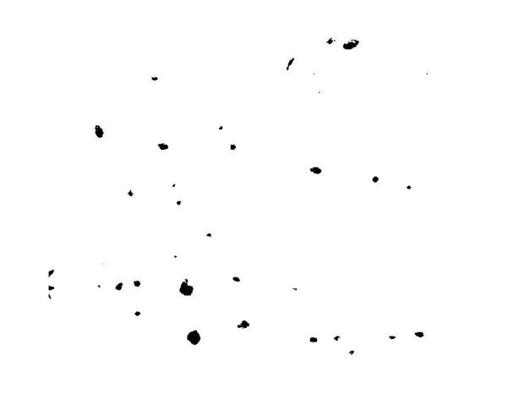

(g) (h)

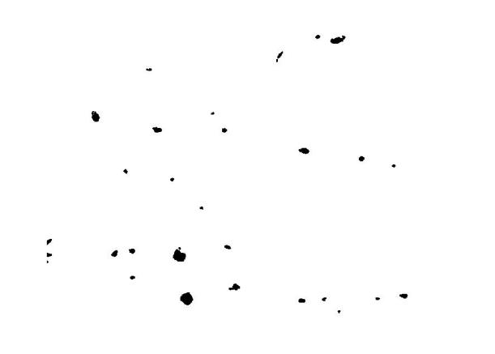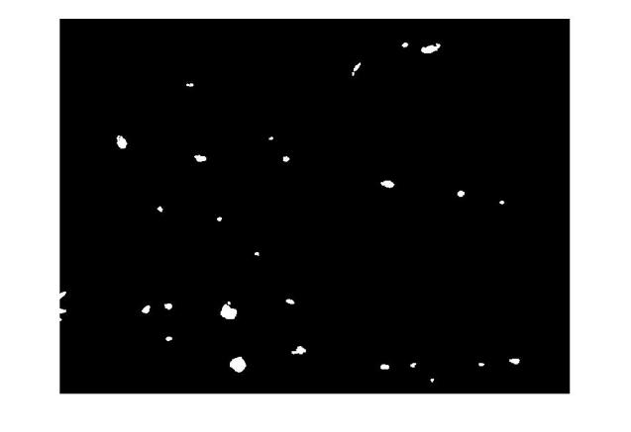

(i)

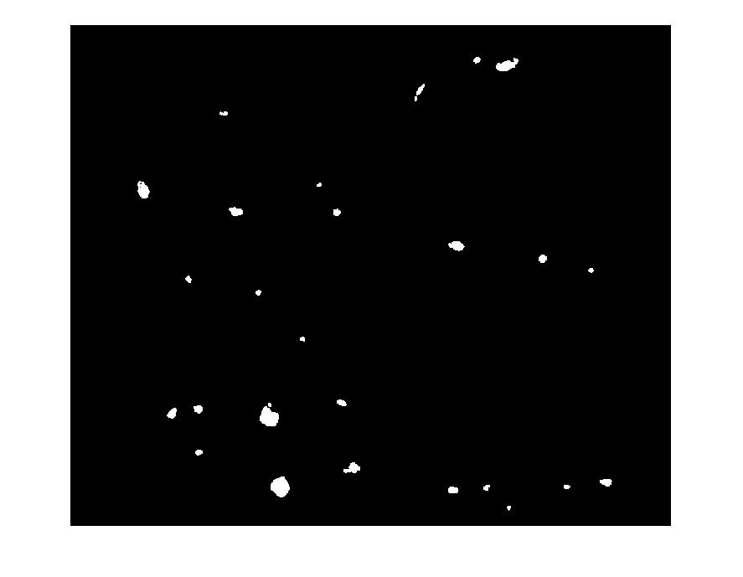

(j)

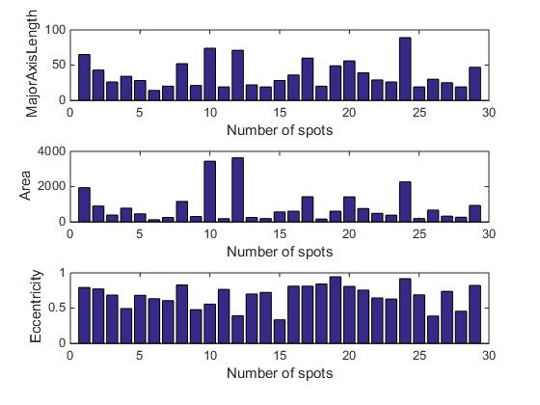

Fig. 5.6 (a) Input image. (b)Contrast enhanced image. (c)Lab converted image. (d)’a’ component in Lab image. (e)BW image (f) Complement of BW image (g) Morphological closing (h) Complement of Morphological closing (i)Clearing border (j)plot between number of spots and features.

**5.3 Results of myrothecium leaf spot**

(a) (b) (c)

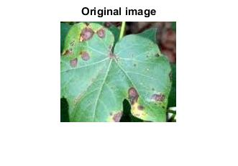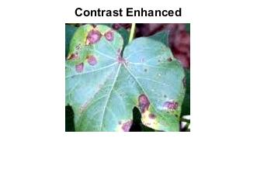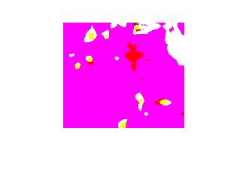

(d) (e) (f)

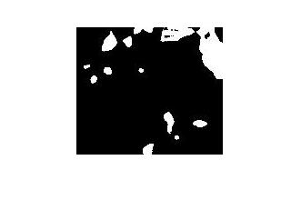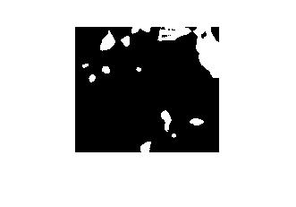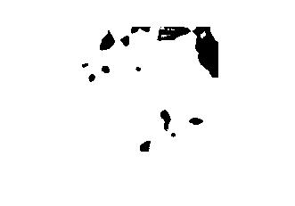

(g) (h)

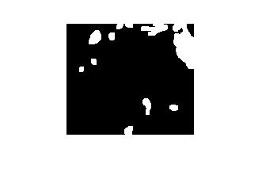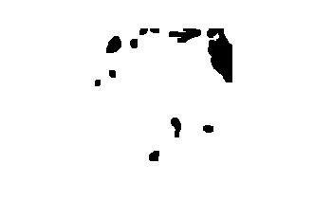

(i)

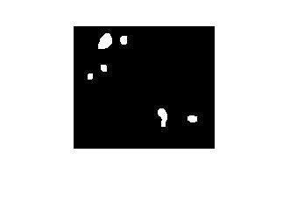

(i)

(j)

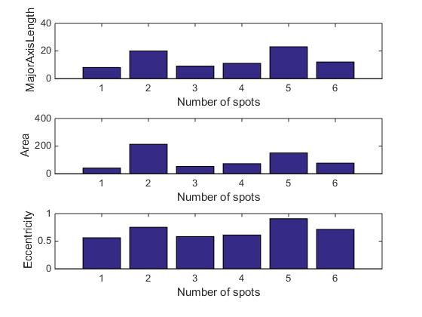

Fig. 5.7 (a)Input image. (b)Contrast enhanced image. (c)Lab converted image. (d)’a’ component in Lab image. (e)BW image (f)Complement of BW image (g)Morphological closing (h)Complement of Morphological closing (i)Clearing border (j)plot between number of spots and features.

**5.4 Results of classification of leaf spot diseases**

The dataset of this project contains 18 images for each disease (4 diseases). The features are extracted from the image which is obtained by multiplying HSI image and connected components image and sent in to csv file. In this file, 70% of the data is taken as training set and 30% of the data is taken as testing set. Class labels a, c, m are Alternaria leaf spot, cercospora leaf spot and Myrothecium leaf spot respectively. Three classifiers namely KNN, Naive Bayes and Decision tree are applied to the dataset. The following are the results for the 3 Classifiers.

**5.4.1 KNN classifier**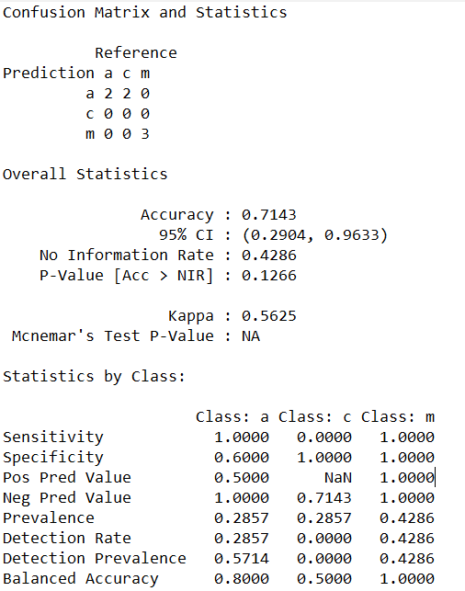

Fig. 5.8 confusion matrix for KNN

**5.4.2 Decision tree classifier**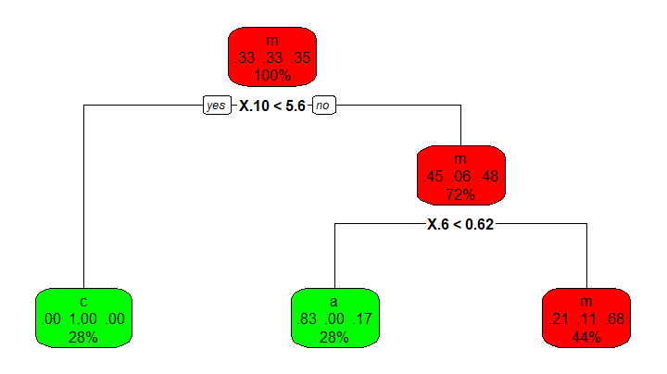

Fig. 5.9 Decision tree

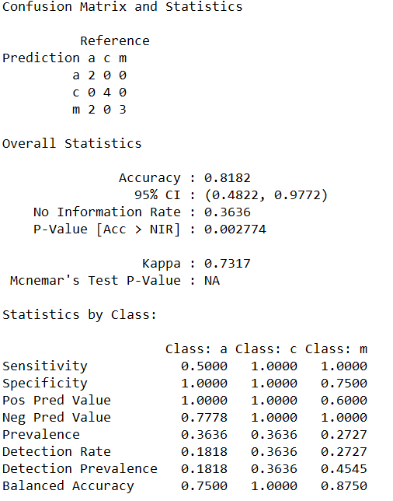

Fig. 5.10 confusion matrix for Decision tree

**5.4.3 Naive bayes classifier**

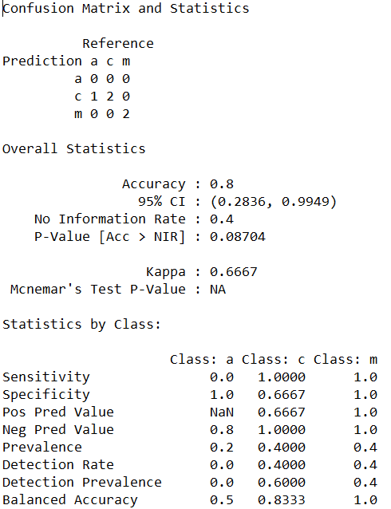

Fig. 5.11 confusion matrix for Naive Bayes

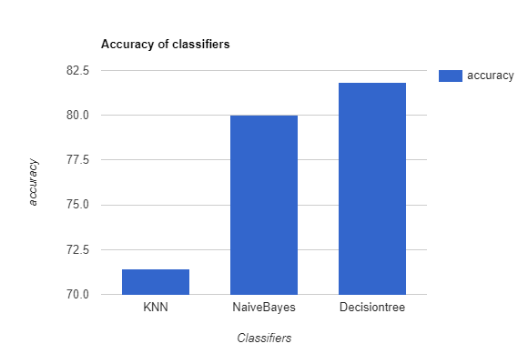

Fig. 5.12 Plot between classifiers and accuracy

By observing the results of the classifiers, it could be seen that all of them performed with accuracy more than 70%. Decision tree gives high accuracy with 81.82% and Naive Bayes with 80%. Sensitivity, Specificity values are high for Decision tree classifier. According to the results obtained, accuracy of naive bayes and decision tree are nearly same.

The results of classifiers that are obtained by considering the features which are extracted from the image which is obtained by multiplying LAB image and connected components image are shown in column3 of Table 5 and Fig. 5.13.

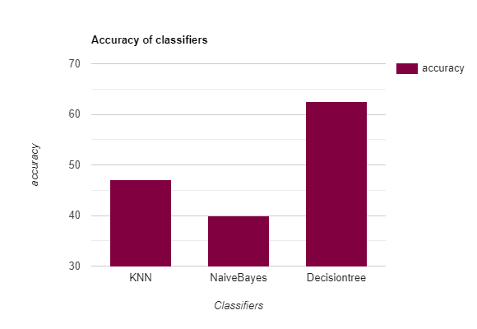

Fig. 5.13 Plot between classifiers and accuracy

The results of classifiers that are obtained by considering pixel values of the original image as features are shown in column4 of Table 5 and Fig. 5.14.

|  |  |  |  |
| --- | --- | --- | --- |
| **Classifiers** | **Accuracy for**  **HSI image features** | **Accuracy for**  **LAB image features** | **Accuracy for**  **Original image features** |
| KNN | 71.43% | 47.06% | 35.29% |
| Naive Bayes | 80% | 40% | 21.43% |
| Decision tree | 81.82% | 62.5% | 36.36% |

Table 5: Classification output

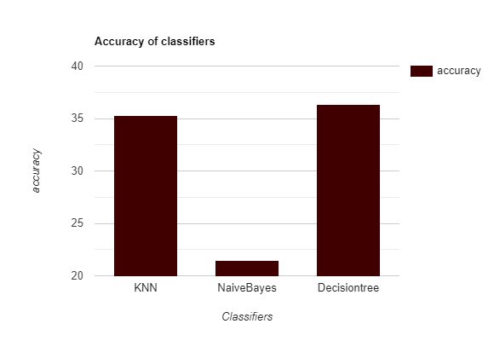

Fig. 5.14 Plot between classifiers and accuracy

By observing the accuracy of classifiers in Table 5, it could be seen that accuracy for classifiers is more in the case of considering the HSI image features. So, these features can be used for better classification of leaf spot diseases.

**5.5 Results of Leaf crumple disease**

Cotton leaf with leaf crumple disease is taken as input and converted to HSI image. The result is shown in Fig. 5.15 (a) and (b).

(a) (b)

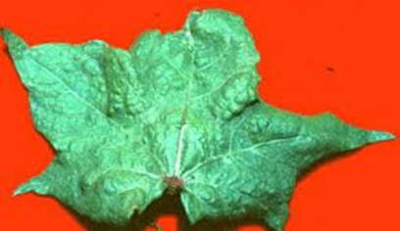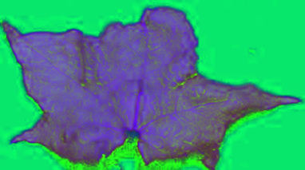

Fig. 5.15 (a) Crumple leaf input image (b) HSI Image of the Crumple leaf

H-Part and S-Part from the HSI image in Fig. 5.15(b) are extracted and both parts are combined. The results are shown in Fig. 5.16 (a), (b) and (c).

1. (b)

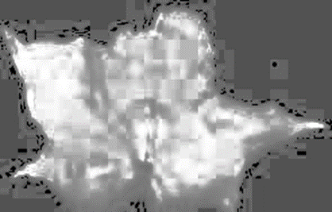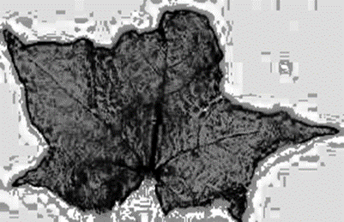

(c)

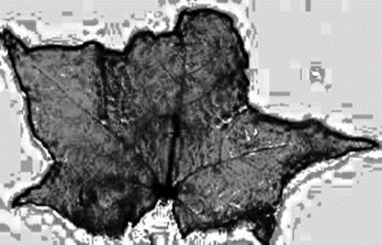

Fig. 5.16(a) H-Part of HSI image (b) S-part of HSI image

(c) H&S – part of HSI image

Apply OTSU segmentation on Fig. 5.16(c) and then apply edge detection on the segmented image. The result is shown in Fig. 5.17 (a) and (b).

1. (b)

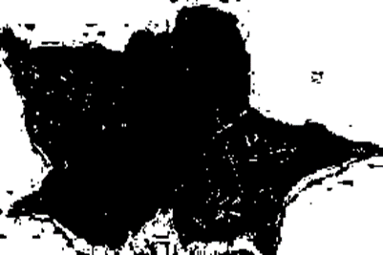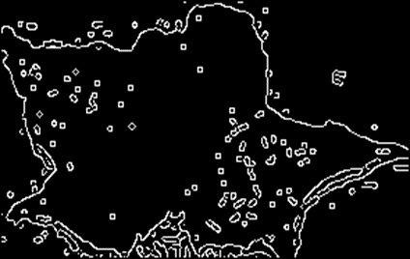

Fig 5.17(a) OTSU segmented image (b): Applying Canny edge detection on segmented image

Cotton leaf image with crumple disease is taken as input Fig.5.15 (a). The leaf image is converted to grey scale image and then the gradient of the image is calculated. The results are shown in Fig. 5.18 (a) and (b).

(a) (b)

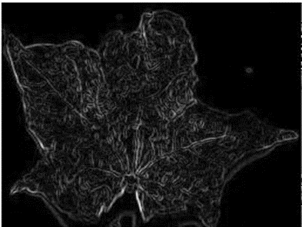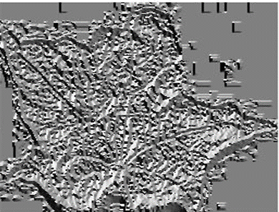

Fig. 5.18 a) Gradient of Crumpled leaf b) Magnitude of Crumpled leaf

The histograms of both the magnitude and direction of the crumpled leaf image are drawn. The results are shown in Fig. 5.19 (a) and (b).

(a)

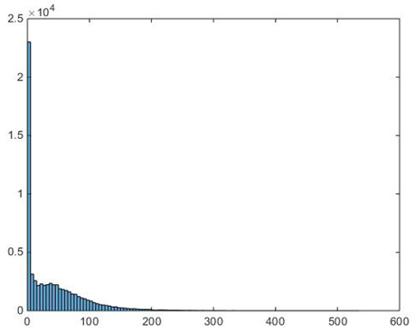

(b)

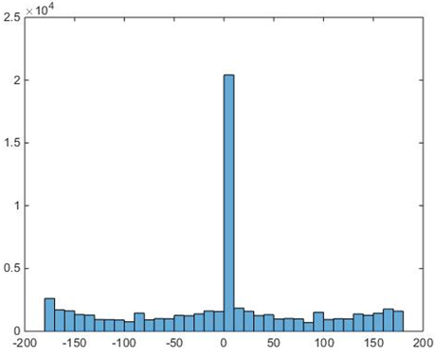

Fig. 5.19 (a) Histogram for the magnitude of crumple leaf (b) Histogram for the direction of crumple leaf

Similarly, the same process is done for the normal cotton leaf

.

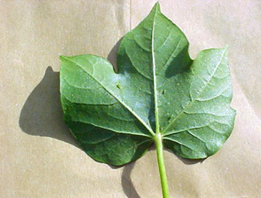

Fig. 5.20 Normal cotton leaf

1. (b)

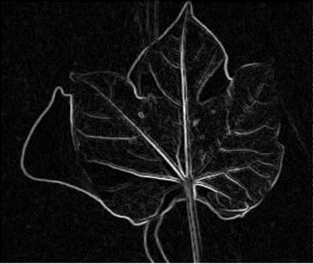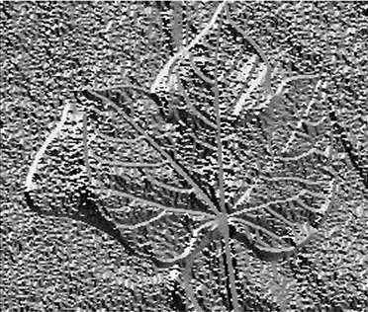

(c)

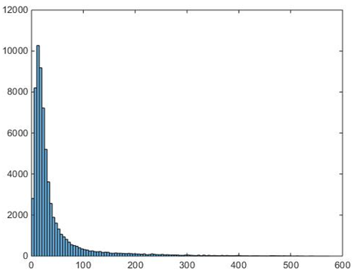

(d)

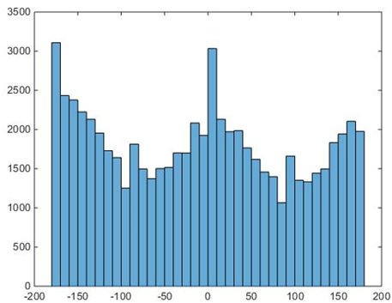

Fig. 5.21 a) Gradient of Normal leaf b) Magnitude of Normal leaf c)Histogram for the magnitude of Normal leaf d) Histogram for the direction of Normal leaf

The results of the standard deviation of magnitude and direction of normal and crumple leaves are shown in Table 6.

|  |  |
| --- | --- |
|  | Standard Deviation |
| Magnitude of Crumple leaf | 48.2 |
| Magnitude of Normal leaf | 60.2 |
| Direction of Crumple leaf | 91.6 |
| Direction of Normal leaf | 107.4 |

Table 6: Standard Deviations

When the cotton leaf image is given as input, the gradient of the image is calculated. If the standard deviation of Magnitude and Direction of leaf is less than 50 and 100 respectively then the leaf is crumple leaf.

**CHAPTER 6**

**CONCLUSION**

Automatic disease identification from the image is the need in agricultural research. The proposed algorithm classifies four cotton diseases. For the identification of spot diseases in cotton plant, leaf input image is taken and features are extracted from HSI and connected components images. The performance of Naive Bayes, KNN, and Decision Tree classifiers are analysed and the disease is identified. For the crumple disease identification, the gradient of the input image is calculated and based on standard deviation of gradient magnitude and gradient direction the leaf is classified.

Disease identification without damaging the plant demands the disease identification from the major plant part that is exposed. Hence in this project the leaf part is considered for disease identification. Disease without much colour variation in leaf is a challenging case for image processing algorithms. This challenge can be tackled by using image enhancement techniques in appropriate colour model. Simple features extracted from the leaves show the improvement in performance of the classifiers. For the future work, the accuracy of the classifiers can be improved by extracting more features from the cotton leaf.

**REFERENCES**

1. Supriya S. Patki, Dr G. S. Sable, ”Cotton Leaf Disease Detection & Classification using Multi SVM ”, International Journal of Advanced Research in Computer and Communication Engineering, Vol. 5, Issue 10, October 2016.
2. A.Sivasangari, K.priya, K. Indira,” Cotton Leaf Disease Detection and Recovery Using Genetic Algorithm”, International Journal of Pure and Applied Mathematics, Volume 117 No.22, 2017.
3. Vivek Chaudhari, C. Y. Patil,” Disease Detection of Cotton Leaves Using Advanced Image Processing ”, International Journal of Advanced Computer Research, Volume-4 Number-2 Issue-15 June-2014.
4. Shweta R. Astonkar1, Dr V. K. Shandilya2, ”Detection and Analysis of Plant Diseases Using Image Processing Technique ”, International Research Journal of Engineering and Technology, Volume: 05 Issue: 04 Apr-2018.
5. Rakesh Chaware, Rohit Karpe, Prithvi Pakhale, Prof.SmitaDesai4, ”Detection and Recognition of Leaf Disease Using Image Processing ”, IJESC, Volume 7 Issue No.5.
6. Premalatha.V, Valarmathy.S, Sumithra.M.G, “Disease Identification in Cotton Plants UsingSpatial FCM & PNN Classifier”, International Journal of Innovative Research in Computer and Communication Engineering, Vol. 3, Issue 4, April 2015.
7. Sujatha R, Y Sravan Kumar Garine Uma Akhil .” Leaf disease detection using image processing ”, Journal of Chemical and Pharmaceutical Sciences, Volume 10 Issue 1 January - March 2017.
8. Pallavi.S.Marathe,” Plant Disease Detection using Digital Image Processing and GSM ”, IJESC, Volume 7 Issue No.4 April 2017.
9. Ms.Nidhi Rajesh Savaji, Vrushabh khandelwal, Kalyani Bhawar, Punam Wankhede, Ravi Kiran Rajbhure,” Plant Disease Detection Using Image Processing”,IJCESR, Volume-5, Issue-3, 2018.
10. Vijay S.Bhong, Prof.B.V.Pawar,” Study and Analysis of Cotton Leaf Disease Detection Using Image Processing”, IJARSET, Vol. 3, Issue 2, February 2016.
11. Prof. Sonal P. Patil, Ms Rupali S.Zambre,” Classification of Cotton Leaf Spot Disease Using Support Vector Machine”, IJERA, Vol. 4, Issue 5( Version 1), May 2014.
12. Mr.Chandrakant Deelip Kokane, Prof.N.L.Bhale, “To Detect and Identify Cotton leaf disease based on the pattern recognition technique”, IJARIIE, Volume-3 Issue-4, 2017.

**PUBLICATIONS**

Anushreddy Kommareddy,Chetansai Kurra,Mithunchandra Pokuri,Satyaanirudh Polisetty,Padmavathi S, “Image based Identification of Leaf crumple and Leaf spot diseases in Cotton plant“ International Journal of Recent Technology and Engineering (IJRTE). **/ Accepted /Submitted**