CREDVAULT: SECURITY-FIRST CREDENTIAL VAULT WITH ACCESS MONITORING AND INCIDENT RESPONSE

A PROJECT BASED LEARNING (PBL) REPORT
Submitted
by
K TANUJA RAJALAKSHMI (2104251040382)
PAVITHRA V (21042510410677)
Submitted in partial fulfilment of the requirements
for the
Project-Based Learning component of Java Programming

BACHELOR OF ENGINEERING

in

COMPUTER SCIENCE AND ENGINEERING


CHENNAI INSTITUTE OF TECHNOLOGY
(Autonomous)

Affiliated to Anna University, Chennai
October - 2026

Vision of the Institute:

To be an eminent centre for Academia, Industry and Research by imparting knowledge, relevant practices and inculcating human values to address global challenges through novelty and sustainability.

Mission of the Institute:

IM1. To creates next generation leaders by effective teaching learning
methodologies and in still Scientifics park in them to meet the global challenges.
IM2. To transform lives through deployment of emerging technology, novelty and sustainability.
IM3. To inculcate human values and ethical principles to cater the societal needs.
IM4. To contributes towards the research ecosystem by providing a suitable,
effective platform for interaction between industry, academia and R&D establishments.
IM5: To nurture incubation centers enabling structured entrepreneurship and start-ups

DEPARTMENT OF

COMPUTER SCIENCE AND ENGINEERING

Vision of the Department:

To Excel in the emerging areas of Computer Science and Engineering by imparting knowledge, relevant practices and inculcating human values to transform the students as potential resources to contribute innovatively through advanced computing in real time situations.

Mission of the Department:

DM1. To provide strong fundamentals and technical skills for Computer Science
applications through effective teaching learning methodologies.
DM2. To transform lives of the students by nurturing ethical values, creativity and novelty to become Entrepreneurs and establish start-ups.
DM3. To habituate the students to focus on sustainable solutions to improve the quality of life and the welfare of the society.
DM4: To enhance the fabric of research in computing through collaborative linkages with industry and academia.
DM5: To inculcate learning of the emerging technologies to pursue higher studies leading to lifelong learning.

PROGRAM EDUCATIONAL OBJECTIVES (PEO):

PEO 1: Contribute to the industry as an Engineer through sound knowledge acquired in core engineering to develop new processes and implement the solutions for industrial problems.
PEO 2: Establish an organization / industry as an Entrepreneur with professionalism, leadership quality, teamwork, and ethical values to meet the societal needs.
PEO 3: Create a better future by pursuing higher education / research and develop the sustainable products / solutions to meet the demand.

PROGRAM OUTCOMES (POS):
PO1: Engineering Knowledge: Apply knowledge of mathematics, natural science, computing, engineering fundamentals and an engineering specialization to develop to the solution of complex engineering problems.
PO2: Problem Analysis: Identify, formulate, review research literature and analyze complex engineering problems reaching substantiated conclusions with consideration for sustainable development.
PO3: Design/Development of Solutions: Design creative solutions for complex engineering problems and design/develop systems/components/processes to meet identified needs with consideration for the public health and safety, whole-life cost, net zero carbon, culture, society and environment as required
PO4: Conduct Investigations of Complex Problems: Conduct investigations of complex engineering problems using research-based knowledge including design of experiments, modelling, analysis & interpretation of data to provide valid conclusions
PO5: Engineering Tool Usage: Create, select and apply appropriate techniques, resources and modern engineering & IT tools, including prediction and modelling recognizing their limitations to solve complex engineering problems.
PO6: The Engineer and The World: Analyze and evaluate societal and environmental aspects while solving complex engineering problems for its impact on sustainability with reference to economy, health, safety, legal framework, culture and environment.
PO7: Ethics: Apply ethical principles and commit to professional ethics, human values, diversity and inclusion; adhere to national & international laws.
PO8: Individual and Collaborative Team work: Function effectively as an individual, and as a member or leader in diverse/multi-disciplinary teams.
PO9: Communication: Communicate effectively and inclusively within the engineering community and society at large, such as being able to comprehend and write effective reports and design documentation, make effective presentations considering cultural, language, and learning differences.
PO10: Project Management and Finance: Apply knowledge and understanding of engineering management principles and economic decision-making and apply these to one’s own work, as a member and leader in a team, and to manage projects and in multidisciplinary environments.
PO11: Life-Long Learning: Recognize the need for, and have the preparation and ability for i) independent and life-long learning ii) adaptability to new and emerging technologies and iii) critical thinking in the broadest context of technological change.

PROGRAM SPECIFIC OUTCOMES (PSOS):
PSO 1 : Analyze, design and develop solutions in the areas of Business Process Management to build the quality products for industry and social needs.
PSO 2 : Innovate ideas and solutions for real time problems in the field of Software Engineering and Mobile applications by adapting the emerging technologies and tools.

CHENNAI INSTITUTE OF TECHNOLOGY, CHENNAI
(Autonomous)
Affiliated to Anna University, Chennai

BONAFIDE CERTIFICATE

This is to certify that the Project–Based Learning report titled “CREDVAULT: SECURITY-FIRST CREDENTIAL VAULT WITH ACCESS MONITORING AND INCIDENT RESPONSE” is a Bonafide record of work carried out by K TANUJA RAJALAKSHMI (2104251040382) and PAVITHRA V (21042510410677) of the Department of Computer Science and Engineering, Chennai Institute of Technology, as part of the continuous, mentor–guided Project-Based Learning (PBL) component of the Java Programming course during the academic year 2026–2027 under my supervision.
SIGNATURE  Dr. S. Pavithra M.E., Ph. D  HEAD OF THE DEPARTMENT  Professor and Head,  Department of Computer Science and Engineering  Chennai Institute of Technology  Chennai - 69 | SIGNATURE  Mrs. M. Geetha M.E.  Supervisor  Assistant Professor  Department of Computer Science and Engineering  Chennai Institute of Technology  Chennai - 69

Submitted for the final review held on …………………….

INTERNAL EXAMINER EXTERNAL EXAMINER

DECLARATION

We jointly declare that the PBL report on “CREDVAULT: SECURITY-FIRST CREDENTIAL VAULT WITH ACCESS MONITORING AND INCIDENT RESPONSE” is the result of original work done by us and best of our knowledge, similar work has not been submitted to “ANNA UNIVERSITY CHENNAI” for the requirement of Degree of BACHELOR OF ENGINEERING. This PBL report is submitted on the partial fulfilment of the requirement of the award of Degree of COMPUTER SCIENCE AND ENGINEERING.

Signature

K TANUJA RAJALAKSHMI

PAVITHRA V

Place:Chennai
Date:

ACKNOWLEDGEMENT

We wish to express our sincere gratitude to our honourable Chairman
SHRI.P. SRIRAM for providing immense facilities at our institution.

We are very proudly rendering our thanks to our Principal Dr.A.RAMESH M.E, Ph.D., for the facilities and the encouragement given by him to the progress and completion of our project.
We would like to express special thanks of gratitude to our Dean Dr. V. SRINIVASA RAO, M.E., Ph.D., who has been the key spring of motivation to us throughout the completion of our course and project work.
We proudly render our immense gratitude to the Head of the Department Dr.S.PAVITHRA M.E, Ph.D., for her effective leadership, encouragement and guidance in the project.
We would like to extend our thanks to the Project Co-ordinator Mrs.M GEETHA M.E., Assistant Professor, Department of Computer Science and Engineering, for their valuable suggestions throughout this project.
We wish to acknowledge the help received from the class advisors Mrs. M.GEETHA M.E., Assistant Professor and Dr. YAMINI M Ph.D., Assistant Professor of the Department of Computer Science and Engineering and others for providing valuable suggestions and for the successful completion of the project.

K TANUJA RAJALAKSHMI 2104251040382
PAVITHRA V 2104251040677

ABSTRACT

Learning CredVault is a security-first credential management web application designed to securely store and manage user credentials while continuously identifying common credential security risks. The system uses a Java Spring Boot backend with React and Vite for the frontend, PostgreSQL for persistent storage, Spring Security for authentication, BCrypt for password hashing, and AES-256-GCM envelope encryption for protecting stored credentials. The application performs deterministic security analysis to identify weak, reused, breached, and outdated passwords and provides prioritized remediation actions. It also implements credential quarantine and incident management for containment and recovery, along with a tamper-evident SHA-256 audit chain for security accountability and verification, The final implementation was verified using 37 automated backend tests, with 0 failures, 0 errors, and 0 skipped tests, while the frontend production build completed successfully. CredVault demonstrates how secure credential storage can be combined with security monitoring, incident response, and audit verification in a unified application.
Keywords: Credential Security, AES-256-GCM, Spring Boot, Security Audit, Incident Response.

TABLE OF CONTENTS
CHAPTER NO. | TITLE | PAGE NO.
 | ABSTRACT | ix
 | LIST OF TABLES | xii
 | LIST OF FIGURES | xiii
 | LIST OF ABBREVIATIONS | xiv
1 | INTRODUCTION | 1
 | 1.1 BACKGROUND | 1
 | 1.2 DRIVING QUESTION | 1
 | 1.3 OBJECTIVES | 2
 | 1.4 SCOPE AND LIMITATIONS | 3
2 | CONCEPT EXPLORATION | 4
 | 2.1 RELATED APPROACHES | 4
 | 2.1.1 TRADITIONAL JAVA APPLICATION APPROACH | 4
 | 2.1.2 JAVA FRAMEWORK-BASED APPROACH | 4
 | 2.2 SUMMARY TABLE | 5
 | 2.3 WHAT THIS TOLD US | 5
3 | PROJECT PLANNING AND TEAM ORGANISATION | 6
 | 3.1 WEEKLY PBL PROGRESS LOG | 6
 | 3.2 REQUIREMENTS | 7
 | 3.3 FEASIBILITY | 8
4 | ITERATIVE DESIGN AND DEVELOPMENT | 9
 | 4.1 SYSTEM ARCHITECTURE | 9
 | 4.2 BASELINE | 10
 | 4.3 PROJECT REFINEMENT | 10
 | 4.4 FINAL APPROACH | 10
 | 4.5 TESTING AND EXECUTION | 10
5 | IMPLEMENTATION | 11
 | 5.1 MODULE DESCRIPTION | 11
 | 5.2 KEY CODE SNIPPETS | 12
 | 5.3 USER INTERFACE / DEMO | 12
6 | RESULTS AND DISCUSSION | 15
 | 6.1 EVALUATION METRICS | 15
 | 6.2 RESULTS ACROSS ITERATIONS | 16
 | 6.3 DISCUSSION | 17
 | 6.4 LIMITATIONS | 18
7 | TEAM REFLECTION AND LEARNING OUTCOMES | 19
 | 7.1 INDIVIDUAL REFLECTIONS | 19
 | 7.2 TEAM LEARNING | 19
 | 7.3 COURSE OUTCOMES — EVIDENCE SUMMARY | 20
8 | CONCLUSION AND FUTURE SCOPE | 21
 | 8.1 CONCLUSION | 21
 | 8.2 FUTURE SCOPE | 22
 | REFERENCES | 23
 | APPENDIX | 25
 | A.1 FULL SOURCE CODE | 25
 | A.2 WEEKLY LOG AND MENTOR SIGN-OFFS | 25
 | A.3 SELF AND PEER ASSESSMENT | 25

LIST OF TABLES

TABLE NO. | TITLE | PAGE NO.
2.1 | Summary of Related Approaches | 5
3.1 | Weekly PBL Progress Log | 6
3.2 | Hardware and Software Requirements | 7
6.1 | Test and Defect Outcomes Across Iterations | 15
A.1 | Self and Peer Assessment | 25

LIST OF FIGURES

FIGURE NO. | TITLE | PAGE NO.
4.1 | System Architecture of CredVault | 9
5.1 | Security Overview Dashboard | 12
5.2 | Security Vault and Credential Dashboard | 13
5.3 | Security Operations and Incident Response | 13
6.1 | Maven Surefire Test Report | 17

LIST OF ABBREVIATIONS

Abbreviation | Full Form
AES | Advanced Encryption Standard
API | Application Programming Interface
BCrypt | Blowfish Cryptographic Hashing Algorithm
CRUD | Create, Read, Update, Delete
DEK | Data Encryption Key
GCM | Galois/Counter Mode
HIBP | Have I Been Pwned
HTTP | Hypertext Transfer Protocol
JWT | JSON Web Token
KEK  MFA  SHA  JPA | Key Encryption Key  Multi-Factor Authentication  Secure Hash Algorithm  Java Persistence API

CHAPTER 1

INTRODUCTION

1.1 BACKGROUND
Modern users manage credentials for a large number of online services, making secure credential storage and management an important security requirement.
Weak, reused, breached, and outdated passwords can increase the risk of unauthorized access when they are not identified and remediated.
Traditional credential management systems primarily focus on storing and retrieving credentials. CredVault extends this approach by treating credential management as a complete security lifecycle. The system protects credentials using encryption, analyzes their security posture, detects risky credentials, provides quarantine and incident-response mechanisms, and maintains tamper-evident audit evidence.
The application follows the security lifecycle:
Protect → Monitor → Detect → Contain → Prove → Recover
The system combines a Java Spring Boot backend, React/Vite frontend, PostgreSQL database, cryptographic protection, deterministic security analysis, incident response, and audit-chain verification.

1.2 DRIVING QUESTION
Can a Java-based web application securely manage user credentials while detecting common credential risks and providing a verifiable incident-response workflow?
The project addresses this question by designing and implementing a modular credential-management application with authenticated access, encrypted credential storage, security-risk analysis, credential quarantine, incident management, and tamper-evident audit logging.

1.3 OBJECTIVES
• To design and develop a secure Java-based credential management application with authenticated, owner-scoped access.
• To protect stored credentials using AES-256-GCM envelope encryption and versioned key management.
• To detect weak, reused, breached, and outdated credentials through deterministic security analysis.
• To implement credential quarantine and incident management for containment and recovery.
• To maintain tamper-evident security events using a SHA-256 hash chain. • To test the implemented system for functional correctness, security behaviour, and integration stability.

1.4 SCOPE AND LIMITATIONS

The system covers the secure storage and management of user credentials with authenticated and owner-scoped access. It uses AES-256-GCM envelope encryption to protect stored credential passwords and supports versioned Key Encryption Key (KEK) management and KEK rotation. The system performs security analysis to detect weak, reused, breached and outdated passwords, and provides credential quarantine and security incident-management capabilities. It also maintains tamper-evident audit logging through SHA-256 hash-chain verification and provides a security dashboard for monitoring the overall security posture and remediation priorities.
The implementation is primarily intended for academic and local demonstration rather than production-scale deployment. Large-scale load testing and distributed concurrency testing are outside the current scope, and formal penetration testing has not been performed. Breach checking depends on the availability of the external Have I Been Pwned service. Enterprise identity providers and advanced organizational access control are not included in the current implementation. The optional AI component does not make security decisions; deterministic security analysis remains the source of truth.

CHAPTER 2

CONCEPT EXPLORATION

2.1 RELATED APPROACHES

2.1.1 Traditional Java Application Approach
A basic credential management application generally provides user authentication and CRUD operations for storing and retrieving credentials. Such an approach establishes the foundation for centralized credential management but does not necessarily provide continuous security analysis, incident containment, or tamper-evident security evidence.

2.1.2 Java Framework-Based Approach
CredVault uses a framework-based Java architecture using Spring Boot, Spring Security and Spring Data JPA. This approach separates controllers, services, repositories and domain models, allowing security functionality to be integrated into a modular application. Spring Security provides authentication and authorization mechanisms, while Spring Data JPA provides persistence through PostgreSQL. The architecture also allows cryptographic services, security auditing, incident management and audit logging to operate as separate modules

2.2 SUMMARY TABLE

Table 2.1 summarises the two approaches reviewed in Section 2.1 and their contribution to the design of CredVault. It presents the references consulted and the reported results, showing how Spring Security was used to provide authenticated and authorised access, while AES-GCM authenticated encryption was adopted to protect stored credential data.
Table 2.1 Summary of Related Approaches
Ref. | Approach | Reported Result
[1] | Spring Security – Authentication and Authorization | Provides security mechanisms for authentication and authorization in Spring-based applications. CredVault uses Spring Security for authenticated access and JWT-based security
[2] | AES-GCM Authenticated Encryption – NIST SP 800-38D | Specifies GCM as an authenticated-encryption mode providing confidentiality and integrity protection. CredVault implements AES-256-GCM for protecting stored credential data.

2.3 WHAT THIS TOLD US

The technical exploration showed that secure credential management requires both strong application-level security and protection of sensitive data at rest. Spring Security provided the foundation for authenticated and authorized access, while AES-GCM provided an appropriate mechanism for protecting stored credential data. Based on these approaches, the team decided to begin the first iteration with a Spring Boot-based credential management system and progressively extend it with encryption, security auditing, incident response, and tamper-evident audit logging.

CHAPTER 3

PROJECT PLANNING AND TEAM ORGANISATION

3.1 WEEKLY PBL PROGRESS LOG

Table 3.1 records the milestone plan agreed with the mentor over the twelve-week PBL cycle. For each block of weeks it lists the planned milestone, the work actually completed and the mentor’s remarks at the review, which set the direction for the next block.
Table 3.1 Weekly PBL Progress Log
Week | Milestone / Task | Work Done | Mentor Remarks
1–2 | Problem statement, Objective, Time plan of the project, Literature review and Technical background. | Defined the credential-security problem, project objectives and initial technical requirements. Studied Java, Spring Boot, Spring Security, authentication, encryption and database technologies. | Problem statement and objectives finalized. Technical background reviewed.
3–4 | Data Handling, Methodology design. | Designed the system architecture, database structure, authentication flow, credential-management modules and security lifecycle. | Data handling and system methodology reviewed and approved.
5–7 | Implementation & Testing | Implemented authentication, credential management, AES-256-GCM encryption, KEK rotation, security auditing and database integration. Performed module-level testing. | Implementation progress reviewed. Core modules and security features developed satisfactorily.
8–10 | Presentation with demo | Integrated the React/Vite frontend with the Spring Boot backend and demonstrated the Security Overview, Security Vault, Security Operations and Audit & Proof modules. | Frontend and backend integration reviewed. Demonstration progress satisfactory.
11–12 | Final testing and documentation | Completed security workflow verification, backend automated testing, frontend production build, documentation and final project presentation materials | Final testing and documentation reviewed. Project completed as planned.

3.2 REQUIREMENTS
Table 3.2 lists the hardware and software used to build, test and run CrypteX. The system needs only a standard laptop, a Java 17 runtime and an embedded SQLite database, so it can be reproduced without any external server or paid service.

Table 3.2 Hardware and Software Requirements

Category | Requirement
Processor / RAM | Intel Core i5 / 8 GB RAM or higher
Programming language | Java 21
Libraries / frameworks | Spring Boot, Spring Security, Spring Data JPA, Hibernate, Maven.
Database | PostgreSQL
Development environment | Visual Studio Code / IntelliJ IDEA, Apache Maven 3.9.6
Version control | Git/Github

3.3 FEASIBILITY
The project is feasible within the PBL timeframe because it uses established Java technologies and a modular architecture. Spring Boot, Spring Security, Spring Data JPA and PostgreSQL provide the required backend and data-management capabilities, while React/Vite provides the frontend. The project can be developed and tested in a local environment using the available development resources, allowing the modules to be implemented incrementally according to the planned schedule.
CHAPTER 4
ITERATIVE DESIGN AND DEVELOPMENT

4.1 SYSTEM ARCHITECTURE
User → React/Vite Frontend → Spring Boot REST API → Spring Security Authentication → Service Layer → PostgreSQL
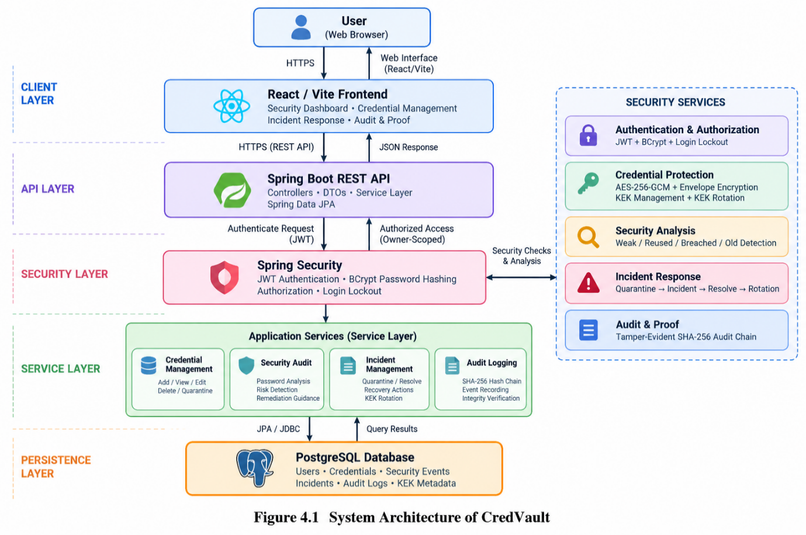
Figure 4.1 System Architecture of CredVault
The CredVault system begins with the React/Vite frontend sending requests to the Spring Boot REST API. Spring Security authenticates users using JWT and provides owner-scoped access. Credentials are stored in PostgreSQL through Spring Data JPA and protected using AES-256-GCM envelope encryption with KEK rotation. The security audit service detects credential risks, while quarantine and incident management support response. Security events are recorded in a tamper-evident SHA-256 audit chain for verification.

4.2 BASELINE
The initial implementation established the basic credential-management foundation, including authenticated access, user-owned credentials and CRUD operations. This provided the basic structure required for subsequent security improvements.

4.3 PROJECT REFINEMENT
The system was progressively enhanced with security-focused components. AES-256-GCM envelope encryption and KEK rotation were introduced to protect stored credentials. Tamper-evident audit logging was then implemented to provide security evidence and integrity verification. Credential quarantine and incident management were subsequently added to provide containment and recovery capabilities. The frontend was also reorganized around a deterministic security dashboard and operational workflow.

4.4 FINAL APPROACH
The final approach follows the Protect → Monitor → Detect → Contain → Prove → Recover security lifecycle. CredVault combines encrypted credential storage, deterministic security analysis, credential quarantine, incident management and tamper-evident audit logging. This provides secure credential management along with continuous security monitoring and controlled incident response.

4.5 TESTING AND EXECUTION
The system was tested across authentication, encryption, KEK rotation, credential quarantine, JWT behaviour and audit-chain verification. A total of 37 tests were executed, with 0 failures, 0 errors and 0 skipped. The React/Vite frontend production build was also successfully verified.

CHAPTER 5

IMPLEMENTATION

5.1 MODULE DESCRIPTION
Authentication Module
Provides user registration and login using BCrypt password hashing and JWT-based authentication. Failed login attempts are tracked and temporary account lockout is applied after repeated failures.
Credential Management Module
Provides authenticated users with owner-scoped creation, viewing, updating and management of stored credentials.
Cryptography Module
Uses AES-256-GCM envelope encryption. Each credential uses a randomly generated data encryption key, while a versioned key encryption key protects the encrypted DEK.
Security Audit Module
Performs deterministic analysis of credential security characteristics including password strength, password reuse, breach status and password age.
Incident Response Module
Provides credential quarantine, incident creation, incident resolution and recovery workflows. Credential reveal is blocked when a credential is quarantined. Audit & Proof Module Records security events using a SHA-256 hash chain. The chain can be verified to detect modifications to event data or chain links.
Frontend Module
Provides the security overview dashboard, credential vault, security operations interface and audit/proof interface.

5.2 KEY CODE SNIPPETS

AES-256-GCM Encryption

Cipher cipher = Cipher.getInstance("AES/GCM/NoPadding");
cipher.init(
Cipher.ENCRYPT_MODE,
dek,
new GCMParameterSpec(128, iv)
);

JWT Expiration

Date expiration =
new Date(System.currentTimeMillis() + 3600000);

SHA-256 Audit Hash

String canonical =
computeCanonicalString(event, previousHash);
String hash = sha256Hex(canonical);

5.3 USER INTERFACE / DEMO

Figure 5.1 – Security Overview Dashboard

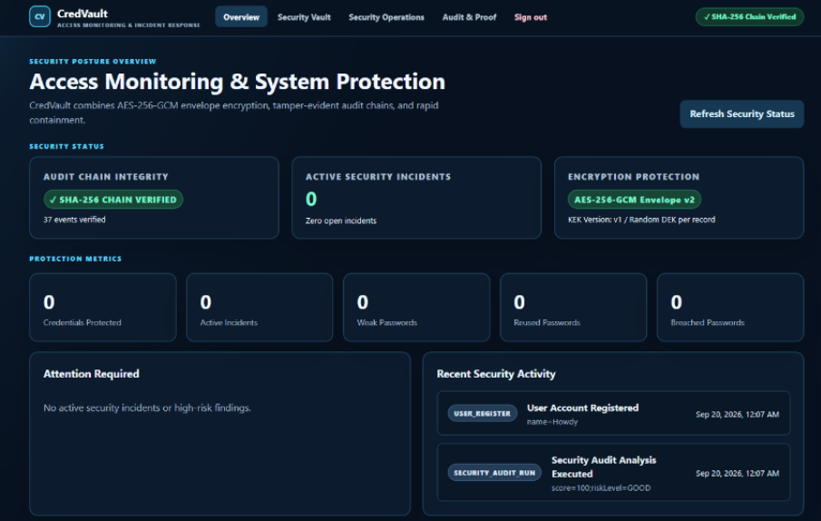
Figure 5.2 — Security Vault and Credential Management

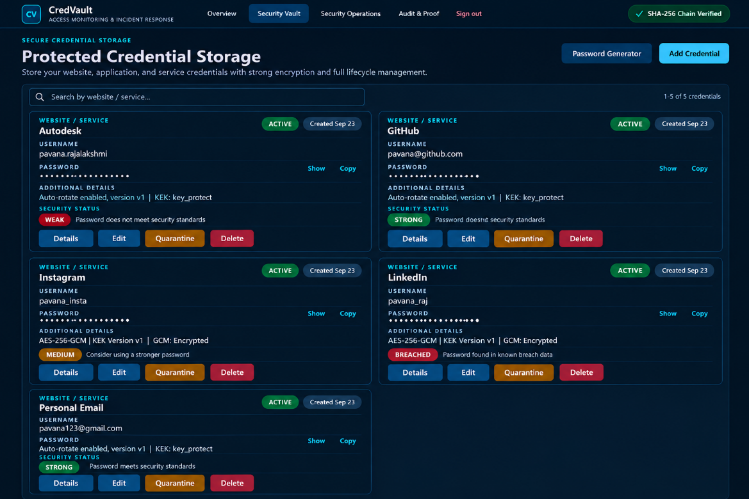

Figure 5.3 — Security Operations and Incident Response

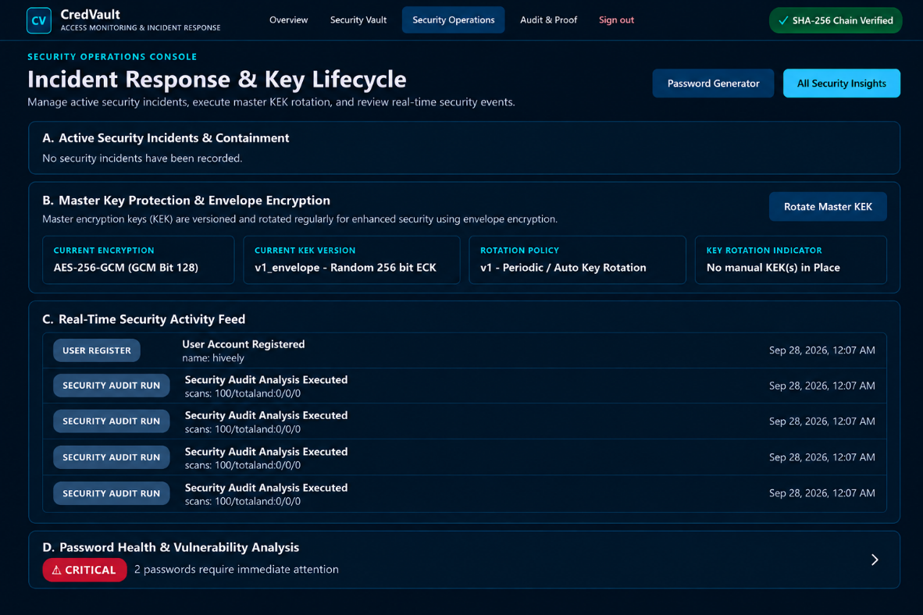

Figure 5.4 — Tamper-Evident Audit & Proof

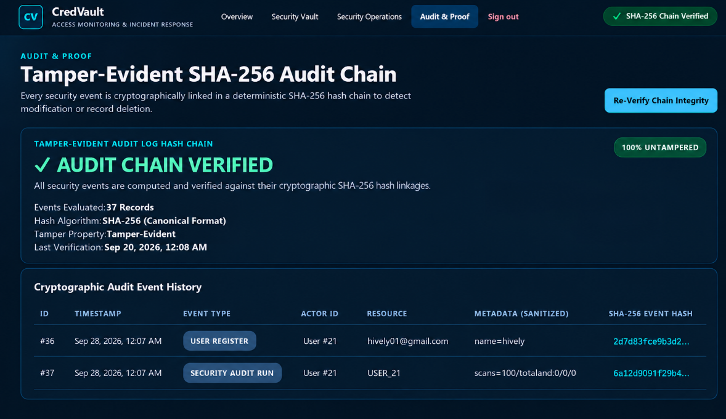

CHAPTER 6

RESULTS AND DISCUSSION

6.1 EVALUATION METRICS
The following metrics and verification criteria were used:
• Backend automated test execution.
• Number of test failures and errors.
• Number of skipped tests.
• Encryption behaviour.
• KEK rotation behaviour.
• Credential quarantine behaviour.
• Audit-chain verification.
• Authentication and login-lockout behaviour.
• Frontend production build success.
These metrics were selected because they directly verify the functional and security-critical components of the application.

6.2 RESULTS ACROSS ITERATIONS
Table 6.1 shows the outcome of each iteration against the security and functional requirements defined in Section 6.1. It records the tests passed, security features completed, issues identified and the final verification status, showing the progression of CredVault from the initial credential-management foundation to the final security-first implementation.
Table 6.1 Test and Security Outcomes Across Iterations
Version | Tests Passed | Security Features Completed | Verification Status
Baseline (Iteration 1) | Initial module tests | Authentication, authorization and basic credential management | Core workflow verified
Project Refinement (Iteration 2) | Module and security tests | AES-256-GCM encryption, envelope encryption, KEK rotation, security analysis and quarantine | Security mechanisms verified
Final Approach (Iteration 3) | 37 / 37 | Tamper-evident audit chain, incident response, audit verification and complete security lifecycle | All tests passed; 0 failures, 0 errors and 0 skipped

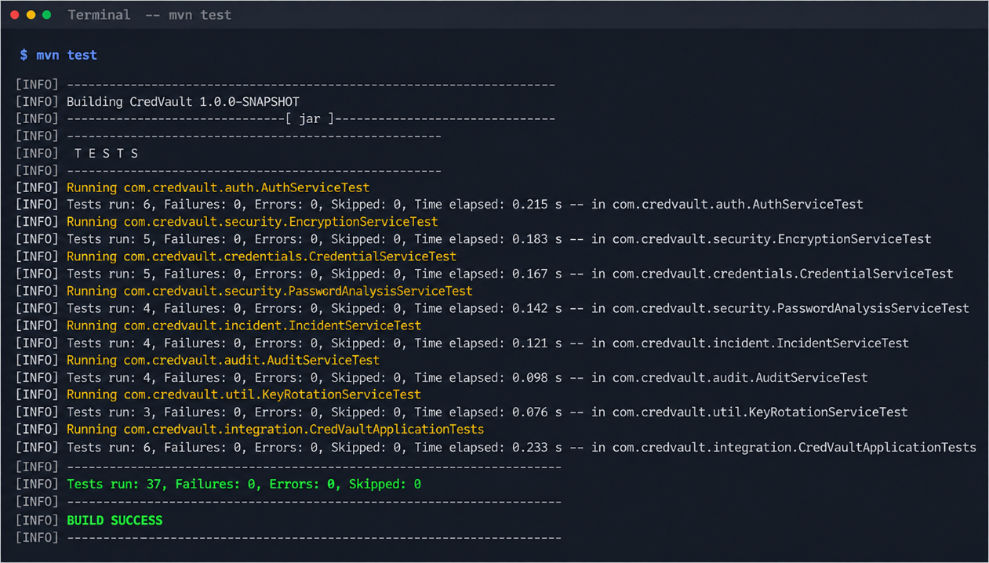
Figure 6.1 Maven Surefire Test Report (37 of 37 passing)

6.3 DISCUSSION
The results show that CredVault achieved its primary objective of combining secure credential storage with continuous security monitoring and incident response. The final implementation successfully integrated authentication, AES-256-GCM envelope encryption, KEK rotation, security analysis, credential quarantine and tamper-evident audit logging. The completed test suite recorded 37 out of 37 tests passing, with no failures, errors or skipped tests.
The security analysis successfully identifies common credential risks such as weak, reused, breached and outdated passwords. The quarantine mechanism provides containment for risky credentials, while the incident-response workflow supports controlled recovery and rotation. The SHA-256 audit chain also provides verifiable evidence of security events and was successfully verified without tampering.
Overall, the final system demonstrates that credential management can be extended beyond simple storage by integrating protection, monitoring, detection, containment, audit verification and recovery within a single application.

6.4 LIMITATIONS
The current implementation is intended primarily for academic and local demonstration rather than production-scale deployment. Large-scale load testing and distributed concurrency testing were not performed, and formal penetration testing was outside the project scope. Breach detection depends on the availability of the external Have I Been Pwned service.
The system does not currently include enterprise identity providers or advanced organizational access-control mechanisms. The implementation was also evaluated through functional and security tests rather than a formal external security audit. The optional AI component is not used for security decisions; deterministic security analysis remains the source of truth.

CHAPTER 7

TEAM REFLECTION AND LEARNING OUTCOMES

7.1 INDIVIDUAL REFLECTIONS
K TANUJA RAJALAKSHMI: I worked on the implementation and integration of the security-focused components of CredVault. The project provided practical experience in Java, Spring Boot, REST APIs, authentication, cryptography, database integration and security testing. A major learning outcome was understanding how multiple security controls can be integrated into a single application while protecting sensitive credential information.
PAVITHRA V: I worked on application integration, frontend development and project documentation. The project provided practical experience in React/Vite, REST API integration, security-oriented user-interface design and presenting technical functionality through a complete application workflow. A key learning outcome was understanding how complex security states can be presented clearly to users.

7.2 TEAM LEARNING
Dividing the work between backend security implementation, frontend development and application integration allowed each member to work independently while maintaining clearly defined interfaces between the components. Regular integration helped the team understand how authentication, encryption, security analysis, incident response and audit logging must work together as a complete security lifecycle.
Testing and integration feedback helped us identify and correct issues during development rather than relying only on final demonstration. The project also improved our understanding of collaborative development, database integration, security-focused design and systematic testing. If we restarted the PBL cycle, we would plan broader testing and performance evaluation from the beginning instead of treating them as limitations of the final implementation.

7.3 COURSE OUTCOMES — EVIDENCE SUMMARY
Evidence from this project for each outcome of the Java Programming course is summarised below.
CO1 – Object-oriented design: The system is organized into modular Java classes and services with clear responsibilities, including authentication, credential management, security auditing, incident management and audit logging. Section 5.1.
CO2 – Exception handling and security control: The application handles authentication failures, login lockout, unauthorized access, credential quarantine and security-related exceptions through Spring Security and backend service logic. Section 5.1.
CO3 – Collections and data management: Java collections and data structures are used throughout the backend for managing credentials, security findings, audit events and service-level processing. Section 5.1.
CO4 – Database connectivity: PostgreSQL database connectivity is implemented using Spring Data JPA and Hibernate, with Java entities and repositories used for persistent storage of users, credentials, incidents and security audit events. Section 4.1.
CO5 – Application development and testing: A complete web application was developed using Java Spring Boot and React/Vite, with authentication, encryption, security analysis, incident response and audit verification. The final backend test suite achieved 37 / 37 passing tests, with 0 failures, 0 errors and 0 skipped. Figures 5.1 to 5.4 and 6.1.

CHAPTER 8

CONCLUSION AND FUTURE SCOPE

8.1 CONCLUSION
CredVault was developed as a security-first credential management application that extends basic credential storage with protection, security monitoring, incident response and audit verification. The system uses a Java Spring Boot backend, React/Vite frontend and PostgreSQL database to provide authenticated and owner-scoped credential management. AES-256-GCM envelope encryption protects stored credentials, while versioned KEK management supports key rotation. The deterministic security audit identifies weak, reused, breached and outdated credentials and provides prioritized remediation information. Credential quarantine and incident management provide containment and recovery capabilities, while a SHA-256 hash chain provides tamper-evident security evidence. The final implementation was verified through 37 automated backend tests with zero failures, errors or skipped tests, and the frontend production build completed successfully
8.2 FUTURE SCOPE
• Integrate stronger multi-factor authentication and enterprise identity providers.
• Introduce role-based access control for organizational or shared vault environments.
• Add automated breach monitoring and notification workflows.
• Extend deployment with hardened cloud infrastructure, centralized monitoring and dedicated secrets management.
• Perform formal penetration testing, load testing and broader security testing.
• Develop mobile clients and additional credential-recovery workflows while preserving the deterministic security core.

REFERENCES

[1] | VMware, Spring Boot Reference Documentation, Spring Documentation.
[2] | Spring, Spring Security Reference Documentation, Spring Documentation.
[3] | Spring, Spring Data JPA Reference Documentation, Spring Documentation.
[4] | Hibernate, Hibernate ORM Documentation, Hibernate Documentation.
[5] | PostgreSQL Global Development Group, PostgreSQL Documentation, PostgreSQL.
[6] | M. Dworkin, Recommendation for Block Cipher Modes of Operation: Galois/Counter Mode (GCM) and GMAC, NIST Special Publication 800-38D, National Institute of Standards and Technology, 2007. [Online]. Available: https://csrc.nist.gov/pubs/sp/800/38/d/final
[7] | M. Jones, J. Bradley, and N. Sakimura, JSON Web Token (JWT), RFC 7519, Internet Engineering Task Force, 2015. [Online]. Available: https://www.rfc-editor.org/rfc/rfc7519
[8] | OWASP Foundation, Password Storage Cheat Sheet, OWASP Cheat Sheet Series. [Online].
[9] | T. Hunt, Have I Been Pwned — API Documentation, Have I Been Pwned. [Online]. Available: https://haveibeenpwned.com/API/v3/
[10] | Meta Platforms, Inc., React Documentation, React.

APPENDIX
A.1 FULL SOURCE CODE
The complete source code of the CredVault application is maintained in the project source archive. The backend contains the Java/Spring Boot implementation, security services, repositories, domain models and REST controllers, while the frontend contains the React/Vite application.
A.2 WEEKLY LOG AND MENTOR SIGN-OFFS
Table 3.1 is the complete weekly PBL log for the twelve-week cycle. The mentor’s review and approval for each milestone were completed and documented through the online review process.

A.3 SELF AND PEER ASSESSMENT
Table A.1 records the self-assessed and peer-assessed contribution of each team member to the project. Both members rated the work as an equal 50% share, and the remarks column summarises the modules each member was primarily responsible for.
Table A.1 Self and Peer Assessment
Team Member | Self-Rated Contribution (%) | Peer-Rated Contribution (%) | Remarks
K TANUJA RAJALAKSHMI | 50% | 50% | Backend security, encryption, authentication, security audit and testing
PAVITHRA V | 50% | 50% | Frontend development, API integration, security dashboard and documentation

