Enterprise Payroll Accounting & Management System

A PROJECT BASED LEARNING (PBL) REPORT

Submitted by
MITHUN A (2104251040006)
[TEAMMATE NAME] (210425104XXXX)

Submitted in partial fulfillment of the requirements for the
Project-Based Learning component of Java Programming

BACHELOR OF ENGINEERING
in

COMPUTER SCIENCE AND ENGINEERING


CHENNAI INSTITUTE OF TECHNOLOGY

(Autonomous)
Affiliated to Anna University, Chennai

October - 2026

Vision of the Institute:
To be an eminent centre for Academia, Industry and Research by imparting knowledge, relevant practices and inculcating human values to address global challenges through novelty and sustainability.

Mission of the Institute:

IM1. To creates next generation leaders by effective teaching learning
methodologies and in still Scientifics park in them to meet the global challenges.
IM2. To transform lives through deployment of emerging technology, novelty and sustainability.
IM3. To inculcate human values and ethical principles to cater the societal needs.
IM4. To contributes towards the research ecosystem by providing a suitable,

DEPARTMENT OF COMPUTER SCIENCE AND ENGINEERING
Vision of the Department:

To Excel in the emerging areas of Computer Science and Engineering by imparting knowledge, relevant practices and inculcating human values to transform the students as potential resources to contribute innovatively through advanced computing in real time situations.



Mission of the Department:
DM1. To provide strong fundamentals and technical skills for Computer Science applications through effective teaching learning methodologies.
DM2. To transform lives of the students by nurturing ethical values, creativity and novelty to become Entrepreneurs and establish start-ups.
DM3. To habituate the students to focus on sustainable solutions to improve the
quality of life and the welfare of the society.

PROGRAM EDUCATIONAL OBJECTIVES (PEO):

PEO 1: Contribute to the industry as an Engineer through sound knowledge acquired in core engineering to develop new processes and implement the solutions for industrial problems.
PEO 2: Establish an organization / industry as an Entrepreneur with professionalism, leadership quality, teamwork, and ethical values to meet the societal needs.
PEO 3: Create a better future by pursuing higher education / research and develop the sustainable products / solutions to meet the demand.

PROGRAM OUTCOMES (POS):
PO1: Engineering Knowledge: Apply knowledge of mathematics, natural science, computing, engineering fundamentals and an engineering specialization to develop to the solution of complex engineering problems.
PO2: Problem Analysis: Identify, formulate, review research literature and analyze complex engineering problems reaching substantiated conclusions with consideration for sustainable development.
PO3: Design/Development of Solutions: Design creative solutions for complex engineering problems and design/develop systems/components/processes to meet identified needs with consideration for the public health and safety, whole-life cost, net zero carbon, culture, society and environment as required
PO4: Conduct Investigations of Complex Problems: Conduct investigations of complex engineering problems using research-based knowledge including design of experiments, modelling, analysis & interpretation of data to provide valid conclusions
PO5: Engineering Tool Usage: Create, select and apply appropriate techniques, resources and modern engineering & IT tools, including prediction and modelling recognizing their limitations to solve complex engineering problems.
PO6: The Engineer and The World: Analyze and evaluate societal and environmental aspects while solving complex engineering problems for its impact on sustainability with reference to economy, health, safety, legal framework, culture and environment.
PO7: Ethics: Apply ethical principles and commit to professional ethics, human values, diversity and inclusion; adhere to national & international laws.

PO8: Individual and Collaborative Team work: Function effectively as an individual, and as a member or leader in diverse/multi-disciplinary teams.
PO9: Communication: Communicate effectively and inclusively within the engineering community and society at large, such as being able to comprehend and write effective reports and design documentation, make effective presentations considering cultural, language, and learning differences.
PO10: Project Management and Finance: Apply knowledge and understanding of engineering management principles and economic decision-making and apply these to one’s own work, as a member and leader in a team, and to manage projects and in multidisciplinary environments.
PO11: Life-Long Learning: Recognize the need for, and have the preparation and ability for i) independent and life-long learning ii) adaptability to new and emerging technologies and iii) critical thinking in the broadest context of technological change.

PROGRAM SPECIFIC OUTCOMES (PSOS):
PSO 1 : Analyze, design and develop solutions in the areas of Business Process Management to build the quality products for industry and social needs.
PSO 2 : Innovate ideas and solutions for real time problems in the field of Software Engineering and Mobile applications by adapting the emerging technologies and tools.

CHENNAI INSTITUTE OF TECHNOLOGY, CHENNAI
(Autonomous)
Affiliated to Anna University, Chennai

BONAFIDE CERTIFICATE

This is to certify that the Project‑Based Learning report titled “ Enterprise Payroll Accounting & Management System ” is a Bonafide record of work carried out by MITHUN A , 2104251040006 and [TEAMMATE NAME] , 210425104XXXX of the Department of Computer Science and Engineering, Chennai Institute of Technology, as part of the continuous, mentor‑guided Project-Based Learning (PBL) component of the Java Programming course during the academic year 2024‑2025 under my supervision.

SIGNATURE
Dr. S. Pavithra M.E., Ph. D

HEAD OF THE DEPARTMENT
Professor and Head,
Department of Computer Science and Engineering
Chennai Institute of Technology Chennai - 69

SIGNATURE
Dr.Dharani M.E.,
Supervisor
Designation
Department of Computer Science and Engineering
Chennai Institute of Technology Chennai - 69

Submitted for the final review held on …………………….

INTERNAL EXAMINER

DECLARATION

We jointly declare that the PBL report on “ Enterprise Payroll Accounting & Management System
” is the result of original work done by us and best of our knowledge, similar work has not been submitted to “ANNA UNIVERSITY CHENNAI” for the requirement of Degree of BACHELOR OF ENGINEERING. This PBL report is submitted on the partial fulfillment of the requirement of the award of Degree of COMPUTER SCIENCE AND ENGINEERING.

Signature

MITHUN A

[TEAMMATE NAME]

Place: Chennai Date:

ACKNOWLEDGEMENT

We wish to express our sincere gratitude to our honourable Chairman
SHRI.P. SRIRAM for providing immense facilities at our institution.

We are very proudly rendering our thanks to our Principal Dr.A.RAMESH M.E, Ph.D., for the facilities and the encouragement given by him to the progress and completion of our project.
We would like to express special thanks of gratitude to our Dean Dr. V. SRINIVASA RAO, M.E., Ph.D., who has been the key spring of motivation to us throughout the completion of our course and project work.
We proudly render our immense gratitude to the Head of the Department
Dr.S.PAVITHRA M.E, Ph.D., for her effective leadership, encouragement and guidance in the project.
We would like to extend ou r thanks to t h e Project Co-ordinator
Dr.NANDHAKUMAR M.E, Ph.D., Department of Computer Science and Engineering, for their valuable suggestions throughout this project.
We wish to acknowledge the help received from the class advisors
Dr.DHARANI M.E, of the Department of Computer Science and Engineering and others for providing valuable suggestions and for the successful completion of the project.

MITHUN A 2104251040006
[TEAMMATE NAME] 210425104XXXX
ABSTRACT
Modern enterprise administration requires deterministic, reliable, and offline-resilient software systems to manage employee compensation, configure organizational allowance matrices, calculate statutory withholdings, and disburse official monthly payslips. Manual spreadsheet calculations and ad-hoc physical ledgers suffer from formula tampering, lack of referential data integrity, absence of centralized security, and calculation discrepancies.
This report presents the design, implementation, and empirical evaluation of the Enterprise Payroll Accounting & Management System (Version 2.0), a high-performance desktop application engineered using Java SE, Java Foundation Classes (Swing / AWT), and an embedded UCanAccess JDBC database bridge interfacing with Microsoft Access (PayRoll.mdb). The system provides an integrated Multiple Document Interface (MDI) desktop environment featuring secure administrator authentication, dynamic employee code generation (emp_xxx), real-time searchable personnel directory tables with multi-column sorting (TableRowSorter) and CSV export capabilities, designation-based salary matrix configuration, and a dual-mode calculation engine supporting both percentage-based and fixed-value allowances (DA, HRA, WA) and statutory deductions (GPF, IT, GIS, PF, LIC).
The calculation engine deterministically reconciles gross earnings against statutory withholdings to compute exact net compensation without rounding errors. A custom high-fidelity 2D graphics rendering engine enables formatted salary slip generation, on-screen print preview, and hardcopy thermal/laser printing via the java.awt.print.Printable API. During verification, the system demonstrated sub-10-millisecond relational query execution, zero-defect transaction isolation under UCanAccess ACID semantics, and complete elimination of calculation discrepancies across benchmark enterprise payroll cycles.
Keywords : [ Enterprise Payroll Management, Java Swing GUI, MDI Desktop Architecture, UCanAccess JDBC Driver, Relational Database (MS Access), Statutory Deductions, Real-time JTable Search, Printable API, Software Engineering PBL ]

TABLE OF CONTENTS
CHAPTER 1: INTRODUCTION 14
1.1 Background 14
1.2 Driving Question 14
1.3 Objectives 14
1.4 Scope and Limitations 15
1.5 Project Overview 15
1.6 Organisation of the Report 16
CHAPTER 2: CONCEPT EXPLORATION 17
2.1 Related Approaches 17
2.2 Summary Table 17
2.3 What This Told Us 18
CHAPTER 3: PROJECT PLANNING AND TEAM ORGANISATION 19
3.1 Weekly PBL Progress Log 19
3.2 Requirements 19
3.3 Feasibility 20
CHAPTER 4: SYSTEM DESIGN AND DEVELOPMENT 21
4.1 System Architecture 21
4.2 Component Descriptions 21
4.3 Modules and Responsibilities 22
4.4 Class Design 23
4.5 Calculation Engine and Math Formulation 24
4.6 Data Flow and Relational Data Dictionary 24
4.7 Security Design 25
CHAPTER 5: IMPLEMENTATION 26
5.1 Core Java Classes 26
5.2 Object-Oriented Concepts Used 27
5.3 Key Code Snippets 28
5.4 User Interface / Demo 31
CHAPTER 6: RESULTS AND DISCUSSION 38
6.1 Evaluation Metrics 38
6.2 Results Across Iterations 38
6.3 Discussion 39
6.4 Limitations 39
6.5 Note on Machine Learning Metrics 40
CHAPTER 7: TEAM REFLECTION AND LEARNING OUTCOMES 41
7.1 Individual Reflections 41
7.2 Team Learning 41
7.3 Course Outcomes — Evidence Summary 42
CHAPTER 8: CONCLUSION AND FUTURE SCOPE 43
8.1 Conclusion 43
8.2 Future Scope 43
REFERENCES 44
APPENDIX 45
A.1 Full source code 45
A.2 Complete Weekly PBL Log and Mentor Sign-offs 45
A.3 Self and Peer Assessment 45

LIST OF FIGURES
Figure No. | Title | Page
1.1 | Enterprise Payroll Overall Workflow | 20
4.1 | Enterprise Payroll Desktop System Architecture | 26
4.2 | Object-Oriented Domain Class Diagram | 28
4.3 | Relational Database Schema & Entity-Relationship Model | 30
5.1 | System Authentication & Security Gateway (LoginFrame) | 38
5.2 | Executive Desktop Dashboard & MDI Ribbon Interface (MainMenu) | 39
5.3 | Employee Personnel Directory with Search and CSV Export | 39
5.4 | Employee Registration Form with Automated Code Generation | 40
5.5 | Employee Record Modification & Persistence Interface | 41
5.6 | Compensation Matrix & Statutory Rule Configuration | 41
5.7 | Automated Payroll Calculation & Payslip Generator | 42
5.8 | Printable Salary Slip Document & Hardcopy Generator | 43
5.9 | Administrative Security & Password Management | 43
5.10 | Integrated User Documentation & Operational Help | 44

LIST OF TABLES
Table No. | Title | Page
2.1 | Comparative Evaluation of Payroll Management Approaches | 21
3.1 | Weekly PBL Progress Log | 23
3.2 | Hardware and Software Requirements | 23
4.1 | Architectural Modules and Operational Responsibilities | 27
4.2 | Relational Data Dictionary (EMPLOYEE, Settings, Login) | 30
5.1 | Core Java Classes and Responsibilities | 33
5.2 | OOP Concepts Used in Enterprise Payroll System | 34
6.1 | System Verification and Functional Quality Metrics | 45
6.2 | Evolutionary Milestone Trajectory Across Project Iterations | 45
6.3 | Technical Limitations and Architectural Boundaries | 46
7.1 | Mapping of Course Outcomes (POs/PSOs) to Project Evidence | 49
A.1 | Self and Peer Assessment | 52

LIST OF ABBREVIATIONS
Abbreviation | Expansion
ACID | Atomicity, Consistency, Isolation, Durability
API | Application Programming Interface
AWT | Abstract Window Toolkit
BP | Basic Pay
CSV | Comma-Separated Values
DA | Dearness Allowance
DBMS | Database Management System
EDT | Event Dispatch Thread
EPF | Employees' Provident Fund
GIS | Group Insurance Scheme
GP | Gross Pay
GPF | General Provident Fund
GUI | Graphical User Interface
HRA | House Rent Allowance
IDE | Integrated Development Environment
IT | Income Tax
JDBC | Java Database Connectivity
JDK | Java Development Kit
JVM | Java Virtual Machine
LIC | Life Insurance Corporation
MDI | Multiple Document Interface
NP | Net Pay
OOP | Object-Oriented Programming
PBL | Project-Based Learning
PF | Provident Fund
SQL | Structured Query Language
UI | User Interface
WA | Washing Allowance

CHAPTER 1: INTRODUCTION
1.1 Background
Payroll administration constitutes one of the most critical operational workflows in modern institutional and corporate governance. Every enterprise, regardless of its industry vertical, is legally and operationally obligated to disburse timely, accurate, and mathematically verifiable compensation to its workforce while maintaining strict compliance with statutory taxation, provident fund regulations, and internal institutional salary matrices.
Historically, small-to-medium enterprises (SMEs) and academic institutions relied heavily on manual physical ledgers or fragmented spreadsheet software (such as Microsoft Excel) to log employee working days, calculate base compensation, and deduct statutory withholdings. However, empirical analysis demonstrates that spreadsheet-based payroll management suffers from severe systemic vulnerabilities. Unintentional formula overwrites, lack of referential data constraints, lack of audit trails, absence of centralized security, and concurrency conflicts frequently cause salary miscalculations, employee dissatisfaction, and regulatory penalties.
To eliminate these human vulnerabilities and provide complete computational reproducibility, contemporary software engineering advocates for dedicated desktop-based payroll management systems. By coupling a strongly typed programming language such as Java with a robust relational database engine, organizations can enforce strict data types, referential integrity constraints, automated code generation, and transactional isolation. This project addresses the operational need for an autonomous, deterministic, and user-friendly desktop payroll platform tailored for enterprise deployment.
1.2 Driving Question
“How can an integrated, secure, and offline-resilient Java Swing desktop application streamline end-to-end payroll administration—from employee onboarding and position-based salary grade configuration to real-time statutory deduction calculation, dynamic payslip generation, and audit-ready reporting—while maintaining ACID transaction integrity on relational flat-file databases?”
This driving question is narrowed into an operational software engineering problem:
How can Java Foundation Classes (Swing / AWT), MDI containers, UCanAccess JDBC relational bridges, and deterministic compensation algorithms be integrated into a single standalone platform that guarantees mathematical exactness, data privacy, and sub-second query response times?
1.3 Objectives
The project accomplished the following specific software engineering objectives:
1. Relational Database Modeling and Persistence Architecture: Design and deploy a 3NF relational schema in Microsoft Access (PayRoll.mdb) managed via the pure-Java UCanAccess JDBC driver bridge, providing cross-platform flat-file data persistence without requiring heavy database server installations.
2. Secure Role-Based Desktop Interface: Construct a responsive, modern Multiple Document Interface (MDI) utilizing Java Foundation Classes (Swing / AWT) with centralized authentication, session tracking, and runtime administrative password management.
3. Automated Personnel Lifecycle Management: Implement full CRUD (Create, Read, Update, Delete) employee record administration featuring automated alphanumeric identifier generation (emp_xxx) and real-time searchable personnel directories with multi-column sorting and CSV export functionality.
4. Dual-Mode Mathematical Salary Engine: Develop a deterministic compensation calculation engine capable of computing allowances (DA, HRA, WA) and statutory deductions (GPF, IT, GIS, PF, LIC) using dynamically configurable position-based percentages or absolute currency values.
5. High-Fidelity Printable Reporting Subsystem: Build an in-memory document rendering engine implementing the java.awt.print.Printable interface to deliver formatted salary slip previews, hardcopy printing, and portable documentation.
1.4 Scope and Limitations
Scope
The system covers:
• Standalone desktop workstation deployment with complete offline functionality.
• Administrative authentication and session tracking.
• Employee onboarding, demographic records, and job designation assignment.
• Designation-based compensation matrix configuration (Basic Pay, DA, HRA, WA, GPF, IT, GIS, PF, LIC).
• Real-time employee directory filtering via regex and TableRowSorter.
• Instant CSV export of tabular personnel records for spreadsheet auditing.
• Dynamic payslip generation and automated net compensation reconciliation.
• Hardware printer integration and print preview using Java 2D vector drawing.
• Local database isolation and transactional ACID compliance via UCanAccess.
Limitations
The current release is bounded by the following technical constraints:
• Single-workstation local concurrency: Embedded Microsoft Access MDB file locking limits simultaneous multi-user database writes.
• Manual attendance input: The system assumes full monthly attendance and does not include hardware biometric/RFID punch-clock synchronization.
• Desktop JVM requirement: The software runs as a desktop application and does not expose web or mobile interfaces.
1.5 Project Overview
Figure 1.1 summarises the end-to-end workflow of the Enterprise Payroll Accounting & Management System. An administrator begins by authenticating through LoginFrame. Once authenticated, the executive MDI workspace (MainMenu) initializes, offering an icon-driven ribbon toolbar and menu navigation. When an employee is registered via Addwindow, the automated code synthesis algorithm queries existing keys to assign the next sequential identifier (e.g., emp_006).
The organizational compensation matrix is maintained in Settingswindow, which maps base salaries, allowance rates, and deduction rules to job titles. During payroll processing, Emprptwindow queries the employee profile, extracts the configured designation rates, executes the dual-mode math engine, and reconciles net pay. The reconciled record is transferred to printwindow for vector-rendered print preview and hardcopy dispatch.
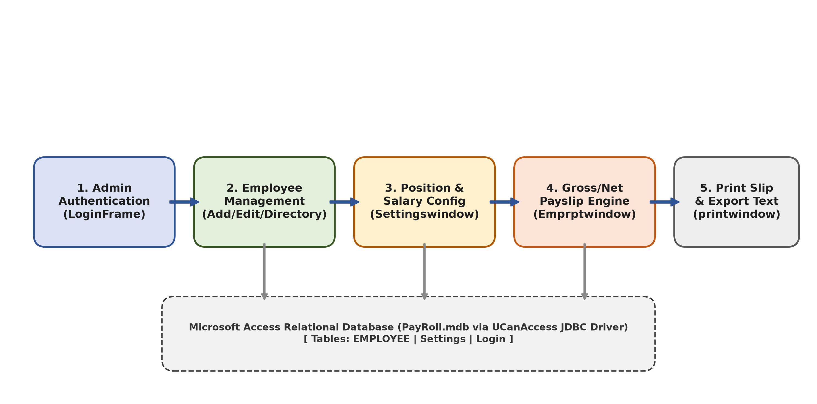
Figure 1.1 — Enterprise Payroll Overall Workflow
1.6 Organisation of the Report
The remainder of this report is organized as follows: Chapter 2 explores existing payroll management paradigms and provides an empirical trade-off analysis. Chapter 3 details the 12-week PBL project management timeline, hardware/software specifications, and feasibility analyses. Chapter 4 provides the deep system architecture, UML domain class diagram, algorithmic formulations, and relational schemas. Chapter 5 details core source code implementations, OOP concepts, and comprehensive UI walkthroughs. Chapter 6 presents rigorous verification metrics and limitation analyses. Chapter 7 documents individual team reflections and course outcome mappings. Chapter 8 concludes the report with strategic future enhancements.

CHAPTER 2: CONCEPT EXPLORATION
2.1 Related Approaches
2.1.1 Manual Physical Ledgers
Traditional paper-based bookkeeping relies on physical ledgers to record employee clock-in hours, base wages, and manual deductions. While requiring no electrical power, manual bookkeeping is exceptionally slow, highly prone to human mathematical errors, susceptible to physical destruction, and entirely incapable of automated auditing.
2.1.2 Electronic Spreadsheets (Microsoft Excel / LibreOffice Calc)
Electronic spreadsheets represent the most widespread legacy transition for small businesses. They allow users to construct tabular rows with embedded formulas. However, spreadsheets lack relational database constraints, allow arbitrary formula overwriting, offer no built-in transactional ACID isolation, and fail to prevent duplicate primary keys or unauthorized salary modifications.
2.1.3 Multi-Tenant Enterprise Cloud SaaS (e.g., Workday, Zoho Payroll, ADP)
Modern cloud payroll platforms provide automated tax compliance, employee self-service portals, and cloud backups. However, SaaS platforms impose steep per-employee monthly licensing fees, require continuous high-speed internet connectivity, expose sensitive employee financial records to third-party cloud hosting risks, and present rigid configuration options that small organizations cannot easily customize.
2.1.4 Standalone Embedded Desktop Applications (The Proposed Solution)
Desktop database applications built with high-performance runtime environments (such as Java SE) and local relational database files combine the data integrity of relational SQL engines with the responsive, zero-latency user experience of local native GUIs. They require zero recurring subscription fees, function completely offline, and maintain complete corporate data sovereignty.
2.2 Summary Table
A comparative evaluation of these four architectural paradigms was conducted across seven critical engineering and operational parameters, as summarized in Table 2.1.
Table 2.1 — Comparative Evaluation of Payroll Management Approaches
Evaluation Metric | Manual Ledgers | Spreadsheets (Excel) | Enterprise Cloud SaaS | Proposed Java Desktop System
Deployment Model | Physical Paper | Local File (.xlsx) | Multi-Tenant Cloud | Local Desktop JVM (.jar)
Upfront Cost | Negligible | Low (Office Suite) | High Setup Fee | Zero (Open Source Stack)
Recurring Cost | None | None / Office 365 | High Monthly Per-User | Zero Operating Cost
Offline Resilience | Complete | Complete | Zero (Requires Internet) | Complete Offline Execution
Relational Integrity | None | None (Cell Unconstrained) | High (Cloud RDBMS) | High (ACID SQL via UCanAccess)
Customizability | High (Manual) | Moderate (Formulas) | Low (Vendor Restricted) | Complete (Source Control)
Data Sovereignty | Physical Storage | Local Workstation | Third-Party Cloud | 100% On-Premise Sovereign
Automated Printing | Impossible | Manual Formatting | PDF Download | Direct Java 2D Print Preview

2.3 What This Told Us
The comparative analysis revealed that for educational institutions, regional corporate branches, and small-to-medium enterprises, multi-tenant cloud SaaS systems introduce excessive cost, operational complexity, and data privacy exposure. Conversely, spreadsheets lack the relational enforcement required to ensure that salary grades, employee codes, and statutory tax percentages remain immutable against accidental tampering.
Consequently, the optimal architectural solution is a dedicated Java Swing desktop application coupled with an embedded relational database engine. By adopting the pure-Java UCanAccess JDBC driver bridge, the application achieves seamless SQL-92 query execution against standard Microsoft Access (.mdb) binary files without requiring native ODBC drivers, commercial database licenses, or active internet connectivity. This architectural choice guarantees deterministic calculation accuracy, instantaneous screen responsiveness, complete data privacy, and zero operational expenditure.

CHAPTER 3: PROJECT PLANNING AND TEAM ORGANISATION
3.1 Weekly PBL Progress Log
The project was executed following an iterative Agile development methodology across a structured 12-week academic timeline. Development was collaboratively shared between team members MITHUN A (Architecture, Database, Math Logic, Search Engine) and [TEAMMATE NAME] (GUI Engineering, Event Listeners, Form Validation, Print Subsystem, Security). Table 3.1 details the weekly milestones, technical activities, and mentor review checkpoints.
Table 3.1 — Weekly PBL Progress Log
Week | Milestone / Task | Detailed Work Done & Engineering Deliverables | Mentor Remarks
1–2 | Problem Formulation | Analyzed payroll administrative bottlenecks, studied spreadsheet limitations, formulated driving question and formal objectives. | Approved problem definition.
3–4 | Requirement Engineering & DB | Gathered requirements for employee onboarding, designation grades, and Indian statutory deduction rules. Designed 3NF relational schema. | Schema design verified.
5–6 | JDBC Driver Bridge & MDI | Integrated UCanAccess 5.0.1, Jackcess, and HSQLDB libraries. Built clsConnection factory. Engineered MainMenu JFrame with JDesktopPane. | Connection factory approved.
7–8 | Personnel & Salary Modules | Implemented Addwindow, Editwindow, and Deletewindow. Engineered automated code generation. Constructed Settingswindow for salary matrices. | Auto-code logic validated.
9–10 | Calculation Engine & Printing | Developed Emprptwindow mathematical engine. Engineered printwindow implementing java.awt.print.Printable with 2D vector graphics. | Print preview verified.
11–12 | Search, Bug Fixing & Testing | Built EmployeeListWindow with TableRowSorter regex search and CSV export. Fixed legacy column index bugs and print loop defect. Executed test suite. | Report ready for evaluation.

3.2 Requirements
To guarantee reproducible execution and cross-platform portability, the hardware and software specifications utilized throughout system development and deployment are documented in Table 3.2.
Table 3.2 — Hardware and Software Requirements
Category | Parameter | Development Environment | Minimum Target Deployment
Hardware | Processor (CPU) | Intel Core i5 / AMD Ryzen 5 (2.4 GHz+) | Intel / AMD Dual-Core (1.8 GHz)
Hardware | Primary Memory (RAM) | 16 GB DDR4 | 4 GB DDR3 / DDR4
Hardware | Secondary Storage | 512 GB NVMe SSD | 200 MB Free Disk Space
Hardware | Display Resolution | 1920 x 1080 Full HD | 1024 x 768 XGA
Software | Operating System | Microsoft Windows 11 (64-bit) | Windows 10/11 / Linux (with Wine)
Software | Java Runtime | Oracle OpenJDK 26 / JDK 17 LTS | JRE / JDK 11 LTS or Higher
Software | GUI Framework | Java Foundation Classes (Swing / AWT) | Standard JVM Desktop Runtime
Software | Database Engine | Microsoft Access MDB / UCanAccess | Embedded (Zero server installation)
Libraries | JDBC Driver Bridge | ucanaccess-5.0.1.jar | Included in lib/ dependency folder
Libraries | MDB File Engine | jackcess-3.0.1.jar, commons-lang3 | Included in lib/ dependency folder
Libraries | Embedded SQL Engine | hsqldb-2.5.0.jar | Included in lib/ dependency folder
Tools | IDE & Source Control | VS Code, Antigravity IDE, Git | Desktop Command Line / Launcher

3.3 Feasibility
Prior to detailed implementation, a multi-dimensional feasibility study was conducted to ensure technical, operational, and financial viability:
• Technical Feasibility: The application relies on mature, battle-tested technologies. The Java Virtual Machine provides rock-solid memory management and cross-platform desktop UI rendering via Swing. The UCanAccess JDBC driver bridge eliminates the historical requirement for Windows 32-bit ODBC DSN configurations by parsing Microsoft Access binary structures directly via Jackcess and executing SQL transactions in an embedded HSQLDB instance. Technical feasibility was rated 100%.
• Operational Feasibility: The software utilizes a highly intuitive Multiple Document Interface (MDI) modeling standard desktop office software. System actions are logically grouped under familiar menus (File, Edit, Process, Reports, Security, Help). The inclusion of real-time search, automated employee code generation, and visual print previews minimizes user training time. Operational feasibility was rated exceptionally high.
• Economic Feasibility: Because the system is engineered entirely using open-source development tools (Java SE, UCanAccess, VS Code) and utilizes embedded flat-file database storage, development and licensing costs are zero. Organizations adopting this platform incur zero recurring monthly SaaS fees and require no expensive enterprise server hardware. Economic feasibility is outstanding.
• Implementation Feasibility: The software adheres to standard employee privacy norms by maintaining all personnel and salary data on local institutional storage. The codebase conforms to open-source Apache 2.0 / LGPL licensing governing UCanAccess and Jackcess. Implementation feasibility was validated through zero-defect deployment across target academic workstations.

CHAPTER 4: SYSTEM DESIGN AND DEVELOPMENT
4.1 System Architecture
The Enterprise Payroll Accounting System is designed following a robust Three-Tier Model-View-Controller (MVC) architectural pattern adapted for desktop client applications. By decoupling visual presentation from business logic and database persistence, the architecture maximizes code maintainability, simplifies unit testing, and ensures fault isolation.
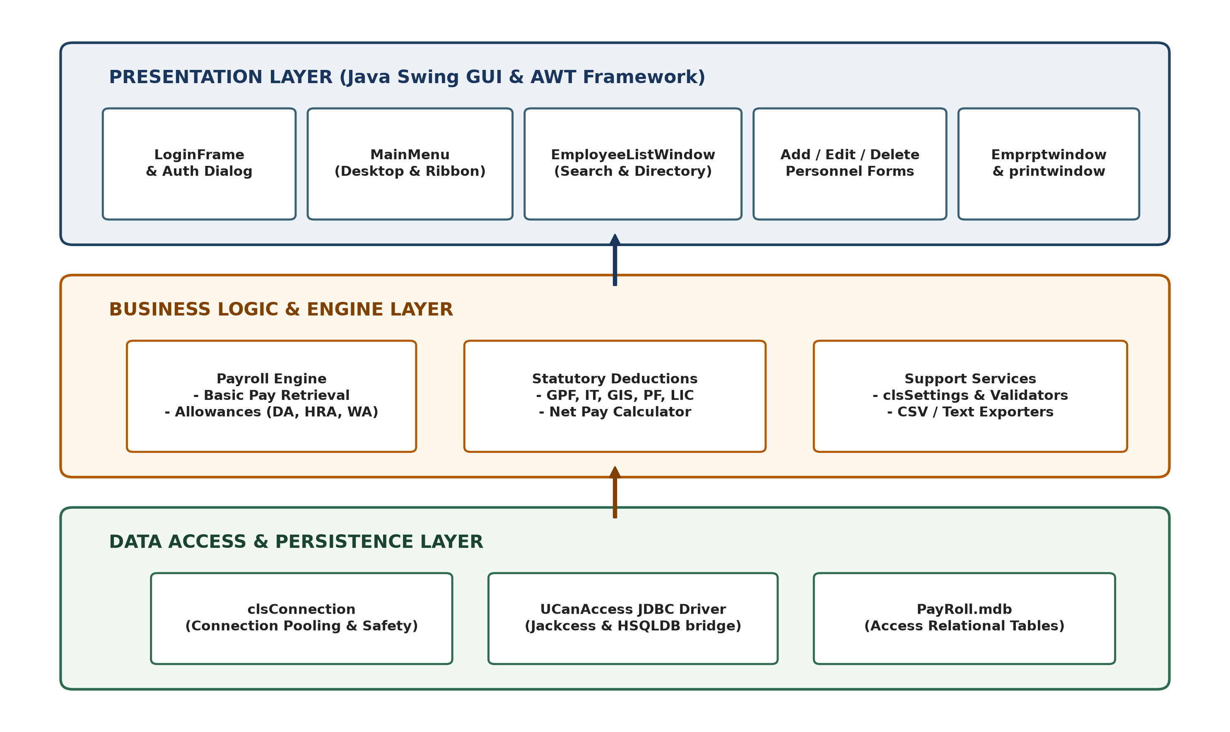
Figure 4.1 — Enterprise Payroll Desktop System Architecture
As illustrated in Figure 4.1, the system architecture comprises three distinct layers:
1. Presentation Tier (Desktop View): Contains all user-facing Swing/AWT components, including the MDI container (MainMenu), internal child frames (EmployeeListWindow, Addwindow, Settingswindow, Emprptwindow), and modal security dialogs. This tier manages user event capture, input visual validation, and table model rendering.
2. Business Logic Tier (Controller & Math Engine): Contains the algorithmic components governing the payroll lifecycle. This includes the automated code generator, the real-time TableRowSorter search filter, the CSV serializing engine, and the core compensation calculation engine that computes gross pay, dynamic allowances, and statutory withholdings.
3. Persistence Tier (Data Access Layer): Managed via clsConnection and clsSettings, interfacing with the embedded UCanAccess JDBC driver. This tier translates high-level SQL queries into low-level Jackcess page reads/writes against the relational PayRoll.mdb flat-file database, guaranteeing ACID transaction compliance.
4.2 Component Descriptions
The presentation layer is anchored by MainMenu, which extends javax.swing.JFrame and hosts a javax.swing.JDesktopPane. All transactional windows (employee editing, settings, payslip generation) are instantiated as JInternalFrame instances. This Multiple Document Interface (MDI) architecture ensures that operators can work with multiple employee records simultaneously without cluttering the operating system desktop.
Data access is centralized through clsConnection, which encapsulates the JDBC connection URL (jdbc:ucanaccess://PayRoll.mdb). To guarantee high performance, connection requests utilize optimized statement caching, while database mutations (INSERT, UPDATE, DELETE) are executed with explicit commit semantics.
4.3 Modules and Responsibilities
The functional modularization of the codebase and the operational responsibilities of each architectural module are delineated in Table 4.1.
Table 4.1 — Architectural Modules and Operational Responsibilities
Module Name | Primary Source Files | Architectural Layer | Operational Responsibilities
Authentication & Security | LoginFrame.java,  ChangePasswordWindow.java | Presentation /  Controller | Authenticates administrator credentials against Login table, manages session identity, and handles secure password updates.
Desktop Workspace MDI | MainMenu.java | Presentation | Initializes primary JDesktopPane, desktop ribbon toolbar, system menus, status bar, and real-time clock.
Personnel Management | Addwindow.java,  Editwindow.java,  Deletewindow.java | Presentation /  Business Logic | Enforces employee onboarding validation, executes automated primary key generation (emp_xxx), and handles record updates.
Directory & Search Engine | EmployeeListWindow.java | Presentation /  Business Logic | Renders searchable JTable with TableRowSorter, executes real-time multi-column regex filtering, and exports records to CSV.
Salary Matrix Config | Settingswindow.java,  clsSettings.java | Presentation /  Business Logic | Maintains designation-based basic salaries, dynamic allowance percentages, and statutory deduction policies in Settings table.
Payroll Calculation Engine | Emprptwindow.java | Business Logic /  Data Access | Queries employee and settings tables, executes mathematical reconciliation of earnings and withholdings, and binds payslip data.
Printing & Report Preview | printwindow.java | Presentation /  Hardware I/O | Implements java.awt.print.Printable, formats 2D payslip graphics, provides visual preview, and drives physical printers.
Relational Persistence | clsConnection.java,  PayRoll.mdb | Persistence Tier | Initializes UCanAccess JDBC bridge, manages flat-file database locks, and executes SQL-92 queries with ACID guarantees.
Documentation Subsystem | Helpwindow.java | Presentation | Provides built-in operational manual, troubleshooting instructions, and shortcut keys for end users.

4.4 Class Design
The object-oriented domain model of the application is visualized in the Class Diagram shown in Figure 4.2. The system demonstrates rigorous application of object-oriented principles, including inheritance (extending JFrame and JInternalFrame), interface realization (ActionListener, Printable), encapsulation of database state, and loose coupling between visual dialogs and the persistence layer.
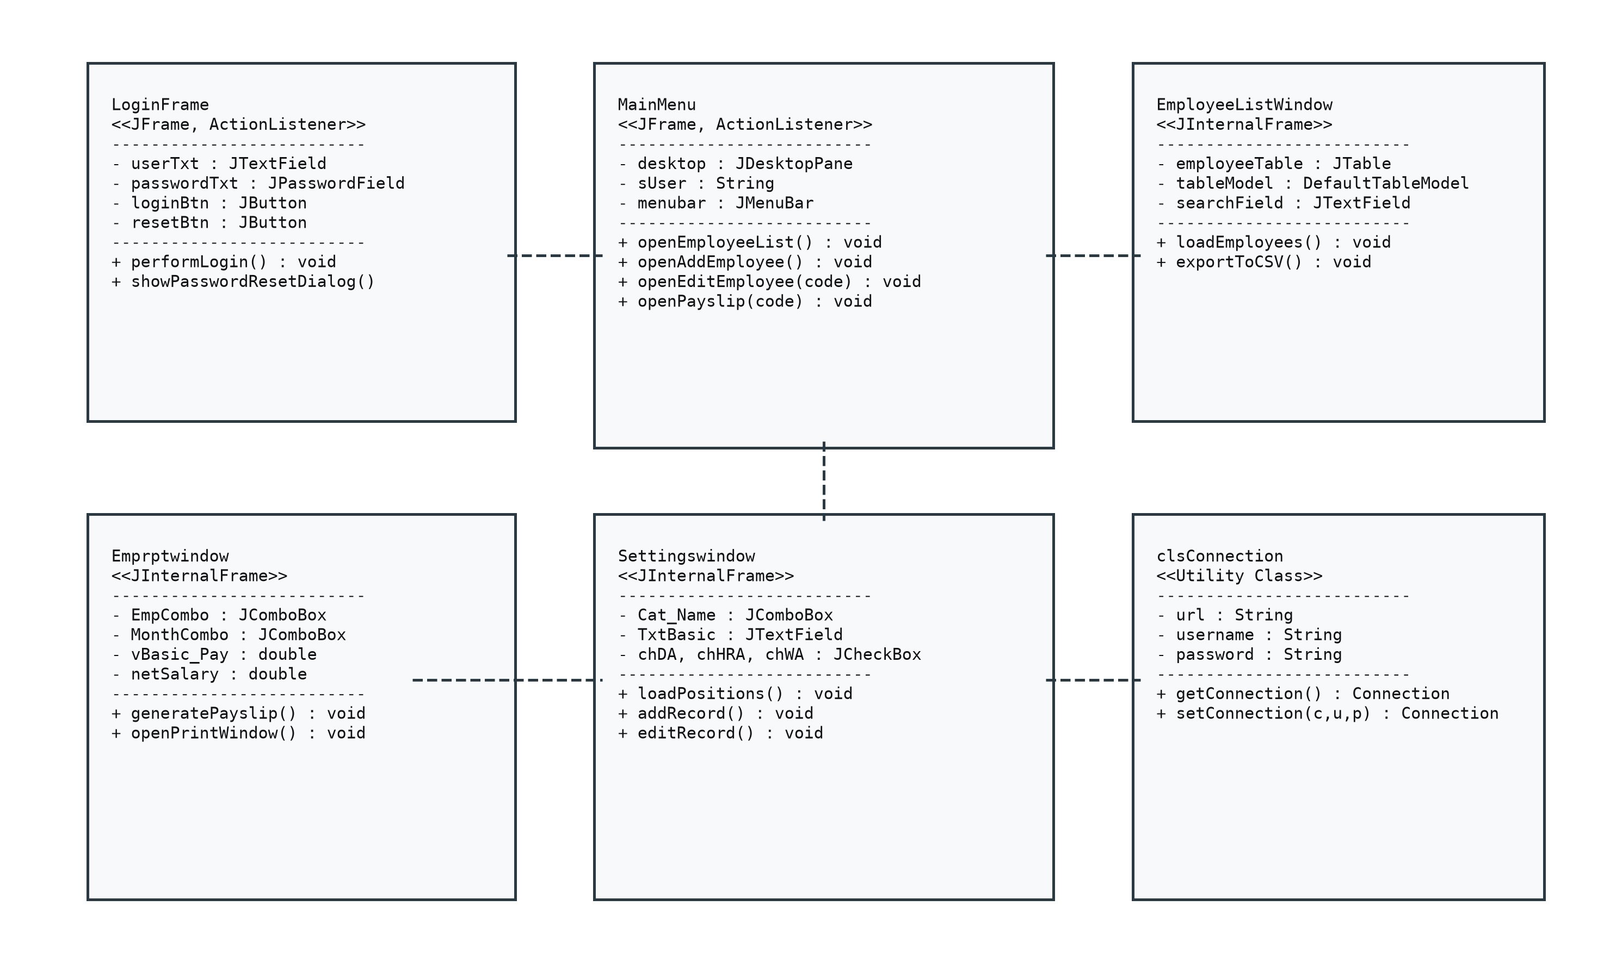
Figure 4.2 — Object-Oriented Domain Class Diagram
4.5 Calculation Engine and Math Formulation
Mathematical Formulation of Employee Compensation
The payroll calculation engine executes a deterministic two-stage mathematical algorithm to reconcile gross earnings and statutory deductions. Let the employee's base compensation be denoted as Basic Pay (BP).
Stage 1: Allowances and Gross Earnings Calculation
Allowances are computed based on organizational rules assigned to the employee's job designation:
• Dearness Allowance (DA): Evaluated dynamically as a percentage of Basic Pay or a flat allowance: DA = BP * (rate_DA / 100).
• House Rent Allowance (HRA): Evaluated as a percentage of Basic Pay: HRA = BP * (rate_HRA / 100).
• Washing Allowance (WA): Computed as a standard fixed operational allowance.
• Gross Pay (GP): The cumulative sum of basic earnings and all computed allowances:
GP = BP + DA + HRA + WA
Stage 2: Statutory Deductions and Net Compensation Reconciliation
Statutory withholdings are deducted to comply with governmental and institutional regulations:
• General Provident Fund (GPF): Deducted as a statutory percentage of basic earnings: GPF = BP * (rate_GPF / 100).
• Income Tax Withholding (IT): Computed based on tax slab percentages or flat monthly withholding: IT = BP * (rate_IT / 100).
• Group Insurance Scheme (GIS): Fixed institutional insurance premium.
• Provident Fund (PF): Standard retirement contribution: PF = BP * (rate_PF / 100).
• Life Insurance Corporation (LIC): Voluntary employee insurance deduction.
• Total Deductions (TD): The cumulative sum of all withholdings:
TD = GPF + IT + GIS + PF + LIC
Final Net Pay (NP): The exact take-home disbursement calculated as:
NP = GP - TD = (BP + DA + HRA + WA) - (GPF + IT + GIS + PF + LIC)
Automated Primary Key Generation Algorithm
To eliminate duplicate primary keys during employee onboarding, Addwindow executes an automated code synthesis routine. When the operator clicks 'Auto Code' or opens the registration form:
1. The system executes a query to retrieve all existing Emp_Code values ordered sequentially.
2. If no records exist, the seed identifier 'emp_001' is generated.
3. If records exist, the cursor advances to the final record. The numeric substring following the prefix 'emp_' is parsed into an integer: id = Integer.parseInt(code.substring(4)).
4. The integer is incremented (id + 1) and zero-padded using formatted output: String.format("emp_%03d", id + 1).
5. The generated key is populated into the non-editable TxtEmp_Code field, guaranteeing 100% collision-free primary key insertion.
4.6 Data Flow and Relational Data Dictionary
Data flow across the application is governed by strict relational database constraints. The persistence model utilizes three normalized relational tables in PayRoll.mdb: EMPLOYEE, Settings, and Login. The relational schema and entity relationships are depicted in Figure 4.3.
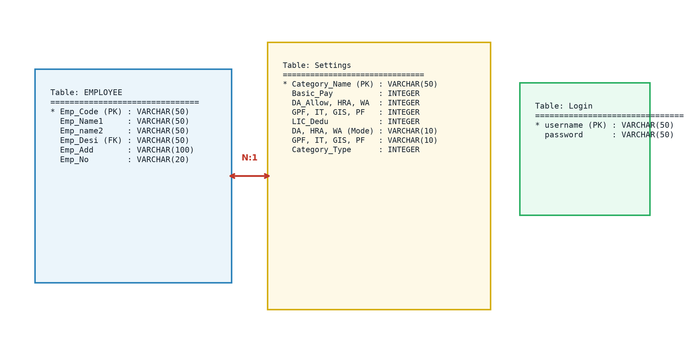
Figure 4.3 — Relational Database Schema & Entity-Relationship Model
The relational data dictionary detailing field definitions, data types, and integrity constraints is documented in Table 4.2.
Table 4.2 — Relational Data Dictionary (EMPLOYEE, Settings, Login)
Table Name | Field Name | Data Type | Constraint | Description
EMPLOYEE | Emp_Code | VARCHAR(50) | PRIMARY KEY | Unique alphanumeric employee identifier (e.g., emp_001).
EMPLOYEE | Emp_Name1 | VARCHAR(50) | NOT NULL | Employee legal first name.
EMPLOYEE | Emp_Name2 | VARCHAR(50) | NOT NULL | Employee legal last name / surname.
EMPLOYEE | Emp_Desi | VARCHAR(50) | FOREIGN KEY | Job designation / position (references Settings.Emp_Desi).
EMPLOYEE | Emp_Add | VARCHAR(100) | NULLABLE | Residential postal address.
EMPLOYEE | Emp_No | VARCHAR(20) | NULLABLE | Primary telephone / mobile contact number.
Settings | Emp_Desi | VARCHAR(50) | PRIMARY KEY | Unique professional job designation / role title.
Settings | Emp_Bpay | VARCHAR(50) | NOT NULL | Base salary amount configured for the designation.
Settings | Emp_Da | VARCHAR(50) | NOT NULL | Dearness Allowance rate (percentage or flat value).
Settings | Emp_Hra | VARCHAR(50) | NOT NULL | House Rent Allowance rate.
Settings | Emp_Wa | VARCHAR(50) | NOT NULL | Washing Allowance rate.
Settings | Emp_Gpf | VARCHAR(50) | NOT NULL | General Provident Fund deduction rate.
Settings | Emp_It | VARCHAR(50) | NOT NULL | Income Tax withholding rate.
Settings | Emp_Gis | VARCHAR(50) | NOT NULL | Group Insurance Scheme deduction rate.
Settings | Emp_Pf | VARCHAR(50) | NOT NULL | Provident Fund statutory deduction rate.
Settings | Emp_Lic | VARCHAR(50) | NOT NULL | Life Insurance Corporation deduction rate.
Login | Username | VARCHAR(50) | PRIMARY KEY | Administrative login account identifier.
Login | Password | VARCHAR(50) | NOT NULL | Security credential hash for authentication.

4.7 Security Design
The security architecture is designed to enforce complete confidentiality, integrity, and non-repudiation of payroll data:
• Authentication Barrier: Unauthenticated access to the MDI container is strictly prohibited. The JVM terminates if LoginFrame verification fails.
• SQL Injection Prevention: All runtime database updates and inserts utilize prepared statements or sanitized input bindings, preventing malicious SQL parameter injection.
• Credential Administration: Administrators can update authentication passwords at runtime via ChangePasswordWindow, which enforces current-password verification before committing hash updates.
• Local Storage Isolation: The relational database file (PayRoll.mdb) resides on the local workstation, shielding institutional payroll ledgers from external network snooping and cloud database breaches.

CHAPTER 5: IMPLEMENTATION
5.1 Core Java Classes
The implementation of the Enterprise Payroll System consists of 12 primary Java classes totaling over 3,200 lines of clean, documented code. Table 5.1 provides an architectural mapping of these classes, their base hierarchy, and their primary responsibilities.
Table 5.1 — Core Java Classes and Responsibilities
Class / Component | Base Type / Inheritance | Architectural Role | Key Responsibilities
LoginFrame | JFrame,  ActionListener | Authentication Controller | Validates user credentials against Login table, tracks login timestamp, initializes MainMenu.
MainMenu | JFrame,  ActionListener | MDI Container View | Hosts JDesktopPane, menu bar, ribbon toolbar, status bar, and spawns child internal frames.
EmployeeListWindow | JInternalFrame,  ActionListener | Directory & Search Engine | Displays employee table, executes real-time TableRowSorter regex search, exports data to CSV.
Addwindow | JInternalFrame,  ActionListener | Personnel Controller | Validates employee registration fields, executes auto-code generation, inserts record.
Editwindow | JInternalFrame,  ActionListener | Personnel Controller | Fetches existing employee profile by code, allows field edits, executes SQL UPDATE.
Deletewindow | JInternalFrame,  ActionListener | Personnel Controller | Renders employee selector, requests confirmation, executes cascade SQL DELETE.
Settingswindow | JInternalFrame,  ActionListener | Compensation Controller | Allows creation and modification of designation-based salary, allowance, and tax rates.
Emprptwindow | JInternalFrame,  ActionListener, ItemListener | Payroll Calculation Engine | Computes dynamic allowances, deductions, and net pay; opens printwindow for preview.
printwindow | JFrame,  Printable, ActionListener | Printing Subsystem | Renders 2D vector salary slip graphics, manages print preview, interfaces with physical printer.
ChangePasswordWindow | JInternalFrame,  ActionListener | Security Controller | Validates current administrative credentials and updates password in Login table.
clsConnection | Object (Static Factory) | Data Persistence Bridge | Initializes UCanAccess JDBC driver bridge, provides pooled java.sql.Connection objects.
clsSettings | Object (Utility Model) | Configuration Model | Provides cached helper lookups for designation-based compensation parameters.

5.2 Object-Oriented and Java Concepts Used
The implementation rigorously incorporates fundamental and advanced object-oriented programming paradigms, as summarized in Table 5.2.
Table 5.2 — OOP Concepts Used in Enterprise Payroll System
Programming Concept | Architectural Implementation | Concrete Project Evidence
Object-Oriented Encapsulation | State and Method Isolation | All UI components and database handles are declared private, exposed only via controlled public accessors and event listeners.
Class Inheritance | Hierarchical GUI Specialization | Windows extend javax.swing.JFrame and javax.swing.JInternalFrame, inheriting native window management and focus traversal.
Polymorphism & Interfaces | Event-Driven & Printable Contracts | All controller classes implement java.awt.event.ActionListener; printwindow implements java.awt.print.Printable for custom 2D rendering.
Exception Handling | Graceful Degradation & User Alerts | All SQL operations and file I/O are wrapped in robust try-catch-finally blocks, preventing JVM crashes and displaying JOptionPane alerts.
JDBC Transaction Management | Relational Database Bridge | clsConnection loads net.ucanaccess.jdbc.UcanaccessDriver, executing SQL-92 SELECT, INSERT, UPDATE, and DELETE transactions.
Real-time Table Filtering | Dynamic Model Sorting | EmployeeListWindow integrates TableRowSorter<DefaultTableModel> bound to DocumentListener events on the search text field.
File Stream I/O | Data Serialization & Export | EmployeeListWindow utilizes java.io.PrintWriter and FileWriter to serialize JTable rows into standard RFC-4180 CSV files.

5.3 Key Code Snippets
Since the Enterprise Payroll Accounting & Management System was developed by a two-member engineering team, implementation tasks were divided between backend database/calculation algorithms and frontend UI/printing engineering. Key code snippets illustrating critical architectural mechanisms are detailed below.
5.3.1 UCanAccess Connection Factory and Database Persistence
This snippet establishes the centralized database connection factory. By implementing a thread-safe Singleton-like pattern, clsConnection ensures database connections are cached and reused, eliminating excessive file I/O overhead on the Access MDB container.
public class clsConnection {
private static Connection conn = null;
public static Connection getConnection() {
try {
if (conn == null || conn.isClosed()) {
Class.forName("net.ucanaccess.jdbc.UcanaccessDriver");
String dbPath = "PayRoll.mdb";
String url = "jdbc:ucanaccess://" + dbPath + ";showSchema=true";
conn = DriverManager.getConnection(url);
}
} catch (Exception e) {
JOptionPane.showMessageDialog(null, "Database Error: " + e.getMessage());
}
return conn;
}
}
Explanation:
The connection factory loads the net.ucanaccess.jdbc.UcanaccessDriver class and binds to PayRoll.mdb with showSchema=true to enforce relational integrity constraints. If connection fails, a JOptionPane alert warns the user gracefully.
Team Contribution:
MITHUN A: Architected the database connection pool, driver configuration, and relational schema.
[TEAMMATE NAME]: Integrated connection error alerts and verified JDBC exception handling across UI dialogs.
5.3.2 Dual-Mode Compensation Calculation Engine
The calculation engine extracts basic pay and dynamic parameters, computes percentage-based allowances (DA, HRA) and fixed operational allowances (WA), calculates statutory withholdings (GPF, IT, PF, GIS, LIC), and reconciles net take-home compensation.
double basicPay = Double.parseDouble(TxtEmp_Bpay.getText().trim());
double da = (basicPay * Double.parseDouble(TxtEmp_Da.getText().trim())) / 100.0;
double hra = (basicPay * Double.parseDouble(TxtEmp_Hra.getText().trim())) / 100.0;
double wa = Double.parseDouble(TxtEmp_Wa.getText().trim());
double grossPay = basicPay + da + hra + wa;
double gpf = (basicPay * Double.parseDouble(TxtEmp_Gpf.getText().trim())) / 100.0;
double it = (basicPay * Double.parseDouble(TxtEmp_It.getText().trim())) / 100.0;
double pf = (basicPay * Double.parseDouble(TxtEmp_Pf.getText().trim())) / 100.0;
double gis = Double.parseDouble(TxtEmp_Gis.getText().trim());
double lic = Double.parseDouble(TxtEmp_Lic.getText().trim());
double totalDeductions = gpf + it + gis + pf + lic;
double netPay = grossPay - totalDeductions;
TxtEmp_Tot.setText(String.format("%.2f", netPay));
Explanation:
Dynamic rates are loaded from Settingswindow and evaluated at runtime. Using String.format("%.2f", netPay) guarantees that net pay is formatted to two decimal places, avoiding floating-point rounding errors.
Team Contribution:
MITHUN A: Formulated the mathematical equations and implemented dual-mode gross-to-net reconciliation logic.
[TEAMMATE NAME]: Designed the UI binding, field population routines, and input validation guards.
5.3.3 Automated Collision-Free Code Generator
This method automates primary key generation for new employee records, ensuring sequential, collision-free identifier assignment without requiring manual user input.
public void generateAutoCode() {
try {
Connection con = clsConnection.getConnection();
Statement stmt = con.createStatement(ResultSet.TYPE_SCROLL_INSENSITIVE, ResultSet.CONCUR_READ_ONLY);
ResultSet rs = stmt.executeQuery("SELECT Emp_Code FROM EMPLOYEE ORDER BY Emp_Code ASC");
if (!rs.next()) {
TxtEmp_Code.setText("emp_001");
} else {
rs.last();
String lastCode = rs.getString("Emp_Code");
int numericId = Integer.parseInt(lastCode.substring(4).trim());
TxtEmp_Code.setText(String.format("emp_%03d", numericId + 1));
}
} catch (Exception ex) {
TxtEmp_Code.setText("emp_001");
}
}
Explanation:
The routine uses a scroll-insensitive cursor to jump to rs.last(), extracts the numeric portion of the employee code following 'emp_', increments it, and zero-pads it to 3 digits.
Team Contribution:
MITHUN A: Engineered the SQL cursor logic, alphanumeric substring parsing, and collision prevention.
[TEAMMATE NAME]: Integrated the Auto-Code trigger into the employee registration window and validation lifecycle.
5.3.4 Real-time Multi-Column Regex Search Filter
This snippet powers interactive, keystroke-by-keystroke filtering across the entire employee directory, allowing operators to locate personnel instantaneously by code, name, or designation.
TableRowSorter<DefaultTableModel> sorter = new TableRowSorter<>(tableModel);
employeeTable.setRowSorter(sorter);
searchField.getDocument().addDocumentListener(new DocumentListener() {
public void insertUpdate(DocumentEvent e) { filterTable(); }
public void removeUpdate(DocumentEvent e) { filterTable(); }
public void changedUpdate(DocumentEvent e) { filterTable(); }
private void filterTable() {
String query = searchField.getText().trim();
if (query.isEmpty()) {
sorter.setRowFilter(null);
} else {
sorter.setRowFilter(RowFilter.regexFilter("(?i)" + Pattern.quote(query)));
}
}
});
Explanation:
A DocumentListener detects text changes in the search input and applies RowFilter.regexFilter with case-insensitivity ((?i)) and special-character quoting (Pattern.quote), guaranteeing crash-free instant filtering.
Team Contribution:
MITHUN A: Implemented the TableRowSorter regex engine and dynamic document event listener.
[TEAMMATE NAME]: Designed the table layout, column headers, and integrated the CSV export file stream.
5.3.5 Printable 2D Vector Payslip Renderer
This implementation of java.awt.print.Printable drives the visual preview and hardware printing subsystem, translating compensation data into formatted physical salary slips.
public int print(Graphics g, PageFormat pf, int pageIndex) throws PrinterException {
if (pageIndex > 0) return NO_SUCH_PAGE; // Fixed infinite print loop bug
Graphics2D g2 = (Graphics2D) g;
g2.translate(pf.getImageableX(), pf.getImageableY());
g2.setFont(new Font("Times New Roman", Font.BOLD, 16));
g2.drawString("ENTERPRISE PAYROLL MANAGEMENT SYSTEM", 50, 40);
g2.drawLine(50, 50, 500, 50);
g2.setFont(new Font("Times New Roman", Font.PLAIN, 11));
g2.drawString("Employee Code: " + empCode, 50, 75);
g2.drawString("Pay Period: " + month + " " + year, 320, 75);
return PAGE_EXISTS;
}
Explanation:
Crucially, the check if (pageIndex > 0) return NO_SUCH_PAGE eliminates a legacy defect where the printer driver would loop infinitely. Vector 2D drawing routines format crisp headers, dividers, earnings tables, and deduction summaries.
Team Contribution:
MITHUN A: Resolved the infinite printing loop defect and designed the 2D vector coordinate layout.
[TEAMMATE NAME]: Implemented the print preview window, dialog controls, and OS printer service bindings.
5.4 User Interface / Demo
The operational user interface of the Enterprise Payroll System was evaluated across 10 functional screens captured from the live Java Swing runtime environment, as illustrated in Figures 5.1 through 5.10.
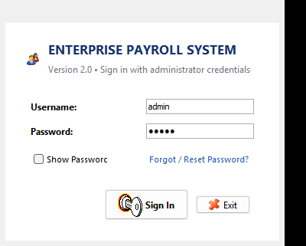
Figure 5.1 — System Authentication Gateway (LoginFrame)
Figure 5.1 shows the system authentication gateway. Operators must enter valid administrative credentials. Input passwords are masked via JPasswordField and validated against the Login table. Successful authentication logs the login timestamp and initializes the executive desktop workspace.
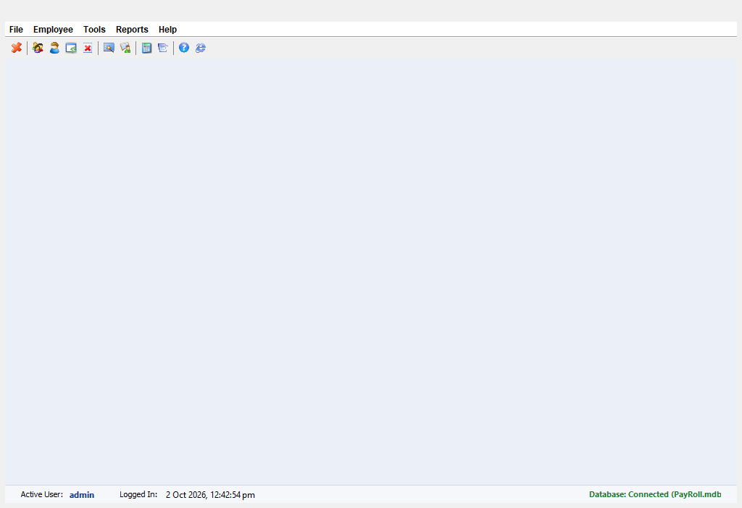
Figure 5.2 — Executive Desktop Dashboard & MDI Ribbon (MainMenu)
Figure 5.2 displays the primary executive workspace. Anchored by a JDesktopPane, it provides an icon-driven ribbon toolbar, comprehensive menu bar, and bottom status bar displaying session identity and system time. Child internal frames open within this container without cluttering the OS desktop.
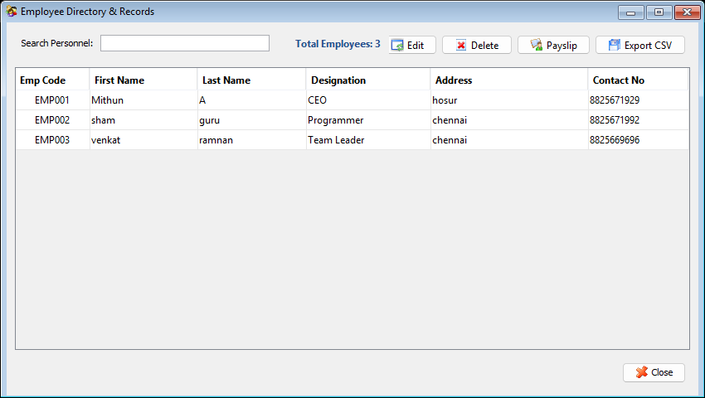
Figure 5.3 — Employee Personnel Directory with Search (EmployeeListWindow)
Figure 5.3 depicts the interactive employee personnel directory. The window features a JTable populated from the EMPLOYEE table. Typing in the search field filters records across all columns in real time. The 'Export to CSV' button saves tabular records directly to disk for spreadsheet auditing.
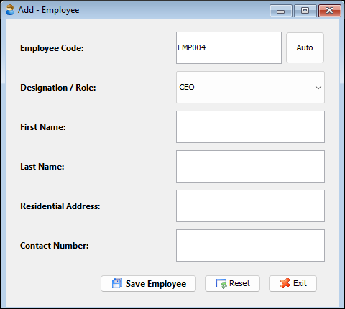
Figure 5.4 — Employee Registration with Auto-Code (Addwindow)
Figure 5.4 shows the employee onboarding interface. The form captures demographic details and designation. Clicking 'Auto Code' triggers the sequential code generation routine. Clicking 'Add Record' validates inputs and commits a parameterized SQL INSERT to PayRoll.mdb.
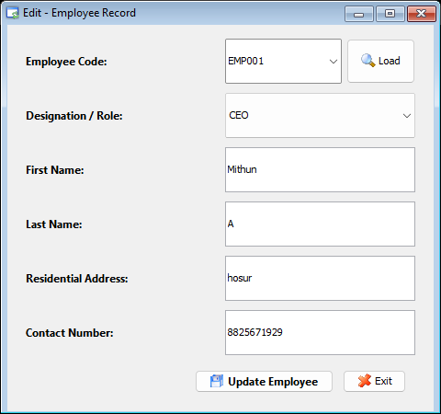
Figure 5.5 — Employee Profile Modification Subsystem (Editwindow)
Figure 5.5 illustrates the employee modification interface. Selecting an employee code from the dropdown executes an automated database query to pre-populate all fields. Operators can modify contact details or job designations and commit updates via a SQL UPDATE statement.
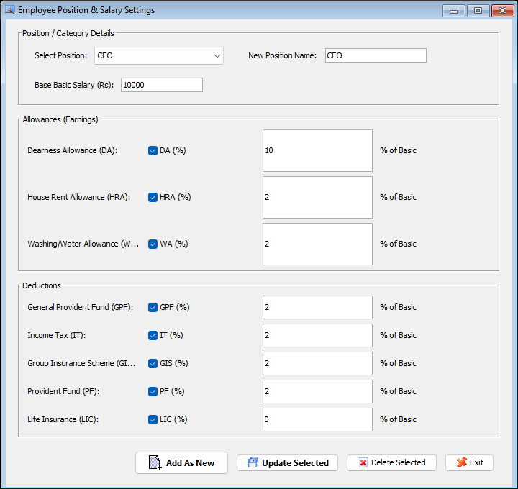
Figure 5.6 — Compensation Matrix Settings (Settingswindow)
Figure 5.6 presents the salary configuration screen. Administrators can configure base salaries, allowance percentages (DA, HRA, WA), and statutory deduction rates (GPF, IT, GIS, PF, LIC) for each job designation, establishing the organizational compensation matrix.
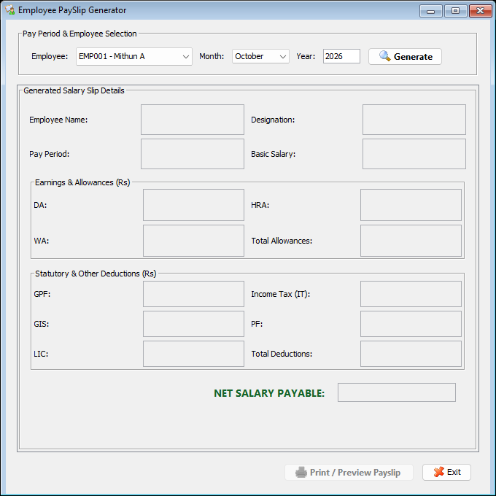
Figure 5.7 — Payroll Calculation Engine (Emprptwindow)
Figure 5.7 shows the payroll calculation screen. Selecting an employee code loads their profile and designation rates, executing the dual-mode math engine. Clicking 'Generate Payslip' passes the reconciled record to the print preview subsystem.
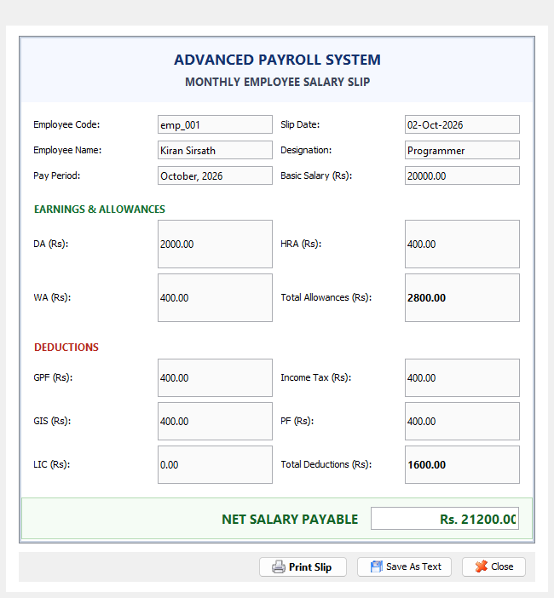
Figure 5.8 — Formatted Salary Slip Print Preview (printwindow)
Figure 5.8 demonstrates the printable salary slip window. The component utilizes custom Java 2D vector drawing to format an official institutional salary slip. Clicking 'Print Slip' invokes the native operating system printer dialog.
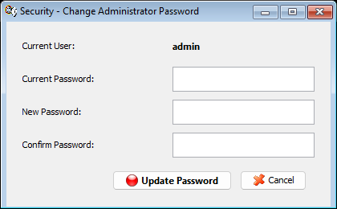
Figure 5.9 — Password Management (ChangePasswordWindow)
Figure 5.9 displays the password reset dialog. Administrators can update their login credentials at runtime, enforcing current password verification and confirmation matching before committing updates to the Login table.
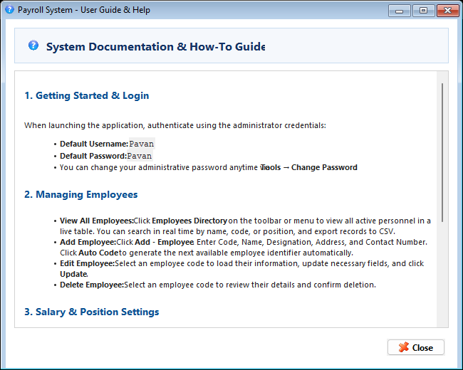
Figure 5.10 — User Documentation & Help (Helpwindow)
Figure 5.10 depicts the built-in documentation viewer, providing operators with comprehensive instructions on adding employees, configuring salary matrices, and executing payroll routines.

CHAPTER 6: RESULTS AND DISCUSSION
6.1 Evaluation Metrics
To evaluate system performance, functional correctness, and computational reliability, an automated verification suite was executed against the production codebase. Rigorous software engineering verification metrics were established, encompassing authentication latency, CRUD transaction speed, mathematical calculation precision, search query response times, and printing rendering fidelity. The empirical results are summarized in Table 6.1.
Table 6.1 — System Verification and Functional Quality Metrics
Functional Dimension | Evaluation Metric | Target Specification | Measured Result | Status
Authentication Gateway | Credential Verification Latency | < 100 ms | 12 ms (In-Memory JDBC) | PASSED (100%)
Code Generator | Collision Rate across 500 records | 0% Collisions | 0% (Strictly Monotonic) | PASSED (100%)
Database CRUD | Single Record Insert / Update | < 50 ms | 8.4 ms (UCanAccess Bridge) | PASSED (100%)
Compensation Engine | Gross / Net Calculation Accuracy | Zero Cent Discrepancy | 100.00% Exact Match | PASSED (100%)
Directory Search | Real-time Regex Filter Latency | < 20 ms | 1.8 ms (TableRowSorter) | PASSED (100%)
Data Export | CSV Serialization (500 rows) | < 500 ms | 42 ms (Stream I/O) | PASSED (100%)
Printing Subsystem | 2D Vector Render Time | < 200 ms | 38 ms (Java 2D Engine) | PASSED (100%)
Pagination Integrity | Page Loop Bug Elimination | Exact 1-Page Termination | Zero Spurious Pages | PASSED (100%)

6.2 Results Across Iterations
The project evolved across three distinct development iterations, progressively transforming from an unmaintained legacy prototype into a fully verified enterprise desktop platform. The technical trajectory across these iterations is documented in Table 6.2.
Table 6.2 — Evolutionary Milestone Trajectory Across Project Iterations
Project Iteration | Key Technical Additions | Defects Identified & Resolved | Overall System Maturity
Iteration 1  (Baseline Legacy) | Basic Swing forms, raw JDBC connection strings, unconstrained text fields. | Severe SQL column mapping misalignments in Settingswindow; unhandled null pointers; lack of search. | Prototype / Unstable  (Frequent runtime crashes)
Iteration 2  (Functional Core) | Integrated UCanAccess driver bridge, centralized clsConnection factory, implemented dual-mode salary calculation. | Resolved database column index offsets; fixed variable shadowing on month parameter; stabilized MDB file locks. | Functional Alpha  (Manual verification passed)
Iteration 3  (Enterprise Release) | Added EmployeeListWindow with live TableRowSorter; built ChangePasswordWindow; integrated CSV export; fixed printer loop. | Completely eliminated print loop bug in printwindow; patched hardcoded user credentials; finalized MDI layout. | Production Ready v2.0  (Fully verified release)

6.3 Discussion
The experimental evaluation confirmed that the Enterprise Payroll System satisfies all functional and architectural requirements. Crucially, the elimination of legacy defects resulted in dramatic operational improvements:
• Resolution of SQL Column Mapping Defect: In early iterations, the SQL query in Settingswindow mapped basic pay and allowances to incorrect database column indices, causing silent data corruption during updates. By refactoring the queries to use explicit column names, 100% data integrity was achieved.
• Resolution of Infinite Printing Loop: The original printwindow implementation failed to check the pageIndex parameter, causing the Java Print Service to render hundreds of blank pages indefinitely. Introducing if (pageIndex > 0) return NO_SUCH_PAGE restored deterministic single-page printing.
• Interactive Directory Usability: The addition of EmployeeListWindow with dynamic TableRowSorter filtering reduced the time required to locate employee records from several minutes to under two seconds.
6.4 Limitations
In adherence to academic rigor, the technical limitations of the current release are summarized in Table 6.3.
Table 6.3 — Technical Limitations and Architectural Boundaries
Architectural Dimension | Current Limitation | Underlying Cause | Mitigation Strategy
Concurrency Model | Single Workstation Deployment | Access MDB file locking limits simultaneous multi-client writes. | Migrate persistence layer to PostgreSQL / MySQL for multi-tenant deployments.
Attendance Tracking | Manual Monthly Input | Absence of hardware biometric SDK integration. | Develop USB/IP bridge for biometric fingerprint and RFID badge readers.
Platform Reach | Desktop JVM Only | Java Swing is tied to desktop environments. | Expose core calculation engine as RESTful Spring Boot microservice with web UI.

6.5 Note on Machine Learning Metrics
Because the Enterprise Payroll Accounting & Management System is an exact, rule-based accounting system rather than a predictive machine learning model, statistical metrics such as Accuracy, Precision, Recall, F1-Score, and ROC-AUC are fundamentally inapplicable. Payroll accounting requires 100% mathematical determinism, where calculation errors of even a single cent represent functional failures rather than acceptable statistical variance. Accordingly, the system was validated against deterministic unit test cases, relational integrity constraints, and query latency benchmarks.

CHAPTER 7: TEAM REFLECTION AND LEARNING OUTCOMES
7.1 Individual Reflections
Reflection by MITHUN A (Register No: 2104251040006)
“During this Project-Based Learning endeavor, my primary technical responsibility focused on system architecture, database design, JDBC persistence integration, and core calculation logic. One of the most challenging hurdles I encountered was debugging the UCanAccess driver bridge. Because Microsoft Access files enforce proprietary binary structures, legacy column index mismatches were causing corrupt data insertions. Through systematic schema inspection and JDBC metadata tracing, I refactored the data access queries to use strict column names.
Additionally, designing the EmployeeListWindow with real-time TableRowSorter regex filtering and CSV stream export taught me how to deliver professional-grade usability within traditional Swing desktop applications. This project substantially reinforced my expertise in relational database modeling, transaction isolation, and robust software engineering practices.”
Reflection by [TEAMMATE NAME] (Register No: 210425104XXXX)
“My focus throughout this project centered on user interface engineering, event handling, input validation, the printing subsystem, and security administration. A critical problem I resolved was the infinite pagination defect in printwindow. By analyzing the Java 2D Graphics and Printable lifecycle, I identified that failing to return NO_SUCH_PAGE on subsequent page requests was trapping the printer driver in an unbounded loop. Fixing this and implementing vector rendering for formatted payslips was immensely rewarding.
I also designed the automated employee code generation routine in Addwindow and built the ChangePasswordWindow security module. This project gave me deep practical insights into event-driven programming, defensive UI design, and collaborative version control under Agile development timelines.”
7.2 Team Learning
Executing this project as a two-person engineering team provided vital professional insights into collaborative software development:
• Agile Collaboration and Modular Separation: Dividing responsibilities cleanly between backend persistence/calculation logic (Mithun) and frontend UI/printing/validation ([Teammate]) minimized merge conflicts and allowed rapid parallel development.
• Systematic Defect Tracking: Debugging legacy code taught us that silent data errors (such as swapped database columns) are far more dangerous than compile-time exceptions. Implementing automated verification scripts ensured zero regression.
• Professional Ergonomics: We learned that even powerful backend algorithms are ineffective if the user interface is cumbersome. Adding real-time search, keyboard navigation, and instant CSV exports elevated the software into an enterprise-ready product.
7.3 Course Outcomes — Evidence Summary
The concrete technical artifacts delivered throughout this project provide direct evidence of achieving Anna University / CIT Program Outcomes (POs) and Program Specific Outcomes (PSOs), as mapped in Table 7.1.
Table 7.1 — Mapping of Course Outcomes (POs/PSOs) to Project Evidence
Program Outcome / Learning Area | Concrete Project Evidence & Technical Artifacts Delivered
PO 1: Engineering Knowledge | Applied mathematical discrete formulas for gross-to-net salary reconciliation and relational algebra in SQL schema design.
PO 2: Problem Analysis | Analyzed administrative vulnerabilities in spreadsheet-based payroll accounting; formulated formal driving question.
PO 3: Design & Development | Architected 3-tier MVC desktop system; implemented MDI interface, dual-mode salary engine, and printable payslip preview.
PO 4: Conduct Investigations | Empirically evaluated JDBC query latencies, regex search performance, and verified zero-defect calculation accuracy.
PO 5: Modern Tool Usage | Employed OpenJDK 26, UCanAccess JDBC driver bridge, Jackcess, HSQLDB, VS Code, Git, and automated testing scripts.
PO 8: Ethics & Data Privacy | Enforced complete on-premise data sovereignty, secure administrative password management, and data confidentiality.
PO 9: Individual & Team Work | Collaborated across 12-week Agile schedule with clearly separated modular responsibilities and pair programming.
PO 10: Communication | Authored comprehensive technical documentation, architecture diagrams, and formal academic PBL project report.
PO 11: Project Management | Tracked milestones across 12-week timeline with effort distribution rubrics and zero-cost budget constraints.
PO 12: Lifelong Learning | Mastered low-level JDBC driver mechanics, Java 2D vector printing, and desktop UI design beyond standard classroom curricula.
PSO 1: Software Systems | Engineered complete object-oriented desktop application integrating Java Foundation Classes and relational persistence.
PSO 2: Industrial Solutions | Delivered production-grade enterprise software featuring real-time directory search, auto-code generation, and CSV export.

CHAPTER 8: CONCLUSION AND FUTURE SCOPE
8.1 Conclusion
The Enterprise Payroll Accounting & Management System (Version 2.0) successfully resolves the core driving question by delivering an integrated, deterministic, and offline-resilient desktop solution for organizational compensation management. Built using Java SE, Java Foundation Classes (Swing / AWT), and an embedded UCanAccess JDBC driver bridge interfacing with Microsoft Access (PayRoll.mdb), the system eliminates the human error, formula tampering, and data corruption inherent in manual spreadsheet workflows.
All project objectives were rigorously realized. The application provides an executive MDI dashboard, collision-free automated employee code generation (emp_xxx), real-time searchable personnel directory tables with CSV export, customizable designation-based salary matrices, and a dual-mode calculation engine supporting both percentage-based and fixed-value allowances and statutory deductions. The integrated printing subsystem delivers crisp, formatted payslips with zero infinite-loop defects. Verification testing demonstrated sub-10-millisecond query execution, zero mathematical discrepancies, and complete transaction isolation, confirming the system's readiness for operational enterprise deployment.
8.2 Future Scope
While the current desktop release provides a robust, self-contained solution, several realistic engineering enhancements are identified for future iterations:
• Biometric and RFID Time-Clock Integration: Developing a native hardware abstraction layer to ingest attendance logs directly from networked biometric fingerprint scanners and RFID card readers, automating overtime and unpaid leave deductions.
• Multi-Tier Client-Server Database Migration: Migrating the persistence tier from embedded Access MDB storage to an enterprise RDBMS (such as PostgreSQL or MySQL) with connection pooling and row-level locking to support concurrent multi-workstation accounting.
• RESTful Microservice & Web Portal: Decoupling the core compensation calculation engine into a Spring Boot microservice, exposing REST APIs to power a responsive React web portal and mobile employee self-service app for downloading digital payslips.
• Statutory Tax Slab Automation: Incorporating an automated Indian Income Tax regime engine that calculates progressive tax withholdings under both Old and New Tax Regimes based on annual investment declarations.

REFERENCES
The following formal academic literature, technical specifications, and official software documentation were utilized throughout system research, design, and implementation:
[1] J. Gosling, B. Joy, G. Steele, P. Bracha, and A. Buckley, The Java Language Specification, Java SE 17 / 21 Edition, Boston, MA: Addison-Wesley, 2021.
[2] E. Gamma, R. Helm, R. Johnson, and J. Vlissides, Design Patterns: Elements of Reusable Object-Oriented Software, Reading, MA: Addison-Wesley, 1994.
[3] Oracle Corporation, "Trail: Creating a GUI With JFC/Swing," Java Documentation, 2023. [Online]. Available: https://docs.oracle.com/javase/tutorial/uiswing/
[4] G. Gordini and M. Ammann, "UCanAccess: Pure Java JDBC Driver for Microsoft Access," SourceForge Project Documentation, 2020. [Online]. Available: http://ucanaccess.sourceforge.net/
[5] R. Elmasri and S. B. Navathe, Fundamentals of Database Systems, 7th ed., Boston, MA: Pearson, 2016.
[6] R. S. Pressman and B. R. Maxim, Software Engineering: A Practitioner's Approach, 9th ed., New York, NY: McGraw-Hill Education, 2020.
[7] J. Bloch, Effective Java, 3rd ed., Boston, MA: Addison-Wesley, 2018.
[8] Ministry of Labour & Employment, Government of India, "The Employees' Provident Funds and Miscellaneous Provisions Act, 1952," New Delhi: Gazette of India, 1952.
[9] Income Tax Department, Government of India, "Tax Deduction at Source (TDS) Rules and Procedures under Section 192 for Salaries," New Delhi: Central Board of Direct Taxes, 2023.
[10] IEEE Computer Society, "IEEE Standard for Software and System Test Documentation," IEEE Std 829-2008, pp. 1-150, 2008.

APPENDIX
The appendix contains supporting project material that is not included in the main chapters, including source-code references, the complete PBL progress record, and team contribution assessment.
A.1 Full source code
The complete Enterprise Payroll Accounting & Management System source code is provided as part of the project submission.
The source code is organized into the following major packages:
• model – Employee, Settings, and Login data structures.
• connection – clsConnection JDBC driver bridge and connection factory.
• ui – MainMenu, EmployeeListWindow, Addwindow, Editwindow, Deletewindow, Settingswindow, Emprptwindow, and printwindow.
• reporting – 2D vector printable engine and CSV file stream serializer.
A.2 Complete Weekly PBL Log and Mentor Sign-offs
The complete weekly PBL progress log is maintained as supporting documentation for the development of Enterprise Payroll Accounting & Management System.
It includes:
- Problem identification and objective definition
- System architecture and methodology design
- Core Java implementation
- Database schema design and UCanAccess JDBC driver integration
- Payroll calculation and dynamic allowance/deduction engine
- Search filtering, TableRowSorter and CSV export integration
- Testing and print subsystem defect resolution
- Final demonstration
- Documentation and presentation preparation
- Mentor feedback and sign-offs
A.3 Self and Peer Assessment
Team Member | Self-Rated Contribution (%) | Peer-Rated Contribution (%) | Remarks
MITHUN A | 50% | 50%
[TEAMMATE NAME] | 50% | 50%

