1)Create an account in Strip

Username: Mithun Kumar
password: Mithunkumar@08
email: mithunkumarmysore08@gmail.com
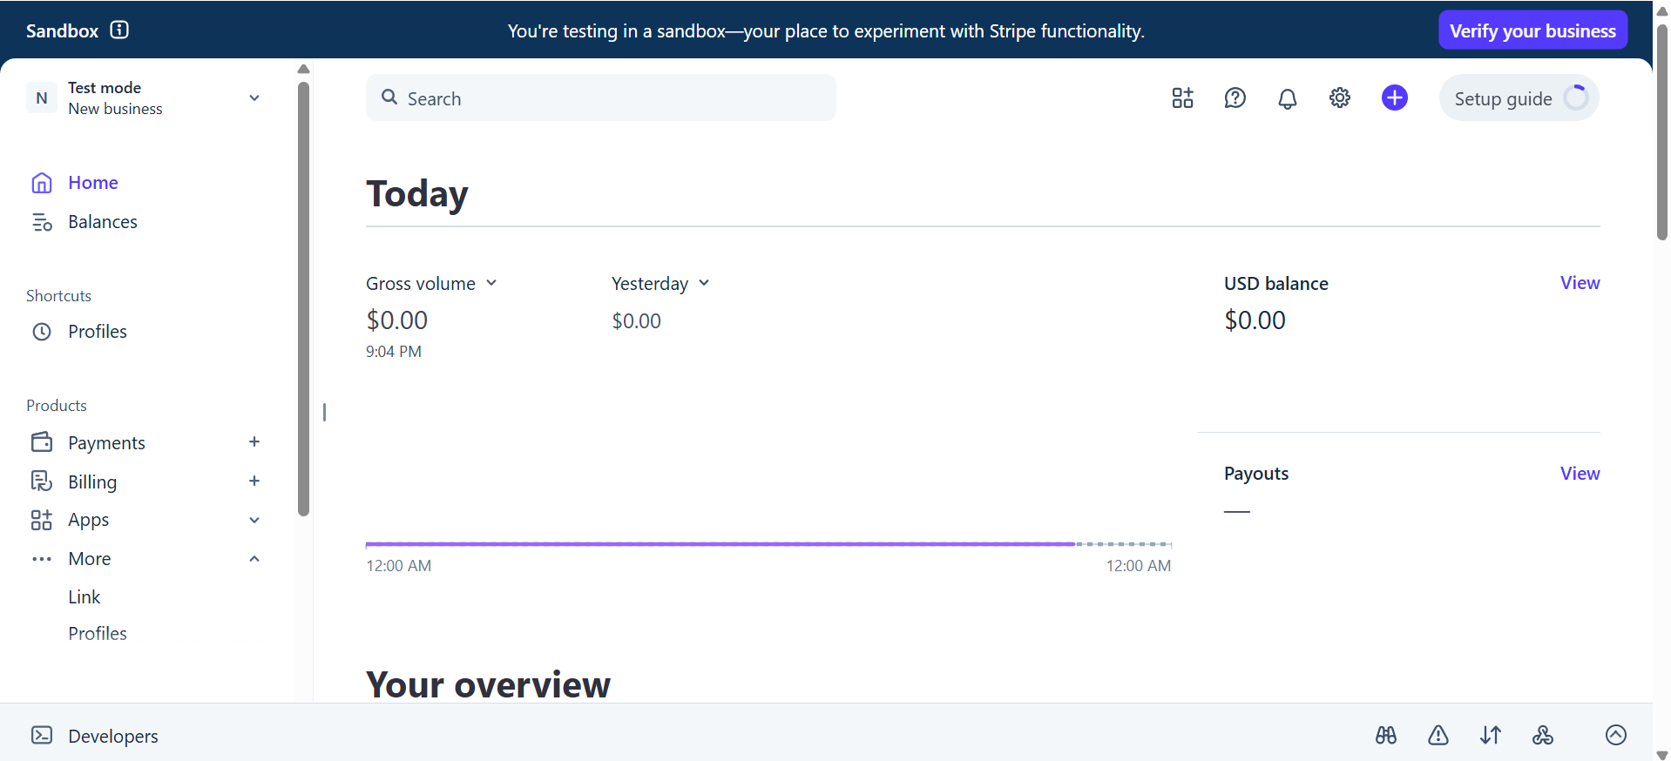

2) test mode -> settings -> developers -> manage API key
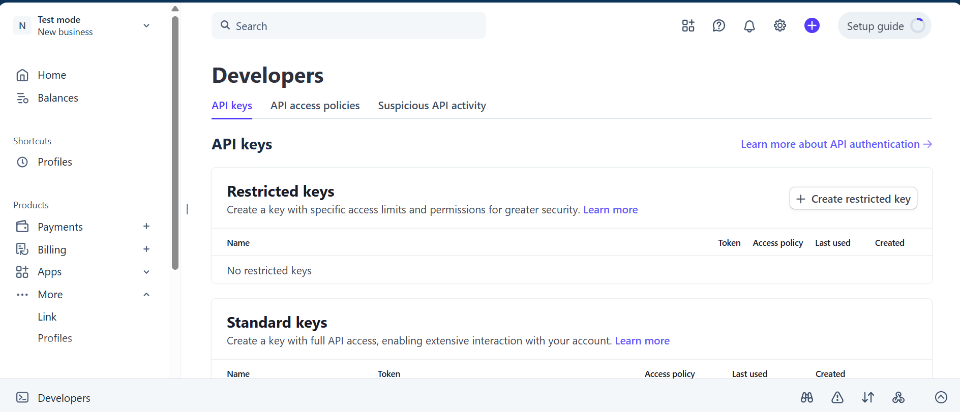

Publishable Key: eypk_test_51TyZP045Dy1c9WAwBu5eDBcnXoHBfV6iNKDcb4forwH5I6a5iwx8KL3KqzE4nWs6UooaDuil4Q6nDgbnMH8O4bKd00LeGKPirJ

Secret Key:
sk_test_51TyZP045Dy1c9WAwE8Wz3ysIim46ZEAg9n7nqw7QX3DV07krtfkLpfEKbklJ23Fk0OtRzJXagBAES5AyZ2bnSvlf00wYGh6ufa

TEST CARD
Card Number: 4242 4242 4242 4242
Expiry Date: Any future date (e.g., 12/34)
CVC: Any 3 digits (e.g., 123)
ZIP/Postal Code: Any valid value
------------------------------------------------------------------------------------------------------------------
Working in Webhook and navigate to localhost when payment is done
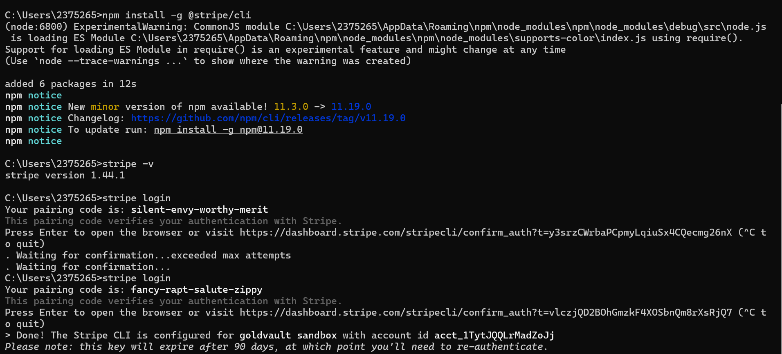
The Stripe CLI is configured for goldvault sandbox with account id acct_1TytJQQLrMadZoJj
stripe listen --forward-to http://localhost:9090/gold/v1/webhook
stripe trigger checkout.session.completed
- Your webhook signing secret is whsec_4be1ae2d0d87f07ce910f768b5105170f913aebc185ecda44c38274241a895d9
- Use the secret key in the controller. And can test from cli by
(stripe trigger checkout.session.completed)
- Test with below to trigger manually
stripe trigger checkout.session.completed --override checkout_session:metadata.sessionId=68fab71e-0774-4b95-9d05-c249865e784b
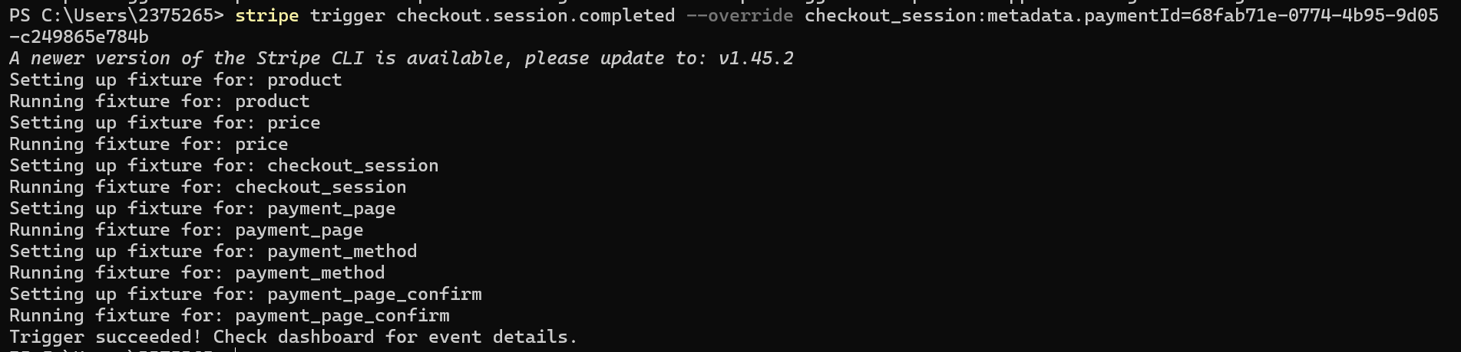

- For Failure test : stripe trigger payment_intent.payment_failed --override payment_intent:metadata.sessionId=68fab71e-0774-4b95-9d05-c249865e784b

Stripe RE-INSTALL
