🛡️ CYBERSECURITY & ETHICAL HACKING INTERNSHIP
Week 2 - Footprinting & Reconnaissance Report
Passive & Active Reconnaissance Using Kali Linux Tools
Intern Name | [Your Full Name]
Batch | Batch Code - B082
Program | NetworkWalks Academy - Cybersecurity & Ethical Hacking Internship
Intern | Mithun Kumar Rajak
Instructor | Waqas Karim CCIE
Week | Week 2 - Footprinting & Reconnaissance
Target Domain | networkwalks.com (authorized training target)
Submission Date | 24 August 2026

1. Objective
The objective of this lab was to perform footprinting and reconnaissance against an authorized target domain using multiple built- in Kali Linux tools. The exercise covered domain registration lookups, web technology fingerprinting, DNS resolution, HTTP header inspection, Web Application Firewall (WAF) detection, and full DNS record enumeration - the standard first phase of any penetration testing engagement.

2. Lab Environment
Attacker Machine | Kali Linux 2026.2 (VirtualBox VM - configured in Week 1)
Target Domain | networkwalks.com
Comparison Domain | example.com (used for baseline/contrast in some tasks)
Network Mode | NAT Network - outbound internet access for live reconnaissance
Tools Used | whois, whatweb, nslookup, curl, wafw00f, dnsrecon

Note: All reconnaissance in this lab was performed against networkwalks.com, the training provider's own public- facing website, as an authorized target for academic exercise purposes only.

3. Tasks Performed

Task 1 - WHOIS Domain Registration Lookup
whois queries a public registry database that stores domain registration details. When a domain is registered, this information (registrar, creation/expiry dates, name servers, contact details) becomes publicly queryable through this command.
$ whois networkwalks.com
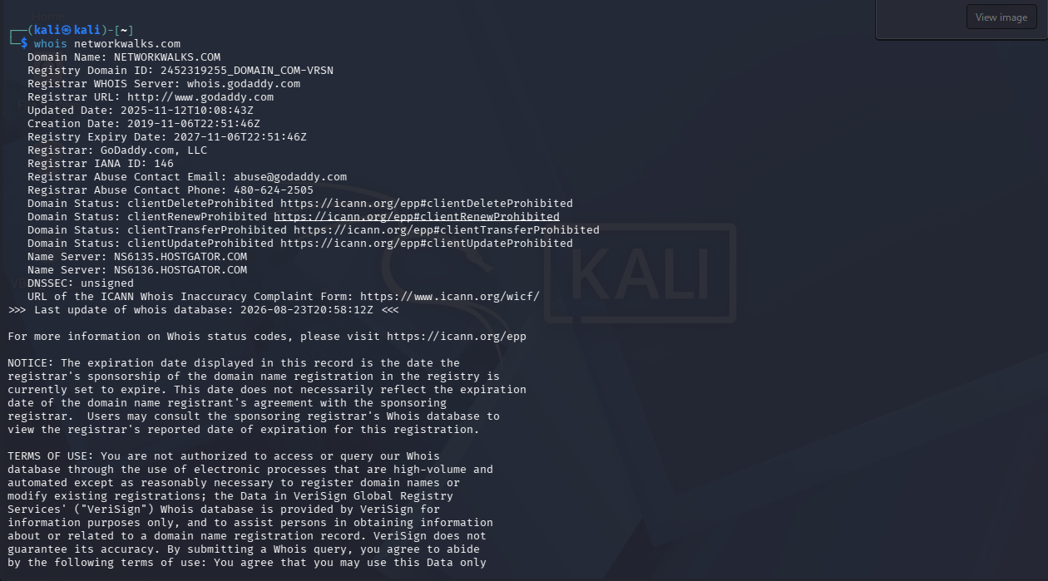
Figure 1 - WHOIS output for networkwalks.com showing registrar (GoDaddy), creation/expiry dates, and name servers.

A second query was run using the - H flag, which suppresses lengthy legal disclaimer text on supporting systems for cleaner output:
$ whois - H networkwalks.com # - H hides legal disclaimers
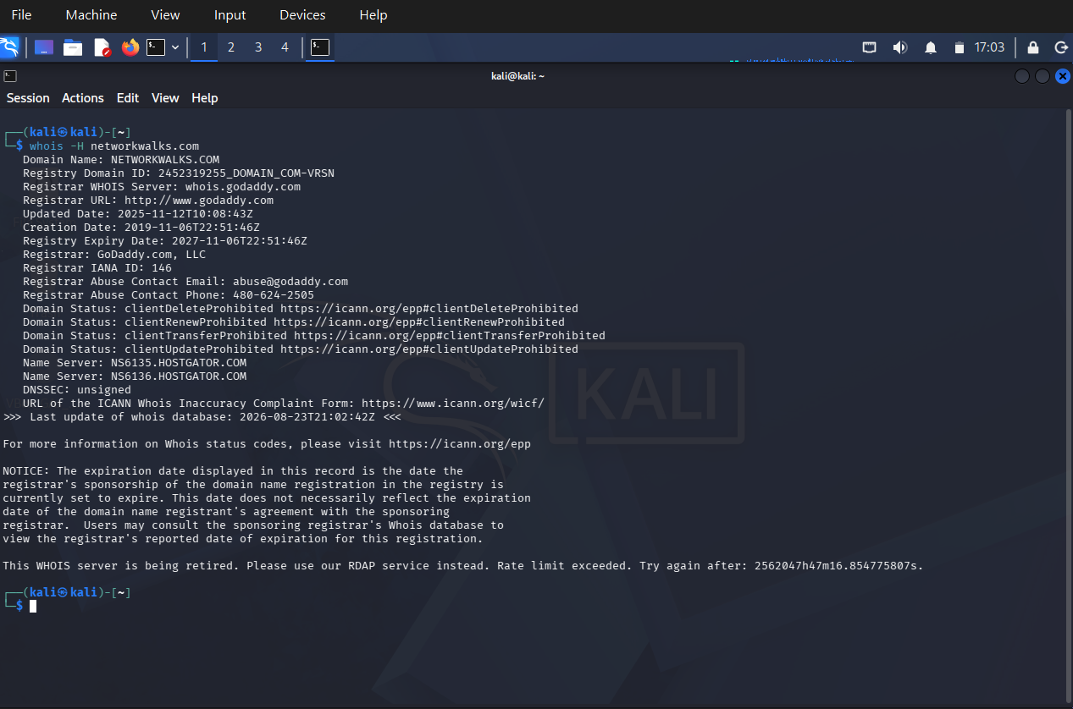
Figure 2 - WHOIS output with the - H flag, showing the same registration data with reduced disclaimer clutter.
Key findings: domain registered via GoDaddy.com, LLC; created 06 Nov 2019; expires 06 Nov 2027; name servers hosted on HostGator (ns6135 / ns6136.hostgator.com); domain locks (clientDeleteProhibited, clientTransferProhibited, etc.) are all active, indicating standard registrar- level protection against unauthorized transfers.

Task 2 - WhatWeb Website Fingerprinting
whatweb is a website fingerprinting scanner. It sends HTTP requests to a target and matches the response - headers, HTML content, cookies, meta tags, JavaScript libraries, and error pages - against a database of signatures ("plugins") to identify the technologies a site runs on, such as:
- CMS platforms (WordPress, Drupal, Joomla)
- Web server software (Apache, Nginx, IIS)
- Programming languages / frameworks (PHP, ASP.NET, Django, Rails)
- JavaScript libraries (jQuery, React, Bootstrap)
- Analytics / tracking tools and security headers
$ whatweb example.com
$ whatweb networkwalks.com
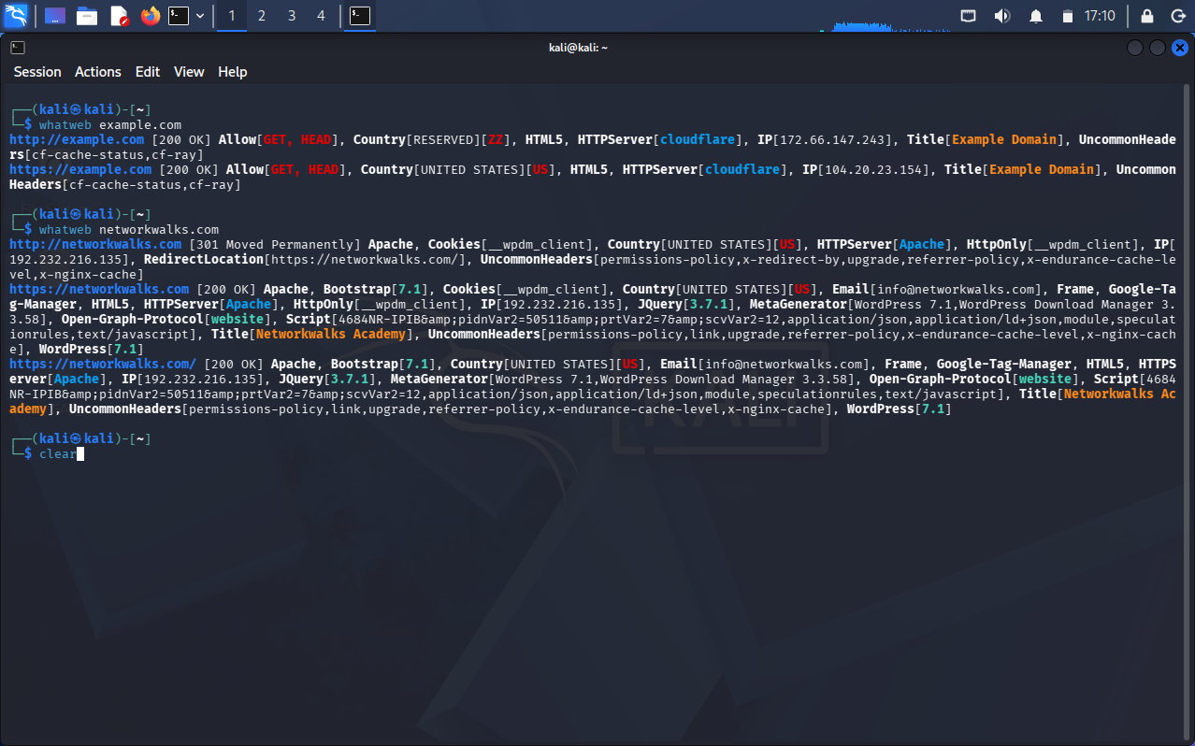
Figure 3 - WhatWeb scan comparing example.com (Cloudflare- fronted) against networkwalks.com (Apache + WordPress stack).
Findings for networkwalks.com: running Apache on IP 192.232.216.135, WordPress 7.1 with WordPress Download Manager plugin (v3.58), Bootstrap 7.1, jQuery 3.7.1, and HTTP redirects from the bare domain to the HTTPS www- prefixed version.
A verbose scan (- v) was then run against networkwalks.com for a detailed plugin- by- plugin breakdown:
$ whatweb - v networkwalks.com
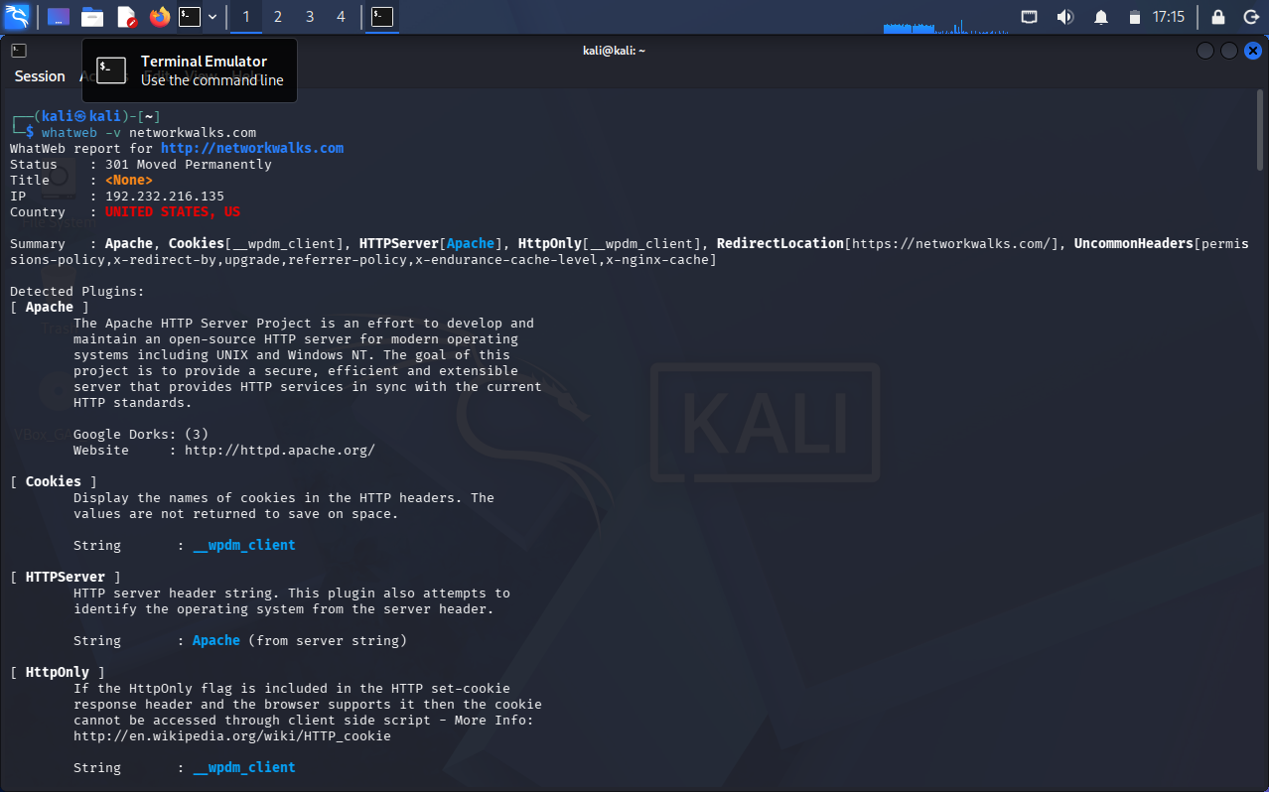
Figure 4 - Verbose WhatWeb report detailing each detected plugin: Apache server, cookie flags, and HttpOnly security attributes.

Task 3 - nslookup DNS Resolution
nslookup queries DNS servers to resolve a domain name to its IP address (or vice- versa), and can query other DNS record types. It is one of the most universal DNS tools, available by default on Linux, macOS, and Windows.
$ nslookup networkwalks.com
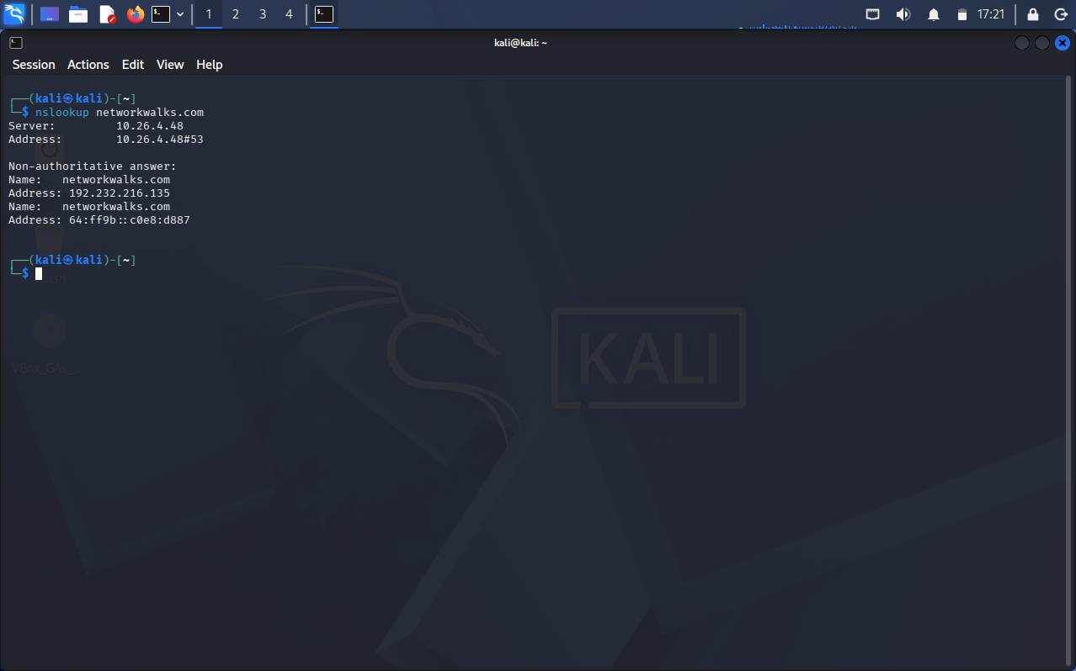
Figure 5 - nslookup resolving networkwalks.com to IPv4 address 192.232.216.135 and its corresponding IPv6 (NAT64) address.
Result: networkwalks.com resolves to 192.232.216.135 (IPv4), with an additional IPv6 NAT64- mapped address returned by the resolver.

Task 4 - curl - I HTTP Header Inspection
The - I flag (short for - - head) sends an HTTP HEAD request instead of a standard GET request. A HEAD request asks the server to return only the response headers, not the page body - a fast, lightweight way to inspect what a server discloses about a resource without downloading it.
$ curl - I https://networkwalks.com
$ curl - I https://example.com
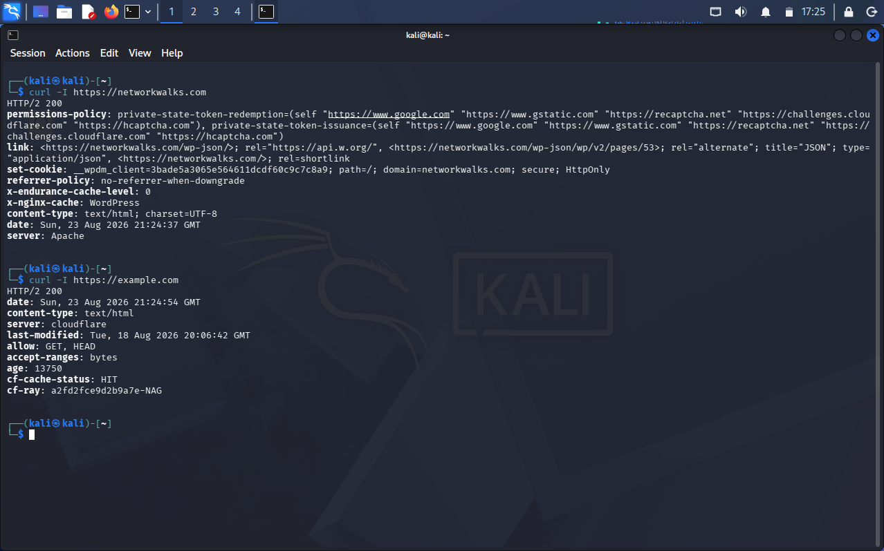
Figure 6 - HTTP response headers for networkwalks.com (Apache, WordPress cache headers) versus example.com (Cloudflare- fronted, cache HIT).
Findings: networkwalks.com discloses server: Apache, a WordPress- generated cache header (x- nginx- cache: WordPress), and a session cookie (__wpdm_client) marked Secure and HttpOnly. example.com is fronted by Cloudflare with a cached response (cf- cache- status: HIT).

Task 5 - wafw00f Web Application Firewall Detection
wafw00f detects whether a website sits behind a Web Application Firewall (WAF), and attempts to identify which vendor (Cloudflare, AWS WAF, Akamai, Sucuri, Imperva, F5 BIG- IP ASM, etc.). It works by sending a mix of normal and deliberately suspicious- looking requests and analyzing how the server's responses differ - WAFs typically block, alter headers, or return custom error pages when they detect malicious- looking traffic.
$ wafw00f https://networkwalks.com
$ wafw00f https://example.com
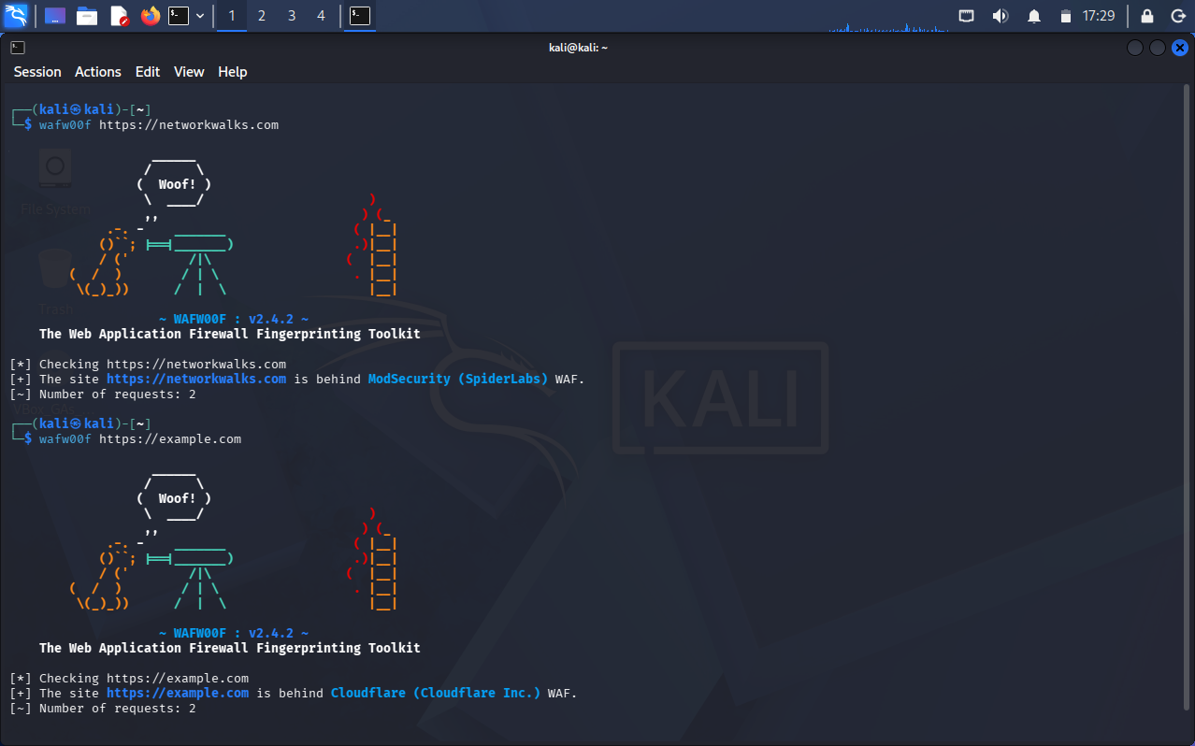
Figure 7 - wafw00f identifying ModSecurity (SpiderLabs) protecting networkwalks.com, and Cloudflare protecting example.com.
Findings: networkwalks.com is protected by ModSecurity (SpiderLabs) WAF. example.com is protected by Cloudflare's own WAF - confirming both sites have active perimeter defenses against common web attacks.

Task 6 - dnsrecon Full DNS Enumeration
dnsrecon is a Python- based DNS enumeration tool that automates pulling every DNS record type for a domain in a single pass, and performs additional reconnaissance such as zone- transfer attempts, subdomain brute- forcing, and reverse lookups on discovered IPs. It functions like nslookup or dig, but scripted to check everything systematically rather than one record type at a time.
$ dnsrecon - d networkwalks.com - t std
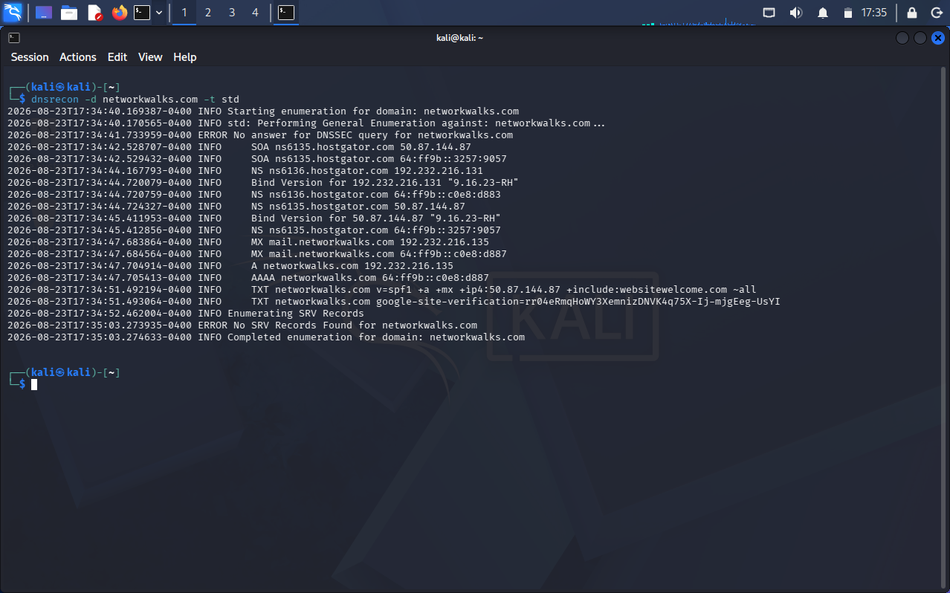
Figure 8 - dnsrecon standard enumeration output showing SOA, NS, MX, A, AAAA, and TXT records for networkwalks.com.
Findings: SOA and NS records point to HostGator name servers (ns6135 / ns6136.hostgator.com, BIND 9.16.23- RH); MX record for mail routes to mail.networkwalks.com; A record confirms 192.232.216.135; TXT records include an SPF policy (v=spf1 +a +mx +ip4:50.87.144.87 +include:websitewelcome.com ~all) and a Google Search Console site- verification token. No DNSSEC signature was found (unsigned), and no SRV records were present.

4. Findings Summary
Category | networkwalks.com | example.com (comparison)
Registrar | GoDaddy.com, LLC | N/A (not queried via whois)
Hosting / Name Servers | HostGator (ns6135/ns6136) | Cloudflare- fronted
Web Server | Apache | cloudflare (edge)
CMS / Stack | WordPress 7.1, Bootstrap 7.1, jQuery 3.7.1 | Static page, no CMS detected
Public IP | 192.232.216.135 | 172.66.147.243 / 104.20.23.154
WAF Detected | ModSecurity (SpiderLabs) | Cloudflare WAF
Notable Cookies | __wpdm_client (Secure, HttpOnly) | None observed
DNSSEC | Unsigned | Not queried

5. Task Checklist
✓ | Task
✔ | Ran whois to retrieve domain registration details for networkwalks.com
✔ | Repeated whois with - H flag to suppress legal disclaimer text
✔ | Ran whatweb to fingerprint web technologies on both target and comparison domains
✔ | Ran whatweb - v for a detailed, plugin- by- plugin technology breakdown
✔ | Ran nslookup to resolve the domain to its IPv4/IPv6 addresses
✔ | Ran curl - I to inspect HTTP response headers without downloading page content
✔ | Ran wafw00f to detect and identify the Web Application Firewall in use
✔ | Ran dnsrecon for full DNS record enumeration (SOA, NS, MX, A, AAAA, TXT)

6. Observations & Learnings
- Passive reconnaissance (whois, nslookup, dnsrecon) can reveal significant infrastructure detail - hosting provider, mail routing, and SPF policy - without ever sending a request directly to the target's web application.
- Active fingerprinting tools (whatweb, curl - I) expose the exact CMS, plugin versions, and server software in use, which in a real assessment would inform which known vulnerabilities to check for next.
- WAF detection (wafw00f) is a critical early step before any active scanning, since it indicates the target has a defensive layer that may block, rate- limit, or alter results of later enumeration and exploitation attempts.
- Comparing a WAF/CDN- fronted site (example.com via Cloudflare) against a directly- hosted site (networkwalks.com via Apache/HostGator) highlighted how differently each infrastructure type responds to the same reconnaissance techniques.

7. Next Steps (Week 3 Preview)
With passive and active footprinting complete, the next phase will move into active network scanning - host discovery, port scanning, and service/version detection using Nmap and Zenmap - building directly on the infrastructure details (IP addresses, hosting provider, server stack) uncovered in this week's reconnaissance.

⚖️ Disclaimer
All reconnaissance activities documented in this report were performed against networkwalks.com and example.com, both of which are appropriate, non- intrusive targets for educational footprinting exercises using only publicly available information (WHOIS, DNS, and HTTP headers). No exploitation, unauthorized access, or intrusive scanning was performed against any system. This work is conducted strictly for learning purposes as part of an authorized internship curriculum.

