🛡️ CYBERSECURITY & ETHICAL HACKING INTERNSHIP
Week 3 - Password Cracking with John the Ripper (JTR)
Cracking Password-Protected PDF Files Using Johnny (GUI for John the Ripper)
Intern Name | Mithun Kumar Rajak
Batch | Batch Code - B082
Program | NetworkWalks Academy - Cybersecurity & Ethical Hacking Internship
Instructor | Wagas Karim (CCIE)
Week | Week 3 - Project Module: Password Cracking with JTR
Submission Deadline | 23:00, Friday 28 August 2026

1. Objective
The objective of this lab was to demonstrate password recovery on password-protected PDF documents using John the Ripper (JTR), a widely used offline password-cracking tool, operated through its graphical front-end "Johnny." The exercise involved extracting a crackable hash from each locked PDF, feeding it to JTR's default wordlist-based cracking engine, and verifying each recovered password by successfully unlocking the corresponding file.

2. Lab Environment & Tools
Host OS | Windows 10/11
Cracking Tool | John the Ripper 1.9.0-jumbo-1 (Cygwin 64-bit, x86_64 AVX2 AC)
GUI Front-End | Johnny (graphical interface for John the Ripper)
Hash Extraction Tool | Online Hash Crack - PDF Hash Extractor (pdf2john/pdf2hashcat)
Target Files | 3x password-protected PDF documents (My Locked PDF1 / PDF2 / PDF3)
Verification Method | Re-opening each PDF in a browser PDF viewer using the recovered password

Note: John the Ripper relies on a target executable path and a supplied password hash to perform its attack; Johnny provides a graphical layer on top of the same underlying JTR engine to manage attacks, view progress, and review cracked results without using the command line directly.

3. Methodology
The same four-stage workflow was followed for each of the three locked PDF files:
- Extract the PDF's password hash using an online PDF-to-hash conversion tool (equivalent to running pdf2john locally).
- Save the extracted hash string to a plain text (.txt) file.
- Load the hash file into Johnny and start a new dictionary/default-mode attack using John the Ripper's engine.
- Once cracked, verify the recovered password by opening the original PDF and confirming access to the flag inside.

4. Task 1 - Cracking "My Locked PDF1"

4.1 Extracting the PDF Hash
The locked PDF was uploaded to the Online Hash Crack PDF Hash Extractor tool, which parsed the file's encryption dictionary and generated a JTR/Hashcat-compatible hash string (format: $pdf$...).
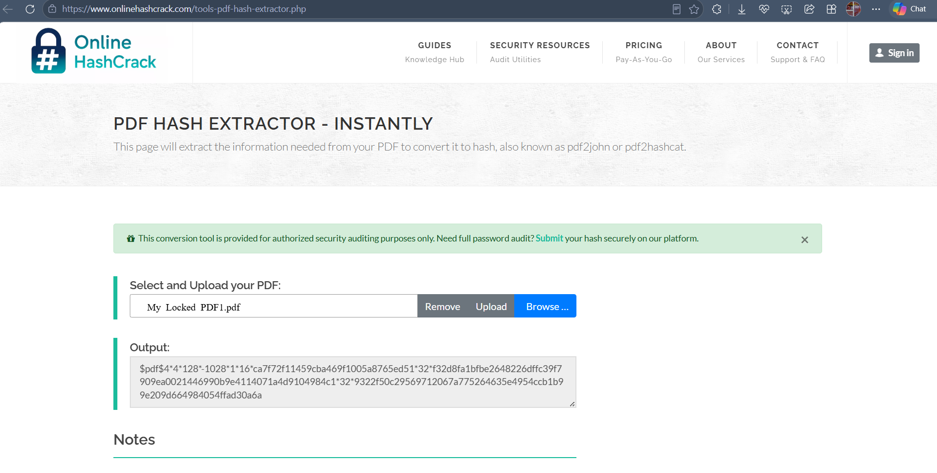
Figure 1 - PDF Hash Extractor tool generating the $pdf$ hash string for My Locked PDF1.
The generated hash was copied and saved into a plain text file (My Locked PDF1-Hash Value.txt) for use as JTR's input.
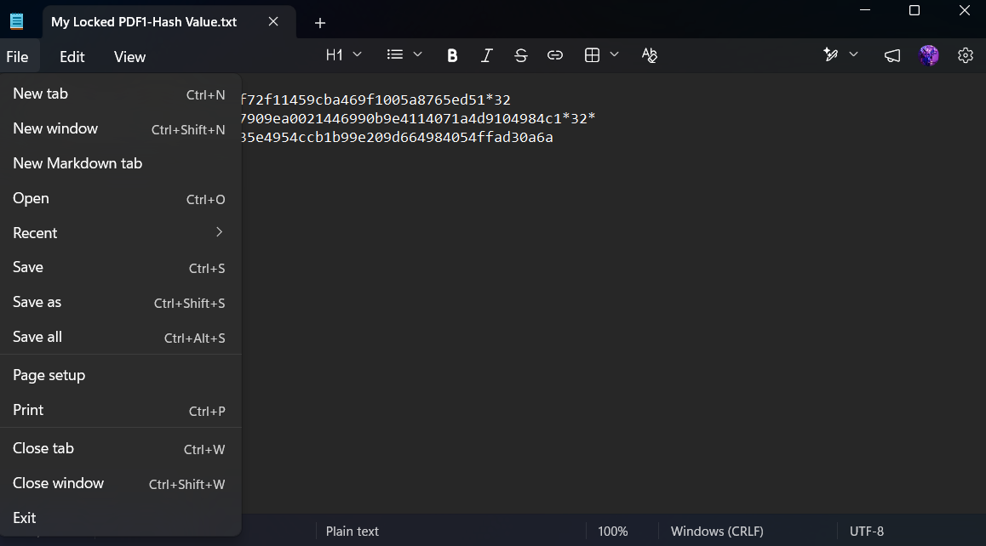
Figure 2 - Extracted hash saved locally as a .txt file for input into John the Ripper.

4.2 Loading the Hash into Johnny and Running the Attack
Johnny was opened and the saved hash file was loaded via Open Password File. Johnny's Settings tab confirmed the correct John the Ripper executable path and detected engine version (1.9.0-jumbo-1).
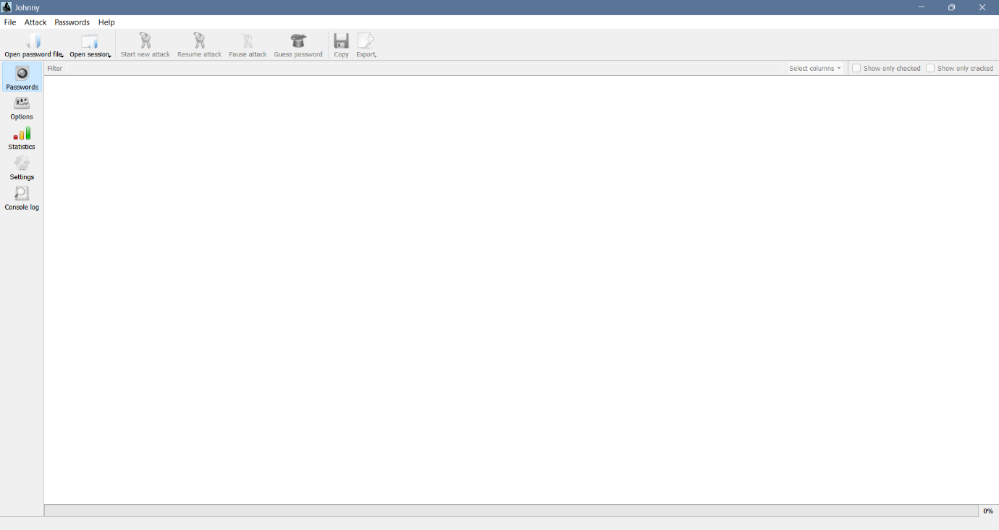
Figure 3 - Johnny's main interface prior to loading a password file.
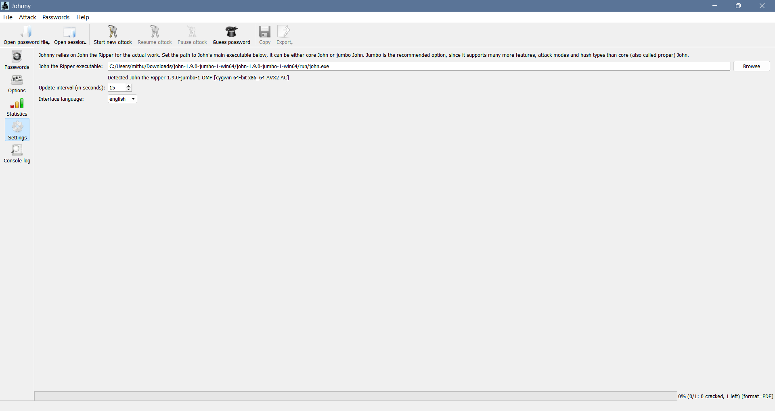
Figure 4 - Johnny's Settings tab confirming the John the Ripper executable path and detected version.
With the hash loaded (format detected automatically as PDF), Start New Attack was triggered from the Attack menu to begin the cracking process.
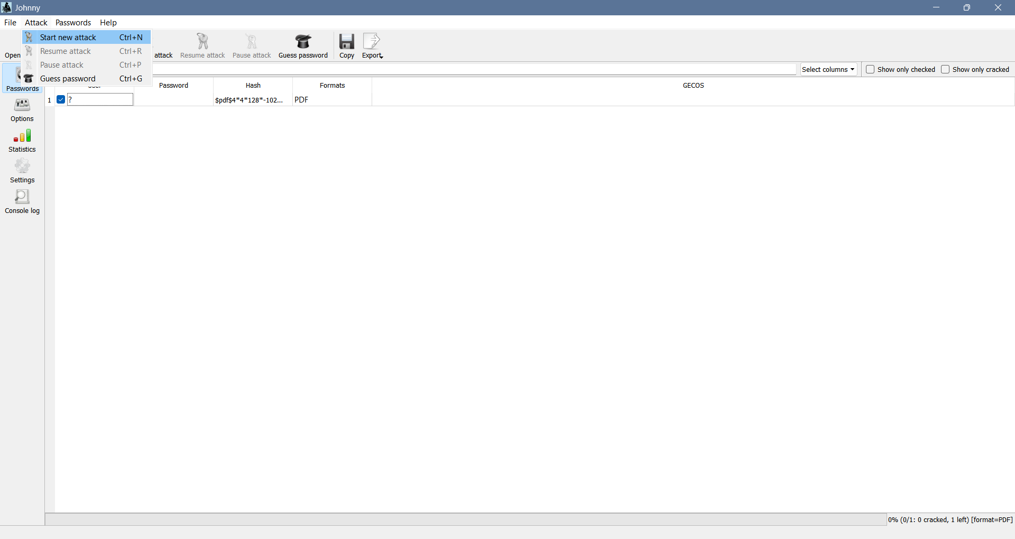
Figure 5 - Hash loaded into Johnny, ready to begin the attack (Start New Attack selected from the Attack menu).

4.3 Result - Password Cracked
John the Ripper completed the attack at 100% (1/1: 1 cracked, 0 left), successfully recovering the plaintext password.
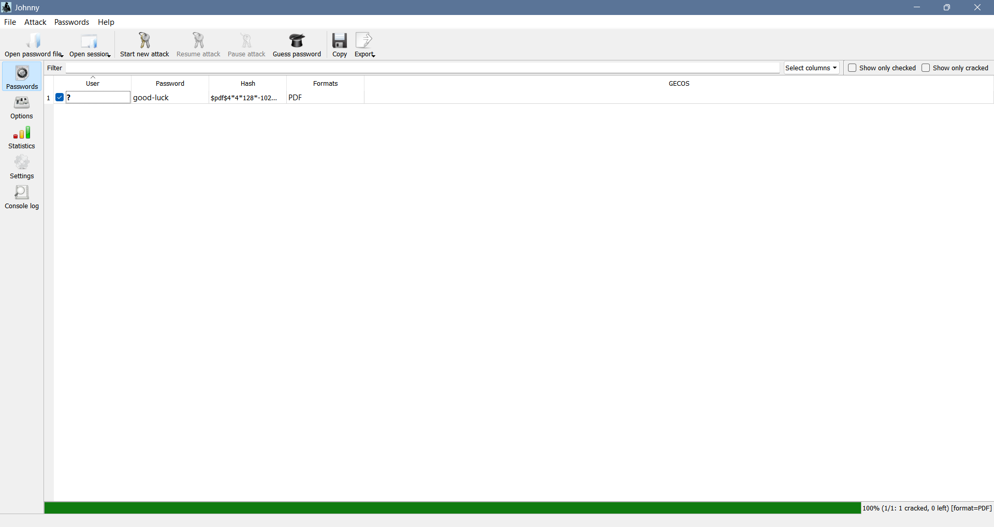
Figure 6 - Johnny displaying the cracked password "good-luck" for My Locked PDF1.

4.4 Verification
The recovered password was used to unlock the original PDF directly in the browser's PDF viewer, confirming the crack was successful.
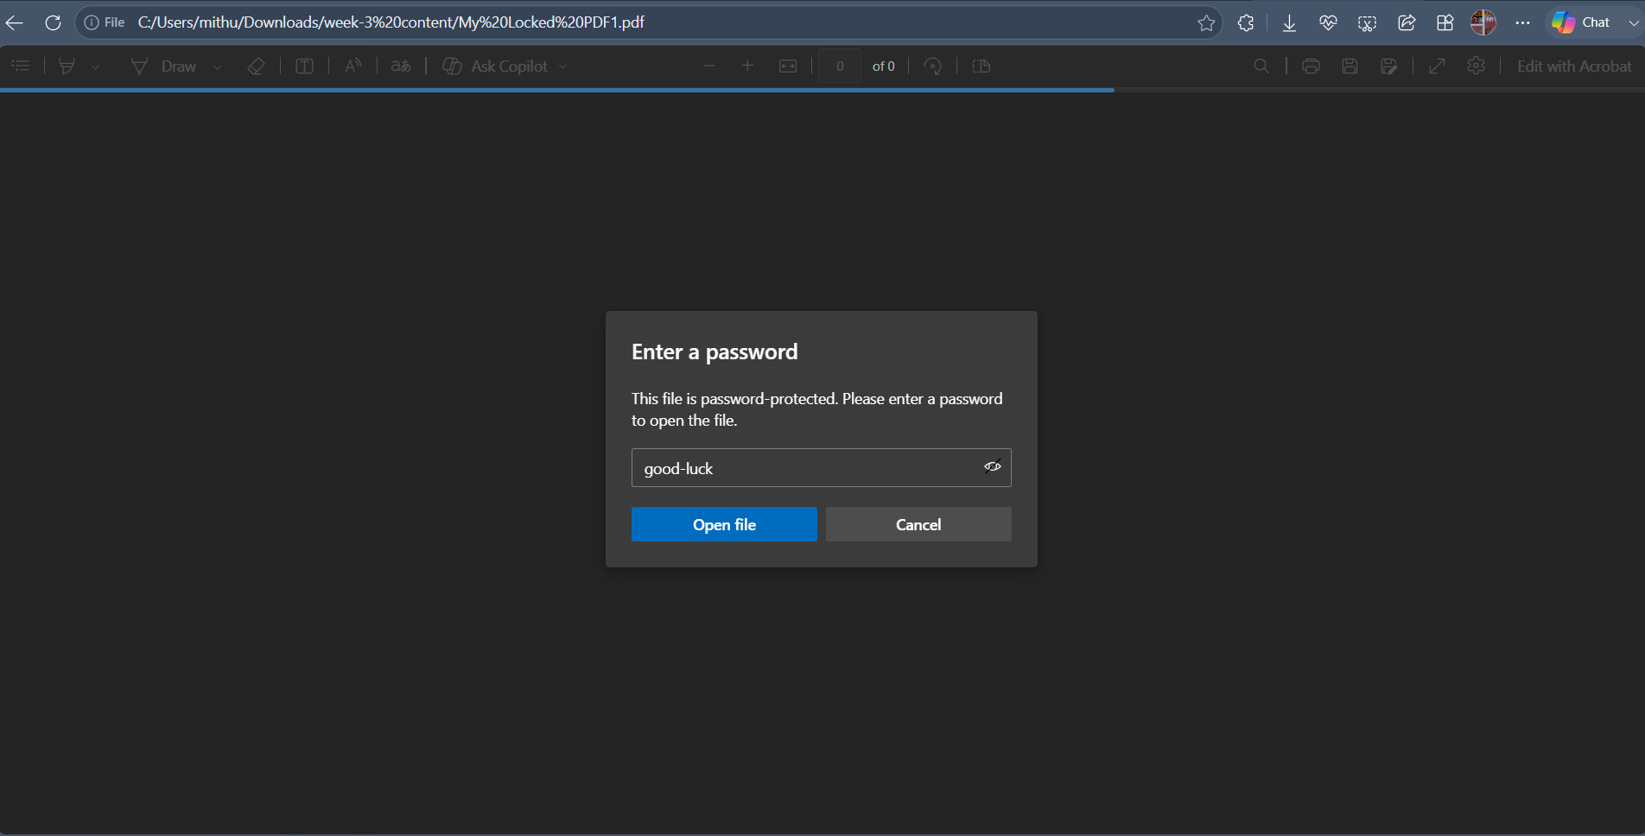
Figure 7 - Entering the recovered password "good-luck" into the PDF's password prompt.
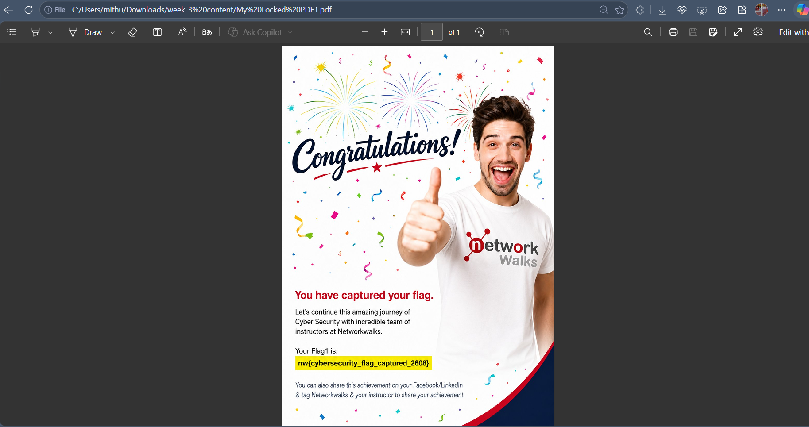
Figure 8 - PDF successfully unlocked, confirming the correct password and revealing the captured flag.

5. Task 2 - Cracking "My Locked PDF2"
The same extraction-and-crack workflow was repeated for the second locked PDF.
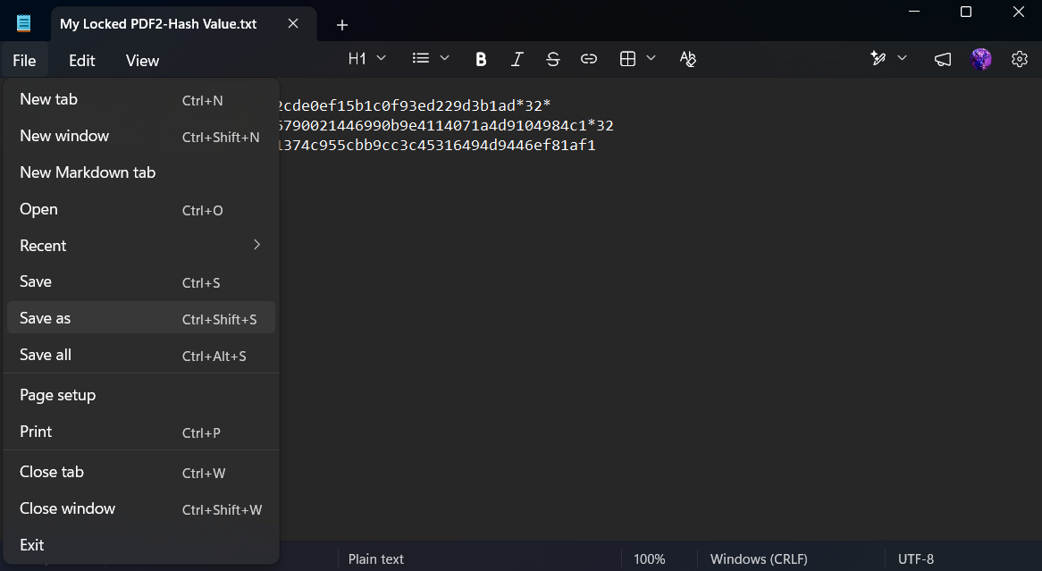
Figure 9 - Hash extracted and saved for My Locked PDF2 (My Locked PDF2-Hash Value.txt).
After loading the hash into Johnny and running the attack, John the Ripper recovered the password. The password was then used to verify access to the PDF directly.
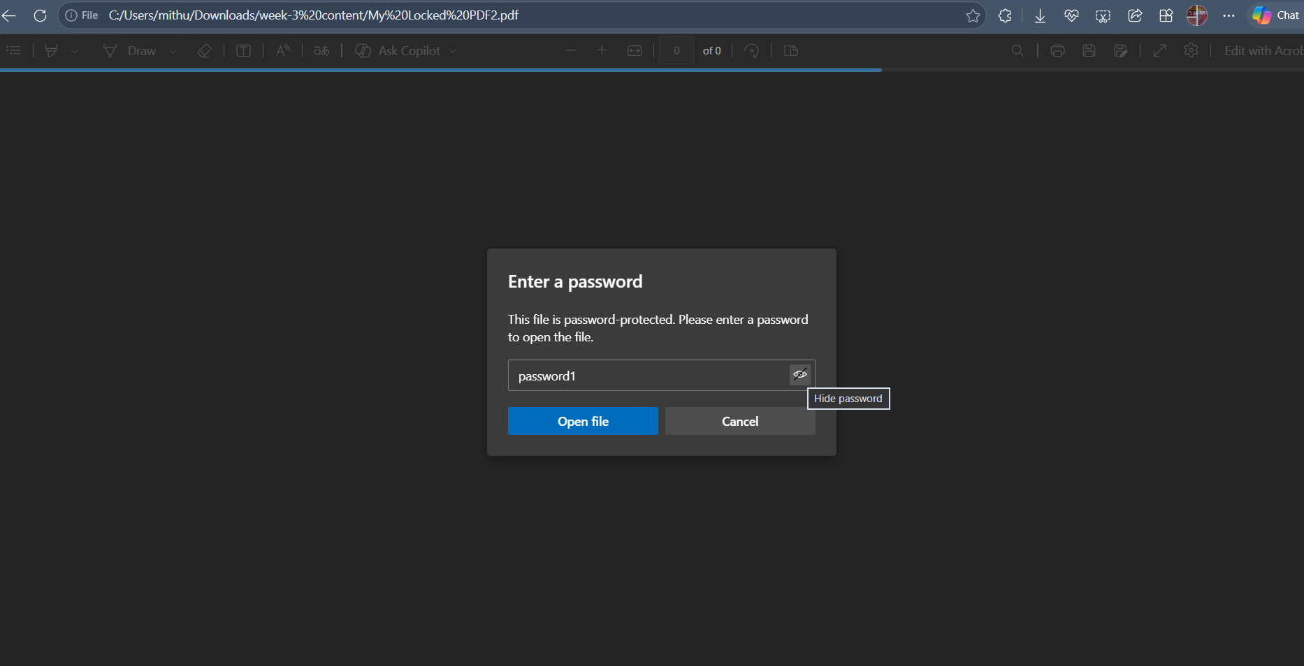
Figure 10 - Recovered password "password1" entered into the PDF's password prompt for verification.
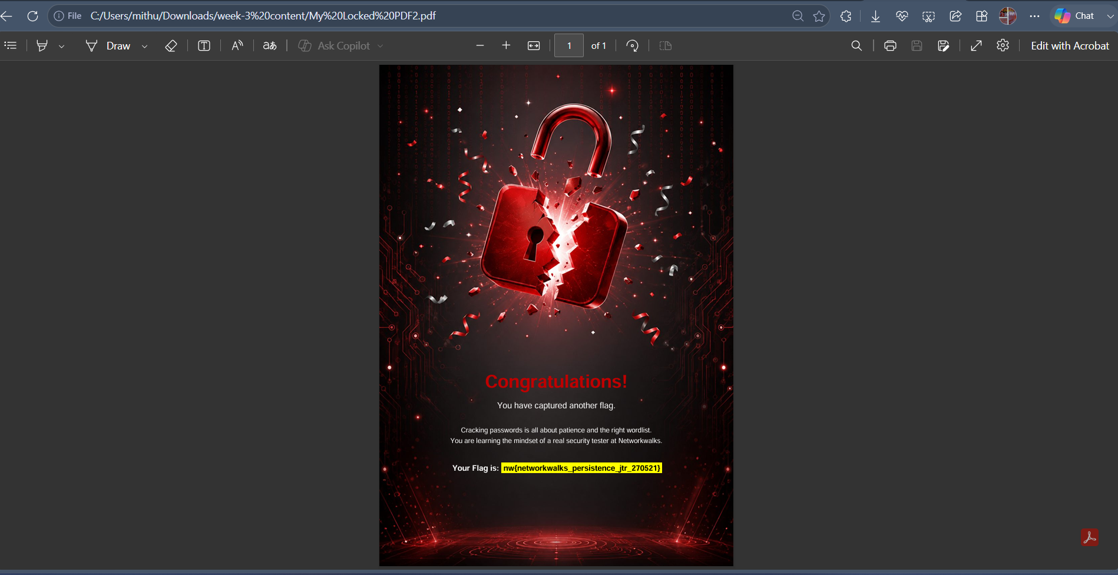
Figure 11 - PDF2 successfully unlocked, confirming the correct password and revealing the second captured flag.

Observation: "password1" is a common, low-complexity password found near the top of most default wordlists (e.g. rockyou.txt), which explains why it was cracked almost instantly.

6. Task 3 - Cracking "My Locked PDF3"
The same workflow was applied a third time to My Locked PDF3.
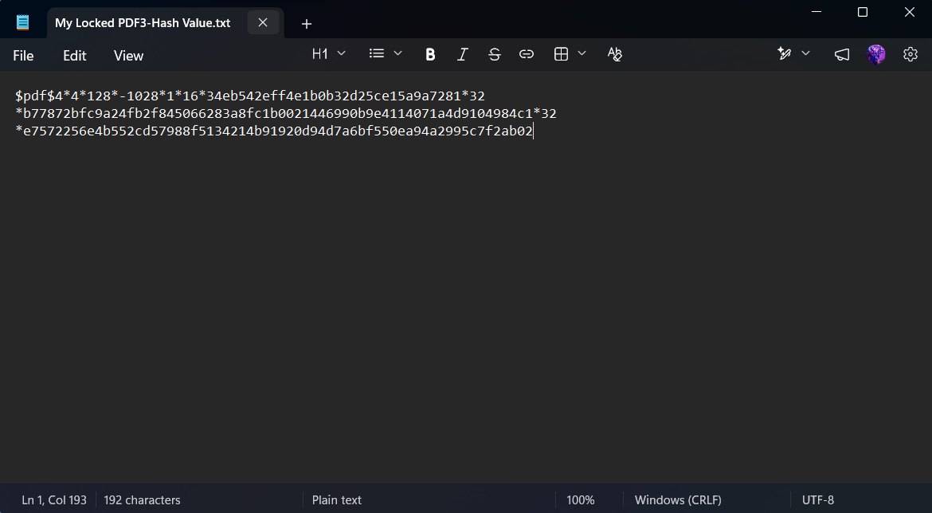
Figure 12 - Hash extracted and saved for My Locked PDF3 (My Locked PDF3-Hash Value.txt).
The hash file was located and opened in Johnny via File → Open Password File, browsing to the Downloads folder containing all previously generated hash files.
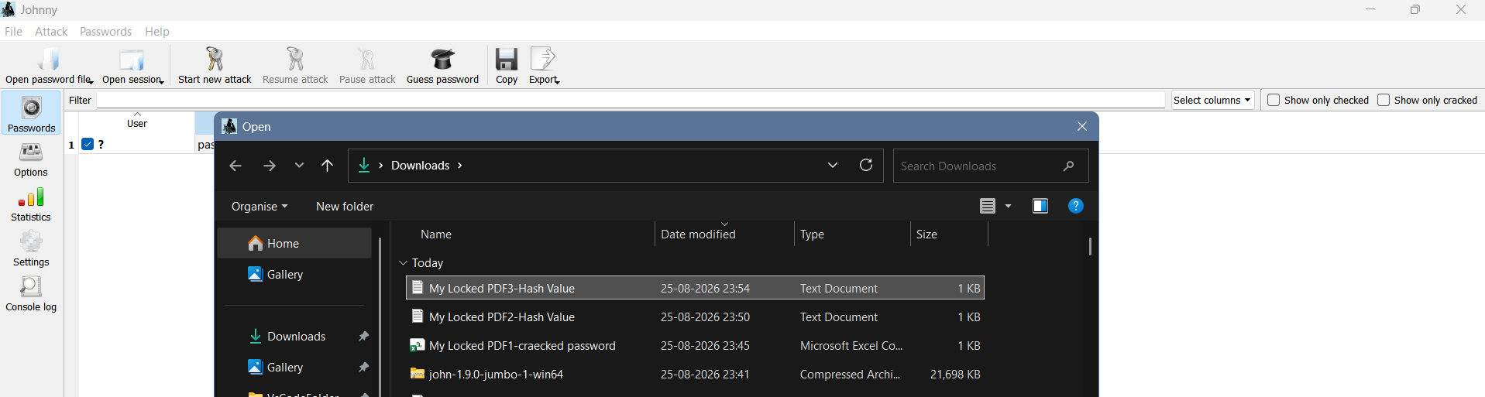
Figure 13 - Browsing to and selecting the My Locked PDF3-Hash Value file inside Johnny's file picker.
With the hash loaded, a new attack was started from the Attack menu.
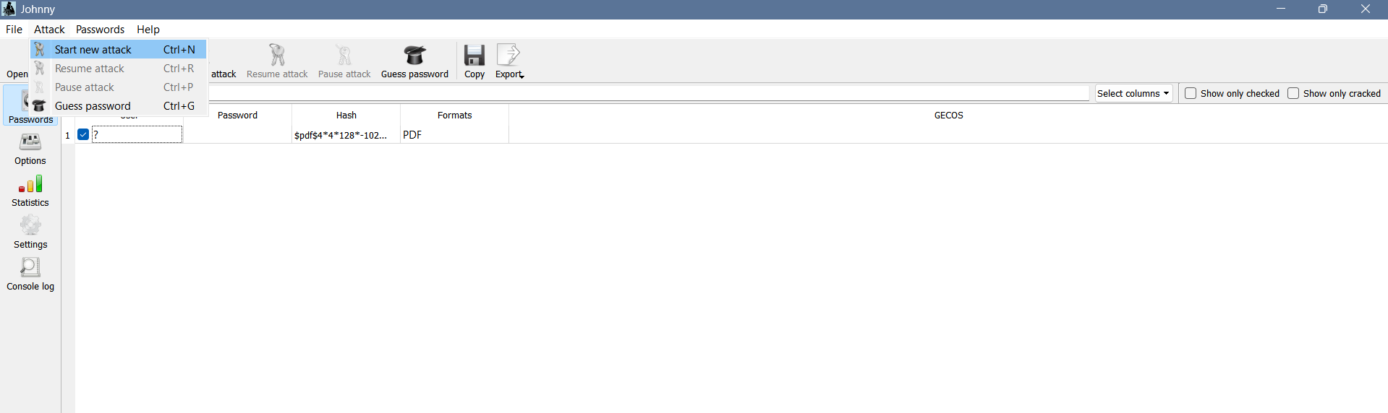
Figure 14 - Starting a new attack in Johnny against the loaded PDF3 hash.
The attack completed successfully, cracking the password.
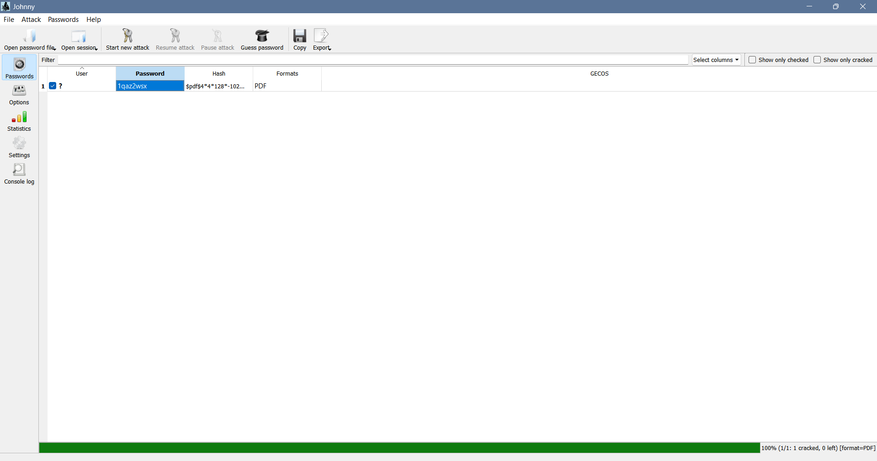
Figure 15 - Johnny displaying the cracked password "1qaz2wsx" for My Locked PDF3 (100% complete, 1 cracked).
The recovered password was verified by unlocking the PDF directly.
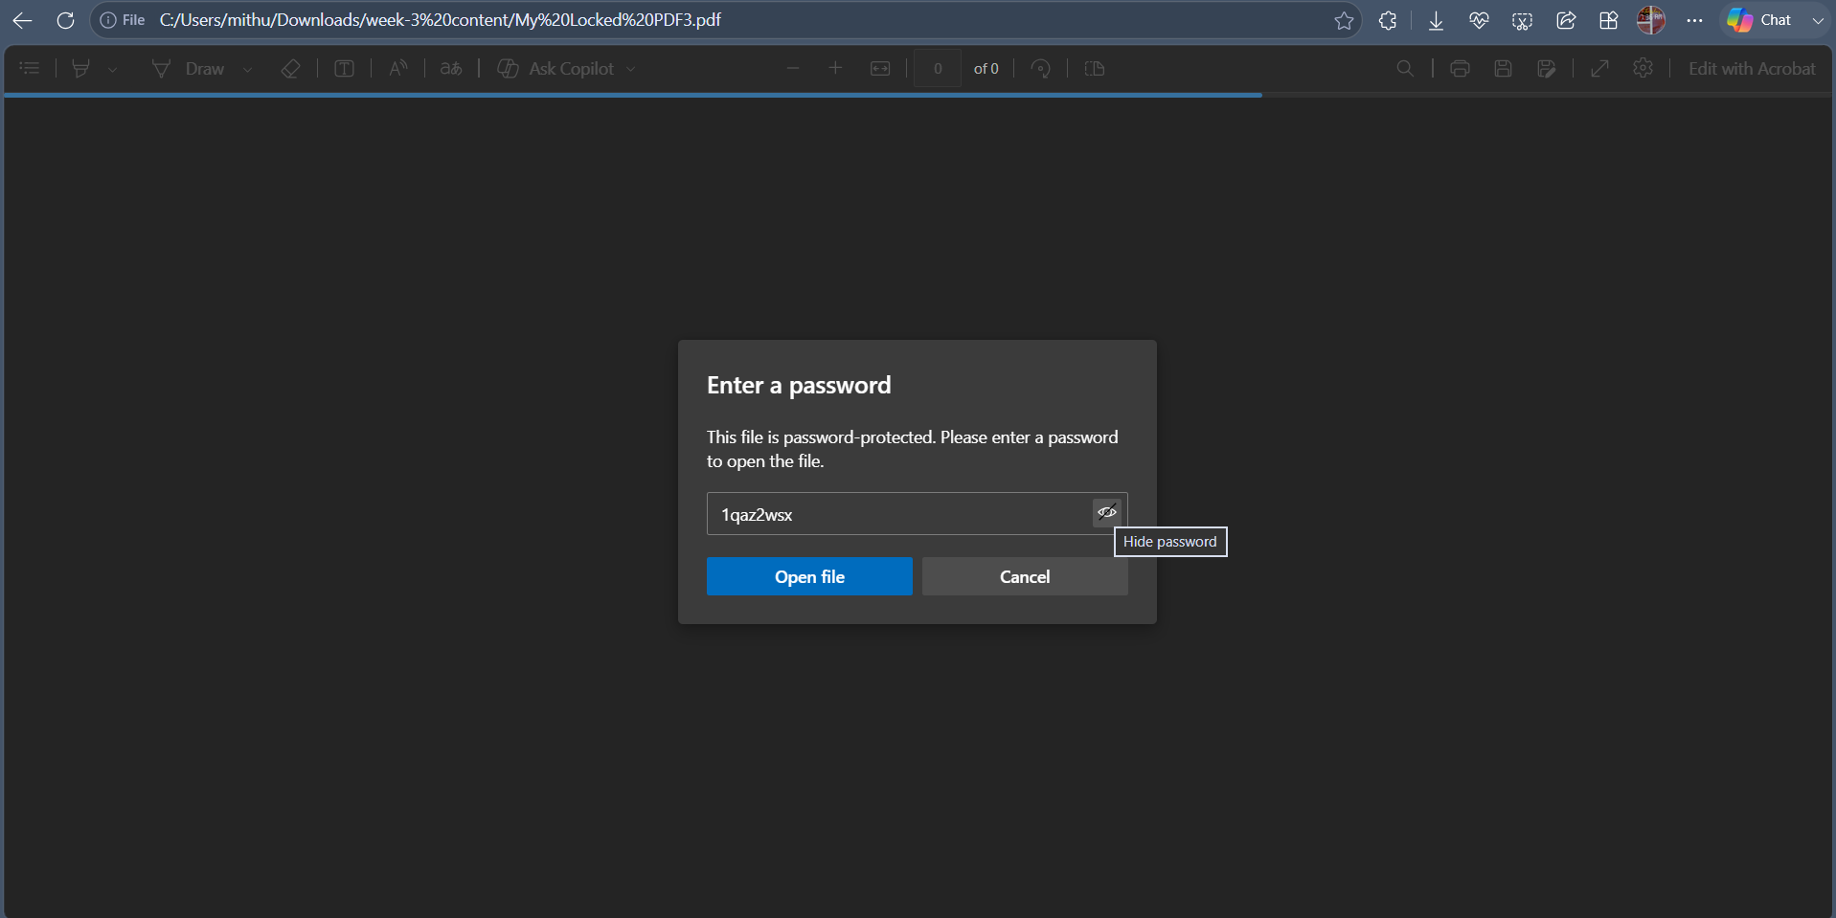
Figure 16 - Recovered password "1qaz2wsx" entered into the PDF's password prompt for verification.
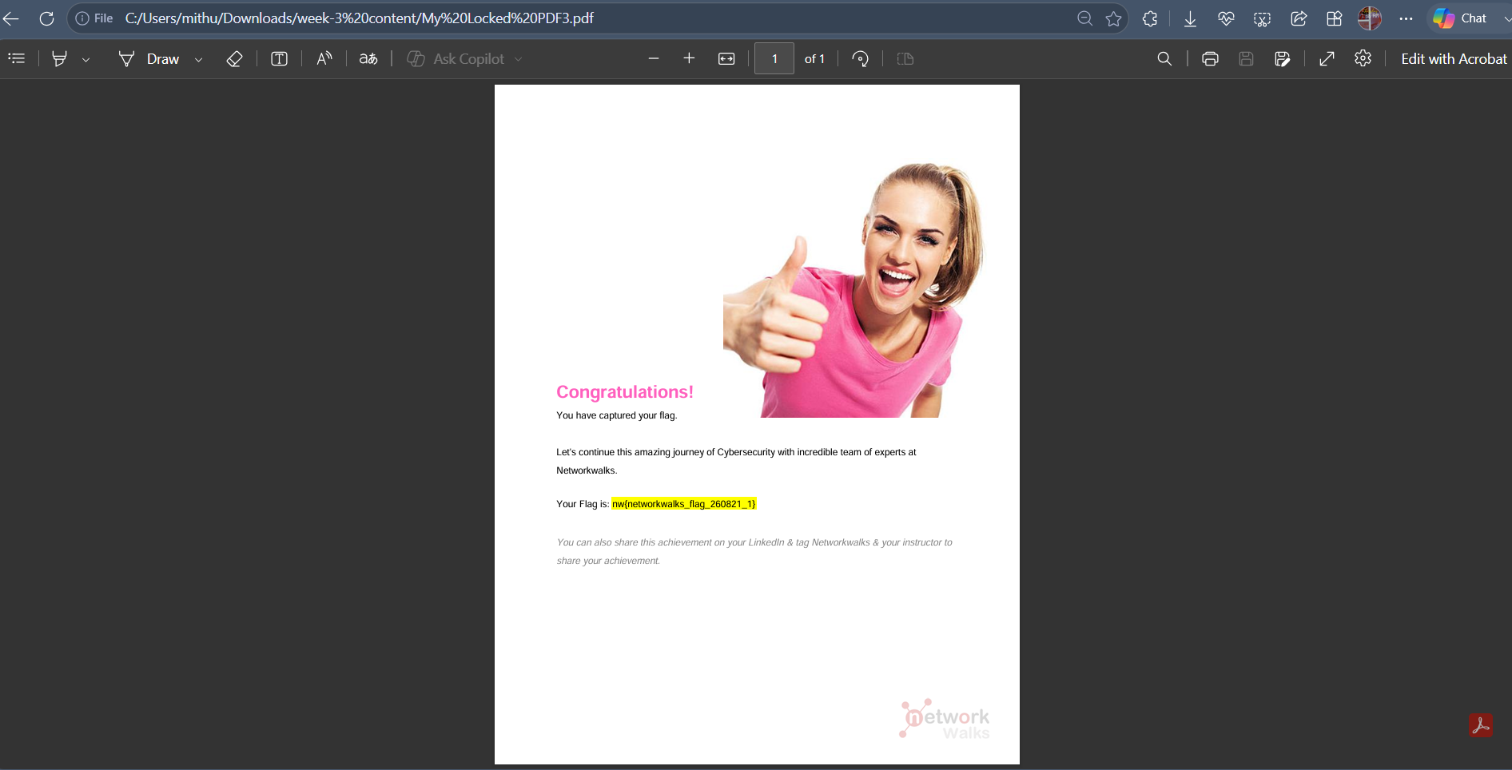
Figure 17 - PDF3 successfully unlocked, confirming the correct password and revealing the third captured flag.

Observation: "1qaz2wsx" is a keyboard-pattern password (first two columns of a QWERTY keyboard read top-to-bottom) - a pattern common enough to appear in most standard cracking wordlists despite looking superficially complex.

7. Results
Target File | Cracked Password | Password Pattern
My Locked PDF1 | good-luck | Dictionary word + hyphen
My Locked PDF2 | password1 | Common default password
My Locked PDF3 | 1qaz2wsx | Keyboard-walk pattern

8. Task Checklist
✓ | Task
✔ | Downloaded and set up John the Ripper (Jumbo edition) and Johnny GUI
✔ | Extracted password hashes from all 3 locked PDFs using the Online Hash Crack tool
✔ | Saved each extracted hash to a local .txt file
✔ | Loaded each hash file into Johnny and confirmed correct JTR executable path
✔ | Ran a new attack in Johnny for each of the 3 hashes
✔ | Successfully cracked all 3 passwords (good-luck / password1 / 1qaz2wsx)
✔ | Verified each password by unlocking the corresponding PDF
✔ | Captured and recorded all 3 flags from the unlocked PDFs

9. Observations & Learnings
- Password hashes for encrypted PDFs can be extracted without any local tooling using online converters, which replicate what a local pdf2john.py script would produce - useful for quick lab exercises, though sensitive real-world files should never be uploaded to third-party online tools.
- Johnny provides a practical visual layer over John the Ripper - attack status, percentage complete, and cracked-password results are all visible without needing to parse raw terminal output.
- All three passwords in this exercise were crackable almost instantly because they were short, common, or pattern-based (a dictionary word, a well-known default password, and a keyboard-walk pattern) - none required brute-force or extended run time.
- This exercise reinforces a core password-security lesson: password strength depends on unpredictability, not just length or the appearance of complexity - "1qaz2wsx" looks complex but is a well-known weak pattern present in most cracking wordlists.

10. Next Steps
Building on this module, the next step (W3-PM2) will repeat password-cracking exercises using additional NetworkWalks-provided tools, further reinforcing practical experience with different hash types and cracking approaches beyond PDF documents.

⚖️ Disclaimer
All password-cracking activities documented in this report were performed against sample PDF files intentionally provided for this internship's training exercise. No unauthorized files, systems, or third-party data were accessed. This work is conducted strictly for educational purposes as part of an authorized internship curriculum.

