🛡️ CYBERSECURITY & ETHICAL HACKING INTERNSHIP
Week 3 - Password Cracking with NetworkWalks Tools
Hash Calculator, Dictionary-Attack Password Cracker & Custom Wordlist Generator
Intern Name | Mithun Kumar Rajak
Batch | Batch Code - B082
Program | NetworkWalks Academy - Cybersecurity & Ethical Hacking Internship
Instructor | Wagas Karim (CCIE)
Week | Week 3 - Project Module 2: Password Cracking with NW Tools
Submission Deadline | 23:00, Friday 28 August 2026

1. Background
Password cracking is the process of recovering a password from stored data or a protected file. Security professionals use it to test how strong a password is and to demonstrate why weak passwords are risky - if a password is short or common, it can be found quickly, which proves the need for strong password policies.
Many file types, including PDF, ZIP, and Office documents, can be locked with a password. When a file is locked, its password is not stored in plain text but as a hash - a scrambled value representing the password. To recover the password, the hash must first be extracted from the file, then run through a cracking tool that tries different candidate words until a match is found.
This lab used two free browser-based tools built by NetworkWalks Academy: the Hash Calculator, to extract a crackable hash from a locked PDF, and the Password Cracker, to recover the real password from that hash via a dictionary attack. A third tool, the Wordlist Generator, was used to build a custom candidate wordlist when the default list proved insufficient. All three tools run entirely in the browser, parsing files locally with nothing uploaded to a server.

2. Objective
To repeat the password recovery exercise from Module 1 (John the Ripper) using NetworkWalks' own online tooling instead of a locally installed cracking suite - extracting hashes, running dictionary attacks, and where necessary generating a custom wordlist - in order to compare results and reinforce the underlying mechanics of offline password cracking.

3. Lab Environment & Tools
Hash Extraction Tool | NetworkWalks Hash Calculator - networkwalks.com/hash-calculator
Cracking Tool | NetworkWalks Password Cracker (Dictionary Attack Lab) - networkwalks.com/password-cracker
Wordlist Tool | NetworkWalks Wordlist Generator - networkwalks.com/wordlist-generator-tool
Target Files | Same 3x password-protected PDFs used in Module 1 (My Locked PDF1 / PDF2 / PDF3)
Processing Mode | Fully client-side (browser) - no files uploaded to any server
Verification Method | Re-opening each PDF with the recovered password to confirm access and capture the flag

4. Task 1 - Cracking "My Locked PDF1"

4.1 Extracting the Hash (Hash Calculator)
The Hash Calculator tool offers three input modes - Text, File, and PDF. The PDF tab was used, which parses an uploaded PDF locally in the browser and extracts a pdf2john/hashcat-compatible hash if the file is encrypted.
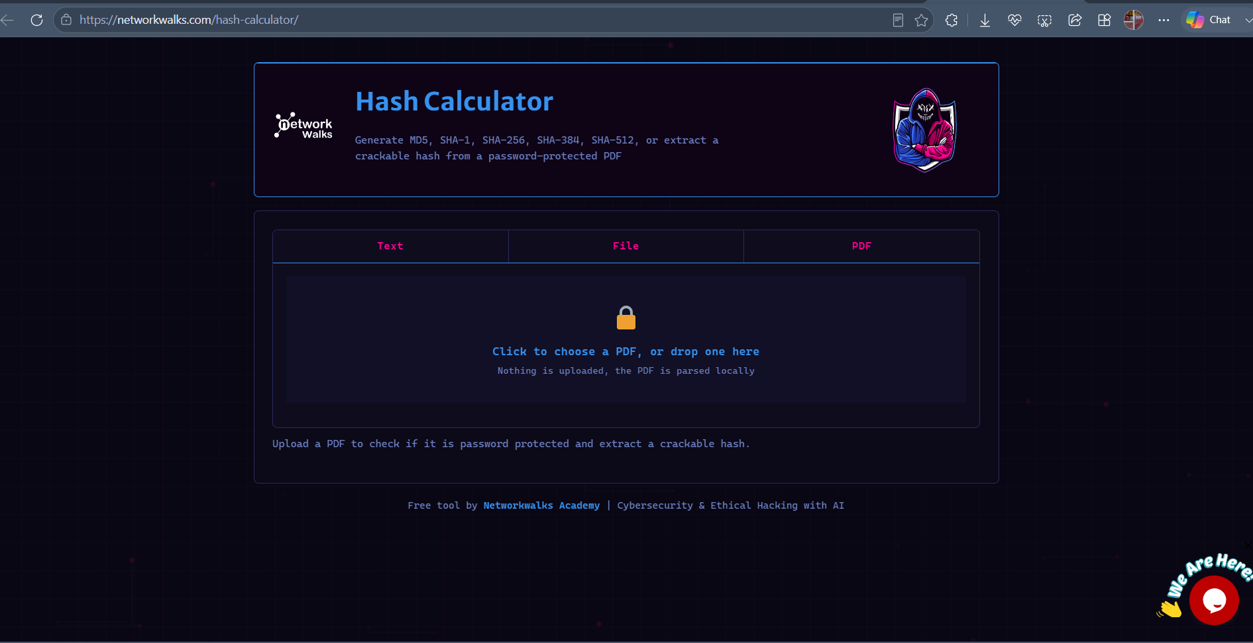
Figure 1 - NetworkWalks Hash Calculator landing page, PDF tab selected, ready to accept a file.
Uploading My Locked PDF1.pdf (266.9 KB) confirmed the file was encrypted and returned its $pdf$ hash, along with metadata: Revision R4, Version V4, 128-bit key length.
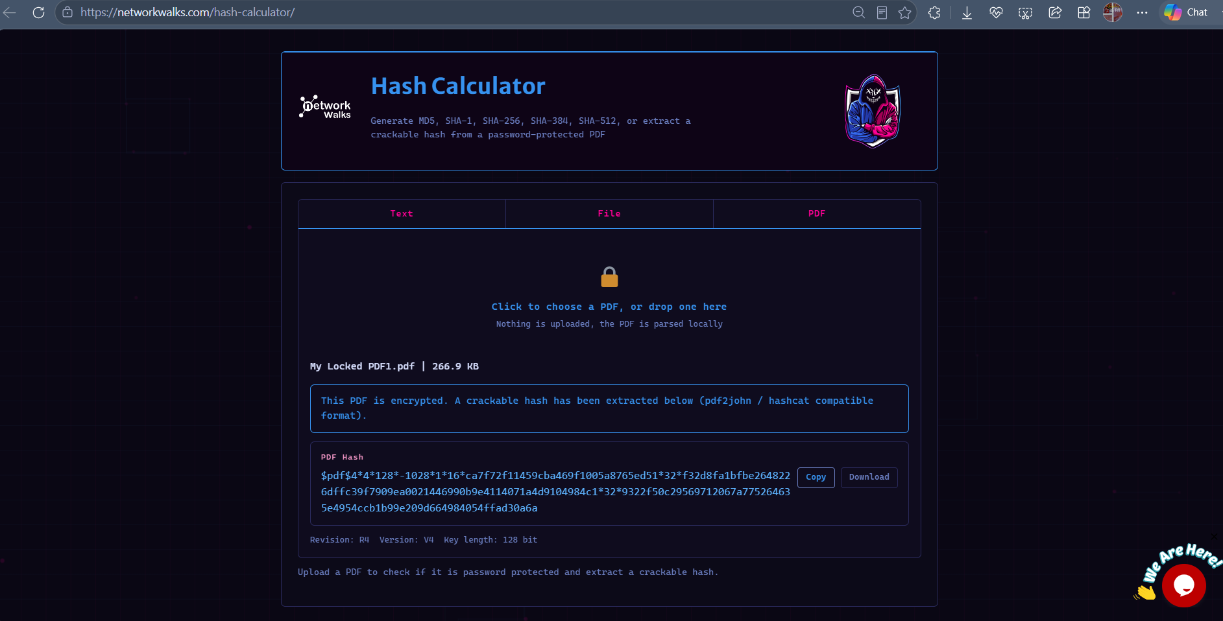
Figure 2 - Hash Calculator output: crackable $pdf$ hash extracted for My Locked PDF1.

4.2 First Attempt - Built-in Wordlist (Failed)
The extracted hash was pasted into the Password Cracker tool, which hashes every word in a chosen wordlist and compares it against the target hash - conceptually the same approach John the Ripper uses internally.
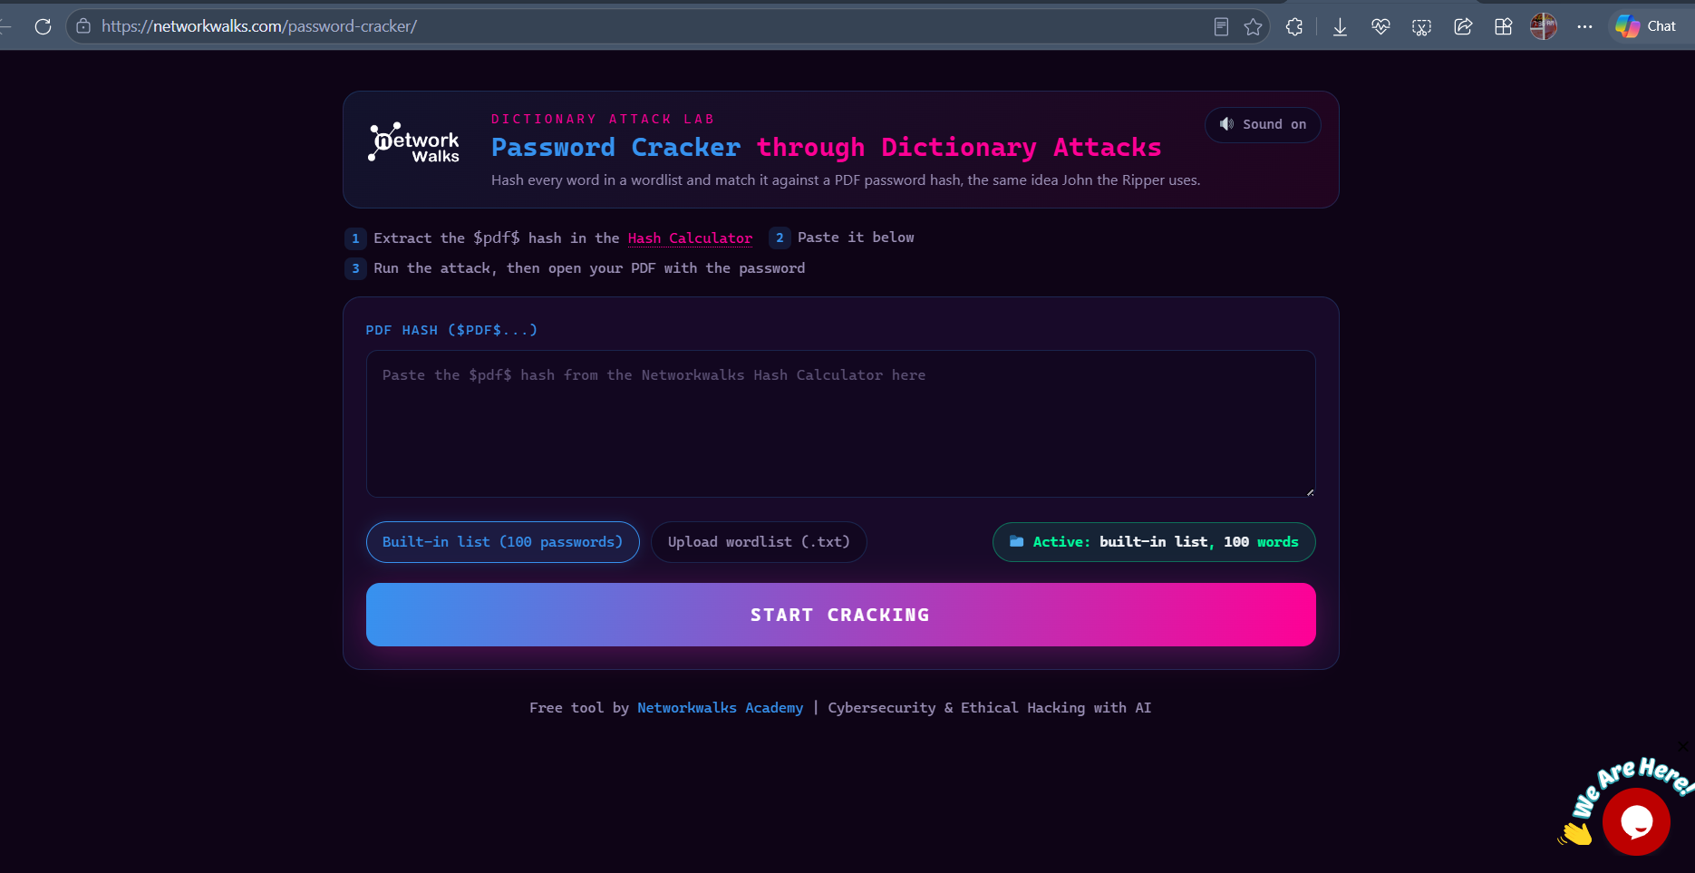
Figure 3 - NetworkWalks Password Cracker (Dictionary Attack Lab) landing page.
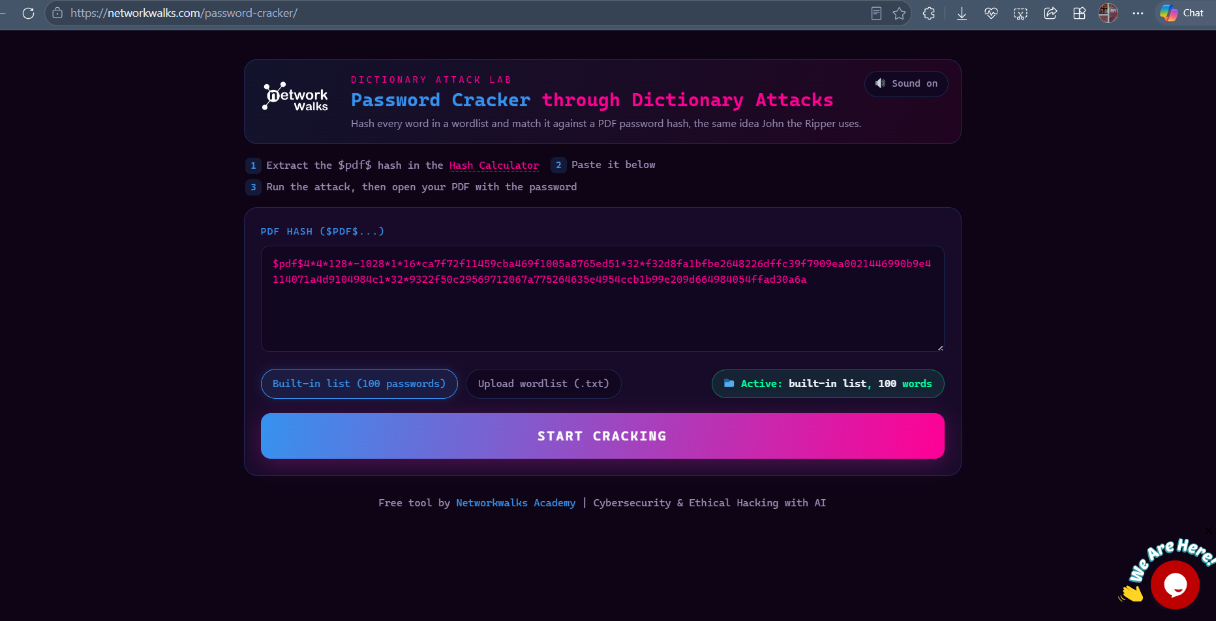
Figure 4 - PDF1's hash pasted into the Password Cracker, built-in 100-password list selected.
The attack was first run against the tool's built-in list of 100 common passwords. This completed at 100% without a match.
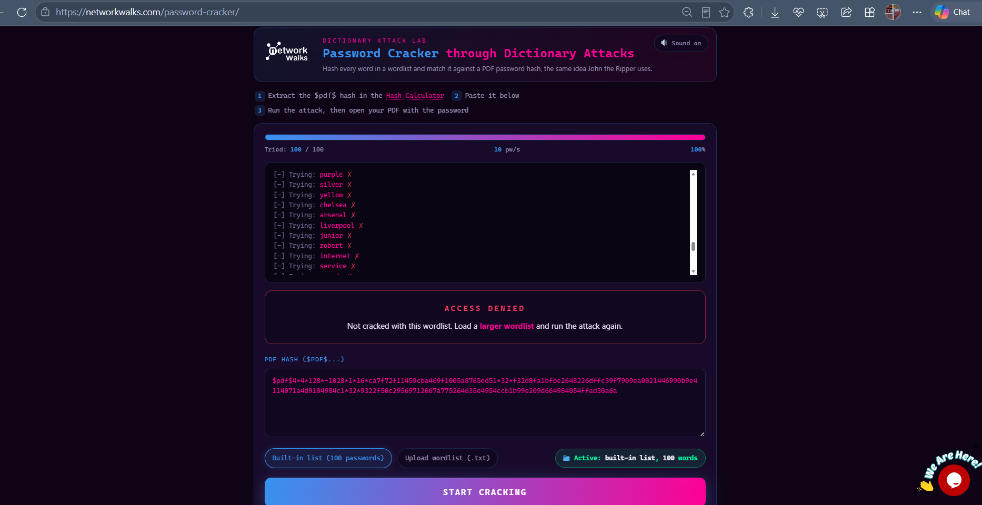
Figure 5 - Attack completed against the built-in 100-word list: ACCESS DENIED, password not found.
Result: ACCESS DENIED - password not present in the 100-word built-in list.

4.3 Second Attempt - Larger Wordlist (Success)
Following the tool's own guidance ("Not cracked with this wordlist. Load a larger wordlist and run the attack again"), a larger wordlist file (JTR_default_password.txt, 3,556 entries - the same default wordlist bundled with John the Ripper) was uploaded and the attack re-run.
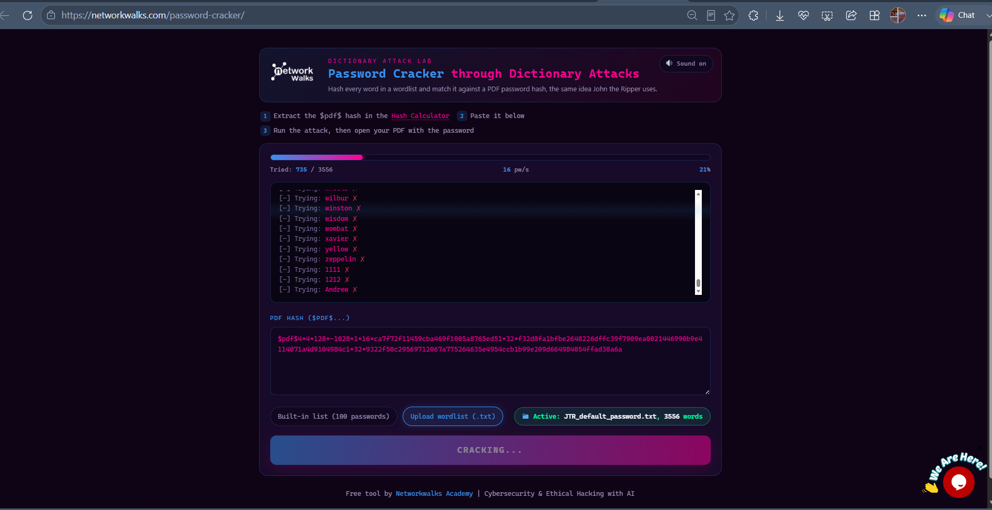
Figure 6 - Second attack in progress using the larger JTR_default_password.txt wordlist (3,556 words).
At 3,456 of 3,556 words tried (97%), the tool found a match.
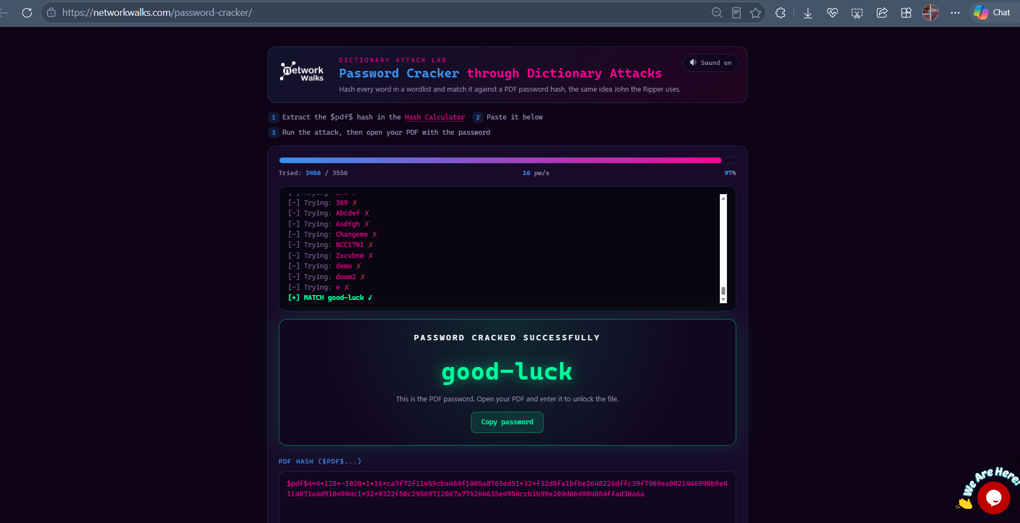
Figure 7 - PASSWORD CRACKED SUCCESSFULLY: "good-luck" recovered for My Locked PDF1.
Result: PASSWORD CRACKED SUCCESSFULLY - "good-luck"

4.4 Verification
The recovered password was used to unlock the original PDF, confirming the crack and revealing the flag.
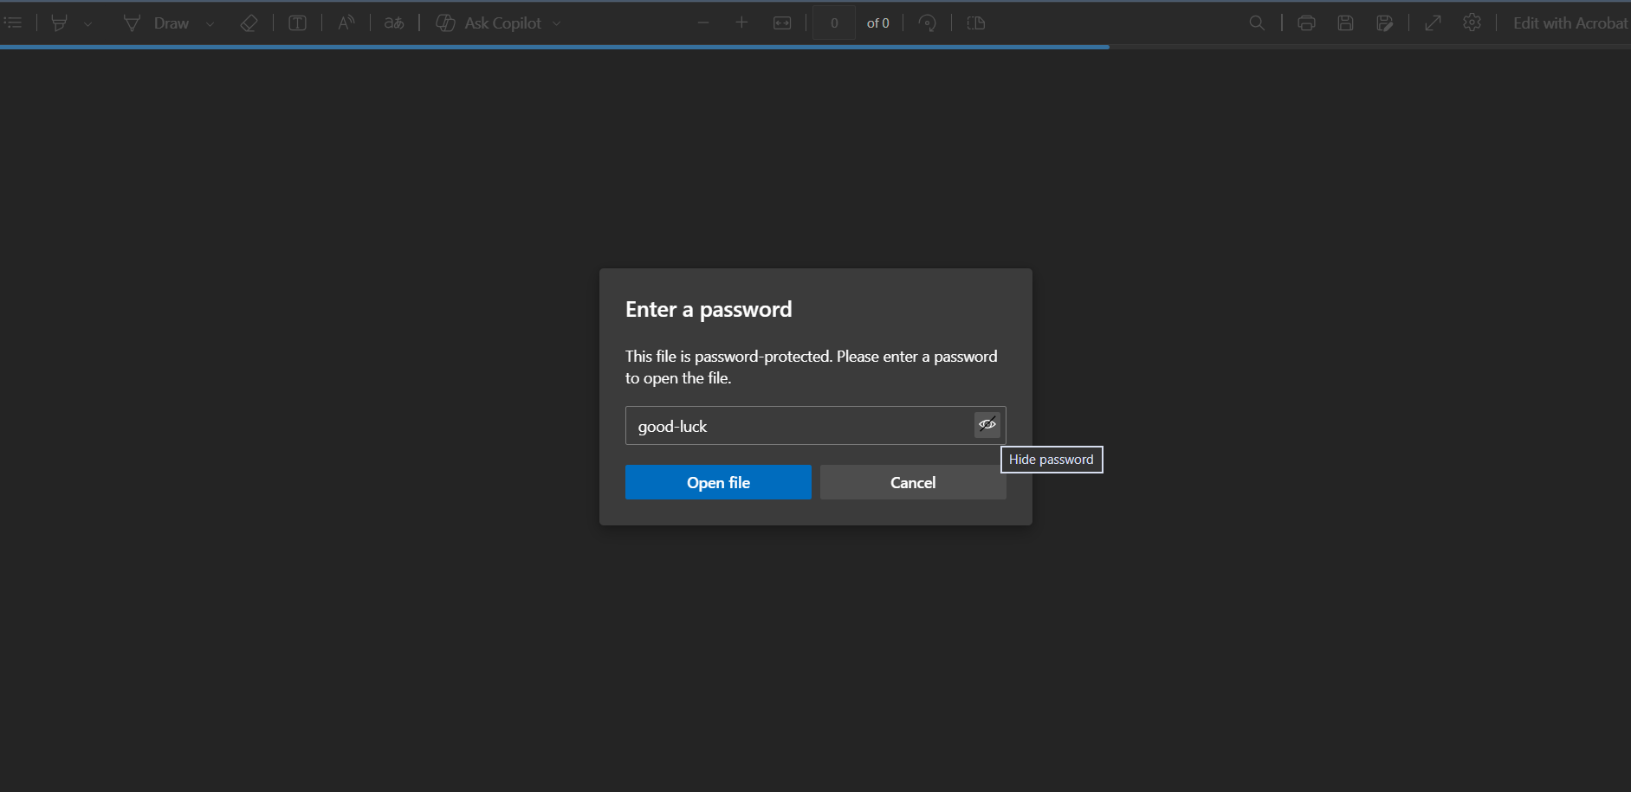
Figure 8 - Recovered password "good-luck" entered into My Locked PDF1's password prompt.
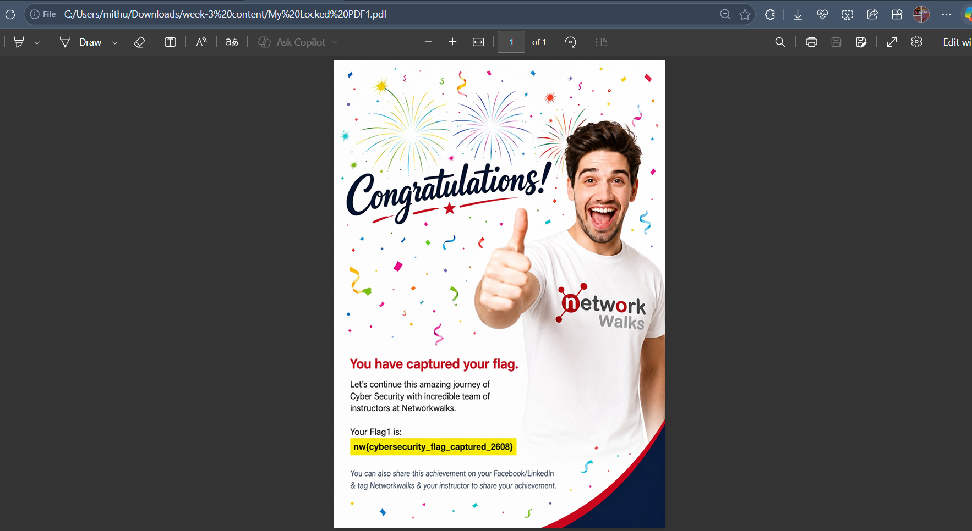
Figure 9 - PDF1 successfully unlocked, confirming the password and revealing the captured flag.
Flag 1 Captured: nw{cybersecurity_flag_captured_2608}
Observation: this task demonstrated directly why wordlist size and quality matter - the correct password was completely absent from a curated 100-word "most common passwords" list, but present in a larger, more comprehensive default wordlist.

5. Building a Custom Wordlist
To speed up cracking the remaining two PDFs, the NetworkWalks Wordlist Generator tool was used to build a small, targeted custom wordlist rather than relying on a large generic one. This tool takes a set of base words (names, keywords, known patterns) and applies configurable mutation rules to generate realistic password candidates - the same principle used in real-world targeted password-guessing engagements, where base words are often derived from OSINT on a target (names, pet names, sports teams, birth years, etc.).
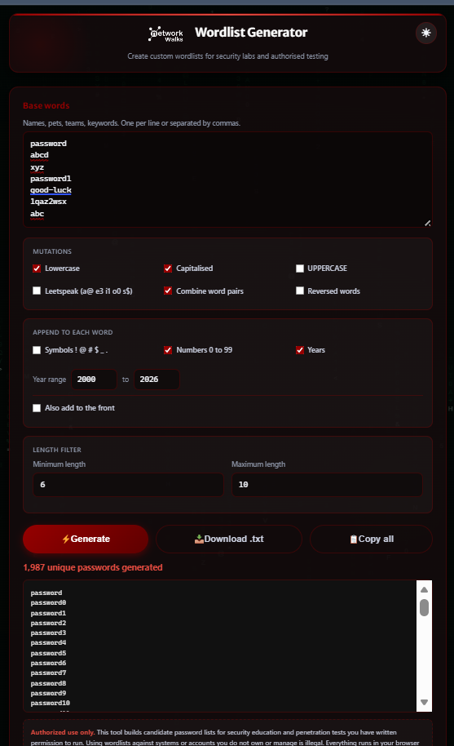
Figure 10 - Wordlist Generator tool: base words entered alongside configured mutation and append options.
Configuration used:
- Base words: password, abcd, xyz, password1, good-luck, 1qaz2wsx, abc
- Mutations enabled: Lowercase, Capitalised, Combine word pairs
- Append rules: Numbers 0–99, Years (2000–2026)
- Length filter: minimum 6, maximum 10 characters
With these settings, the tool generated 1,987 unique candidate passwords, combining each base word with the enabled mutations and suffixes.
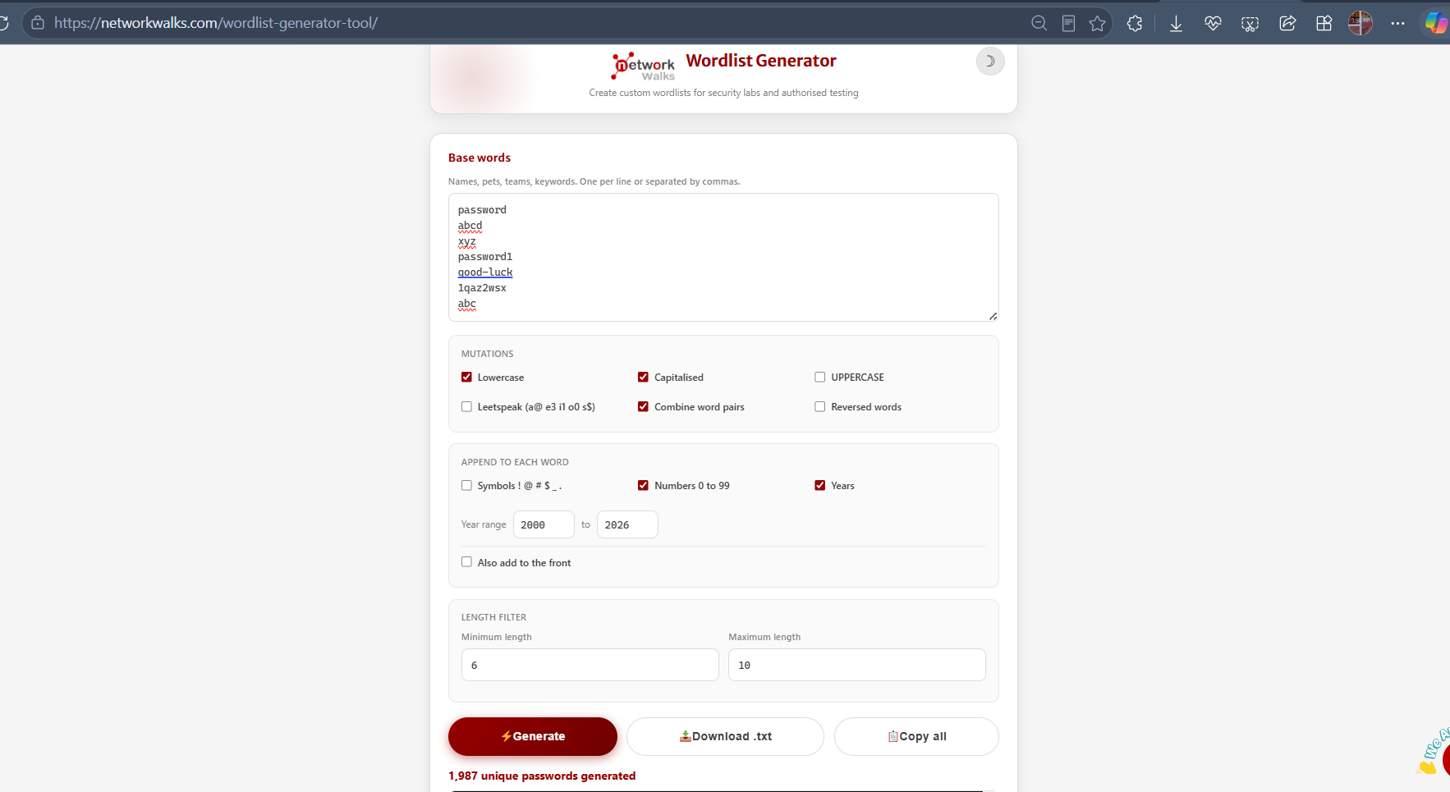
Figure 11 - Full Wordlist Generator interface confirming 1,987 unique passwords generated from the configured base words and mutation rules.

6. Task 2 - Cracking "My Locked PDF2"
The same Hash Calculator PDF workflow was repeated for the second file.
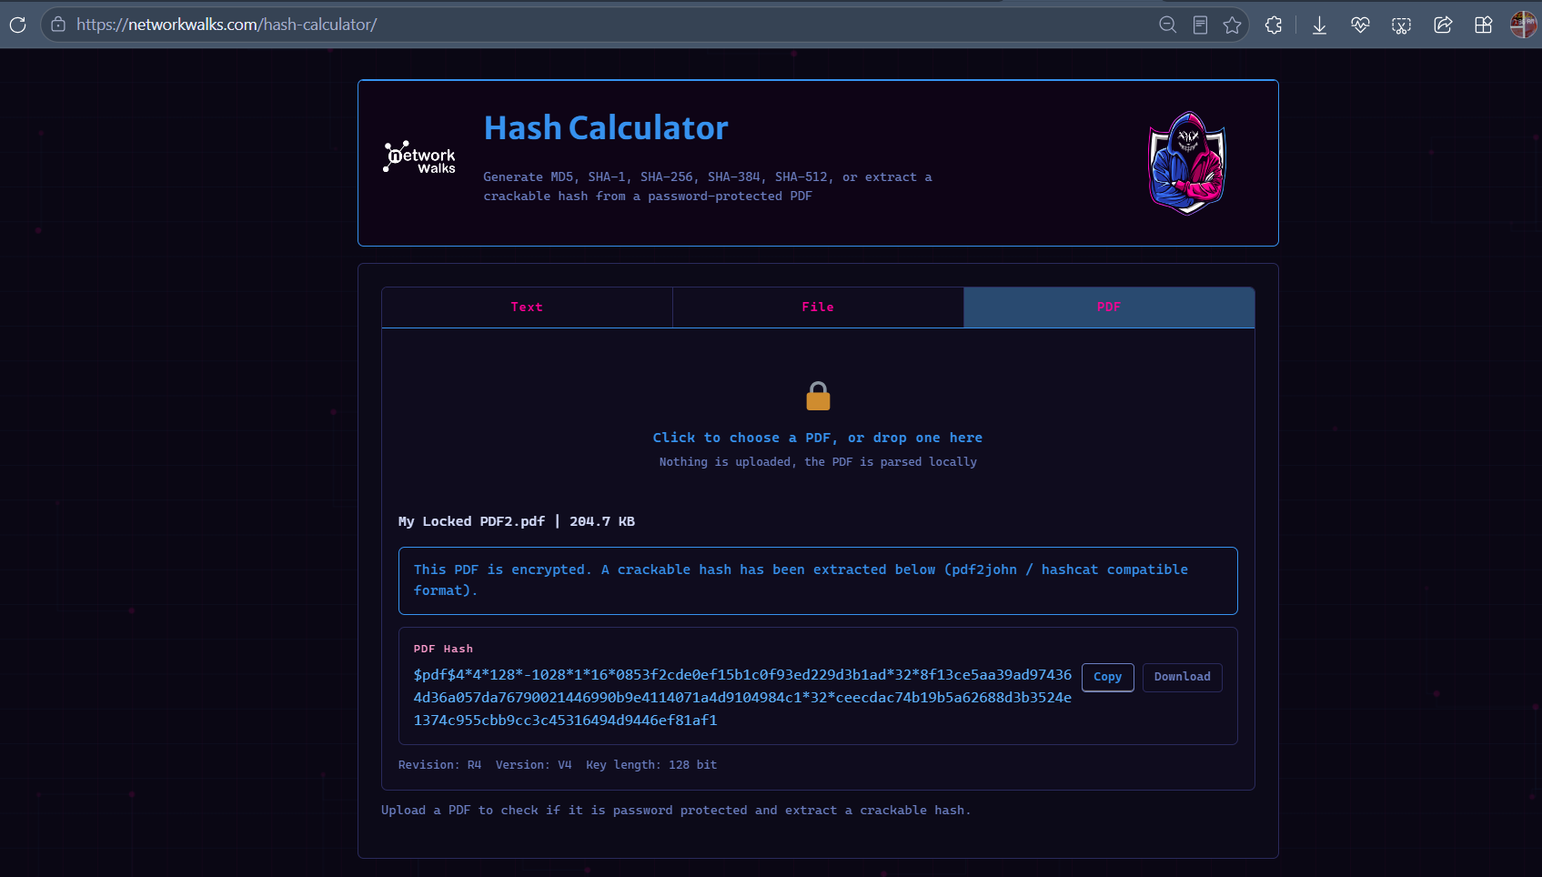
Figure 12 - Hash Calculator extracting the $pdf$ hash for My Locked PDF2 (204.7 KB, R4/V4, 128-bit).
The extracted hash was pasted into the Password Cracker, this time using the custom-generated wordlist (networkwalks-wordlist (2).txt, 1,987 entries) instead of the built-in or JTR default lists. A match was found almost immediately, at only 3 of 1,987 words tried.
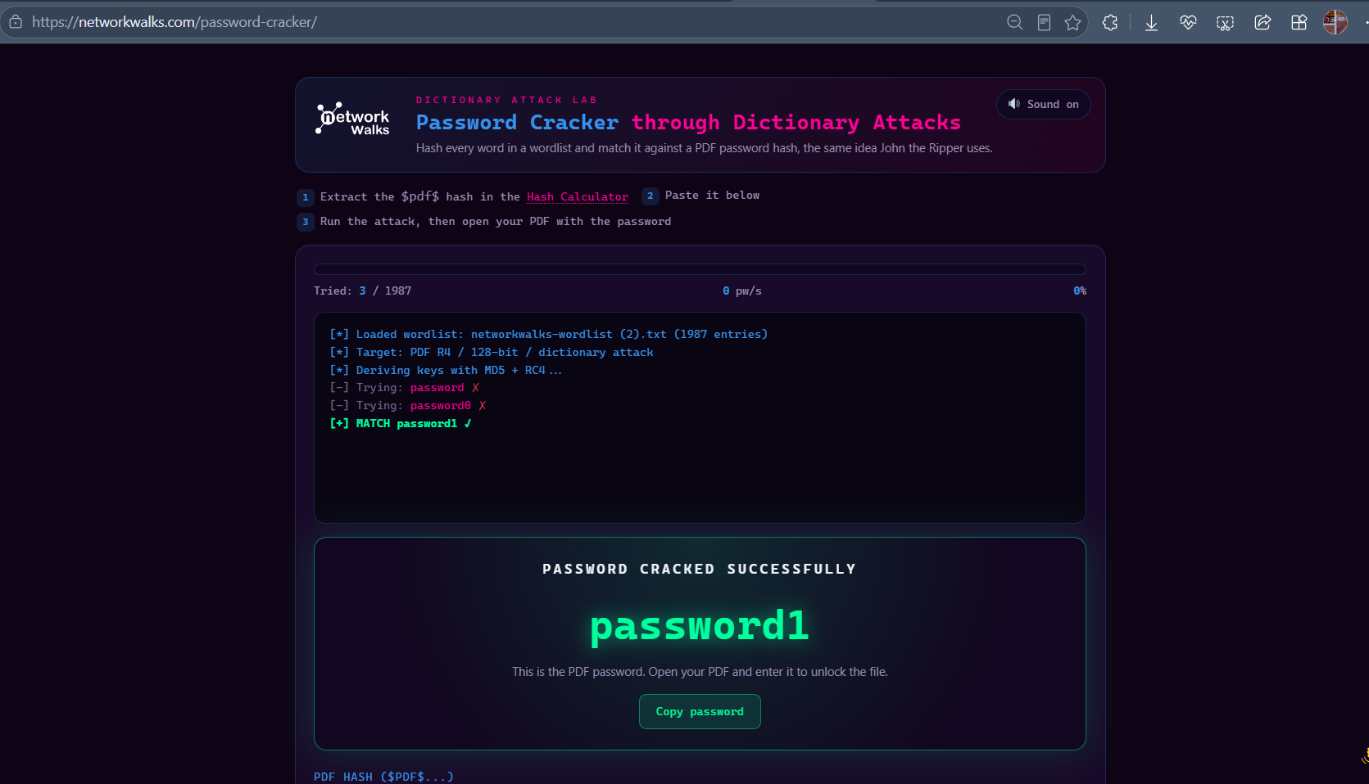
Figure 13 - PASSWORD CRACKED SUCCESSFULLY: "password1" recovered for My Locked PDF2 using the custom wordlist.
Result: PASSWORD CRACKED SUCCESSFULLY - "password1" (matched in 3 attempts)
This result matches the password recovered for the same file in Module 1 using John the Ripper directly, confirming both cracking methods are consistent.

7. Task 3 - Cracking "My Locked PDF3"
The Hash Calculator was used a third time to extract PDF3's hash.
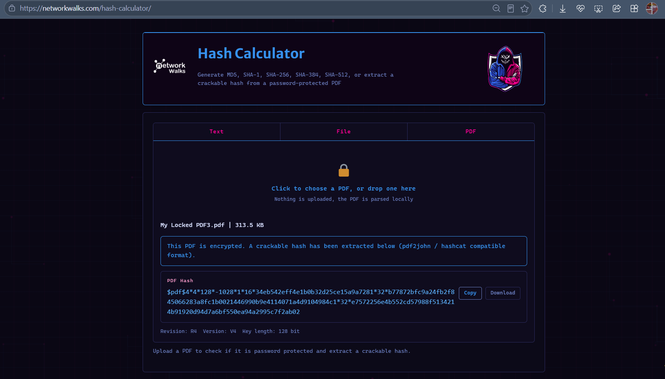
Figure 14 - Hash Calculator extracting the $pdf$ hash for My Locked PDF3 (313.5 KB, R4/V4, 128-bit).

The hash was loaded into the Password Cracker using the same custom wordlist.
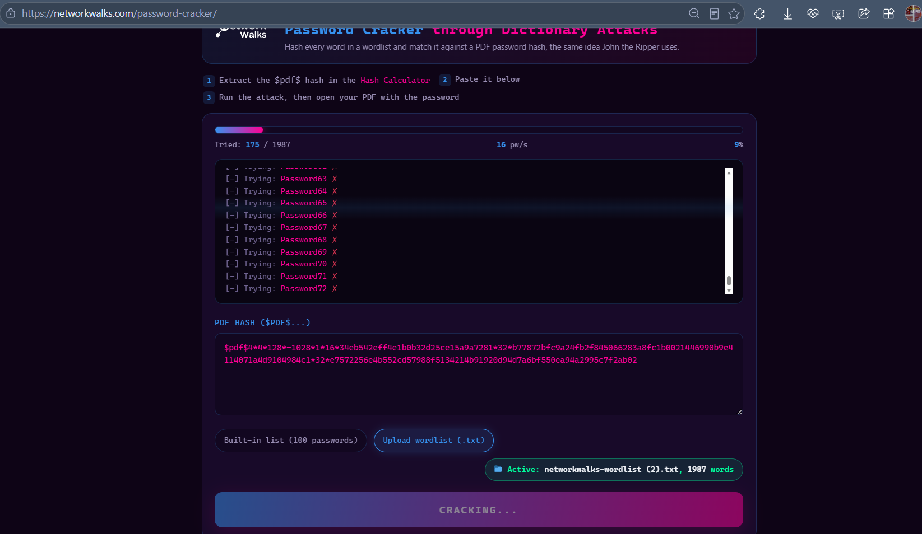
Figure 15 - Attack in progress against My Locked PDF3 using the custom 1,987-word list (9% complete).
The attack matched the password at 513 of 1,987 words tried (26%).
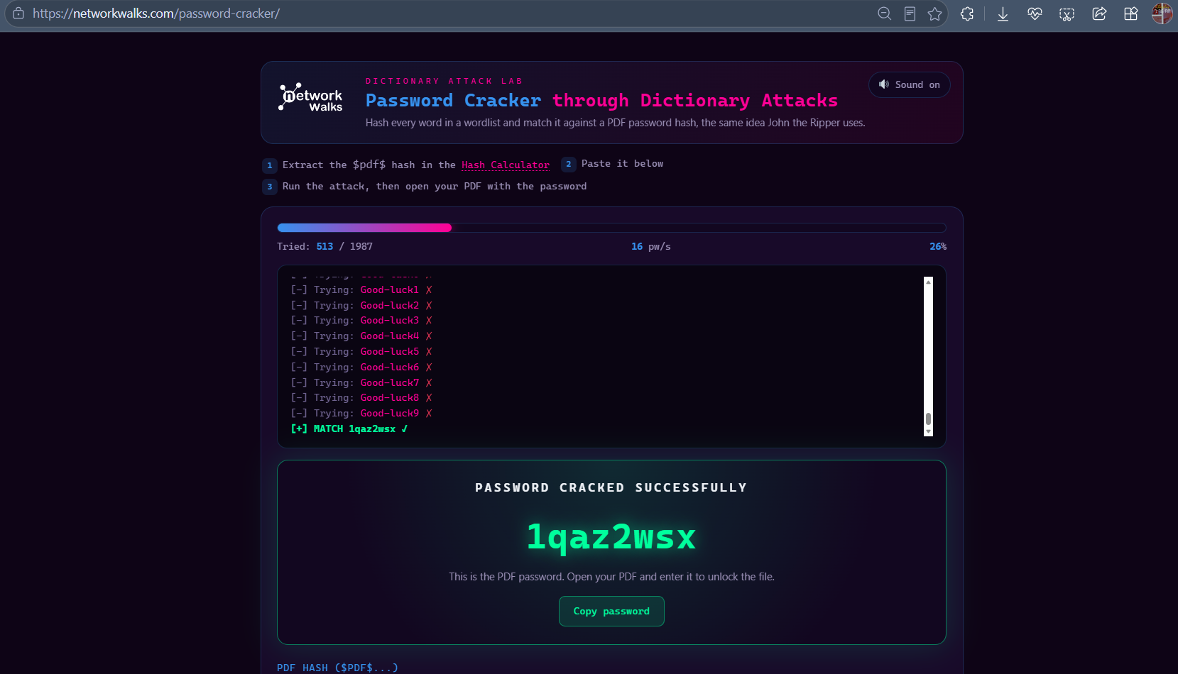
Figure 16 - PASSWORD CRACKED SUCCESSFULLY: "1qaz2wsx" recovered for My Locked PDF3.
Result: PASSWORD CRACKED SUCCESSFULLY - "1qaz2wsx" (matched in 513 attempts)
The recovered password was verified by unlocking the PDF directly, revealing the third flag.
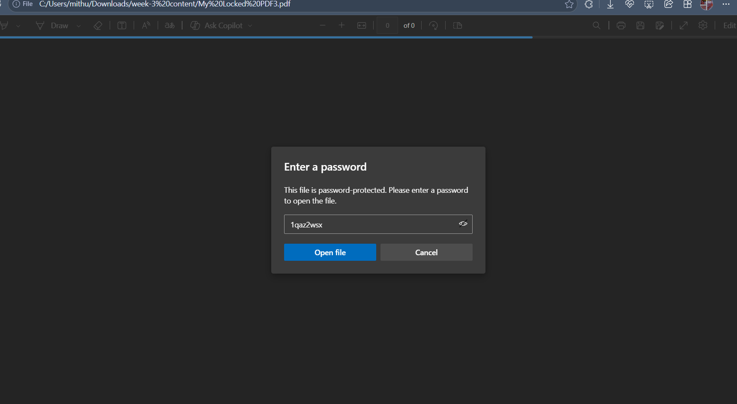
Figure 17 - Recovered password "1qaz2wsx" entered into My Locked PDF3's password prompt.
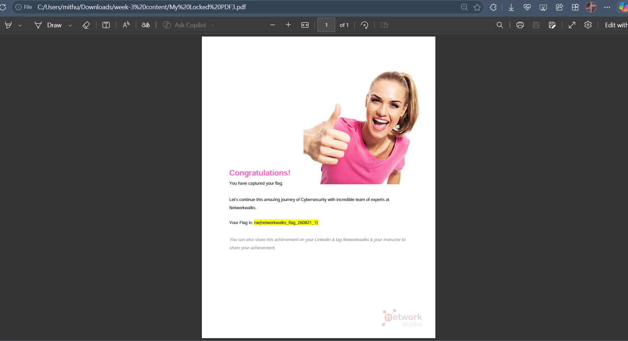
Figure 18 - PDF3 successfully unlocked, confirming the password and revealing the third captured flag.
This result also matches the password recovered for the same file in Module 1 using John the Ripper, again confirming consistency between the two cracking approaches.

8. Results
Target File | Wordlist Used | Attempts to Match | Password Cracked
My Locked PDF1 | Built-in (100 words) → JTR_default_password.txt (3,556 words) | Failed at 100 / Matched at 3,456 | good-luck
My Locked PDF2 | Custom-generated wordlist (1,987 words) | Matched at 3 | password1
My Locked PDF3 | Custom-generated wordlist (1,987 words) | Matched at 513 | 1qaz2wsx
Cross-check against Module 1 (John the Ripper): all three passwords recovered using NetworkWalks' browser-based tools were identical to those recovered locally with John the Ripper in Module 1, confirming that both approaches - a full offline cracking suite and a lightweight browser-based dictionary attack - arrive at the same result when given a wordlist that contains the correct password.

9. Task Checklist
✓ | Task
✔ | Extracted the PDF hash for all 3 locked files using the NetworkWalks Hash Calculator
✔ | Ran an initial dictionary attack on PDF1 using the built-in 100-word list (failed)
✔ | Escalated to a larger wordlist (JTR_default_password.txt, 3,556 words) and successfully cracked PDF1
✔ | Used the Wordlist Generator to build a custom, targeted 1,987-word candidate list
✔ | Cracked PDF2's password using the custom wordlist
✔ | Cracked PDF3's password using the custom wordlist
✔ | Verified all recovered passwords by unlocking their respective PDFs
✔ | Captured flags from PDF1 and PDF3, and cross-checked all results against Module 1 (JTR)

10. Observations & Learnings
- A dictionary attack is only as effective as its wordlist - the correct password for PDF1 was completely missed by a curated "top 100 passwords" list but found quickly once a larger, more comprehensive wordlist was used.
- Custom wordlist generation (base words + mutation rules) dramatically narrows the search space when there is any prior knowledge or pattern to work from, cracking PDF2 and PDF3 in a fraction of the attempts a generic wordlist would need.
- Combining a small set of realistic base words with common mutations (capitalisation, appended numbers/years, word-pair combinations) mirrors how real attackers build targeted wordlists from OSINT - reinforcing why predictable personal details make weak password choices.
- Running the same 3 PDFs through both a local tool (John the Ripper) and a browser-based tool (NetworkWalks Password Cracker) produced identical results, demonstrating that the underlying cracking logic - hash a candidate, compare to target - is consistent regardless of implementation.

11. Next Steps
With both essential Week 3 modules complete (JTR and NetworkWalks tools), remaining time can be used to explore the optional modules - the AI-assisted JTR lab using Claude with the Hexstrike MCP integration, and/or the Mediroza Hospital patient portal hacking exercise - ahead of the Week 3 submission deadline (23:00, Friday 28 August 2026).

⚖️ Disclaimer
All password-cracking activities documented in this report were performed against sample PDF files intentionally provided for this internship's training exercise, using tools built by NetworkWalks Academy specifically for authorised security education. No unauthorized files, systems, or third-party data were accessed. This work is conducted strictly for educational purposes as part of an authorized internship curriculum.

