Week 2 Lab Report
Network Scanning with Zenmap (Nmap GUI)

1. Objective
To use Zenmap, the graphical front-end for Nmap, to scan a target host for open ports and running services, and to visualize the scanned network as a topology diagram.

2. Environment
The scan was run from a Windows host machine with Zenmap installed. The host's network configuration was first confirmed using the ipconfig command, which showed a VirtualBox host-only adapter (192.168.56.1) and an active Wi-Fi adapter (10.26.4.191) used to reach the internet.
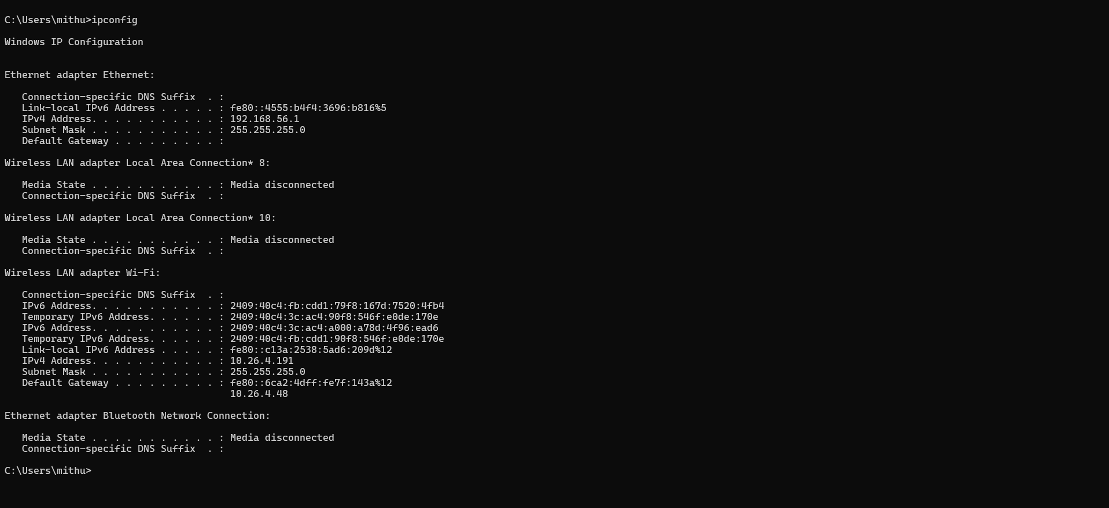
Figure 1: Host machine IP configuration (ipconfig)

3. Scan Details
Target: networkwalks.com (resolved to 192.232.216.135)
Profile: Quick scan
Command: nmap -T4 -F networkwalks.com
Result: Host is up (0.24s latency); 1 IP address scanned in 4.60 seconds; 87 of 100 common TCP ports were filtered (no response), with 13 ports found open.
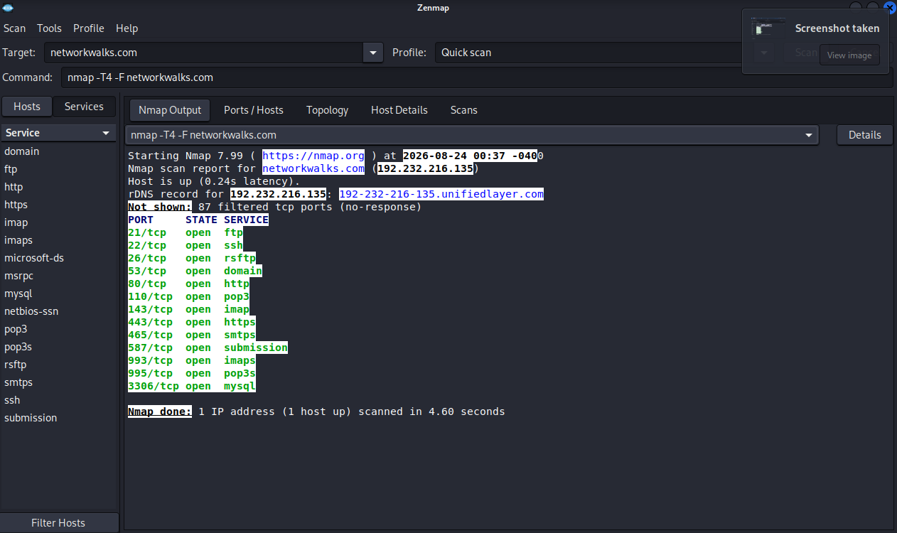
Figure 2: Zenmap Quick Scan output for networkwalks.com

4. Open Ports and Services
Port | State | Service
21/tcp | open | ftp
22/tcp | open | ssh
26/tcp | open | rsftp
53/tcp | open | domain
80/tcp | open | http
110/tcp | open | pop3
143/tcp | open | imap
443/tcp | open | https
465/tcp | open | smtps
587/tcp | open | submission
993/tcp | open | imaps
995/tcp | open | pop3s
3306/tcp | open | mysql

5. Topology View
Zenmap's Topology tab displays a fisheye diagram of the scanned network. The local machine appears as "localhost" at the centre, connected by a line to the scanned target networkwalks.com (192.232.216.135), with the host's own local IP (10.26.4.191) shown alongside it.
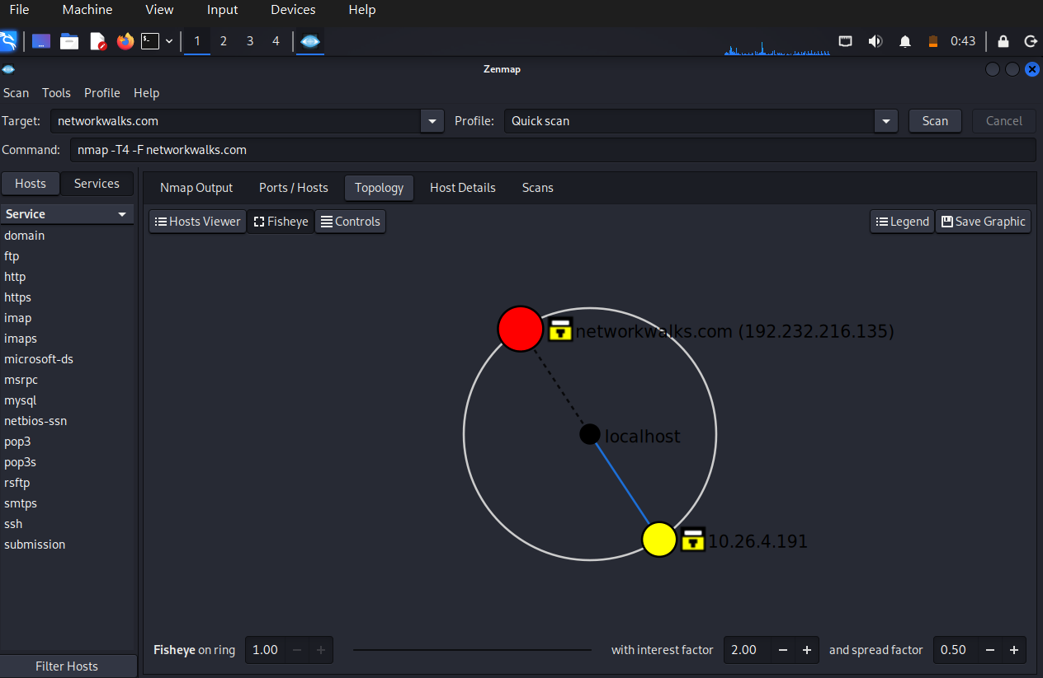
Figure 3: Zenmap Topology view of the scanned host

6. Conclusion
The Quick scan identified 13 open ports on networkwalks.com, mostly associated with web (80, 443), mail (25/26, 110, 143, 465, 587, 993, 995), DNS (53), FTP (21), SSH (22), and MySQL (3306) services — consistent with a shared web/mail hosting server. Zenmap's GUI made it straightforward to run the scan, read the results, and visualize the host relationship without needing to work from the Nmap command line directly.

