# **Read Me**

## **Image Download**

The weekly methane images from February 2019 to December 2021 are contained in the folder “Images”. Steps to reproduce this task are listed below:

**First**, the weekly images from February 2018 to December 2021 should be downloaded from Google Earth Engine using [this code](https://code.earthengine.google.com/9d01b9962a1794813d77ff23ae0fcd0c?accept_repo=users%2Ffitoprincipe%2Fgeetools). After clicking “Run”, your web browser may be unresponsive for a few minutes while the code executes.

There will be 153 images ready to download:

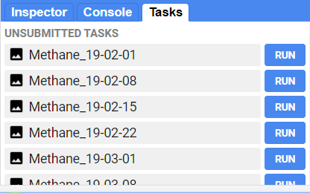

For each image, click “Run”. The following window will pop up and hit “Run” again:

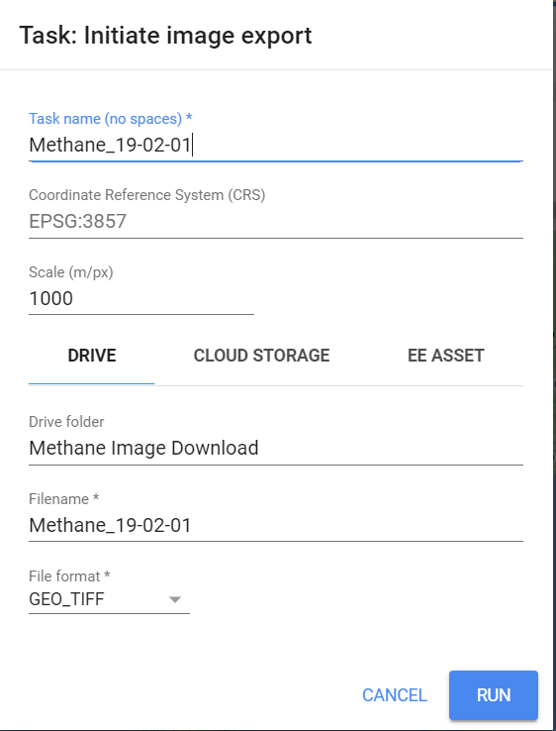

Each file will be saved in your Google Drive in a folder called “Methane Image Download”. Note that this script will download all data during the study period, but you do **not** need to download images during the monsoon season due to missing data.

Alternatively, follow these instructions to download all at once:

<https://benny.istan.to/blog/20220319-batch-task-execution-in-google-earth-engine-code-editor>

## **Image Interpolation**

Missing data in the images were filled using the Inverse Weighted Distance (IDW) interpolation method and are stored in the folder “Interpolated”. Note that IDW was not applied to all pixels, but only those that are missing to preserve the original pixel values where we can. In addition, this process was only applied to images from January to April and November to December because cloud cover during the monsoon season (May to October) obscures Bangladesh.

This was completed using the “GapFilling.py” script. Steps to reproduce this task are listed below:

**Next**, you will find a python script contained in this folder called “GapFilling.py”. Right-click and select “Edit with IDLE (ArcGIS Pro):

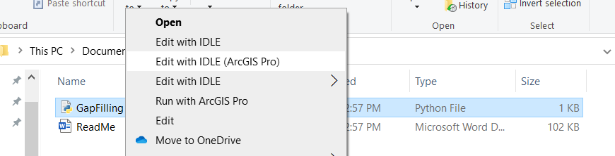

You will need to change the user parameters:

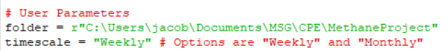

folder is the location of the MethaneProject folder on your computer.

timescale is “Weekly” or “Monthly”. This option changes what folder the images will be found in. For example:

"C:\Users\jacob\Documents\MSG\CPE\MethaneProject/Weekly/Images"

OR

"C:\Users\jacob\Documents\MSG\CPE\MethaneProject/Monthly/Images"

Click F5 to run the script. If the interpolated images already exist on your computer, you will get an error saying they cannot be overwritten.