EXPT NO: 5 | IMPLEMENTATION OF A RECURRENT NEURAL NETWORK (RNN) FOR TEXT GENERATION
DATE: 18-09-2026

PRE-LAB QUESTIONS (PROVIDE BRIEF ANSWERS TO THE FOLLOWING QUESTIONS)

- Explain the purpose of a Recurrent Neural Network (RNN) in processing sequential data.

- A Recurrent Neural Network (RNN) is designed to process sequential data, where the order of information is important. Unlike traditional neural networks, an RNN maintains information from previous inputs using a hidden state. This allows it to learn relationships and patterns across a sequence. RNNs are commonly used for text, speech, time-series data, and language translation.

- Why is an RNN considered an appropriate model for text generation tasks?

- An RNN is suitable for text generation because text is naturally sequential. The meaning of a word often depends on the words that came before it. An RNN processes words one after another and uses information from previous words to predict the next word or character. For example, after learning the sequence "I am going to the", it can predict a suitable next word such as "market" or "school".

- Describe the concept of sequence modeling in natural language processing.

- Sequence modeling in Natural Language Processing involves learning patterns and relationships within an ordered sequence of words or tokens. The model considers both the individual elements and their order to understand or predict language. Examples include predicting the next word in a sentence, machine translation, text generation, sentiment analysis, and speech recognition. RNNs are commonly used for sequence modeling because they can retain information from earlier parts of a sequence.

- Explain the importance of tokenization during text preprocessing for RNN-based text generation.

- Tokenization is the process of dividing text into smaller units called tokens, such as words, characters, or subwords. It is important because an RNN cannot directly process raw text. Tokenization converts a sentence into individual units that can be processed sequentially.
- For example:
"I love deep learning" → ["I", "love", "deep", "learning"]
These tokens are then converted into numerical values and given as input to the RNN. Proper tokenization helps the model learn the structure and patterns of language effectively.

- Explain the significance of converting text into numerical representations before training an RNN.

- Neural networks, including RNNs, perform mathematical operations and therefore cannot directly understand words or characters. Text must be converted into numerical representations such as integer encoding, one-hot encoding, or word embeddings. For example:
"cat" → 1
"dog" → 2
"bird" → 3

These numerical representations allow the RNN to process the text, identify relationships between words, learn patterns from sequences, and generate predictions. Word embeddings are especially useful because they can represent semantic relationships between similar words.

AIM
To implement a Recurrent Neural Network (RNN) for text generation and evaluate its ability to generate meaningful text by predicting the next word in a sequence.

SOFTWARE REQUIREMENTS
- Python
- TensorFlow or keras or PyTorch
- Google Colab
- GitHub
- Numpy
- Matplotlib

OBJECTIVES
Students will be able to:
- Understand the architecture and working of Recurrent Neural Networks (RNNs).
- Perform text preprocessing techniques for sequence modeling.
- Generate input sequences suitable for training an RNN model.
- Build and train an RNN model for text generation.
- Generate text by predicting the next word in a sequence.
- Evaluate the performance of the trained RNN using generated text.
- Analyze the effectiveness of RNNs in learning sequential patterns from textual data.

PROCEDURE
PART A: DATASET PREPARATION
Perform the following tasks:
- Load the Tiny Shakespeare dataset from Hugging Face.
- Explore the dataset and examine the text samples.
- Convert the text into lowercase (if required).
- Tokenize the text into individual words.
- Build a vocabulary and assign a unique integer index to each word.
- Generate input sequences for next-word prediction.
- Apply sequence padding to obtain inputs of equal length.
- Split the prepared sequences into training and validation datasets.

(CODE: CONATAINS STUDENT ROLL NOS
SCREENSHOT OF CODE
SCREENSHOT OF OUTPUT)

PART B: IMPLEMENTING THE RNN MODEL
Perform the following tasks:
- Create an Embedding layer to convert words into dense vector representations.
- Add a Simple RNN layer to learn sequential dependencies in the text.
- Add a Dense output layer with Softmax activation for next-word prediction.
- Compile the model using an appropriate optimizer and loss function.
- Display the model architecture and summary.

(CODE: CONATAINS STUDENT ROLL NOS
SCREENSHOT OF CODE
SCREENSHOT OF OUTPUT)

PART C: COMPARISON OF OPTIMIZATION ALGORITHMS
Perform the following tasks:
- Train the RNN model using the prepared training dataset.
- Validate the model using the validation dataset.
- Record:
  - Training accuracy
  - Validation accuracy
  - Training loss
  - Validation loss
- Visualize:
  - Accuracy vs. Epoch
  - Loss vs. Epoch

(CODE: CONATAINS STUDENT ROLL NOS
SCREENSHOT OF CODE
SCREENSHOT OF OUTPUT)

PART D: DEEP LEARNING EXPERIMENT MANAGEMENT
Perform the following tasks:
- Provide a seed word or sentence as input to the trained model.
- Generate text by repeatedly predicting the next word in the sequence.
- Produce multiple text samples using different seed inputs.
- Compare the generated text for coherence and contextual relevance.
- Document the observations and upload the notebook to GitHub.

(CODE: CONATAINS STUDENT ROLL NOS
SCREENSHOT OF CODE
SCREENSHOT OF OUTPUT)

EXPECTED OUTCOME
Students will understand how an RNN learns sequential information and generates meaningful text based on previously learned patterns. Students will learn to preprocess textual data and train a Recurrent Neural Network (RNN) for text generation. They will evaluate the model's performance using training metrics and generate text through next-word prediction.

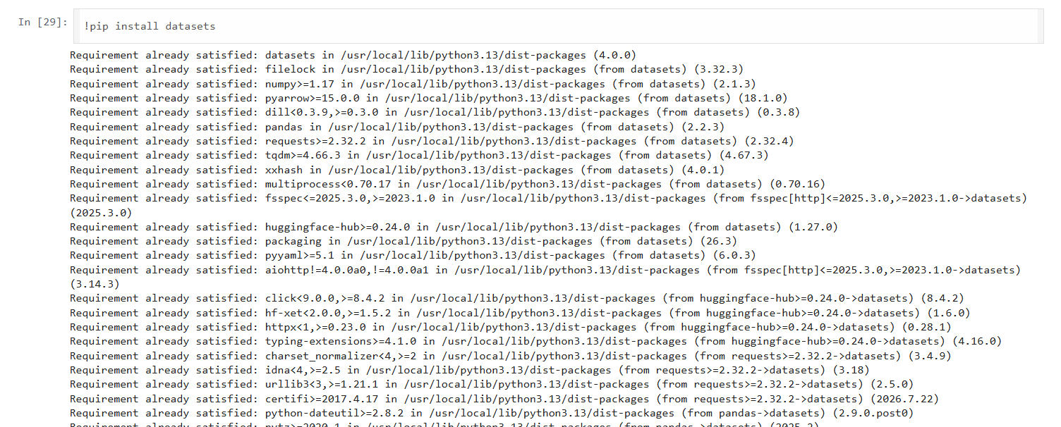
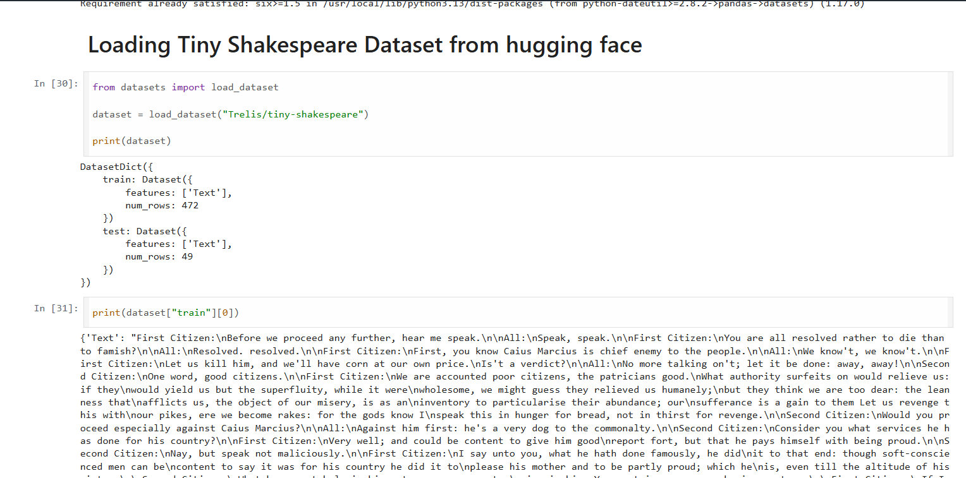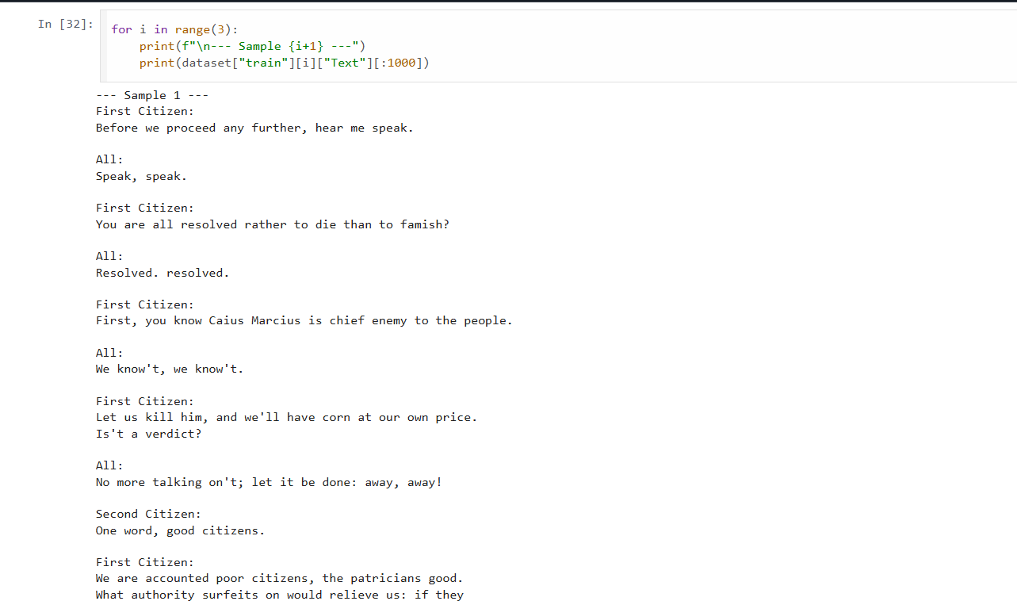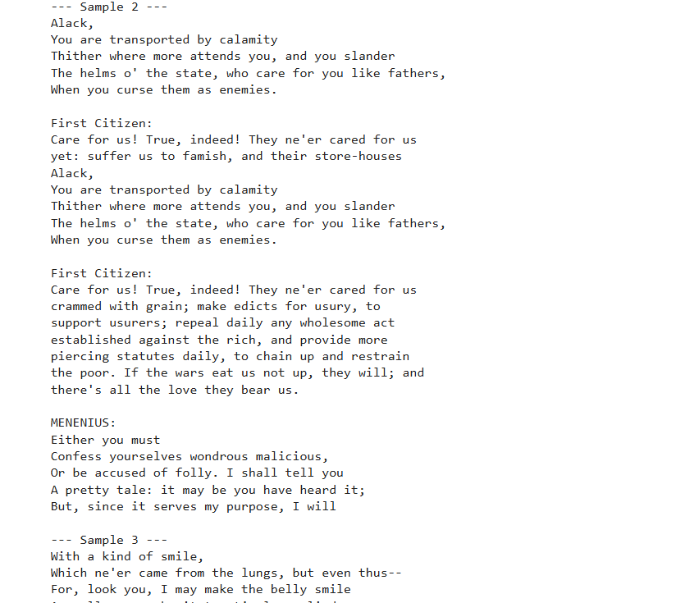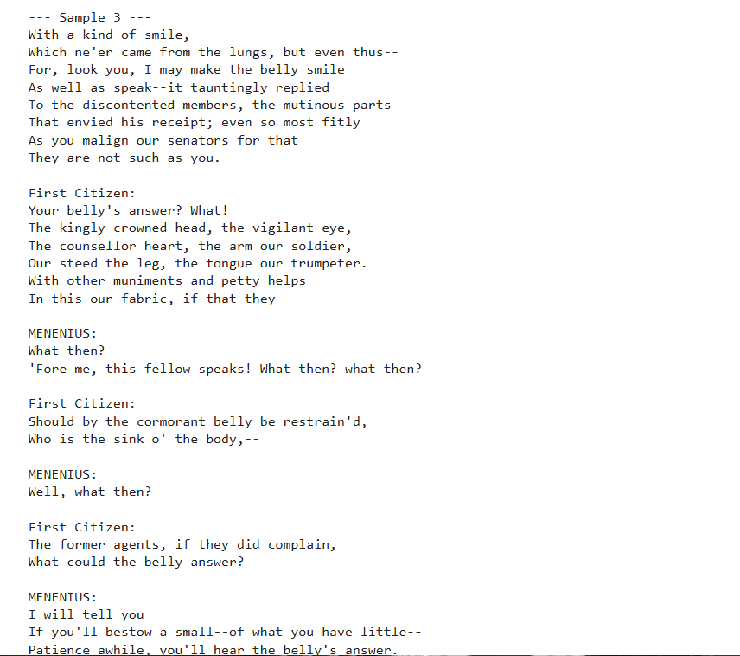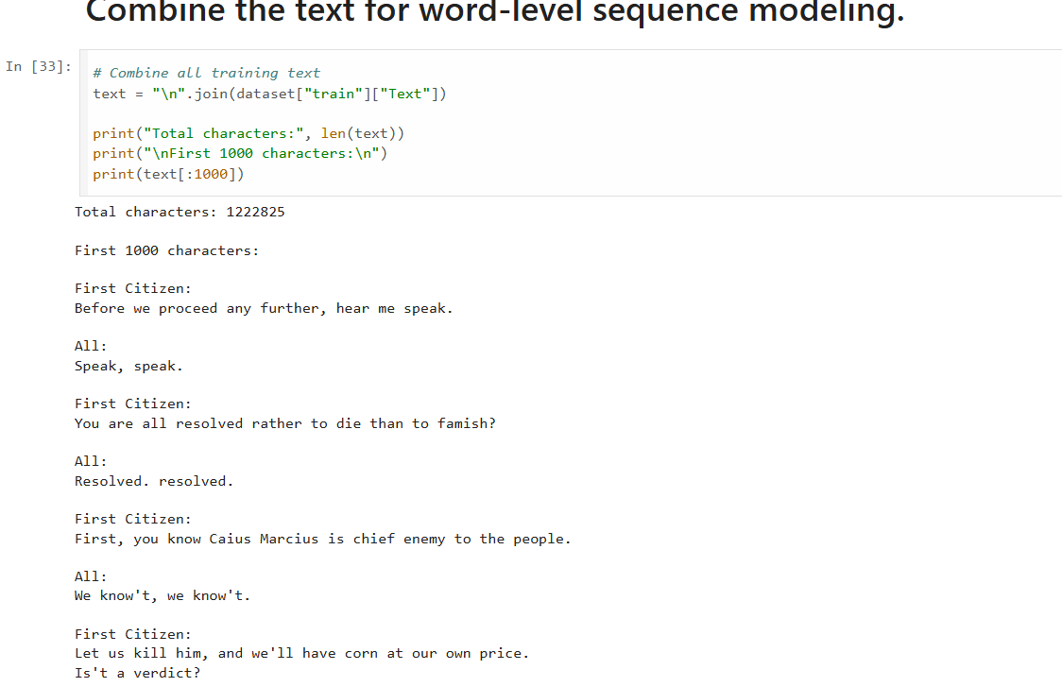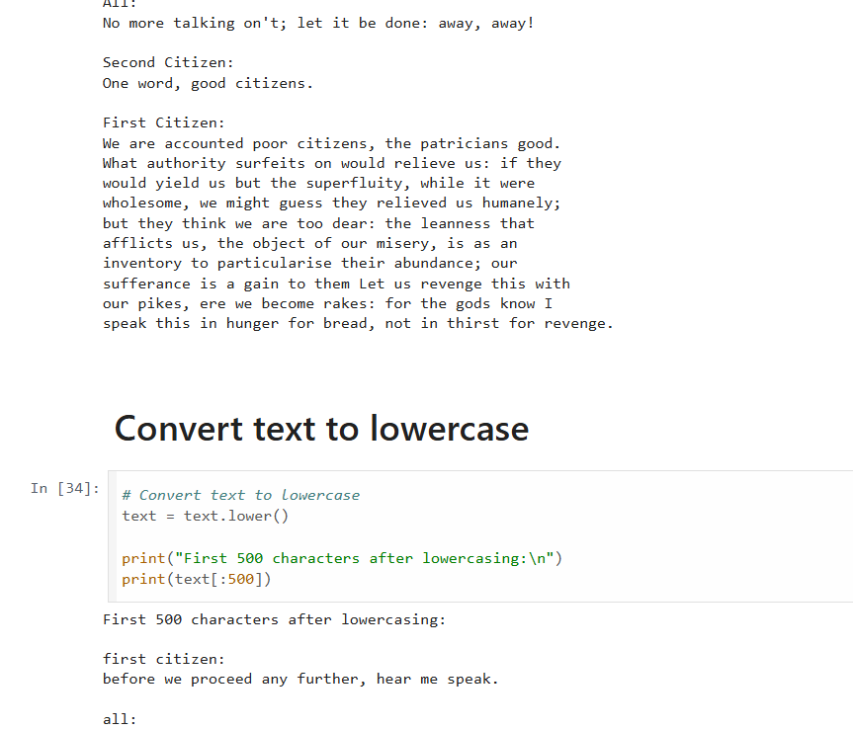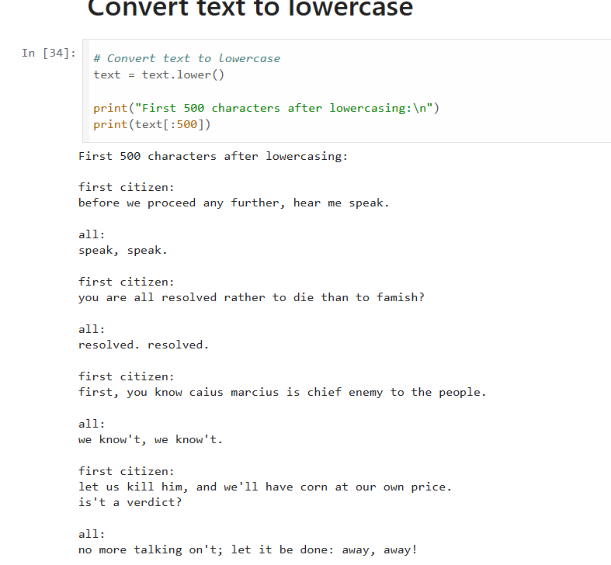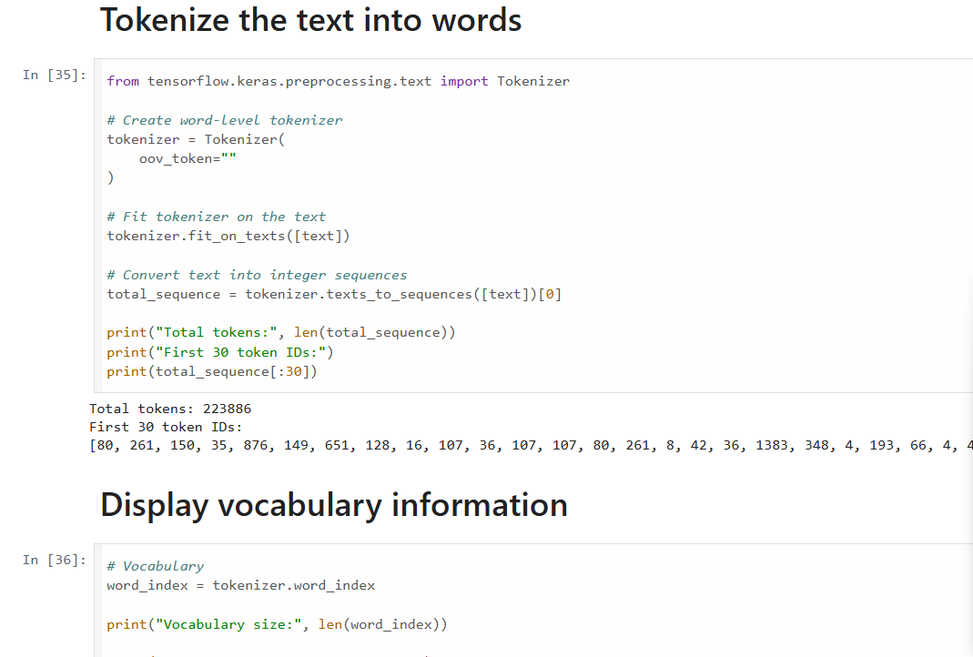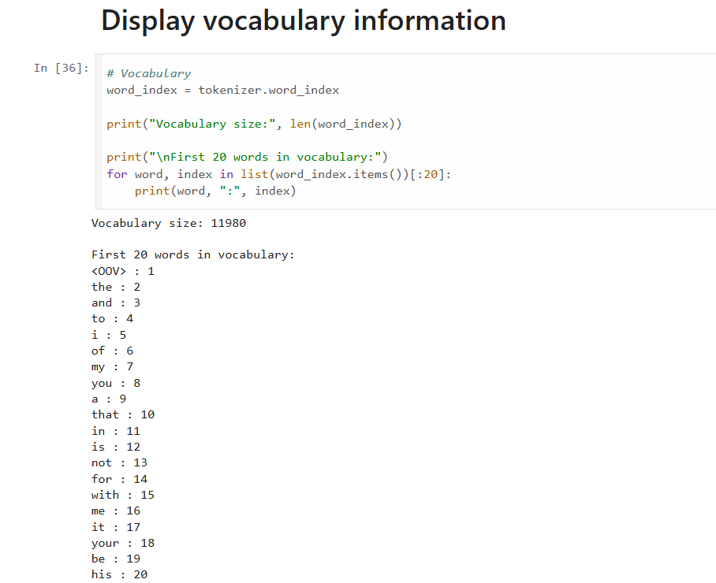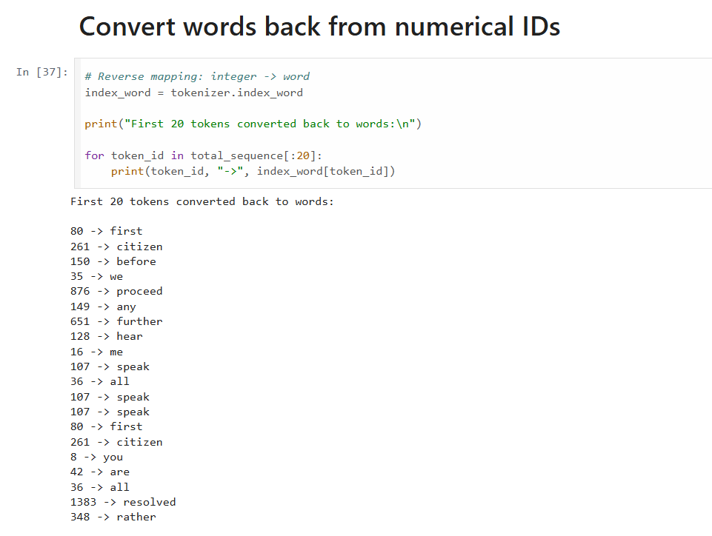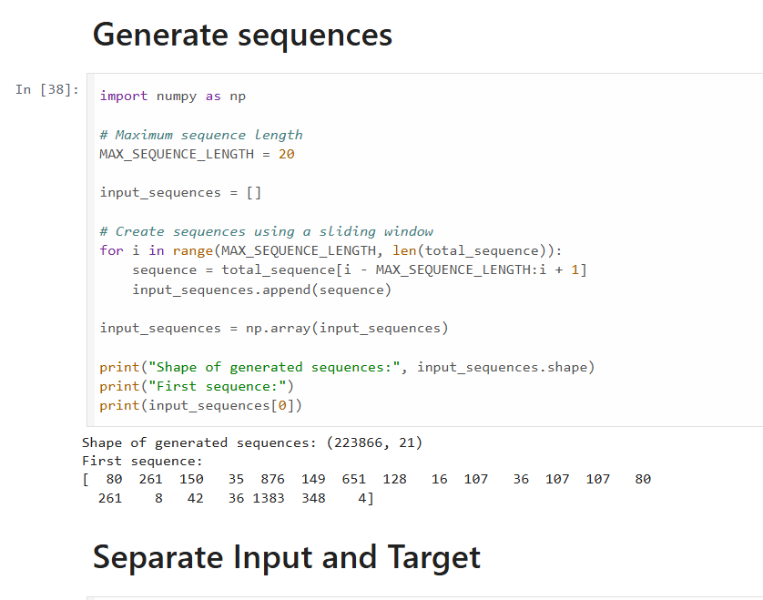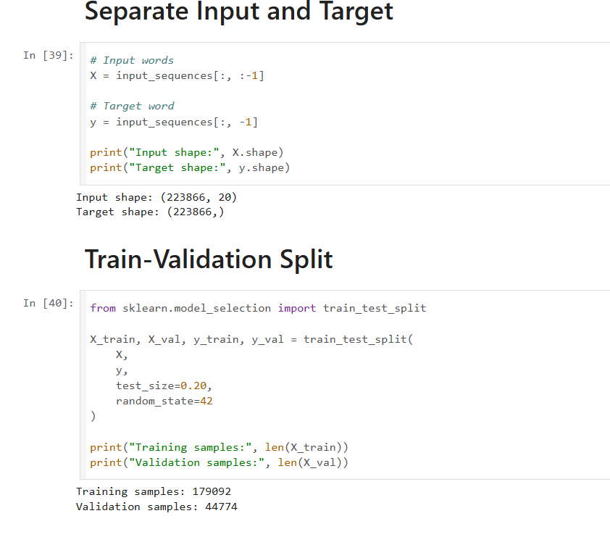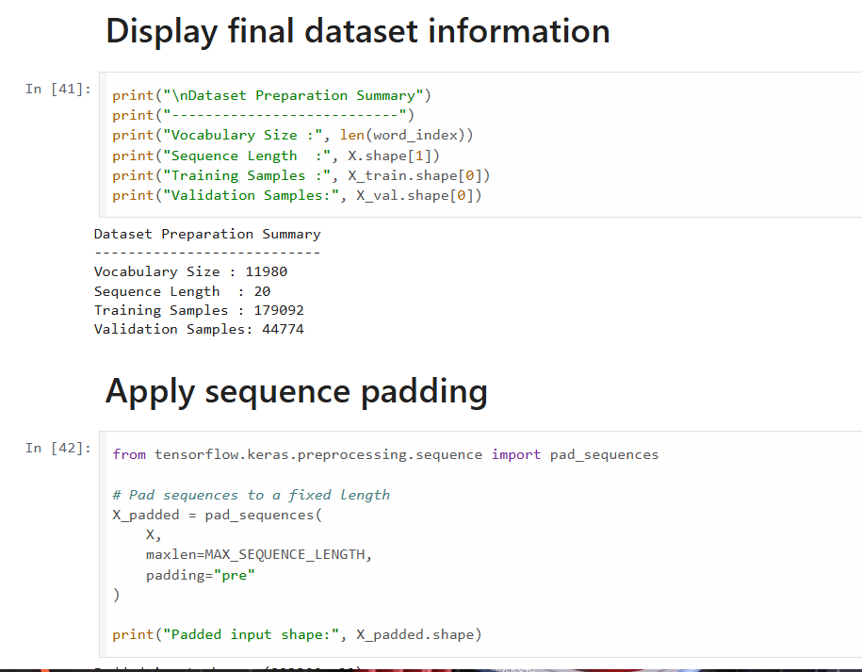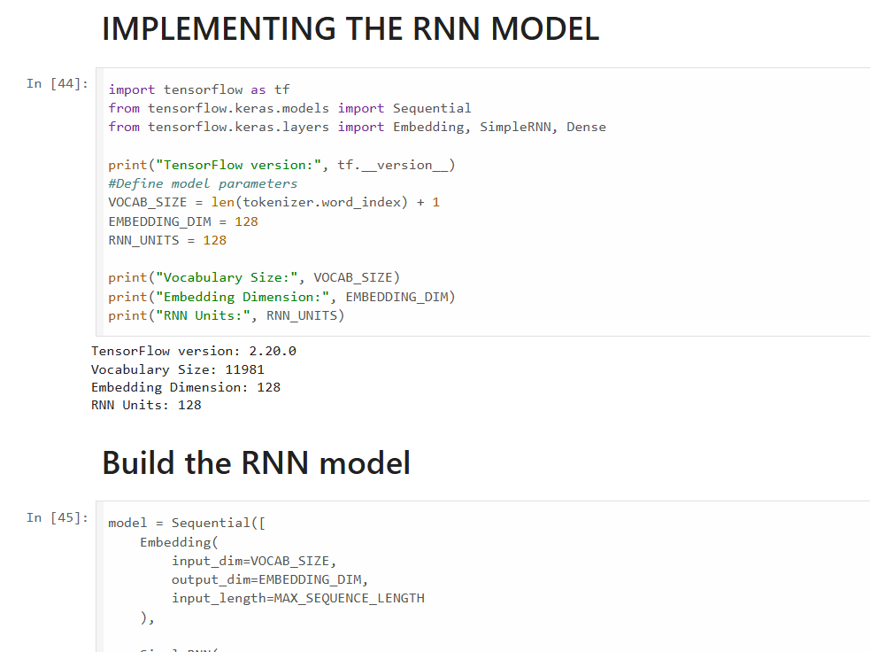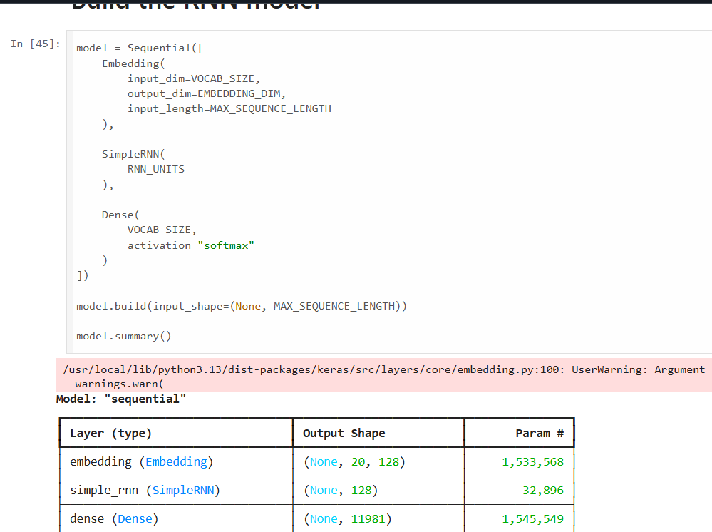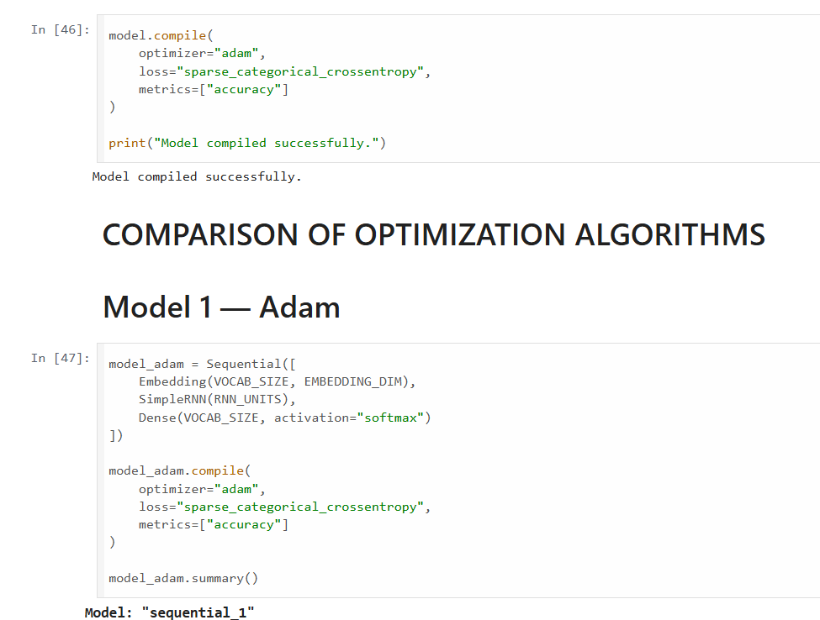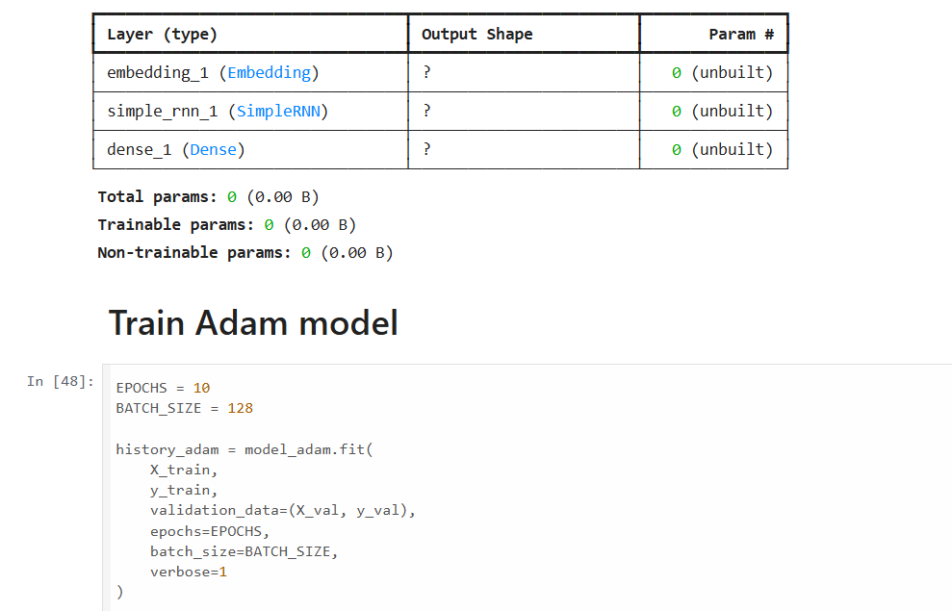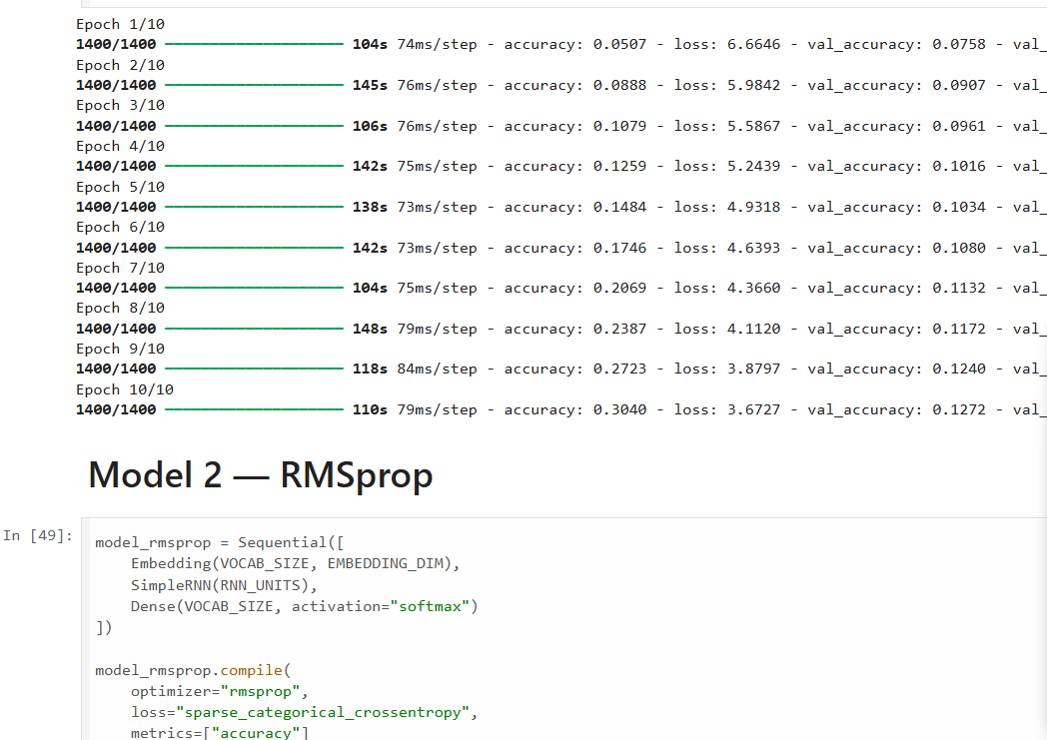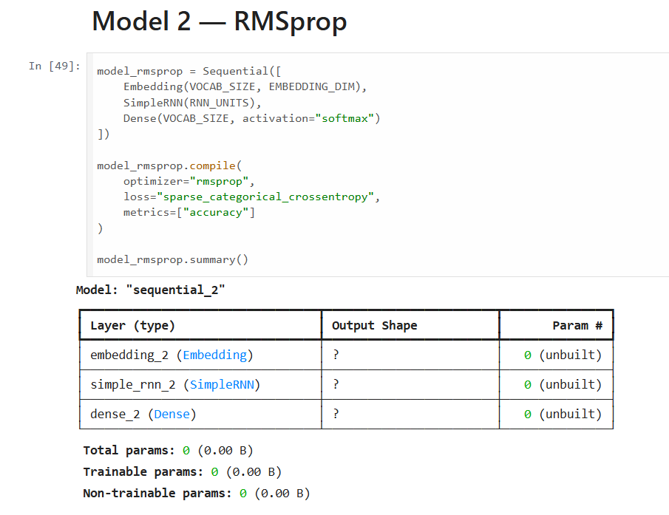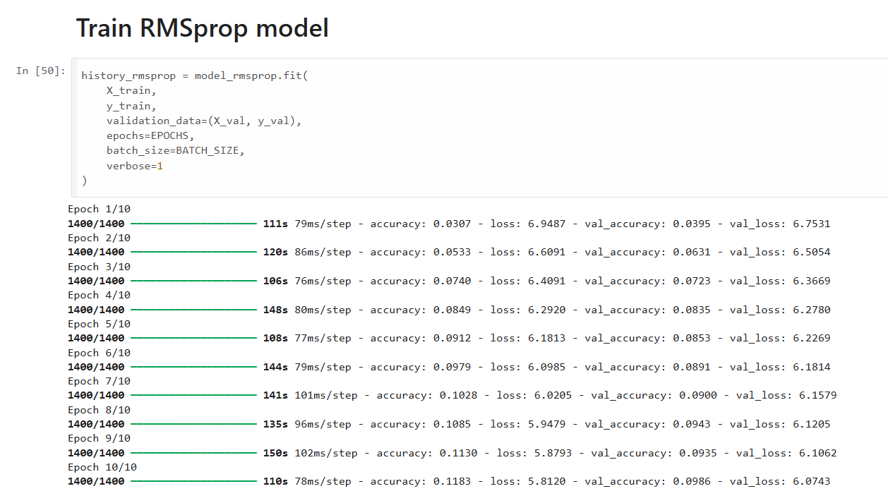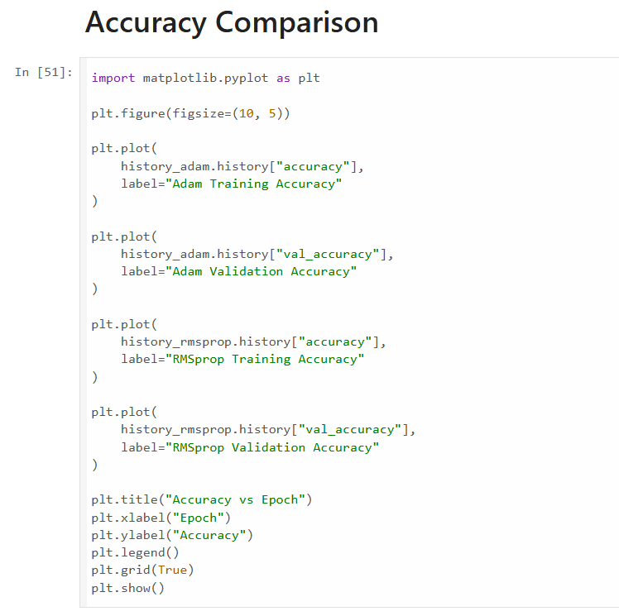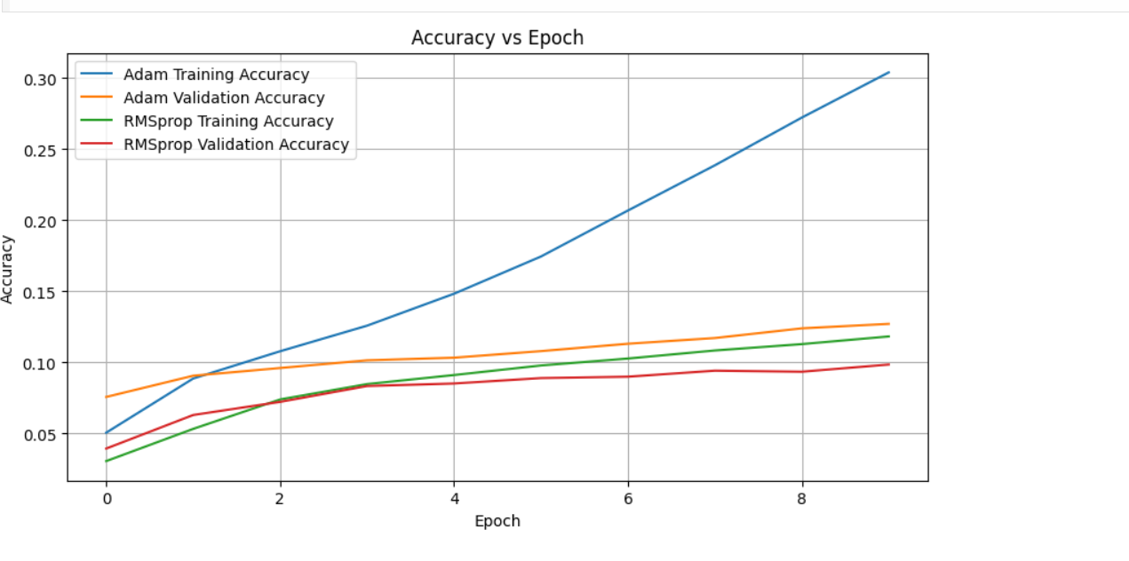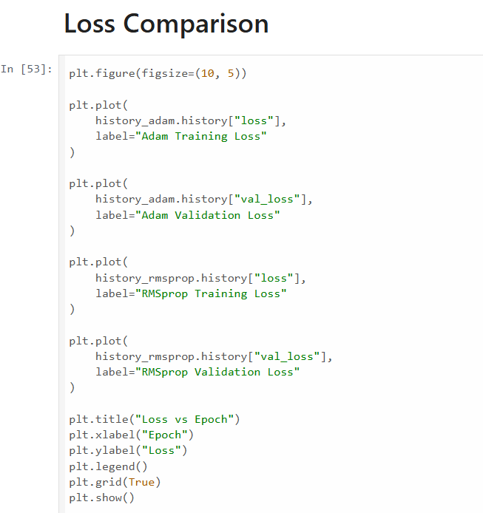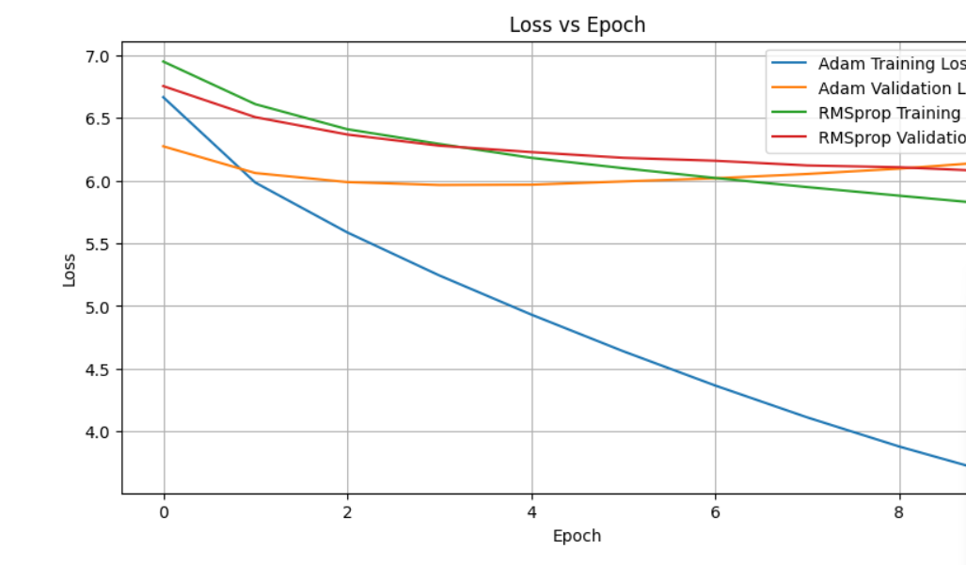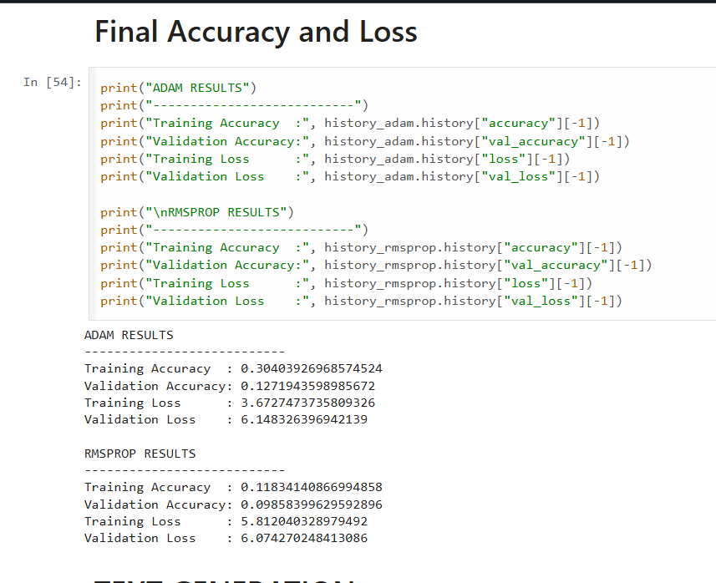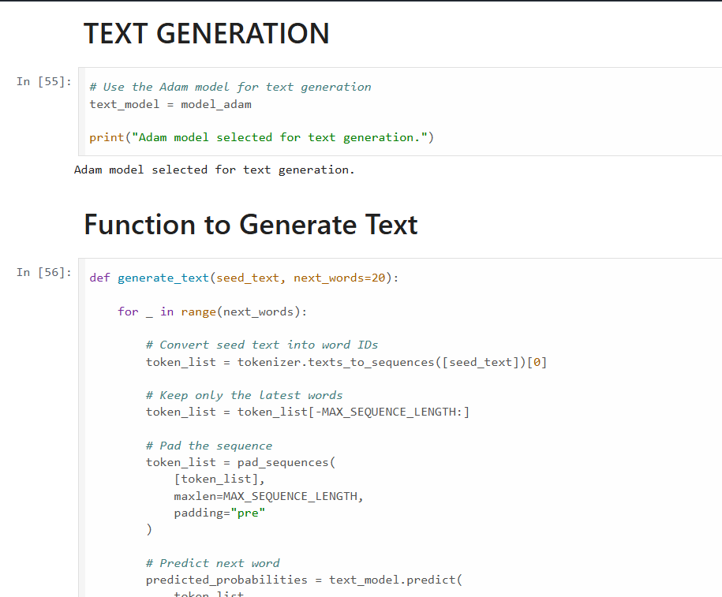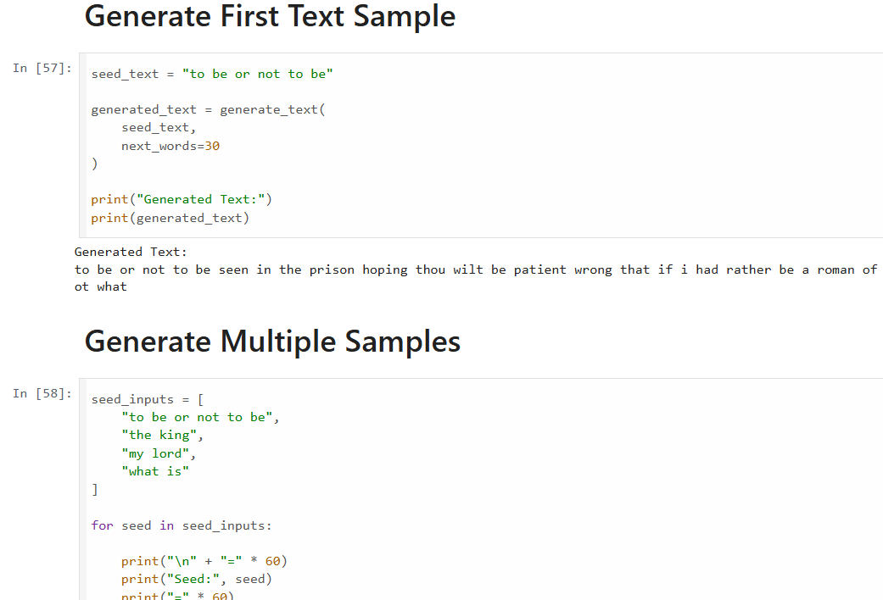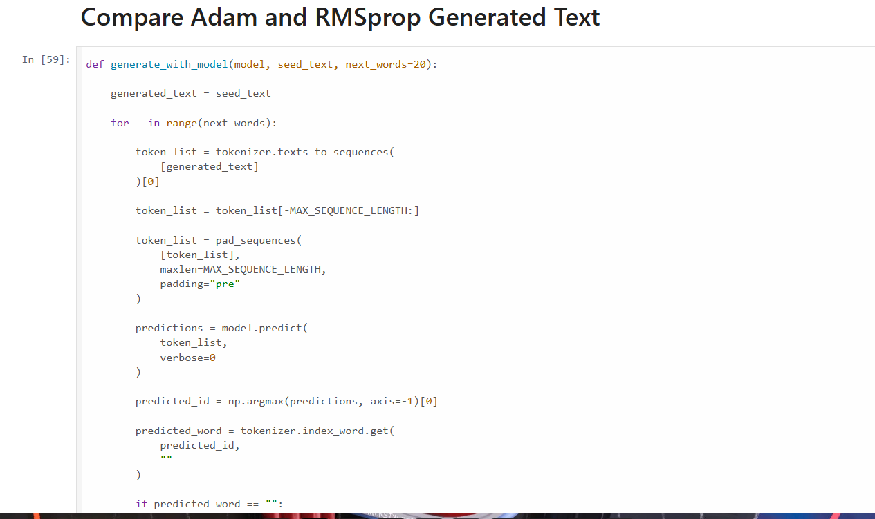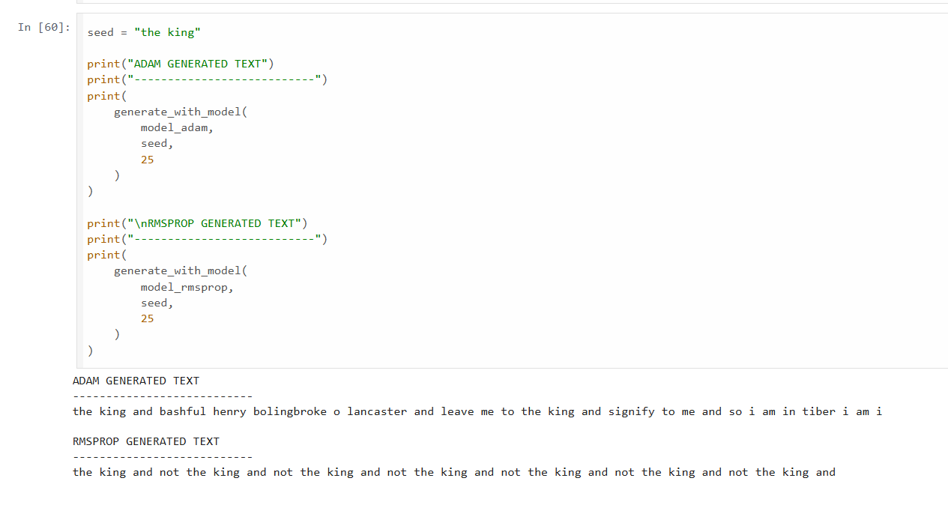

POST-LAB QUESTIONS (PROVIDE BRIEF ANSWERS TO THE FOLLOWING QUESTIONS)

- Describe the role of the hidden state in an RNN during sequence processing.

- The hidden state acts as the memory of an RNN. As the RNN processes each element in a sequence, it combines the current input with information stored from previous inputs. This updated hidden state carries contextual information forward through the sequence. For example, while processing a sentence, the hidden state helps the RNN use previous words to understand or predict the next word.

- Discuss the effect of training an RNN model for an insufficient number of epochs.

- If an RNN is trained for too few epochs, it may not have enough time to learn the important patterns and relationships in the training data. This can result in underfitting, where the model performs poorly on both training and new data. In text generation, the generated text may be inaccurate, repetitive, or lack meaningful structure. Increasing the number of epochs can improve learning, but too many epochs may lead to overfitting.

- Explain the purpose of padding when preparing text sequences for RNN training.

- Padding is used to make all input sequences the same length before training. Since text sequences may have different numbers of tokens, shorter sequences are filled with special values, usually 0, until they match a predefined maximum length.
- For example:
[5, 8, 12] → [5, 8, 12, 0, 0]
[3, 7, 9, 2, 6] → [3, 7, 9, 2, 6]
Padding allows sequences to be efficiently processed in batches and ensures that the input data has a consistent shape.

- Discuss one limitation of a Simple RNN when processing long text sequences.

- One major limitation of a Simple RNN is its difficulty in remembering information from earlier parts of a long sequence. During training, it can suffer from the vanishing gradient problem, where information from distant time steps gradually becomes less influential. As a result, the model may fail to capture long-term dependencies in text. Models such as LSTM and GRU are often used to overcome this limitation.

- Discuss the effect of sequence length on the performance of the text generation model.

The sequence length determines how much previous context is provided to the model when predicting the next word or token.

- Short sequence length: The model receives less context and may miss important relationships between earlier and later words, resulting in less meaningful text.
- Long sequence length: The model receives more context and can potentially generate more coherent text, but training requires more computational resources and may be difficult for a Simple RNN due to long-term dependency problems.

Therefore, an appropriate sequence length should be selected to balance contextual information, model performance, and computational efficiency.

ASSESSMENT
Description | Max Marks | Marks Awarded
Pre Lab Exercise | 5
In Lab Exercise | 10
Post Lab Exercise | 5
Viva | 10
Total | 30
Faculty Signature

