

**School of Computer Science and Engineering**

**Programme: B. Tech(CSE)**

**Course Title: Machine Learning**

**Course Code: BCSE209L**

**Slot: C2+TC2**

**Title: Food Recommendation in Restaurant**

**Team Members:**

**Mithun Raj | 22BAI1136**

**Bhagath U | 22BAI1461**

**Hariharan | 22BAI1465**

**Faculty: S.A SAJIDHA**

**TABLE OF CONTENTS**

|  |  |  |
| --- | --- | --- |
| **Chapter Number** | **Title** | **Page Number** |
| **1** | **Abstract** | **3** |
| **2** | **Introduction with objective** | **4** |
| **3** | **Literature Review** | **5** |
| **4** | **Proposed Methodology with Flowchart** | **11** |
| **5** | **Dataset Overview** | **16** |
| **6** | **Experimental results with sample user input and output** | **17** |
| **7** | **Conclusion** | **22** |
| **8** | **References** | **23** |

**LINK FOR DATASET AND CODE:**

[**https://drive.google.com/drive/folders/12h0egOeIwymOr8g8NNsGWfhScJC1gQvd?usp=sharing**](https://drive.google.com/drive/folders/12h0egOeIwymOr8g8NNsGWfhScJC1gQvd?usp=sharing)

**ABSTRACT**

The project "Food Recommendation In A Restaurant" utilizes machine learning techniques to provide personalized dishes at a restaurant based on user preferences. We are utilizing the K Means clustering algorithm in our code, along with a preprocessing step to handle missing data and categorize variables. The dataset contains information about the flavour, temperature, and spiciness of various food items. Our aim is to suggest food choices that suit each person's preferences, taking into account factors such as flavour, temperature, and spiciness. By employing machine learning methods, our goal is to enhance the dining experience by offering personalized suggestions.

**INTRODUCTION WITH OBJECTIVE**

In this project, we are using machine learning to suggest restaurant dishes according to user likes. Our code uses the K Means clustering algorithm and a preprocessing step for managing missing data and categorizing variables. The dataset has important info on flavour, temperature, and spiciness of different dishes.

The main goal of this project is to offer customized food options that cater to each person's preferences, taking into account important elements like taste, temperature, and spiciness. Through using advanced technology and analysing data, our aim is to improve the dining experience for restaurant patrons by providing personalized recommendations.

In order to accomplish this goal, the code we have developed utilizes the K Means clustering algorithm. This algorithm works by grouping together food items that have similar characteristics. This grouping enables us to categorize dishes with comparable flavour profiles, temperature preferences, and spiciness levels. By studying these clusters, we are able to suggest dishes that are likely to appeal to an individual's unique taste preferences.

Moreover, our code features a pre-processing phase to address missing data and classify variables. This stage guarantees that the dataset is sanitized and ready for further examination. Missing data in numeric fields, like flavour, temperature, and spiciness levels, are managed by applying suitable strategies. Encoding methods are utilized to process categorical variables, allowing for their utilization in the machine learning algorithms.

We're working on a project to improve the dining experience for restaurant guests. Our goal is to make the meal selection process more enjoyable and satisfying by giving personalized suggestions tailored to each person's preferences. By using machine learning techniques and examining the data we have, we can provide valuable recommendations that match each person's preferred flavours, temperatures, and spice levels.

In this project, we aim to demonstrate how machine learning can benefit the restaurant industry. By using data analysis and modelling, we can create tailored dining experiences. Our goal is to offer precise recommendations that enhance customer satisfaction and create unforgettable dining moments.

**LITERATURE REVIEW**

**Abstract**

This literature review delves into the domain of food suggestion systems that take the assistance of machine learning algorithm. When we say machine learning algorithm, there are plentiful amount of algorithms that can make this project possible. This literature review will take a look at some of the algorithms that can be used to create this project. A consumer’s Food preferences can be affected by suggestions given to them. Suggestions can be made to them in the form of a program than can recommend few food items according to the input given by them such as their preferred cuisine, taste, temperature etc. When a consumers cannot decide on what food they can have or when they want to try something new, they can take help from this food suggestion system to get some new recommendations. In this paper we propose a few recommendation systems that is trained on the basis of inputs given by the consumer or on the basis of dataset given by the developer. When it comes to user given input, their preference is based on the likes as well as the dislikes of the consumer, indicating their personalized diet and their health conditions.

**Introduction**

The Literature titled “Food Recommendation in a Restaurant” introduces an innovative approach to personalized food recommendations. This system is designed to adapt to individual consumer behaviour and specific dietary needs, leveraging the power of machine learning algorithms. The primary focus of this research is to create a system that can learn from user behaviour and make intelligent recommendations accordingly.  
  
The system is not just a simple recommendation engine, but a sophisticated tool that takes into account various factors such as nutritional requirements, personal preferences, and dietary restrictions. It uses deep learning and genetic algorithms to analyse and understand the user’s needs and preferences. The goal is to provide a personalized and unique user experience, enhancing customer satisfaction and engagement.  
  
This research is a significant contribution to the fields of e-commerce, nutrition, and machine learning. It demonstrates the potential of machine learning in creating personalized experiences and highlights the importance of considering health and nutrition in product recommendations. The system’s ability to adapt to user behaviour and consider dietary needs could revolutionize the way we think about food recommendations and personal nutrition. This paper is a step towards a future where technology and nutrition go hand in hand to create healthier and more informed consumers.

**Body**

The Main theme of this Literature review is to review and analyse different approaches used in the Machine Learning model that come under the category of “Suggestion System”.

**Food Recommendation**

The methodology of the “Food Recommendation System Using Machine Learning” is complete and multifaceted. It begins with a user registration module where customers provide details such as their name, user id, password, email, and phone number. Once registered, users can log in to access the system. The customer is then taken to the “preference Portal” where they can add their preference to the food on the basis of calories, Nutrition, Taste, cuisine, etc. after the inputs are given, the model can run its Deep Learning model to find the food items that are close to the consumer’s preferences [1].

Unlike other papers, this paper is written on a working model “DIETOS” which is a web-based dietary recommender system designed to help both healthy people and those with chronic diseases manage their diet. It creates personalized plans by collecting user health information through questionnaires and medical data. Unlike other recommender systems, this model focuses on a user's health profile rather than past dietary choices. This allows it to consider factors like chronic conditions and the beneficial properties of local foods, while also avoiding foods that might negatively impact the user's health [6].

Next one proposes a new system for recommending healthy meals specifically tailored to Indian women athletes and active young women. This system utilizes Long Short-Term Memory networks, a type of artificial intelligence that excels at analysing sequences. In this case, the LSTM would likely analyse user data like activity levels, goals, and dietary preferences over time to suggest personalized meal plans. Interestingly, the model focuses on incorporating Indian foods, suggesting it considers the cultural and dietary needs of its target audience [7].

The research paper "Improving Food Recipe Suggestions with Hierarchical Classification of Food Recipes" explores a method to enhance recipe recommendations on online platforms. It proposes a hierarchical classification system for food recipes. This means the system categorizes recipes based on a layered structure. The paper acknowledges that traditional content-based recommender systems, which often focus on ingredients, can be computationally expensive. This hierarchical classification offers a potentially more efficient way to analyse recipes and make recommendations [9].

**Grocery Recommendation**

The model is the “Grocery Product”, which allows users to view and complete transactions for various categories of products like biscuits, chocolates, yogurt, and noodles. Users select the product and provide the necessary details to complete the transaction. This module presents a list of questions to the customer based on their genetic profile, such as their taste for salt, sugar, fat, protein, and energy. The responses to these questions are saved for future analysis [2].

The paper “What’s for Dinner? Recommendations in Online Grocery Shopping,” addresses the challenge of recommending grocery items online, framing it as a binary classification problem. It explores a dataset from Instacart, supplemented with nutritional data, to understand consumer purchasing patterns and improve recommendation systems. Utilizing Instacart’s dataset, the paper details the orders, users, and products involved, along with the process of generating training, validation, and test sets for various models. To achieve this the model uses machine Learning concepts such as Logistic regression, Support vector machines. Finally to evaluate the model’s effectiveness, the model uses neural network algorithm [3].

Next paper discusses the increasing trend of online grocery shopping and the importance of recommendation systems in making the shopping experience easier and faster for customers. It emphasizes the need for precise and quick recommendations that align with customer interests and necessities. Two algorithms are highlighted, they are, the slope one algorithm for item-to-item collaborative filtering and the min hash algorithm for generating results based on user profiles [5].

**Crop Recommendation**

This Machine learning paper is offering a new tool for farmers. A Machine Learning Based Crop Suggestion System. This system analyses various factors like soil properties, climate data, and past crop yields to recommend the most suitable crops for a specific piece of land. By using machine learning algorithms like decision trees or k-nearest neighbours, the system can identify patterns and relationships between these factors and successful crops. This empowers farmers to make data-driven decisions about what to plant, potentially increasing yields and reducing risks [8].

**E-commerce Recommendation**

The paper presents a novel book recommendation system that integrates content-based filtering, collaborative filtering, and association rule mining to provide efficient and effective recommendations tailored to the buyer’s interests. The paper also addresses the limitations of content-based filtering in assessing the quality of content and introduces collaborative filtering, which relies on the opinions of other users to evaluate the quality of items [4].

The final paper Explains about Collaborative Filtering. Collaborative Filtering is a well-established recommender system technique employed extensively in e-commerce platforms. This approach rests on the assumption that users with historically similar purchasing behaviour will likely exhibit similar preferences in the future. In essence, CF leverages past user-item interactions to predict a specific user's interest in unrated items [10].

**PROPOSED METHODOLOGY**

The proposed methodology for the "Food Recommendation in a Restaurant" project includes using the K Means clustering algorithm and a preprocessing pipeline to manage missing data and categorize variables. The system design includes data preprocessing, clustering, and personalized recommendation generation as essential components.

#### 1] Data Preprocessing

The first step is to load the dataset, which includes details about the taste, temperature, and spiciness of different food items. The dataset is then prepared for analysis by addressing any missing values in numerical columns like 'sweet level', 'spice level', 'bitter level', 'sour level', and 'salt level'. To do this, the missing values are replaced with the average values of the corresponding columns. Categorical columns like 'temperature' and 'taste' are also identified for additional processing.

#### 2] K Means Clustering

A preprocessing pipeline is then created using the ColumnTransformer class from scikit-learn, which includes transformers for both numerical and categorical data. The K Means algorithm is set up to form five clusters, which helps in grouping similar food items together based on their taste, temperature, and spiciness. This clustering method allows for the discovery of patterns and similarities between various dishes, which is essential for generating personalized recommendations.

**3] Personalised Recommendation Generation**

In order to provide customized meal suggestions, we have created a function called "recommend_dishes". This function relies on user input, such as flavour preferences, temperature preference, and spice level. The input data is processed using the same method as the dataset. The function then computes the similarity or distance between the user's input and every dish, using either Euclidean distance or cosine similarity as the metric. The final recommendations are determined by a set threshold, and the suggested dishes are returned along with information about their cuisine and flavour profile using tkinter(python) as user interface.

The system design includes the steps of preparing data, grouping, and creating custom recommendations to improve the dining experience for customers with personalized and suggestions based on their preferences.

This approach uses machine learning techniques to give precise and customized suggestions, enhancing customer happiness and pleasant dining experience for every person.

**FLOWCHART**

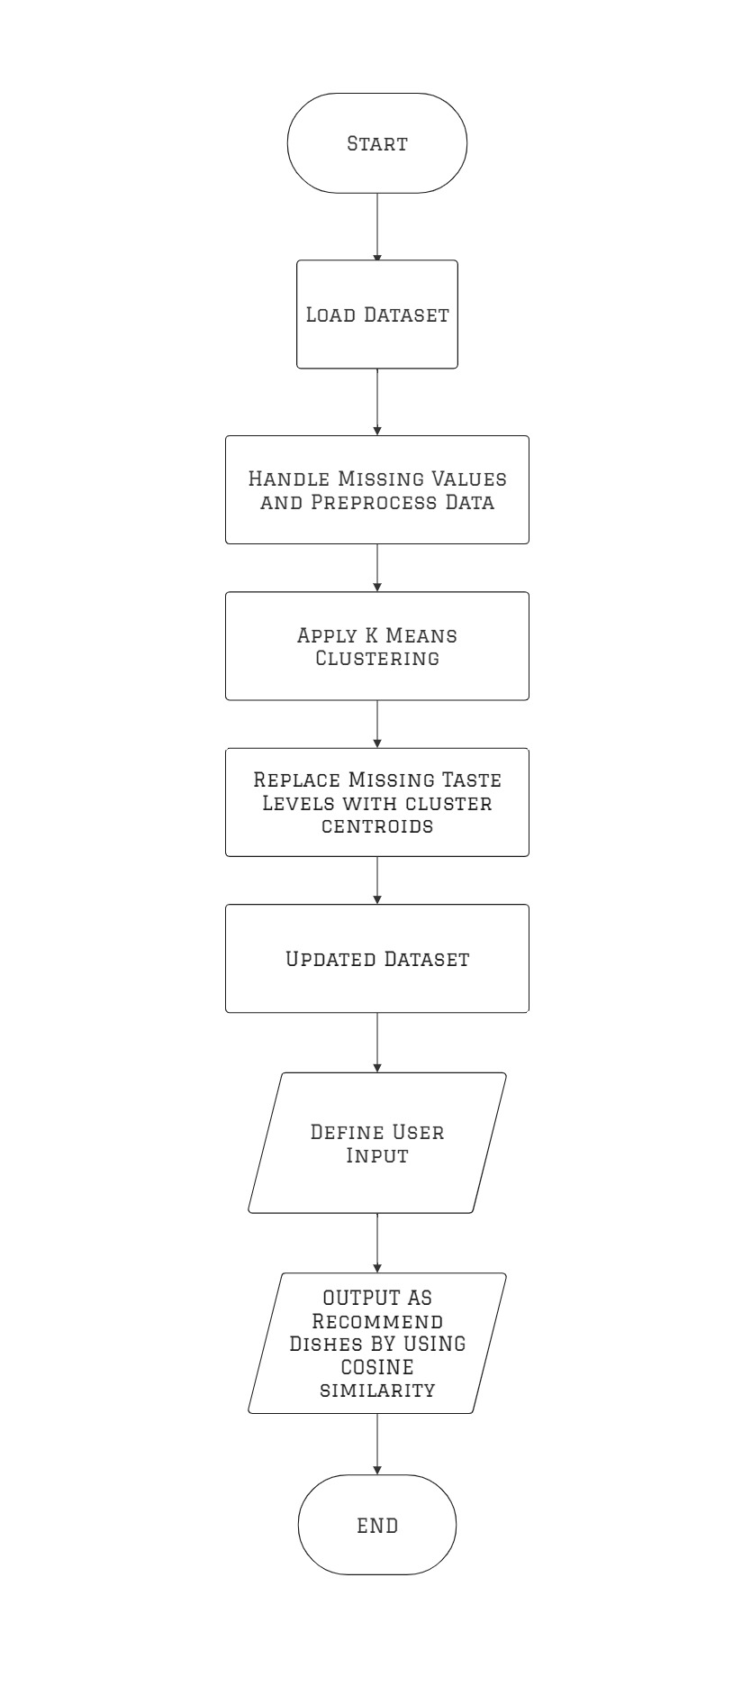

**Load Dataset:**

This step involves loading the dataset which provides details about different dishes. This dataset could include information like serving temperature (hot, cold, etc.), spiciness, sweetness, saltiness, and bitterness.

Handle Missing Values and Preprocess Data

In this step, we will address any missing data in the dataset and prepare the data for machine learning. Preprocessing tasks may involve filling in missing values and scaling numerical features.

Apply K-Means Clustering:

In this next stage, we will use K-means clustering to analyse the data. K means clustering is a type of machine learning algorithm that automatically groups data points into a set number of clusters (k). In this instance, these clusters could potentially reflect distinct taste profiles.

Replace Missing Taste Levels with Cluster Centroids:

In this process, we fill in any missing taste levels in the data by using the cluster's centroid that the data point belongs to which is the average of all data points within the cluster.

**Updated Dataset:**

In this step, the dataset will be updated to fill in missing taste level values. Taste levels that were previously missing in the dataset will be filled in with new data and the updated dataset will be saved in a new CSV file format

Define User Input:

In this stage, we get the input from the user. This could be their likes and dislikes in terms of cuisine, taste, temperature, spiciness, sugariness, saltiness, and bitterness.

Output as Recommend Dishes by Using Cosine Similarity:

To recommend dishes to the user, we use cosine similarity to compare the user input with each dish in the dataset. In this scenario, the user input and the dish features are both represented as vectors. The dishes that have the highest cosine similarity to the user input are the ones recommended to the user

**DATASET OVERVIEW**

### Taste Profiles

The dataset categorizes the taste of the dishes into the following categories:

* Spicy
* Sweet
* Salty
* Sour
* Bitter

### Temperature and Spice Level

The created dataset includes information about the temperature (hot/cold) and spice level of the dishes. The spice level is represented on a scale from 0 to 9, with 0 being not spicy at all and 9 being extremely spicy.

### Sweet, Salt, Sour, and Bitter Levels

The dataset includes information about the sweet, salt, sour, and bitter levels of the dishes. These are also represented on a scale from 0 to 9, with 0 being not present at all and 9 being extremely present.

The created "Food Dataset" has collection of different dishes from a variety of cuisines such as Chinese, Italian, Indian, American, and Korean. This dataset was compiled using Google Forms, serves as a valuable resource for understanding and analysing food preferences.

**EXPERIMENTAL RESULTS**

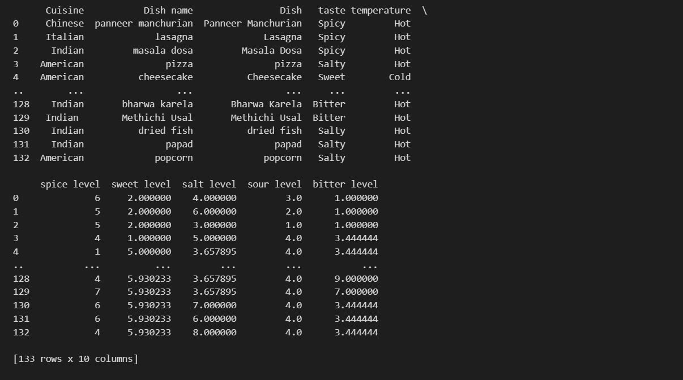

Updated Dataset: This refers to the dataset that has been modified to address the missing taste level values.

Filled taste levels: This indicates that the missing values in the "taste level" column of the dataset have been imputed with some data.

The updated dataset is being saved as CSV file format.

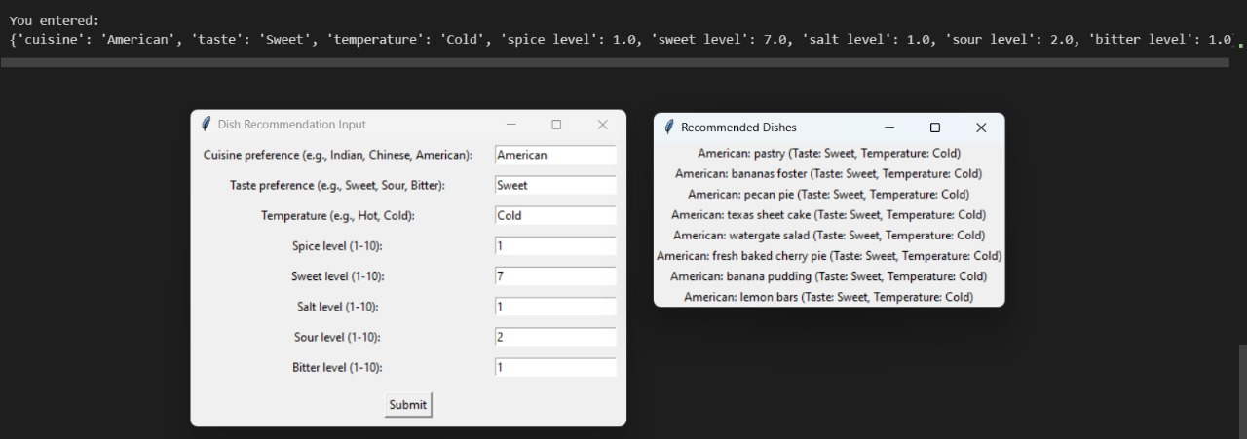 The recommender system works by gathering information from users about different qualities of a dish, such as sweetness and spice level, to suggest similar dishes. Results from testing have shown that the system effectively suggests dishes that align with the user's tastes. For example, when a user indicated a sweetness level of 7 and desired a cold temperature, the system suggested a variety of American desserts like pecan pie, banana pudding, and lemon bars.

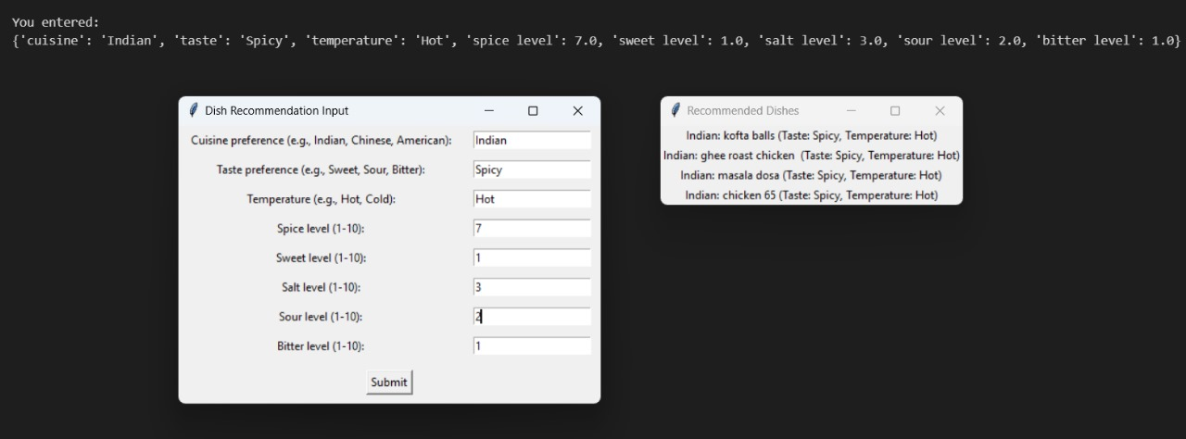

Here also, the results show that the recommender system is capable of suggesting dishes that align with the user's spice threshold. For instance, here when the user indicated a spice level of 7, the system proposed a variety of Indian dishes such as chicken 65, masala dosa, ghee roast chicken, and kofta balls.

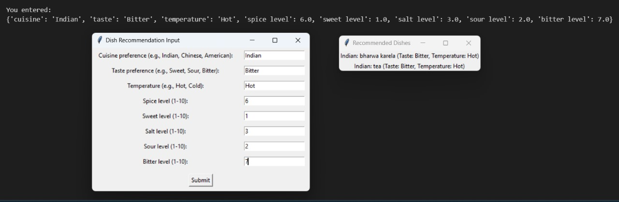

In this example, the user input a preference for bitterness at level 7, spiciness at level 6, saltiness at level 3, and desired a hot temperature. As a result, the system suggested Indian dishes that are renowned for these specific tastes, such as Bharwa karela.

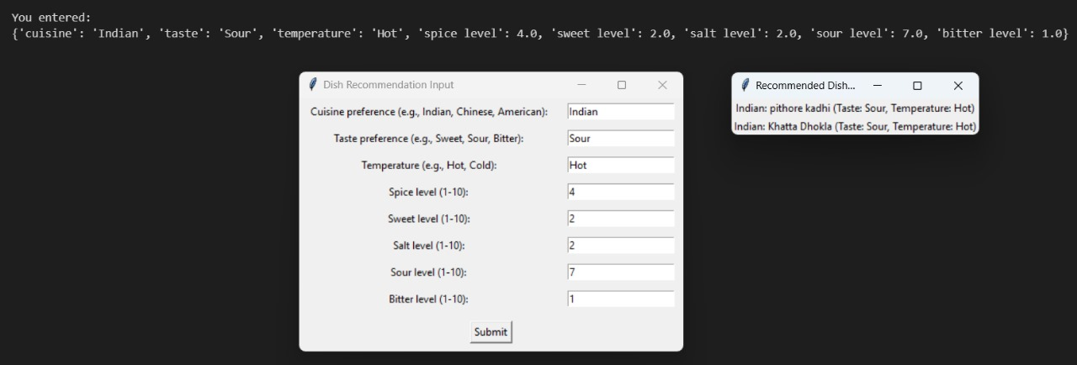

In another example, the user input a preference for sour at level 7, spiciness at level 4, saltiness at level 2, and desired a hot temperature. As a result, the system suggested Indian dishes that are renowned for these specific tastes, such as Pithore Kadhi and Khatta Dhokla

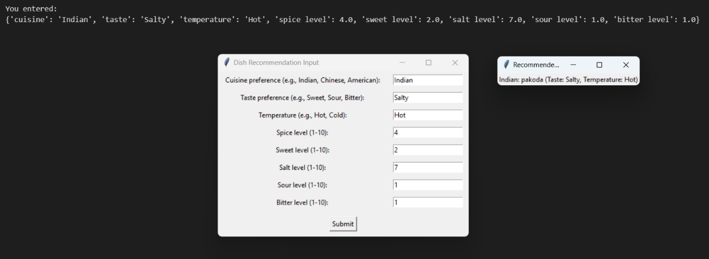

In this final example, the user input a preference for salt at level 7, spiciness at level 4, saltiness at level 2, and desired a hot temperature. As a result, the system suggested Indian dishes that are renowned for these specific tastes, such as Pakoda

In summary, using a K-Means clustering and cosine similarity, this system recommender can be valuable for suggesting dishes to users according to their preferred spice levels. This method can be successful in recommending dishes similar to ones the user has previously enjoyed.

**CONCLUSION**

In conclusion, the food recommendation project shows how data preprocessing, clustering algorithms, and user input can be used to give personalized dish suggestions. This involves using K Means clustering to group dishes and filling in missing taste levels with cluster centroids, improving the dataset for more precise recommendations. The focus on users, such as defining their input for dish suggestions, guarantees a customized and interactive experience for the people using the system. As a result, this project shows how machine learning can be used effectively in cooking applications and emphasizes the potential for creating user-friendly recommendation systems in various fields. It underscores the importance of decision-making that prioritize user experience to achieve meaningful results.

**REFERENCES**

1. “Intelligent Food Recommendation System Using Machine” Learning by Pratiksha Ashok.
2. “An enhanced recommendation scheme for online grocery shopping” by Yi-Jing Wu and Wei-Guang Teng.
3. “What’s for Dinner? Recommendations in Online Grocery Shopping” by Alan Flores-Lopez, Skip Perry and Poorvi Bhargava.
4. “book recommendation system based on combine features of content based filtering, collaborative filtering and association rule mining” by Ashish Fatarphekar, Tejas Nashikkar, Vivek Patil and Gayatri Naik.
5. “Online Grocery Recommendation System” by Suja Panicker
6. “DIETOS: A recommender system for adaptive diet monitoring and personalized food suggestion” by Barbara Calabrese, Pietro Hiram Guzzi, Mario Cannataro and Mariadelina Simeoni.
7. “A healthy nutrition suggestion model for indian women sports players & active youth using long short-term memory” by Keerthana Ramaraj, Valliammal Narayan, Thookanayakanpalayam Thyagarajan Dhivyaprabha and Parthasarathy Subashini.
8. “Machine Learning Based Crop Suggestion System” by R Varun Prakash, M Mohamed Abrith and S Pandiyarajan.
9. "An enhanced recommendation scheme for online grocery shopping" by Yi-Jing Wu, Wei-Guang Teng.
10. “E-Commerce Product Recommendation Method Based on Collaborative Filtering Technology” by JunBo Xia.