AWS Academy courses and certification details

Available in https://aws.amazon.com/training/awsacademy/

1. AWS Academy Cloud Foundations

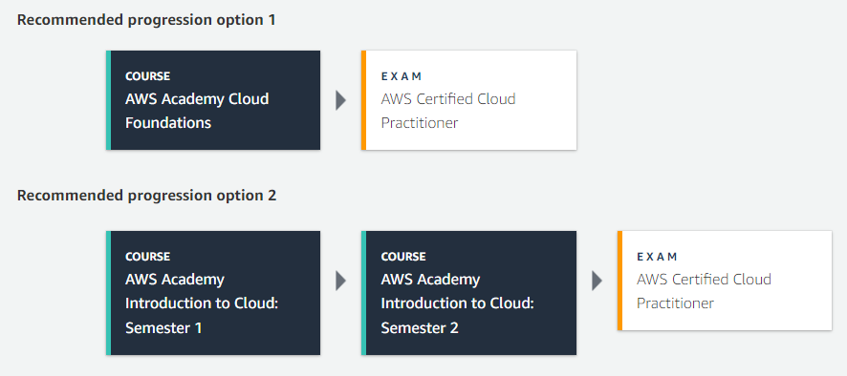

1. AWS Academy Cloud Developing

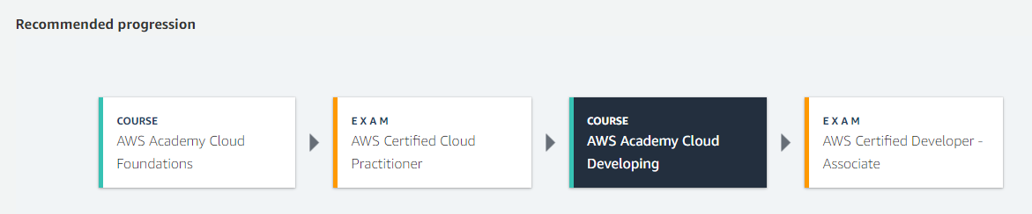

1. AWS Academy Cloud Architecting

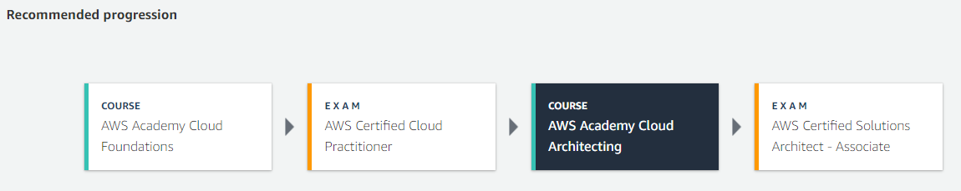

1. AWS Academy Cloud Operations

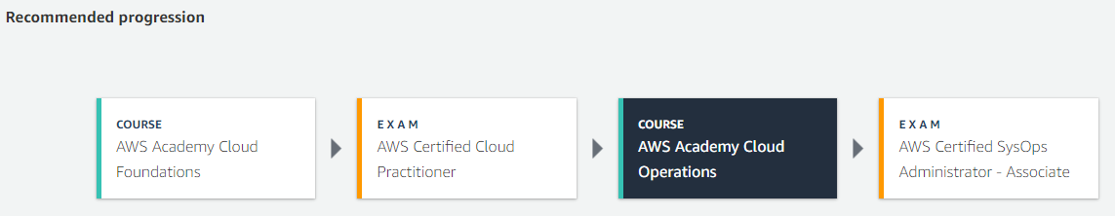

1. AWS Academy Machine Learning Foundations

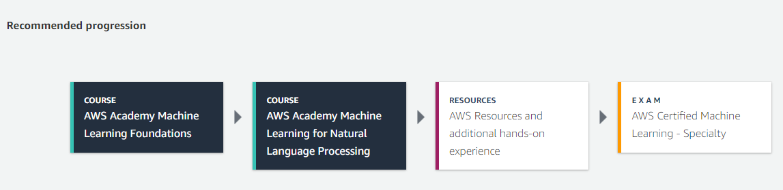

1. AWS Academy Data Analytics

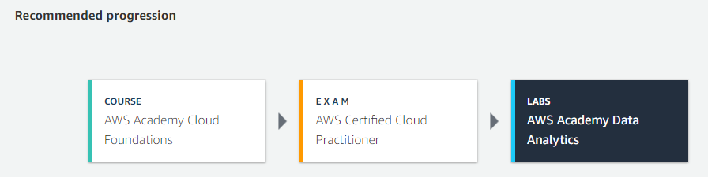

1. Data centers

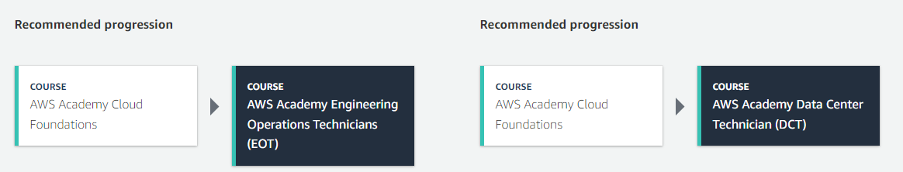

1. AWS Academy Cloud Security Foundations

