Written By: Dimiter Dinkov

Student Number: C15334276

The use cases I implemented were the list all games, search for a game and rate a game.

I ignored the login/register since the specification said I didn’t need to implement them. So the application assumes the user is already logged in.

Demonstration Link : <https://screencast-o-matic.com/watch/cblQqi2EA2>

PS. I didn’t bother going through the code in the video because it would have been too long, but I think I have it pretty much explained in comments in the code.

Update Class Diagram:

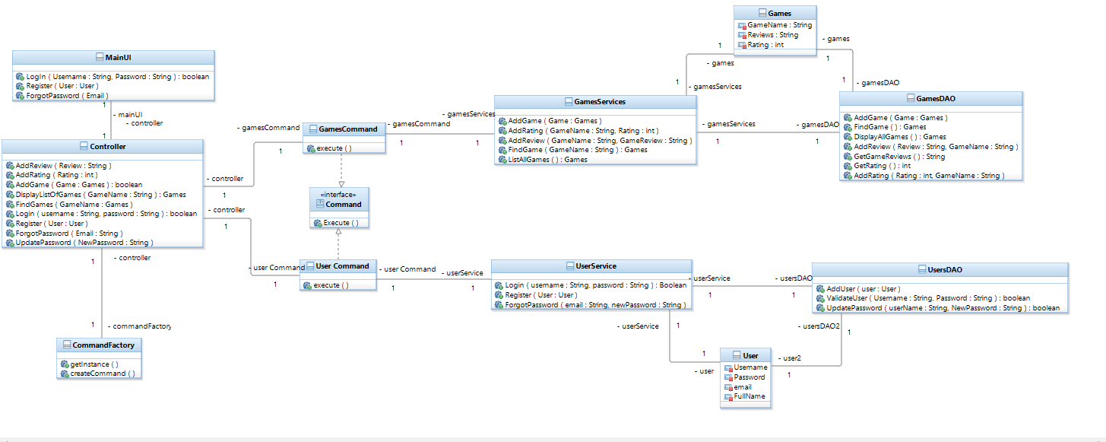

The reason for updating the design of the web applications was because I felt like I needed classes to manage any http requests coming in from the web application. In my original design, I had very few classes that only covered the functionality if the application was ran as a desktop application and not a web app. With this new design, the application can now handle the HTTP requests coming in from the web app properly and communicate them to the appropriate classes so the request is carried out.

Updated Sequence for one use case:

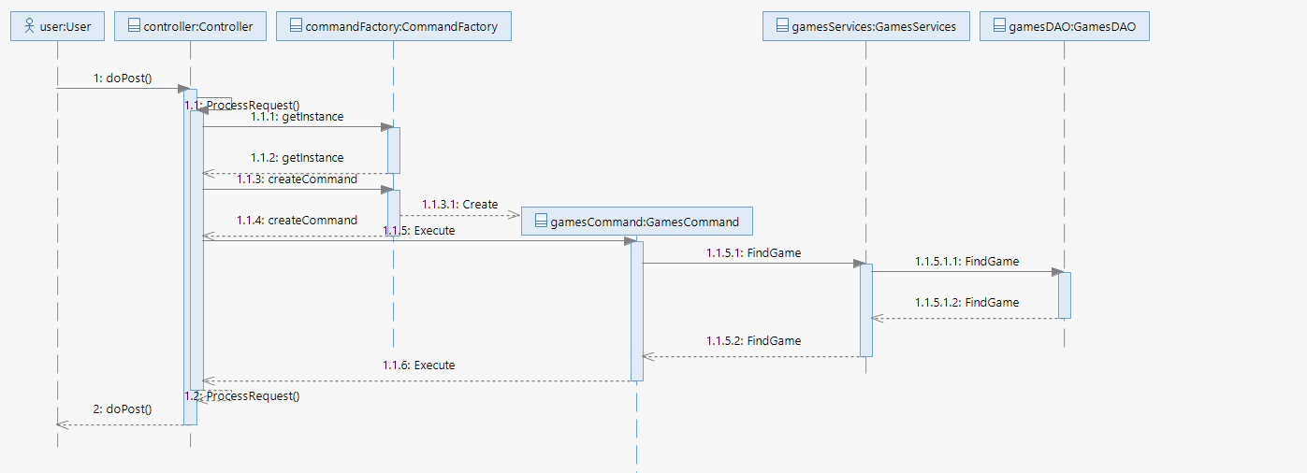

As you can see here, the updated design now forces the controller to communicate with the command factory. In this way any http requests that come into the controller are turned into objects by the command factory and are then returned to the controller.