# Summary

The project is to build high quality short term rental accommodation in a remote or wilderness location. The target market are Sydney residents who want relaxing weekends away in high quality properties within a 2.5 hour drive from Sydney. The properties will be listed with online holiday rental sites such as Stayz and Airbnb.

We have 3 outcomes for the project:

1. Positive cash flow investment – the repayments and running costs must be covered by revenue from bookings
2. Accommodation for family closer to Sydney– fulltime accommodation as onsite property manager allocated as one of the cabins
3. Resource for ministry use – spare capacity can be used for ministry

The aim is to build 6 houses and use 5 as rentals with one reserved for the onsite property manager.

The land will be a rural block with a wilderness outlook which is within 15 minutes’ drive of a main town. Minimum land would be 10 acres in order to have all buildings out of sight of each other.

We will identify the best location and mix of accommodation types in order to provide enough rental income to cover the property and building cost loan repayments.

# Financial Requirements

In order to build the properties we need to be sure that the loan repayments will be covered by the revenue from rentals

## Weekend Income Details

|  |  |  |
| --- | --- | --- |
| Advertised amount | $ 450.00 | Typical Stayz advertised amount |
|  |  |  |
| Revenue | $ 418.50 | For loan repayments |
| Booking fees | $ 31.50 | Stayz booking fees (7% of total) |
|  |  |  |
| Cleaning fees | $ 25.00 | Additional income |
|  |  |  |
| Total booking amount | $ 475.00 | Full customer billed amount |

## Cabin Availability

|  |  |
| --- | --- |
| Number of cabins for rent: | 5 |
| Weekends per year: | 52 |
| Available weekends per year: | 260 |

## Loan Details

Total project cost: $900,000

Deposit: $100,000

Loan Amount: $800,000

Loan Term: 25 years

Interest Rate: 7%

## Repayments Summary

|  |  |  |  |  |
| --- | --- | --- | --- | --- |
| Loan Balance | Repayment | Bookings Req | Wkend Occ | Cleaning Fees |
| $ 600,000 | $50,858.73 | 122 | 46.9% | $ 3,050 |
| $ 700,000 | $59,335.18 | 142 | 54.6% | $ 3,550 |
| $ 800,000 | $67,811.64 | 163 | 62.7% | $ 4,075 |
| $ 900,000 | $76,288.09 | 183 | 70.4% | $ 4,575 |
| $ 1,000,000 | $84,764.55 | 203 | 78.1% | $ 5,075 |

Notes:

* This is only based on weekend bookings, ie 2 days per week. If during the year there are longer bookings such as weekly bookings over summer then this will reduce the number of weekend bookings needed to break even.
* The rates are based on the advertised daily rate on Stayz. This rate would increase during peak times such as school holidays, long weekends, and Christmas/New year periods.
* Does not include any additional business costs, such as running costs (gas bottles), or maintenance on the buildings, or vehicles for the property manager.

## Building Summary

The budget for land is 300k. This leaves 600k for buildings, or an average of 100k each building.

Research indicates that building costs of $1050 are achievable. This means that a building area of around 90m2 could be achieved for 100k total spend.

Questions:

* Does the costing include allocations for basic furnishings (stove/fridge)
* Does the costing include solar panels/battery packs
* Costs for extras such as decking

### Electricity Power and Storage

Solar Panels - http://hellosolar.com.au

Platinum pack – 5kW panels (Free upgrade to 6kW as of 19/2/2018) plus inverter $4,000

#### Zinc Bromide Battery

[https://redflow.com/products/redflow-zbm2/](https://redflow.com/products/redflow-zbm2/" \t "_blank)

## **ZBM2 Technical Specifications**

**Voltage**

* 48 Volt DC nominal batteries (typical operating range 40-60V)

**Capacity**

* Maximum 10kWh energy output per daily cycle
* No reserved battery capacity requirement – full 10kWh cycle depth available

**Dimensions**

* 845 L x 823 H x 400 W (mm)
* 33 L x 32 H x 16 W (in)

**Weight**

* 240 kg (530 lb) with electrolyte
* 90 kg (198 lb) without electrolyte

**Electrolyte volume**

* 100 L (26Gal)

**Net energy efficiency**

* 80% DC-DC Max

**Internal (electrolyte) operating temperature**

* Operating electrolyte temperature range of 15°C to 50°C (59°F to 122°F), ZBM2 can typically operate at ambient temperatures outside this range for extended periods

**Communication**

* MODBUS RS485

**Safety data sheet**

* DG Class 8 for electrolyte

**Power rating**

* 3kW (5kW peak)
* 3kW continuous: current up to 75A (40V disconnection point) \*1
* 5kW duration depending on the State of Charge (SOC): current up to 125A (40V disconnection point) \*1, 2

**Regulatory compliance marks**

* CE and RCM

**Warranty**

* 36,500 kWh of energy delivered or 10 years (whichever comes first) \*3
* Expected electrode stack throughput 40,000 kWh
* No cycle depth limitations – battery performance and lifetime is not sensitive to cycle depth

#### Tesla Powerwall2

<https://www.tesla.com/en_AU/powerwall>

# **Technical Specs**

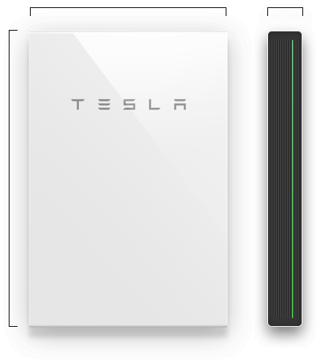

44" / 1150mm29" / 755mm5.5" / 155mm

* **Usable Capacity**13.5 kWh
* **Depth of Discharge**100%
* **Efficiency**90% round-trip
* **Power**7kW peak / 5kW continuous
* **Supported Applications**Solar self-consumptionBack-up powerTime-of-use load shifting (coming soon)Off-grid capabilities (coming soon)
* **Warranty**10 years
* **Scalable**Up to 10 Powerwalls
* **Operating Temperature**-4°F to 122°F / -20°C to 50°C
* **Dimensions**L x W x D: 44" x 29" x 5.5"(1150mm x 755mm x 155mm)
* **Weight**125 kg
* **Installation**Floor or wall mountedIndoor or outdoor
* **Certification**North American and InternationalStandardsGrid code compliant

### Example House Designs

### Cedar Creek House

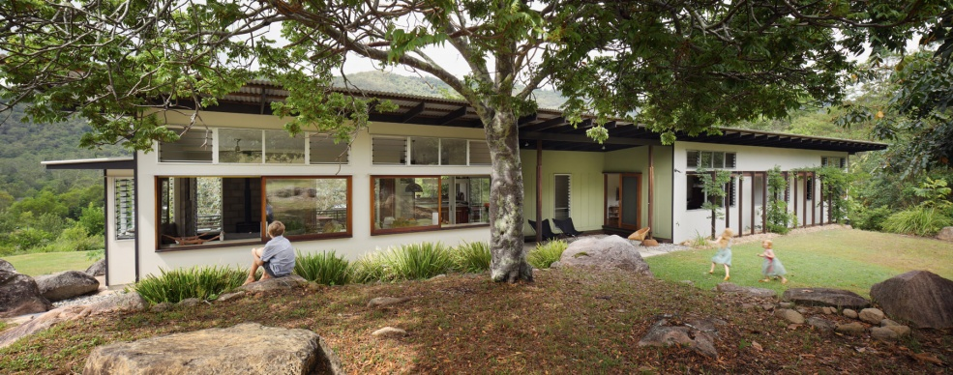

Architect site:

[https://blighgraham.com.au/project/cedar-creek-house-and-studio/](https://blighgraham.com.au/project/cedar-creek-house-and-studio/" \t "_blank)

Construction article:

[https://www.homestolove.com.au/chris-and-sonias-eco-friendly-queensland-bush-home-1991](https://www.homestolove.com.au/chris-and-sonias-eco-friendly-queensland-bush-home-1991" \t "_blank)

Quotes:

“Taking cues from the Californian cases study houses of the 40s, 50s and 60s, a 3.6m structural grid locates prefabricated steel frames that enabled the main support structure to be erected in a day and for infill timber framing to be subsequently carried out by the owner-builder within these frames under the sun and rain protection of a single plane roof.”

“Altogether, the cost amounted to about $1050 per square metre”

Rammed Earth Wall House

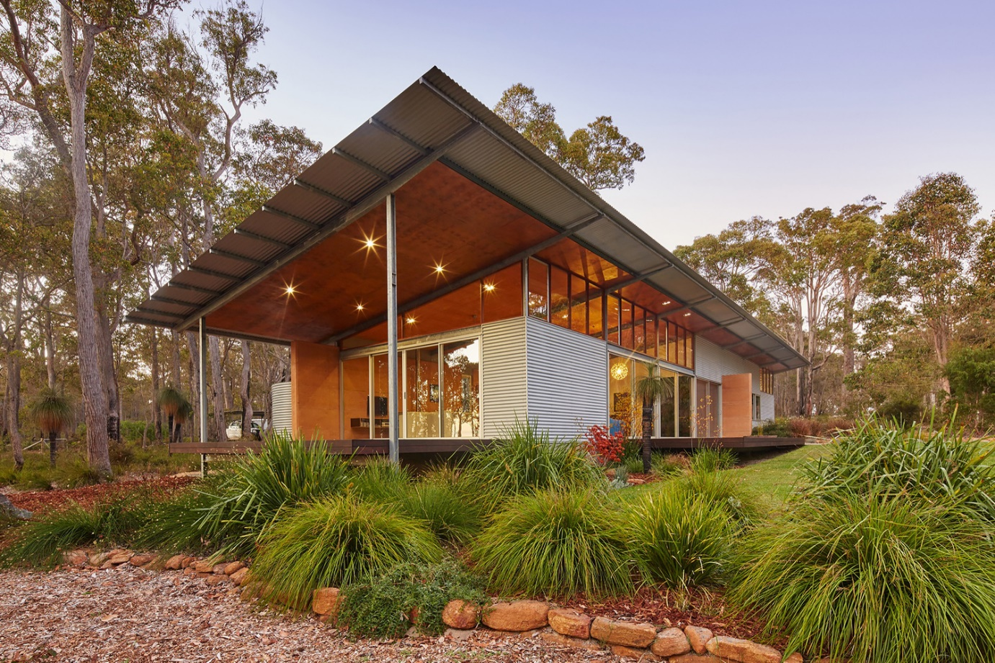

[https://www.archdaily.com/780377/bush-house-archterra-architects](https://www.archdaily.com/780377/bush-house-archterra-architects" \t "_blank)

Highway House – Tasmania

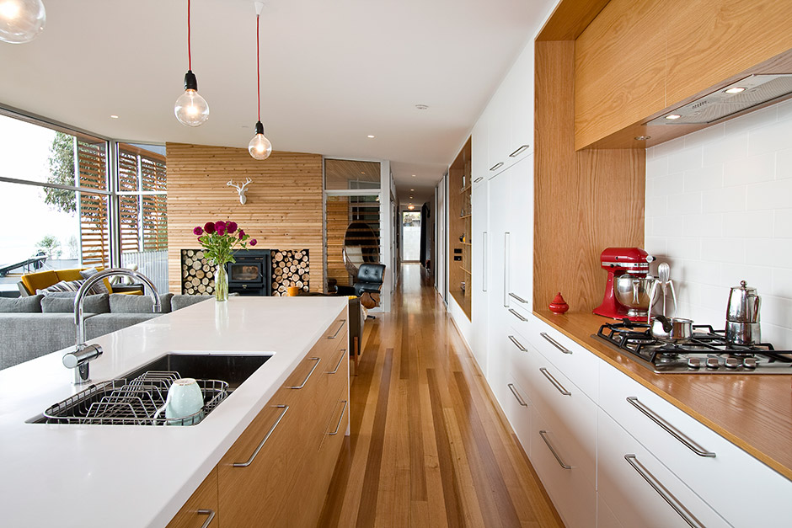

Total of 134m2 – (including garage??)

This compact 1,453 sq ft single level **house** designed by Room 11 is located on the Australian island of Tasmania

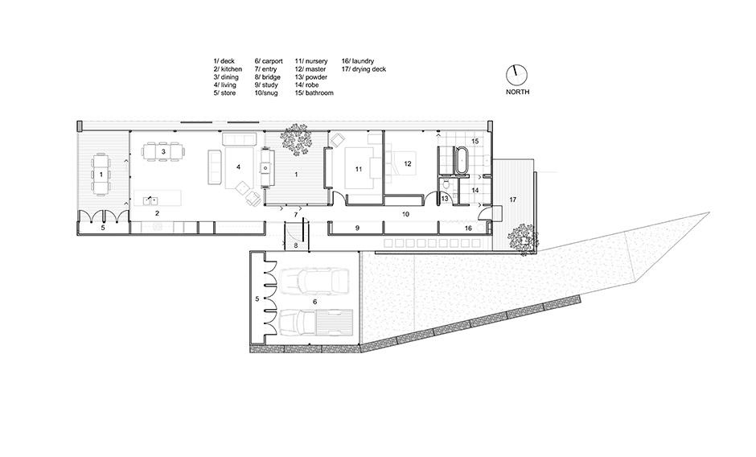

## Tax Benefits

Additional benefits for each of us as investors could include:

1. Tax benefits from depreciation of the new properties?
2. Tax deductability of the interest amount?