Trigger-Lock Gun-Range Management System

## Installation Instructions

Software ver1.0, Increment Period 6

Written by Christian Lundblad

**If initial installation has already been completed, please see changelog on page 5**

Quick Install Instructions

# Install Oracle Express 11g

1. Download Oracle from the following link: [Download Here](http://www.oracle.com/technetwork/database/database-technologies/express-edition/downloads/index.html)
2. Once you have downloaded the appropriate version for your operating system, unzip the file to your hard drive, and run Setup.exe. Click “Next”, Accept the terms and conditions, and click “Next” again.

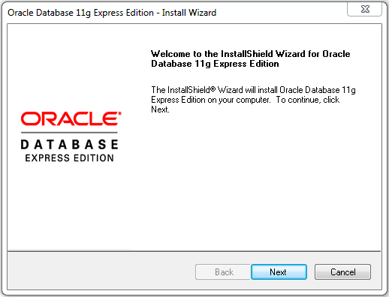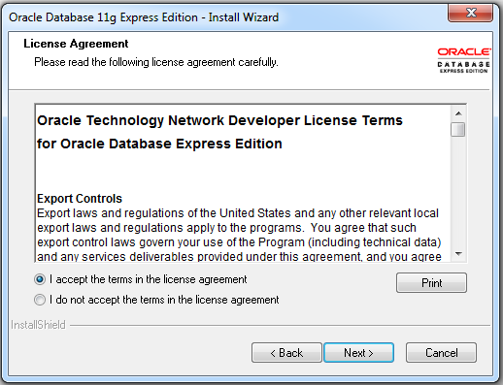

1. Select your preferred install location. If the selected folder does not exist, it will be created. Once done, click “Next”. The next screen will ask you to enter the password which will be your database SYS and SYSTEM passwords. Select something secure, but easy for you to remember. Click “Next” when done.

***\*\*\*\*DO NOT FORGET IT, OR YOU WILL NOT BE ABLE TO ACCESS YOUR DATABASE\*\*\*\****

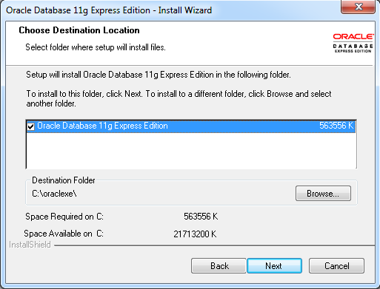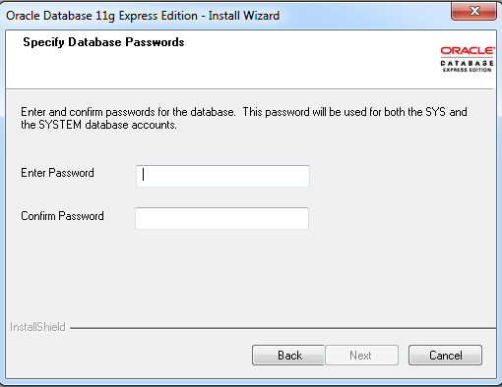

1. The next screen will show you the installation settings for verification, including the port numbers to connect to your database server remotely. These settings are already installed into the Trigger-Lock software, but you may want to write them down for future use. Once completed, click “Install”. Installation may take several minutes to complete. Once completed, click “Finish”.
2. The database automatically will start each time the PC boots, but if you need to manually start or stop, shortcuts in start menu.

# Open SQL Command Line.

1. Before you can connect to the database from the Trigger-Lock software, the database script needs to be loaded. After the Oracle install is completed, there should be a shortcut on your desktop and/or your start menu for “Run SQL Command Line”.

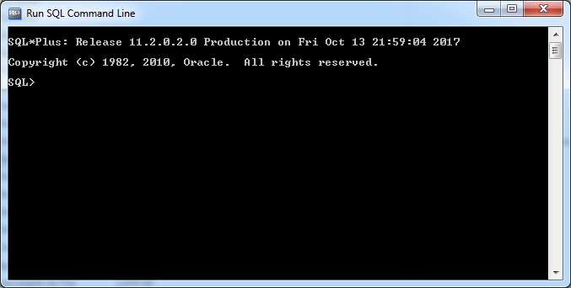

1. Connect as the SYSTEM username (created during the installation) by entering “CONNECT SYSTEM/password” at the SQL> prompt, replacing password with your SYS/SYSTEM password you created earlier, and hit enter. If successful, the next line will say “Connected”, and will return to the SQL> prompt.
2. Now that we are connected, you can create your system administrator login, or SYSADMIN. At the SQL> prompt, type “CREATE USER SYSADMIN IDENTIFIED BY password;” again replacing password with your choice of password. You may use the same password as you did previously, if you choose, although it is recommended to be a new unique password. Hit enter when completed, but do not forget the semicolon at the end of the command. If successful, you will get a “User Created” response, and then return to the SQL prompt.
3. Next, we will give the sysadmin login the database rights it requires. At the SQL prompt, type “GRANT DBA TO SYSADMIN WITH ADMIN OPTION;” again not forgetting the semicolon. You should get a “Grant succeeded” reply, and return to the SQL prompt. This command grants the database administrator role to the sysadmin login. Leave the SQL Command Line window open, as we will need it for our next steps.

**NOTE: The SYS or SYSTEM login will not be used in the software, but will be used for back-end database login, and loading updated scripts. The SYSADMIN login will be used for the front-end administrator login (in the Trigger-Lock software itself). Your SYS/SYSTEM login will not work within the Trigger-Lock front-end software.**

# Run the Start Script to load database

At the SQL prompt, type “@path”, where “path” is the path of the startScript.sql file included in the Installation files (example: “@D:\startScript.sql”). You will see a list of responses showing the creation of the database schema.

Congratulations! You have now successfully installed the database for your Trigger-Lock software.

# Installing Java Runtime Environment

The Trigger-Lock software requires an updated installation of Java Runtime Environment (JRE). Most computers will already have this installed, but if yours does not, it will need to be installed before you will be able to execute this software.

1. Visit the [Java Download Site](http://www.oracle.com/technetwork/java/javase/downloads/jre8-downloads-2133155.html) and find the latest version of Java Runtime Environment for your appropriate operating system. You will need to check the bubble to accept licensing agreement before you can click the download link. Once it is downloaded, run the installation program.
2. You may select a destination folder, or keep the default folder by clicking “Install”. Once installation is completed, click “Close” to finish.

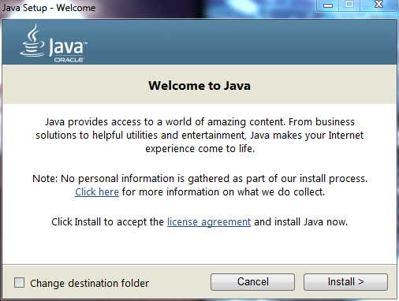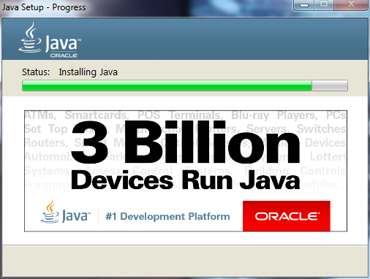

You are now ready to run the Trigger-Lock Software.

# Changelog and Installing v1.0 Updates

To install the software updates:

1. Connect as the SYSTEM username (created during the installation) by entering “CONNECT SYSTEM/password” at the SQL> prompt, replacing password with your SYS/SYSTEM password you created earlier, and hit enter. If successful, the next line will say “Connected”, and will return to the SQL> prompt.
2. At the SQL prompt, type “@path”, where “path” is the path of the updateScript1.0.sql file included in the updated Installation files (example: “@D:\ updateScript1.0.sql”). You will see a list of responses showing the creation of the database schema.
3. Repeat step 2 to run database script data.sql to load the test data.
4. Copy the executable JAR file Trigger-Lock v1.0.jar and replace the original executable JAR file, Trigger-Lock v0.3a.jar. The new file contains all the newly implemented features.

v1.0 Changelog

* Database
  + Updated guns.caliber and ammo.caliber fields to varchar2(16) (from 10).
  + Corrected retail and manager rights to sequences
  + Altered caliber, location, manufacturer, and model in guns to Not Null
* Application Features
  + Added List, Add, Edit, and Delete ammo
  + Added List, Add, Edit, and Delete guns
  + Added ‘return guns from range or cleaning’ which moved location to either cleaning, or lockup.
  + Added range visit transactions, which allow:
    - Cashing out transaction
    - Rental of firearms
    - Purchase of ammo
    - Purchase of targets
    - Both beginning or renewing range memberships
* Bug Fixes
  + Fixed states so they were not showing incorrect value
  + Corrected rights to sequences for the non-DBA user roles