Trigger-Lock Range Management Software

## **User’s Manual for Ver 1.0, increment period 6**

### Written by Christian Lundblad

Table Of Contents

3 **Logging into the Software**

4-5 **Manage Users:**

* *Adding, Removing, Listing Users*
* *Updating User Accounts and Roles*

6-8 **Customer Menu**

* *Adding New Customers*
* *Search Through Existing*
* *Deleting Existing*
* *Edit Existing*

8-10 **Adding a Range Visit**

10-11 **Guns Menu**

* *Adding New Guns*
* *List Guns*
* *Edit Existing Gun*
* *Delete a Gun*
* *Return Gun from Range or Cleaning*

12 **Ammo Menu**

* *Adding New Ammo*
* *List Ammo*
* *Edit Existing Ammo*
* *Delete Ammo*

13 **Manage Menu**

* *Add, List, Edit, or Delete Calibers*
* *Add, List, Edit, or Delete Manufacturers*

14 **Reports Menu**

* *Service Contacts Report*

14 **Help Menu**

15 **System Requirements & Technical Details**

After installation is completed, to run the program, double-click on the included JAR file. Initially, the only software user created will be SYSADMIN, which was created during the installation process (see “Installation Document”).

# Logging in

Once executed, the main program window will load. Initially, the File menu has options for Login, and Exit. All other options are disabled, or hidden, until your login is successful. Enter your username and password in the required fields (password is case sensitive) and hit “Submit”. If you get an error, please double check your credentials, or see your system admin to reset your password. Please be aware that both the username and the password will be case sensitive.

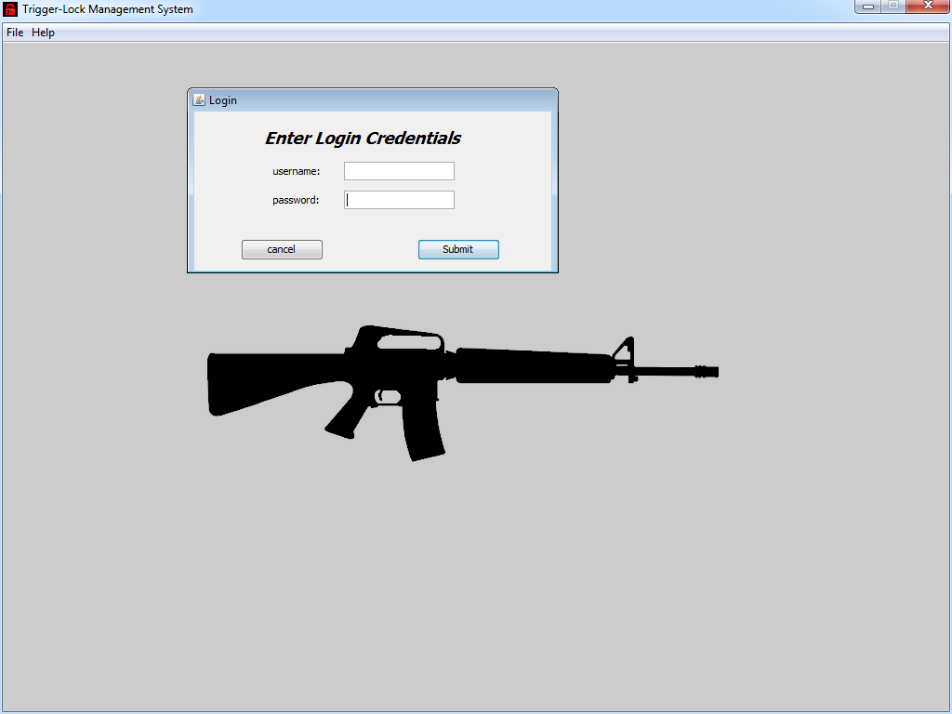

# Managing User Accounts

If you are logged in with a DBA or Owner role, you will have access to the Manage Users menu. This will allow the creation and removal of user accounts, as well as listing existing accounts, and updating the user role. Preset user roles are as follows:

* 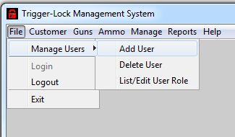Both the DBA and Owner role accounts have full access to all database tables, and user accounts. The default Sysadmin has DBA role assigned.
* Manager role accounts do not have access to manager users, or the “Manage” menu for managing caliber and manufacturer list. Other than that, they have full access.
* Retail role accounts do not have access beyond the File menu (for login and logout) and the Customer menu. They can add, remove, and update customer records, as well as add range visits.

# Adding New Users

To add a new user account:

1. Login to the software with either DBA or Owner rights.
2. Click the File -> Manage Users ->Add User menu.
3. Enter the new username, and the new password.
4. Hit “create” and you will get a confirmation that the new user was created, or an error if it was not.
5. If you do receive an error, check common failure reasons:
   1. ensure the username does not already exist
   2. the username cannot be the same as one of the role names (DBA, Owner, Manager, Retail).

# Deleting Users

To delete an existing user account:

1. 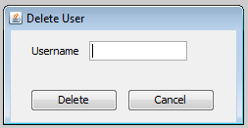Login to the software with either DBA or Owner rights.
2. Click the File -> Manage Users ->Delete User menu (shown above).
3. Enter the new username, and hit “delete”.
4. You will get a confirmation that the user was deleted, or an error if it was not.

# Listing and Updating User Roles

To view all current user accounts, and roles (excluding your own):

1. Login to the software with either DBA or Owner rights.
2. Click the File->Manage Users->List/Edit User Role User menu (shown right).
3. The list will populate in a table in a new window.

# Updating User Roles

1. 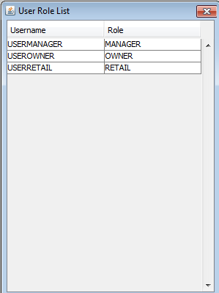Once the table of current users is loaded, you may select any row, and right click to select “edit selected” to access the Edit User Role window, seen below. Once a new role is selected, click “Save Changes” to apply the new role to the user.

# 

# Adding Customers

All database roles have the rights to add new customer records. The new customer records will then be available immediately throughout the system. To add a new customer record:

1. Once logged in to the system, click the Customer menu on the upper right side of the window, and select Add Customer.
2. The Add Customer window will load, giving you access to fill out the Add Customer form. The only fields that are required are First name and Last name. All other fields are optional, however, both the email field, zip code field, and phone number fields will only accept valid entries, if not left blank.
3. First and Last name fields are alphanumeric character Strings, maximum length of 12 characters. Both are required.
4. Email field is 30 character limit, alphanumberic, and must validate as the proper format for an email address.
5. Address and City are both alphanumeric strings, both 30 characters maximum. Neither is required, nor are they specific to a format.
6. State has a drop-box which includes all 50 US states. Currently, we are not supporting addresses outside of the continental United States.
7. Both zip code and phone number are optional, but if entered, each has specific require format.
   1. Zip code must be numeric only, and has a limit of 5 characters.
   2. Phone number has a limit of 12 character, but only requires 10 digital to be valid. You can use dashes or spaces optionally, i.e. 555-555-5555.
8. The check box is to be used if the customer is signing up for a new range membership. Once checked, the customer will have a set range membership expiration of 1 year from the date entered.
9. Once all required fields are entered, click Submit to create the customer record. You will be notified if successful.
10. 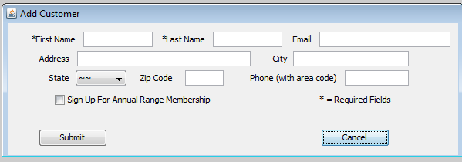If unsuccessful, you will an error stating as such.

# Searching for Customers

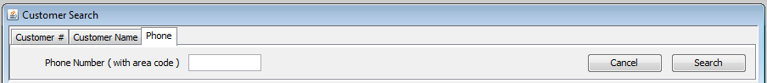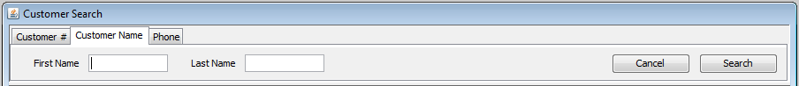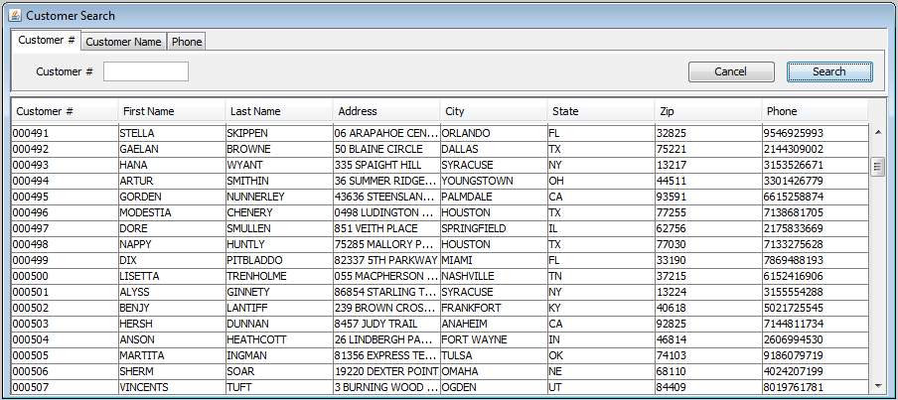Another item in the Customer menu is the Customer Search. This feature allows us to load a list of customers based on one of three search options: Customer Number, Customer Name, and Customer Phone Number.

1. Customer Number Search:
   1. The search string can either be blank, or a 6-digit number entry.
   2. Leading 0s are allow if provided.
   3. If the field is left blank a wildcard search will be completed, which will show all current customer records.
2. Customer Name Search:
3. The search string can be blank, a full first and last name, or a partial name.
4. Each name field can be up to 12 characters.
5. If the field(s) are left blank, a wildcard search will be completed, which will show all current customer records.
6. Customer Phone Number Search:
   1. Customer may enter their full 10-digit phone number, with area code. No partial fields will be accepted.
7. Once you have the desired search string, hit search and you be shown the results page below. If you click cancel, your results will be cleared.

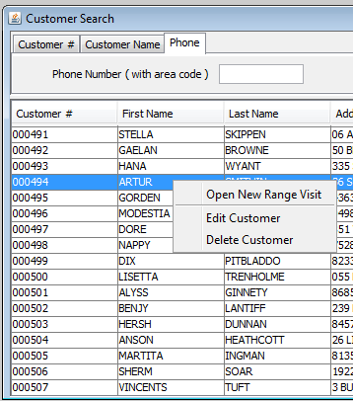Once a record is selected, a right click will bring up a contact menu with 3 choices.

# Editing Customers

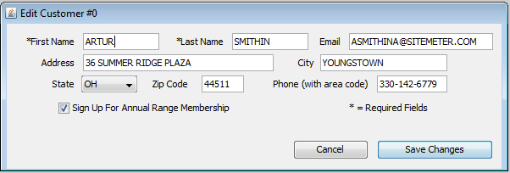When selected, this option will open the edit customer window for the selected customer. All fields remain the same restrictions as the initial add customer screen, and there is an option to cancel, or to save changes you have made. The saved changes are committed to the database immediately.

# Deleting Customers

Once the search results are loaded, the user can click the row of their choosing to highlight it, and that will allow access to the right-click context menu**. If you choose to delete a customer record, it cannot be reversed.**

# Adding a Range Visit

The add range visit feature is the basic transaction that will be performed primarily by the retail and manager role users. It is broken down into the following:

* The customer number will be auto-populated to the top of the window.
* The Range Fee field will display $15.00 if the customer is not a range member, or $0.00 if the customer is a range member, as members do not pay range fees per visit. If a customer decides to purchase a new membership, the range fee will be changed to the member price.

# Adding a Range Visit (continued)

* The Rental Fee checkbox is to be used is a customer wishes to utilize one of the range’s rental guns. Upon checking the box, a $10.00 change will be added to the window, and a new window will open to allow a choice of firearms from the current stock.
  1. Once the first field is used to select a manufacturer, it will populate the second field with calibers, and then so forth will that selection populate the models, and then the serial numbers.
  2. Once a valid selection is made in all 4 boxes, the “Confirm” button will be enabled, and allow completion of the gun selection process.
  3. If cancel is clicked, it will return to the New Range Visit window, and remove the $10.00 rental charge, since no selection was made.
* The Ammo checkbox is to be used if the customer wishes to purchase any range ammo. All ammo purchases are made in 10 round increments. Upon clicking the checkbox, a new window will open to select type and quantity of ammunition.
  1. 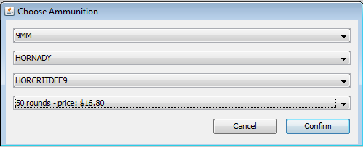The first box will populate with all current calibers that are stocked for ammo, followed then by manufacturers, model number, and finally quantity selection from current stock. The price for the number of rounds is displayed to the right of the quantity selection.
  2. Once a valid selection is made in all 4 boxes, the “Confirm” button will be enabled, and allow completion of the ammo selection process.
  3. If cancel is clicked, it will return to the New Range Visit window, and remove the checkmark, since no selection of ammo was made.
  4. If confirm is clicked, the price of the chosen ammo will be added to the New Range Visit window, and order total will update.
* Once back at the New Range Visit window, the next option is number of targets the customer wishes to purchase. Each target is $0.25 each, and the selected quantity will be updated to the order total.
* If the customer is not a member, the membership checkbox will allow them to start an annual range membership. This will void out any range fee, and add a membership fee of $200.00 to the total. The membership will be good for one year form the date it is started, and can be renewed at any time during that membership for a 20% discount of normal membership price, $160.00. If customer is already a member, the option will instead be to renew their membership for the discounted $160.00 membership fee.

# Adding a Range Visit (continued)

* Once all selections are made, the order total will be shown, including 7% sales tax. **Note: all options are optional, and if a range member wanted to visit the range, and opted out of any other choices, the transaction total would be $0.00. You would still complete the transaction normally, as it records the range visit.** Once the “Complete Purchase” button is clicked, the order total will again be provided, so proper payment can be made. If the customer has rented a gun, there will be a notification showing that gun is checked out. The window will clear once the transaction is finalized.

# Guns Menu

The next menu we will discuss is the Guns menu. The menu contains options for:

* Adding a new gun
* Editing or deleting an existing gun
* Returning a gun from the range or cleaning

This menu is restricted from retail employees, so those without manager rights or above will be unable to access it.

# Adding a new Gun

To add a new gun to the database, click the Guns menu, and click “Add New”. The Add Gun window will load (shown right).

1. All fields will be required to add a gun record. They are as follows:
   1. Serial number – this alphanumeric field is a maximum of 20 characters.
   2. Model – this alphanumeric field is a maximum of 30 characters.
   3. Caliber – the caliber is selected from a list of pre-entered calibers. If the caliber of the gun you are trying to add is not listed, see your owner or database administrator to have it added (see later section on adding new calibers).
   4. Manufacturer - the manufacturer is selected from a list of pre-entered manufacturers. If the manufacturer of the gun you are trying to add is not listed, see your owner or database administrator to have it added (see later section on adding new manufacturers).
2. Once all entries are made, click submit to add the gun record to the database. The initial location will always be set to “LOCKUP”.

# Editing/Deleting a Gun

The Edit/Delete option in the Guns menu will load the Guns List, showing info on all the guns currently in the database. Serial, Manufacturer, Model Number, and Caliber will have been populated by the Add Gun option, but Location and Last Visit Used will be dependent on the use history of the firearm. Locations of “RANGE-######” indicate that the weapon is currently in use by another customer on the range.

1. 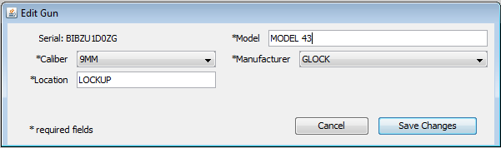To edit a gun record, select a gun from the list, and right click to show the edit and delete options. Editing a gun is similar to editing a customer, as both changes are applied to the database immediately.
2. The field restrictions are the same as the Add Gun window, requiring all entries. The serial number is not editable, so if it is incorrect, delete the record and re-enter correctly.
3. To delete a gun record, right clock the selected list item, and click delete. You will be given a confirmation option, as this cannot be undone. Ensure the serial number selected matches, and confirm the delete action.

# Returning a Gun from Range/Cleaning

To track weapons for accountability, the location is updated as it changes. As a customer finishes a range visit, and returns any rental weapons, the location is changed to cleaning, and then back to Lockup.

To return a gun from the range to cleaning:

* Enter the serial number of the firearm, select “return from range”, and click “return”. You will get a confirmation message showing the location has transferred successfully.

To return a gun from cleaning to lockup:

* Enter the serial number of the firearm, select “return from cleaning”, and click “return”. You will get a confirmation message showing the location has transferred successfully.

# Ammo Menu

The ammo menu, available to manager roles and above, allow adding new ammo, or editing and deleting previously entered ammo records.

1. To add new ammo, click the Add New option in the Ammo menu, and the Add Ammo window will open:
   1. 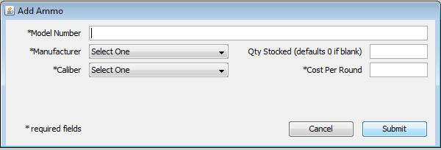Model Number, Manufacturer, Caliber, and Cost per Round fields are required, although Qty Stocked can be entered, or left blank to default to 0.
   2. Model Number - can be 30 alphanumeric characters.
   3. Manufacturer - the manufacturer is selected from a list of pre-entered manufacturers. If the manufacturer of the ammo you are trying to add is not listed, see your owner or database administrator to have it added (see later section on adding new manufacturers).
   4. Caliber - the Caliber is selected from a list of pre-entered Calibers. If the Caliber of the ammo you are trying to add is not listed, see your owner or database administrator to have it added (see later section on adding new Calibers).
   5. Qty Stocked – This numeric entry can be up to 6 digits, but defaults to 0 if left blank.
   6. Cost per Round – This decimal entry can be up to 5 digits, including the period. It cannot be left blank.
   7. Once all entries are valid, click submit to add the new ammo record.
2. To edit or delete existing ammo records, click the Edit/Delete option in the Ammo menu. This will list all currently added ammo options:
   1. 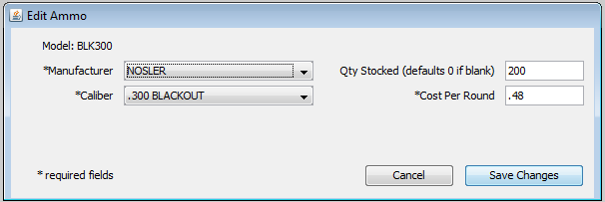To edit, select a record and right click and click Edit Selected.
   2. The Edit Ammo window will load, and contains the same options as the Add Ammon window, with the same restrictions. Once satisfied with changes, click “Save Changes” to apply, or “Cancel” to cancel. You will get a confirmation that changes are saved.
   3. To delete an Ammo record, right click and select Deleted Selected. You will be given a confirmation window, as these changes cannot be reversed.

# Manage Menu

The manage menu has options for the Caliber list, and the Manufacturer list. Both of those options have two selections, ether to add or edit/delete.

1. To add a new caliber:
   1. Click Manage menu, Caliber List, and Add.
   2. Once the Add Caliber window opens, enter the new caliber, and click “Submit”.
   3. 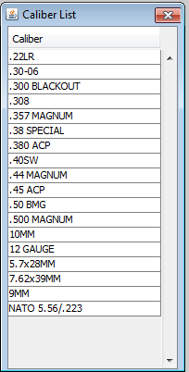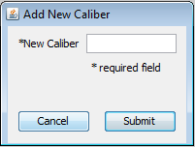The caliber will have a limit of 16 alphanumeric characters, so abbreviate as needed (ex: Mag for Magnum, ACP for Automatic Colt Pistol).
2. To Delete an existing caliber:
   1. **Before you can delete a caliber, all guns and ammo of that caliber must be removed from the system, otherwise the delete operation will fail.**
   2. 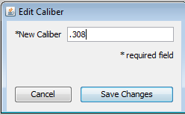If nothing is tied to the caliber, click Manage menu, Caliber List, and Edit/Delete to load the Caliber List.
   3. Select the caliber you wish to remove, and right click to select “Delete Selected”. This cannot be reversed, so you will be warned before confirming delete action.
3. To Edit an existing caliber:
   1. Click Manage menu, Caliber List, and Edit/Delete to load the Caliber List.
   2. Select the caliber you wish to remove, and right click to select “Edit Selected”.
   3. The Edit Caliber window will load. It has the same restrictions at the add caliber window. Save Changes once done.
4. To add a new Manufacturer:
   1. Click Manage menu, Manufacturer List, and Add.
   2. Once the Add Manufacturer window opens, enter the new Manufacturer information, and click “Submit”.
      1. Company Name – restricted to 20 alphanumeric characters, and is the only required field.
      2. Address – restricted to 30 alphanumeric characters.
      3. City - restricted to 30 alphanumeric characters.
      4. State – select a US state from the drop-down list.
      5. Zip code – restricted to 5 numerical characters.
      6. 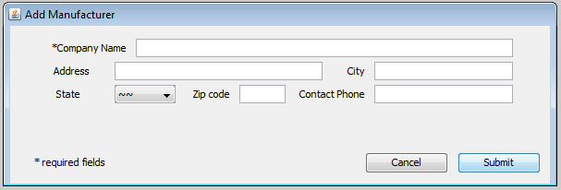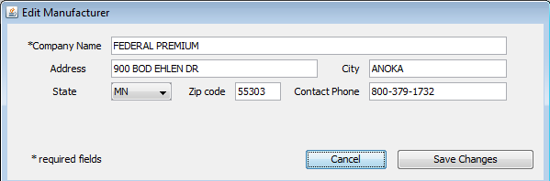Contact Phone – restricted to 10 numerical digits, with optional spaces or dashes.

# Manage Menu (continued)

To Delete an existing Manufacturer:

* 1. **Before you can delete a** Manufacturer**, all guns and ammo of that** Manufacturer **must be removed from the system, otherwise the delete operation will fail.**
  2. If nothing is tied to the Manufacturer, click Manage menu, Manufacturer List, and Edit/Delete to load the Caliber List.
  3. Select the Manufacturer you wish to remove, and right click to select “Delete Selected”. This cannot be reversed, so you will be warned before confirming delete action.

1. To Edit an existing Manufacturer:
   1. Click Manage menu, Manufacturer List, and Edit/Delete to load the Manufacturer List.
   2. Select the Manufacturer you wish to remove, and right click to select “Edit Selected”.
   3. The Edit Manufacturer window will load. It has the same restrictions at the add Manufacturer window. Save Changes once done.

# Reports Menu

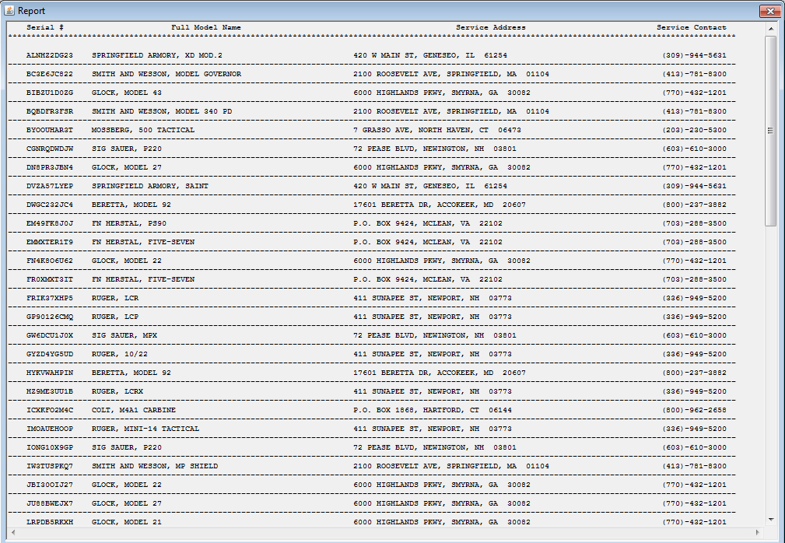Manager roles and above have access to the Reports Menu. Currently, the only report is the Service Contacts report. This report lists all current guns, along with their manufacturer addresses and phone numbers, for when the weapons need servicing from the OEM for warranty work, recalls, and custom repairs.

1. To access the report, click the Reports Menu, and select “Service Contacts”.
2. The report will populate in a new window. If you need to print the data, select all the included text in the window, and use ctrl-C to copy it to your clipboard. You can then paste it into a new text file, or word processor file for printing and/or saving. (a print feature within the program will be released in a future update).

# Help Menu

The help menu currently has one option, “About”. This currently displays some basic information about the creator of this software.

# System Requirements & Technical Details

This program is written in Java for use in a Microsoft Windows environment. It is recommended to use Windows 7, or later. The software also requires that the Java Runtime Environment is up to date, which is included in the installation instructions.

The Database the software runs on is using Oracle 11g, and will be managed by your Database administrator. It is recommended that they perform backups of the database weekly to minimize loss of data and records in an emergency.

For additional technical concerns, please see your system administrator.