Functional Requirements Document

Version | Description of Change | Author | Date
1.0 | Basic | Reddy | 12/05/2018

CONTENTS
1 INTRODUCTION 3
2 FUNCTIONAL REQUIREMENTS 3
Admin - user who sits in theater 3
Data Flow Diagrams 6
Logical Data Model/Data Dictionary 7
Functional Requirements 7
5 OTHER REQUIREMENTS 7
Interface Requirements 7
Data Conversion Requirements 8
Hardware/Software Requirements 8
Operational Requirements 8
APPENDIX A - GLOSSARY 12

INTRODUCTION
Block Ticket - Build a website to book movie tickets

FUNCTIONAL REQUIREMENTS

Total pages
  - login page
  - Home page
  - Movie selection page
  - Seat selection
  - Order summary page
  - Payment page

Admin - user who sits in theater
- Login page
Every time user logins we should get his system IP address and that need to compared with stored IP address along with username and password which are stored in Database. after validation inputs, user should get an access.

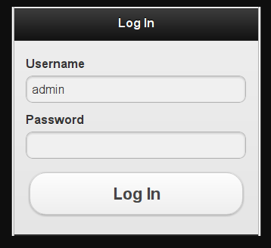

- Home page
This page is basically a greeting page and may be later we may implement previous day report details along with greeting. This page should fetch particular theater's screens and movie details.
after selecting movie, the page should get redirect to next page i.e., seat selection page
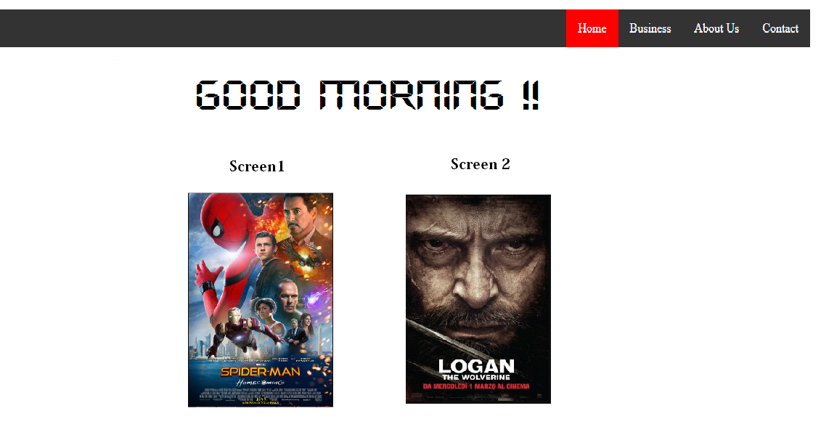
- Seat selection page
This page should fetch selected movie's details like show time, available seats. Seats are check boxes and they shud get populated dynamically from DB.
Like if A row has 10 seats in DB for particular theater, 10 check boxes shud appear in the seat selection page against A row.
This will reduce the designing and hard coding of WebPages for each and every theater.

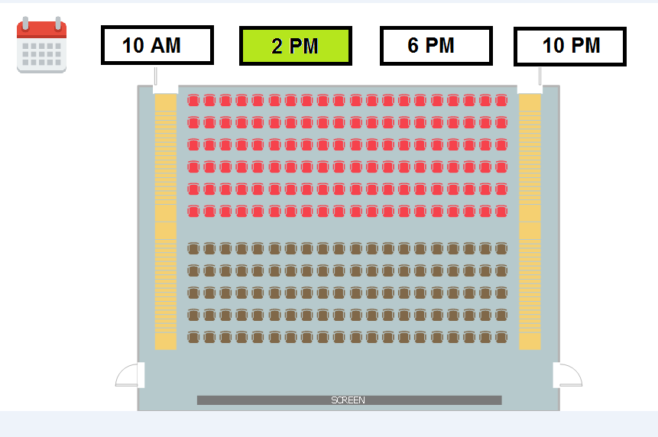
By default seat shud populate current day's first show i.e., 10 AM details
user can select day by clicking on calendar icon, then he has to select show time then only seat shud show. I mean after date selection, time selection only seats shud gets loaded into the page.

on click of Calendar icon shud be like below. Calendar shud have today + next 4 days
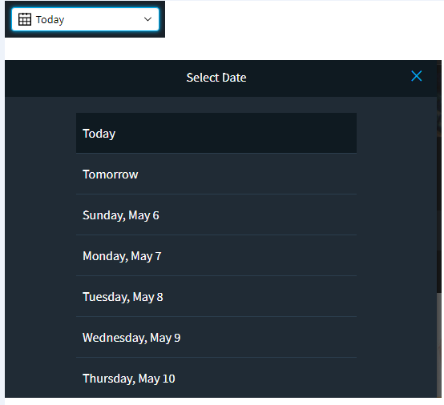
.
after selecting seats, page shud get redirected to Order summary page. (user can select any number of seats at seat selection page as there is no pop asking how many members are going like in BookMyShow).

- Order summary page.

This page shud fetch details from seat selectio page. details like Movie name, show time, number of seats, seating order (row name) and grand total.
we shud have two text boxes to get phone number from customer to which we will be sending the ticket. we will not print the Ticket
we have two text boxes. after first check box is to send ticket to user. if first time sending fails, we will use second check box (taking precaution that customer shouldn't get missed the ticket. after confirmation from customer only admin need to click on the click out button point to remember while giving presentation)
on clicking check out button, page shud get directed to Home page

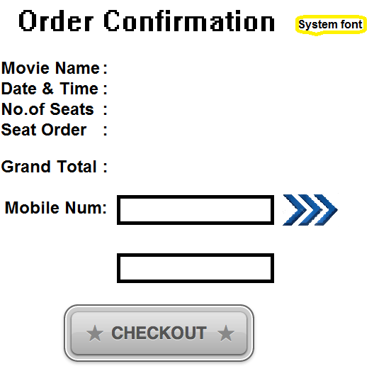

Data Flow Diagrams
[Decompose the context level diagrams to determine the functional requirements. Data flow diagrams should be decomposed down to the functional primitive level. These diagrams are further decomposed during design.]

Logical Data Model/Data Dictionary
[Create the initial Logical Data Model. Describe data requirements by providing data entities, decomposition, and definitions in a data dictionary. The data requirements describe the business data needed by the application system. Data requirements do not describe the physical database and are not at the level of identifying field names.]

Functional Requirements
[List the functional requirements of the system.]

Functional Requirements Group 1
[List the functional requirements for each functional requirements group.]
Exhibit 4 - Sample Requirements Group 1
Section/ Requirement ID | Requirement Definition
FR1.0. | The system shall [parent requirement group 1].
FR1.1 | The system shall [child/parent requirement].
FR1.1.1 | The system shall [child requirement].
FR1.1.2 | The system shall [child requirement].

Functional Requirements Group 2, Etc.

OTHER REQUIREMENTS
[Describe the non-behavioral requirements.]

Interface Requirements
[Describe the user interfaces that are to be implemented by the system.]

Hardware Interfaces
[Define hardware interfaces supported by the system, including logical structure, physical addresses, and expected behavior.]

Software Interfaces
[Name the applications with which the subject application must interface. State the following for each such application: name of application, external owner of application, interface details (only if determined by the other application).
It is acceptable to reference an interface control document for details of the interface interactions.]

Communications Interfaces
[Describe communications interfaces to other systems or devices, such as local area networks.]

Data Conversion Requirements
[Describe the requirements needed for conversion of legacy data into the system.]

Hardware/Software Requirements
[Provide a description of the hardware and software platforms needed to support the system.]

Operational Requirements
[Provide the operational requirements in this section.
Do not state how these requirements will be satisfied. For example, in the Reliability section, answer the question, “How reliable must the system be”? Do not state what steps will be taken to provide reliability.
Distinguish preferences from requirements. Requirements are based on business needs, preferences are not. If, for example, the user requires a special response but does not have a business-related reason for it, that requirement is a preference.
Other applicable requirements on system attributes may be added to the list of subsections below.]
Operational requirements describe how the system will run and communicate with operations personnel.

Security and Privacy
[Provide a list of the security requirements using the following criteria:
A. State the consequences of the following breaches of security in the subject application:
- Loss or corruption of data
- Disclosure of secrets or sensitive information
- Disclosure of privileged/privacy information about individuals
- Corruption of software or introduction of malware, such as viruses
- State the type(s) of security required. Include the need for the following as appropriate:
- Physical security.
- Access by user role or types.
- State access control requirements by data attribute. For example, one group of users has permission to view an attribute but not update it while another group of users has permissions to update or view it.
- State access requirements based on system function. For example, if there is a need to grant access to certain system functions to one group of users, but not to another. For example, "The system shall make Function X available to the System Administrator only".
- State if there is a need for certification and accreditation of the security measures adopted for this application]
The Security Section describes the need to control access to the data. This includes controlling who may view and alter application data.

Audit Trail
[List the activities recorded in the application’s audit trail. For each activity, list the data recorded.]

Reliability
A. [State the following in this section:
- State the damage can result from failure of this system—indicate the criticality of the software, such as:
- Loss of human life
- Complete or partial loss of the ability to perform a mission-critical function
- Loss of revenue
- Loss of employee productivity
- What is the minimum acceptable level of reliability?
B. State required reliability:
- Mean-Time-Between-Failure is the number of time units the system is operable before the first failure occurs.
- Mean-Time-To-Failure is the number of time units before the system is operable divided by the number of failures during the time period.
- Mean-Time-To-Repair is the number of time units required to perform system repair divided by the number of repairs during the time period.]
Reliability is the probability that the system processes work correctly and completely without being aborted.

Recoverability
[Answer the following questions in this section:
A. In the event the application is unavailable to users (down) because of a system failure, how soon after the failure is detected must function be restored?
B. In the event the database is corrupted, to what level of currency must it be restored? For example “The database must be capable of being restored to its condition of no more than 1 hour before the corruption occurred”.
C. If the processing site (hardware, data, and onsite backup) is destroyed, how soon must the application be able to be restored?]
Recoverability is the ability to restore function and data in the event of a failure.

System Availability
[State the period during which the application must be available to users. For example, “The application must be available to users Monday through Friday between the hours of 6:30 a.m. and 5:30 p.m. EST. If the application must be available to users in more than one time zone, state the earliest start time and the latest stop time. Consider daylight savings time, too.
Include use peak times. These are times when system unavailability is least acceptable.]
System availability is the time when the application must be available for use. Required system availability is used in determining when maintenance may be performed.

General Performance
[Describe the requirements for the following:
A. Response time for queries and updates
B. Throughput
C. Expected rate of user activity (for example, number of transactions per hour, day, or month, or cyclical periods)
Specific performance requirements, related to a specific functional requirement, should be listed with that functional requirement.

Capacity
[List the required capacities and expected volumes of data in business terms. Do not state capacities in terms of system memory requirements or disk space—if growth trends or projections are available, provide them]

Data Retention
[Describe the length of time various forms of data must be retained and the requirements for its destruction.
For example, “The system shall retain application information for 3 years”. Different forms of data include: system documentation, audit records, database records, access records.]

Error Handling
[Describe system error handling.]

Validation Rules
[Describe System Validation Rules.]

Conventions/Standards
[Describe system conventions and standards followed.
For example: Microsoft standards are followed for windows, Institute of Electrical and Electronics Engineers (IEEE) for data formats, etc.]

APPENDIX A - GLOSSARY
[Define terms, acronyms, and abbreviations used in the FRD.]

