Automating Bathtub model to identify SLR and potential landcover loss on different scenarios
Bijoy Mitra¹
¹ Department of Geography & the Environment, College of Natural Sciences and Mathematics, University of Denver, Denver, CO 80208, USA
1. Problem Definition and Motivation
Sea level rise is a direct consequence of climate change. Coastal communities face growing risks from permanent inundation and loss of productive land. Understanding exactly how much agricultural land, urban area, or natural habitat will be lost under a specific climate scenario is critical for planning and policy decisions.
Traditional flood mapping methods are often expensive or slow. This toolbox addresses that gap. It is built for ArcGIS Pro users who need to model inundation extent and land cover loss across multiple sea level rise scenarios. By combining elevation thresholds with classified land cover data, the tool translates sea level projections into concrete spatial estimates. It supports any IPCC SSP scenario and works across different geographic regions with appropriate input data.
2. Design Overview
2.1 Overall Workflow
The tool runs a linear, automated pipeline from raster inputs to polygon outputs and a summary CSV. The user provides a DEM, a classified LULC raster, sea level heights by year, and a scenario label. The tool loops through each year-height pair and runs the same sequence each time. It identifies vulnerable pixels, isolates them through reclassification, converts them to a dissolved flood polygon, then masks the LULC raster to calculate land cover loss per class.
2.2 Major Functions
The script has one core custom function and a main processing loop. raster_to_dissolved_area converts an inundation raster into a final polygon. It dissolves pixel-level boundaries into a single continuous feature and calculates geodesic area in square kilometers. This function runs twice per time step, once for flood extent and once for the LULC-masked output.
The main processing loop runs the raster calculator, reclassifies the result, calls the dissolve function for both flood and LULC outputs, and appends results to a running list. After all time steps complete, results are pivoted by year and land cover class and exported as a CSV.
2.3 Key Design Decisions
Sea level heights and LULC class names are user-defined value tables rather than hardcoded values. This keeps the tool flexible across different study areas and scenarios. Output files are named using height, year, and scenario label to prevent overwriting across runs. Geodesic area calculation is used for accuracy across different coordinate systems. The bathtub model was chosen for its simplicity and broad applicability in data-sparse regions.
Parameter | Description
Workspace | Root folder for all outputs
Output Folders | InundatedRaster, InundatedPolygon, FinalInundatedPolygon
DEM Raster | Elevation input for the study area
LULC Raster | Classified land cover input
Scenario Label | SSP scenario name for file labeling
Year-Height Table | Projected sea level heights by year
LULC Class Names | Code-to-name mapping for land cover classes
Output CSV Path | File path for the final results table

3. Toolbox Overview:
This toolbox models sea level rise and estimates land cover loss in ArcGIS Pro. It uses a Digital Elevation Model (DEM) and a classified Land Use and Land Cover (LULC) raster.
Step 1: Set Up Your Workspace
The first parameter asks for your workspace folder path. This is the root directory where all outputs will be stored. Type the full path, for example: Z:\Projects\SLR_Analysis. The folder must already exist on your machine. The tool will not create the workspace itself, but it will build subfolders inside it automatically. Make sure you have read and write permissions for this location.

Step 2: Define Your Output Folder Paths
The next three parameters set names for three subfolders. These are InundatedRaster, InundatedPolygon, and FinalInundatedPolygon. You can keep those default names or enter custom ones. Each folder serves a specific purpose. InundatedRaster stores all intermediate and reclassified raster outputs. InundatedPolygon holds the raw polygon conversions before dissolving. FinalInundatedPolygon contains the final dissolved flood polygons with area calculations. If these folders do not exist, the tool creates them automatically.
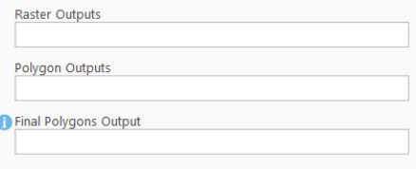
Step 3: Load Your Raster Inputs
The tool needs two raster datasets as inputs. The first is your DEM, which represents ground elevation across your study area. It should be clipped to your region of interest before loading. The second is your LULC raster, a classified land cover dataset. Common land cover classes include water, vegetation, barren land, and built-up areas. The pixel values in the LULC raster must be integers representing each class. Both rasters must overlap spatially. The tool reads the LULC raster's spatial reference and applies it to all outputs, so ensure it carries a valid projection.
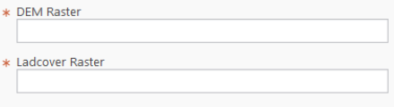
Step 4: Choose Your Climate Scenario
Enter the name of your SSP scenario as a short text label. This label appears in all output file names to keep results organized. For example, type ssp126 for the low-emission scenario or ssp585 for the high-emission one. The tool does not automatically pull sea level values from any database. You manually supply the heights in the next step. This field is purely a labeling tool, but consistent naming across runs makes comparison easier later.
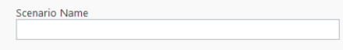
Step 5: Enter Sea Level Heights and Years
This is one of the most important parameters. It accepts a table of year and height pairs representing your sea level rise projections. Each height value must be in the same unit as your DEM. If your DEM is in centimeters, enter heights in centimeters. If it is in meters, use meters. Format each pair as year height and separate multiple pairs with semicolons. For example: 2030 91;2040 189;2050 340;2100 1023. The tool loops through every pair and runs a complete analysis for each time step. You can include as many time steps as needed. Using more time steps gives a finer picture of gradual inundation over time.
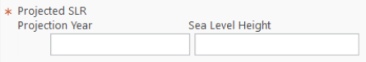
Step 6: Enter LULC Class Names
This parameter maps your LULC pixel values to readable class names. Format each entry as code name and separate them with semicolons. For example: 1 Water Body; 2 Vegetation; 3 Barren; 4 Built-up. The numeric codes must exactly match the pixel values in your LULC raster. If a code in the raster has no matching entry here, the tool will label it as "Unknown" in the output. Double-check these codes against your LULC classification table before running the tool. Incorrect codes will result in misclassified or missing entries in the final CSV.
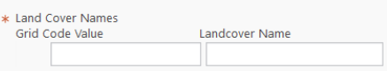
Step 7: Set the Output CSV Path
Enter the path for your output CSV, including the filename and .csv extension. For example: SLR_Output.csv. The tool saves a pivot table to this location after all time steps are processed. The table shows area loss in square kilometers for each land cover class across every year. Make sure the destination folder exists before running the tool. The tool will not create missing folders along the output CSV path.
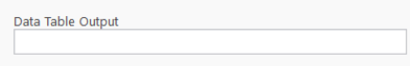
3.8 Understanding the Output Files
Each output file is named using the sea level height, year, and scenario label. For example, a flood polygon for 2050 under SSP5-8.5 at 340 cm would be named Final_Inundation_340_2050_ssp585.shp. This naming convention makes it easy to identify and compare outputs across runs. The final CSV contains one row per land cover class per year. Columns include Year, Scenario, Height, LULC class name, and Area in square kilometers.
4. Conclusion and Future Work
This toolbox automates coastal inundation modeling and land cover loss estimation in ArcGIS Pro. It combines raster calculation, reclassification, polygon conversion, masking, and area calculation into a single tool run. Outputs are clearly labeled and ready for downstream analysis across any SSP scenario or study region.
4.1 Limitations
The tool uses a bathtub model, which flags all pixels below a given elevation regardless of hydrological connectivity. Isolated inland depressions may appear flooded even if they have no coastal connection. Land cover is also assumed static across all future time steps, which does not reflect real-world change. Results depend heavily on the quality of the DEM and LULC inputs. The tool does not account for tidal variation, storm surge, or sediment dynamics.
4.2 Future Improvements
Several extensions would improve the tool's accuracy and usability. Adding a hydrological connectivity filter would reduce false positives from inland low-lying areas. Integrating dynamic LULC projections would allow the tool to reflect anticipated land use change alongside sea level rise. Supporting additional output formats such as GeoJSON or interactive web maps would make results more accessible. Automating chart generation from the CSV output within the same tool run would also reduce the steps needed for final reporting.

