# Resolve Now: Your Platform for Online Complaint

# At

# Smartbridge

**Submitted by Team ID: LTVIP2025TMID52105**

**Team Leader: Team Members:**

*Mitra Bindu Goriparthi* Devi Pranavi Janjanam

*Harsha Vardhan M*

Krishna Chaitanya K

**Overview:**

**Resolve Now** is a digital platform designed to streamline the complaint resolution process by connecting consumers with businesses, service providers, and regulatory bodies. Whether it's a delayed delivery, poor customer service, billing error, or product defect, Resolve Now empowers users to file, track, and resolve complaints—all in one place.

**Our Mission**

To bridge the gap between consumers and organizations by fostering transparent, efficient, and fair dispute resolution through technology.

**Key Features**

* **Easy Complaint Submission**  
  File a complaint in minutes using our intuitive web or mobile interface. Just select the company, explain your issue, and attach any supporting documents.
* **Smart Routing**  
  Resolve Now uses smart algorithms to route complaints to the right department or escalation level within an organization.
* **Complaint Tracker**  
  Stay updated in real-time. Get notified when your complaint is received, reviewed, responded to, or resolved.
* **Escalation Support**  
  If an issue is unresolved, escalate it to higher authorities, regulators, or public forums directly from the platform.
* **Company Response Dashboard**  
  Businesses have access to a dedicated portal to view, respond to, and manage complaints effectively.
* **Data Insights & Trends**  
  Aggregate insights help organizations spot patterns, improve customer service, and prevent future complaints.

**Who It’s For**

* **Consumers**  
  Frustrated with poor service or unmet expectations? Resolve Now gives you a voice and a structured pathway to get your issues addressed.
* **Businesses**  
  A centralized platform to resolve complaints, improve brand reputation, and understand customer pain points.
* **Regulatory Bodies**  
  Partner with us to ensure compliance, monitor complaint patterns, and promote fair practices across industries.

**Benefits**

* Reduces time and stress for consumers
* Increases resolution rates
* Boosts accountability for service providers
* Provides a public reputation layer (optional review/rating system)
* Promotes transparency in complaint management

**Use Cases**

* E-commerce: Refund or delivery disputes
* Telecom: Network or billing complaints
* Banking: Unauthorized transactions, loan issues
* Government services: Delays or inefficiencies
* Utilities: Billing, outage issues

**Platform Availability**

Resolve Now is available via:

* **Web Portal:** [www.resolvenow.com](http://www.resolvenow.com/)
* **Mobile App:** iOS and Android (Coming soon)

**Security & Privacy**

We take user privacy seriously. All complaints are encrypted and data is shared only with relevant parties under strict privacy protocols.

**Join the Resolution Movement**

Whether you’re a consumer seeking fairness or a business aiming to improve customer relationships, **Resolve Now** is your trusted platform for online complaints.

Top of Form

Bottom of Form

**Conclusion**

In an age where customer experience defines brand loyalty and public trust, **Resolve Now** stands as a vital platform to ensure every voice is heard and every complaint is addressed. By simplifying the complaint process and promoting accountability, we aim to create a more transparent, responsive, and fair environment for consumers and organizations alike.

Whether you're an individual seeking justice or a company striving for service excellence, **Resolve Now** empowers you to take action, build trust, and drive meaningful resolution—quickly, efficiently, and digitally.

**Resolve smarter. Resolve faster. Resolve Now.**

**Outcome:**

* **Home page**
* **Register page**
* **Login page**
* **Complaint page**
* **Complaint status**

Home page:

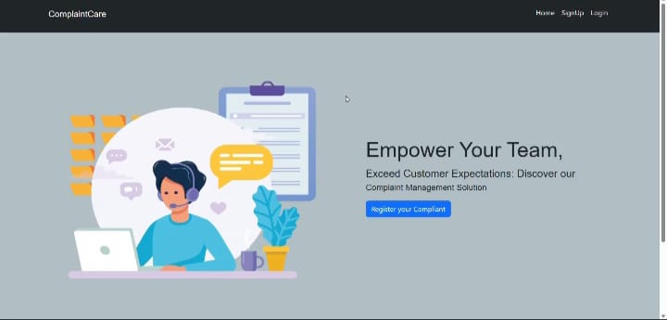

**Register page:**

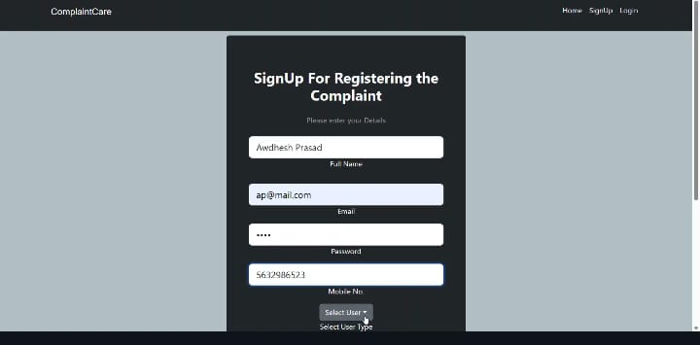

Login page:

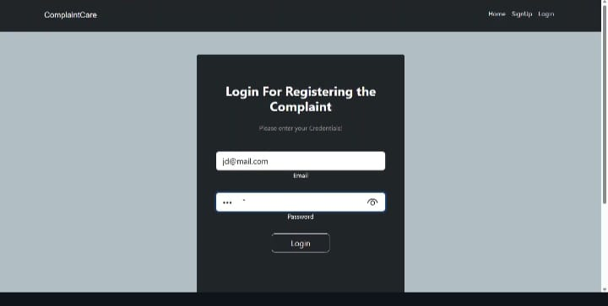

**Complaint Status:**

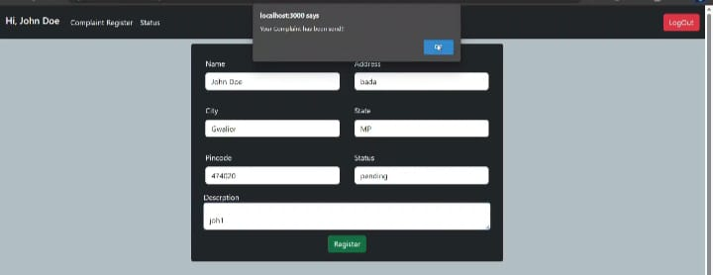

**User complaints:**

