**SORTING VISUALIZER DOCUMENTATION**

* **Introduction:**
* The Sorting Visualizer is an interactive web application that demonstrates the step-by-step process of various sorting algorithms through visual representation. This educational tool helps users understand how different sorting algorithms work by displaying real-time animations of the sorting process. The application currently implements two fundamental sorting algorithms: Merge Sort and Insertion Sort, making it an excellent resource for students and developers learning about sorting algorithms.
* **Requirements:**
* Python 3.7 or higher
* Web browser with JavaScript enabled
* **Technologies:**
* Python, Html, CSS, JavaScript
* **Screenshot:**
* 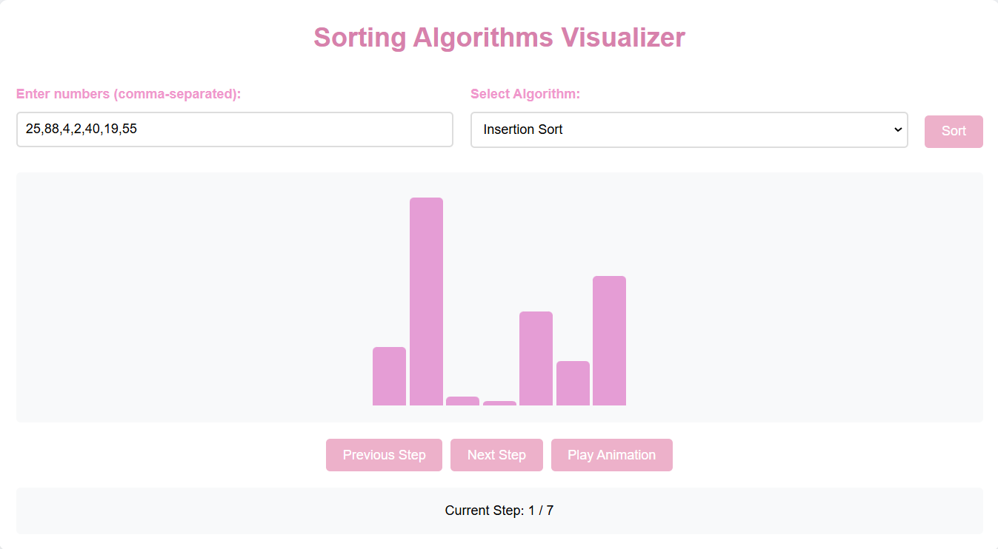**INSERTION SORT:**

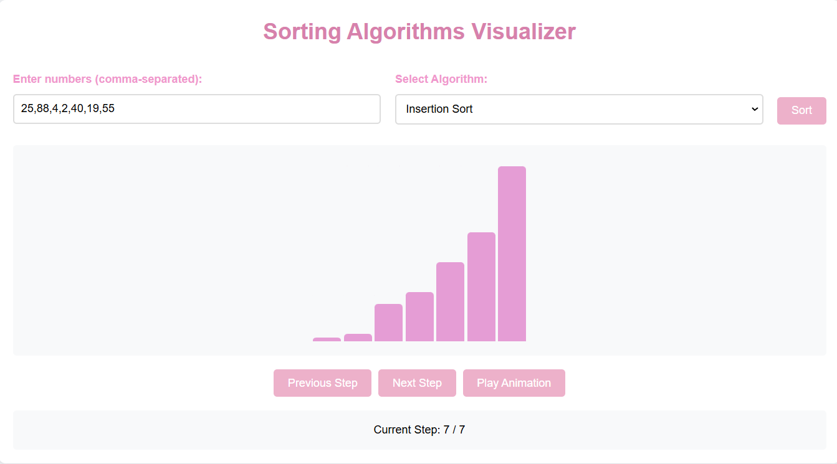

* **MERGE SORT:**

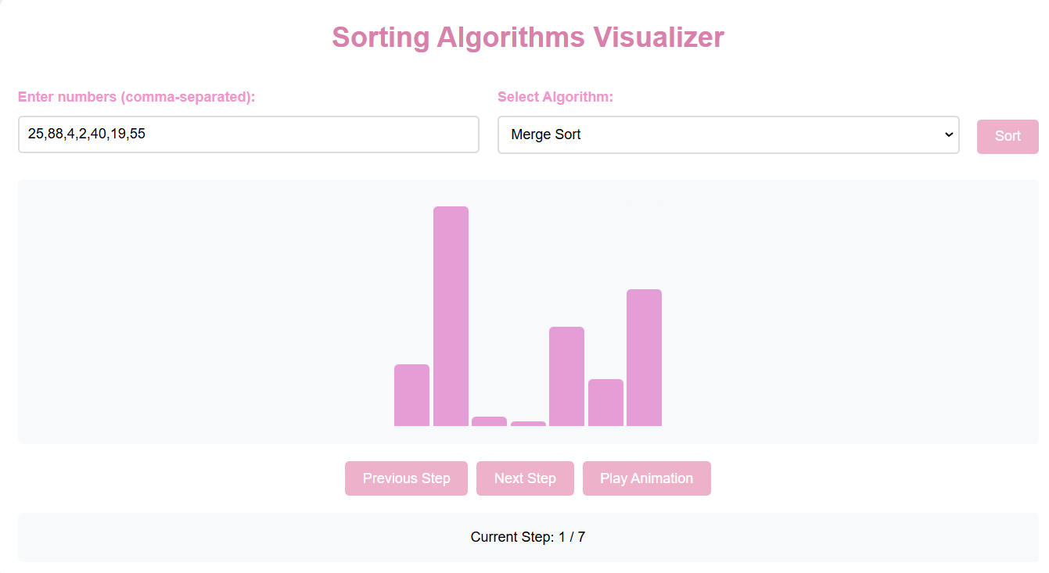

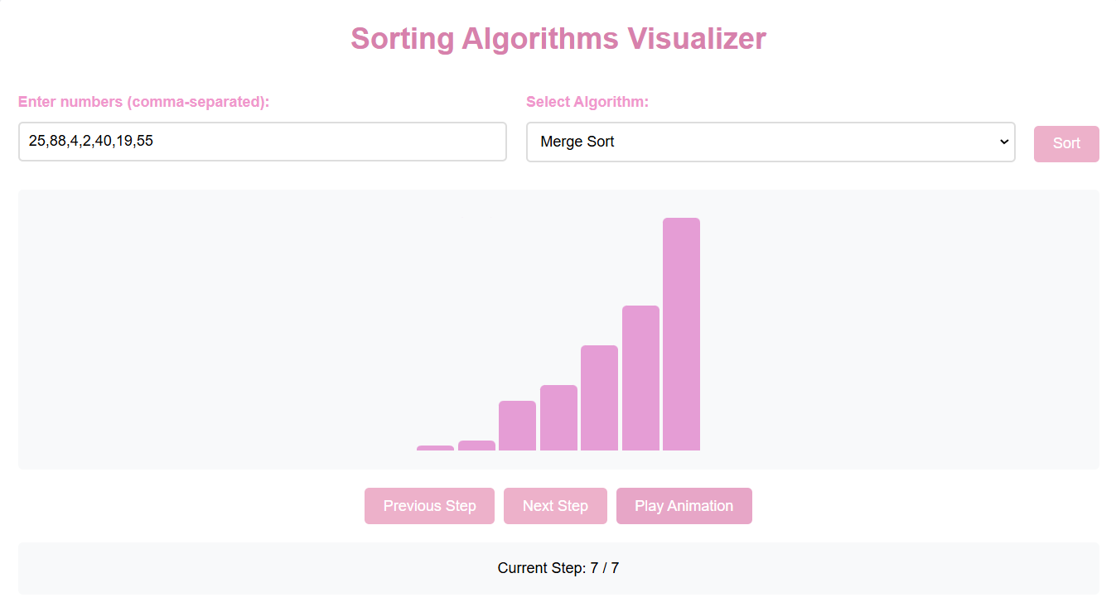**Conclusion:**

The Sorting Visualizer project successfully demonstrates the implementation of sorting algorithms through an interactive and visually appealing interface. The combination of Flask backend and vanilla JavaScript frontend provides a lightweight yet powerful solution for algorithm visualization. The project serves as both an educational tool and a demonstration of modern web development practices.