Оглавление

The NYPD uses altered images in its facial recognition system, new documents show 1

Facebook shuts down an Israeli firm’s effort to influence politics in West Africa 4

Netflix’s animated fantasy series Disenchantment will return on September 20th 6

Брюссель 7

# J:\MyPictures4\4885.jpg

# The NYPD uses altered images in its facial recognition system, new documents show

6

*In one case, a photo of the actor Woody Harrelson was used to locate a suspect*

|  |  |
| --- | --- |
| https://cdn.vox-cdn.com/thumbor/Mt2Xi7puJgorEDdWBit4l7dDDag=/0x0:800x530/1200x800/filters:focal(336x201:464x329)/cdn.vox-cdn.com/uploads/chorus_image/image/63844650/DSC_4562.0.jpg | [A new report](https://www.flawedfacedata.com/) from Georgetown Law’s Center on Privacy and Technology (CPT) has uncovered widespread abuse of the New York Police Department’s facial recognition system, including image alteration and the use of non-suspect images. In one case, officers uploaded a picture of the actor Woody Harrelson, based on a witness description of a suspect who looked like Harrelson. The search produced a match, and the matched suspect was later arrested for petty larceny. |
| “The stakes are too high in criminal investigations to rely on unreliable—or wrong—inputs,” CPT senior associate Clare Garvie writes in the report. “Unfortunately, police departments’ reliance on questionable probe photos appears all too common.” | J:\MyPictures4\4885.jpg |

[SHARE](https://www.theverge.com/2019/5/16/18627548/nypd-facial-recognition-altered-faces-privacy)

In more complex cases, image editing software can be used to manipulate a photo to create a higher chance of an affirmative match. One training presentation recommends the “removal of facial expression technique,” in which an open-mouthed subject is edited into a neutral mug shot expression. Crucially, this can mean pasting in stock images of eyes or lips, which can affect the matching algorithm in unpredictable ways.

An slide from NYPD training materials, uncovered as part of the Georgetown report. Image: CPT

Reached for comment by The Verge, an NYPD representative did not dispute any of the specific claims in the report, but emphasized the investigative value of facial recognition. “The NYPD constantly reassesses our existing procedures and in line with that are in the process of reviewing our existent facial recognition protocols,” Detective Denise Moroney said in a statement. “No one has ever been arrested on the basis of a facial recognition match alone. As with any lead, further investigation is always needed to develop probable cause to arrest. The NYPD has been deliberate and responsible in its use of facial recognition technology.”According to CPT’s report, many departments also use police sketches as raw material for facial recognition, an unsupported and broadly inaccurate technique. Researchers found at least six departments across the US that permit sketches to be used in facial recognition searches, including the Maricopa County Sheriff’s Office in Arizona and the Maryland Department of Public Safety. There’s no indication that the NYPD uses police sketches in this way.

Facial recognition has become a widely used technique in law enforcement, although it remains controversial and largely unregulated. [A companion report from CPT](https://www.americaunderwatch.com/) describes how real-time facial recognition systems have been quietly put in place in Detroit and Chicago, largely outside the view of residents.

Amazon came under fire in 2018 for [marketing a cloud-based facial recognition service](https://www.theverge.com/2018/5/22/17379968/amazon-rekognition-facial-recognition-surveillance-aclu)(dubbed Rekognition) to cities and police departments, despite concerns over privacy and [racial bias](https://www.theverge.com/2019/1/25/18197137/amazon-rekognition-facial-recognition-bias-race-gender). Amazon continues to offer the service, despite criticism from AI researchers as well as [shareholders](https://www.theverge.com/2019/4/4/18295396/amazon-rekognition-ban-vote-sec-shareholders) and [employees](https://www.theverge.com/2018/11/8/18077292/amazon-rekognition-jeff-bezos-andrew-jassy-facial-recognition-ice-rights-violations) at Amazon. Microsoft offers [a similar service](https://click.linksynergy.com/deeplink?id=nOD%2FrLJHOac&mid=24542&u1=verge&murl=https%3A%2F%2Fazure.microsoft.com%2Fen-us%2Fservices%2Fcognitive-services%2Fface%2F) through its Azure cloud hosting system called Face API.

The city of San Francisco [voted to ban the use of facial recognition](https://www.theverge.com/2019/5/14/18623013/san-francisco-facial-recognition-ban-vote-city-agencies) by city agencies earlier this week, largely in response to civil rights concerns.

The practices described in the report underscore how few judicial restraints there are on police use of facial recognition. Courts have produces centuries of court rulings on when an officer can search a suspect’s home or take them into custody, but there are few corresponding rules for how police can use a software tool for matching faces. Database searches are typically framed as an investigative technique, which means they rarely need to stand up to the scrutiny of a court. Any leads are confirmed with separate evidence before a case can be brought, so any search that produces a viable lead is seen as successful, no matter how many innocent false positives are drawn into the system along the way.

Many proponents of facial recognition believe that algorithmic improvements will assuage civil rights concerns by reducing error rates, but Garvie is skeptical. “[Technical] improvements won’t matter much if there are no standards governing what police departments can feed into these systems.” she writes. “In the absence of those rules, we believe that a moratorium on local, state, and federal law enforcement use of face recognition is appropriate and necessary.”

**Update 9:58am ET:** Updated with NYPD statement

## Facebook shuts down an Israeli firm’s effort to influence politics in West Africa

1

*Linked to a shadowy company called Archimedes Group*

By [Nick Statt](https://www.theverge.com/authors/nick-statt)[@nickstatt](https://www.twitter.com/nickstatt)  May 16, 2019, 11:38am EDT

[SHARE](https://www.theverge.com/2019/5/16/18627776/facebook-election-interference-shut-down-west-africa-instagram-pages-groups-israeli-firm)

Illustration by William Joel / T

Facebook today said it detected dozens of Facebook accounts that were engaging in what it calls “coordinated inauthentic behavior,” which is the company’s broad phrase for election interference and other forms of public manipulation via news and social media, directed primarily at West African countries. More notable, however, is the source: Israel.

This is the first time Facebook says it’s detected such activity from the country, and Facebook even names an Israeli commercial entity, Archimedes Group, that it says was behind the behavior. The goal ostensibly was to have some type of effect on local elections and the political atmosphere, although Facebook says it can’t divine the exact intentions of the group and there is no indication that it was in any way linked to the Israeli government. Although it was centered on West African countries like Nigeria, Senegal, Togo, and Niger, Facebook also detected activity aimed at users in Angola, Tunisia, and parts of Southeast Asia and South America.

“The people behind this network used fake accounts to run Pages, disseminate their content and artificially increase engagement,” Nathaniel Gleicher, the head of cybersecurity policy at Facebook, wrote [in a blog post published this morning](https://newsroom.fb.com/news/2019/05/removing-coordinated-inauthentic-behavior-from-israel/). “They also represented themselves as locals, including local news organizations, and published allegedly leaked information about politicians. The Page administrators and account owners frequently posted about political news, including topics like elections in various countries, candidate views and criticism of political opponents.”

FACEBOOK SAYS AN ISRAELI COMPANY, ARCHIMEDES GROUP, WAS INVOLVED

As a result, Facebook says it’s shut down 65 Facebook accounts, 161 pages, 23 groups, and 12 events. It also detected and shut down four Instagram accounts related to the effort. It’s also banned Archimedes Group and all of its subsidiaries, and Facebook sent a cease and desist letter to the company.

On its website, Archimedes Group’s tagline is, “Winning elections worldwide.” It advertises itself as a kind of consultant for social media marketing related to elections, writing, “When approaching a client’s challenge, we address all possible facets relating to it. We then formulate a concise yet comprehensive solution that will use every tool and take every advantage available in order to change reality according to our client’s wishes.”

“We identified these accounts and Pages through our internal investigations into suspected coordinated inauthentic behavior. We have shared information about our analysis with industry partners and policymakers,” Gleicher wrote. “We’re constantly working to detect and stop this type of activity because we don’t want our services to be used to manipulate people. We’re taking down these Pages and accounts based on their behavior, not the content they posted.”

Beyond this one particular instance in Israel, most of Facebook’s efforts in combating election interference, foreign policy meddling, and state- and corporate-sponsored misinformation have been centered on Iran and Russia, although there has been an uptick in the past couple of years of this type of behavior coming from [India, Pakistan, the Philippines, and other countries](https://www.theverge.com/interface/2019/4/2/18291413/facebook-regulation-mark-zuckerberg-european-tour).

## Netflix’s animated fantasy series Disenchantment will return on September 20th

7

*Return to Dreamland*

By [Andrew Liptak](https://www.theverge.com/authors/andrew-liptak)[@AndrewLiptak](https://www.twitter.com/AndrewLiptak)  May 16, 2019, 11:28am EDT

[SHARE](https://www.theverge.com/2019/5/16/18627805/netflix-matt-groening-disenchantment-season-2-fantasy-series-return-september-20th)

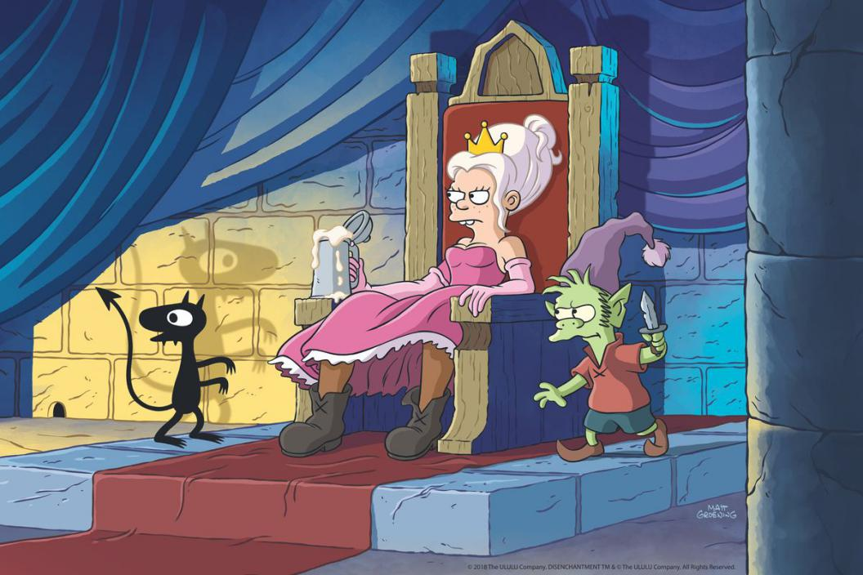Image: Netflix

The second season of Matt Groening’s fantasy series Disenchantment will begin streaming on Netflix starting on September 20th, 2019. It’s the second half of the streaming service’s order, after season 1 premiered last August.

Netflix announced that the show’s second season would begin streaming in a tweet, which came with a timely nod to Game of Thrones.

Will she win... or booze? Disenchantment returns September 20. [pic.twitter.com/8ZchIk96XP](https://t.co/8ZchIk96XP)

— Disenchantment (@disenchantment) [May 16, 2019](https://twitter.com/disenchantment/status/1129031247827595266?ref_src=twsrc%5Etfw)

Set in a fantasy world called Dreamland, the series follows a princess named Bean, her elf friend and companion Elfo, and a demon known as Luci. On its face, the series looked as though it could be the fantasy version of Groening’s Futurama, but the first batch of 10 episodes [was a bit underwhelming](https://www.theverge.com/2018/8/7/17661852/disenchantment-review-netflix-bojack-horseman-big-mouth-animated-originals-comparison), coming off as a series that’s too safe, especially compared to that of Netflix’s other animated offerings.

But while the first season underwhelmed, there’s certainly room for improvement. We’ll see when the second season premieres this fall.

# Брюссель

1. Брюссель наложил оштраф на
   1. банки Barclays, RBS, Citigroup, JPMorgan и MUFG в размере €1,07 млрд за участие в картельном сговоре по манипулированию валютным рынком по 11 валютным парам.
      1. Citigroup был оштрафован на 311 млн евро, за ним последовали RBS на 249 млн евро, JPMorgan на 229 млн евро, Barclays на 210 млн евро и японский
      2. MUFG на 70 млн евро.
   2. Но это только начало.
   3. По итогам расследования
   4. будет подан гражданский коллективный иск США на сумму $2,3 млрд ку 15 банками.
2. Чиновники ЕС обнаружили, что
   1. две отдельных группы использовали чаты, для обмена информацией о заказах клиентов, ценах и
   2. другой торговой деятельности
   3. с целью манипулирования с
   4. потовыми рынками.
3. Антиконкурентная деятельность проводилась в отношении евро, фунта стерлингов, иены и швейцарского
4. франка, долларов США, Канады,
   1. Новой Зеландии и Австралии,
   2. а также датской, шведской и норвежской крон.
5. Обмен информацией позволил
   1. им принимать решения о
6. том, продавать или покупать валюты, которые они имели в своих портфелях. Эти обмены
   1. информацией также позволяли
   2. трейдерам определять возможности для координации действий на рынке.
7. Банк UBS так же участвовал в сговоре, но не был оштрафован, потому что сам настучал чиновникам ЕС о
   1. двух таких группах. Другие банки
   2. решили урегулировать обвинения с регуляторами ЕС, и их штрафы были снижены на 10%.
8. "Мы рады разрешить этот
   1. исторический вопрос, который касается поведения одного из бывших сотрудников. С тех пор мы
   2. значительно улучшили контроль”, - сказал представитель JPMorgan.
9. Представитель Barclays отказался от комментариев. RBS признал вывод следствия и заявил в своем заявлении,
   1. что его штраф в размере 249 млн евро был “полностью покрыт существующими положениями”.
   2. Он добавил, что он сотрудничает с другими неназванными властями в дальнейших аналогичных
   3. исследованиях прошлых
   4. нарушений в торговле валютой и может столкнуться с более “материальными” штрафами и последствиями.
10. Власти Великобритании, США,
11. Швейцарии и Сингапура с 2014 года оштрафовали 15 банков на сумму более $10 млрд., связанных с валютным с
12. говором, в то время как расследования
13. также привели к многомиллиардным расчетам по гражданским искам.
14. В США и Великобритании до сих пор поданы иски к некоторым банкам о возмещении убытков от
    1. имени нескольких инвестиционных менеджеров.
    2. ЕС сказал, что есть еще
    3. одно расследование с участием Credit Suisse, относительно " предполагаемого нарушения, которое, возможно, имело место в другом чате”, но он отказался предоставить какие-либо дополнительные детали по этому делу.
    4. Юристы для инвесторов в американском гражданском деле ждут решения, чтобы запустить
    5. Tвропейскую часть исков. Дэвид Скотт, управляющий партнер Scott and Scott, соруководитель американ
    6. Cкого иска, сказал, что европейские инвесторы пока остались без компенсации.
15. "Мы ждали этого шага, прежде чем
    1. начать действия по восстановлению. Наша фирма будет работать над возмещением убытков,
16. Понесенных неамериканскими пенсионными фондами, управляющими активами, страховыми компаниями и транснациональными корпорациями, в том числе, в результате неправомерных действий банков”,-сказала Белинда Холлуэй, партнер Scott and Scott.