**Q) *Make an interactive button with JS to change the HTML of a page***

***[Hint: use document.getElementById(" ").innerHTML= to change the HTML]***

***after that try document.getElementById(" ").innerText= and find the difference between the two.***

**=>**

**Use innerHTML**

**HTML instruction:-**

<!DOCTYPE html>

<html lang="en">

<head>

    <meta charset="UTF-8">

    <meta name="viewport" content="width=device-width, initial-scale=1.0">

    <title>Document</title>

</head>

<body>

    <button onclick="changeHTML()">Button</button>

    <div id="changeable"></div>

    <script>

**function** changeHTML(){

            document.getElementById("changeable").innerHTML= "<h1>Hello World</h1>"

        }

    </script>

</body>

</html>

**Output:-**

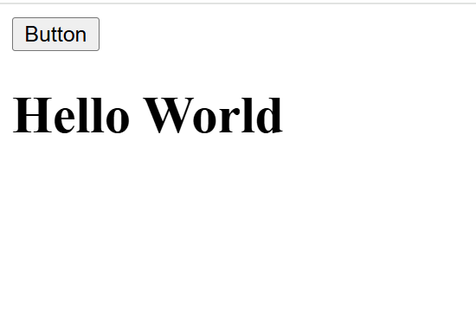

**Use innerText**

**HTML instruction:-**

<!DOCTYPE html>

<html lang="en">

<head>

    <meta charset="UTF-8">

    <meta name="viewport" content="width=device-width, initial-scale=1.0">

    <title>Document</title>

</head>

<body>

    <button onclick="changeHTML()">Button</button>

    <div id="changeable"></div>

    <script>

**function** changeHTML(){

            document.getElementById("changeable").innerText= "<h1>Hello World</h1>"

        }

    </script>

</body>

</html>

**Output:-**

