**Q) Make the following layout using HTML and CSS.**

**=>**

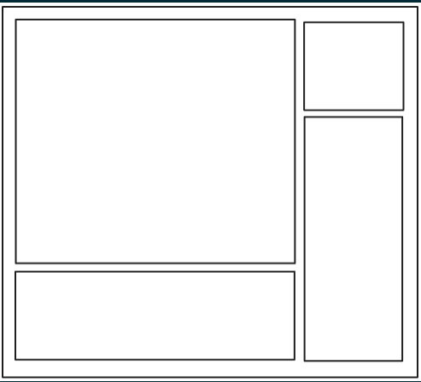

**HTML instruction:-**

<!DOCTYPE html>

<html lang="en">

<head>

    <meta charset="UTF-8">

    <meta name="viewport" content="width=device-width, initial-scale=1.0">

    <title>Document</title>

    <link rel="stylesheet" href="Q1.css">

</head>

<body>

    <div class="grid">

        <div class="item_1">1</div>

        <div class="item_2">2</div>

        <div class="item_3">3</div>

        <div class="item_4">4</div>

    </div>

</body>

</html>

**CSS instruction:-**

*{

    margin: 0;

    padding: 0;

    box-sizing: border-box;

}

body{

    font-family: 'Poppins', sans-serif;

    background-color: #f1f1f1;

}

.grid{

    display: grid;

    grid-template-columns: 3fr 1fr;

    grid-template-rows: repeat(3, 1fr);

    gap: 10px;

    padding: 20px;

    max-width: 500px;

    margin: auto;

}

.grid > div{

    background-color: aqua;

    text-align: center;

    padding: 10px;

    border: 2px solid black;

}

.item_1{

    grid-row: 1/3;

}

.item_4{

    grid-row: 2/4;

}

.item_1,

.item_4{

    background: url("./image.jpg");

}

.item_2,

.item_3{

    background: url("./image1.jpeg");

}

**Output:-**

Imge1

Imge3

Imge2

Imge4