**Q) Make a HTML page with the following layout.**

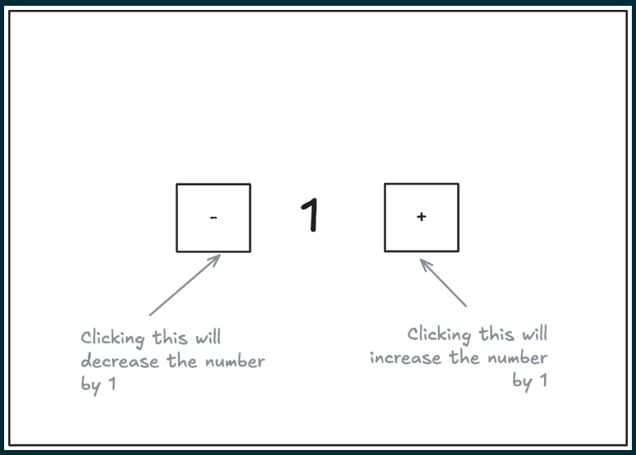

**=>**

**HTML instruction:-**

<!DOCTYPE html>

<html lang="en">

<head>

    <meta charset="UTF-8">

    <meta name="viewport" content="width=device-width, initial-scale=1.0">

    <title>Document</title>

    <link rel="stylesheet" href="style.css">

</head>

<body>

    <div class="container">

        <h1>Number</h1>

            <button id="minus">-</button>

            <h1 id="number">0</h1>

            <button id="plus">+</button>

    </div>

    <script>

**let** minusbutton=document.getElementById("minus")

**let** plusbutton=document.getElementById("plus")

**let** numberbox=document.getElementById("number")

**let** num=1;

        minusbutton.addEventListener("click",()**=>**{

            num -= 1;

            numberbox.innerText = num

        });

        plusbutton.addEventListener("click",()**=>**{

            num += 1;

            numberbox.innerText = num

        });

    </script>

</body>

</html>

**CSS instruction:-**

.container{

    display: flex;

    justify-content: center;

    align-items: center;

    gap: 10px;

    min-height: 100vh;

}

**Output:-**