**Q1) Make the following layout using HTML and CSS.**

**=>**

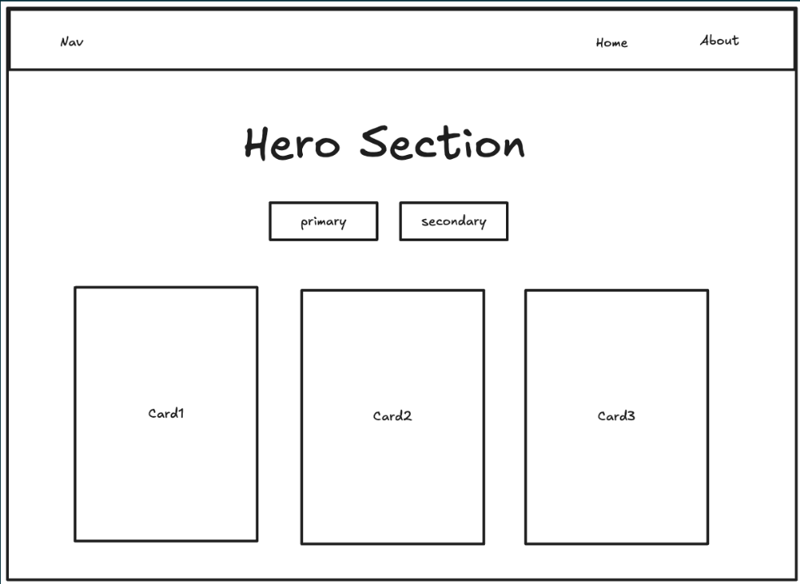

**HTML instruction:-**

<!DOCTYPE html>

<html lang="en">

<head>

    <meta charset="UTF-8">

    <meta name="viewport" content="width=device-width, initial-scale=1.0">

    <title>Document</title>

    <link rel="stylesheet" href="https://cdn.jsdelivr.net/npm/bootstrap@5.3.3/dist/css/bootstrap.min.css">

</head>

<body>

    <nav class="navbar navbar-expand-lg bg-body-tertiary">

        <div class="container-fluid">

          <a class="navbar-brand" href="#">Nav</a>

          <button class="navbar-toggler" type="button" data-bs-toggle="collapse" data-bs-target="#navbarNavAltMarkup" aria-controls="navbarNavAltMarkup" aria-expanded="false" aria-label="Toggle navigation">

            <span class="navbar-toggler-icon"></span>

          </button>

          <div class="collapse navbar-collapse" id="navbarNavAltMarkup">

            <div class="navbar-nav ms-auto" >

              <a class="nav-link" href="#">Home</a>

              <a class="nav-link" href="#">About</a>

            </div>

          </div>

        </div>

      </nav>

      <div class="px-4 py-5 my-5 text-center">

        <h1 class="display-5 fw-bold text-body-emphasis mb-3">Make things work</h1>

        <div class="col-lg-6 mx-auto">

          <div class="d-grid gap-2 d-sm-flex justify-content-sm-center">

            <button type="button" class="btn btn-primary btn-lg px-4 gap-3" fdprocessedid="ivagv">Sign Up</button>

            <button type="button" class="btn btn-outline-secondary btn-lg px-4" fdprocessedid="z3i0o9">Learn more</button>

          </div>

        </div>

      </div>

      <div class="container text-center">

        <div class="row">

          <div class="col">

            <div class="card" style="width: 100%;">

                <div class="card-body">

                  <h5 class="card-title">Card title1</h5>

                  <p class="card-text">Some quick example text to build on the card title and make up the bulk of the card's content.</p>

                  <a href="#" class="btn btn-primary">Go somewhere</a>

                </div>

              </div>

          </div>

          <div class="col">

            <div class="card" style="width: 100%;">

                <div class="card-body">

                  <h5 class="card-title">Card title2</h5>

                  <p class="card-text">Some quick example text to build on the card title and make up the bulk of the card's content.</p>

                  <a href="#" class="btn btn-primary">Go somewhere</a>

                </div>

              </div>

          </div>

          <div class="col">

            <div class="card" style="width: 100%;">

                <div class="card-body">

                  <h5 class="card-title">Card title3</h5>

                  <p class="card-text">Some quick example text to build on the card title and make up the bulk of the card's content.</p>

                  <a href="#" class="btn btn-primary">Go somewhere</a>

                </div>

              </div>

          </div>

        </div>

      </div>

      <script src="https://cdn.jsdelivr.net/npm/bootstrap@5.3.3/dist/js/bootstrap.bundle.min.js"></script>

</body>

</html>

**Output:-**

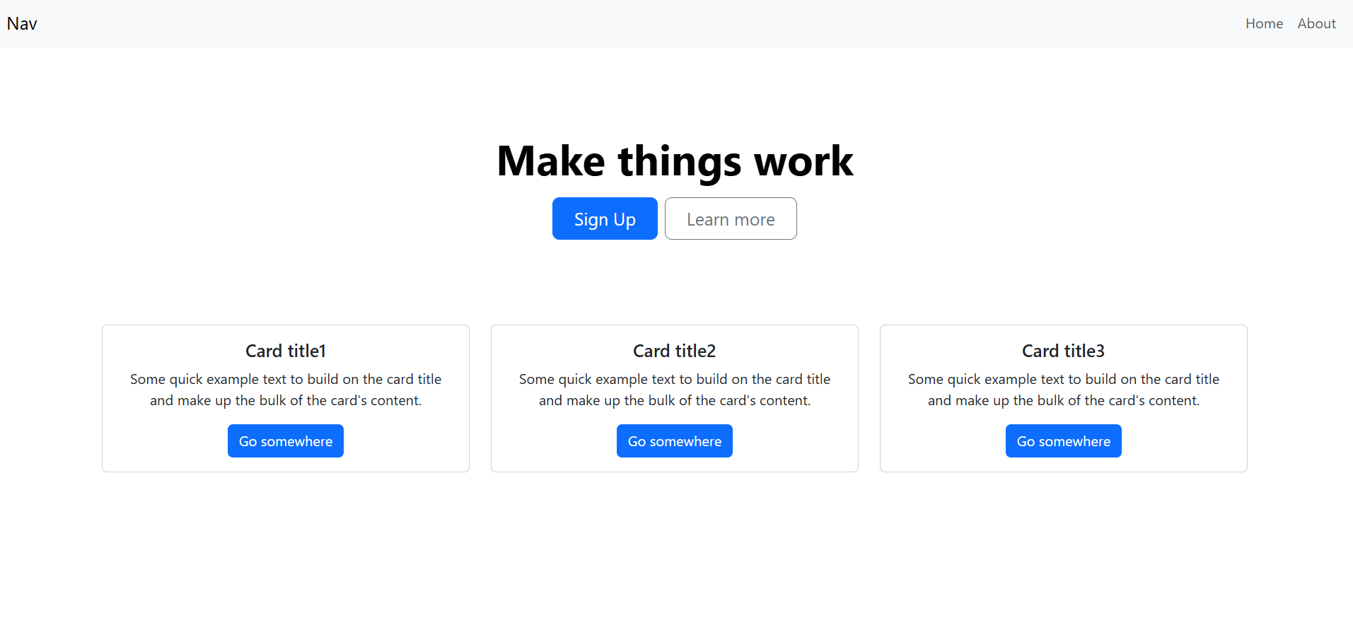

**Q2) Make a landing page using HTML and CSS.**

**=>**

**HTML instruction:-**

<!DOCTYPE html>

<html lang="en">

<head>

    <meta charset="UTF-8">

    <meta name="viewport" content="width=device-width, initial-scale=1.0">

    <title>Bootstrap button copy</title>

    <link rel="stylesheet" href="https://cdn.jsdelivr.net/npm/bootstrap@5.3.3/dist/css/bootstrap.min.css">

    <link rel="stylesheet" href="styles.css">

</head>

<body>

    <h2 class="heading mt-3">Bootstrap Buttons</h2>

    <div class="container mt-3">

        <button type="button" class="btn btn-primary">Primary</button>

        <button type="button" class="btn btn-secondary">Secondary</button>

        <button type="button" class="btn btn-success">Success</button>

        <button type="button" class="btn btn-danger">Danger</button>

        <button type="button" class="btn btn-warning">Warning</button>

        <button type="button" class="btn btn-info">Info</button>

        <button type="button" class="btn btn-outline-primary">Primary</button>

        <button type="button" class="btn btn-outline-secondary">Secondary</button>

        <button type="button" class="btn btn-outline-success">Success</button>

        <button type="button" class="btn btn-outline-danger">Danger</button>

        <button type="button" class="btn btn-outline-warning">Warning</button>

        <button type="button" class="btn btn-outline-info">Info</button>

    </div>

    <hr>

    <h2 class="heading mt-5">Bootstrap Buttons</h2>

    <div class="container mt-3">

        <button type="button" class="b b-primary">Primary</button>

        <button type="button" class="b b-secondary">Secondary</button>

        <button type="button" class="b b-success">Success</button>

        <button type="button" class="b b-danger">Danger</button>

        <button type="button" class="b b-warning">Warning</button>

        <button type="button" class="b b-info">Info</button>

        <button type="button" class="b b-primary1">Primary</button>

        <button type="button" class="b b-secondary1">Secondary</button>

        <button type="button" class="b b-success1">Success</button>

        <button type="button" class="b b-danger1">Danger</button>

        <button type="button" class="b b-warning1">Warning</button>

        <button type="button" class="b b-info1">Info</button>

    </div>

</body>

</html>

**CSS instruction:-**

.b{

    border-radius: 0.375rem;

    outline: none;

    border: none;

    padding: 6px 12px;

    font-size: 1rem;

    font-weight: 400;

    transition: background-color 0.3s,

                border 0.3s;

}

.b-primary{

    background-color: #0d6efd;

    color: #fff;

}

.b-primary:hover{

    background-color: #1a66d8;

}

.b-secondary{

    background-color: #63757d;

    color: #fff;

}

.b-secondary:hover{

    background-color: #59666b;

}

.b-success{

    background-color: #198754;

    color: #fff;

}

.b-success:hover{

    background-color: #127446;

}

.b-danger{

    background-color: #dc3545;

    color: #fff;

}

.b-danger:hover{

    background-color: #b72332;

}

.b-warning{

    background-color: #ffc107;

    color: #000;

}

.b-warning:hover{

    background-color: #ffc720;

}

.b-info{

    background-color: #0dcaf0;

    color: #000;

}

.b-info:hover{

    background-color: #1ad5fb;

}

.b-primary1{

    border: #0d6efd solid 1px;

    background: transparent;

    color: #0d6efd;

}

.b-primary1:hover{

    background-color: #0d6efd;

    color: #fff;

}

.b-secondary1{

    border: #63757d solid 1px;

    background: transparent;

    color: #63757d;

}

.b-secondary1:hover{

    background-color: #63757d;

    color: #fff;

}

.b-success1{

    border: #198754 solid 1px;

    background: transparent;

    color: #198754;

}

.b-success1:hover{

    background-color: #198754;

    color: #fff;

}

.b-danger1{

    border: #dc3545 solid 1px;

    background: transparent;

    color: #dc3545;

}

.b-danger1:hover{

    background-color: #dc3545;

    color: #fff;

}

.b-warning1{

    border: #ffc107 solid 1px;

    background: transparent;

    color: #ffc107;

}

.b-warning1:hover{

    background-color: #ffc107;

    color: #000;

}

.b-info1{

    border: #0dcaf0 solid 1px;

    background: transparent;

    color: #0dcaf0;

}

.b-info1:hover{

    background-color: #0dcaf0;

    color: #000;

}

**Output:-**

