**Exp31:-**

**Title of the program:-**

Write a C program to separate a combing string into two string.

**Program instruction:-**

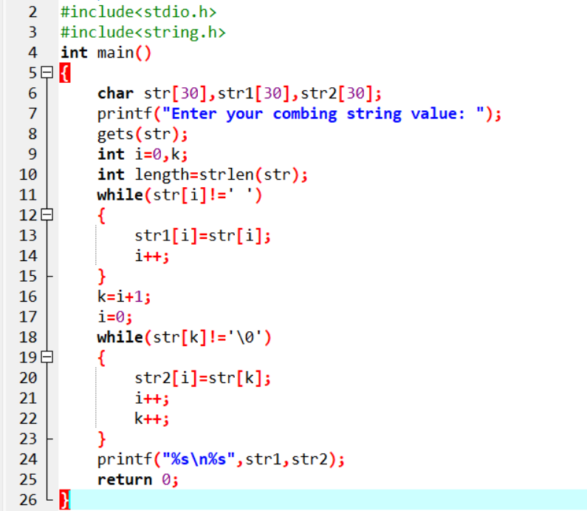

**Output:-**

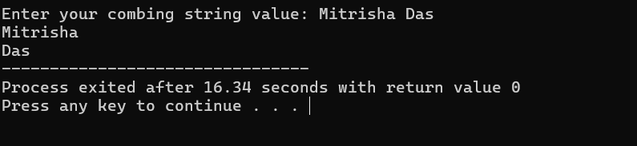

**Exp32:-**

**Title of the program:-**

Write a C program to search neon numbers between 1 to 1000.

**Program instruction:-**

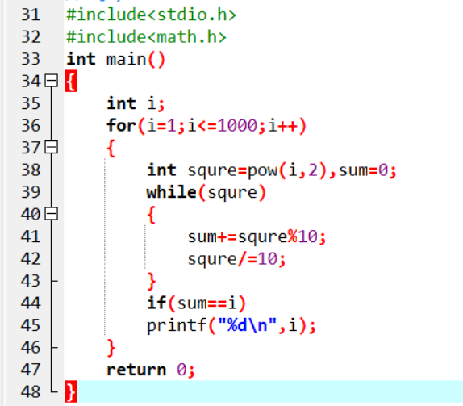

**Output:-**

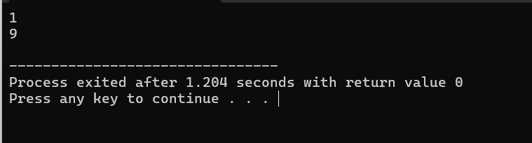

**Exp33:-**

**Title of the program:-**

You are given few numbers and compute the median.

**Program instruction:-**

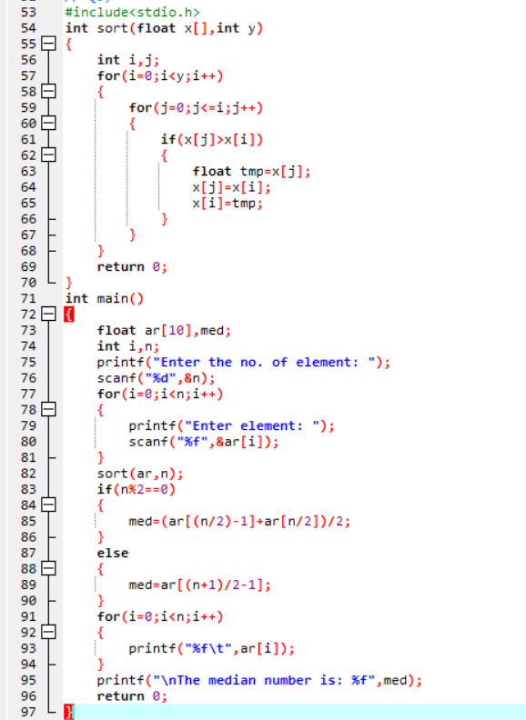

**Output:-**

