**Exp17:-**

**Title of the program:-**

Frame a class & store your name & roll no in two variables write a method to print your name & roll no.

**Program instruction:-**

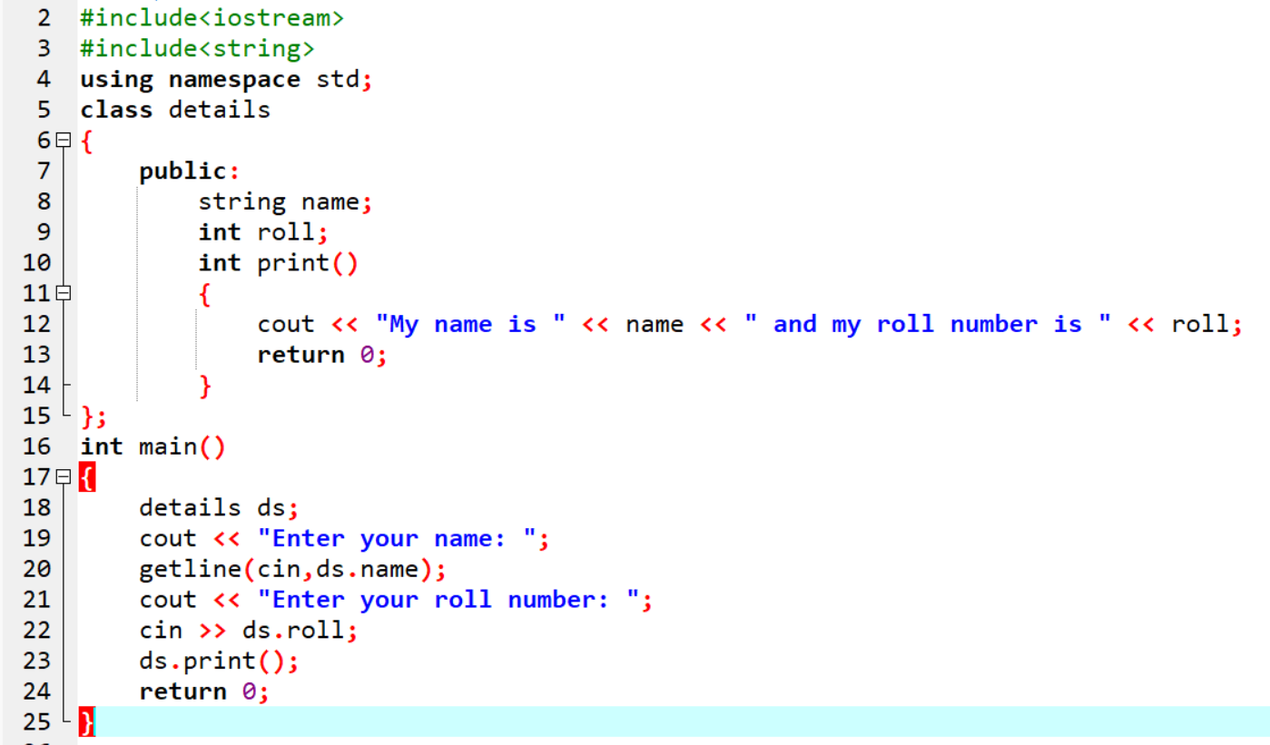

**Output:-**

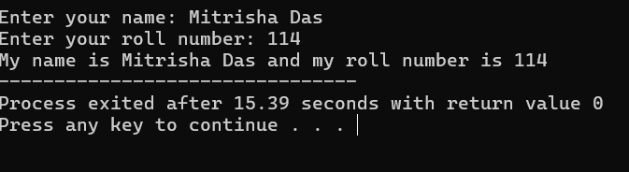

**Exp18:-**

**Title of the program:-**

Write a program to print a string from upper case to lower case & vice versa.

**Program instruction:-**

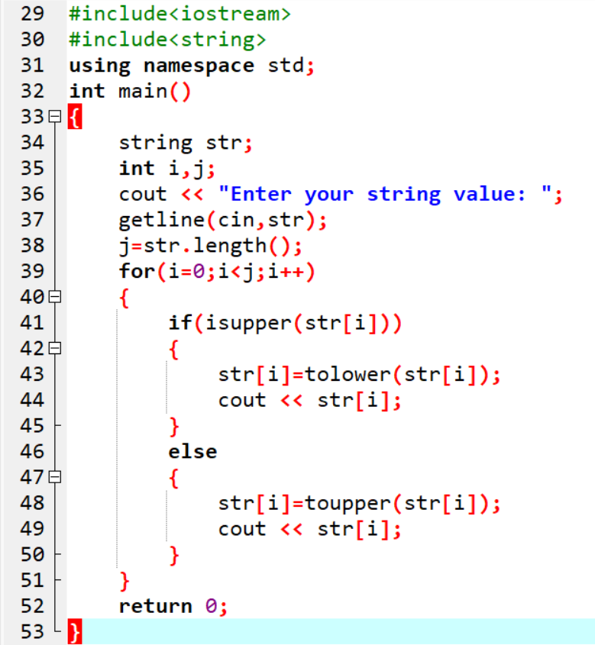

**Output:-**

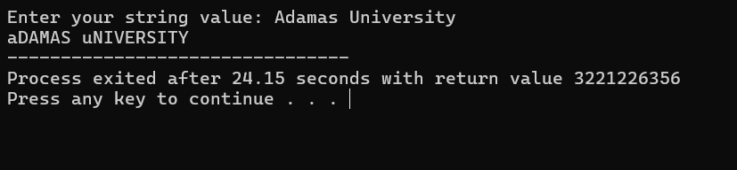

**Exp19:-**

**Title of the program:-**

Write a program to extract integer characters from a string. If no integer found then print “no integer”.

**Program instruction:-**

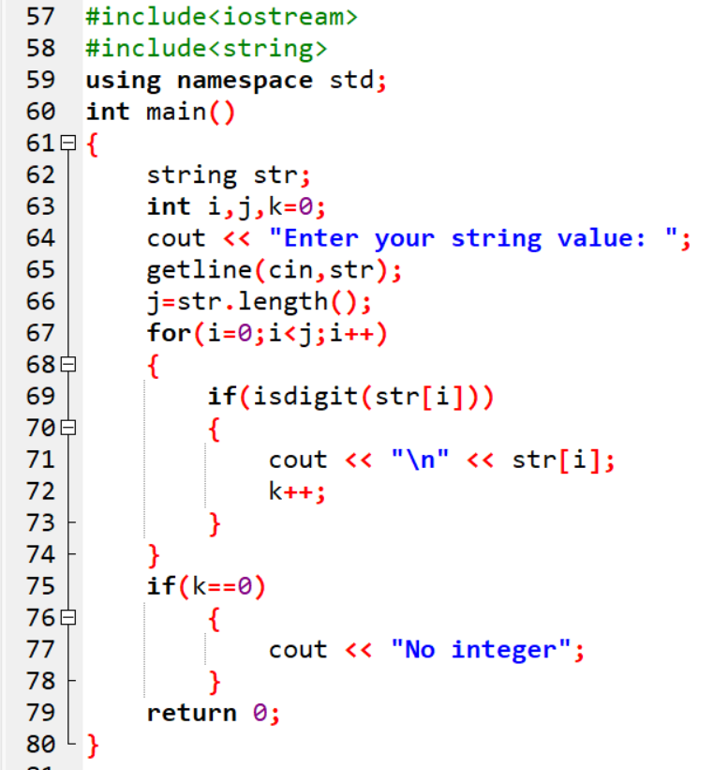

**Output:-**

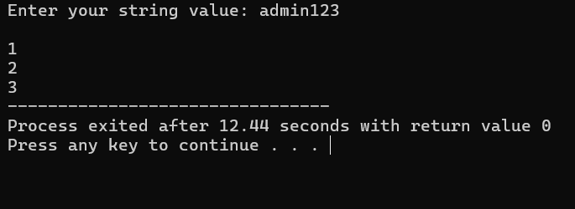

**Exp20:-**

**Title of the program:-**

Username= “admin123” & password= “sysadmin@1234”. Compare the credentials with user inputs. If correct credentials are given by user then print “logged in” else print “try again”.

**Program instruction:-**

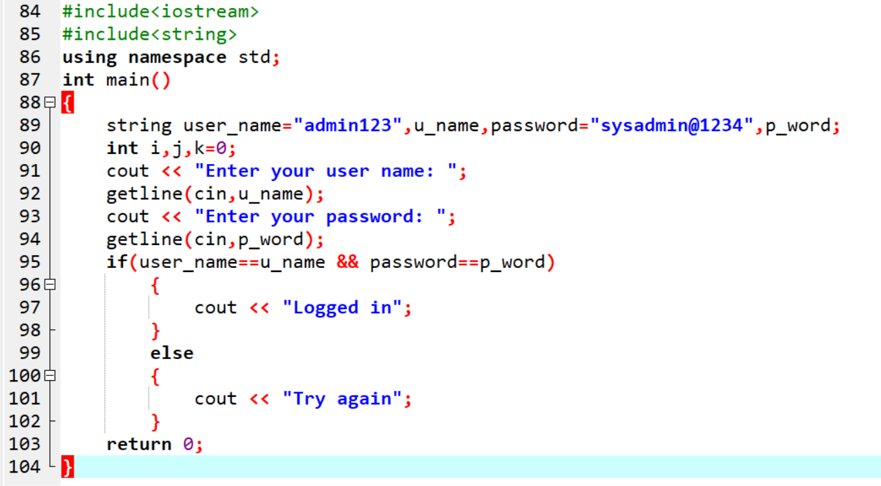

**Output:-**

