** **

**CHHATTISGARH SWAMI VIVEKANAND TECHNICAL UNIVERSITY,BHILAI(C.G.)**

**BHILAI INSTITUTE OF TECHNOLOGY , DURG(C.G.)**

*MINI Project Report*

on

***TOPIC***

***GLOVID NOT JUST A GLOVE***

**“ Machine Design – II - LAB ”**

**Guided By :- Submitted By :-**

DR. SHUBHRATA NAGPAL NAME OF STUDENTS

SHASHANK SHUKLA

AARUSH INGOLE

ADITYA BISEN

SUMIT SARKAR

PROFESSOR (I/C)

B.E. VIth  Sem “A”, SESSION – EVEN 2020

Mechanical Engineering Department

Bhilai Institute of Technology, Durg (C.G.)

**CERTIFICATE**

This is to certificate that report of the mini project submitted is an outcome of the project work entitled **“GLOVID”** carried out by

NAMES -SHASHANK SHUKLA

ADITYA BISEN

AARUSH INGOLE

SUMIT SARKAR

Univ Roll No. -300103717099

Univ Roll No. 300103717009

Univ Roll No. 300103717001

Univ Roll No. 300103717105

Carried out under my guidance and supervision **in Bachelor of Engineering , Six Semester in Mechanical Engineering at Chhattisgarh Swami Vivekanand Techanical University,** Bhilai (C.G), India

To best of my knowledge the report is

* Embodied the work candidates themselves
* Has duty been completed
* Is up to the desired standard for the purpose of which is submitted

Dr. Shubhrata Nagpal

Professor In charge

Machine Design Lab

**TABLE OF CONTENTS**

*CERTIFICATE i*

*ACKNOWLEGEMENT ii*

*ABSTRACT iii*

**CHAPTER ONE**

INTRODUCTION

OBJECTIVES

PROJECT JUSTIFICATION

**CHAPTER TWO**

LITERATURE REVIEW

**CHAPTER THREE**

DESIGN OF PARTS

**CHAPTER FOUR**

DISCUSSION

CONCLUSION

***DECLARATION***

I hereby declare that the mini project entitled “GLOVID” submitted by us to BHILAI INSTITUTE OF TECHNOLOGY DURG in partial fulfillment of bachelor of engineering in mechanical engineering is record of bonafied project work carried out by us under the guidance of Dr. SHUBHRATA NAGPAL I further declare that the work reported in this project is not been submitted and will not be submitted in any other institution or university.

**ACKNOWLEDGEMENT**

**We have taken efforts in this project. However, it would not have been possible without the kind support and help of many individuals and organizations. We would like to extend my sincere thanks to all of them.**

**We are highly indebted to Dr. Shubhrata Nagpal for her guidance and constant supervision as well as for providing necessary information regarding the project & also for her support in completing the project**

**We would like to express our gratitude towards our parents for their kind cooperation and encouragement which helped us in completion of this project.**

**Our thanks and appreciations also go to our team members in developing the project and people who have willingly helped us out with their abilities.**

**ABSTRACT**

**We all are aware of the dangers we are facing now due to the disease of COVID- 19. And we also know that the government is doing its best for preventing it from spreading. The best method recommended by WHO is social distancing, the result of which we are facing lockdown worldwide. People can keep themselves safe by washing their hands in a regular interval with soap or alcohol based sanitizers. The glove is based on this idea that the alcohol based sanitizers can kill the virus on any surface, thus it is required to sanitize the products we buy, the surface we touch in public spaces. Other than the glove we also recommend the following techniques and methods for prevention against the virus.**

**INTRODUCTION**

**Coronavirus disease 2019 (COVID-19) is an infectious disease caused by severe acute respiratory syndrome corona virus 2 (SARS-CoV-2). It was first identified in December 2019 in Wuhan, China, and has since spread globally, resulting in an ongoing pandemic. As of 17 May 2020, more than 4.66 million cases have been reported across 188 countries and territories, resulting in more than 312,000 deaths. More than 1.7 million people have recovered.**

**Common symptoms include fever, cough, fatigue, shortness of breath, and loss of smell and taste. While the majority of cases result in mild symptoms, some progress to an unusual form of acute respiratory distress syndrome (ARDS) likely precipitated by cytokine storm, multi-organ failure, septic shock, and blood clots. The time from exposure to onset of symptoms is typically around five days but may range from two to fourteen days.**

**The virus is primarily spread between people during close contact,] most often via small droplets produced by coughing, sneezing, and talking. The droplets usually fall to the ground or onto surfaces rather than travelling through air over long distances. Less commonly, people may become infected by touching a contaminated surface and then touching their face. It is most contagious during the first three days after the onset of symptoms, although spread is possible before symptoms appear, and from people who do not show symptoms. The standard method of diagnosis is by real-time reverse transcription polymerase chain reaction (rRT-PCR) from a nasopharyngeal swab. Chest CT imaging may also be helpful for diagnosis in individuals where there is a high suspicion of infection based on symptoms and risk factors; however, guidelines do not recommend using CT imaging for routine screening.**

**Recommended measures to prevent infection include frequent hand washing, maintaining physical distance from others (especially from those with symptoms), quarantine (especially for those with symptoms), covering coughs, and keeping unwashed hands away from the face. In addition, the use of a face covering is recommended for those who suspect they have the virus and their caregivers. Recommendations for face covering use by the general public vary, with some authorities recommending for them, some recommending against them, and others requiring their use. There is limited evidence for or against the use of masks (medical or other) in healthy individuals in the wider community.**

**According to the World Health Organization, there are no available vaccines nor specific antiviral treatments for COVID-19. On 1 May 2020, the United States gave Emergency Use Authorization to the antiviral remdesivir for people hospitalized with severe COVID-19. Management involves the treatment of symptoms, supportive care, isolation, and experimental measures. The World Health Organization (WHO) declared the COVID-19 outbreak a Public Health Emergency of International Concern (PHEIC) on 30 January 2020 and a pandemic on 11 MLocal transmission of the disease has occurred in most countries across all six WHO regions.**

**OBJECTIVES**

**Since there is no yet proven vaccine developed for the COVID -19, there is a need of preventive measures to prevent the transmission of the disease .Preventive measures to reduce the chances of infection include staying at home, avoiding crowded places, keeping distance from others, washing hands with soap and water often and for at least 20 seconds, practising good respiratory hygiene, and avoiding touching the eyes, nose, or mouth with unwashed hands. The U.S. Centers for Disease Control and Prevention (CDC) recommends covering the mouth and nose with a tissue when coughing or sneezing and recommends using the inside of the elbow if no tissue is available. Proper hand hygiene after any cough or sneeze is encouraged. The CDC has recommended cloth face coverings in public settings where other social distancing measures are difficult to maintain, in part to limit transmission by asymptomatic individuals. The U.S. National Institutes of Health guidelines do not recommend any medication for prevention of COVID-19, before or after exposure to the SARS-CoV-2 virus, outside the setting of a clinical trial.**

**Protective equipment**

**Precautions must be taken to minimise the risk of virus transmission, especially in healthcare settings when performing procedures that can generate aerosols, such as intubation or hand ventilation. For healthcare professionals caring for people with COVID-19, the CDC recommends placing the person in an Airborne Infection Isolation Room (AIIR) in addition to using standard precautions, contact precautions, and airborne precautions.**

**The CDC outlines the guidelines for the use of personal protective equipment (PPE) during the pandemic. The recommended gear is a PPE gown, respirator or facemask, eye protection, and medical gloves.**

**When available, respirators (instead of facemasks) are preferred. N95 respirators are approved for industrial settings but the FDA has authorised the masks for use under an Emergency Use Authorisation (EUA). They are designed to protect from airborne particles like dust but effectiveness against a specific biological agent is not guaranteed for off-label uses. When masks are not available, the CDC recommends using face shields or, as a last resort, homemade masks.**

**Mechanical ventilation**

**Many developed countries do not have enough hospital beds per Most cases of COVID-19 are not severe enough to require mechanical ventilation or alternatives, but a percentage capita, which limits a health system's capacity to handle. The type of respiratory support for individuals with COVID-19 related respiratory failure is being actively studied for people in the hospital, with some evidence that intubation can be avoided with a high flow nasal cannula or bi-level positive airway pressure. Whether either of these two leads to the same benefit for people who are critically ill is not known. Some doctors prefer staying with invasive mechanical ventilation when available because this Severe cases are most common in older adults (those older than 60 years,[172] and especially those older technique limits the spread of aerosol particles sudden spike in the number of COVID-19 cases severe enough to require hospitalisation. This limited capacity is a significant driver behind calls to flatten the curve.**

**The objective of glove is the same to prevent the transmission of the disease by touching several objects in public places which might be ones carrying the virus. The glove not only prevent the user from being infected by touching the surface but it also prevents the spreading by disinfecting the surface itself , so that the non user of glove will also be prevented from the virus. Since in the time of crisis such as this we cannot expect everyone to have all the resources. We know that this glove is not the only solution for this purpose but it might be one of them, we also recommend that other techniques such as motion detection, which prevents the necessity of touch to be installed in the places. We recommend the sanitation of the public places by the drones, maintaining social distancing, more accuracy in contact tracing, digitization of money transfer process and also other norms given by the government. We are together in this crisis and together we will win.**

**PROJECT JUSTIFICATION**

We know that COVID-19 is spreading at high rate and since its vaccine is not yet produced therefore it is a great risk to our health. It is more contagious than common flu and can also spread through non-living things as the virus can survive on plastic and steel for up to 72 hours and on cardboard for upto 24 hours.

The glove will serve 2 purposes -

1. It will prevent us from virus.
2. Furthermore, it will disinfect the surface and by that it will also protect the non-user of the glove.

It helps our country to fight against COVID-19. Secondly, it will help the poor people to get employed.

We can’t go outside conveniently and can’t freely interact with the objects,the things we may touch leaves the virus behind which is a potential threat to others.thus this gloves will help to easily interact with the object without any difficulty.

This virus, despite being harmful, has brought unity to humanity.

**LITERATURE REVIEW**

**Start-ups, entrepreneurs from Indian Institute of Technology, Roorkee are trying to tackle COVID-19 epidemic by innovation, developing technologies and medical devices on a war footing.**

**“It is heartening to learn that our incubated companies, past and present, are coming forward to tackle COVID-19. We stand with the government at this critical juncture and I am very hopeful that our country will be successful in protecting us from widespread misery,” said Professor Ajit K Chaturvedi, director of the IIT Roorkee.**

**Incubated at TIDES Business Incubator, these products are going to be available in the market pretty soon, covering the broad spectrum from diagnosis, treatment and safety in a pandemic situation.**

**“During this unprecedented time, we are committed to augmenting the government efforts to tackle COVID-19. TIDES Business Incubator plays a catalytic role in encouraging the spirit of entrepreneurship and innovation. By designing equipment for diagnosis, treatment and safety, we are gearing to meet the challenges in this crisis,” said Azam Ali Khan, CEO, TIDES, IIT Roorkee.**

**Log9 Materials, a Sequoia & Exfinity funded startup, has come up with an innovative, first-of-its-kind product named CoronaOven that makes use of UV-C light in combination with significant design parameters in order to effectively sanitize the surfaces of various products/objects of regular use in healthcare and household settings, thus preventing surface-to-human transmission (of COVID-19 causing virus).**

**Graduated from TIDES, Log9 Materials developed this technology within two weeks of time, beating the lockdown challenges which is now ready for mass deployment.**

**Realizing the immense need for sanitizers to fight COVID-19 spread and the impending shortage, Heal Agnostics Private Limited developed a herbal sanitizer in the lab itself and distributed more than 2500 litres of it, free of cost within IIT Roorkee campus.**

**The startup is mainly developing technology for fast detection of various types of cancer, but living up to the true spirit of a social entrepreneur, they rose up to the occasion to meet a timely need.**

**Shellios, a smart helmets startup, founded by tye IIT alumnus Amit Pathak, is developing a 'Powered Air Purifying Respirator' (PAPR) which can be used by health workers and doctors to counter infection in the hospital premises.**

**They are also separately working on another model of low-cost respiratory aid.**

**Vyaan, a cleantech startup, led by a group of the IIT alumni is developing an extremely low-cost reusable mask which can be made available in mass quantity.**

**Test right Solution, founded by alumnus Shubham Rathore, is developing a Real-Time PCR and virus detection kit.**

**This indigenously developed system is expected to be floated at 1/4th of the cost and would multiply the number of tests conducted, by enhancing the existing hospital and lab facilities available in the country.**

**TBS Planet, a media-tech start-up at the IIT is providing free online subscription of its comics to motivate children during the lockdown period.**

**"The most interesting aspect is that the products are developed in a short span of time in the labs itself, overcoming the limitations of supply chain and access to equipment. Though the results, thus, achieved, only re-emphasize the role played by the institute and its alumni in such challenging times, added the director.**

**Earlier, with the increasing number of COVID-19 cases in the country, the biggest challenge was to ensure sufficient quantities of Ventilator.**

**Professor Akshay Dwivedi and professor Arup Das, from the department of mechanical engineering, along with All India Institute of Medical Sciences, Rishikesh developed a low cost, portable closed-loop ventilator. Aptly named, ‘Pran Vayu’, the ventilator has feedback that can control tidal volume and breath per minute.**

**Some of the features of the ventilator are remote monitoring by health professionals, touch screen control of all operating parameters, moister, and temperature control for inhaled air.**

**"The ventilator has generated extraordinary interest from the industry community with several offers for manufacturing in scale. The team has also developed face shields which can be used by health workers/ doctors while treating COVID-19 patients," said Akshay Dwivedi.**

**Raven Eye, an incubated startup founded by professor Kamal Jain of IIT has developed a surveillance system to fight COVID-19 through a unique tracking mobile application.**

**Using geo-fencing technology, the system generates alert if any individual violates quarantine. In case the network is not available, the application will send an alert through SMS.**

**DESIGN OF PARTS**

The following materials were used in making this unique glove - ‘**GLOVID’** :

1. Alcohol absorbing sponge
2. Tubes
3. Sanitizer kit (with lid)
4. Parachute glove cover (with zipper)
5. Base glove (sponge)

* **When the tube is connected to the sanitizer-**

**MECHANISM:**

**The tube is embedded into the sponge when we force our fingers inwards in a direction of making a fist, the tubes are connected to a main tube exerts pressure into the sanitizer kit and the sanitizer through the tube goes to the sponge which absorbs it( Fig 1).Thus when we touch the infected area of some sort, this will disinfect the area with the help of sanitizer,and keep it clean for others to touch without get infected.Regular excretion of sanitizer will help the sponge to clean by itself, no need to bother to wash it again.**

* **When the tube is not connected to the sanitizer**

**MECHANISM :**

**When there is no use of the sponge gloves, a half glove (made of parachute material) which is clamped to the frontside of the gloves located on the wrist, that can be used to wear to cover the sponge area (Fig. 2). This helps us to avoid unnecessary use of extra sanitizer and we can work with ease without any uncomfortability in sponge gloves.The tube is detached from the sanitizer kit and is clamped at a distance. The sanitizer kit is connected with a lid which serves two purposes -**

1. **That it will help the sanitizer to flow from the tube to the sponge**
2. **Secondly,it can also be used as a switch to cut the supply of sanitizer going through the tubes and eventually to the sponge(closing the lid by rotating it in clockwise direction to the dispersion tubes which will block the exit point of the sanitizer kit).**

**The sanitizer is released from the sanitizer kit into the tubes in the same way a soap dispenser works-**

**The soap dispensing pump relies on both the components of the bottle and air suction to draw the fluid upwards and fight against the law of gravity.**

**Each time you push down on, or prime, the actuator, the piston puts pressure on the spring and moves the ball upward, taking some soap product with it.**

**When you release the actuator, the piston and spring return to their resting position, sealing off the housing chamber to stop liquid from flowing back up into the bottle.**

**The cover pouch:**

**This will help the parachute cover to be kept inside the glove with ease.Whenever we want to use the cover we can easily open it by the zipper and put it over the base glove. This way we can use the covered gloves where we don’t want to use the sanitizer one.**

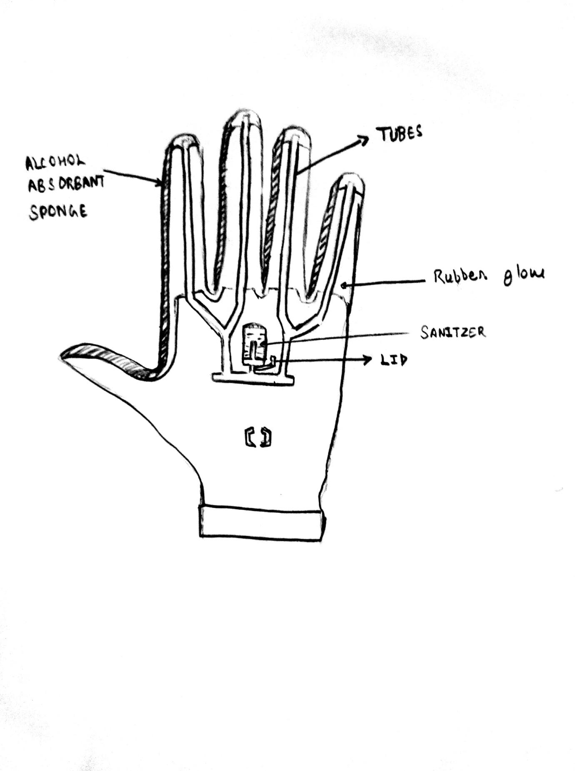

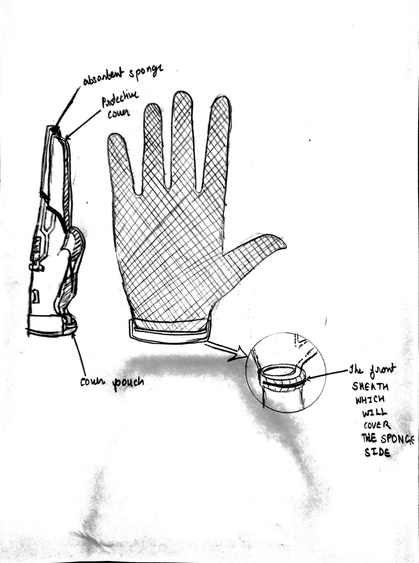

**DISCUSSION**

**We all are aware of the dangers we are facing now due to the disease of COVID- 19. And we also know that government is doing its best for preventing it from spreading. The best method recommended by WHO is social distancing, the result of which we are facing lockdown worldwide. People can keep themselves safe by washing their hands in a regular interval with soap or alcohol based sanitizers. The glove is based on this idea that the alcohol based sanitizers can kill the virus on any surface, thus it is required to sanitize the products we buy, the surface we touch in public spaces. Other than the glove we alos recommend the following techniques and methods for prevention against the virus.**

* **The motion sensors – Rather than prevention against the touching, the best way would be to avoid touching at all, motion sensors installed in doors are a good example. Although it cannot be installed everywhere (that’s where the glove comes in, obviously) but it should installed in the places it can be.**
* **To follow social distancing the boxes are being made outside the shops one meters apart, and also in queues. People should follow this rule strictly, we recommend some distance sensing sensors between the people standing in the queue, and create alarm whenever someone come closer to each other and the associative can handle the situation.**
* **Sanitizing of the public places with the drones – it will surely prevent the workers now employed for doing these jobs from being attacked by the virus , although the employment problem of our country cannot be solved by this. Drones can also be used to advice people to wear masks outside whenever they are not seen wearing masks as they are doing in China.**
* **The contact tracing app – this might be the biggest reason besides testing for success of flattening the curve in growing cases in South Korea. Arogya Setu app introduced by Indian govt. is also a great step but it can be enhanced to prevent people going to the place where the patients have been until it’s sanitized.**
* **Testing kit – the biggest requirement is of course the testing kit, it should be produced in more amounts and also more upgraded versions are being made which can give the results in less amount time.**

**CONCLUSION**

**Covid -19 has caused a global crisis that is tearing through the world more interconnected by technology than ever before.But compared to previous outbreaks of disease like ebola,SARS,MERS,swine flu this outbreak is in much larger scale ,this flu is more contagious than any other flu.Technology also provides leaders and their countries with new tools to respond effectively and efficiently.**

**All countries have their own unique circumstances when responding to the crisis,but ultimately, they face the same two challenges. First, they have to organise to fight the virus and prevent loss of life.Second ,they have to navigate the enormous economic and social disruption caused to cushion the impact.**

**How leaders and their countries choose to approach technology and the policies they put in place around it, will make the difference between the outcomes that are bearable and outcomes that are catastrophic.**

**So this is our contribution that may make a difference.**