TASK-3
Goal
Create a small Flask-based application (todo app, notes app, contact form, etc.).
Requirements
- Flask routing & templates
- CRUD operations (optional)
- Bootstrap UI
Deliverables
- Source code on GitHub
- Hosted version (Render, PythonAnywhere) optional
IDEA OF IMPLEMENTATION
Flask-todo-App/
│── app.py
│── todo.db
│── templates/
│ ├── base.html
│ ├── index.html
│ ├── add.html
│ └── edit.html
└── static/
└── style.css
Flask-todo-App/
app.py
from flask import Flask, render_template, request, redirect
from flask_sqlalchemy import SQLAlchemy

app = Flask(__name__)

app.config['SQLALCHEMY_DATABASE_URI'] = 'sqlite:///todo.db'
app.config['SQLALCHEMY_TRACK_MODIFICATIONS'] = False

db = SQLAlchemy(app)

# Database Model
class Todo(db.Model):
id = db.Column(db.Integer, primary_key=True)
task = db.Column(db.String(200), nullable=False)

with app.app_context():
db.create_all()

# Home Page
@app.route('/')
def home():
todos = Todo.query.all()
return render_template('index.html', todos=todos)

# Add Task
@app.route('/add', methods=['GET', 'POST'])
def add():
if request.method == 'POST':
task = request.form['task']
new_task = Todo(task=task)
db.session.add(new_task)
db.session.commit()
return redirect('/')

return render_template('add.html')

# Edit Task
@app.route('/edit/<int:id>', methods=['GET', 'POST'])
def edit(id):
todo = Todo.query.get_or_404(id)

if request.method == 'POST':
todo.task = request.form['task']
db.session.commit()
return redirect('/')

return render_template('edit.html', todo=todo)

# Delete Task
@app.route('/delete/<int:id>')
def delete(id):
todo = Todo.query.get_or_404(id)
db.session.delete(todo)
db.session.commit()
return redirect('/')

if __name__ == "__main__":
app.run(debug=True)
base.html
<!DOCTYPE html>
<html>
<head>
<title>Todo App</title>

<link href="https://cdn.jsdelivr.net/npm/bootstrap@5.3.0/dist/css/bootstrap.min.css" rel="stylesheet">

</head>

<body class="bg-light">

<div class="container mt-5">

{% block content %}
{% endblock %}

</div>

</body>
</html>

Index.html
<!DOCTYPE html>
<html>
<head>
<title>Todo App</title>

<link href="https://cdn.jsdelivr.net/npm/bootstrap@5.3.0/dist/css/bootstrap.min.css" rel="stylesheet">

</head>

<body class="bg-light">

<div class="container mt-5">

{% block content %}
{% endblock %}

</div>

</body>
</html>
Add.html
{% extends 'base.html' %}

{% block content %}

<h2>Add Task</h2>

<form method="POST">

<div class="mb-3">

<label>Task</label>

<input
type="text"
name="task"
class="form-control"
required>

</div>

<button class="btn btn-primary">
Save
</button>

<a href="/" class="btn btn-secondary">
Back
</a>

</form>

{% endblock %}
edit.html
{% extends 'base.html' %}

{% block content %}

<h2>Edit Task</h2>

<form method="POST">

<div class="mb-3">

<label>Task</label>

<input
type="text"
name="task"
class="form-control"
value="{{todo.task}}"
required>

</div>

<button class="btn btn-success">
Update
</button>

<a href="/" class="btn btn-secondary">
Back
</a>

</form>

{% endblock %}
Style.css
body{
background:#f4f4f4;
}

table{
background:white;
}

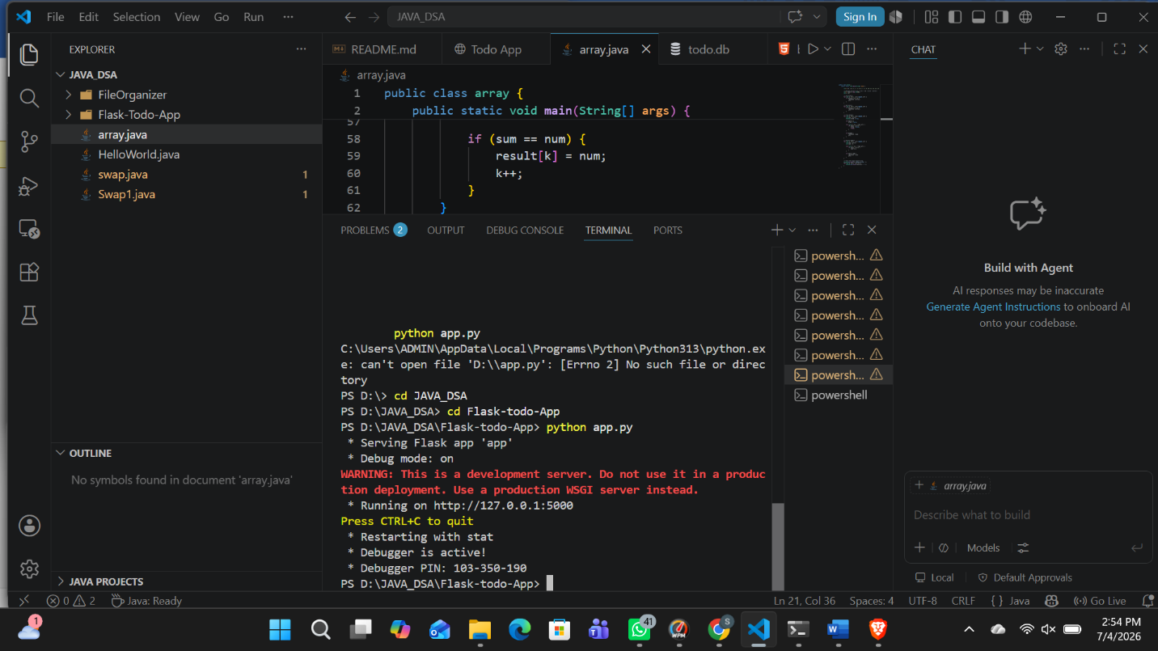

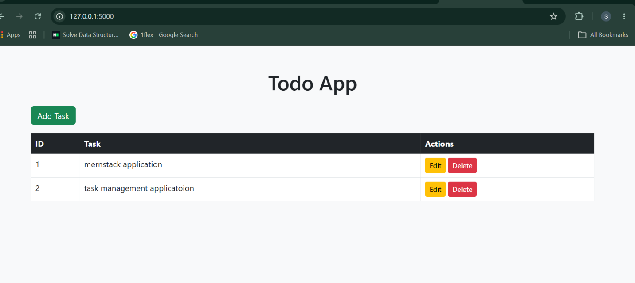
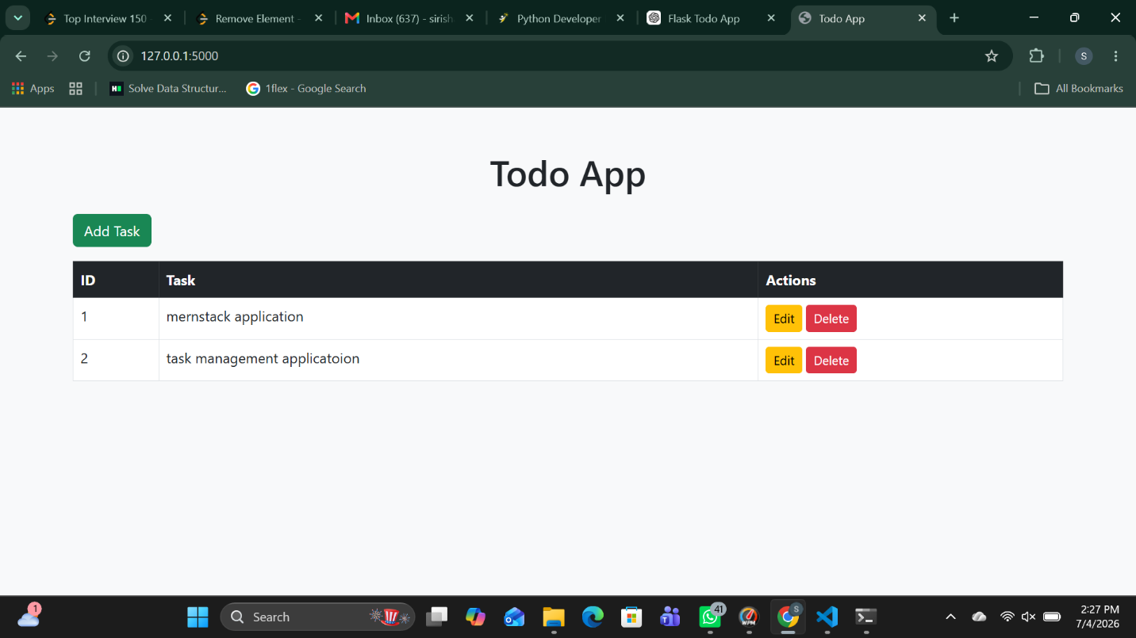

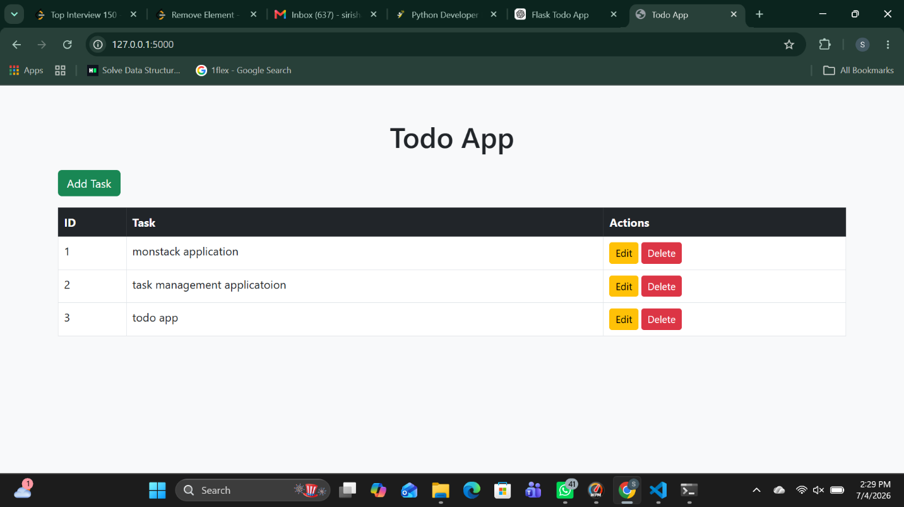

Github link…..
https://github.com/MittaSirisha/InternSpark

Task link……
https://github.com/MittaSirisha/InternSpark/blob/main/TASK-3.docx

