TASK-2
Goal
Analyze a dataset, clean it, and generate summary statistics.

Requirements
- Load CSV using Pandas
- Perform cleaning, filtering, grouping
- Generate meaningful insights

Deliverables
- Notebook (.ipynb) or script
- Graphs (optional)

IDEA OF IMPLEMENTATION
Data_Analysis_Project/
│── dataset.csv
│── data_analysis.py
│── README.md
│── output/
│ ├── sales_by_category.png
│ └── cleaned_data.csv

FileOrganizer
data_analysis.py

import os
import pandas as pd
import matplotlib.pyplot as plt

filename = "dataset.csv"

if not os.path.exists(filename):
print(f"Error: '{filename}' not found.")
exit()

if os.path.getsize(filename) == 0:
print(f"Error: '{filename}' is empty.")
exit()

try:
df = pd.read_csv(filename)
except pd.errors.EmptyDataError:
print("Error: CSV file has no data or headers.")
exit()
except Exception as e:
print("Error:", e)
exit()

print("First 5 Rows:")
print(df.head())

print("\nDataset Information:")
print(df.info())

print("\nMissing Values:")
print(df.isnull().sum())

df = df.drop_duplicates()

numeric_cols = df.select_dtypes(include="number").columns
for col in numeric_cols:
df[col] = df[col].fillna(df[col].median())

categorical_cols = df.select_dtypes(include="object").columns
for col in categorical_cols:
df[col] = df[col].fillna(df[col].mode()[0])

os.makedirs("output", exist_ok=True)

df.to_csv("output/cleaned_data.csv", index=False)

if "Sales" in df.columns:
filtered = df[df["Sales"] > 1000]
print("\nFiltered Data:")
print(filtered)

if "Category" in df.columns and "Sales" in df.columns:
category_sales = df.groupby("Category")["Sales"].sum()
print("\nSales by Category:")
print(category_sales)

print("\nSummary Statistics:")
print(df.describe())

print("\nInsights")
print("Total Records:", len(df))

if "Sales" in df.columns:
print("Average Sales:", df["Sales"].mean())
print("Highest Sales:", df["Sales"].max())
print("Lowest Sales:", df["Sales"].min())

if "Category" in df.columns and "Sales" in df.columns:
category_sales.plot(kind="bar")
plt.title("Sales by Category")
plt.xlabel("Category")
plt.ylabel("Total Sales")
plt.tight_layout()
plt.savefig("output/sales_by_category.png")
plt.show()
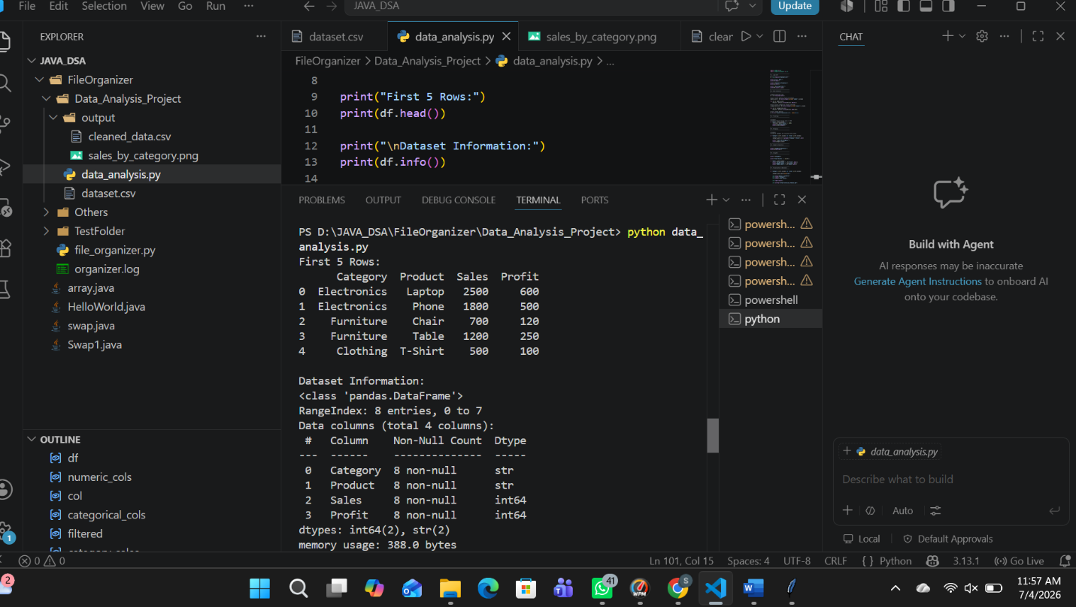

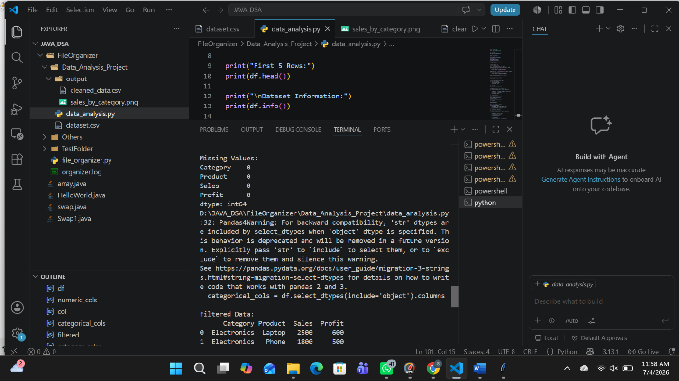
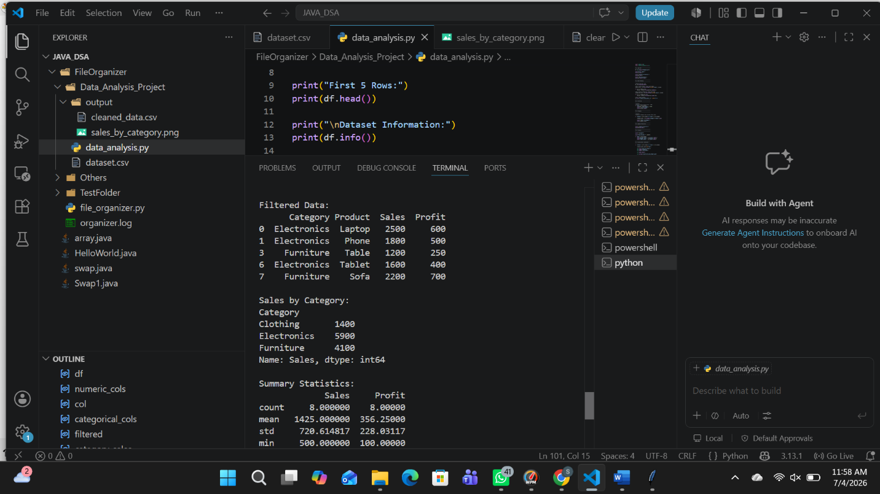

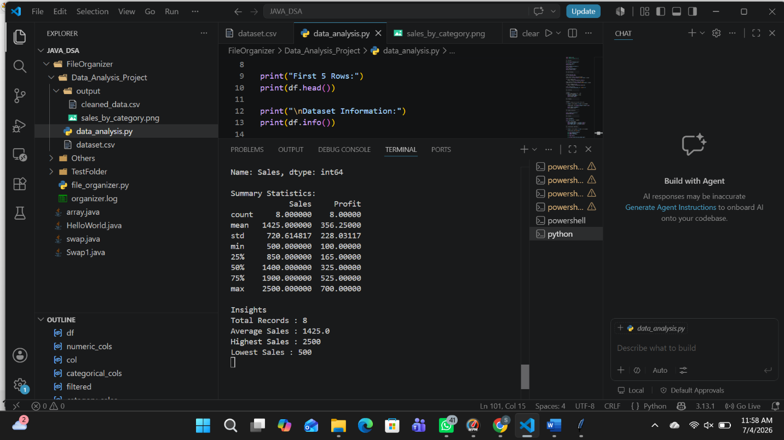

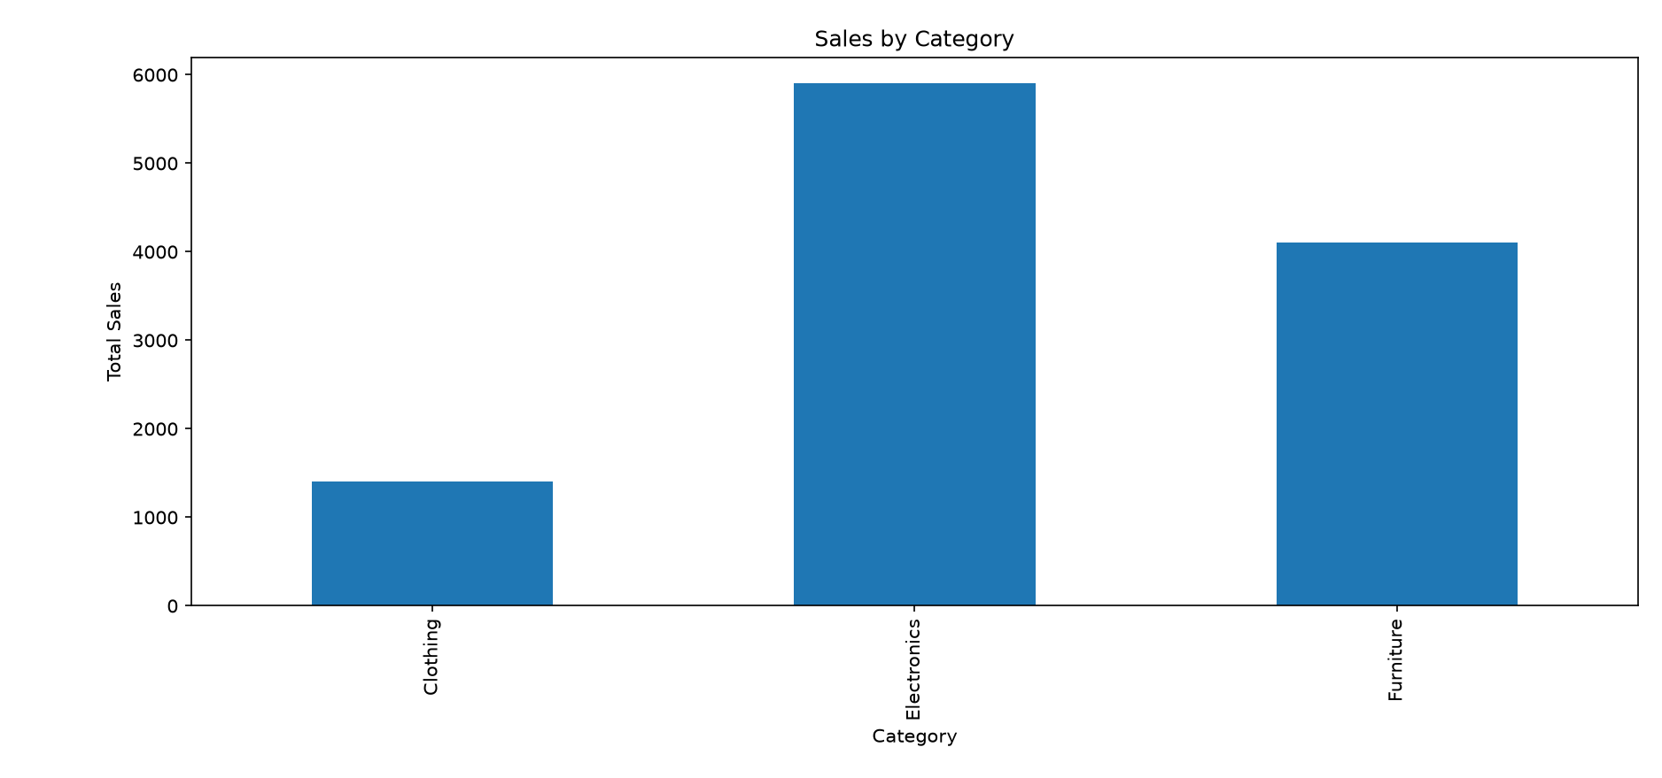

GitHub repository link….
https://github.com/MittaSirisha/InternSpark

TASK LINK….
https://github.com/MittaSirisha/InternSpark/blob/main/TASK2.docx

