TASK - 1

Goal
Create an automation script that performs file operations, renaming, sorting, or cleaning tasks.

Requirements
- Use OS module & exception handling
- Generate logs for operations
- Add user input support

Deliverables
- GitHub source code
- Sample input/output

IDEA OF IMPLEMENTATION
FileOrganizer/
│── file_organizer.py
│── organizer.log
│── README.md
│── TestFolder/
│ ├── image.jpg
│ ├── document.pdf
│ ├── notes.txt
│ ├── music.mp3
│ └── video.mp4

FileOrganizer
file_organizer.py

import os
import shutil
import logging

logging.basicConfig(
filename="organizer.log",
level=logging.INFO,
format="%(asctime)s - %(levelname)s - %(message)s"
)

FILE_TYPES={
"Images":[".jpg",".jpeg",".png",".gif"],
"Documents":[".pdf",".doc",".docx",".txt",".ppt",".pptx"],
"Videos":[".mp4",".avi",".mkv"],
"Music":[".mp3",".wav"],
"Archives":[".zip",".rar",".7z"],
"Programs":[".exe",".msi"],
}

def organize_files(folder_path):
try:
if not os.path.exists(folder_path):
print("Folder does not exist!")
logging.error("Folder not found: %s",folder_path)
return
files=os.listdir(folder_path)
for file in files:
file_path=os.path.join(folder_path,file)
if os.path.isdir(file_path):
continue
_,extension=os.path.splitext(file)
moved=False
for category,extensions in FILE_TYPES.items():
if extension.lower() in extensions:
category_folder=os.path.join(folder_path,category)
if not os.path.exists(category_folder):
os.makedirs(category_folder)
destination=os.path.join(category_folder,file)
shutil.move(file_path,destination)
print(f"Moved: {file} -> {category}")
logging.info("Moved %s to %s",file,category)
moved=True
break
if not moved:
other_folder=os.path.join(folder_path,"Others")
if not os.path.exists(other_folder):
os.makedirs(other_folder)
shutil.move(file_path,os.path.join(other_folder,file))
print(f"Moved: {file} -> Others")
logging.info("Moved %s to Others",file)
print("\nOrganization Completed Successfully!")
logging.info("Organization completed.")
except PermissionError:
print("Permission Denied!")
logging.error("Permission denied.")
except Exception as e:
print("Error:",e)
logging.exception("Unexpected Error")

if __name__=="__main__":
folder=input("Enter Folder Path: ")
organize_files(folder)

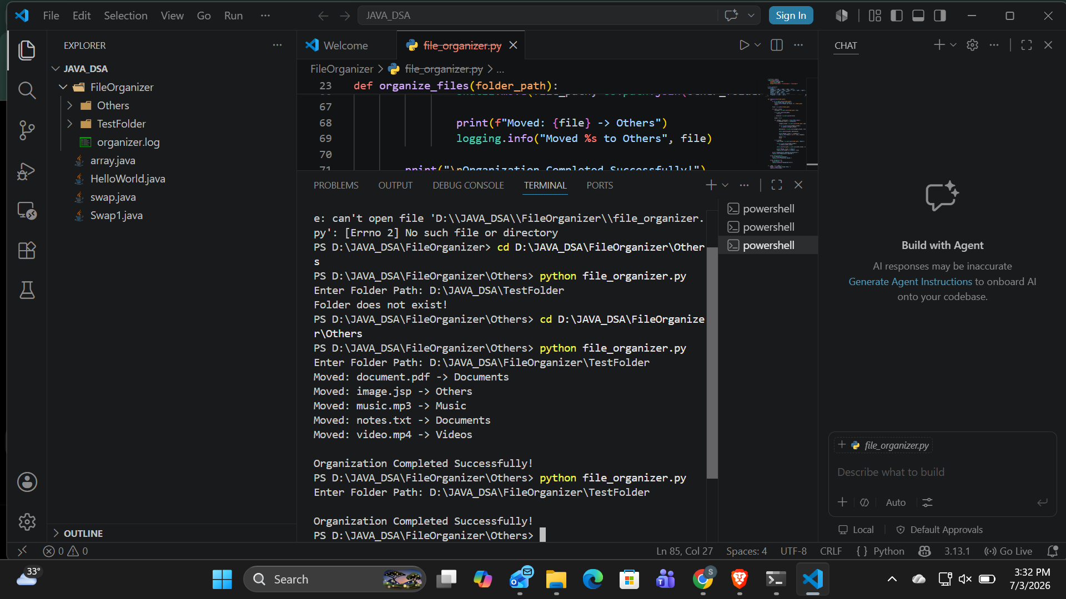

GitHub repository link….
https://github.com/MittaSirisha/InternSpark

Task Link…….
https://github.com/MittaSirisha/InternSpark/blob/main/task1.docx

