**Industrodrome Data Analyst Intern Assignment**

1. **Simple Moving Average (SMA) Strategy**

SMA is calculated by averaging the closing prices of a stock over the last **x** number of days.

**Logic Behind the Strategy**

The Simple Moving Average (SMA) strategy is based on comparing the closing price of a stock with its 30-day SMA. The logic is as follows:

Buy or Entry Signal: When the closing price is above the 30-day SMA, indicating an upward trend.

Sell or Exit Signal: When the closing price is below the 30-day SMA, indicating a downward trend.

**Entry and Exit Points**

CSV file having data of Entry and Exit Point has been uploaded separately.

Here is a screenshot of Entry and Exit points graph which has been generated using **matplotlib Library** of python.

Here Green Arrow represents an upward trend (buy signal) and Red Arrow represents downward trend (Sell Signal).

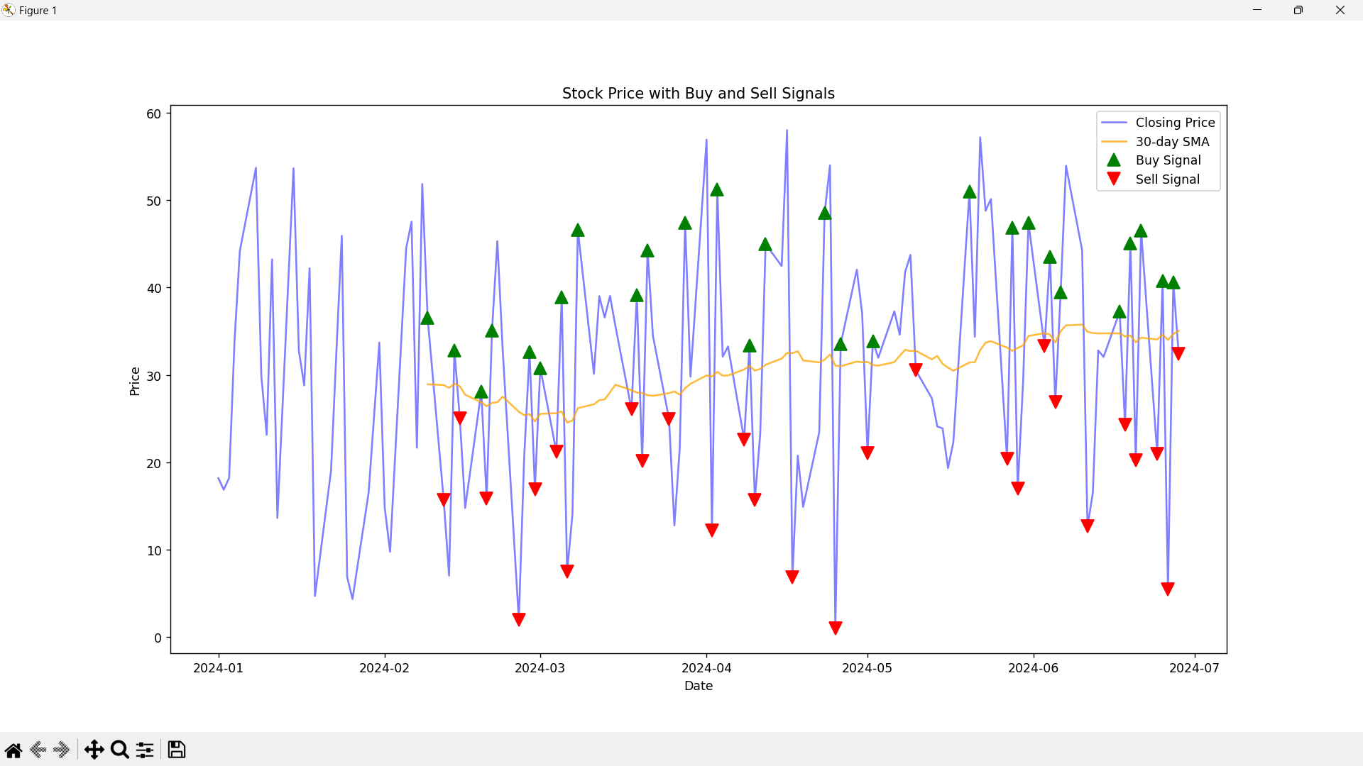

**Total Percentage Increase Achieved by the Strategy:**  -100%