Project Report: SPACE DODGE – CNN Based Hand Gesture Game

1. Introduction:
This project presents an interactive game titled 'Space Dodge', which is controlled using hand gestures detected through a Convolutional Neural Network (CNN)-based approach. The game integrates computer vision, machine learning, and real-time interaction to provide a unique gaming experience where the player controls a spaceship using gestures instead of traditional input devices.
The system uses a webcam to capture hand movements, processes them using MediaPipe’s pretrained CNN model for hand landmark detection, and translates them into in-game actions. This demonstrates the practical application of AI/ML in gaming and human-computer interaction.

2. Technology Stack:
The project is built using the following technologies:
• Python: Core programming language used for development.
• OpenCV: Used for image processing and real-time video capture.
• MediaPipe: Provides a CNN-based hand landmark detection model.
• NumPy: Used for numerical computations and array handling.
• Pygame: Used for background music playback.
• SoundDevice: Used for generating and playing sound effects.
MediaPipe plays a crucial role as it uses a pre-trained deep learning (CNN) model to detect 21 hand landmarks, which are further analyzed to classify gestures.

3. Working of the Game:
The working of the game can be divided into multiple stages:
1. Input Capture:
The webcam captures real-time video frames of the user’s hand.
2. Hand Detection and Gesture Recognition:
The MediaPipe CNN model processes each frame and detects hand landmarks. Based on the position of fingers, gestures are classified into:
• Fist → Move Left
• Open Palm → Move Right
• Peace Sign → Overdrive Mode
3. Game Logic:
The player controls a spaceship that must avoid incoming asteroids. The spaceship can move left or right based on gestures and can shoot bullets automatically.
4. Collision Detection:
The system checks collisions between:
• Bullets and asteroids (destroying asteroids)
• Spaceship and asteroids (reducing player lives)
5. Scoring and Levels:
The player earns points by destroying asteroids and collecting stars. The difficulty increases as the level progresses.
6. Sound and Visual Effects:
The game includes sound effects (shooting, explosion, damage) and visual effects (particles, animations) to enhance user experience.
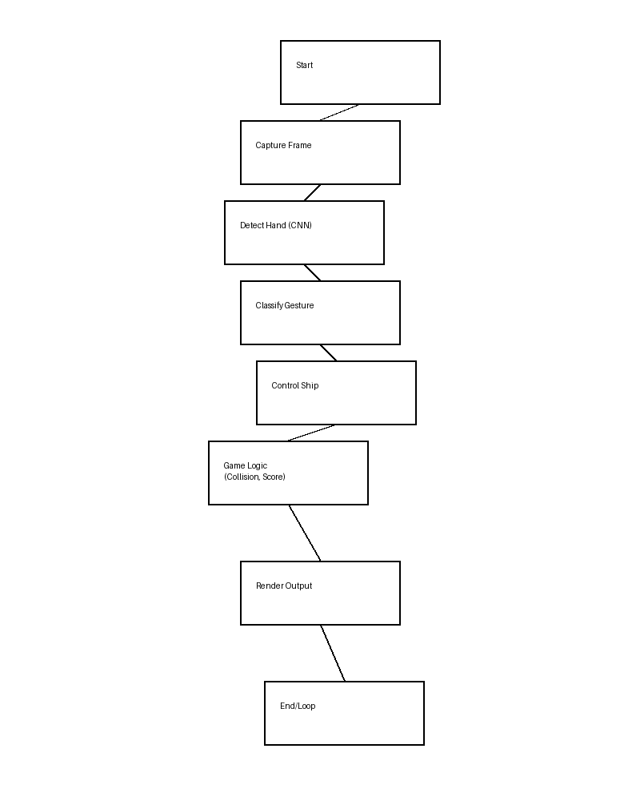

4. Key Features:
• Real-time hand gesture control using CNN
• Interactive gameplay with increasing difficulty
• Sound effects and background music
• Particle effects and animations
• Gesture confidence visualization
• Smooth and optimized performance

5. Conclusion:
The Space Dodge game successfully demonstrates how machine learning and computer vision can be integrated into gaming applications. By using CNN-based gesture recognition, the project eliminates the need for traditional input devices and creates a more immersive user experience.
This project can be further extended by adding more gestures, multiplayer features, or deploying it as a web/mobile application. Overall, it highlights the potential of AI-driven interfaces in modern interactive systems.
Submitted By:
Prasoon Mittal
UID-25LMMC3121
Naval Sharma
UID-25LMMC3108
Anshita Mishra
UID-25LMMC3060

