**Vi Editor:**

Using the vi editor in Linux can be a bit intimidating for beginners, but it's a powerful and widely used text editor. Here are the basic steps to use vi:

***Opening a File:***

To open a file using vi, open a terminal and type:

“

Vi *filename*

*“*

Replace "filename" with the name of the file you want to edit.

***Modes in vi:***

vi has two main modes: *command mode and insert mode.*

***Command Mode:*** This is the mode you start in. Here, you can navigate the document and issue commands.

***Insert Mode:*** In this mode, you can actually insert and edit text.

Switching between Modes:

• To switch from command mode to insert mode, press **i**.

• To switch from insert mode to command mode, press **Esc**.

**Basic Navigation in Command Mode:**

Use arrow keys to move the cursor.

• h - move left

• j - move down

• k - move up

• l - move right

• 0 - move to the beginning of the line

• $ - move to the end of the line

• G - move to the end of the file

• gg - move to the beginning of the file

**Editing in Command Mode:**

• dd - delete the current line

• x - delete the character under the cursor

• yy - copy the current line

• p - paste the copied or deleted text after the cursor

**Saving and Exiting:**

• :w - save changes

• :q - quit (exit vi)

• :wq - save and quit

• :q! - quit without saving (force quit)

**Inserting Text in Insert Mode:**

• Press i to enter insert mode.

• Type the text you want to insert.

• Press Esc to return to command mode.

**Searching:**

• **/search_term** - search for "search_term" forward in the document • **?search_term** - search for "search_term" backward in the document • Press n to go to the next occurrence, and N to go to the previous one.

**Vim Editor:**

Certainly! Here are some fundamental and useful Vim commands that you should know:

1. **Opening and Saving Files:**

- Open a file: `vim filename`

- Save changes: In command mode, type `:w` and press Enter.

- Save and quit: `:wq` or `ZZ` (in command mode).

**2. Basic Navigation:**

- Move cursor left: `h`

- Move cursor right: `l`

- Move cursor up: `k`

- Move cursor down: `j`

- Move to the beginning of the line: `0` (zero)

- Move to the end of the line: `$`

**3. Text Editing:**

- Enter insert mode (to start typing): `i`

- Enter insert mode at the beginning of the line: `I`

- Enter insert mode at the end of the line: `A`

- Delete a character: Press `x` in command mode.

- Delete a line: `dd`

- Undo: `u`

- Redo: `Ctrl-r`

**4. Copy, Cut, and Paste:**

- Copy (yank) a line: `yy`

- Cut a line: `dd`

- Paste after the cursor: `p`

- Paste before the cursor: `P`

**5. Search and Replace:**

- Search forward: In command mode, type `/` followed by the search term and press Enter. - Search backward: In command mode, type `?` followed by the search term and press Enter.

- Replace: In command mode, type `:%s/old/new/g` to replace all occurrences of "old" with "new" globally.

**6. Visual Mode:**

- Enter visual mode: `v`

- Select a block of text: Move the cursor to highlight text.

- Copy the selected text: After selecting, press `y`.

- Cut the selected text: After selecting, press `d`.

- Indent selected lines: After selecting, press `>`.

**8. Splitting Windows:**

- Split the window horizontally: `:split`

- Split the window vertically: `:vsplit`

- Switch between windows: `Ctrl-w` followed by an arrow key.

**9. Tabs:**

- Open a new tab: `:tabnew`

- Switch between tabs: `gt` (next tab) and `gT` (previous tab)

- Close the current tab: `:tabclose`

**10. Miscellaneous:**

- Undo changes in visual mode: `U`

- Repeat the last command: `.`

**Nano Editor:**

Nano is a simple and user-friendly text editor available on many Unix-like systems. Here's a basic guide on how to use Nano:

**Opening a File:**

1. Open a File:

- To open a file with Nano, use the following command:

```

**nano filename**

```

- Replace "filename" with the name of the file you want to edit.

**Basic Navigation:**

**1. Moving the Cursor:**

- Use the arrow keys to move the cursor up, down, left, or right.

**2. Page Navigation:**

- Move to the next page: `Ctrl + V`

- Move to the previous page: `Ctrl + Y`

**Editing Text:**

**1. Inserting Text:**

- Nano is in "Insert" mode by default. Simply start typing to insert text.

**2. Deleting Text:**

- Use the Backspace key to delete the character before the cursor.

**3. Cut, Copy, and Paste:**

- Ctrl+K = cut the text

- Ctrl + U = paste the text

**4. Search and Replace:**

- Search: `Ctrl + W`, then enter the search term and press Enter.

- Replace: `Ctrl + \`, then enter the search and replace terms and press Enter.

**5. Undo and Redo:**

- Nano doesn't have a specific undo command. You can use the undo key combination for your terminal, typically `Ctrl + Shift + Z`. Redo is not supported.

**Saving and Exiting:**

**1. Save Changes:**

- Press `**Ctrl + O**`, then press Enter to save the changes.

**2. Exit Nano:**

- Press `**Ctrl + X`** to exit Nano. If there are unsaved changes, Nano will prompt you to save before exiting.

**Other Commands:**

**1. Help:**

- Press `**Ctrl + G**` to open the help menu, which provides information on available commands.

**2. Line Numbers:**

- Press `**Ctrl + C`** to display the current line number and column at the cursor position.

Nano is a straightforward text editor, and these basic commands should help you perform common tasks

**“SED” stream editor**

Used on Unix systems to edit files quickly and efficiently. It takes input from the file name provided by the user and print the output in the terminal.

**Sed -n ‘3p’ filea**

It will print the 3rd line from the filea

To see **the range of lines** in a particular file

**Sed -n ‘3,6p’ filea**

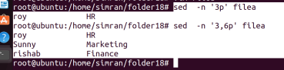Now we have following file:

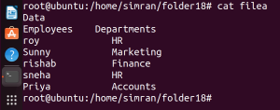

If we want to see employees from HR department only:

**Sed -n ‘/HR/p’ filea**

****Now if you want to see some particular lines only then **we use multiple expressions** with “sed” command.

**Sed -n -e ‘3p’ -e ‘4p’ filea**

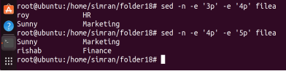Similarly, if you want to see employees from HR and Finance departments

Sed -n -e ‘/HR/p’ -e ‘/Finance/p’ filea

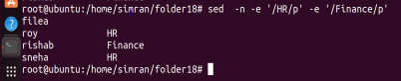

If you are seeing particular line let’s say line number 3 and with line number 3 you want to see just the two lines next to it

**sed -n ‘2,+2p’ filea**

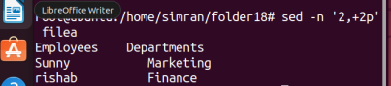If you want to see even number of lines:

**Sed -n ‘1~2p’ filea**

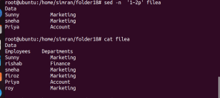

If you want to see odd number of lines:

**sed -n ‘2~2p’ filea**

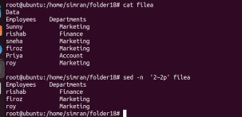

Now how to read expressions from a file

Lets assume we have this following file having expression written in it

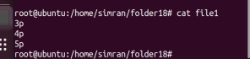

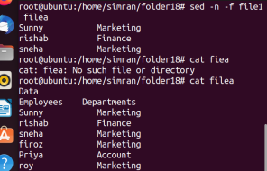

How to replace a word in a file:

**(* with these commands we are just seeing the modified data but not actually doing any change in original file)**

**sed ‘s/Marketing/Accounts/g’ filea**

**Here s is substitute and g is to Global**

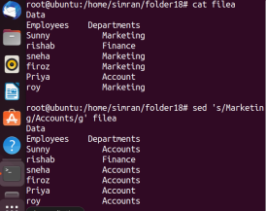

Now if you want to replace the words but not in whole file :

We have following file:

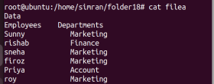Now changing the word of particular file (Replacing word Finance in line number 4) **sed ‘4 s/Finance/Admin/g’ filea**

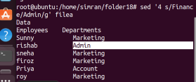Now except 4th line we need to change the department name throughout the file **sed ‘4! s/Finance/Admin/g’ filea**

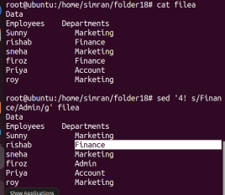

Now how to do changes in the original file by using these commands: **sed -i ‘4! s/Finance/Admin/g’ filea**

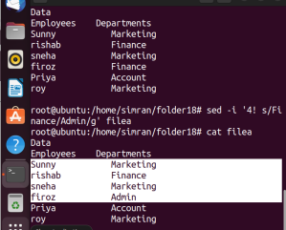Now how to change department of a particular user

**sed ‘/rishab/ s/Finance/Admin/g/’ filea**

****How to delete lines

**sed ‘1d’ filea**

It will delete the first line in the filea

**Sed ‘$d’ filea**

It will delete the last line in the file

Deleting particular lines in the file:

